- Exploratory Data Analysis
  - Initial Exploratory Data Analysis Using Power BI
Figure 9.4.1 in Appendix 9.3 shows the maximum arsenic for all potential corresponding variables, filtered by aquifer group 1 (AG1). The wells samples where As was above the Canadian Drinking Water Standards (CDWS) were more turbid – even more than As samples with sea water intrusion. Furthermore, higher As did not have much chloride or specific conductance. As ≥ CDWS did not tend to exhibit high levels of sulfate (>250 mg/L [1]), nitrogen or high alkalinity (>150 mg/L[1]). The remainder of the plots with other variables for As showed no distinct patterns.
B.C.’s groundwater alkalinity is predominantly a function of geology and aquifer materials. While northeastern B.C tends to have higher alkalinity over 200 mg/L due to Carbonate rich bedrock such as limestone and dolostone while groundwater interacting with volcanic rocks in southwestern B.C. is far lower ***. The increase of specific conductance may possibly be indicative of dissolved bicarbonates/carbonates, this would further increase the total alkalinity and pH buffering capacity of groundwater****.
Presumably very few increases of this could be explained by saltwater intrusion due to the low chloride concentration. However more feasibly the common aquifer geology contains carbonate rich aquifer mineralogy that is conductive to arsenic release under alkaline reducing conditions***. Possible past flow paths might additionally have transported arsenic rich waters with alkalinity, which over time was isolated from other ionic sources. Further research should view the relative ratios of chloride, sulfate and bromide to match that of seawater to determine if it is saltwater intrusion****.
Manganese over the Canadian water drinking standards of *** against other factors are shown in Section 9.3, Appendix. In aquifer group 1, manganese levels all had high iron levels, low phosphorus levels and high levels of water hardness. These levels furthermore had moderate specific conductance, but not at the cut off for seawater intrusion and low turbidity.
The geochemistry of Mn and Fe in groundwater is closely linked due to both existing in various redox states with groundwater chemistry microbially mediated****. Low reducing conditions indicate soluble Mn+2 and Fe+2, while Mn+4/Fe+3 is from insoluble iron hydroxides ***. The metals absorb to/coat sentiment grains during recharge areas. Further sedimentary aquifers and those with volcanic voices show elevated Mn and Fe. Whereas granitic and metamorphic terrains yield lower due to less contact time with Mn/Fe bearing minerals****. This is presumably the case for aquifer group 1.
In addition, Lead above the Canadian drinking water standard of **** against all other factors from aquifer group 1 are shown in Section 9.3, Appendix and follow a similar pattern to manganese. Low specific conductance, low turbidity and very low chloride levels were apparent patterns along with higher lead concentrations leading to limited extent of hardness. Meanwhile uranium had few levels above the Canadian water drinking standards of ***** (Section 9.3, Appendix). However, an apparent pattern was shown when it came to, rising concentrations with rising specific conductance, hardness, calcium, dissolved sulfate, alkalinity, PH, and turbidity.
higher lead concentrations in groundwater combined with low specific conductance, turbidity and chloride levels possibly indicate lead being mobilized from Groundwater pipes and well fixtures instead of being leached from aquifer materials. While localized contamination plumes from past industrial use of leaded petroleum and mining waste possibly have an explanation as well for the raised lead, although not for other specific parameters.***
Likewise, the relationship between higher Uranium and rising specific conductance, total hardness, calcium, dissolved sulfate, alkalinity, pH and turbidity indicate that ions released are coupled to increasing rock water interactions that are influenced by evolving ion geochemistry ****. groundwater interactions with rock sediments containing carbonate sulfate and clay minerals releasing entrapped uranium ions the soluble ability equilibrium is impacted by changes in pH, redox and ionics. the specific conductance, hardness and turbidity increase due to the dissolution of the Native materials as reactions, consume carbonate buffering over time***. This might as well indicate that intrusion of saline waters that creates more oxidizing conditions****.
The line graphs of aquifer Group One (Section 9.3, Appendix) shows a downward trend of iron. Nonetheless it is difficult to tell if a yearly trend exists or if it is purely based on sampling frequency and distance. Furthermore, lead goes down slightly as does arsenic, while there is a spike in uranium. Although uranium could be due to growing interest in testing. Moreover, seasonality is difficult to determine given that samples were taken in different places. However specific conductance, turbidity and chloride show somewhat of a potential distinct seasonality pattern. In addition to the above analysis for saltwater intrusion, not enough data is available to make numerous or if any conclusions.
Increased changes in runoff and rainfall patterns might alter groundwater flow gradients and changed geochemical conditions to that of oxidizing conditions, removing iron from the water***. Specific conductance and chloride show seasonal pattern due to well pumping in aquifers that show saltwater intrusion. Likewise, turbidity would display a pattern due to seasonality, resulting soil and groundwater interactions.
Section 9.3, Appendix) Shows the different metals along with their Canadian water drinking standard limit against precipitation for Aquifer group 1, Cd, Pb, As. Which all were low precipitation predominantly the ones above CWD standards. Mn above the drinking water standards was slightly related to low concentrations. Furthermore, higher specific conductance, turbidity and chloride above the saltwater intrusion cut off was showing to be related to low precipitation. Along with hardness related slightly to low precipitation and higher nitrogen, sulfate and alkalinity which had lower precipitation levels. Meanwhile Fe tended to slightly increase with higher precipitation.
the mobilization of these Metals indicate reducing conditions brought on by less precipitation and less Flushing, longer flow paths, and extended groundwater residence time ***.
The climatology monthly precipitation values were subtracted from precipitation to get the difference between the actual and predicted values (‘FD’). Values above Zero were taken to be flooding conditions, while values below 0 were taken to be drought conditions. For Aquifer group 1, no pattern was observed for alkalinity, calcium, sulfate, Fe, PH, P and hardness. Considering most of the above were associated with low precipitation values. This might indicate that the well is in an already dry area or wet area when it came to Fe. Further uranium over the drinking water standard, demonstrated a higher relationship with drought conditions. The higher amount of uranium in drought conditions is expected as results of the concentration effects. Flooding conditions more associated with nitrogen, Cd over drinking water standards, Mn over drinking water standard earths, turbidity and surprisingly chloride. . aquifer Group 1 has a greater hydraulic connectivity to Overland water bodies and results in a relationship that might create a significance. Arsenic slightly over drinking water standards were related to flooding conditions as well ??. Further the slight relationship to Arsenic and flooding would presumably result to runoffs of anthropogenic sources.

. Minimum temperature (Section 9.3, Appendix) aquifer group 1 was associated with increasing alkalinity, nitrogen, potassium, chloride and specific conductance that were over the seawater intrusion cut off and Cd, Pb, and As. Following Mn above the Canadian water drinking water standards was associated with increasing minimum temperature. The difference between the minimum temperature and the stimulated minimum temperature, (Section 9.3, Appendix) was plotted against the four medals of interest and all other factors. Higher temperature differences imply a relationship to an increase of Lead and manganese, above their Canadian drinking water standard limits. Meanwhile Cd and arsenic imply having a relationship to lower temperature differences. While iron and chloride above the saltwater intrusion cut off increased with the higher temperature differences.
Accelerate weathering reactions that occur with higher temperature, dissolving carbonates, k, and N within aquifer materials. Indirectly, the shifts in precipitation impact groundwater geochemistry and directly impact microbial mechanisms. Said warmer conditions furthermore increase microbial metabolisms in soils and aquifers, altering the nitrogen cycle through nitrogen and denitrification to release more dissolved nitrogen***. In addition, earlier snow melt and spring runoff could introduce more land surface ions through financial flow pathways, especially given aquifer group one which has a larger hydraulic connection to Overland flows than any other aquifer groups***. Additionally change from vegetation could impact the soil organic matter that enters groundwater recharge and result in an influence Associated biogeochemical process ***.
Maximum average monthly temperature for Aquifer group 1 was graft against all other factors (Section 9.3, Appendix). Turbidity, nitrogen, iron, and uranium increased with the maximum temperature. Meanwhile the difference between average maximum temperature and stimulated maximum temperature showed an increase of Cd over CWDS maximum standards, with chlorine and turbidity over saltwater intrusion cut offs.
Turbidity and chloride over saltwater cut offs would presumably be due to anthropogenic origins of more pumping on existing salt water and intruded and vulnerable groundwater during hotter weather for both Agriculture and household use.
The line time frames indicated that there is a significant influence of geography as indicated by the variation of climatology, stimulated values and seasonality in all temperature and precipitation factors that were apparent.
Aquifer group 2 consisted of around 330 data samples. Line and seasonality graphs of the data variables indicated significant sampling errors with calcium, alkalinity, and hardness (Section 9.3, Appendix). While sulfate, specific conductance, and dissolved chloride indicated significant seasonality. However, the rest was difficult to identify between an actual seasonal pattern verse sampling and distant effects. H? and specific conductance indicated a slight decrease throughout time. Moreover, TDs and sulfate involved a noticeable increase.
sulfate might be a result of biological processes and specific inductance along with dissolved chloride which might result to groundwater usage habits as aquifer group 2 is primarily consisted of confined aquifers, the increase in sulfates and TDS might be due to overdrawing or contamination.
Uranium for aquifer group 2 [Section 9.3, Appendix] did not have any concentrations above the Canadian water drinking standard. However, a similar but smaller trend observed in Aquifer group 1 was observed. Following lead concentrations above the Canadian drinking water standards for group 2 was partially related to alkalinity, while other factors contained no supporting patterns. Manganese samples that were over the Canadian water drinking standard had high alkalinity, low phosphorus, high potassium, and high hardness. With arsenic above the Canadian water drinking standard, against all other variables for aquifer group 2 had high turbidity and no other indication of patterns.
Furthermore, lead and alkalinity may indicate higher concentration in confined aquifers that have a longer residential times with more opportunities for rock water Rock interactions that leech lead***. reducing conditions are more common in low oxygen confined aquifers and as a result solubilize previously bound lead***. Lastly any disturbance to confining layers from human activity could expose confined aquifers to lead sources at the surface.
High Mn levels with high Fe, low turbidity, low phosphorus and high hardness potentially indicates aquifer materials that contain crystalline iron and manganese oxide/hydroxide minerals, under reducing conditions****. Furthermore, it indicates that a longer set residence time allows the complete dissolution of oxides and settlement to settle moving turbidity***** . Therefore, historically is reduced in undergoing organic redox processes instead of microbial mediation. This is due to the low phosphorus availability ****. As well it indicates there is a significant distance from the region zones that maintain persistent reducing conditions for soluble Fe and Mn. Furthermore, hardness is dominated by calcium/magnesium ions from carbonate mineral weathering rather than manganese/iron oxides.
Precipitation for aquifer group 2 was graphed against all factors (Section 9.3, Appendix) Cd, Pb, As, and as shown above, CWDS and chloride, turbidity, and specific conductance above saltwater intrusion cut off limits were associated with lower precipitation. While manganese above the Canadian water drinking standard cut off was slightly associated with lower precipitation. Furthermore, the differences between actual monthly precipitation and stimulated monthly precipitation was then compared to all other factors to stimulate flood drought conditions. Drought like conditions were related to lead and arsenic above the Canadian water drinking standards. As well as flood like conditions were related to P and arsenic below the Canadian water drinking standards.
drought like conditions for lead and arsenic could relate to the draw down from underlying or above late aquifers***. And metals indicate significant saltwater intrusion given that this aquifer group consists of confined coastal aquifers. Further manganese could easily be due to a concentration effect. While flood like conditions related to phosphorus and arsenic may be due to contamination of the Wellhead or surrounding well heads***.
Minimum monthly mean temperature for aquifer group 2 was graphed against all other factors (Section 9.3, Appendix). This showed a related increase in chlorides, As, Cd and Mn over CDWS limits. The difference between minimum temperature and predicted minimum temperature showed an increase of chloride and specific conductance over the water intrusion cut off limit and As, Mn over CDWS limits. Furthermore, uranium and sulfate increased as well with minimum temperature difference. While maximum monthly mean temperature had similar patterns to the minimum monthly mean temperature. Additionally, the differences between mean maximum monthly temperatures and stimulated maximum monthly temperatures plotted against all other factors showed an increase of chloride and specific conductance over the saltwater intrusion limit, slight turbidity and Cd over the Canadian water drinking standard maximum.
Chloride, uranium, and As over CDWS limits increased overtime For Aquifer group 2 with all factors showing significant seasonality along with indications of the impact of geography.
Aquifer group 3 had about 300 samples. While arsenic above the Canadian water drinking standard against all other factors [Section 9.3, Appendix] showed the height of turbidity as being low with specific conductance and low chloride. Cadmium had no patterns again.
Low permeability fractured flow with minimal water rock interactions tended to produce clearer, lower ion concentrated groundwater. Furthermore, deep buried sediments in fractured sedimentary offers have undergo lithification and reduce fracture porosity where rock water interactions are limited****. Similarly, in Flatline volcanic flows, gentle topography results in laminar flow through well connected black fractures with less turbulent mixing****. Additionally phreatic zones are below the influences of most surface water processes****.
Manganese above the Canadian water drinking standards [Section 9.3, Appendix] for group 3 showed high alkalinity, calcium, iron, potassium and hardness, following a similar concentration pattern to aquifer group 1. Additionally, it showed lower specific conductance and turbidity. Meanwhile lead samples above the Canadian water drinking standards for group 3 [Section 9.3, Appendix] were mostly alkaline while the specific conductivity followed a similar pattern to manganese. Furthermore, uranium did not have r many values above the Canadian water drinking standard. However, a smaller similar pattern for Aquifer group 3 was observed to Aquifer group 2.
Higher Magnesium, with higher alkalinity, calcium iron, potassium and hardness indicates an extended long rock- water interaction over long flow paths and stagnant water stagnation zones within the fracture Network*** and upwelling of formations after circulation brings the ions to surface***.
Line graphs indicate many sampling errors in Aquifer group 2 [Section 9.3, Appendix]. Furthermore, chloride and specific conductance had a noticeable increase along with variations that suggested potential seasonality.
Monthly precipitation was plotted against all other values for Aquifer group 3 [Section 9.3, Appendix]. N, Cd, and pH increased with increasing precipitation, while As, U and Fe increased with decreasing precipitation. Furthermore, the differences between stimulated and actual monthly precipitation were also plotted against all other values. While flooding showed a similar pattern in Aquifer for group 2. Meanwhile droughts showed an increase for Ca, specific conductance over the saltwater intrusion cut off, and Mn, As above the CDWS limits.
The increased precipitation from higher recharge and rising water cables expands the saturation zone and increases the height storage capacity. This may dilute to a certain amount above the concentration of dissolved Iron by flushing and mixing***. Meanwhile droughts shift aquifers to a closed system and change the geochemistry through continued rock water exchange without replenishment***. The creased recharge allows more oxygen exchange in the vadose zone and changed redox conditions that may be impacting solubility of iron and Fe.
Minimum mean monthly temperature was plotted against all other factors for Aquifer group 3 [Section 9.3, Appendix]. While a decrease in alkalinity, Ca, K, P, hardness, U, and As was showing. Meanwhile sulfates, Cd, Mn and Pb showed an increase. Following the differences between the actual and stimulated minimum mean monthly temperatures plotted against all other factors showed an increase in Cd and a decrease in Fe. With maximum mean monthly temperature showing similar patterns to minimum mean monthly temperature. As did the difference between actual and stimulated maximum monthly temperatures.
The line timelines increase in the difference between the minimum temperature and the stimulated min minimum temperature and that all graphs showed significant seasonality.
  - Descriptive and Summary Statistics
Given that most values are scaled to be centered around zero and the smallest, this means the coefficients of variance is quite large (Section 9.5, Appendix). Variance and standard deviation were also fairly large, which indicated that there is a large spread of data. This is expected due to certain wells being over the contamination standards, while others are not, due to groundwater chemistry in different geology and other factors.
The bar graph of aquifer samples (Section 9.2 Appendix) indicates that primarily aquifer sampling was concentrated in aquifer group 1, with occasionally being concentrated in aquifer group 2. Box plots (Section 9.2 Appendix) demonstrate that for Cd, Pb, U, and Mn there is a large variation for aquifer groups two and three. a moderate amount of variation was showing for arsenic in aquifer groups 1, 2, and 3 and for manganese in aquifer group one. Uranium, lead and cadmium were usually low but had a lot of extreme outliers indicating potential well contamination.
Pearson, Kendall and Spearman correlations matrices were calculated for the entire dataset, drought dataset, flood dataset, rising minimum temperature dataset, rising maximum temperature dataset and seawater intrusion dataset. Pearson and Kendall correlations were focused on as the first represents linear correlations and the second is similar to spearman's representing nonparametric correlations but considered to be more stringent***. The full Kendall's correlation for the entire data set is showing in the appendix (Section 9.5 Appendix). Matrices did not take aquifer types into account and thus this may be an area for further study.
Table *** displays both the Kendall’s rank Correlation and Pearson correlation for the entire data set, flood data set and drought data set with a cut off of P >= 0.5. Heavy Metals of Interest and nitrogen as it has been extensively studied in these types of conditions were looked at. Both Arsenic and nitrogen showed no significant correlation to any variables in all three data sets. this goes against previous studies which demonstrate both N and As correlation ****. Said lack of correlation may also be due to lack of consistent sampling methods which is often demonstrated in large groundwater databases.
Manganese had a weak relationship to iron in the normal data set which remained somewhat consistent in the flooded data set but deteriorated in drought conditions. This supports the widespread reducing conditions from the raising water table/saturated soils from increased recharge from flooding which leads to co Mn and Fe precipitation.
the relationship between manganese and iron is explained in the previous section. flooding data Maintain dissimilar and bills and Pearson coefficient. this is likely due to the fact that flooding creates uniformly distributed reduction States and thus Geochemical co-precipitation. in drought data that relationship is uncoupled because us the lowering of the water table creates local oxidized environments which spatially uncouple the uniform relationship. These shifts in redox conditions Often cause the Divergence of each concentration.
Lead had an extremely strong linear correlation with cadmium and a moderately nonparametric correlation with cadmium as well. Both these correlative relationships weakened in droughts. In floods however, the linear correlation decreased but the parametric relationship remained somewhat consistent. this combination is usually anthropogenic and means and probably influenced linearly by geochemistry ****.
lead and cadmium show a strong Pearson correlation and a moderate Kendall correlation. This relationship As he has various natural sources relationship is difficult to determine as BC has various natural sources of Cd and lead, variably aquifer lithology, has high areas of both mining, industrial activity and petroleum mining and this relationship is typically In scene in well water fixtures. given that the observation well stations are governmentally run and undergo regular periods of maintenance, a high relationship is unlikely to be silly due to well water fixtures. Kootney region have historical lead contamination due to the Joint emissions from Decades of anthropogenic activity. likewise, the trail operation smelter in southern BC also admitted both lead and can into the surrounding air, Soil and Water for over a hundred years. Spatial auto correction would Reveal more about this relationship.
The difference Pearson’s are measures linear correlations and are highly influenced by Measurement errors while Kendall measures monotonic increase or decrease that may or may not be linear. this could account for the different scene between the Kendall’s and Pearson relationship in cadmium and arson and Lead. with flood and drought, or noise is added, and Bears are more common outliers are more common. how is less impacted by variability and outliners thus decreases less. the Pearson coefficient for flood conditions Maybe due to sediment interactions and the difference in transport and deposition rates caused by said flooding. Sediment Providence and depositional environments would also indicate that they'd be a varying horses and non-uniform contaminate that would delink their observed relationship in droughts.
Uranium had a weak relationship with hardness and calcium that deteriorated in flood conditions and further deteriorated in drought conditions. These relationships were likely more linear due to the lower Kendall’s values.
There is a moderate linear relationship between uranium and calcium in The regular data. this relationships seen to be slightly weaker in flooded data set and completely uncoupled in drought data sets. Geology this week relationship might be due to Aqua for Geology as uranium commonly occurs in calcium nuts rocks minerals like Limestone release via weathering process and BC has areas of carbonate bedrock. these two elements are also correlated due to longer groundwater residential times and perhaps anthropogenic activities. flooding could slightly weaken the relationship via increased erosion and runoff that transport uranium in Pathways independent calcium in groundwater. this again will slightly decouple their concentration lowering the Pearson correlation. Droughts May indicate that the mobility of uranium and calcium are governed by distinct geochemical factors such as Doc's condition redox conditions, mineral equilibria and microbial activity. this would de-couple them so that no statistical correlation is observed.
Table 4:1: Pearson (cutoff p ≥ 0.5) and Kendall rank correlations for each element of interest (As, Mn, Pb, U) and N for the entire dataset, flood dataset and drought dataset.
Element of Interest | Related Element | Normal |  | Flood |  | Drought
Element of Interest | Related Element | Pearson | Kendall | Pearson | Kendall | Pearson | Kendall
As | - | - | - | - | - | - | -
Mn | Fe | 0.5168 | 0.4111 | 0.5175 | 0.4092 | - | -
N | - | - | - | - | - | - | -
Pb | Cd | 0.9534 | 0.5630 | 0.7089 | 0.5768 | 0.6691 | 0.4870
U | Ca | 0.5670 | 0.3620 | 0.4978 | - | - | -
 | Hardness | 0.5610 | 0.3977 | - | - | - | -

The correlations from minimum temperature rise and maximum temperature rise data sets for As, Mn, N, Pb, and U are showing in Table ****. Arsenic and nitrogen had no correlations. the weak correlation between manganese and iron deteriorated with both increasing minimum and maximum temperatures. this again might be due to lack of data or it may indicate different Rock geochemical processes.
Relationship between manganese and iron with increasing maximum and minimum temperatures are somewhat equivalent to that of droughts. with the rising minimum temperature it is an indication that soils and sediments are dried out thus resulting in oxidation like conditions. Rising maximum temperatures often are indicators of drought, accelerate microbial metabolism and redox plexus and also limit the seasonality in which influence ideal redox reactions Spring and fall in some aquifers indicate a transitional level between high and low for temperature and oxygen which provides a more stable intermediate redox zones for Mn and Fe coprecipitation. Temperatures this limit this influence.
Increasing maximum and minimum temperature for U Demonstrated a similar relationship to droughts. this again might be due to redox changes p. uranium solid abilities more redox sensitive well calcium is relatively stable. Drying soils and increase redox reactions from temperature would release the two elements via different processes.
further research might want to explore this relationship in depth over other areas and data sets. likewise, the weak relationship between uranium and calcium or hardness deteriorated so that there's no correlation in both increasing minimum and maximum temperature day data sets.
both the linear and parametric correlation between lead and cadmium deteriorated to similar values of that of drought both minimum and maximum temperature rise. Need to intensified this might be due to increased evaporator Trent ration during hotter period it's that concentrate lead and Cd differently due to variations in solid reality. it could also be due to extreme and frequent redox shifts from the higher temperatures that a couple metal mobilization or fluctuating soil moisture transporting both contaminations differently via particulate and solution-based pathways.

Table 4:2: Pearson (cutoff p ≥ 0.5) and Kendall rank correlations for each element of interest (As, Mn, Pb, U) and N for the entire dataset, dataset with rising minimum temperatures and dataset with rising maximum temperatures.
Element of Interest | Related Element | Normal |  | Minimum Temperature Rise |  | Maximum Temperature Rise
Element of Interest | Related Element | Pearson | Kendal | Pearson | Kendal | Pearson | Kendal
As | - | - | - | - | - | - | -
Mn | Fe | 0.5168 | 0.4111 | - | - | - | -
N | - | - | - | - | - | - | -
Pb | Cd | 0.9534 | 0.5630 | 0.6692 | 0.4870 | 0.6566 | 0.4816
U | Ca | 0.5670 | 0.3620 | - | - | - | -
 | Hardness | 0.5610 | 0.3977 | - | - | - | -

Kendall and Pearson correlation for normal and seawater intrusion data sets for as, Mn, N, Pb and U are showing in Table *** . Arsenic and nitrogen have no correlations. Lead’s Cadmium correlation with cadmium drops to a still somewhat strong linear correlation but a parametric correlation similar to that of droughts in the saltwater intrusion data set.
The weak interrelationship between lead and Cd in saltwater attrition could be due to multiple factors. the first would be co-precipitation promoted by saltwater mixing of s e oxide / hydroxide which can also Savage and Co precipitate Pb and mechanical link their transport. Likewise of iron and Lead contamination Legacy sources of iron and Lead contamination Maybe immobilized that U saltwater intrusions. Also have more shared marine and rock sources of iron and Lead which would promote their Association during intrusion episodes.
The relationship between iron and Mn is completely decoupled in saltwater intrusion. this might be due to different geochemical controls, competing ions from seawater that interfere with the Mn/Fe binding behaviors and soil and aquifers, redock shifts from oxygenated seawater and kinetic factors as intrusion relatively to groundwater flow could affect the degree of geochemical relief equilibrium between the two.

negative week linear and parametric correlations were also showing for uranium in seawater intruded well data sets. this might be due to location or sampling biases.
Correlation between uranium and calcium disappear in the saltwater intrusion data set. instead, week negative linear correlations between chloride were showing. This Relationship was solely linear as the Kendall correlation was lower than expected.
A weak negative relationship between lead and uranium also was showing in the saltwater intrusion data set May have also had a parametric or additional complexities due to the similarity in Kendall scores. Meanwhile the relationship between lead and uranium was inverse that of lead-iron with saltwater intrusion. This again Could be partially due to the changing redox conditions Description condition competition sorption competition by saline metals from previous Legacy sources. that uranium weekly competes for subs and sites and readily deserves well pressure from intruding ceiling ions can squeeze out cation-bound uranium.
The relationship between and calcium uranium and calcium in the main dataset seem to be replaced by a similar relationship between uranium and potassium. hardness remained nearly unchanged. However, alkalinity showed a somewhat higher weak correlation in saltwater intrusion.
Hardness relationship heavily mimics that of flooding conditions specifying that the same issues of sediment disposal and redox conditions may remain despite the addition of different ions. Consistent With the addition of Ca in saltwater due to its effects on placing mg concentrations. competition effects from intruded Mg/Na might display Ca from exchange sites compared to mg and Elevate the Mg concentration with uranium. likewise, dissolution of calcite versus dopamate will release different ratios of Ca:Mg when that couples strongly to U dissolution from carbonates.
Alkalinity is influenced by bicarbonate and carbonate ions Which buffer pH changes. saltwater intrusion induces extra calcium and slightly raises pH through ion exchange and carbonate mineral dissolution. which releases Intern releases a Cascade of more calcium and pushes the inorganic carbon equilibria towards increasing bicarbonate and carbonate ions. the higher alkalinity and higher pH favor increased aqueous complexions of UO2 2+ and calcium through carbonate and hydroxide species and creates the observe positive correlation during intrusion episodes. Cation Exchange is less sensitive to small variations in alkalinity and pH in regular water compared to sea water mixing and occurrence sampling issues might be a problem due to the small amount of saltwater intrusion data.
Intruded potassium competes with exchange sites for Ca/Mg/Na that may previously immobilized U and liberate it into the groundwater where minimal complexes of chloride occurs. Negative correlation uranium’s negative correlation with lead and chloride May indicate me indicate natural sources of Cl/ Pb From that immobilized from sediments decreasing the solubility due to the precipitation of chlorides and so a complex at higher ionic strengths. Meanwhile, under more stable freshwater conditions without geochemical /transport perturbation, subtle factors controlling uranium’s Association would be outweighed by intrinsic noise.

Table 4:3: Pearson (cutoff p ≥ 0.5) and Kendall rank correlations for each element of interest (As, Mn, Pb, U) and N for the entire dataset, and with noticeable sea water intrusion.
Element of Interest | Related Element | Normal |  | Sea Water Intrusion
Element of Interest | Related Element | Pearson | Kendal | Pearson | Kendal
As | - | - | - | - | -
Mn | Fe | 0.5168 | 0.4111 | - | -
N | - | - | - | - | -
Pb | Cd | .9534 | .5630 | 0.7810 | 0.4870
Pb | Fe | - | - | 0.5940 | 0.4338
Pb | U | - | - | -0.5228 | -0.4382
U | Ca | .5670 | .3620 | - | -
U | Cl | - | - | -0.5538 | -0.3452
U | Pb | - | - | -0.5128 | -0.4382
U | K | - | - | 0.5514 | 0.3521
U | Hardness | 0.5610 | 0.3977 | 0.5536 | 0.3399
U | Alkalinity | - | - | 0.6212 | 0.3873

Table *** shows the metals of interest that are above the limits set by the Canadian drinking water standard guidelines in addition to saltwater intrusion factors above the respective cutoffs. Uranium above cut-offs is scarce mainly as testing for it seem to be more recent and this might also be the reason why most of it is associated with Rising temperatures and droughts. Sonic above limits seem to have no clear pattern as it occurs in both flood and drought along with Rising minimum and maximum temperatures. this might be due to increased anthropogenic means in combination with pure climate change effects. Lead above cut off was found in 289 samples. datasets that had higher minimum or maximum temperatures than expected often had a higher proportion of lead above its limits. manganese had the most samples above recommended guidelines of 344. most of those data points occurred in droughts, rising minimum temperatures and Rising maximum temperatures. Sea Water intrusion factors had a higher in occurrence in drought, rising minimum temperatures and rising maximum temperatures. this makes sense as those increase Demand on vulnerable aquifers and thus lead to over pumping.
saltwater intrusion factors such as specific conductance, residue filterable, and chloride are known to increase with droughts due to overcome pumping and overuse of groundwater. Manganese above Canadian drinking water standards is often seen in drought, rising minimum temperature and rising maximum temperature data. that is likely due to the Boring of the water tables oxidation of sediments, less recharge and longer residence time and greater biological and chemical reaction rates. Uranium above CWDS Has only a few values so it's difficult to determine if the there is an underlying General correlation or relationship or if it's just due to spatial factors. potential lead and arsenic relationships with droughts, minimum temperature, and maximum temperature are discussed in the previous chapter.
Table 4:4: Metals of interest that are above the limits set by the Canadian Drinking Water guidelines in addition to saltwater intrusion factors above their respective cutoffs for the full, drought, flood, rising minimum temperature, and rising maximum temperature datasets
 | As Above Limit | Pb Above Limit | Mn Above Limit | U Above Limit | Specific Conductance over cutoff | Residue Filterable 1.0u over cutoff | Chloride over cutoff | Total Data Points
Full Dataset | 81 | 289 | 344 | 6 | 107 | 79 | 52 | 1147
Drought Dataset | 37 | 138 | 162 | 4 | 69 | 49 | 29 | 530
Flood Dataset | 31 | 124 | 135 | 1 | 32 | 22 | 18 | 455
Dataset with Minimum Temperature Rise | 46 | 170 | 208 | 3 | 75 | 52 | 38 | 713
Dataset with Maximum Temperature Rise | 38 | 151 | 190 | 4 | 66 | 44 | 31 | 611
Chloride or Specific Conductance | 71 | 26 | 41 | 0 | 99 | 70 | 47 | 106

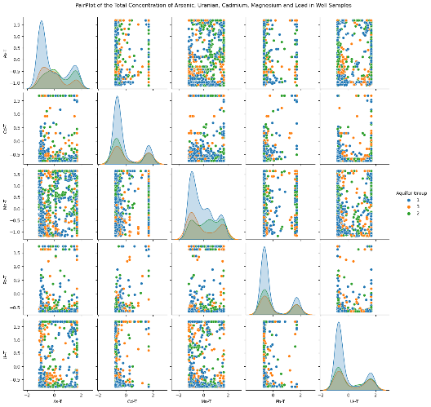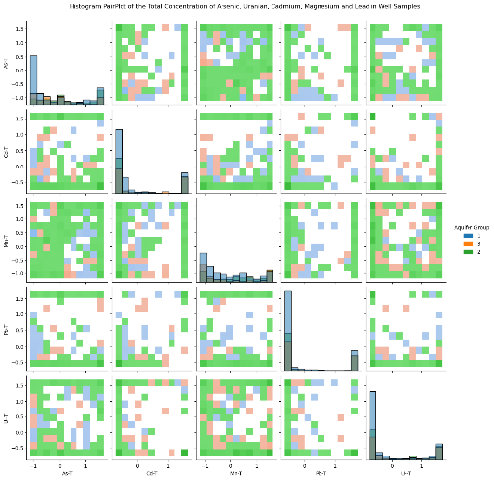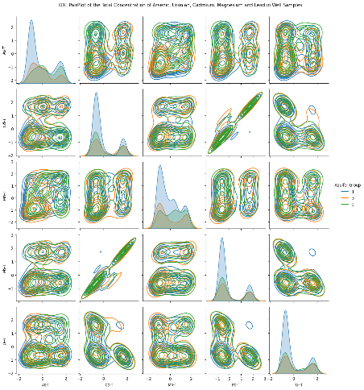
B)
C)
A)
Figure 4.1: A) From Left to right: A) pairplot, B) hisplot and C) KDE plots of the relationship between metals of interest for the full dataset.
Figure 1 shows the pair plot, histogram, and kernel density estimator (KDE)All the metals of Interest. Uranium's relationship with cadmium is seen on both the pair plot and KDE. Agonies and arsenic agonies and arsenic show no apparent pattern. a slight relationship between cadmium and Lead is observed in the KDE plot and his plots along with manganese and cadmium.
Relationships of precipitation factors, and other variables seem to display similar relationships to that showing with the correlation plots (Section 9.2 Appendix). there doesn't seem to be much Stand Out differences between the drought, flood, maximum temperature, or rising minimum temperature in comparison to the entire data set. lesser or greater variations of the same pattern are shown. heat maps and show increasing temperature/ temperature differences, somewhat decreasing precipitation/precipitation differences and increasing turbidity over the years per well location (Section 9.2 Appendix).

  - Saltwater Intrusion Exploratory Data Analysis
Table 7 (Section 9.3, Appendix) Shows various combinations of different saltwater intrusion cutoffs and the resultant data points, Metals of Interest and saltwater intrusion factors. from this, the best data set can be found by using the cutoff for chloride of 150 micrograms per liter or a specific conductance of 1,000. this gives a data set of 106 points that has no uranium over limits, few manganese over limit and few Lead over limit. however, 71 of 81 samples of arsenic in the total data set also appeared in the saltwater intrusion dataset with these criteria.
Table appendix shows the Metals above Canadian drinking water standards with saltwater intrusion. a high amount of arsenic love Canadian water drinking standards occurs in the data set with chloride or specific conductance over saltwater intrusion limits but not in the data set with both specific conductance over the saltwater intrusion cutoff. despite not showing any Pearson or Kendall's correlation in our previous analysis, arsenic could be due to already mobilization from competing ions and reducing environments. previously observed positive correlations of arsenic in saltwater intrusion with chloride or specific conductance has been observed by *****.
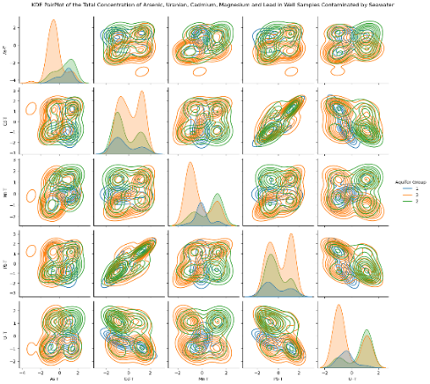
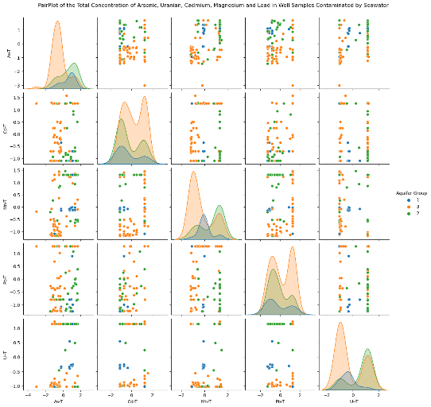
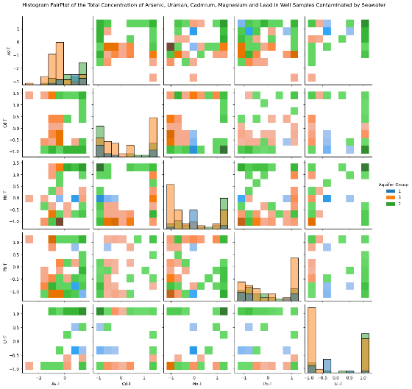
A)
B)
C)

Figure 4.2: A) From Left to right: A) pairplot, B) hisplot and C) KDE plots of the relationship between metals of interest for SWI dataset where specfic conductance ≥ 1000 or chloride ≥ 150 μg/L.
Figure *** shows the relationship between different Metals with saltwater intrusion for each aquifer group. Some of the week correlations between uranium and Lead. it also shows that a lot of the aquifer types are with water saltwater intrusion are aquifer type 2. Figures in the appendix show expected or undetermined relationships for seawater intrusion variables, temperature and precipitation variables and all other variables (Section 9.3, Appendix)

AG1
AG2
AG3
Alkalinity
residual non filterable
Sulfate
MT
FD
HW
SWI
Metals of interest
OBS
OBSWell
EMS
CDWS
Minimum temperature
Maximum temperature
Chloride

