  - Uniform Manifold Approximation and Projection (UMAP)
    - Data Pre-Processing
Data was processed as above.
- Hardness, Alkalinity, Climatology factors, and Residue Filterable were dropped due to redundancy.
- Furthermore, Latitude, Longitude, date and OBS Well were dropped from the dataset as geography and time are in subsequent analysis.
- While outliers were replaced via IQR thresholds, and the dataset was transformed via Sklearn power transformer via Yeo-Johnson method.
Data spasticity (not sure what this means) was calculated, and the data was highly sparse [5]. A quick principal component plot via Sklearn’s python library showed that the global data structure was difficult to understand without considering the local data structure relations (Appendix 9.8)[6]. Additionally, a quick Uniform Manifold Approximation and Projection (UMAP) plot was created to demonstrate the effect of spar sity.
    - Exploratory UMAP
A function called draw_UMAP was written to run and generate multiple UMAP plots based on series of nearest neighbors, minimum distance, and metrics.
- The default of this function was 15 nearest neighbors, Euclidean metric and a minimum distance of 0.1.
- Random state was set to 42 to ensure better reproducibility and the number of components was set to two, keeping most of the graphs in 2D.
- An array of Nearest neighbor values [2, 5, 10, 20, 50, 100, 200] run through the function with the current data set and specified via aquifer group to analyze both high local and global data structures. Nearest neighbors signify how local or global the view of the data structure is [6]. Essentially the nearest neighbor in UMAP akin to that in k-nearest neighbors with the regular default value being 15.
- An array of minimum distance values [0.0, 0.1, 0.25, 0.5, 0.8, 0.9] was run through the function and specified via aquifer group to analyze clustering. The minimum distance (min_dist) represents the distance each parameter is apart from each other in low dimensional space[6]. This influences the clustering of data points with the general default value being 0.1.
- The function draw_ was then utilized to view the effects of different relevant metrics of measurements. Minkowski style metrics ('Euclidean', 'Manhattan', 'Chebyshev', 'Minkowski') and normalize/correlation metrics ('Mahalanobis', 'Minkowski', 'correlation') were run through the function and plotted.
- UMAPs using Squared Euclidean and Canberra metrics were separately plotted without the use of a function primarily to rotational issues.
Canberra distance showed the most promising clustering pattern as it is weighted in chunks similar to Manhattan, but emphasizes measures close to the origin which corresponds to the change in concentrations of interest[7] [8]. The results of these are discussed in Appendix 9.8 and Section 8.
A second function, draw_UMAP3D was created to visualize the UMAP clusters in different dimensions Using mpl_toolkits utilizing the same default parameters of draw_UMAP. The well data set was then graphed in 1D, 2D and 3D and grouped by aquifer group.

    - Exploratory UMAP for Climate Change Factors.
Five additional datasets were created and transformed as above:
- One where the chloride concentration was above 150 mg/L or where the specific conductance was above 1,000 uS/cm and was created to specifically analyses factors where wells had seawater intrusion.
- One to represent data for drought that took rows where ‘FD < 0.
- The dataset for floods took rows with FD > 0 to analyse the effects of precipitation.
- DatatHW took values where HW > 0.
- Lastly, DatatMT took values where MT >0. these were to analyze the effects of rising maximum and minimum temperatures due to potential climate change.
All datasets were run through draw_UMAP with both Euclidean and Canberra metrics. Five more datasets consisting of the same rows with the addition of latitude and longitude were created and run through draw_UMAP with a Canberra metric. The results of these are discussed in Appendix 9.8 and Section 8.
    - Supervised UMAP for Metals

A function called supervised_UMAP was defined with nearest neighbors= 30, two components, random state = 42, low memory on, minimum distance = 0.1 and on a Canberra metric. This function takes in a list of arrays as Y values and a matrix as X and performs and plots UMAP figures in accordance with the specified Y column.
Aquifer groups were encoded utilizing one hot encoding. A list was made referencing the columns of As, Mn, Pb, and U as the Y input was for the above function, while the data frame without said metals was used as X. This visualized how UMAP clustering occurred from the perspective of each metal. Furthermore, similar supervised UMAPs for each metal were run using the data set for seawater intrusion, drought, flood, and Rising temperatures. Details of these are displayed in Appendix 9.8 and Section 8. The cluster graphs that occurred demonstrated vague shapes but required further details.
    - Supervised UMAP for Metals and HDBSCAN
HDBSCAN (Hierarchical Density-Based Spatial Clustering of Applications with Noise) was further utilized to cluster the dataset as it can distinguish noise and has more flexible parameters then DBScan [9].
UMAP was applied to each metal concentration of As, Mn, Pb, and U:
- Euclidean distance metric, 30 = nearest neighbors, min_dist=0.1, number of components =2
- Models were fitted to metal concentrations (Y), labels and X.
- X was transformed to 2D space via UMAP model
HDBSCAN was then applied to each 2D UMAP projection with a minimum cluster size of 5 and then cluster labels were predicted.
The UMAP+HDBSCAN for each metal was evaluated by [4]:
- Calculating the Silhouette and Calinski-Harabasz scores.
- Reporting the ratio of non-noise points.
- Calculating the Adjusted Rand Index (ARI) and Adjusted Mutual Information (AMI) between true labels and predicted clusters for non-noise points.
To visualize each UMAP 2D projections were overlaid with true labels and predicted clusters were plotted on a 2x2 grid for qualitative analysis.
The methodology was repeated using the Canberra distance metric for UMAP to compare structure preservation and clustering performance under different metrics. The same procedure was then run for seawater intrusion, drought and flood data along with datasets rising minimum and maximum temperatures. Details of these are displayed in Appendix 9.8 and Section 8.

Uniform Manifold Approximation and Projection (UMAP) Analysis
  - UMAP Original Analysis
Principal components analysis (Section 9.8, Appendix) showed insufficient results thus a clustering mechanism that preserves lower dimensional data.
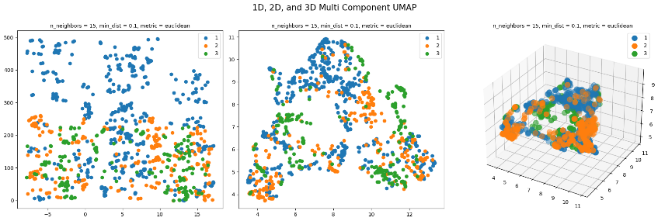

Figure 7.1: From left to right: 1D, 2D and 3D UMAP of the entire dataset with minimum distance = 0.1, nearest neighbors = 15 and Euclidean metric per aquifer group.

Fig ### shows UMAP clustering conducted with minimum distance = 0.1, nearest neighbors = 15 and Euclidean metric. In order Optimize viewing, 2D sections of the data will be used.
The data set was analyzed to find the ideal you map parameters (Section 9.8, Appendix). minimum distance decides on how far apart data points can be, with smaller distances allowing for points further apart from each other and larger distances meaning that points have to be closer together. Data set shows more clustering with lower minimum distances so thus the standard minimum distance of 0.1 Will be used from now on. Neighbors represent how many data points will make a cluster, only low with extremely low near Neighbors bracket less than five brackets, not much of a clustering pattern is seen. likewise zooming out with an extreme amount of nearest Neighbors such as 200, no clustering patterns are as a apparent. the clearest clustering patterns were demonstrated between the 10 to 20 nearest Neighbors thus the standard amount of nearest Neighbors, 15 will be used.
Distance based matrices were determined (Section 9.8, Appendix). Minkowski distance matrices are essentially similar models but with the different distance parameter. you still Euclidean best matrices Assumes that the distance parameter is 2 and has influences that there are no constraints between movements of the two points. This assumption might not be true Due to the data set still utilizing geology and other factors but does indicate feasible clustering. Matrix metrics Manhattan metrics are Minkowski with p equal to 1 And basically members the sum of horizontal and vertical components thus assuming that the distance moves in a block like pattern. Unfortunately, Dimensions here are not equally important and thus despite it showing decent clustering, it will not be used. Minkowski Matrix again looks very similar to both previous matrices and using it would be redundant. Chebyshev metrics is essentially the sum of both vertical and horizontal movement but assumes Unrestricted movement in all directions in a grid like structure. Though that UMAP generated for this matrices bares a resemblance Euclidean, unrestricted movement between data points is not realistic due to the location of well geography. that you map plot for Minkowski is extremely similar to both Manhattan and Euclidean which makes sense as they are all different versions of the same model.
Normalized special UMAP matrices Were also taken Into consideration. Mahalanobis Measures the difference between points and distributions to allow for the correlation of data and scales however the plots generated did not indicate any clear pattern. weighted minkowski distances applies more weight to different dimensions than others. A plot generated Demonstrates that there is a weighted component When it comes to aquifer group 3, but that method is far too harsh. The metric seuclidean Takes the squared euclidean Matrix on standardized data into account and shows a similar but well further defined graph to plot. The correlation metric takes the correlation between each data set as a distance metric it . this plot shows three main clusters that may be centered around geography given aquifer type 3 is primarily consistent of volcanic rocks and aquifer type 1 is extremely consistent around low-lying or coastal midline areas. spatial Metrics such as haversine Not used due to the distance of latitude and longitude being too small. The Canberra mattress is a special matrices that is used with sparse data. the scaling used beforehand did assign more meaning to zeros and again might be the best option given how spasticity has been repeatedly calculated to be zero on said data sets.
  - UMAP Conditional Analysis
UMAP clustering using Canberra metric, nearest neighbours =15, and minimum distance =0.1, was conducted on the entire dataset, dataset involving seawater intrusion, increasing maximum temperature (HW>0), increasing minimum temperature (MT>0), Drought (FD<0) and flood (FD>0) datasets with and without including latitude and longitude (Section 9.8, Appendix). For the full data set latitude and longitude had a significant influence on aquifer group three. three main clusters were observed, one primarily composed of aquifer Group 1 while the other two were a mix. removing latitude and longitude made the clusters more circular. the data set involving seawater intrusion showed the most interesting pattern as the clusters with latitude and longitude inversely mirrors the one without. other than that, the Clusters are somewhat similar. with the umaps for Rising maximum temperature, the plot including latitude and longitude shows a lesser overall right slant and aquifer group one is more spread out. the corresponding you map without latitude and longitude shows a similar structure but or slanted. this may indicate that distance affects are slight but may not be the main overall underlying relationship of the data set. Rising minimum temperature umaps show a More distinct difference. Three clusters are more separated without latitude or longitude then with latitude and longitude. this might indicate that rising minimum temperature’s influence can be highly indicative of geography, even more so than maximum temperature. Drug the plots or drought indicated that distance has fewer clear clusters then compared to the umap plot without considering latitude or longitude. in the plot without latitude and longitude, clusters seem to be more focused around aquifer groups while with the latitude and longitude included, similar clusters related to aquifer groups occur but are not as strong. this indicates for Drought data, it would be highly advantageous in future research to exclude distance matrices in order to get to any other underlying core lusters or correlations in future research. flooding data plots indicated the opposite, clusters were more visible and clearer with latitude and longitude and often trended by aquifer grouped by aquifer type. meanwhile without latitude and longitude food similar groupings occurred but were less clear. this indicates that for flooding condition's location matters in order to be able to understand any underlying water quality data correlations.
  - Supervised UMAP Metal Analysis
Afterwards a supervised umap plots were run for each metal Of Interest as Yand the corresponding variables as X. this was done for the regular data set, the data set with saltwater intrusion, the data set for floods, the data set for droughts, the data set for Rising maximum temperatures and the data set with Rising minimum temperatures (Section 9.8, Appendix).

The regular metals showed three distinct clusters for Mn, as and U While Pb had a about five distinct clusters. this might correlate to the mount of underlying significant factors in the factor analysis. With the saltwater intrusion data set the number of clusters were kept the same for As and Mn but spread further apart perhaps indicating the effects of induced conductance. Lead however had four distinct clusters one having the highest concentration of lead well uranium had at least five distinct clusters. as no Factor analyzes we're done on saltwater intrusion data sets, this might be related to the indication correlated metals from the exploratory data analyzes. the flooded data set was unclear and difficult to understand. the data set on drought again was to Spurs and difficult to understand however there appear to be some clustering for high levels of arsenic and manganese that did not seem to appear in the regular data set.
Arsenic and manganese in Rising maximum temperatures demonstrated the start of what maybe three clusters that are not similar to any other data set. lead had one indicated cluster with a higher amount of lead values however that again was difficult to interpret it . uranium again was difficult to interpret it. the umaps involving Rising minimum temperatures showed a cluster of high values for arsenic and a profile of manganese similar to that of droughts data sets. the Pb and U were similar to that of rising maximum temperatures data set.
  - HBSCAN and UMAP Analysis
Fully understand any clusters Behind these relationships, hdbscan was performed. with euclidean as a metric most of the clustering scores for too low (Section 9.8, Appendix). The Only Exception would be uranium which displayed seven particular clusters in the cross section taken. Afterwards nearest neighbor was raised to 30 and minimum cluster number was lowered to five along with utilizing Canberra metrics to deal with data sparsity.
Fig **** shows the UMAP and HBSCAN for each metal of interest for each major dataset. For the main data set, and then Mn , and as have too low of adjusted Rand indexes (ARI) and adjusted Mutual information indices (AMII) to be considered significant. The clustering for lead however Indicates potential future research directions as despite a low silhouette score, it has somewhat more higher a r i and a m m I scores. uranium has somewhat low silhouette score again indicating that there is a lot of differentiation between different water factors but also has a higher ARI and AMII and thus might show potential or further clustering analyzes in future research. Both lead and uranium show across section that signifies multi-cluster types in three main areas and indicates a larger three-dimensional structure.
With the data for Rising maximum temperatures, As, Mn, and Pb all have insignificant clustering scores to be considered a valid indication of the data structure. the clustering score for Uranium however indicated a slight correlation with the ARI and AMII being around 0.200 and .310 Go with a very low silhouette score . on the figure for uranium and Rising maximum temperatures, a slight resemblance to the regular data set is observed however additional clusters have been added and others have been shifted around thus indicating the overall data is structure that influences uranium has changed. Umap clustering and Hbdscan for Rising minimum temperature indicated that again arsenic and manganese for insignificant. For lead and uranium were slightly more representative with higher ARI and AMII scores and indicate perhaps future area of study to do more robust clustering on better data sets. the clustering the clustering showing for both the plots of lead and uranium are have more distinct clusters and indicative of higher clusters in that dimensional space. lead is highly unlike the Clusters showing for Rising maximum heat waves while uranium has an overall 3D cross-sectional shape but more distinct clusters at in different places. this may be indicative of a lot of soil and ground influences as the difference between night and day temperature seems to influence those.
For the flooded data set again manganese and arsenic did not have high enough scores to indicate that the clustering was significant. however Lead despite having a silhouette score of about .20 had a ARI of .20 and AMII of .30 meanwhile Uranium had a silhouette score of 0.3128 with a AMII of 0.78. the relationship between lead might indicate a different perhaps anthropogenic indicator of the entire data structure making up what influence is it the figures for lead for the flooded data set indicated that it is a cross section of a larger more complex higher order dataset with a lot of clusters A lot of clusters and unlike the data sets data shapes of the rest of the data. the uranium plot for floods had about seven distinct clusters and again indicated that it is influenced by a very complex three-dimensional data structure. two clusters stood out. Clusters graphs made for Drought data set showed similar trends when it came to scores as the other data sets. However the clustering graphs for both lead and uranium different significantly. lead looks like a less spread out version and rotated version of flooded data set while uranium seems to be a more stretched out version of the original but with seven different key clusters.
For saltwater intrusion unfortunately had low scores for all metals of Interest and thus the resulting clusters are not representative of the actual data structure and are at random. further research These similar clustering methodology for other data sets that are more suitable for seawater intrusion in groundwater.

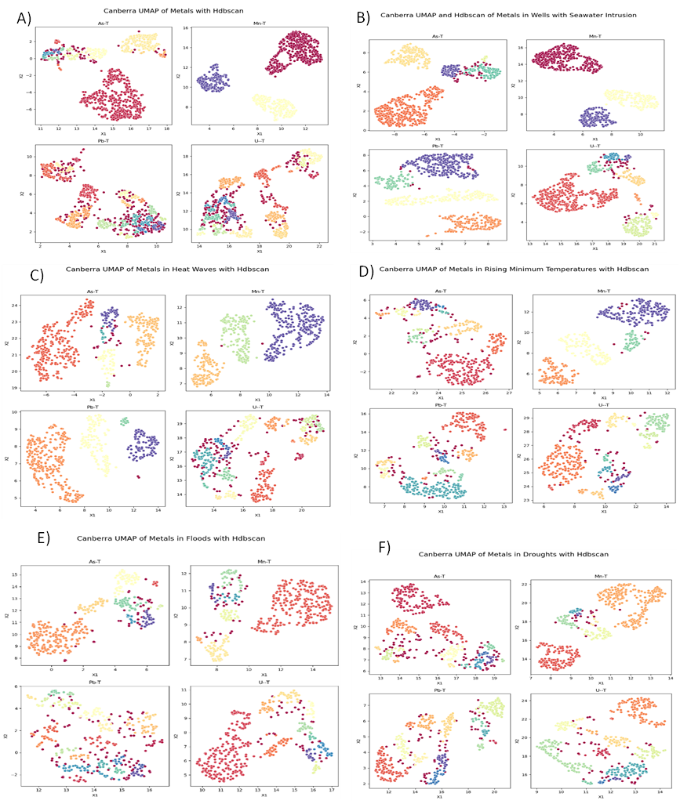
Figure 7.2: A) Supervised UMAP with minimum distance = 0.1, nearest neighbors =30, metrics as Canberra with Y as As, Mn, Pb, U and X as all other variables for the full dataset with a subsequent HBDscan performed. Clustering minimum = 5.
B) Supervised UMAP with minimum distance = 0.1, nearest neighbors =30, metrics as Canberra with Y as As, Mn, Pb, U and X as all other variables for the SWI dataset with a subsequent HBDscan performed. Clustering minimum = 5.
C) Supervised UMAP with minimum distance = 0.1, nearest neighbors =30, metrics as Canberra with Y as As, Mn, Pb, U and X as all other variables for the dataset with rising maximum temperatures followed by subsequent HBDscan. Clustering minimum= 5.
D) Supervised UMAP with minimum distance = 0.1, nearest neighbors =30, metrics as Canberra with Y as As, Mn, Pb, U and X as all other variables for the dataset with rising minimum temperatures followed by subsequent HBDscan. Clustering minimum=5.
E) Supervised UMAP with minimum distance = 0.1, nearest neighbors =30, metrics as Canberra with Y as As, Mn, Pb, U and X as all other variables for the drought dataset followed by subsequent HBDscan. Clustering minimum =5.
F) Supervised UMAP with minimum distance = 0.1, nearest neighbors =30, metrics as Canberra with Y as As, Mn, Pb, U and X as all other variables for the flood dataset followed by subsequent HBDscan. Clustering minimum =5.

UMAP Analysis

UMAP Original Analysis
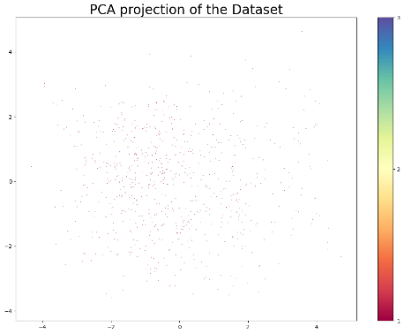
Figure 9.8.1: Principal component analysis of the entire dataset.
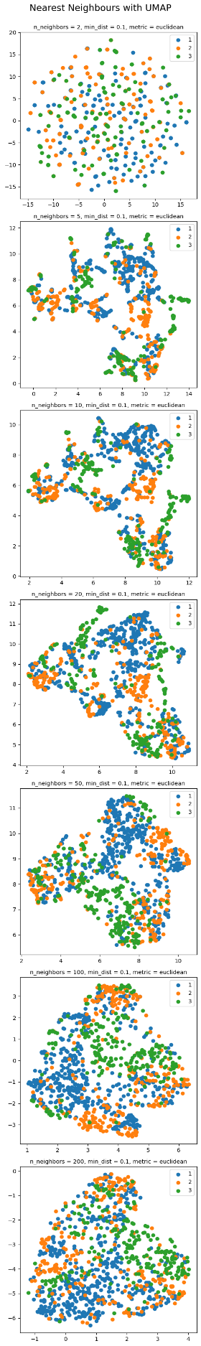
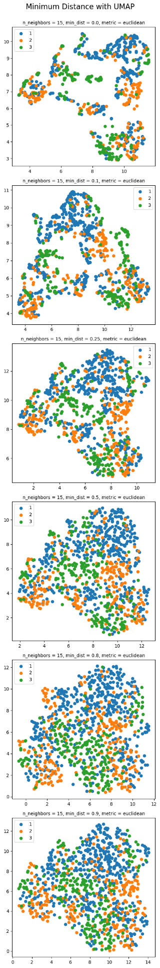
A)
B)
Figure 9.8.2: A) UMAP analysis of the entire dataset categorised by aquifer group with minimum distance of 0.1, Euclidean metric and nearest neighbors of 2, 5, 10, 20, 50, 100 and 200. B) UMAP analysis of the entire dataset categorised by aquifer group with nearest neighbor of 15, Euclidean metric and minimum distance of 0.0, 0.1, 0.25, 0.5, 0.8 and 0.9.
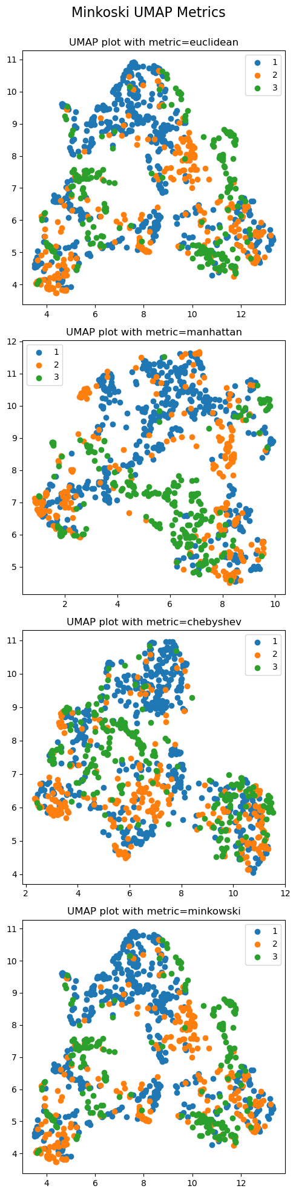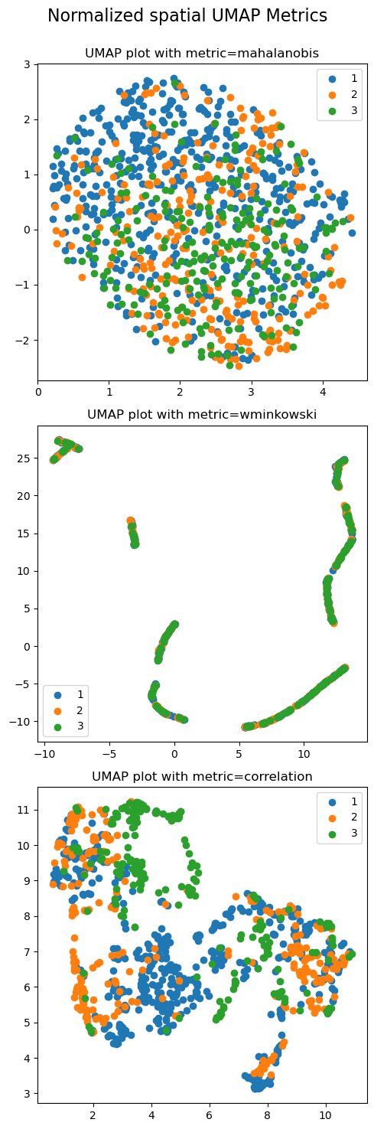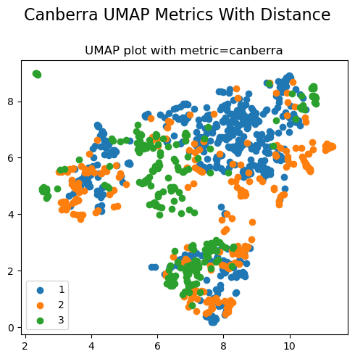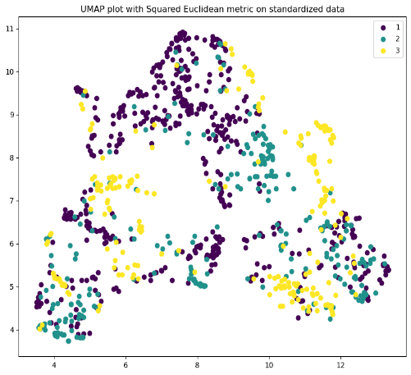
Figure 9.8.3: A) UMAP analysis of the entire dataset categorised by aquifer group with minimum distance= 0.1, nearest neighbors =15 and different Minkowski metrics.
B) UMAP analysis of the entire dataset categorised by aquifer group with minimum distance= 0.1, nearest neighbors =15 and different normalized spatial based metrics.
C) UMAP analysis of the entire dataset categorised by aquifer group with minimum distance= 0.1, nearest neighbors =15 and Canberra metric (top) and normalized squared Euclidean metric (bottom).
A)
B)
C)

UMAP Conditional Analysis

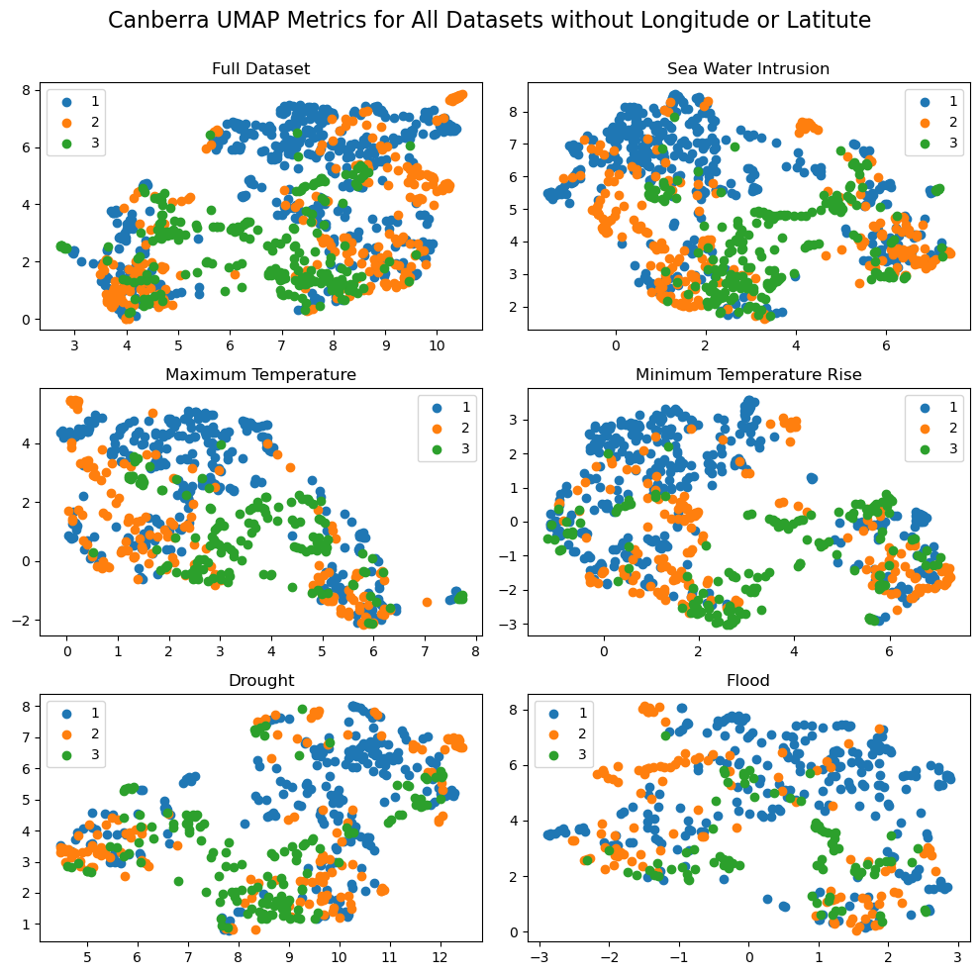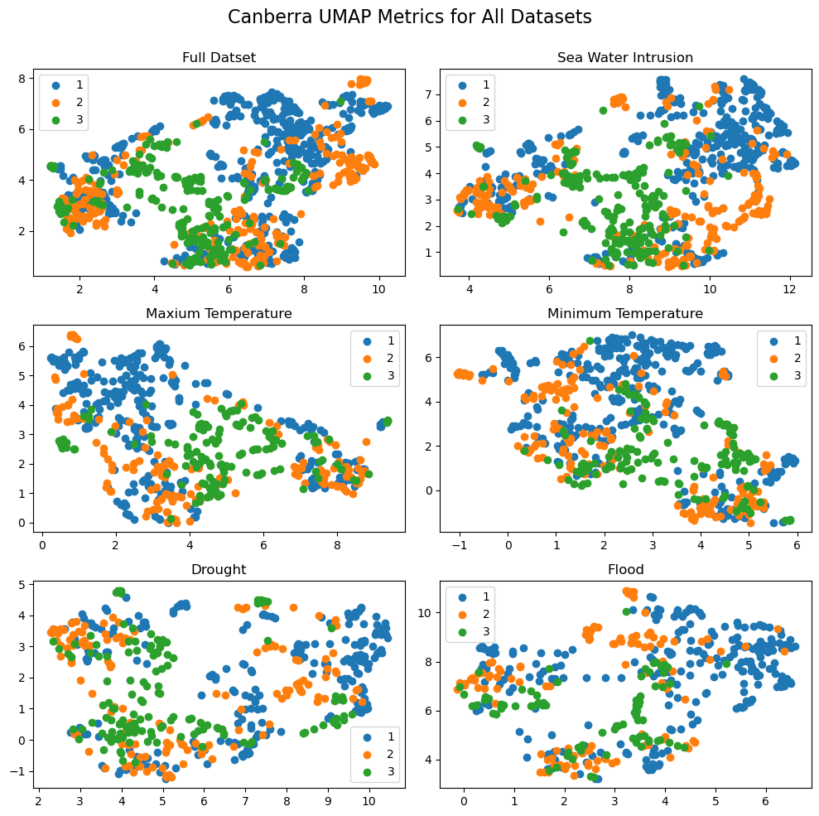
Figure 9.8.4: A) UMAP analyses categorised by aquifer group with minimum distance= 0.1, nearest neighbors =15 and different metric=Canberra for the full, SWI, Maximum temperature rise, minimum temperature rise, drought and flood datasets with latitude and longitude as variables.
B) UMAP analyses categorised by aquifer group with minimum distance= 0.1, nearest neighbors =15 and different metric=Canberra for the full, SWI, Maximum temperature rise, minimum temperature rise, drought and flood datasets without latitude and longitude as variables.
B)
A)

Supervised UMAP Metal Analysis
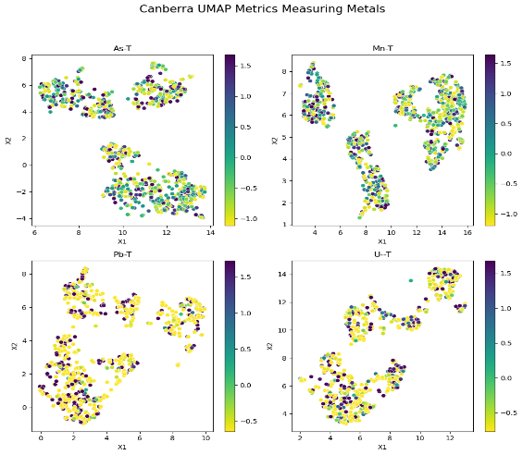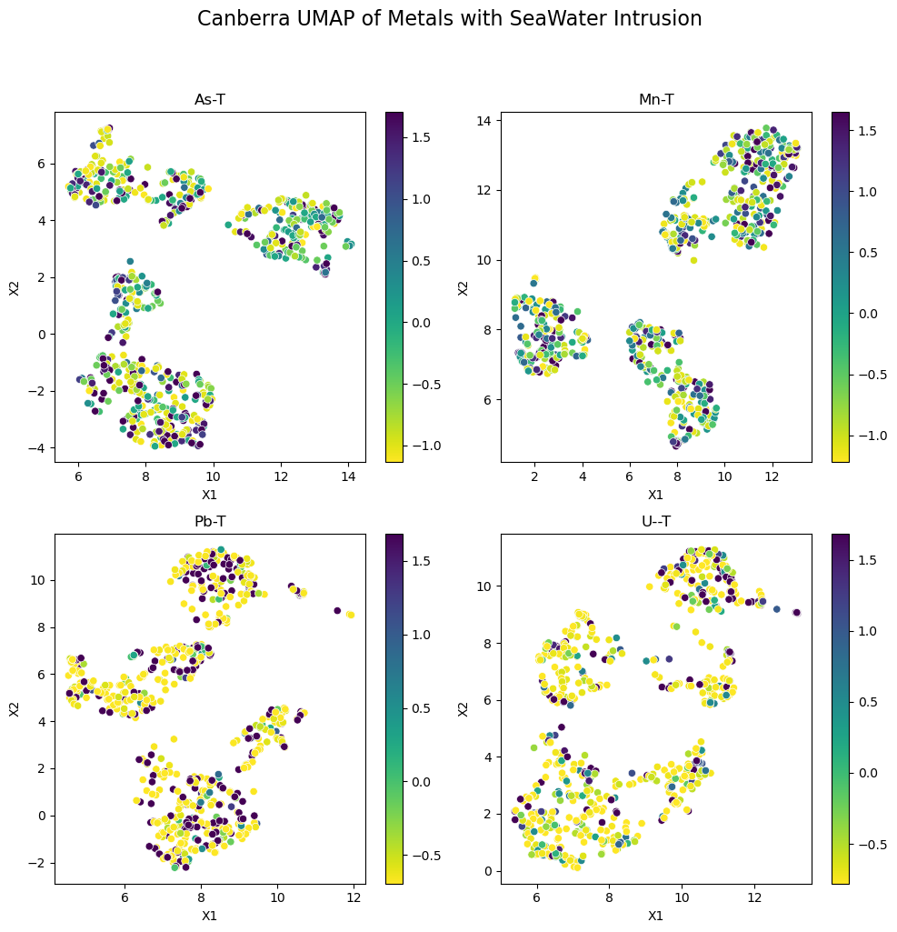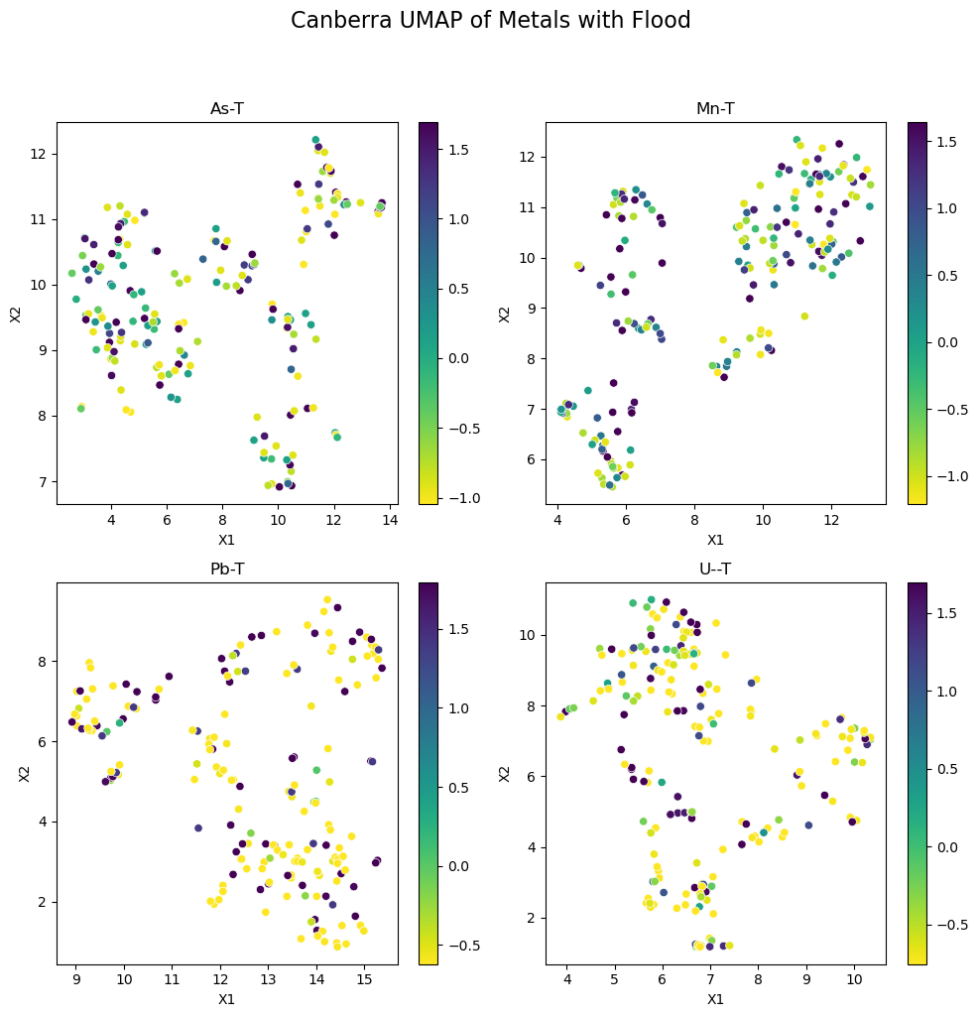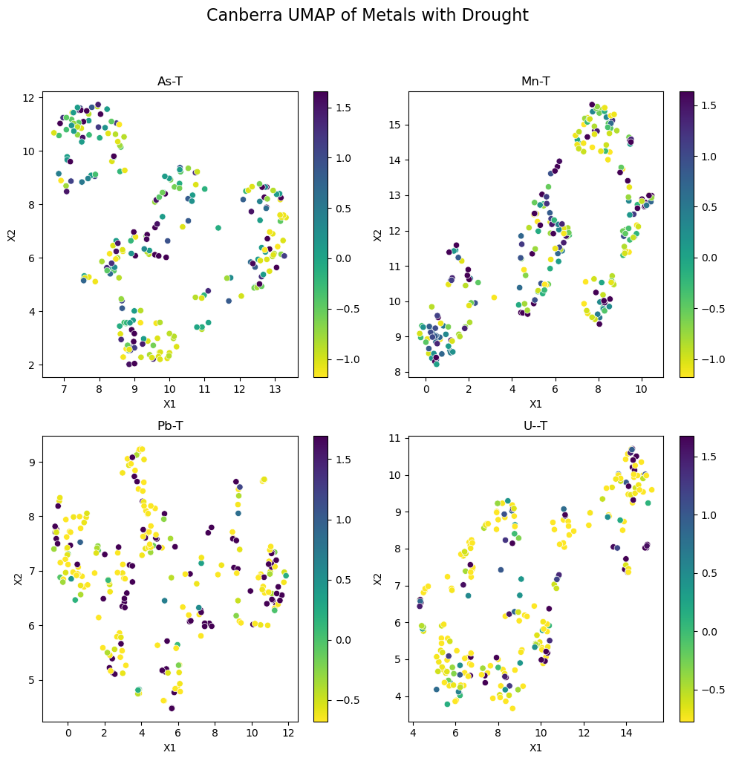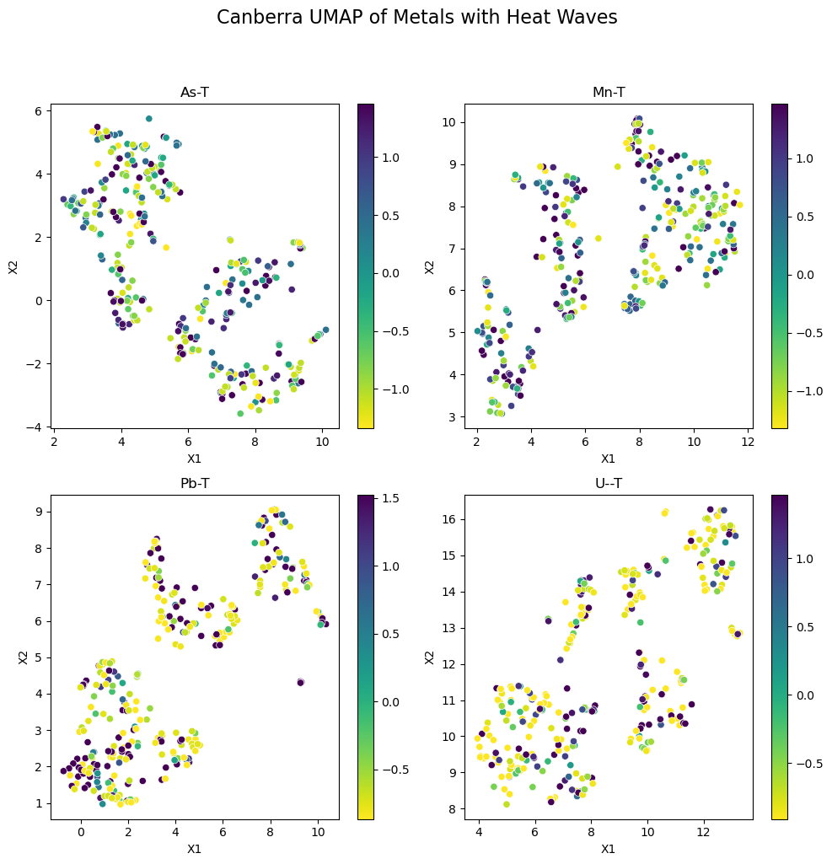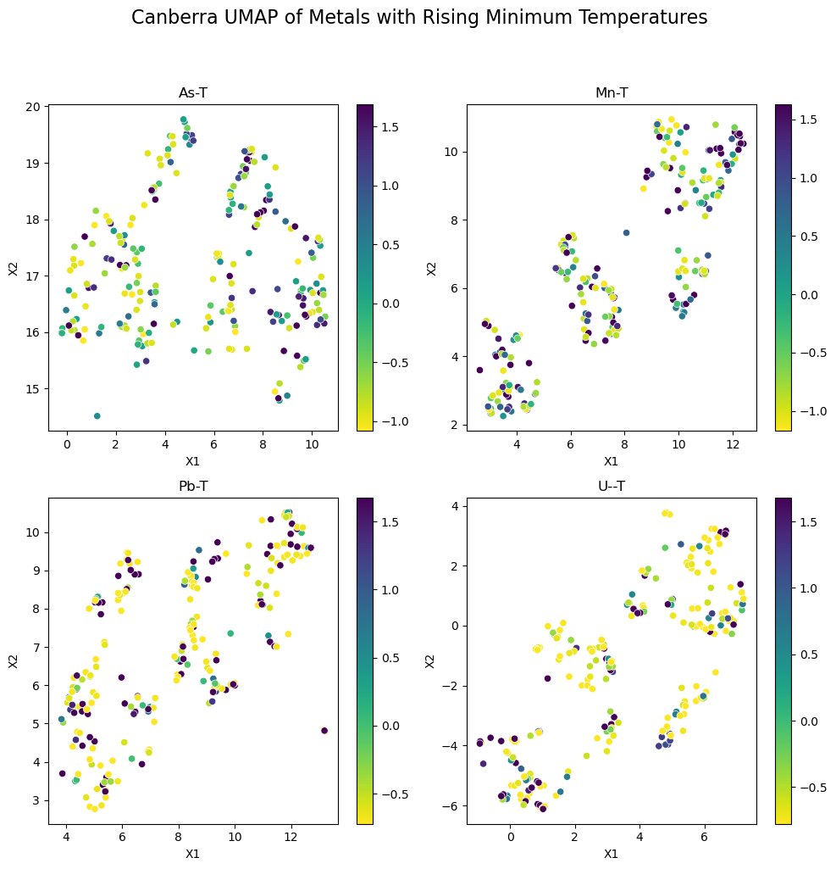
B)
C)
D)
E) 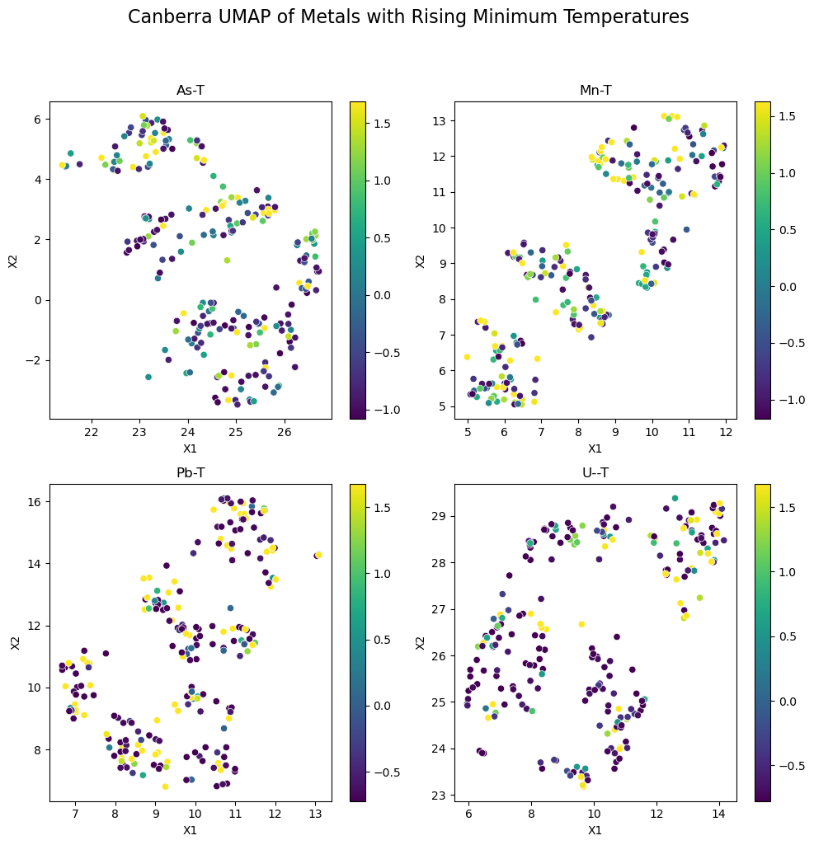
F)
A)
Figure 9.8.5: A) Supervised UMAP with minimum distance = 0.1, nearest neighbors =15, metrics as Canberra with Y as As, Mn, Pb, and U and X as all other variables for the full dataset. The colorbars represent the scaled concentration hence the values.
B) Supervised UMAP with minimum distance = 0.1, nearest neighbors =15, metrics as Canberra with Y as As, Mn, Pb, and U and X as all other variables for the dataset with saltwater intrusion.
C) Supervised UMAP with minimum distance = 0.1, nearest neighbors =15, metrics as Canberra with Y as As, Mn, Pb, and U and X as all other variables for the flood dataset.
D) Supervised UMAP with minimum distance = 0.1, nearest neighbors =15, metrics as Canberra with Y as As, Mn, Pb, and U and X as all other variables for the drought dataset.
E) Supervised UMAP with minimum distance = 0.1, nearest neighbors =15, metrics as Canberra with Y as As, Mn, Pb, and U and X as all other variables for the dataset with rising maximum temperatures.
F) Supervised UMAP with minimum distance = 0.1, nearest neighbors =15, metrics as Canberra with Y as As, Mn, Pb, and U and X as all other variables for the dataset with raising minimum temperatures.

HBSCAN and UMAP Analysis
Table 9.7.1: HBSCAN scores and corresponding meanings.
 | Silhouette Score | Calinski-Harabasz Score | Ratio of non-noise points | Adjusted Rand Index | Adjusted Mutual Information
Meaning | How well matched is a object is to its own cluster verse other clusters. Measure appropriate clustering | How defined the model’s clusters are | How much of data is being used in clusters | Measure similarity between two data clustering | Similar to Rand Index but uses mutual information obtained from observing on other
Range | 1 to -1 |  | 0-1 | -1 to 0 to 1 | 0 - 1
Bad Scores | Anything negative |  |  | Anything negative  0 – random clustering | 0 – random clustering
Ideal Score | 1 | Higher scores = more defined clusters | Higher ratio  (not always ‘good’ ) | 1 – perfect match | 1 – perfect match

Table 9.7.2: HBDSCAN scores for each metal of each dataset.
Dataset | Metal | Silhouette Score | Calinski-Harabasz Score | Ratio of non-noise points | Adjusted Rand Index | Adjusted Mutual Information
Data-T (Euclidean) | As | 0.0320 | 98.6308 | 0.6081 | 0.0424 | 0.1098
Data-T (Euclidean) | Mn | 0.0502 | 160.1020 | 0.5929 | 0.0281 | 0.0623
Data-T (Euclidean) | Pb | 0.1001 | 169.2389 | 0.6487 | 0.0717 | 0.1305
Data-T (Euclidean) | U | 0.1507 | 230.2228 | 0.7096 | 0.3152 | 0.3129
Data-T (Canberra) | As | 0.3663 | 318.16288 | 0.9350 | 0.02139 | 0.0685
Data-T (Canberra) | Mn | 0.6872 | 3183.7569 | 1.0000 | -0.0026 | 0.0023
Data-T (Canberra) | Pb | 0.2039 | 119.6639 | 0.7736 | 0.1089 | 0.1770
Data-T (Canberra) | U | 0.3715 | 535.9273 | 0.8274 | 0.2313 | 0.3088
HW | As | 0.316 | 266.920 | 0.881 | 0.0165 | 0.0330
HW | Mn | 0.439 | 881.912 | 0.990 | -0.0021 | -0.0020
HW | Pb | 0.463 | 757.033 | 0.989 | 0.0037 | 0.0286
HW | U | 0.2731 | 137.453 | 0.820 | 0.2000 | 0.3074
MT | As | 0.485 | 680.245 | 0.935 | 0.0402 | 0.0517
MT | Mn | 0.410 | 896.868 | 0.876 | 0.0224 | 0.0254
MT | Pb | 0.2368 | 312.2184 | 0.882 | 0.0191 | 0.1103
MT | U | 0.415 | 497.454 | 0.925 | 0.1387 | 0.2013
Flood | As | 0.3932 | 355.194 | 0.844 | 0.039005 | 0.0620
Flood | Mn | 0.4474 | 514.846 | 0.960 | -0.00282 | 0.0041
Flood | Pb | 0.1954 | 62.309 | 0.756 | 0.1997 | 0.3101
Flood | U | 0.3128 | 256.329 | 0.923 | 0.05442 | 0.1780
Drought | As | 0.4027 | 558.269 | 0.972 | 0.01923 | 0.0434
Drought | Mn | 0.4850 | 845.077 | 0.900 | 0.01963 | 0.0264
Drought | Pb | 0.3839 | 350.666 | 0.8698 | 0.0859 | 0.1465
Drought | U | 0.2880 | 279.249 | 0.9094 | 0.1261 | 0.1914
SWI | As | 0.4960 | 1003.657 | 0.9516 | 0.0140 | 0.0389
SWI | Mn | 0.6522 | 3206.905 | 1.0000 | -0.0014 | 0.0027
SWI | Pb | 0.4457 | 1454.763 | 0.9854 | 0.0119 | 0.0309
SWI | U | 0.3481 | 452.346 | 0.9359 | 0.0070 | 0.1180

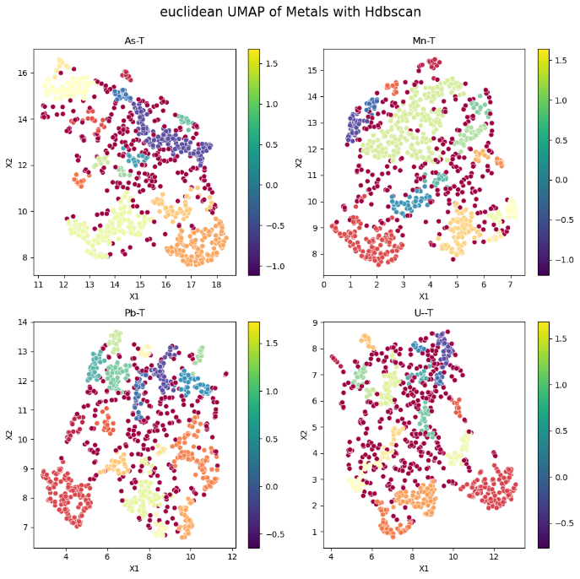
Figure 9.8.6: Supervised UMAP with minimum distance = 0.1, nearest neighbors =15, metrics as Euclidean with Y as As, Mn, Pb, and U and X as all other variables for the full dataset with a subsequent HBDscan performed. The color bars represent nothing as HBDscan was overlayed on said clusters. Clustering minimum was 10.

