Title: Impact of Climate Change on Metal Contamination in Well Water through Saltwater Intrusion, Flooding, and Temperature Rise

Abstract

Key Words

Acknowledgement

Abbreviations Used

Chapter: Introduction

Study Background
Climate change is one of the most pressing global challenges of the generation with severe primary and secondary consequences for both natural and human systems. Anthropogenic activities, especially fossil fuel burning and deforestation, have increased greenhouse gas emissions in the atmosphere resulting in changes to the earth’s climate system. Said changes have profound implications on various aspects of human lives including ecosystems, agricultural, public health and water resources.
Numerous scientific studies since the Intergovernmental Panel on Climate Change (IPCC) have established knowledge on climate change, research priorities, policy discussions, and funding initiatives concerning the essential relationship with water resources. Most highlighted the need to address the impact of climate change; including impacts on water resources and water quality(Sýs et al., 2021). These studies and panels have provided evidence of rising sea levels, increased temperatures, altered precipitation patterns and more extreme intense weather events. Said studies linked these changes to human activities and further demonstrated the relationship between human activities and the destruction of the delicate balance of the planet's ecosystem.
With the development of general circulation models for climate change and the inclusion of new knowledge on metal transportation, scientists can predict future climate scenarios along with the identification of emerging contaminants. Recently, organisations are acknowledging the value of granting public access to their database thus allowing for more widespread analysis of models (Klein et al., 2017). Environmental monitoring database specifically focused on climate change are also starting to utilise groundwater data and groundwater quality data (Amanambu et al., 2020; Ministry of Environment - Water Stewardship Division - Aquifers, n.d.). Previously, most climate change water models were focused on hydrological/overland flow with groundwater studies being a secondary priority. Groundwater impact was analyses via localised studies for aquifer vulnerability like DRASTIC(Maqsoom et al., 2020). Currently, hydrodynamical climate risk models are now attempting to incorporate soil and ecological tools and modflow-style models to account for hydraulic connectivity and solute transport (Amanambu et al., 2020).
Artificial intelligence and machine learning has led to tracking of secondary effects of climate change such as water contamination. These additions are now starting to be used to investigate the impact of climate change on water resources. With increasing droughts caused by climate change, aquifer vulnerability has started to include not just water quantity but the effect on water quality(Barbieri et al., 2023). The effect of flooding on well water quality is starting to expand beyond biological contamination. Saltwater intrusion assessments have also become a focus due to over pumping from droughts and rising sea levels. In addition, development of risk assessment frameworks such as USEPA risk assessment guidance have provided a structured approach to evaluating risks posed by metal contaminations in well water; inclusive of pathways, toxicity, and the potential impacts of climate change(Sýs et al., 2021).

Rationale for the Study
Well water is an essential source of drinking water, in both developed and underdeveloped countries throughout the world. Approximately two thirds of the population of Nova Scotia currently rely on private well water (G. W. Kennedy & Drage, 2020). Though the primary effects of climate change on the groundwater level have been studied, critical analysis on the secondary effects of climate change such as metal contamination is relatively scarce. This lack of data is important for assessing human health impacts as well as impacts on ecosystems and water resource management.
This thesis contributes to the understanding of the impact of climate change on metal contamination of Arsenic, Lead, Manganese and Uranium in groundwater/well water in British Columbia. Three critical trajectories were examined: saltwater intrusion, flooding/drought, and temperature rise.
These three events can exaggerate natural or existing sources of metal contamination or introduce new passages for anthropogenic sources(Kumar, 2012). Over pumping during drought seasons, rising sea levels and changing hydraulic patterns can lead to the intrusion of saltwater into aquifers and the alteration of the metal composition in well water. More frequent flooding events can immediately transfer and disperse metal contaminants from various sources, such as agriculture or heavy industry; and can alter soil composition and allow for the mobility of metals into the well water source over time(Ciszewski & Grygar, 2016). Rising temperatures can influence the mobility and release of metals from geological structures into well water(Hemmerle & Bayer, 2020).
Utilizing data from the Environmental Monitoring Stations from British Columbia, Canada, the resulting thesis aims to discover relationships between metal such as U, As, Mn, and Pb over a 40-year timeframe and climate change conditions. This framework can be used to highlight the necessity of metal contamination testing in well water. This analysis will help create of a base of knowledge that can be used to build future predictive models for groundwater contamination with climate change effects. In addition, this thesis could further contribute towards ecosystem models and human health models to improve informed decision making and policy development. Ultimately, the aim is to help build an understanding of how climate change will influence what is in groundwater.

Research Objectives
This study aims to gain an understanding on how climate change will influence what is in well water/groundwater. Biological contamination will not be a focus in this scope. The three main objectives are:
- To assess the variations in metal contamination levels in well water under different climate change-induced factors, including saltwater intrusion, flooding/drought events, and temperature rise.
- To contribute to the existing knowledge based on the interactions between climate change and metal contamination in well water, providing insights for future predictive modelling that could influence policymaking, water resource management, and environmental planning.
- To assess the potential impact of climate change on the vulnerability and resilience of well water as a source of drinking water, considering the specific metal contamination risks.

Hypotheses
- Increased saltwater intrusion due to climate change may lead to elevated levels of metal contamination in well water.
- Drought events resulting from climate change may result in higher concentrations of metals in well water via oxidation. While Flooding may lead to a dilution effect on metals.
- Rising temperatures caused by climate change may enhance the leaching and reactions of metals but not by much. Different metals will exhibit varying levels of sensitivity to climate change-induced factors, resulting in differential contamination patterns in well water.

Literature Review

Overview of Metal Contamination in Well Water

Sources of Metal Contamination in Well Water

Naturally Occurring/Geogenic Metals in Geological Formations
Geological formations naturally contain minerals with heavy metals that can leach into groundwater depending on the mineral composition of the surrounding rocks and soil, the local hydrogeology, and the dual chemical aquifer characteristics (Earle, 2019a). Said groundwater contamination is caused by processes such as volcanic eruptions, rock weathering and leaching into groundwater by the actions of water. Leaching occurs through geochemical interactions that dissolve present metals into groundwater.
One of the examples of this is in sedimentary formations such as limestone, dolomite or shale in which the associated arsenic release via weathering is influenced by redox conditions, pH and other minerals present (Bradl, 2005). Iron and manganese are also commonly found in these rock formations and their release is promoted in conditions with high oxygen levels (Earle, 2019a). Manganese in Nova Scotia is associated with the Windsor Group limestone formation(G W Kennedy, 2021). International examples of metal contamination include arsenic contamination in the Bengal delta in Bangladesh, in which sediments release levels of arsenic(Mukherjee & Bhattacharya, 2001). The High Plains Ogallala aquifer in the United States contains sedimentary rock formations associated with uranium and in reducing conditions, is leached into groundwater(Plumlee et al., 2004). For a larger conceptual example –arsenic from sedimentary formations would be formed during diagenesis and related arsenic rock cycles in Figure 2.1.1.
Igneous rock, formed from volcanic rock; and metamorphic rocks, formed from rocks changed by heat and pressure underground can contain various trace metals, and uranium and radium either as composing or accessory minerals(Ulmer-Scholle et al., 2015). Examples of these are granite, syenite, basalt, gabbro, nepheline, and andesite(Bradl, 2005). Here, metal leaching depends on various groundwater chemical factors such as mineral solubility, water rock interactions, and water infiltration from fractures or fissures. Volcanic ash and lava flow contain heavy metals like lead, mercury and arsenic. These are released by volcanic activity and are transported into nearby soils and sediments. Afterwards, groundwater interacts with deposits resulting in metal leaching (Earle, 2019a). More international examples include arsenic contamination in groundwater in the Andean region of Argentina and Chile; and manganese contamination from Basaltic formations in aquifers in India (Sujith et al., 2014; Tapia et al., 2019). Conceptually, these rock cycle processes for arsenic contamination are related to the metamorphism, volcanic emissions and hydrothermal activities in Figure 2.1.1.
Further in-depth lithology is out of scope.
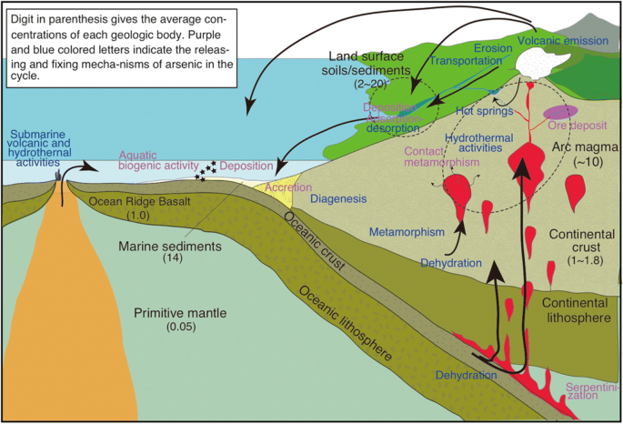
Figure 2.1.1: Arsenic geologic cycle. Digit in parenthesis gives the average concentrations of each geologic body. Purple and blue colored letters indicate the releasing and fixing mechanism of arsenic in the cycle. (Masuda, 2018).

Anthropogenic sources of Metal Contamination
Anthropogenic activities increase metal contamination in water sources, particularly groundwater, and subsequently well waters. Emissions, effluence and waste disposal from mining smelting, manufacturing and other industrial activities can release various metals into the environment which enter groundwater systems via surface runoff, infiltration or direct contamination(A. Singh et al., 2022). In the Canadian context, mining activities are a significant source of contamination. For example, the mining operations from the Sudbury region in Ontario incur groundwater contamination from copper, nickel and cobalt(Vogels, 2014; Voutchkova et al., 2021). It is similar in the United States, where the Silver Valley region through Ohio and Idaho has groundwater affected by lead, zinc and other metal contamination due to mining operations(Snow, 2012). Additionally, groundwater can be contaminated by agricultural practices with the use of fertilizers, pesticides and animal waste via leaching and through groundwater recharge processes(Li et al., 2021). Climate change exaggerates the impact of these contamination sources by extreme weather events, erosion and contaminant transportation. Future research is required to fully understand how anthropogenic sources influence metal contamination.

Corrosion of plumbing materials and well infrastructure as a source of metal contamination
Another source of metal contamination in groundwater is due to the corrosion of piping materials and degradation of well infrastructure(Pieper et al., 2018). Critical components of a well such as pipes, fittings and pumps made of lead, copper and zinc; corrode over time and release metals into the water flow. Climate change influences corrosion by altering water chemistry parameters such as pH, and dissolved oxygen levels. With increasing temperature fluctuations, this typically increases corrosion rates and leads to enhanced metal leaching(Staben et al., 2015).
In addition, rusted iron oxides may reduce/remove some water contaminates like arsenic similar to soil processes(van Genuchten et al., 2020).
These considerations are beyond the scope of this thesis.

Common Metals Found in Well Water
The type of metal contamination found in well water/groundwater is dependent on geography, geology and water chemistry. In Nova Scotia, common contaminates are manganese, arsenic, magnesium, lead, uranium and fluoride due to the surrounding geography(G. Kennedy & Drage, 2018). Internationally, arsenic, cadmium, selenium, and copper are common(Khan et al., 2023) .
Lead contamination in ground and well water is a concern due to health effects particularly in pregnant women and children(Brender et al., 2006). The contaminate source tends to be lead leaching from plumbing materials such as pipes and fittings in the plumbing system, aggravated by low pH and prolonged contact time(Subramanian et al., 1995).
Galena, a lead sulfite material, is currently found in hydrothermal veins and mineral deposits (A. Singh et al., 2022). Groundwater interactions will cause lead-iron dissolution and subsequently cerussite, a lead carbonate mineral in oxidized lead deposits can contaminate groundwater flow (Jurgens et al., 2019). Current lead contamination research is often focused on piping and drinking water systems and not geological formations.
Zinc contamination is recognized in well water and drinking water systems, often leaching from corroded galvanized iron or zinc coated plumbing in low pH or acidic conditions (Oyem et al., 2015). Zinc rich soils lead to groundwater contamination via erosion and deposition of zinc containing sediments with water infiltration into groundwater. Last, an additional source of zinc contamination can be via volcanic eruptions in volcanic regions(Oyem et al., 2015).
Groundwater contamination in copper is again typically due to the corrosion of copper plumbing materials such as pipes, fittings and fixtures, releasing copper ions into the waterflow through the distribution system. This is aggravated by acidic water, high chlorine levels and prolonged contact time with piping surfaces*. In specific geochemical conditions, copper contamination can be caused by groundwater percolation through natural occurring geological formations including chalcopyrite, a copper bearing mineral from hydrothermal veins, porphyry rock, malachite, azurite and other natural sources with depositions of copper. Cyprus and the western United States (i.e. Arizona) have high natural copper contamination of groundwater due to these naturally occurring causes.
Iron contamination is formed by both natural sources and corroded iron plumbing (Health Canada, 2022). It is more of an aesthetic concern than a health concern.
Other contaminants are primarily caused by anthropogenic activities. For example, mercury contamination in groundwater arises from coal combustion, industrial discharges and mining via runoff and infiltration, or indirectly via deposition of atmospheric mercury onto land surfaces (Barringer et al., 2013). Natural geological sources of mercury can include certain mercury bearing minerals such as cinnabar via volcanic eruptions which release elemental mercury vapor and mercury sulfides(Herdianita & Priadi, 2008). Mercury contamination is particularly common around the Pacific Ring of Fire countries(Herdianita & Priadi, 2008). Areas that have concerns around natural mercury contamination include regions in Guizhou Province, China (Beckers & Rinklebe, 2017).
Groundwater contamination with cadmium primarily arises from anthropogenic sources including mining, phosphate fertilizer production, improper waste disposal and industrial discharges (Butterman & Reston, 2004). Cadmium is relative mobility in water and in areas that have high cadmium soil concentrations, can leach into groundwater. Though it is a trace mineral and not commonly associated with specific formations, the leaching process can be enhanced by the weathering and erosion of sphalerite and volcanic activity. Jinzu River Basin and Toyama Bay, Japan contain cadmium rich sediments and have experienced natural contamination (Butterman & Reston, 2004).

Uranium
As stated previously, uranium can occur from anthropogenic pollution. In addition, uranium is naturally associated with igneous and metamorphic geological formations (Earle, 2019a). Uranium sources can come from groundwater interactions of uranium bearing minerals such as Uraninite (pitchblende, a primary mineral or of uranium) or Coffinite (Nolan & Weber, 2015). This occurs in the High Plans and Central Valley aquifers in the US (Figure 2.1.2) and may be also added by biotic nitrate reduction. Weathering of sedimentary deposits such as sandstones can also contain elevated levels of uranium. In Nova Scotia uranium is a significant risk in well water and is dominantly controlled by Bedrock geology (G. Kennedy & Drage, 2018)(Figure 2.1.3).
Uranium is often released into groundwater through natural weathering and dissolution processes, dependent on pH redox factors (Alam & Cheng, 2014). Mineral release is often the controlling factor for groundwater contamination. Deabsorption from mineral surfaces along with respective reaction kinetics, oxidation conditions and thermodynamics also plays a role in uranium water contamination. Iron and magnesium oxide such as goethite, hermatite and ferrihydrite are known to absorb uranium ions and reduce their mobility and groundwater (Sato et al., 1997). Reductive precipitation often immobilizes uranium (Alam & Cheng, 2014). Other substances enhance uranium transport such as organic matter such as humic and fulvic acids via uranium complexes and thus facilitate U movement throughout the subsurface (Smedley & Kinniburgh, 2023). Carbonate minerals such as calcite or domate enhance the transportation of uranium by forming complexes with uranium ions and allowing them to be more mobile in water.
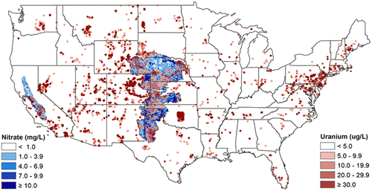
Figure 2.1.2: A map of uranium (red) and nitrate (blue) concentrations for groundwater aquifers in the US (Nolan & Weber, 2015).
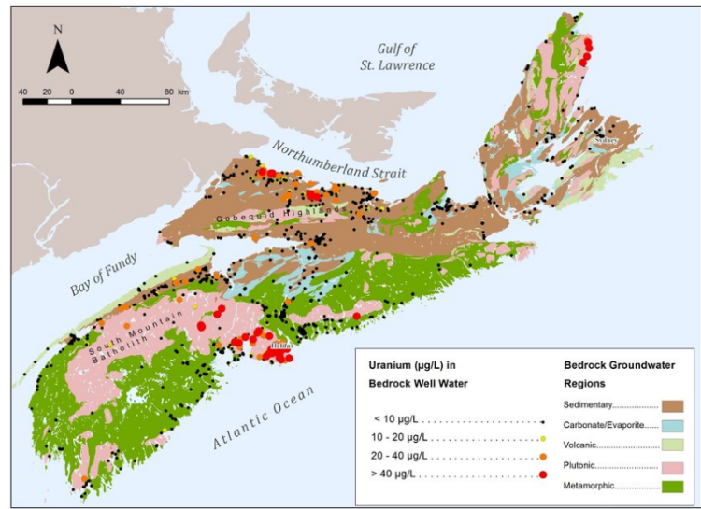
Figure 2.1.3: Uranium in well water/groundwater for Nova Scotia (G. Kennedy & Drage, 2018).

Arsenic
Arsenic contamination can be caused by anthropogenic sources. Often it is linked to geological formations rich with arsenic-bearing minerals released into the surrounding soil and water via natural weathering processes; and groundwater interactions leading to leaching and subsequent groundwater contamination (Bradl, 2005). Some recognized examples are arsenopyrite, an iron arsenic sulfide mineral found in hydrothermal mineral deposits, and Pyrite(Earle, 2019b). Arsenic is also naturally present in volcanic deposits and sedimentary deposits such as alluvial aquifers or deltaic environments (Mukherjee & Bhattacharya, 2001).
In Nova Scotia, arsenic contamination is naturally occurring, and influenced by bedrock geology (G. Kennedy & Drage, 2017) (Figure 2.1.5). Arsenic levels were more associated with drilled wells rather than dug or surface levels. Similarly, USGS found that 7% of sampled wells exceeded 10 μg/L for arsenic particularly in the Southwest U.S. and in the Glacial aquifer system in the northern U.S.(DeSimone et al., 2014). The Pinemont Blue Ridge and Valley area in the eastern Appalachian region, the Texas coastal upland aquifer system and the Mississippi River alluvial valley aquifer in the Southeastern U.S. are principal concerns for arsenic contamination (Figure 2.1.4). In the southwest U.S. basin-filled aquifers, arsenic is sourced from volcanic and granitic bedrock (DeSimone et al., 2014). Groundwater residence time, high pH, arid climate and rock type contribute to the elevated concentrations. Internationally, Bengal Delta, Bangladesh, and West Bengal, India are severely contaminated with arsenic derived from Himalayan sediments that has caused an arsenic contamination crisis affecting the lives of millions of people (Mukherjee & Bhattacharya, 2001).
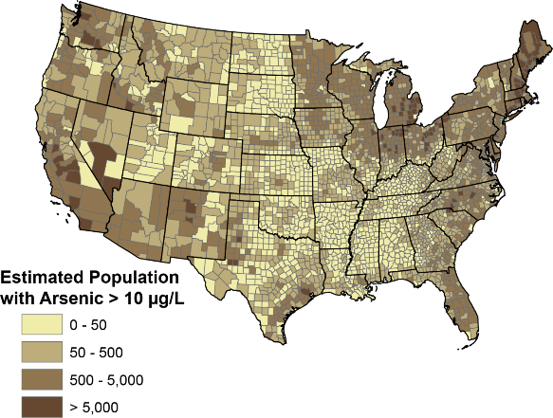
Figure 2.1.4: Estimations of private well users in U.S. counties that are contaminated with Arsenic (DeSimone et al., 2014).
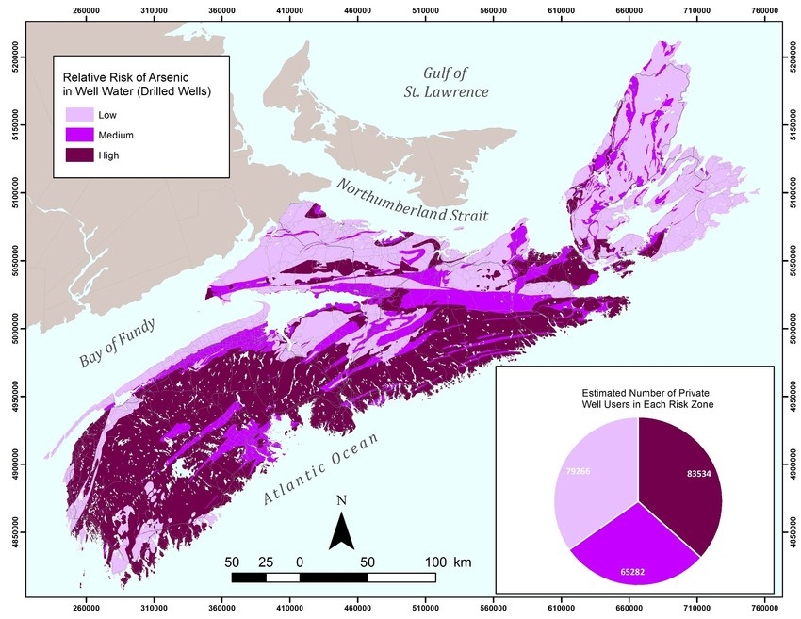
Figure 2.1.5: Arsenic risks in groundwater for Nova Scotia. (G. Kennedy & Drage, 2017)

Manganese
Manganese is naturally present in rocks and soils as it comprises 0.085% to 0.095% of the earth’s crust and often enters groundwater through the dissolution of manganese bearing minerals and natural weathering processes (Daughney, 2003).
Manganese has multiple optimization states in the natural environment but is commonly found as the reduced water-soluble Mn(II) and the oxidized insoluble Mn(IV) (Zhang et al., 2020). Common manganese oxides include pyrolusite (MnO₂), manganite (Mn₂O₃-H₂O), hausmannite (Mn₃O₄) and psilomelane. Other minerals include manganese carbonates (e.g., rhodochrosite, MnCO₃), manganese silicates (e.g., rhodonite, MnCa SiO₄) and ferromagnesian silicates (hornblende, olivine)(Earle, 2019). In Nova Scotia, manganese contamination is related to sedimentary processes, replacement processes and vein processes (G W Kennedy, 2021).
Said contamination can be more pronounced in areas with low oxygen levels or reducing conditions which favor the release of manganese from minerals(Ahmad, 2012). The oxidized form of manganese has low solubility in near neutral conditions and thus was found to be invertedly related to pH, which suggested that manganese precipitants form at higher pH levels in the presence of oxygen or carbonate. Elevated manganese concentrations in groundwater are assumed to be associated with less complex or evolved groundwater chemistry, with higher manganese concentrations near shallow water tables(Rusydi et al., 2021). Other studies show an increase in manganese dissolution with increased contact via higher aquifer residence time and increasing with total dissolved solids in a floodplain(Matsunaga et al., 1993). Pyrolusite, manganese oxide and rhodochrosite, a manganese carbonate mineral, are examples where these factors occur.
In Nova Scotia, 22.5% of well water samples exceeded Health Canada's maximum allowance for manganese (Kennedy & Drage, 2020) (Figure 2.1.7). Unlike other contaminates such as uranium, manganese contamination is also a concern in both bedrock and superficial aquifers in the sedimentary bases due to the geochemistry (Kennedy & Drage, 2020). The manganese deposits are associated with sedimentary processes hypogene originated, replacement and vein type processes. The carboniferous strata, notably Windsor group limestone or infilling fissures of crystalline rock is associated with manganese ores. Northeastern United States has a similar problem with manganese contamination in groundwater and thus has similar concerns with 46% of well water samples exceeding maximum standards in New England, U.S.(McMahon et al., 2019)(Figure 2.1.6). The province of Quebec, Canada, West Bengal State, India and Bangka Island, Indonesia also report a lot of manganese contamination (Federal-Provincial-Territorial Committee on Drinking Water, 2016; Sujith et al., 2014).
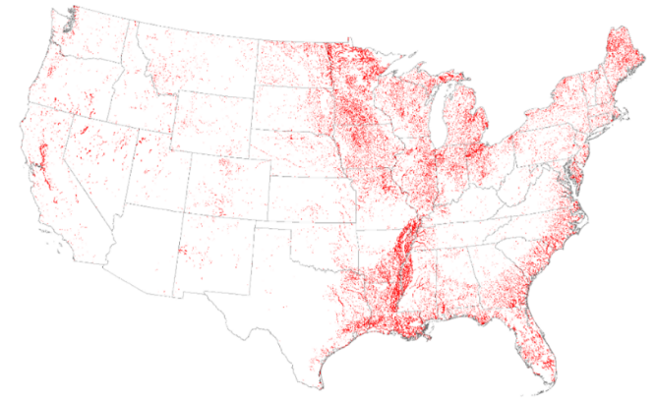
Figure 2.1.6: Red areas are representative of highest population densities that may be consuming water from domestic wells with elevated manganese concentrations (McMahon et al., 2019).
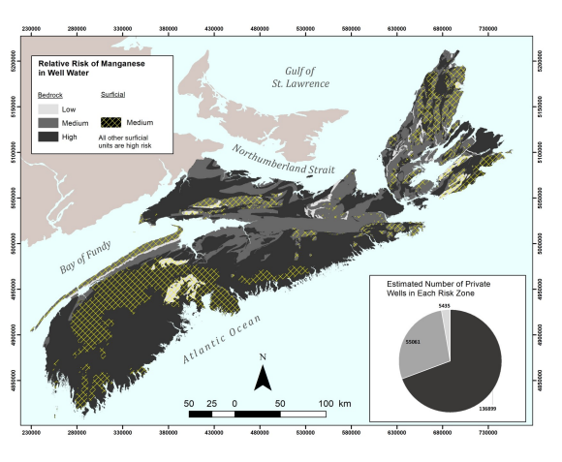
Figure 2.1.7: Mn contamination risk for Nova Scotia, Canada (G W Kennedy, 2021).

Health Effects of Well Water/Groundwater Metal Contamination

Adverse health effects of specific metals
One major concern related to groundwater metal contamination is the detrimental health effects on drinking water consumers. This section focuses the health effects of well water metal contamination with specific emphasis on the metals mentioned above, and their long-term and short-term effects for vulnerable populations.
Lead contamination in well water is a serious health concern. When consumed, lead accumulates in the body over time and has a detrimental effect on the developing nervous systems of young infants, children and pregnant women (Levallois et al., 2018). Higher levels of lead exposure can lead to neurotoxic effects such as cognitive function impairment, developmental delays, learning disabilities, decreased IQ and behavioral problems in children and adults.
One of the more publicized examples of lead contamination is the Flint, Michigan Water Crisis from 2014 (Hanna-Attisha et al., 2016). Due to lead contamination in the drinking water distribution system, the effect of widespread lead poisoning was studied with noticeable effects amount young children. In the U.S., lead contamination in drinking water is classified as a prioritized public health issue with the Environmental Protection Agency proposing regulations to replace lead water pipes in U.S. cities within 10 years(US EPA, 2020). The total cost of lead contamination is substantial, as it includes healthcare expenses, structural changes, environmental regulatory changes, and the unmeasurable effects of the individuals affected by developmental issues and loss of productivity in adulthood (Levallois et al., 2018). Consumption of high amounts of copper from copper contaminated water can lead to gastrointestinal symptoms such as nausea, vomiting and diarrhea(Bost et al., 2016). Prolonged exposure to elevated copper levels in water can result in long term health effects such as liver and kidney damage; the highest risk group being people with pre-existing liver and kidney conditions or genetic disorders that impair copper metabolism (Wilson’s disease)(Gerhardsson, 2022). Infants and small children are considered to be high susceptibility to copper toxicity when they drink more water.
Iron contamination of well water gives rise to an aesthetic effect where elevated levels of iron cause unpleasant tastes, a metallic odor and discoloration (Abbaspour et al., 2014; Health Canada, 2022). Excessive intake of iron from contaminated water can cause gastrointestinal discomfort such as cramps, abdominal pain and diarrhea.
Excessive zinc intake through contamination of drinking water results again in gastrointestinal disturbances including nausea, vomiting, and abdominal cramps (Rehman et al., 2018). Over prolonged periods, higher levels of zinc in drinking water interferes with the absorption of other nutrients in the human body, leading to nutritional deficiencies in copper or iron.
Cadmium contamination in drinking water causes kidney damage, including tubular dysfunction and renal failure on a short time scale(Bae et al., 2001). Long-term, cadmium is a classified carcinogen and prolonged exposures to high levels is associated with an increase of lung and prostate cancer. Cadmium can accumulate in bones and lead to osteoporosis and weakening of skeletal systems of the human body (Agency for Toxic Substances and Disease Registry, 2004).

Uranium
The primary exposure route of uranium is estimated to be the direct ingestion of well water (Bjørklund et al., 2020). According to the Environmental Protection Agency (EPA), uranium makes up 99% of the toxicological and radiological dose to human consumers (Corlin et al., 2016). The EPA is concerned about potential toxicological and radiological risks to human drinking water consumers. Safe uranium content in water ranges is still being debated between from 2.5 - 38 × higher than the current uranium EPA limit of 30 μg/L as the conservative and protective restriction by the EPA regarding to kidney hazards under long-term continuous exposures (Corlin et al., 2016).
Uranium is primarily eliminated by the human body through the kidneys thus elevated and prolonged contamination of it in drinking water results in kidney damage (M. Ma et al., 2020). The damage is related to the nephrotoxicity of uranium directly damaging renal tubular cells and leading to impaired kidney function with decreased filtration and excretion of waste products electrolyte imbalances and chronic kidney disease. This damage to the renal system occurs with accumulation of uranium in the kidneys resulting in inflammation oxidation stretch stress and alterations in cellular metabolism(M. Ma et al., 2020). The buildup leads to impaired kidney function and potential renal toxicity manifesting as Panera tubular dysfunction and acute kidney injuries. This is seen in northern Sri Lanka which the hydro geochemistry has elevated U and Cd levels and there is a higher prevalence of chronic kidney disease that consists of two to three percent of the population over eighteen years of age(Corlin et al., 2016).
As uranium is a radioactive element, its decay emits ionizing radiation and damages DNA (M. Ma et al., 2020). Uranium exposure is associated with an increase of certain cancers, due to DNA mutations promoting the development cancerous cells of leukemia, kidney and lung cancer. The exact mechanism is complex and often involves both direct DNA damage and indirect oxidation, stress and inflammation(Bjørklund et al., 2020).
Evidence suggests that uranium has adverse effects on reproductive health(Wang et al., 2020). In men, uranium exposure has been associated with decreased sperm quality and altered hormone levels. In women uranium exposure during pregnancy may pose risks to fetuses, potentially lower fetal growth, developmental abnormalities and a risk of premature birth(Wang et al., 2020). Uranium exposure has also been linked to an increase in birth rates of identical twins.
Uranium accumulates in human bone tissue after prolonged exposure and about 90% of the contamination accumulated will remain long term in human bone tissue for about 1.5 years(Kurttio et al., 2005). The effect of uranium accumulation in bone tissue is relatively unknown and requires further research.
The cost of uranium contamination in vulnerable populations is significant, as it includes healthcare expenses related to the diagnosis, and the management of long-term conditions such as kidney disease and cancer. Societal costs of uranium contamination include productivity losses due to illnesses, long term care for those with chronic conditions, and environmental remediation to mitigate and prevent further damage.

Arsenic
Arsenic is a known carcinogen. The genotoxic property of arsenic disrupts DNA repair mechanisms, leading to genetic alterations and the development of cancerous cells(KAPAJ et al., 2006). Arsenic contamination leads to an increased risk of several types of cancer including skin, bladder, lung and kidney cancer. Dermatology manifestations of high levels of arsenic exposure in drinking water are hyperpigmentation and skin lesions, known as arsenic induced dermatosis which presents as hyperkeratosis to more severe skin cancer (Hopenhayn, 2006). Arsenic can cross the blood-brain barrier to accumulate in the central nervous system leading to neurotoxic effects. Research suggests chronic arsenic exposure is related to an increased risk of cardiovascular disease, inclusive of the development of atherosclerosis, hypertension, heart attacks and strokes(Bae et al., 2001).
Chronic arsenic exposure is also related to an increased risk of cardiovascular diseases(KAPAJ et al., 2006). Arsenic induces oxidative stress inflammation, endothelial dysfunction and contributes to the development of atherosclerosis hypertension. This increases risks of heart attacks and strokes. Arsenic related respiratory health effects have been observed via inhalation of arsenic containing particles/dust that leads to respiratory tract irritation and chronic respiratory conditions(Martinez et al., 2011).
Arsenic is also associated with neurological and development impairments. It can cross the blood-brain barrier and accumulated in central nervous system leading to neurotoxic effects(Argos et al., 2012). Prenatal exposure is linked to developmental issues such as impaired cognitive function and increased infant mortality(Rodrigues et al., 2015). Further evidence suggests arsenic disrupts normal endocrine functioning as it interferes with hormone synthesis release and signaling pathways. This leads to the destruction of various hormonal systems including thyroid and reproductive systems.
Even low levels of exposure over prolonged period causes significant health risks(KAPAJ et al., 2006). Inorganic compounds are more toxic than Organo arsenical compounds and trivalent arsenide is more toxic than pentavalent arsenate.
Meanwhile the cost of health damage related to diagnosis, treatment and management of arsenic related health conditions such as cancer and severe skin disorders, cardiovascular diseases and neurological impairment is quite substantial. The societal costs may encompass productivity losses, long-term care for individuals with chronic conditions and public health interventions to address arsenic contamination and provide safe drinking water access.

Manganese
In lower doses, manganese is commonly associated with bad tastes, odor, and laundry clothing staining. In fact, Manganese is essential to human health as it acts as a cofactor in the active centers of various enzymes for development maintenance of nerve and immune functions and regulation(Federal-Provincial-Territorial Committee on Drinking Water, 2016).
However, prolonged exposure to elevated magnesium levels leads to neurological effects, particularly in infants and children(Rodrigues et al., 2015). Some potential effects include neuro behavioral changes, such as mood swings and irritability. Other effects are more detrimental, including motor dysfunction, with movement and coordination difficulties; or with muscle rigidity, tremors, memory deficits and cognitive impairment resembling Parkinson's disease(Lucchini et al., 2014). Inhalation of magnesium containing droplets during everyday activities such as showering or irrigation can lead to respiratory problems, including respiratory tract irritation resulting in coughing, wheezing, and shortness of breath(Federal-Provincial-Territorial Committee on Drinking Water, 2016). Studies show that chronic manganese exposure is associated with a hepatoxicity effect as manganese accumulates in the liver resulting in liver dysfunction and damage. Other studies show an impact on pancreatic function resulting in diabetes like symptoms.
Human and animal studies support the view that high levels of manganese taken internally significantly alters cardio functions by increasing heart rates(O’Neal & Zheng, 2015). Manganese exposure is assumed to inhibit myocardial contractions, dilate blood vessels and induce hypertension which also has a direct effect on mitochondrial functions.
Young infants and children are susceptible to the developmental effects of manganese exposure(Rodrigues et al., 2015). Manganese contamination can cross the placenta and accumulate in developing brains and lead to decreased cognitive abilities motor deficits and behavioral issues in children. The elderly are another population of concern due to the large number of people who develop idiopathic Parkinson's symptoms due to Mn exposure and may have subclinical pathology (Parmalee & Aschner, 2016). Increased doses of manganese could push them past the point of no return. Gender and ethnicity and genetics and pre-existing conditions like chronic liver disease also play a factor in manganese toxicity (O’Neal & Zheng, 2015). Manganese blood levels in a 2011 National Health and Nutrition Examination Survey (NHANES) of U.S. residents reported higher Mn blood concentration levels in women than men(Oulhote et al., 2014). It was suggested that sex related metabolic differences may underlie the concentration discrepancy. This was supported by studies among Chinese, Korean, Italian and Canadian populations (Oulhote et al., 2014).
Due to more understanding of the toxicity and biochemistry of Mn accumulation, manganese has started to become more of a governmental concern (Federal-Provincial-Territorial Committee on Drinking Water, 2016; O’Neal & Zheng, 2015). This is a concern in Nova Scotia and U.S., Korea, Italy and China. The cost of health damage associated with magnesium varies on factors such as the concentration, duration of exposure, and individual susceptibility. This includes Healthcare expenses related to diagnostic treatment and management in conditions, detoxification and care for those who are critically ill due to health effects. Societal costs also include productivity losses and public health interventions.

Vulnerable Populations and Differential Health Impact
As previously mentioned above, children are particularly vulnerable to the health implications of metal contamination in well water (Mohod & Dhote, 2013). Their developing bodies, neurological systems and organs make them more susceptible to adverse effects when exposed to heavy metal contamination such as lead, arsenic or manganese.
Children may experience developmental effects as previously detailed, including neurological impairments. Lead and manganese adversely impact developing nervous systems and cause cognitive impairments, learning disabilities and behavioral problems that persist into adulthood affecting quality of life (Bae et al., 2001). Manganese exposure disrupts regular brain development and affects attention, memory and intellectual functioning(Rodrigues et al., 2015). Meanwhile, arsenic exposure during critical brain stage development leads to permanent neurological impairments such as decreased IQ, learning difficulties and behavioral issues.
Metal contamination causes growth deformities and developmental delays in children(Rodrigues et al., 2015). Exposure during the critical stages of growth results in delays in motor skills, and overall growth parameters; along with malformed limbs and deformities.
Children are most vulnerable during infancy and early childhood(Hanna-Attisha et al., 2016). Young children between the ages 6 months to 6 years or more vulnerable to lead exposure due to the higher rate of hand to mouth behavior, and thus increasing the likelihood of ingesting lead. Developing brains are more susceptible to manganese exposure particularly in infancy and early childhood, in which contamination has long-lasting impact on cognitive function and behavior(Rodrigues et al., 2015).
Pregnant woman with developing fetuses are vulnerable to metal contamination in well water due to placental transfer, where metal contamination such as lead, arsenic and manganese can cross the placenta and reach the developing fetus (Rodrigues et al., 2015). This leads to implications such as birth defects for lead, arsenic, and mercury exposure that affects various organ system development and results in long-term health consequences for the unborn child. Arsenic interferes with the embryonic development and disrupts formation of essential organs and structures in developing fetuses (Brender et al., 2006). Arsenic is also associated with birth defects such as neural tube defects, limb abnormalities, and other health defects. Fetal exposure to manganese through the placenta is associated with adverse birth outcomes, including lower birth weight, smaller head circumference and developmental delays(Rodrigues et al., 2015).
During pregnancy, expectant mothers have physiological changes that increase absorption and distribution of metals throughout the body(Brender et al., 2006). This includes an increase in blood volume and hormone level changes thus impacting the way metals are metabolized and transported throughout the body(Oulhote et al., 2014). Arsenic in particular causes an increased risk of pregnancy complications such as preterm birth and preeclampsia(Brender et al., 2006). Lead and arsenic destruct metabolic and hormone processes in maternal bodies leading to disturbances in glucose metabolism, thyroid, and other physiological processes. Prolonged exposure to said metals during pregnancies also carry an increased risk of certain chronic diseases for the mother(Brender et al., 2006).
The elderly and those with compromised immune systems and pre-existing health conditions are also more susceptible to metal contamination in well water (Mohod & Dhote, 2013). Vulnerability of the elderly seems to be widened by advanced age particularly for those above sixty five years, due to age-related changes in bodily systems and decreased physiological resilience(Gavino-Lopez et al., 2022). Those from lower socioeconomic backgrounds also face vulnerabilities due to lack of access to proper healthcare, inadequate housing and lack of alternative water remediation. Lead exposure can also further impact cognitive function in individuals with age-related cognitive decline(N. Singh et al., 2017). Manganese exposure exasperates said age-related cognitive decline and leads to further impairment, touching deficits and motor dysfunction (Parmalee & Aschner, 2016). Arsenic exasperates cardiovascular disease is such as hypertension arthrosis and an increased heart attack and stroke risk(Argos et al., 2012).
Heavy metal exposure also exacerbates existing health conditions. People with pre-existing cardiovascular conditions such as hypertension coronary art disease or congestive heart failure are more vulnerable to cardiovascular effects of metal contamination and thus said conditions are exaggerated by arsenic and lead and result in increased risk of heart attacks and strokes (Bae et al., 2001). Those with pre-existing respiratory conditions like asthma, chronic obstructive pulmonary disease or bronchitis may also experience exaggerated symptoms when exposed to metal contaminants, such magnesium and arsenic that irritate the respiratory tract (Agency for Toxic Substances and Disease Registry, 2004). Those with pre-existing kidney diseases or impaired kidney functions are vulnerable to the effects of cadmium and arsenic contamination that further compromise kidney functions and worsen existing kidney damage, potentially leading to renal dysfunction and failure (Mohod & Dhote, 2013). People with liver disease like cirrhosis or hepatitis are more susceptible to the hepatoxic effects of metal contamination like arsenic and manganese that contribute to liberal inflammation oxidative stress. Lastly, patients with compromised immune systems or undergoing immunosuppressive therapies are more vulnerable to the health effects of metal contamination as they have a reduced ability to mount an effective immune response thus have an increased susceptibility to infections and difficulties combating metal toxic effects(A. Singh et al., 2022).

Health Effects of Metal Contamination in Well Water
The toxicity effects of metal contamination in groundwater can be acute, chronic or cumulative. Acute toxicity refers to the immediate short-term health consequences that occur after a single high dose of a contamination(Rehman et al., 2018). Exposure typically occurs over a relatively brief period ranging from minutes to hours and acute effects/symptoms, manifest quickly and have an immediate onset. Examples include gastrointestinal issues from sink water contaminated with its copper leading to nausea, vomiting, diarrhea and destructing normal digestive processes or high levels of zinc which cause abdominal pain, nausea and diarrhea (Koller, 1980). Another acute effect is respiratory problems from metal contaminated water vapors when showering. Aluminum, for example, leads to wheezing coughing and respiratory distress (Wallace & Buha Djordjevic, 2020).
Chronic toxicity is the long-term effects that develop over an extended period of continuous or repeated exposure to metal contamination (Mohod & Dhote, 2013). The time frame ranges from months to years depending on the substance and exposure duration. Said effects develop gradually and may become apparent after a significant duration of exposure. A common symptom of this is organ damage. Cadmium exposure leads to cadmium accumulations in kidneys and thus causes progressively renal damage (Alvarez et al., 2021). Hexavalent chromium damages the respiratory, liver and kidneys over time.
Cumulative toxicity refers to the gradual accumulation of metal contamination in the body because of repeated and continuous prolonged exposure (Wallace & Buha Djordjevic, 2020). The body may not be able to eliminate or excrete certain metals thus they build up over time and lead to an increasing risk of chronic health conditions. The primary root of exposure is often through ingestion(Mohod & Dhote, 2013). Metals are consumed, absorbed in the bloodstream through the gastrointestinal tract and distributed throughout the body. This buildup leads to increased health risks and potential development of chronic diseases. Some metals have affinities for certain organs and thus buildup of toxin levels occurs in specific tissues(Rehman et al., 2018). This buildup is known to cause carcinogenic effects, especially with arsenic, cadmium and chromium; and systematic effects over various body systems.

Long-term implications and potential for synergistic effects:
Synergistic effects can occur with exposure to multiple metal contamination in well water. In this, the combined toxicity is greater than the sum of individual metal exposures(N. Singh et al., 2017). The interaction of different metals interacting within the body can have potential additive toxic effects as the presence of one metal may enhance the toxicity of another, leading to more severe health consequences.
Synergistic effects occur through various mechanisms including increased absorptions, metabolism and enhanced cellular damage(Cedergreen, 2014). For example, lead and cadmium exposure have a synergistic effect on kidneys(Bae et al., 2001). Both metals do cause kidney damage but together their toxic effects are amplified and lead to a higher risk of renal dysfunction and severe kidney damage. Arsenic and chromium exhibit synergistic effects on lungs as with exposure to both contaminants, the combined effect on lung tissue is greater than the additive effect of each metal alone and thus increases the likelihood of cancer (Bae et al., 2001).
There are multiple mechanisms to explain how synergistic metals effects increase health issues. One mechanism is via increased absorption and bioavailability enhancement of one metal via another metal contaminate(Cedergreen, 2014). An example of this is if one metal disrupts bodily protective barriers and enabling easier entry for another metal into tissues. Another mechanism is by enhanced cellular damages as the presence of one metal can intensify damage caused by another's via mechanisms such as oxidative stress, DNA damage, destruction of cellular signaling pathways, or interference with enzyme functioning. Lastly synergistic effects can be explained by certain metals affecting the metabolism and elimination of other metals and thus leading to accumulation in tissues and prolonged exposure which increases the toxic effects of the involved metals(N. Singh et al., 2017). Synergistic effects often are very common in industrialized, mining or agriculture areas with multiple heavy metal pollutants and emissions occurring at once.
Metal contamination can have both cumulative effects and synergistic effects in the body. Exposure to multiple metals may exhibit both the synergistic effects with combined toxicity greater than the sum of their individual effects and accumulative effects where the metals also accumulate in the body over time(Wallace & Buha Djordjevic, 2020). Thus, the presence of multiple metal contaminates both enhances individual toxic effects and contribute to a higher risk of long-term health problems due to cumulative buildup. An example is the lead and cadmium as previously mentioned(Bae et al., 2001). Not only is there a synergistic effect, both metals accumulate in the body over time leading to cumulative effects on overall health. The combined presence increases the severity of kidney damage and long-term metal accumulation in tissues. Other examples are arsenic and lead which exhibits synergistic effects on neurodevelopment in children and leads to more severe impairment (Bae et al., 2001).

Climate Change Impacts on Water Resources
Climate change is a global phenomenon that is increasingly becoming a more pressing issue and is caused mainly by the release of anthropogenic greenhouse gases such as methane, water vapor, carbon dioxide and nitric acid oxide(Kumar, 2012). Climate change manifests in various ways such as rising temperature, altered precipitation patterns, rising sea level, and more frequent and extreme weather events. These changes have significant implications for water resources with both surface and groundwater systems being affected. Consideration of these risks and effects is critical for understanding potential risks to water availability and quality thus especially the subsequent contamination of well water.
Global climate change disrupts the hydrological cycle that governs circulation and water distribution (Sýs et al., 2021). This includes increased evaporation from surface water bodies, soil and vegetation via higher temperatures accelerating water kinetic energy (Amanambu et al., 2020). Evaporation increases reduces the water available for groundwater recharge, river flows and water sources that contribute to well water. These effects then influence aquifer contaminate mobility (Peel et al., 2022). Figure 2.3.1 gives an overview of the watershed effects on a groundwater system including that of vegetation/stream (Riparian zones).
Hydraulic cycle changes also impact water storage systems such as reservoirs and lakes, exaggerating water scarcity and forcing populations to rely on groundwater as an alternative source (Sýs et al., 2021). Rising temperatures also diminish snowpacks and glaciers which are a critical recharge source for many regions(Schilling et al., 2020). This reduces the availability of meltwater during the dry season.
Another climate change disruption is the effect on precipitation patterns with timing, duration, and special distribution changes of rainfall(Sýs et al., 2021). This results in more frequent rainfall events in some regions and prolonged drought in others. Altered participation patterns lead to changes in runoff dynamics (Ciszewski & Grygar, 2016). With increased rainfall intensity comes rapid runoffs which cause erosion and sediment transport thus potential for contaminated sediments to enter into river and underground water sources(Basahi et al., 2018). Prolonged dry, reduced runoff results in a reduced recharge rate of water source(Fallahati et al., 2019). This reduction diminishes dilution effects and increases the likelihood of metal contaminations concentrated in well water.
Climate change also affects soil moisture content, a factor that plays a vital role in groundwater recharge (Wossenyeleh et al., 2020). Dry, increased soil moisture deficits reduce results in changing aquifer properties especially vadose effects leading to a higher concentration of contaminants in remaining water sources.
Sea level rise from meltwater can exacerbate the vulnerability of coastal regions, leading to saltwater intrusion into freshwater aquifers and jeopardize potable water sources (Basack et al., 2022). This also is increased by coastal erosion and storm surges, which further degrade water quality, as salinized wall water infiltrates coastal aquifers.
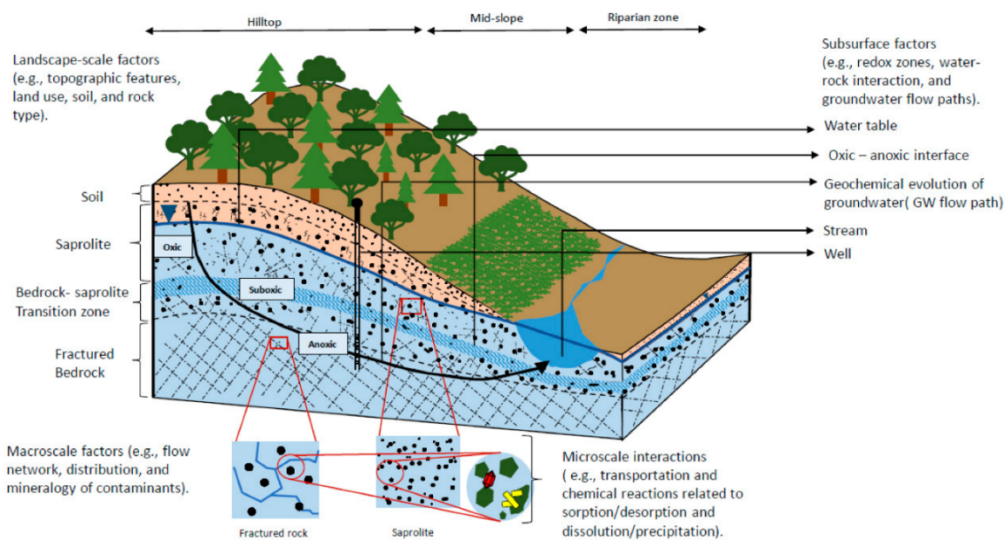
Figure 2.3.1: Conceptual model of groundwater geochemical evolution in saturated and unsaturated zones (Peel et al., 2022). This includes hydrogeochemical factors influencing contamination chemistry. Lithologic boundaries are represented by dashed lines.

Changes in Precipitation Patterns

Increased frequency and intensity of extreme weather events
Numerous studies have documented the increasing intensity and frequency of extreme weather events (Amanambu et al., 2020). This includes heavy rainfall, storms, hurricanes, and other intense precipitation events. These have profound implications for water resources and hydrological systems due to disaster events and infiltration(Saeed & Attaullah, 2014). In some areas, warmer temperatures increase atmospheric moisture content and the potential of more intense rainfalls. Excessive rainfall can overwhelm water treatment systems and lead to contamination infiltration into groundwater (Geris et al., 2022). This is demonstrated by Figure 2.3.2. Intense rainfall results in rapid runoff, soil erosion and flooding that pose risks to groundwater contamination of groundwater.
Excessive rainfall contributes to increased erosion and sediment transport especially in areas with steep slopes and inadequate vegetation covers(Geris et al., 2022). The sediments enter water sources introducing sediment-bound metals into groundwater. The generalized increased sediment load also impacts water quality and creates more water treatment processes challenges(Santos et al., 2011).
More frequent and intense storms/hurricanes are also due to climate change. Warmer sea temperature provides more energy to fuel the weather systems resulting in more intense and destructive storms(Blake et al., 2003). Storms and hurricanes bring heavy rainfall, strong winds, storm surges and increased sediment transfer all which impact water quality in the hydrological systems and increase contaminations of well water with sediments from surrounding areas.
Urbanized areas with inadequate drainage and decreased potential for infiltration are more prone to be affected by flooding (Ciszewski & Grygar, 2016). Urban flooding leads to more runoff during heavy rainfall events and elevate the contamination risk via increases pollution/contaminates from urban areas into well sources. This type of flooding can compromise the integrity of well casing and allow contaminants to directly enter well water systems.
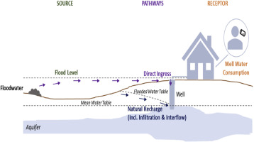
Figure 2.3.2: Schematic to demonstrate the connection between source contamination in groundwater carried by flood events(Andrade et al., 2018)

Shifts in regional rainfall patterns
Shifts with the distribution, timing, and quantity of rainfall in different areas another outcome of climate change. These shifts significantly impact water resources including groundwater and influence contamination.
Climate change can cause uneven distribution of rainfall as some regions experience increased rainfall while others experience drought (Barbieri et al., 2023). This results in water scarcity in areas with reduced with rainfall. Reduced precipitation impacts groundwater recharge which lowers water levels in aquifers and increases metal concentration. As the water table drops, previous untouched contamination zones may be exposed and released into groundwater(Appleyard et al., 2006). This also leads to special variations in groundwater distribution as set areas experience localized water scarcity.
Altered poor precipitation patterns can lead to changes in aquifer storage capacity, permeability and porosity (Wossenyeleh et al., 2020). These changes affect the movement of water within the aquifer and the transport of metals to well water sources. In addition, based on said geological characteristics, reduced rainfall and lower aquifer water levels might affect aquifer storage capacity (Wossenyeleh et al., 2020).

Implications for water availability and distribution
Precipitation pattern changes have widespread implications for water availability and distribution. Small changes in rainfall patterns lead to the direct impacts of the distribution quality and timing of water sources in both surface and groundwater. Water scarcity caused by reduced rainfall and prolonged dry, reduces the water availability for domestic agricultural and industrial needs(Fallahati et al., 2019). This might increase competition for limited surface water resources and require extensive alternatives such as groundwater. The reliance on groundwater and increased groundwater withdrawal heightens contamination risk due to changes in groundwater dynamics and untouched contamination zones(Fallahati et al., 2019). This results in the need for authorities to increase adaptive measures, water conservation efforts and monitor water quality.

Changes in Groundwater Resources

Influence of climate change on groundwater recharge
Groundwater recharge is the process which water infiltrates soil and replenishes aquifers. This is significantly influenced by climate change due to precipitation patterns, temperature and land surface conditions.
Changes in regional precipitation patterns was discussed above. Evapotranspiration is increased with warmer temperature and depletes soil moisture, thus reducing the amount of water for infiltration and decreased groundwater recharge (Figure 2.3.3) (Liu et al., 2020). Soil moisture content is reduced by prolonged dry thus further limiting water availability for infiltration and recharge.
Land use practices such as urbanization, agricultural practices and deforestation alter the capacity of the soil and the natural flow of water into soil and aquifers (Geris et al., 2022). Infiltration capacity, combined with the effects of climate change leads to a decreased groundwater charge and lower groundwater levels. Regions dependent on seasonal snow melt have reduced recharge rates due to the diminished snow accumulation and accelerated glacier melting from climate change temperature rise (JR Williams, 1970). This also affects the timing and volume of water at least during melt season as snowpacks act as a natural reservoir that slowly releases water to recharge in the surface.
Climate change into sea level rise also increases the risk of saltwater intrusion into coastal aquifers (Kumar, 2012) . With seawater infiltrating freshwater, the groundwater is contaminated, and usability is reduced. This leads to an increase in hydraulic pressure altering natural groundwater flow patterns and impeding freshwater infiltration(Nayak & Nandimandalam, 2023). Freshwater and saltwater interfaces shifting in land also reduces the availability of space for recharge and limits freshwater replenishment. These hamper the natural processes that maintain the balance of fresh water in the aquifer.
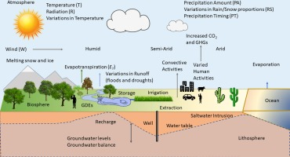
Figure 2.3.3: Schematic of the interaction of groundwater systems with climate change(Amanambu et al., 2020). Direct changes involve precipitation (form and timing), transpiration and evaporation. Indirect changes involve water extraction.

Effects of altered precipitation on aquifer levels
As an expansion of previous paragraphs, the recharge and discharge dynamic of aquifers is directly influenced by changes in intensity, distribution and timing of precipitation. Water use in times of drought can also drop groundwater levels.
Recharge reduction is caused by prolonged dry periods and/or decreased rainfall. This limits the water available for infiltration and subsequent recharge due to multiple aquifer and soil interactions(Mosley et al., 2014). Soil moisture content decreases and becomes less permeable, which reduces infiltration rates. Intense rainfall events also limit subsequently infiltration and recharge as via an increase in runoff and surface flow, if the soil is too impermeable or compacted to absorb the excess water. Vegetation dynamics caused by the impact of precipitation on vegetation growth and evaporative transportation also decreases recharge(T. Ma et al., 2020). Decreased plant growth and transpiration reduces the amount of water that is absorbed by the plants and subsequently released into the soil.
Less frequent rainfalls or concentrated intense rainfalls in shorter time periods prolongs times between recharge events(Kumar, 2012). This delayed recharge leads to situations with extraction rates overcoming recharge rates and results in overdraft from groundwater over abstraction(Staben et al., 2015). Aquifer depletion, uncertainties in water availabilities caused by climate change, also encourages well water users abstracting groundwater excessively as a precautionary during reduced rainfall. This overextraction further depletes aquifers. This overextraction can cause an upwelling and a shift in age depth distribution where water is drawn from more contaminated aquifers (Levy et al., 2021) (Figure 2.3.4).
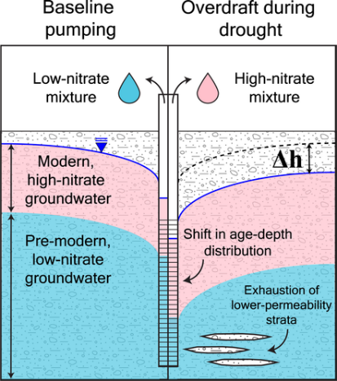
Figure 2.3.4: Model of overdraft effects on hydraulic head Δh and water quality for a well during drought (Levy et al., 2021)
Altered precipitation patterns also affect the seasonal variations in aquifer levels (Riches et al., 2007). Regions that rely on rainfall for recharge find that precipitation patterns changes impact the seasonality of aquifer levels. In dry seasons, less rainfall reduces the infiltration and recharge water amount, demand increases evaporation is increased due to higher temperatures and reduced soil moisture, and thus limits the water from reaching the aquifer (Levy et al., 2021). These interactions lead to lower aquifer levels.
Increased rainfalls can result in higher aquifer levels. Seasons or monsoons give opportunities for infiltration and recharge (Sahu et al., 2020). This along with reduced evapotranspiration rates reduced enhanced water aquifer recharge. Thus aquifer levels may be higher during wet seasons(Riches et al., 2007). A leg effect between participation precipitation and aquifer response will be seen due to the time required for water to infiltrate soil and reach groundwater (Wossenyeleh et al., 2020). Thus, aquifer levels may continue to rise even after the end of the wet season with this water movement. The inverse will happen during dry seasons - aquifer levels may continue to decline after dry season as water is continuously extracted from the aquifer (Wossenyeleh et al., 2020).
Lastly, precipitation pattern changes affect the interactions between groundwater and surface water bodies. This can diminish the discharge of groundwater into streams lakes and rivers resulting in decreased base flow (Wei et al., 2016). Base flow is a sustained flow of water from groundwater into surface water bodies such as rivers lakes and streams and helps maintain surface water levels during dry periods. This provides a reliable water source for ecosystems and meeting water demands. In addition, surface water and groundwater are connected interconnected through exchanges that occur along the ground water-surface water interface (Lewandowski et al., 2020). These may include movement of water from surface water into aquifers or upward movement of groundwater to surface water bodies. Participation pattern changes influence these exchanges through altering recharge/discharge dynamics.
All the above processes have significant implications for the aquifer storage capacity and aquifer understanding aquifer levels. Understanding of these interactions with climate change is critical and necessary for new sustainable water resource management(Amanambu et al., 2020). This includes monitoring aquifer levels assessing new recharge rates and implementing recharge enhancement strategies such as artificial recharge techniques and land management practices. Managing groundwater extraction rates along with promoting water conservation are critical for ensuring long-term sustainability and aquifer availability of groundwater with climate change.

Increased risk of groundwater depletion and saltwater intrusion
Increased water demand, rising temperatures, precipitation pattern changes and groundwater deletion depletion also can contribute to saltwater intrusion(Basack et al., 2022). Saltwater intrusion occurs when saltwater infiltrates its freshwater aquifers and compromises its groundwater quality and usability.
Salt water is held back from inland freshwater systems via hydraulic pressure. The transition zone is where the hydraulic pressure of both freshwater and salt water is equivalent. Said saltwater-freshwater interface is a dynamic mixing zone influenced by tides, pumping rates, aquifer characteristics, head gradients (Basack et al., 2022). Its behavior is related to the density and salinity to the two water types. Homogenous aquifers will have a uniform transition zone that is a consistent distance from the coastline with a smooth transition of water salinity and well-defined mixing gradient. Heterogeneous aquifers have variations in permeability, porosity and geological structures that influence the transition zone to be more complex and irregular (Hussain et al., 2019). Confined heterogenous aquifers may also exhibit different hydraulic head distributions.
In addition, there are multiple ‘modes’ of saltwater intrusion (Figure 2.3.5). In some, denser saltwater found in coastal aquifers sinks to the bottom forming a saltwater wedge which infiltrates weaker inland freshwater (Basack et al., 2022). Others such as upconing occur when saltwater rises below and intrudes into a freshwater aquifer, displacing it (Werner et al., 2013). This is observed with excessive pumping near the coastline – the withdrawal of freshwater lessens the freshwater hydraulic head and creates a cone of depression, drawing saltwater towards the well.
Storm surges, increased sea levels and lower freshwater recharges elevated hydraulic saltwater pressure and press seawater further inland, displacing freshwater (Werner et al., 2013). In addition storm surges from extreme weather events can cause drive seawater further inland into areas that are not typically prone to intrusion and alter the natural groundwater flow.
Saltwater intrusion makes potable water undrinkable and unsuitable for agricultural purposes due to the salinity level alone. However, it also causes increased corrosion and pitting of well structures that may result in introduced metal contamination(Tansel & Zhang, 2022). Similarly, the groundwater chemistry – pH, conductivity, and redox conditions changes. This in turn impacts the speciation and solubility of metals and can lead to the dissolution of metal contaminates already existing in soils and rock formations (Zhu et al., 2022)

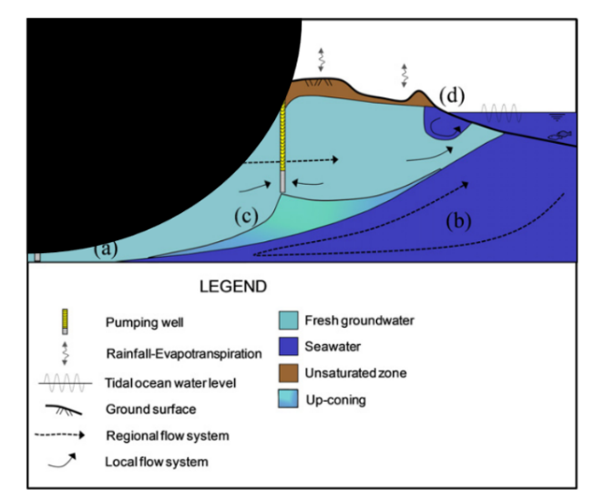
Figure 2.3.5: Diagram of saltwater intrusion in an unconfined aquifer. A) saltwater wedge toe, b) circulation in the seawater zone driven by densities, (c) seawater upconing and cone of depression. (Werner et al., 2013)

Further Description of British Columbia

Figure 5.1: Power Bi Map of observation well stations in British Columbia.
Figure 5.1 shows the observation OBS Wells throughout British Columbia. The corresponding weather stations and closer views of OBS Well locations are seen in appendix **. The well and weather stations have differing locations that will introduce inaccuracy. Future research should evaluate this level of inaccuracy on QGIS or ArcGIS. Time constraints meant both well data could not be spatially autocorrected. Satellite imaging picture research would do well to utilize both Queens and Warren's autocorrection as well as the correct version of Kringing for more accurate information. Likewise, time clustering algorithms and special clustering algorithms such time space cube and dbscan could help further differentiate between actual factors, and properties of one of the most complex unique hydrological provinces in Canada. Spatial auto correction would be useful as it would identify underlying patterns such as sites that are solely to monitor industrial activity or mines; versus an underlying pattern in bedrock and geology. The 100- and 10-year peak flows are shown in Appendix **. The maximum while the maximum of precipitation for each well is shown in appendix **. Though not all of the monthly precipitation will go into runoff, it does give an indicator that in a lot of cases the 10- and 100-Year Peak flows would have been exceeded at times. These indicate the severity of flooding. 100 Year Peak flow lines are higher magnitudes and may overwhelm flood protection barriers such as Lucky's; and burns for wastewater lagoons and landfills, which would allow more contamination to enter aquifers. Also, larger Peak flows enable contamination to be transported further laterally during overland flooding, exposing a broader area of subsurface to potential contamination. Recurrence intervals of the 10-year flood means that flooding is more frequent, so aquifers are exposed to emanations from flooding more often, leading to a cumulative impact over time from less concentrated sources. Future research areas could be to include Peak flow and more of the hydraulic connectivity to groundwater pollution during flooding for a better understanding of these dynamics. Low flow zones and annual runoffs are showing in the appendix **.
British Columbia is divided into eight different low flow hydrology zones that are representative of the lowest flow rate during the corresponding driest seasons. These are broadly representative of water flow regimes, focused during drought, and based on average daily flow. These can coincide with decreased water table pressures, lower hydraulic pressure, and impacts the connected groundwater via reduced recharge. This again increases the concentration effect. It also can affect shallow aquifers connected to intermittent streams or surface water through contamination infiltration during drought receptions. Reduced over bank flooding diminishes the flushing out of normal contaminates under normal flow conditions.

Figure 0.2: Map of B.C. hydrologic zones from iMAP B.C ****.
Figure# shows the previous British Columbia hydrologic zones in British Columbia while the updated zones are shown in Appendix **. Hydraulic zones are smaller defined places that take into account climate, terrain, geology, precipitation and other factors to provide more context for regional water patterns. Hydraulic zones allow baseline assumptions to be made for hydrology within the same area. Most of the well stations occur in the nine to ten hydraulic zones in the south. The Fraser Plateau had braided* outwash channels that transport sediments from place or contamination from mining over large distance. Meanwhile, fractured basal causes in the Thompson region transport uranium and arsenic from mineral spread. Likewise, said zones indicate if the contamination is pluvial, nevial or mixed recharge. Appendix** and Figure # shows the example of hydrogeologic boundaries mapping the effect of something like mountain pine beetle on the flow watershed. It is necessary to link spatially the flow streams and watershed basins to aquifer contamination.

Figure 0.3: Map of geological terranes of British Columbia ****.
Appendix** shows the map of geo aquifer regions along with observations and characteristics. It is seen that mapping only extends to highly industrialized or highly populated areas. This indicates lack of data that future modeling objectively could produce with the influence of both groundwater hydraulic and water contamination data. The geological map, geological era of rock map and quaternity geology map of rock in British Columbia are showing in the Appendix**.
The LG map will demonstrate where sedimentary, volcanic, metaphoric and intrusive rocks are located and what their dominant underlying structure is along with the corresponding timeline. This can indicate where some places might get potential groundwater contamination. Due to the complexity of this map, the following figures provide a better explanation##.

Quaternary geology is the geology that happened from 2.58 million years ago to today. Quaternary geology is primarily influenced during the Quaternary, a period consisting of numerous interglacial cycles. A lot of this geology is dominated by the retreat of the Cordilleran ice sheet and Winstonian glaciation. This again will affect groundwater due to mineral deposits left behind by the formation, movement and dynamics of different ice sheets. Appendix** and figure## show locations where dominant quaternary geology factors exist.
Geological age appendix and terrains figure, commonly resemble themselves and represent the retreat outward of the coast from tectonic plate removals over the years. this in the significantly influences aquifers as it indicates dominant metals that can be found, trapped seawater intrusion from throughout the millennia, And formations of different aquifer heterogeneity. Figure# also shows fault lines which do indicate slips and different geological influences of different Parks and influencing infiltration and how the geology Groundwater chemistry influences the aquifer and potential release.


Figure 0.4: Soil parent materials in British Columbia. *******
Figure# and appendices** represent the soil groups as specified by the Canadian soil classification that are dominant in BC and the parental material of said soil groups. Furthermore, the permeability of some soils, such as brunisolic soils and Orthic Humo-Ferric Podzols, transport pollutants into bedrock aquifers while the acidic conditions of punzelic soil mobilize metals. Gleysolic soils may act as aquatards but may as well transport contaminations within saturated lowland conditions (i.e. Saltspring Island Aquifier). Brunisolic soils The variable oxidative conditions to mobilize Mn naturally and podzolic soils low ph enhancesMetal migration. Mn Above guidelines are frequently seen in fabric blogs underline by fibrosick peaks in Northern Vancouver Island. Likewise in the Quesnel highland, uraniferous zones leach uranium into shallow dug wells that are partially controlled by the redox conditions in the brunisolic regolith.
Further the parent materials of the resulting soil groups in British Columbia are shown in Figure #**. Alluvium/colluvium are highly permeable materials that transport contaminants rapidly if near or over contaminated sites and can transport metals like Mn from mineralized outcrops into aquifers. Moreover, organic compounds such as bogs release dissolved organic compounds and leech metals like manganese under anaerobic conditions. Meanwhile morainal (glacial drift) deposits containing heterogeneous mixtures of material that can provide multiple float paths with course sediments, transport contaminants and find sediment trapping plumes. With Glacial Fluvial outwash, for example sands and gravels can spread plumes over long distance especially in the Nelson region. However, Residual soils can mean that weathering will mobilize arsenic in central BC from mineralized bedrock. Morainal Closet have heterogeneity of retards that controls contaminant Mobility, trapping contaminants through absorption, or facilitating plumes through provincial preferential flow pass via more sediments such as kames or eskers. saturation zones Within moraines can also mobilize sequence contamination and change redox conditions.

