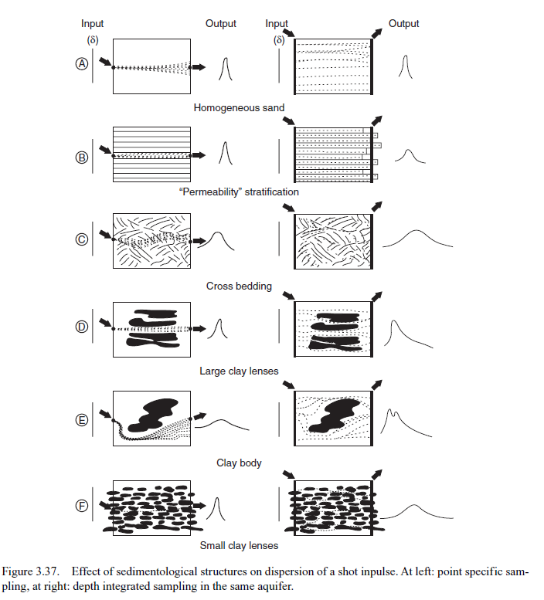

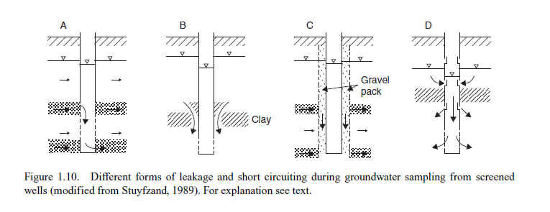

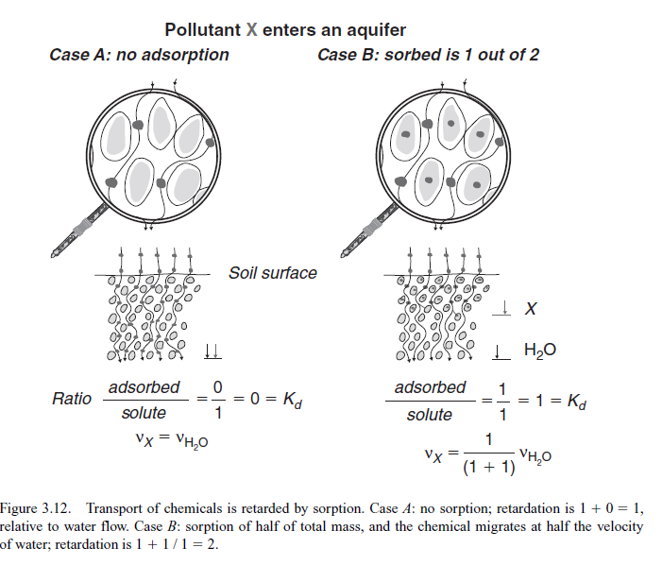
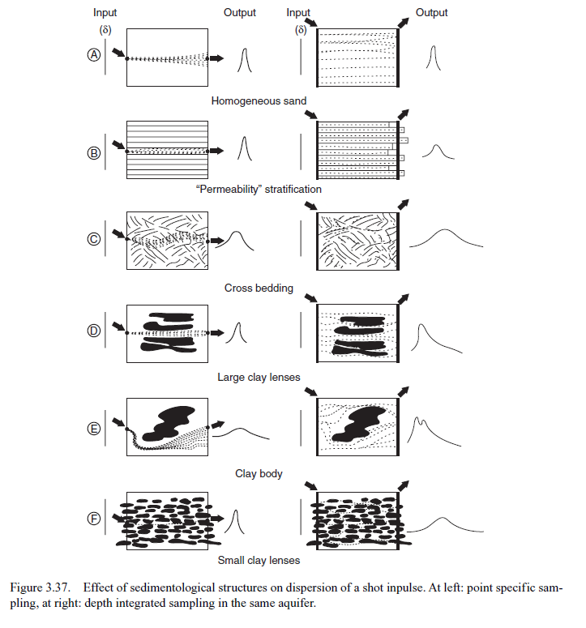

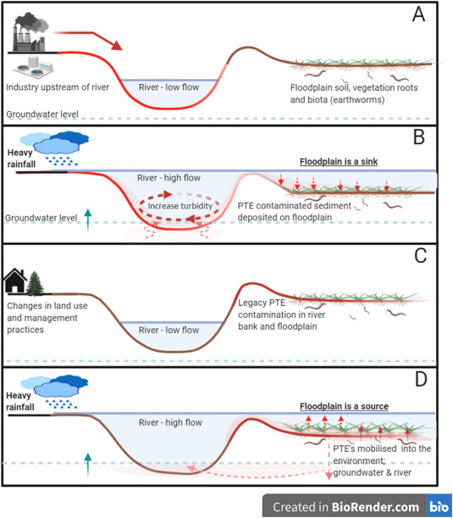

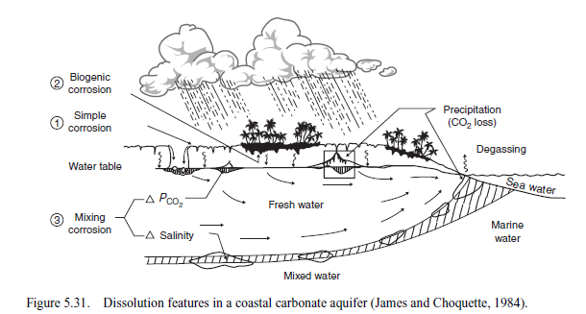
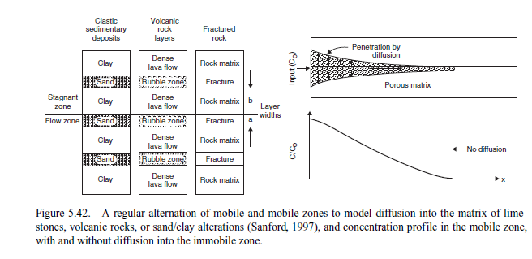
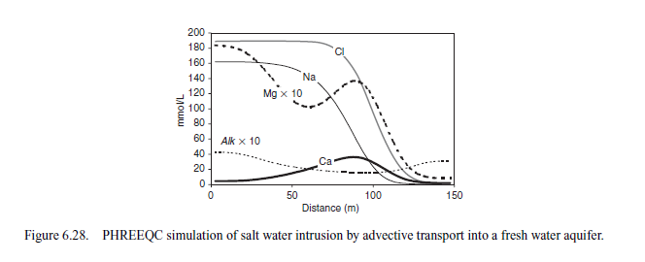

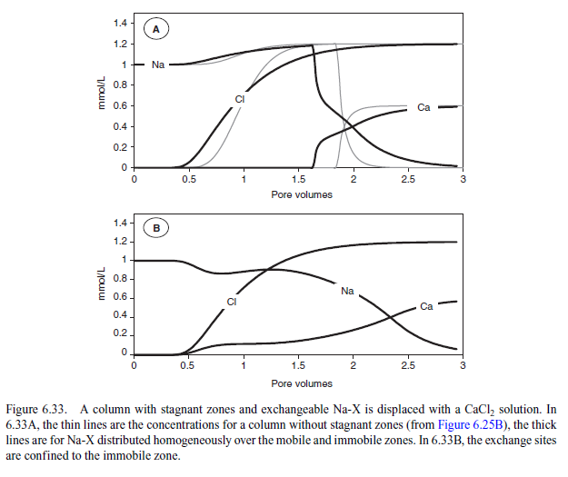
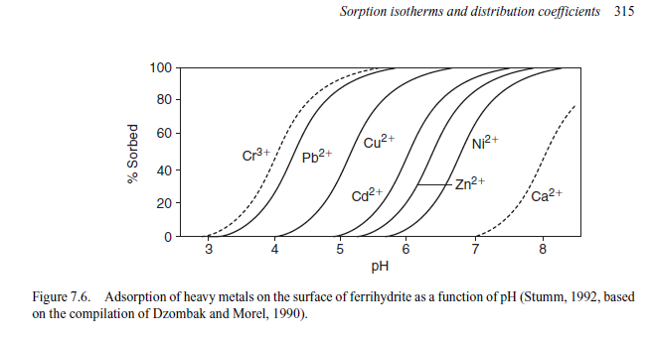
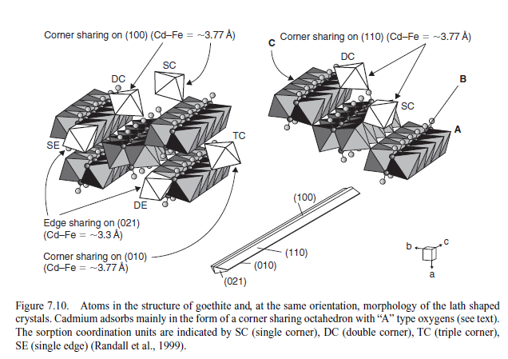
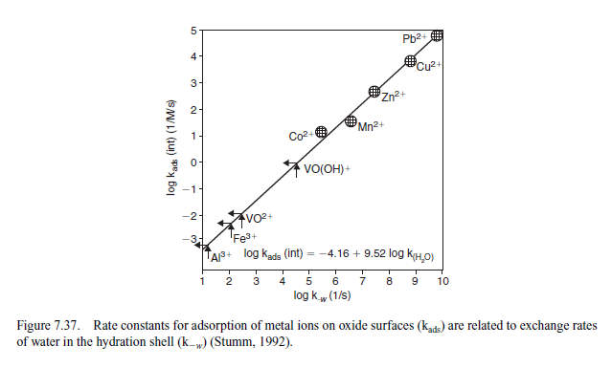
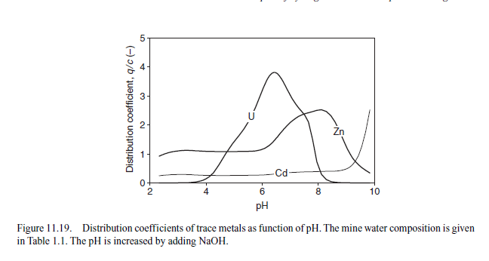
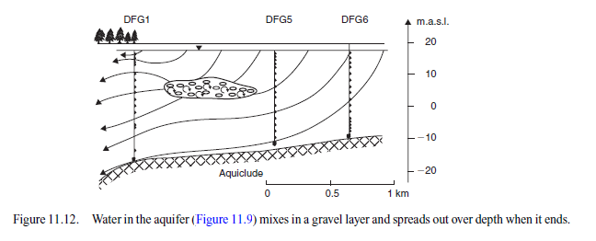
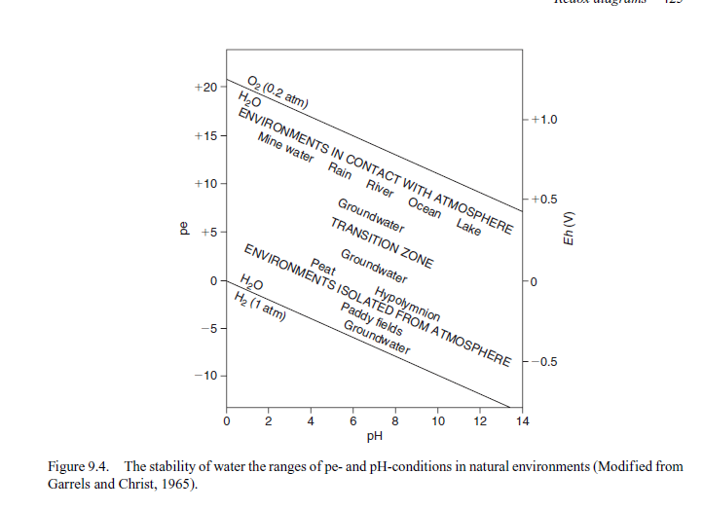
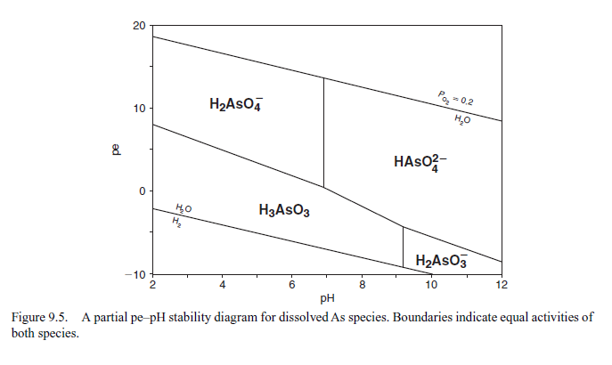
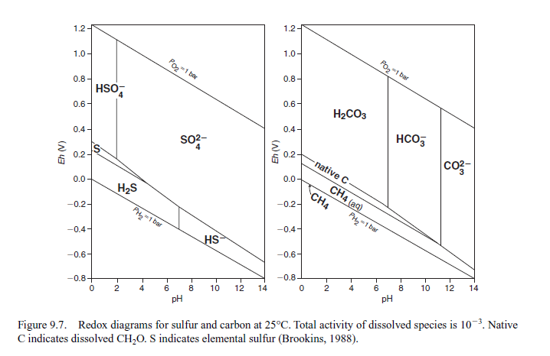
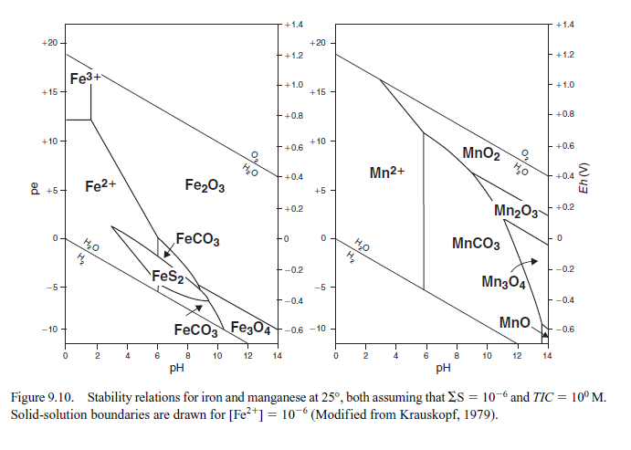
 | Factor 1 | Factor 2 | Factor 3 | Factor 4 | Factor 5 | Factor 6 | Factor 7
Main | SWI and weathering | Time and redox | Direct climate change | Unconfined/ Confined | Fractures/ unconfined
Drought | SWI and weathering | Time and redox | Direct climate change | Unconfined/ Confined | Fractures/ confined | Distance
Flood | SWI and weathering | Time and redox | Unconfined/ Confined | Direct climate change | Distance | Fractures | Anthropogenic

 | Main | Drought | Flood
Factor 1 | Specific Conductance | Specific Conductance | Specific Conductance | Factor 1
Factor 1 | Residue Filterable 1.0u | Residue Filterable 1.0u | Residue Filterable 1.0u | Factor 1
Factor 1 | Ca | Alkalinity Total 4.5 | Chloride | Factor 1
Factor 1 | Alkalinity Total 4.5 | Sulfate | Alkalinity Total 4.5 | Factor 1
Factor 1 | Sulfate | Ca | Sulfate | Factor 1
Factor 1 | U | Chloride | Ca | Factor 1
Factor 1 | Chloride |  |  | Factor 1
Factor 2 | Pb | Pb | Pb | Factor 2
Factor 2 | Fe | Fe | Fe | Factor 2
Factor 2 | Mn | Sample Months | Sample Months | Factor 2
Factor 2 | Sample Months |  |  | Factor 2
Factor 3 | Maximum °C | Maximum °C | Minimum °C | Factor 4
Factor 3 | Minimum °C | Minimum °C | Maximum °C | Factor 4
Factor 3 |  | Precipitation |  | Factor 4
Factor 4 | Aquifer_2 | Aquifer_2 | Aquifer_2 | Factor 3
Factor 4 | Aquifer_1 | Aquifer_1 | pH | Factor 3
Factor 4 |  |  | Aquifer_1 | Factor 3
Factor 5 | Aquifer_1 | Aquifer_2 | Fe | Factor 6
Factor 5 | Aquifer_3 | K | Mn | Factor 6
Factor 5 |  | Mn | Aquifer_3 | Factor 6
Factor 5 |  | Aquifer_3 |  | Factor 6
Factor 6 |  | Latitude | Latitude | Factor 5
Factor 6 |  | U | U | Factor 5
Factor 6 |  | Chloride | Longitude | Factor 5
Factor 6 |  |  | Precipitation | Factor 5
 |  |  | As | Factor 7
 |  |  | Pb | Factor 7

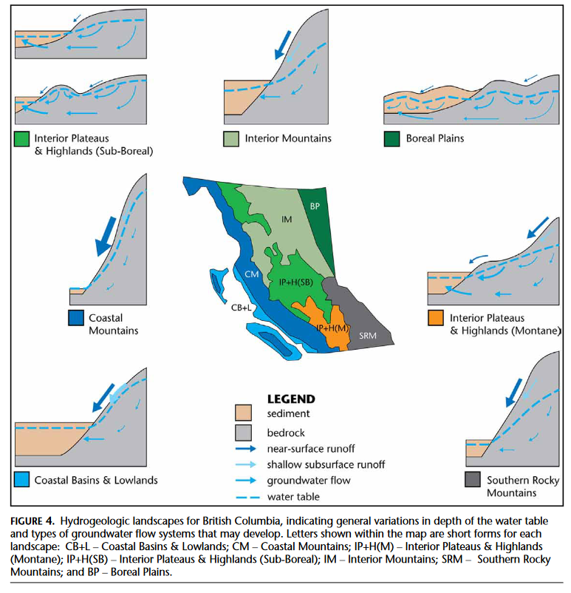
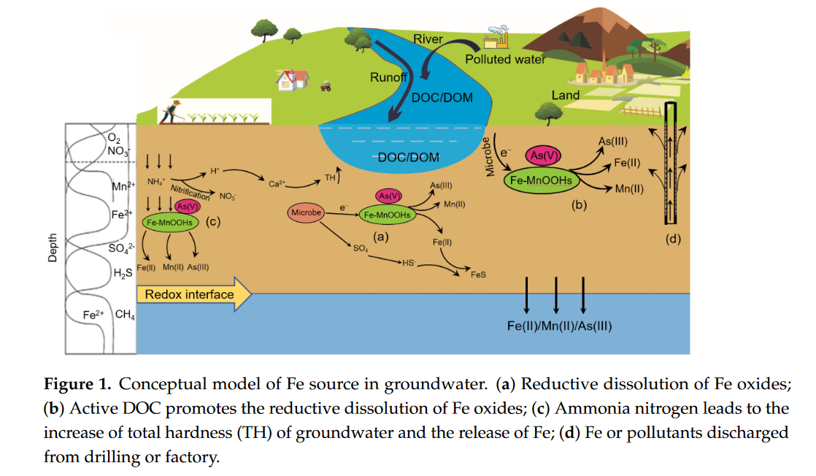
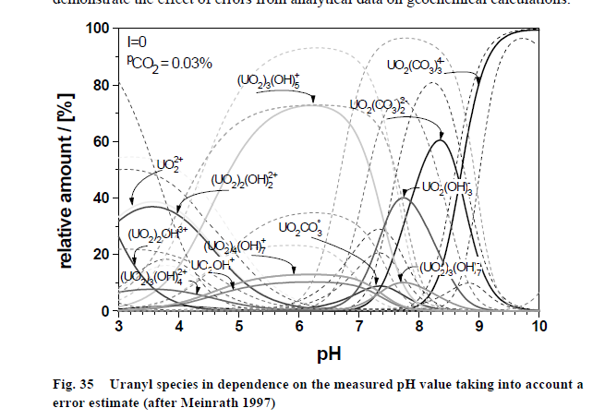
Rock Geochemistry | Redox (including microbial) | Sea Water Intrusion | Climate Change Factors | Metals
Hardness (Total) [mg/L CaCO3] | Sulfate [mg/L] | Specific Conductance [uS/cm] | Tx_Climatology [°C] | U [mg/L]
K [mg/L] | pH | Residue Filterable 1.0u [mg/L] | Tn_Climatology [°C] | Pb [mg/L]
Ca [mg/L] | P [mg/L] | Chloride [mg/L] | Maximum Temperature [°C] | Mn [mg/L]
Alkalinity Total 4.5 [mg/L] | N.Kjel:T [mg/L] |  | Minimum Temperature [°C] | Cd [mg/L]
 | Fe [mg/L] |  | Precip_Climatology [mm] | As [mg/L]
 |  |  | Precipitation [mm]

- Contact matt seeing if I can help. Infromed of the challenges the company has experienced. Ask to provide a more relevant perspective shift.
- Contact Dad about jobs. Draft email to lisa Kattan
- Contact Corlette
- Contact VA2
- Contact Dr. McBean
- Draft out career research
- Make indeed job resume
[°C]
(Allen et al., 2014)
(Carmichael et al., 2008). (B.C. Ministry of Environment and Climate Change Strategy, 2023) (Ootes et al., 2017) (Andrade et al., 2018) (Werner et al., 2013) (Levy et al., 2021)
(Nolan & Weber, 2015). (DeSimone et al., 2014) (McMahon et al., 2019) (Jurgens et al., 2019) (Kennedy & Drage, 2020), (Xia et al., 2022) (Appelo & Postma, 2004)

(Amanambu et al., 2020), (Peel et al., 2022), (Masuda, 2018), (Earle, 2019), (Almost 9M Canadians Depend on Ground Water, 2019), (BC Mining Law Reform, 2021; Jurgens et al., 2022)
(Larry D. Jones, 1990) (Johnston & Mccartney, 1965; McGuigan et al., 2010) (Pell & Hora, 1990) (Xia et al., 2022) (Appelo & Postma, 2004) (Wei et al., 2016). (Neidhardt & Shao, 2023)
(Richardson et al., 2024; Zhang et al., 2023)
(Leyden et al., 2016) (Wossenyeleh et al., 2020) (Bondu et al., 2016)
(Zhong et al., 2023) (Rudd et al., 2023) (Al-Amri et al., 2023) (Crawford et al., 2022)
(Blake et al., 2019) (Bruins, 2016) (Nicomel et al., 2016) (Krupka & Serne, 2002) (Schock et al., 2005)
(Ferguson et al., 2020) (Skierszkan et al., 2021)
(iMapBC, n.d.) (Wei et al., 2016)
Al-Amri, N. S., Abdurahman, S. G., & Elfeki, A. M. (2023). Modeling Aquifer Responses from Flash Flood Events through Ephemeral Stream Beds: Case Studies from Saudi Arabia. Water, 15(15), Article 15. https://doi.org/10.3390/w15152735
Allen, D. M., Stahl, K., Whitfield, P. H., & Moore, R. D. (2014). Trends in groundwater levels in British Columbia. Canadian Water Resources Journal / Revue Canadienne Des Ressources Hydriques, 39(1), 15–31. https://doi.org/10.1080/07011784.2014.885677
Almost 9M Canadians depend on ground water. (2019, March 9). Ground Water Canada. https://www.groundwatercanada.com/almost-9m-canadians-depend-on-ground-water-4620/
Amanambu, A. C., Obarein, O. A., Mossa, J., Li, L., Ayeni, S. S., Balogun, O., Oyebamiji, A., & Ochege, F. U. (2020). Groundwater system and climate change: Present status and future considerations. Journal of Hydrology, 589, 125163. https://doi.org/10.1016/j.jhydrol.2020.125163
Andrade, L., O’Dwyer, J., O’Neill, E., & Hynds, P. (2018). Surface water flooding, groundwater contamination, and enteric disease in developed countries: A scoping review of connections and consequences. Environmental Pollution, 236, 540–549. https://doi.org/10.1016/j.envpol.2018.01.104
Appelo, C. A. J., & Postma, D. (2004). Geochemistry, Groundwater and Pollution. CRC Press.
BC Mining Law Reform. (2021). Maps. BC Mining Law Reform. https://reformbcmining.ca/maps/
B.C. Ministry of Environment and Climate Change Strategy. (2023, February 28). British Columbia Regional Streamflow Inventory Reports [Govermental]. Province of British Columbia. https://www2.gov.bc.ca/gov/content/environment/air-land-water/water/water-science-data/water-data-tools/provincial-hydrology-program/resources/streamflow-inventory#reports
Blake, F., Grant, K., MacKenzie, D., Scott, J., & Craw, D. (2019). Surficial arsenic redistribution above gold-mineralised zones in East Otago, New Zealand. New Zealand Journal of Geology and Geophysics, 62(4), 573–587. https://doi.org/10.1080/00288306.2019.1647854
Bondu, R., Cloutier, V., Rosa, E., & Benzaazoua, M. (2016). A Review and Evaluation of the Impacts of Climate Change on Geogenic Arsenic in Groundwater from Fractured Bedrock Aquifers. Water, Air, & Soil Pollution, 227(9), 296. https://doi.org/10.1007/s11270-016-2936-6
Bruins, J. (2016). Manganese Removal from Groundwater. Role of Biological and Physico-Chemical Autocatalytic Processes.
Carmichael, V., Kenny, S., Gellein, C., Wei, M., & Allen, D. (2008). Re-evaluating the aquifer hydraulic properties within the Okanagan Valley, British Columbia, Canada. GeoEdmonton’08. https://members.cgs.ca/documents/conference2008/GEO2008/pdfs/193.pdf
Crawford, S. E., Brinkmann, M., Ouellet, J. D., Lehmkuhl, F., Reicherter, K., Schwarzbauer, J., Bellanova, P., Letmathe, P., Blank, L. M., Weber, R., Brack, W., van Dongen, J. T., Menzel, L., Hecker, M., Schüttrumpf, H., & Hollert, H. (2022). Remobilization of pollutants during extreme flood events poses severe risks to human and environmental health. Journal of Hazardous Materials, 421, 126691. https://doi.org/10.1016/j.jhazmat.2021.126691
DeSimone, L., McMahon, P., & Rosen, M. (2014). The quality of our Nation’s waters—Water quality in Principal Aquifers of the United States 1991-2010 (ISSN 2330–5703; U.S. Geological Survey Circular 1360). U.S. Geological Survey. https://pubs.usgs.gov/circ/1360/
Earle, S. (2019). Physical Geology—2nd Edition. BCcampus. https://opentextbc.ca/physicalgeology2ed/
Ferguson, G., Cuthbert, M. O., Befus, K., Gleeson, T., & McIntosh, J. C. (2020). Rethinking groundwater age. Nature Geoscience, 13(9), 592–594. https://doi.org/10.1038/s41561-020-0629-7
iMapBC. (n.d.). Retrieved December 1, 2023, from https://maps.gov.bc.ca/ess/hm/imap4m/
Johnston, A. G., & Mccartney, W. D. (1965). Manganese occurrences in Canada. https://ostrnrcan-dostrncan.canada.ca/handle/1845/104174
Jurgens, B. C., Faulkner, K., McMahon, P. B., Hunt, A. G., Casile, G., Young, M. B., & Belitz, K. (2022). Over a third of groundwater in USA public-supply aquifers is Anthropocene-age and susceptible to surface contamination. Communications Earth & Environment, 3(1), 1–9. https://doi.org/10.1038/s43247-022-00473-y
Jurgens, B. C., Parkhurst, D. L., & Belitz, K. (2019). Assessing the Lead Solubility Potential of Untreated Groundwater of the United States. Environmental Science & Technology, 53(6), 3095–3103. https://doi.org/10.1021/acs.est.8b04475
Kennedy, G. W., & Drage, J. (2020). A review of private well contaminants, testing, and mitigation behaviours in Nova Scotia (Open File Report ME 2020-004). Nova Scotia Energy and Mines Geological Survey. https://novascotia.ca/natr/meb/data/pubs/20ofr04/ofr_me_2020-004.pdf
Krupka, K., & Serne, R. (2002). Geochemical Factors Affecting the Behavior of Antimony, Cobalt, Europium, Technetium, and Uranium in Vadose Sediments. https://doi.org/10.2172/15004491
Larry D. Jones. (1990). URANIUM AND THORIUM OCCURRENCES IN BRITISH COLUMBIA (OPEN FILE 1990–32). Minisby of Energy, Mines and Petroleum Resources. https://cmscontent.nrs.gov.bc.ca/geoscience/publicationcatalogue/OpenFile/BCGS_OF1990-32.pdf
Levy, Z. F., Jurgens, B., Burow, K., Voss, S., Faulkner, K., Arroyo‐Lopez, J., & Fram, M. (2021). Critical Aquifer Overdraft Accelerates Degradation of Groundwater Quality in California’s Central Valley During Drought. Geophysical Research Letters, 48. https://doi.org/10.1029/2021GL094398
Leyden, E., Cook, F., Hamilton, B., Zammit, B., Barnett, L., Lush, A. M., Stone, D., & Mosley, L. (2016). Near shore groundwater acidification during and after a hydrological drought in the Lower Lakes, South Australia. Journal of Contaminant Hydrology, 189, 44–57. https://doi.org/10.1016/j.jconhyd.2016.03.008
Masuda, H. (2018). Arsenic cycling in the Earth’s crust and hydrosphere: Interaction between naturally occurring arsenic and human activities. Progress in Earth and Planetary Science, 5(1), 68. https://doi.org/10.1186/s40645-018-0224-3
McGuigan, C. F., Hamula, C. L. A., Huang, S., Gabos, S., & Le, X. C. (2010). A review on arsenic concentrations in Canadian drinking water. Environmental Reviews, 18(NA), 291–307. https://doi.org/10.1139/A10-012
McMahon, P. B., Belitz, K., Reddy, J. E., & Johnson, T. D. (2019). Elevated Manganese Concentrations in United States Groundwater, Role of Land Surface–Soil–Aquifer Connections. Environmental Science & Technology, 53(1), 29–38. https://doi.org/10.1021/acs.est.8b04055
Neidhardt, H., & Shao, W. (2023). Impact of climate change-induced warming on groundwater temperatures and quality. Applied Water Science, 13(12), 235. https://doi.org/10.1007/s13201-023-02039-5
Nicomel, N. R., Leus, K., Folens, K., Van Der Voort, P., & Du Laing, G. (2016). Technologies for Arsenic Removal from Water: Current Status and Future Perspectives. International Journal of Environmental Research and Public Health, 13(1), Article 1. https://doi.org/10.3390/ijerph13010062
Nolan, J., & Weber, K. A. (2015). Natural Uranium Contamination in Major U.S. Aquifers Linked to Nitrate. Environmental Science & Technology Letters, 2(8), 215–220. https://doi.org/10.1021/acs.estlett.5b00174
Ootes, L., Elliott, J., & Rowins, S. (2017). Testing the relationship between the Llewellyn fault, gold mineralization, and Eocene volcanism in northwest British Columbia: A preliminary report.
Peel, H. R., Balogun, F. O., Bowers, C. A., Miller, C. T., Obeidy, C. S., Polizzotto, M. L., Tashnia, S. U., Vinson, D. S., & Duckworth, O. W. (2022). Towards Understanding Factors Affecting Arsenic, Chromium, and Vanadium Mobility in the Subsurface. Water, 14(22), Article 22. https://doi.org/10.3390/w14223687
Pell, J., & Hora, Z. (1990). High-tech metals in British Columbia.
Richardson, C. M., Davis, K. L., Ruiz-González, C., Guimond, J. A., Michael, H. A., Paldor, A., Moosdorf, N., & Paytan, A. (2024). The impacts of climate change on coastal groundwater. Nature Reviews Earth & Environment, 5(2), 100–119. https://doi.org/10.1038/s43017-023-00500-2
Rudd, H., Neal, A., Genereux, D. P., Shea, D., & Nichols, E. G. (2023). Vulnerability of wells in unconfined and confined aquifers to modern contamination from flood events. Science of The Total Environment, 901, 165729. https://doi.org/10.1016/j.scitotenv.2023.165729
Schock, M., Scheckel, K., DeSantis, M., & Gerke, T. (2005). Mode of Occurrence, Treatment and Monitoring Significance of Tetravalent Lead.
Skierszkan, E. K., Dockrey, J. W., Helsen, J., Findlater, L.-L., Bataille, C. P., de Laplante, G., McBeth, J. M., Mayer, K. U., & Beckie, R. D. (2021). Persistence of Uranium in Old and Cold Subpermafrost Groundwater Indicated by Linking 234U-235U-238U, Groundwater Ages, and Hydrogeochemistry. ACS Earth and Space Chemistry, 5(12), 3474–3487. https://doi.org/10.1021/acsearthspacechem.1c00307
Wei, M., Klaus Rathfelder, & Jennifer Turner. (2016). Determining the Likelihood of Hydraulic Connection – Guidance for the Purpose of Apportioning Demand from Diversion of Groundwater on Streams (Technical WSS2016-01; Water Science Series). Water Protection and Sustainability Branch, Ministry of Environment of British Columbia. https://a100.gov.bc.ca/pub/acat/documents/r50832/HydraulicConnectMW3_1474311684426_4310694949.pdf
Werner, A. D., Bakker, M., Post, V. E. A., Vandenbohede, A., Lu, C., Ataie-Ashtiani, B., Simmons, C. T., & Barry, D. A. (2013). Seawater intrusion processes, investigation and management: Recent advances and future challenges. Advances in Water Resources, 51, 3–26. https://doi.org/10.1016/j.advwatres.2012.03.004
Wossenyeleh, B. K., Verbeiren, B., Diels, J., & Huysmans, M. (2020). Vadose Zone Lag Time Effect on Groundwater Drought in a Temperate Climate. Water, 12(8), 2123. https://doi.org/10.3390/w12082123
Xia, X., Teng, Y., & Zhai, Y. (2022). Biogeochemistry of Iron Enrichment in Groundwater: An Indicator of Environmental Pollution and Its Management. Sustainability, 14(12), Article 12. https://doi.org/10.3390/su14127059
Zhang, L., Wu, Y., Ni, Z., Li, J., Ren, Y., Lin, J., & Huang, X. (2023). Saltwater intrusion regulates the distribution and partitioning of heavy metals in water in a dynamic estuary, South China. Marine Environmental Research, 186, 105943. https://doi.org/10.1016/j.marenvres.2023.105943
Zhong, S., Zhou, S., Liu, S., Wang, J., Dang, C., Chen, Q., Hu, J., Yang, S., Deng, C., Li, W., Liu, J., Borthwick, A. G. L., & Ni, J. (2023). May microbial ecological baseline exist in continental groundwater? Microbiome, 11(1), 152. https://doi.org/10.1186/s40168-023-01572-4

As
Statistically significant predictors from OLS regression models for As
 | Main | SWI | Drought | Flood
Alkalinity | + |  | + | +
Chloride | - |  | -
Fe | + | + | + | +
P | + |  | +
Sulfate | + | + | +
Hardness* | +
K | + | - | +
pH |  |  | +
Residue Filterable |  |  |  | +
Time | -
x | - | -
N |  | -
Aquifer_1 |  | + | + | +
Aquifer_2 |  |  | + | +
Aquifer_3 |  | - |  | +
Precipitation |  |  |  | -
Maximum °C |  |  |  | -
Minimum °C |  |  |  | +

Statistically significant predictors from OLS regression models for Pb
 | Main | SWI | Drought | Flood
P | -
Residue Filterable | + |  | + | +
Sulfate | - | - | -
HW* | +
Time | - | -
Fe |  | + | + | +
K |  | - | -
Aquifer_1 |  | + | + | +
Aquifer_2 |  | + | + | +
Aquifer_3 |  | + | + | +
N |  |  | -
Precipitation |  |  | - | -
Specific Conductance |  |  |  | -
Minimum °C |  |  |  | +
Maximum °C |  |  |  | -
pH
Statistically significant predictors from OLS regression models for Mn
 | Main | SWI | Drought | Flood
Alkalinity | + | - |  | +
Chloride |  | -
P |  | +
Specific Conductance |  | + | +
Residue Filterable | -
pH |  | - | -
Fe | + |  | + | +
K | + | + | + | +
N | + |  | + | +
x | - | - | - | -
y |  | -
Aquifer_1 | -
Aquifer_2 |  | +
Aquifer_3
Maximum °C | - |  |  | -
Minimum °C | +
Hardness* | +
FD* | +
HW* | +
MT* | -

Statistically significant predictors from OLS regression models for U
 | Main | SWI | Drought | Flood
Alkalinity |  | + |  | +
Sulfate |  | + | + | +
Chloride |  |  | -
K |  |  | + | +
Fe |  |  |  | -
N | - |  |  | -
X | +
y | + |  |  | +
Precipitation |  |  | -
pH |  | -
Time |  | + | + | +
Aquifer_1 | - | - | - | -
Aquifer_2 | - |  | -
Aquifer_3 |  | + | +
Min Temp | -
Max Temp | +
MT* | +

