Integrated Groundwater Management: Addressing Metal Contamination, Climate Change, and Health Outcomes
- *** Add abstract: 250 words
Finish introduction: What story do I want to tell – This is how integrative groundwater management in the face of climate change for metals is affected and here are the consequences
  - Integrated groundwater management
  - Scope:
    - Should I add in covering international, national, and local policy implications?
- Add more relevant case studies:
- Finish conclusion
  - Add policy recommendations
- Journals to target:
  - 1) Environmental Science & Policy: policy implications
Groundwater resources are often hidden and more difficult to conceptualize in comparison to surface water. Despite groundwater reserves representing up to 90% of readily available freshwater on the planet, managing it has been a messy problem with multiple stakeholders and decision makers that have conflicting goals, complex, multifaceted and changing systems of interest along with uncertainties from limited knowledge, data, standardization and information***. With climate change, groundwater resources will be more taxed due to droughts, lack of recharge and overreliance on due to temperature change. Groundwater quality will also degradant because of flooding, natural disasters and saltwater intrusion. Integrated Groundwater Management is structured framework and process that encourages coordinated groundwater management with related resources (i.e. surface water) while taking non policy interactions into account to balance economic, social welfare and ecosystem preservations throughout time and space**. It recognizes the interrelations of many issues and thus attempt to solve them concurrently instead of in isolation.
This study examines how integrative groundwater management (IGM) approaches must evolve beyond their traditional focus on quantity management to address metal contamination in drinking water supplies. While current legislation primarily emphasizes extraction rates, drought storage, and aquifer depletion, it fails to adequately incorporate climate change impacts on groundwater quality and associated health outcomes. We analyze how aspects of climate change’s influences can influence IGM approaches with multi leveled engagement and different stakeholders leading to the degradation of water quality with metal contamination. Hence leading to human health effects. The research highlights the critical need for inclusive stakeholder engagement processes that address systemic inequalities in water governance and proposes policy frameworks that integrate health metrics into groundwater management decisions to protect vulnerable populations.
Integrative groundwater management represents a critical paradigm shift needed to address the complex challenges of geogenic metal contamination in drinking water supplies. While conventional groundwater policies remain fixated on quantity parameters and extraction limits, they systematically overlook the presence and behavior of contaminants like arsenic, lead, manganese, and uranium that pose significant health risks including neurodevelopmental disorders, cardiovascular disease, and various cancers.
Climate change exacerbates these challenges as shifting precipitation patterns, temperature increases, and extreme weather events alter groundwater recharge rates and flow dynamics, mobilizing previously stable metal deposits within aquifers. These climate-driven mechanisms create exposure pathways that traditional management approaches fail to address. Integrative management responds by developing unified monitoring systems that track both hydrological changes and contaminant levels, establishing regulatory frameworks incorporating climate projections into risk assessments, and implementing adaptive strategies to protect vulnerable populations from emerging contamination patterns.
While the contamination of groundwater by pathogenic microorganisms is often the primary focus of concern in drinking water, another significant threat to water quality that warrants equal attention is the presence of heavy metals. Unlike microbial contaminants, which may be more readily detected and addressed, heavy metals can persist in the environment and bioaccumulate within the human body, leading to chronic health conditions.
Heavy metals, such as lead, uranium, manganese, and arsenic, are a class of dense, naturally occurring elements that pose significant health risks due to their potential for toxicity and bioaccumulation. These contaminants can enter groundwater systems through both anthropogenic sources, such as industrial activities, agricultural practices, and improper waste disposal, as well as geogenic sources resulting from the weathering and dissolution of metal-bearing minerals within the Earth's crust.
Despite these serious risks, most integrative groundwater management policies remain overwhelmingly focused on quantity issues such as extraction rates, aquifer depletion, and drought resilience, while systematically neglecting quality parameters. This policy imbalance creates critical blind spots in regulatory frameworks, particularly regarding heavy metal contamination that requires specialized monitoring protocols and intervention strategies. As climate change alters groundwater dynamics and potentially mobilizes geogenic contaminants like arsenic, lead, manganese, and uranium, this quantity-centric approach becomes increasingly inadequate for protecting public health and ensuring water security. Truly integrative management must expand beyond volumetric concerns to incorporate comprehensive quality monitoring, exposure pathway analysis, and health outcome surveillance to address these persistent metal contamination challenges.

Introducing Integrative Groundwater Management
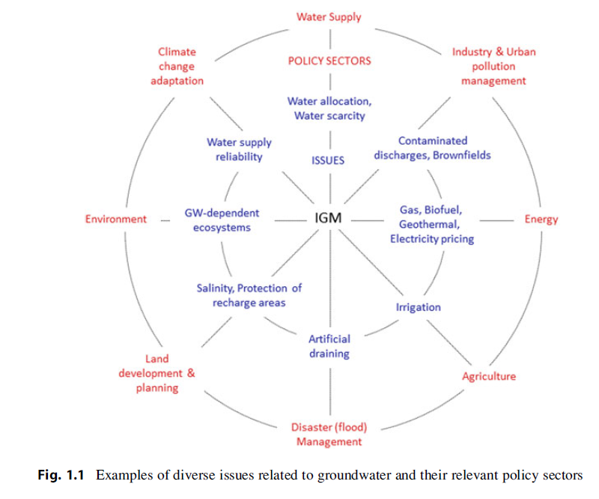
Figure 1: Map of relevant groundwater issues and policy sectors ***
IGM requires a joint assessment and treatment and issues (Figure 1) to avoid offsetting plans of actions. The IGM dimension of governance is ever present but often acts as a the first block to effectiveness. This includes requiring responsible collective actions to control, protect, and sustainable use groundwater resources and watersheds facilitated by legal and regulatory frameworks, sustainability awareness, polices, finances and policies**. Kaufmann-Hayoz et al lists five times of tools for this: government command and controls, economic measures such as taxes or water markets, collaborative agreements between groundwater stakeholders, communication instruments to influence consumer behaviour and attitudes and infrastructure investments**. The rest of the review will explore how each of these controls and assessments related to groundwater metal quality in relation to climate change.

Lead Effects and The Water Energy Nexus
Reynolds (***) argues that people especially groundwater stakeholders fall into three main thinking traps when it comes to conceptualising and managing complex uncertainty of groundwater; Reductionism, dogmatism, and managerialism. All of these interplay into the managing (or mismanaging) of a key part of IGM in the face of climate change; the water energy nexus.
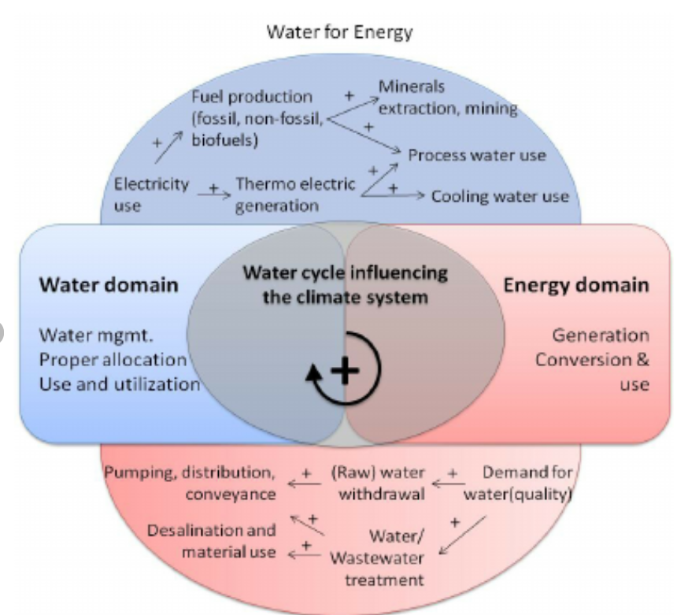
Figure 2: A short diagram of the water-energy nexus relationship***
Water and energy are intrinsically connected – both by the necessity of energy to get and distribute clean useable water and the necessity of water to get energy in which every energy process from fossil fuels to geothermal relies on water for cooling, steam generation, production, etc (Figure 2)**. Climate change intrinsically links this relationship through the water cycle – droughts and changing precipitation patterns will make clean water more scarce and thus require more energy to extract and/or purify**. In groundwater, the energy needed for pumping and injections may come from fossil fuels thus creating more emission Meanwhile with rising temperature, etc, more energy is needed and thus more water. In addition, the lack of water means that also energy supplier such as hydroelectricity and geothermal produce a reduced amount of energy.
IGM in the face of climate change must consider both the energy production and water source reliability (Figure 1). The interconnectedness of both water and energy means that one cannot afford to slip into reductionism via only considering groundwater separate from energy production effects, nor can one only look at the perspectives of one sole stake holder alone such as energy producers or groundwater managers with conflicting short term interests.
Given this review is focused on the effects of water quality, the relationship of groundwater to energy productions will be a focus. Specifically on lead as it is both an anthropogenic and geogenic pollution. Firstly, as energy demand increasing so does fracking, introducing more lead into the groundwater system ***. This is particularly concerning as there is a lack of hard data when it comes to groundwater migratory pathways ***. With growing water scarcity, this also leads to competition from other users such as in the Eagle Field Formation, Texas ***.
Traditional geothermal plants stability and energy production are traditionally related to groundwater levels and thus subsidence might be compounded in events like a drought ***. Lead is part of the construction, piping and may be part of geothermal fluid ***. Thus a drought may result in increase Pb concentrations being released into groundwater. Droughts and floods also influence the capacity and stability of hydropower. Increased surface water-groundwater interactions have been observed with dams under drought like conditions/reduced water reserves ***. This could lead to an increased amount of lead contamination via anthropogenic pollution.
Lead contamination in well water poses severe health risks, especially for infants, children, and pregnant women, causing neurotoxic effects including cognitive impairment, developmental delays, and decreased IQ [43]. The 2014 Flint Water Crisis highlighted these dangers [44], prompting the EPA to propose nationwide lead pipe replacement within a decade [45]. The total economic burden encompasses healthcare costs, infrastructure changes, regulatory measures, and long-term impacts on affected individuals' development and productivity [43].
The understanding of these health impacts, particularly on vulnerable populations, is crucial for the development of effective strategies to mitigate and manage metal contamination in groundwater-derived drinking water sources.

Uranium Groundwater Contamination and the Conflict of Interest with Industry and Agriculture
Dogmatism is the second thinking trap that may adversely influence IGM, especially when it comes to adapting it to climate change influences. This is the over relance of one dominate perspective while ignoring that of lesser stake holders. The effects of this are highlighted when it comes to the aspect of agriculture and industry of IGM (Figure 1).
Uranium is can be introduced into groundwater via overland anthropogenic activities in industry and mining and via agriculture from fertilizers or geogenic suspension due to groundwater overexploitation. With climate change, groundwater is overexploited to make up for changing perception patterns and with the addition of fertilizers to ensure proper food production ***** (Figure 3). Industry is becoming increasingly reliant on groundwater as well due to the instability of reliable surface water. Overland land use is also influenced via mining activities for materials necessary for adaptive technology and as previous containment strategies of waste sites did not account for climate change events ***.
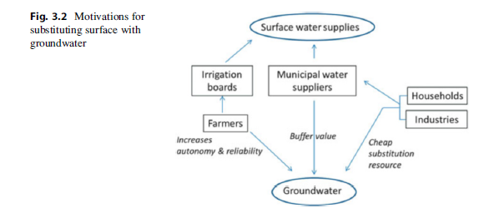
Figure 3: Motivations for each stakeholder to utilize groundwater (***p60)
Data interoperability including the lack of publicly available data divided among multiple providers, unstandardized databases, missing data, honestly few centralized and complete databases ***. Without a holistic overview, it difficult for modellers to build scientifically conceptualized models, identify issues or key problems and policy makers to make effectively step in to preserve the degradation of the water sources. Northwestern india for example, due to the lack of data and hidden data, suffers poor groundwater management (and also some uranium contamination) as it often did not consider pumping to the necessary extent (***) resulting in depleted aquifers and thus an introduction of heavy metals from changing geochemistry and fertilizers ***.
Compounding that is the perspectives from industrial giants to small scale farmers. Groundwater anarchy sees overexploitation groundwater resources via small scale farmers without equitable water access***. Inequality and margination along with the necessity of groundwater economy leads to farmers developing unreported individual tube wills and pumps. An historical informal groundwater economy without proper oversight has led to a flexibility of non-traditional agricultural practices in Morocco, Algeria and Tunisia and thus strengthen the economic power of small scale farmers***. Decreasing surface water and springs now puts additional demands on aquifers. In the Mitidja plain in Algeria, it is estimated that 23% of the volumetric water utilized for interrogation was utilized by those not officially acknowledged***. Legislative polices also incentivise farmers to declare structures to be ‘legal’ when they are in fact not: i.e. a deeper tube well within a well.
Industrial usages of groundwater may be heavily independent on surface land usages. Development is often determined by the observance (or the assumption) of economic players to pick up the tab of groundwater deterioration***. Over-extracted aquifers contaminated via point and non point pollution have been silently ignored for decades. Thus making it difficult to determine who caused said pollution (i.e. diffuse pollution) or holding perpetrators responsible if they no longer exist (abandoned industrial sites, wells, bankrupt companies) ****. Thus leading to public institutions having to pick up the tab. The contingent valuation method is an alternative method to calculate the costs of industrial development based on the people’s willingness to pay for hypothetical groundwater remediation scenarios ***. Currently it has been used in the United States and Europe. However, as the net benefit must also be for the public paying for the cleanup not the corporation, it may not be popular or possible in some countries with the current states of politics
Uranium contamination in well water primarily threatens human health through direct ingestion, accounting for 99% of toxicological and radiological exposure according to the EPA [53]. While the current regulatory limit is 30 μg/L, scientific debate continues regarding safe thresholds, with some studies suggesting higher concentrations may still protect against kidney damage [53].
As uranium is primarily eliminated through the kidneys, prolonged exposure damages renal tubular cells, impairs kidney function, and can lead to chronic kidney disease—notably in northern Sri Lanka where local hydro geochemistry contributes to elevated rates affecting 2-3% of adults [53]. Being radioactive, uranium can damage DNA, potentially increasing cancer risks including leukemia and kidney cancer [52,54].
Research indicates uranium exposure may also harm reproductive health, decreasing sperm quality in men and potentially causing fetal developmental issues and increased twin births in pregnant women [55]. Additionally, approximately 90% of absorbed uranium remains in bone tissue for up to 1.5 years [56], with uncertain long-term health implications.
The societal costs encompass healthcare expenses, productivity losses, and environmental remediation requirements.

Groundwater Arsenic Contamination, Water Extraction and Ecosystems
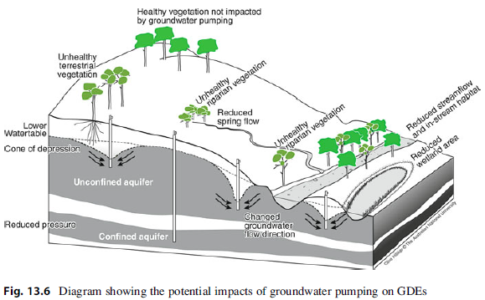
Figure 4: Pumping impacts of groundwater (**** p334)

The last thinking trap, managerialism overlooks the limitations of existing interventions within dealing with uncertainty ***. In IGM, this trap becomes more apparent when it comes to groundwater extraction. The definition of a ‘safe yield’ coined 115 years ago to be the net annual supply used without lowing the groundwater table, has undergone multiple redefinitions, from a shift of focus from surface water discharge to pumping (***p24). This water budget myth/oversimplification based solely on ‘recharge’ meant that a lot of the full impact of groundwater on ecosystems were underestimated which is critical with climate change. In addition, the concept of what defines “an undesired result” did not traditionally include ecosystem health *** and rather focused on economical benefits. The policy of single handedly utilizing recharge to determine extraction without considering longer time scale consequences or ecological discharge means that sustainable extractions are often a lot less then dictated ***.

Transboundary water conflicts for groundwater aquifers complicate the matter as nations may have different standards for withdrawal in addition to different notions of what and where are acceptable ecosystem impacts, who pumps and who pays for remediation *** (p39). Examples of these conflicts included Ceylanpinar aquifer between Syria and Turkey and aquifers between India and Pakistan.

IGM: spartial/vertical extent of monitoring: water flow (New Mexico), human activities such as pumping, landfills that change geochemical conditions.
  - No pumping, high As from deep aquifer moves up to shallow parts with upward gradients.
  - Depth, well operation/pumping duration and position in hydraulic gradient, increasing groundwater age,
  - Mixing groundwater from different parts of aquifer system (Tampa florida
    - Igho volume pumping
  - Drawdown
  - Can’t mitigate with source remediation
- Water extraction
- Groundwater depletion
- P53 diagram
  - P60

Arsenic, a confirmed carcinogen, disrupts DNA repair mechanisms, increasing risks of skin, bladder, lung, and kidney cancers (Kapaj et al., 2006). High exposure causes dermatosis with hyperpigmentation and skin lesions [58]. Arsenic crosses the blood-brain barrier, causing neurotoxicity and cognitive impairments, particularly during prenatal development [60,61].

Chronic exposure increases cardiovascular disease risk through oxidative stress, inflammation, and endothelial dysfunction [50]. Arsenic exposure also causes respiratory tract irritation [59], endocrine disruption affecting thyroid and reproductive systems, and increased infant mortality (Kapaj et al., 2006).

Even low-level prolonged exposure poses significant health risks, with inorganic arsenic compounds (especially trivalent arsenite) being more toxic than organic forms (Kapaj et al., 2006). The societal costs include healthcare expenses for treating arsenic-related conditions, productivity losses, long-term care requirements, and public health interventions to ensure safe drinking water.

Mitigating the health impacts of arsenic contamination in groundwater-derived drinking water is a critical public health priority, necessitating comprehensive scientific research, evidence-based policymaking, and the development of effective strategies to safeguard vulnerable populations.

Managed Aquifer Recharge and Groundwater Manganese Contamination
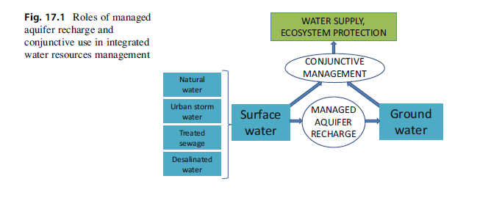
Figure 5: Managed aquifer recharge in IGM (**** p436)
- MAR Recharge 421
- What is it
- Gaps

- Treated wastewater (Mn increase)
- Salinity
- Objective treatment in WQ
Manganese is an essential micronutrient supporting nerve and immune functions and enzyme regulation [41], but prolonged exposure to elevated levels causes significant health risks. Low-dose contamination primarily affects water aesthetics (taste, odor, staining) [41], while chronic exposure leads to serious neurological effects.
Studies show prolonged manganese exposure causes neurobehavioral changes (mood swings, irritability) and severe neurological impairments (motor dysfunction, tremors, cognitive deficits resembling Parkinson's disease) [61,62]. Developing brains in infants and children are especially vulnerable, as manganese crosses the placenta and accumulates in the brain [61].
Additional health impacts include hepatotoxicity [41], potential pancreatic dysfunction resembling diabetes [41], and cardiovascular effects (increased heart rates, altered myocardial contractions, hypertension) [63]. The elderly face heightened risk of Parkinson's-like symptoms from lifelong manganese accumulation [64].
Individual susceptibility varies by gender, ethnicity, genetics, and pre-existing conditions like chronic liver disease [63]. Growing understanding of manganese toxicity has prompted regulatory guidelines in regions including Nova Scotia, the United States, Korea, Italy, and China [41,63].
Health damage costs from manganese contamination vary based on concentration, exposure duration, and individual susceptibility. These include direct healthcare expenses (diagnosis, treatment, management, detoxification, and critical care) and broader societal costs (productivity losses and public health interventions). Integrative groundwater management approaches are essential to minimize these health and economic impacts through coordinated monitoring, treatment, and protection strategies.
Differential Health Impacts and Vulnerable Populations Affected by Groundwater Metal Contamination
A consideration of IGM in respects to groundwater quality with climate change is its most vulnerable stakeholders. Children, pregnant women, the elderly, and those with pre-existing conditions are most vulnerable to metal contamination in groundwater.
Children's developing bodies are particularly susceptible to heavy metals like lead, arsenic, and manganese, resulting in neurological impairments, cognitive deficits, learning disabilities, and developmental delays [50,61]. Manganese disrupts brain development [61], while arsenic exposure can permanently lower IQ and cause behavioral issues [60]. Young children (6 months-6 years) face higher lead exposure risk due to hand-to-mouth behaviors [44].
Pregnant women risk placental transfer of metals to developing fetuses, causing birth defects and pregnancy complications including preterm birth and preeclampsia [19,61].
The elderly (particularly over 65) experience increased vulnerability due to age-related physiological changes [66]. Lead worsens cognitive decline [67], manganese exacerbates motor deficits, and arsenic aggravates cardiovascular conditions [50,60]. Those with existing respiratory, kidney, or liver diseases face greater organ function risks [51,65].
Lower socioeconomic status amplifies these vulnerabilities through limited healthcare access and fewer water remediation options.
The differential health impacts and vulnerability of specific populations underscore the need for targeted public health interventions, enhanced monitoring, and the development of effective mitigation strategies to protect the most vulnerable members of communities affected by groundwater metal contamination.

What is at Stake: Health Effects of Groundwater Metal Contamination
Metal contamination in groundwater produces three types of toxicity effects. Acute toxicity causes immediate health consequences after short-term exposure, such as gastrointestinal issues from copper-contaminated water, zinc-induced abdominal pain, or respiratory problems from aluminum-contaminated water vapors during showering [68,69]. Chronic toxicity develops gradually over months or years of continuous exposure, often resulting in organ damage [65]. Cumulative toxicity occurs when metals accumulate in the body due to prolonged exposure, as some metals cannot be effectively eliminated [69]. Primarily entering through ingestion, these metals are absorbed into the bloodstream via the gastrointestinal tract and distributed throughout the body [65]. Many metals target specific organs, creating concentrated toxin levels in particular tissues [49]. This accumulation can lead to carcinogenic effects, especially with arsenic, cadmium, and chromium, and cause systematic damage across multiple body systems.

Long-term Implications and Potential for Synergistic Effects of Groundwater Metal Contamination
IGM looks at multi dimensional issues that groundwater faces. In order to prevent falling into reductionist thinking traps, it must be acknowledged that multiple simultaneously occurring groundwater issues resulting from climate change influences results in multiple occurring groundwater mental contamination.
Simultaneous exposure to multiple metals in groundwater can create synergistic effects, where combined toxicity exceeds the sum of individual exposures [67]. These interactions occur through increased absorption, altered metabolism, and enhanced cellular damage [71]. For example, lead and cadmium together amplify kidney damage beyond their individual effects [50], while arsenic and chromium combination increases lung cancer risk synergistically [50].
These synergistic mechanisms include one metal enhancing another's bioavailability, amplifying cellular damage through oxidative stress or DNA disruption, and interfering with elimination processes, leading to greater accumulation [67,71]. The resulting effects are both synergistic and cumulative, as metals build up in tissues over time [69], exemplified by lead-cadmium kidney damage and arsenic-lead neurodevelopmental impairments in children [50].
This complex interplay necessitates comprehensive risk assessment, targeted mitigation strategies and multidimensional groundwater management to avoid both immediate and long-term health implications for affected communities.

VII. Conclusion (will have to completely rewrite)
- Summary of Key Findings
  - policy recommendations for managing groundwater contamination by lead, uranium, manganese, and arsenic.
  - Policy gaps: related to naturally occurring contaminants.
  - Areas where current policies are lacking or could be improved.
  - policy recommendations for managing groundwater contamination by lead, uranium, manganese, and arsenic.
    - Specifically private well owner usage, climate change,
  - Address how policy should reflect environmental science: interactions of geogenic contaminate cycles
- Future Research Directions
  - Long-term monitoring programs.
  - Strategies for community participation in monitoring and remediation efforts to reduce human health effects
- Closing
  - the importance of integrating scientific understanding with policy to protect public health and environmental integrity
  - Call to action
- The findings from this comprehensive examination will be essential for informing policy decisions and regulatory frameworks aimed at protecting public health and ensuring the long-term availability of safe, clean groundwater supplies. The evidence generated will equip policymakers, water resource managers, and public health officials with the necessary knowledge to develop and implement effective policies, guidelines, and intervention strategies to mitigate the risks posed by geogenic heavy metal contamination in groundwater. Understanding the geogenic factors governing heavy metal contamination, such as the weathering and dissolution of metal-bearing minerals, is crucial for guiding the development of targeted remediation strategies and the sustainable management of this vital water resource.

