Natural Metal Contaminants in Groundwater Resources: A Review of Climate-Induced Changes to Lead, Uranium, Manganese, and Arsenic Cycling
- *** Add abstract: 250 words
- Finish introduction: What story do I want to tell – This is how metals get into groundwater, this is the importance in climate change,
    - To assess the metal’ influence on biogeochemical cycles.
    - To synthesize the current knowledge on sources, fate, and these metals in groundwater. (Basically the two above)
  - Scope:
    - Environmental science and geology
- Add it 1 new diagram. Remove diagrams from Nova scotia, Add in lead in states diagram
- Add more relevant case studies: Specific recent geogenic contamination events
- Finish conclusion

- Journals to target:

  - 2) Environmental Health Perspectives: health impacts
  - 3) Science of The Total Environment: comprehensive environmental impacts

Groundwater constitutes approximately 30% of global freshwater resources and serves as the primary drinking water source for over 2 billion people worldwide***. As climate change intensifies precipitation patterns, alters recharge mechanisms, and accelerates hydrological extremes, the dynamics of groundwater systems are undergoing significant transformation. Rising temperatures, shifting rainfall regimes, and increased frequency of extreme weather events directly influence groundwater table fluctuations, aquifer geochemistry, and water-rock interactions. These climate-driven changes are particularly significant for the mobilization and transport of geogenic metal contaminants—including lead, uranium, manganese, and arsenic—whose solubility, speciation, and environmental fate are highly sensitive to modifications in redox conditions, pH, and biogeochemical cycling processes within groundwater environments****.
Geogenic metals including lead, uranium, manganese, and arsenic represent a distinct class of groundwater contaminants characterized by their persistence, environmental mobility, and complex biogeochemical behavior. While anthropogenic sources contribute to their environmental burden, natural weathering processes of metal-bearing minerals within aquifer materials constitute a substantial pathway for groundwater contamination. Climate change amplifies these natural release mechanisms through multiple pathways: accelerated chemical weathering under higher temperatures, altered redox boundaries due to changing groundwater levels, increased dissolution rates during intense precipitation events, and enhanced mineral surface interactions during extended drought periods. These climate-driven modifications to water-rock interactions are fundamentally reshaping the spatial and temporal distribution of metal contaminants in groundwater systems worldwide, often in ways that are difficult to predict using conventional hydrogeological models.
This review aims to provide a comprehensive examination of the key aspects of heavy metal contamination in groundwater resources with a focus on geogenic lead, uranium, arsenic and manganese along with potential affects of climate change influences. The identification of primary geogenic sources, including the weathering and dissolution of metal-bearing minerals, will be a focal point along with climate change influences anthropogenic pollutions. The underlying hydrogeochemical processes governing the mobilization and transport of heavy metals within groundwater systems will be thoroughly explored.
While current climate change research has predominantly focused on groundwater quantity issues (aquifer depletion, changing recharge patterns), this review addresses the critical but understudied dimension of groundwater quality, specifically how climate-induced hydrogeochemical shifts affect metal contaminant behavior. The combination of topics between hydrogeology, geology, and climate science will be used to address complex environmental interactions, particularly how changing precipitation patterns, groundwater levels, and temperature regimes may affect contaminant behavior. By focusing on geogenic contaminants, especially in relation to climate change, the review addresses an area often overshadowed by groundwater quantity and anthropogenic pollution research, providing new insights into naturally occurring contaminants whose mobilization mechanisms are being transformed by rapidly shifting environmental conditions.

Geogenic metal contaminants (lead, uranium, manganese, arsenic) in groundwater present multifaceted challenges beyond their documented origins. This review synthesizes the latest research on these contaminants' sources, transport mechanisms, ecological impacts, and health risks, with particular emphasis on climate change implications. Rising temperatures, altered precipitation patterns, and changing hydrological cycles increasingly influence metal mobilization and bioavailability in groundwater systems. By integrating current understanding of climate-driven changes to geochemical processes with contaminant behavior, this work provides a comprehensive overview to help anticipate future contamination scenarios, develop, adaptive water management strategies, and enhancing environmental resilience in vulnerable regions experiencing accelerated climate impacts.

Geological Sources and Climate-Mediated Mobilization of Geogenic Metals in Aquifer Systems
Geological formations often contain minerals with heavy metals that may leach into groundwater, depending on the mineral composition of the surrounding rocks and soil, the local hydrogeological conditions, and the dual chemical characteristics of the aquifer [1]. This groundwater contamination can be attributed to various processes, including volcanic eruptions, rock weathering, and the leaching of metals into the groundwater through geochemical interactions that dissolve the present metals into the water.

Geological formations often contain minerals with heavy metals that may leach into groundwater, depending on the mineral composition of the surrounding rocks and soil, the local hydrogeological conditions, and the dual chemical characteristics of the aquifer [1]. This groundwater contamination can be attributed to various processes, including volcanic eruptions, rock weathering, and the leaching of metals into the groundwater through geochemical interactions that dissolve the present metals into the water.
Geological formations, such as sedimentary rocks like limestone, dolomite, or shale, can contain minerals with heavy metals that may leach into groundwater. This process is influenced by various factors, including the redox conditions, pH, and the presence of other minerals in the surrounding environment [2]. For instance, iron and manganese are commonly found in these rock formations, and their release into the groundwater is often promoted by conditions with high oxygen levels [1]. An example of this is the association between manganese and the Windsor Group limestone formation in Nova Scotia [3].
Similar groundwater contamination issues have been observed in other regions. In the Bengal delta of Bangladesh, sediments have been found to release elevated levels of arsenic [4]. Additionally, the High Plains Ogallala aquifer in the United States contains sedimentary rock formations associated with uranium, which can be leached into the groundwater under reducing conditions [5].
- Recently 3 primary studies
- Focus on Adsorption and co-precipitation, Dissolution and desorption
- Rock cycle: Weathering/erosion: Sed rocks act as a sink, weathering releases them
- Sedimentation and Deposition:
- Heavy metals released from weathered rocks can be transported and deposited in sedimentary environments, such as floodplains, lakes, and marine settings, where they can accumulate and be incorporated into sedimentary rocks.
- The heavy metal content in sedimentary rocks can be further concentrated through processes like adsorption, co-precipitation, and organic matter incorporation
- Climate change: Increas of redoc ph, enhanced rock weathering: increased rates, chemical weathering
Igneous and metamorphic rocks can also contain various trace metals, including uranium and radium, either as primary or accessory minerals [6]. Examples of such rocks include granite, syenite, basalt, gabbro, nepheline, and andesite [2]. In these cases, metal leaching is dependent on groundwater chemical factors, such as mineral solubility, rock-water interactions, and water infiltration through fractures or fissures.
Furthermore, volcanic activity can release heavy metals like lead, mercury, and arsenic, which are then transported into nearby soils and sediments. Subsequent groundwater interactions with these metal deposits can result in further metal leaching [1]. Examples of this phenomenon include arsenic contamination in groundwater in the Andean region of Argentina and Chile, as well as manganese contamination from basaltic formations in aquifers in India [7,8].
- Climate change: Increased diffusion, icreased temperatures/thermal effects on biogeocimical processes,
- Subcrtical cracking
- Accelerated weathering, extreme participation pattern, acid rain, glacier retrieats
- Especially when new
- Require more intense weather
- 3 primary studies
Conceptually, these rock cycle processes related to arsenic contamination can be associated with the metamorphism, volcanic emissions, and hydrothermal activities depicted in Figure 2.1.1 [1].
- 3 primary studies
- How climate change may affect rock cycles
- Transport,shift, mineral transformation
  - Freeze thaw cycles in temperate regions
- Uplift, Erosion, and Recycling:
- Tectonic processes, such as uplift and erosion, can expose previously buried rocks (sedimentary, igneous, or metamorphic) to weathering and erosion, allowing the heavy metals to re-enter the rock cycle.
- Positive feedback loop with CO2 weathering
- Silicate rocks, climate change and metals
- This recycling of heavy metals through the rock cycle can continue indefinitely, with the metals being continuously redistributed and potentially concentrated in different geological environment

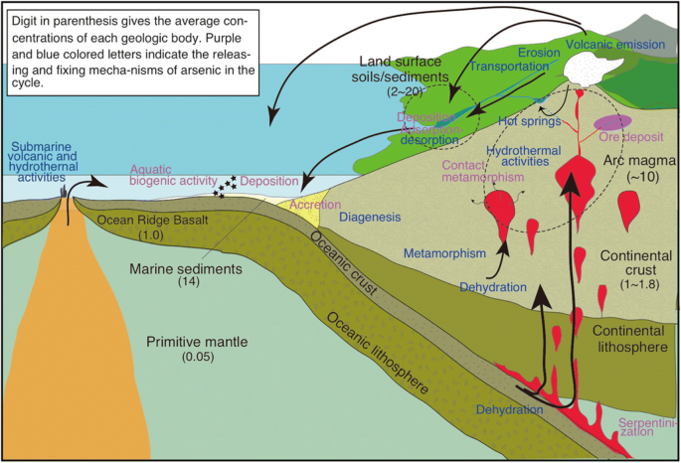
Figure 2.1.1: Arsenic geologic cycle. Digit in parenthesis gives the average concentrations of each geologic body. Purple and blue colored letters indicate the releasing and fixing mechanism of arsenic in the cycle. [9].

Anthropogenic sources as Drivers of Metal Contamination in Groundwater Systems

Anthropogenic Sources of Metal Groundwater Contamination activities can significantly increase the levels of metal contaminants in water resources, particularly groundwater and well water. Emissions, effluents, and waste disposal from mining, smelting, manufacturing, and other industrial processes can release various metals into the environment. These metals can then enter groundwater systems through surface runoff, infiltration, or direct contamination [10].

In the Canadian context, mining activities are a major source of groundwater contamination. For instance, the mining operations in the Sudbury region of Ontario have led to the contamination of groundwater with elevated levels of copper, nickel, and cobalt [11,12]. A similar situation exists in the United States, where the groundwater in the Silver Valley region of Ohio and Idaho has been affected by lead, zinc, and other metal contamination due to mining activities [13].

Furthermore, groundwater can also be contaminated by agricultural practices, such as the use of fertilizers, pesticides, and animal waste. These agricultural inputs can leach into the groundwater and contribute to the overall metal contamination through groundwater recharge processes [14].

- Extreme weather events
- Flooding
- Sediment resuspension
- Sandwitching of flood and drought

The release of metals from anthropogenic sources, including industrial activities and agricultural practices, can have significant implications for the quality of groundwater resources and the health of surrounding communities that rely on these water sources.
The Influence of Well Infrastructure and Piping Materials on Groundwater Metal Contamination
- Combine with anthropogienic
In addition to anthropogenic sources such as industrial activities and agricultural practices, the deterioration of well infrastructure and the corrosion of piping materials can also contribute to metal contamination in groundwater [15]. The critical components of a well, including pipes, fittings, and pumps, can be constructed from materials such as lead, copper, and zinc, which can gradually corrode over time and release these metals into the water flow.
***** 2 primary examples
- Accelerated corrosion, physical damage, wet-dry cycles
- Thermal stress, soilchemistry
- Fires
Furthermore, the presence of rusted iron oxides in the well system can have a complex influence on groundwater contaminant levels. While these iron oxides may have the ability to reduce or remove certain contaminants, such as arsenic, through adsorption or co-precipitation processes similar to those observed in soil environments [16], the overall effect on the geochemical composition of the groundwater can be variable and dependent on site-specific conditions.
*** one primary example.
The mobilization of metals from the degradation of well infrastructure and the potential for iron oxides to interact with groundwater contaminants underscores the importance of considering the hydrogeochemical characteristics of the well system when evaluating sources and pathways of metal contamination in groundwater. Addressing these infrastructure-related factors is crucial for developing effective strategies to mitigate the impact of metal pollutants on groundwater resources.
- Climate change
- Add image
Geogenic and Anthropogenic Sources of Metals in Groundwater and Well Water
The specific metals found as contaminants in groundwater and well water are largely dependent on the local geography, geology, and hydrochemical characteristics of the aquifer system [17]. In Nova Scotia, common metal contaminants include manganese, arsenic, magnesium, lead, uranium, and fluoride, reflecting the regional geological composition. Internationally, arsenic, cadmium, selenium, and copper are also frequently encountered as groundwater pollutants [18].
Lead contamination in groundwater and well water is a particular concern due to its potential health impacts, especially on pregnant women and children [19]. The primary source of lead in these water resources is often the leaching of lead from plumbing materials, such as pipes and fittings, within the distribution system. This process can be exacerbated by factors like low pH and prolonged contact time [20]. Geologically, lead may also be present in the form of galena (lead sulfide) in hydrothermal veins and mineral deposits, which can undergo dissolution and reprecipitation as lead carbonate (cerussite) under oxidizing conditions, leading to groundwater contamination [21].
**** Add in lead contamination diagram
Add geogenic lead primary examples
**** Lead in climate change
**** Add in diagnram

Similarly, zinc contamination in well water and drinking water systems is commonly attributed to the corrosion of galvanized iron or zinc-coated plumbing materials, particularly in low pH or acidic conditions [22]. Groundwater contamination by zinc can also occur through the erosion and deposition of zinc-containing sediments, as well as volcanic emissions in regions with active volcanism [22].
Copper contamination in groundwater is typically associated with the corrosion of copper plumbing materials, including pipes, fittings, and fixtures, facilitated by factors such as acidic water, high chlorine levels, and prolonged contact time [23]. However, in specific geochemical settings, copper contamination can also arise from the weathering and dissolution of natural copper-bearing minerals, such as chalcopyrite, malachite, and azurite, which are found in hydrothermal veins, porphyry deposits, and other geological formations [11]. Regions with high natural copper mineralization, such as Cyprus and the western United States, are particularly prone to this type of groundwater contamination.
In contrast, iron contamination in groundwater can originate from both natural sources and the corrosion of iron plumbing materials, although it is more of an aesthetic concern than a health issue [24].
- Should I remove Cu and Fe? Cd more affected by climate change
- Cu affects from climate change
Other metal contaminants, such as mercury and cadmium, are primarily associated with anthropogenic activities. Mercury contamination in groundwater can arise from coal combustion, industrial discharges, mining, and the deposition of atmospheric mercury, as well as from natural geological sources, including mercury-bearing minerals like cinnabar and volcanic emissions [25,26]. Cadmium contamination, on the other hand, is primarily linked to anthropogenic activities, such as mining, phosphate fertilizer production, improper waste disposal, and industrial discharges, though it can also be enhanced by the weathering and erosion of sphalerite and volcanic activity [27].

In summary, the presence and distribution of metal contaminants in groundwater and well water systems are the result of a complex interplay between geogenic (natural geological) and anthropogenic (human-induced) sources and processes, which must be carefully considered when addressing groundwater quality concerns.
Uranium Contamination in Groundwater: Geogenic and Anthropogenic Influences
Uranium can be introduced into groundwater systems through both anthropogenic and natural geogenic processes. While anthropogenic pollution can contribute to uranium contamination, the element is also naturally associated with igneous and metamorphic geological formations [1].
The primary sources of natural uranium in groundwater are the weathering and dissolution of uranium-bearing minerals, such as uraninite (pitchblende) and coffinite [28]. This process is particularly prevalent in aquifer systems like the High Plains and Central Valley aquifers in the United States (Figure 2.1.2), where uranium release may be further enhanced by biotic nitrate reduction. Additionally, the weathering of sedimentary deposits, such as sandstones, can also lead to elevated uranium levels in groundwater. In Nova Scotia, uranium has been identified as a significant risk factor in well water, with the bedrock geology being the dominant control on its distribution [17] (Figure 2.1.3).
The release of uranium into groundwater is primarily driven by natural weathering and dissolution processes, which are influenced by factors such as pH and redox conditions [29]. Mineral release is often the controlling factor for groundwater uranium contamination, with de-adsorption from mineral surfaces and the associated reaction kinetics, oxidation conditions, and thermodynamics playing a crucial role.
Certain mineral phases, such as iron and magnesium oxides (e.g., goethite, hematite, and ferrihydrite), have the ability to adsorb uranium ions, thereby reducing their mobility and transport in groundwater a Reductive precipitation can also serve to immobilize uranium in the subsurface [29]. Conversely, the presence of organic matter, including humic and fulvic acids, can form stable uranium complexes, facilitating the enhanced transport and mobility of uranium in the groundwater system [31]. Additionally, the formation of uranium complexes with carbonate minerals, such as calcite or dolomite, can also increase the solubility and mobility of uranium in the aqueous phase.
- Add climate change effects and policies history
The understanding of these geochemical processes and the identification of the primary sources, both anthropogenic and geogenic, are crucial for the effective management and remediation of uranium contamination in groundwater resources.
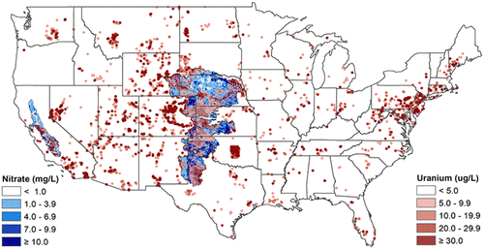
Figure 2.1.2: A map of uranium (red) and nitrate (blue) concentrations for groundwater aquifers in the US [28].

Geogenic and Anthropogenic Arsenic Contamination of Groundwater
Arsenic contamination in groundwater can arise from both anthropogenic and natural geogenic sources. While anthropogenic activities can contribute to arsenic pollution, a significant portion of groundwater arsenic contamination is driven by the natural weathering and release of arsenic-bearing minerals from geological formations [2].
Some of the primary arsenic-containing minerals that can release the metalloid into the surrounding environment include arsenopyrite (an iron-arsenic sulfide) and pyrite, which are commonly found in hydrothermal mineral deposits [32]. Arsenic can also be naturally present in volcanic deposits and sedimentary environments, such as alluvial aquifers or deltaic settings [4].
The prevalence of geogenic arsenic contamination in groundwater has been well-documented in various regions. In Nova Scotia, arsenic levels in groundwater have been found to be strongly influenced by the local bedrock geology, with higher arsenic concentrations associated with drilled wells compared to dug wells or surface water sources [33] (Figure 2.1.5).
Similar patterns have been observed in other parts of the world. The United States Geological Survey (USGS) has reported that approximately 7% of sampled wells exceeded the 10 μg/L arsenic standard, particularly in the southwestern United States and the Glacial aquifer system in the northern United States [34]. Specific areas of concern include the Pinemont Blue Ridge and Valley area in the eastern Appalachian region, the Texas coastal upland aquifer system, and the Mississippi River alluvial valley aquifer in the southeastern United States (Figure 2.1.4). In these regions, the primary source of arsenic is often attributed to the weathering and dissolution of arsenic-bearing minerals in volcanic and granitic bedrock, facilitated by factors such as groundwater residence time, high pH, arid climate, and the overall geochemical characteristics of the aquifer system [34].
Internationally, the Bengal Delta region of Bangladesh and West Bengal, India, has experienced a severe arsenic contamination crisis, with the arsenic being derived from the Himalayan sediments that make up the deltaic environment [4]. This has led to widespread exposure and significant public health concerns for the affected populations.
- Add climate change effects
Comprehending the geogenic sources, mobilization mechanisms, and hydrogeochemical drivers of arsenic contamination in groundwater is pivotal for developing effective mitigation and management strategies to address this persistent environmental challenge.
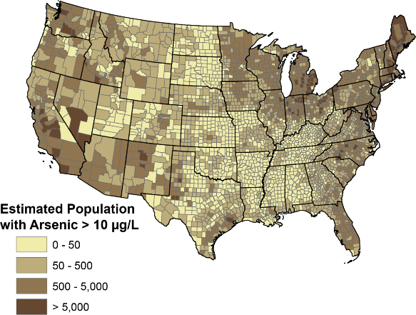
Figure 2.1.4: Estimations of private well users in U.S. counties that are contaminated with Arsenic [34].

Geogenic Sources and Hydrogeochemical Controls of Manganese in Groundwater
Manganese is a naturally occurring element that is widely distributed in the Earth's crust, comprising approximately 0.085% to 0.095% of its composition [35]. This element can enter groundwater systems through the dissolution of manganese-bearing minerals and natural weathering processes.
Manganese commonly exists in multiple oxidation states in the natural environment, with the reduced, water-soluble Mn(II) form and the oxidized, insoluble Mn(IV) form being the predominant species [36]. The primary manganese-containing minerals include pyrolusite (MnO2), manganite (Mn2O3-H2O), hausmannite (Mn3O4), and psilomelane, as well as manganese carbonates (e.g., rhodochrosite, MnCO3), manganese silicates (e.g., rhodonite, MnCa SiO4), and ferromagnesian silicates (e.g., hornblende, olivine) (Earle, 2019b).
In the context of Nova Scotia, the presence of manganese in groundwater has been linked to various geochemical processes, including sedimentary processes, replacement processes, and vein-type processes [3]. The mobilization of manganese is often more pronounced in areas with low oxygen levels or reducing conditions, which favor the release of manganese from mineral phases [37].
The oxidized form of manganese has relatively low solubility under near-neutral pH conditions, leading to the formation of manganese precipitates at higher pH levels in the presence of oxygen or carbonate [38]. Elevated manganese concentrations in groundwater are typically associated with less evolved groundwater chemistry, often near shallow water tables. Additionally, increased aquifer residence time and higher total dissolved solids can enhance the dissolution and mobilization of manganese [39].
The prevalence of manganese contamination in groundwater is a significant concern in various regions. In Nova Scotia, for example, 22.5% of well water samples exceeded the Health Canada's maximum allowance for manganese [40] (Figure 2.1.7). Unlike some other contaminants, manganese contamination is a concern in both bedrock and superficial aquifers in the sedimentary basins due to the specific geochemical conditions [40]. Similar issues have been reported in the Northeastern United States, the province of Quebec (Canada), West Bengal State (India), and Bangka Island (Indonesia) [8,41,42].

Understanding the geogenic sources, mobilization processes, and hydrogeochemical controls of manganese in groundwater is crucial for developing effective strategies to mitigate and manage this persistent environmental issue.

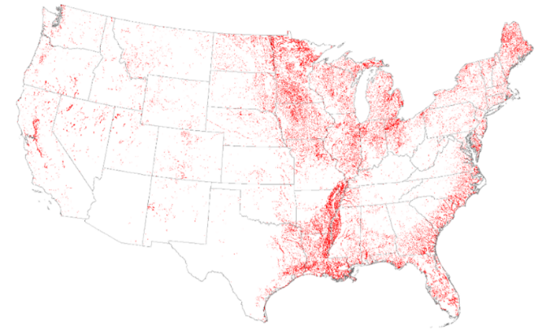
Figure 2.1.6: Red areas are representative of highest population densities that may be consuming water from domestic wells with elevated manganese concentrations [42].

- Add in policy gaps
**** Add conclusion
VII. Conclusion
- Summary of Key Findings
  - Recap metals contamination sources
  - policy recommendations for managing groundwater contamination by lead, uranium, manganese, and arsenic.
  - Policy gaps: related to naturally occurring contaminants.
  - Discuss how policy can mitigate health risks:
  - Areas where current policies are lacking or could be improved.
  - policy recommendations for managing groundwater contamination by lead, uranium, manganese, and arsenic.
    - Specifically private well owner usage, climate change,
  - Address how policy should reflect environmental science: interactions of geogenic contaminate cycles
- Future Research Directions
  - Long-term monitoring programs.
  - Strategies for community participation in monitoring and remediation efforts to reduce human health effects
  - Development of predictive models for contaminant behaviors.
- Closing
  - the importance of integrating scientific understanding with policy to protect public health and environmental integrity
  - Call to action

