Title: Impact of Climate Change on Metal Contamination in Well Water through Saltwater Intrusion, Flooding, and Temperature Rise

Abstract

Key Words

Acknowledgement

Abbreviations Used

Thesis Organization

Table of Contents
Abstract 1
Key Words 1
Acknowledgement 1
Abbreviations Used 1
Thesis Organization 1
1 Introduction 2
1.1 Study Background 2
1.2 Rationale for the Study 2
1.3 Research Objectives 3
1.4 Hypotheses 3
4 Literature Review 3
1.1 Overview of Metal Contamination in Well Water 3
4.1.1. Sources of Metal Contamination in Well Water 3
4.1.2. Common Metals Found in Well Water 5
1.2 Health Effects of Well Water/Groundwater Metal Contamination 7
4.2.1. Adverse health effects of specific metals 7
4.2.2. Vulnerable Populations and Differential Health Impact 12
4.2.3. Health Effects of Metal Contamination in Well Water 14
4.2.4. Long-term implications and potential for synergistic effects: 14
1.3 Climate Change Impacts on Water Resources 15
4.3.1. Changes in Precipitation Patterns 16
4.3.2. Changes in Groundwater Resources 18
4.3.3. Focus of this thesis 20
3 Thesis Methodology: 20
3.1 Data Sources, Storage and Management 20
3.1.1 Water Quality Data 20
3.1.2 Characterization of Aquifer Types 23
3.1.3 Addition of Data Indicating Temperature and Precipitation 24
3.2 Preliminary Exploratory Data Analysis 25
3.2.1 Metals Preliminary Exploratory Data Analysis 25
3.2.2 Second Preliminary Exploratory Data Analysis 26
3.3 Exploratory Data Analysis 27
3.3.1 Data Processing 27
3.3.2 Outlier removal 28
3.3.3 Scaling and Normalization: 28
3.3.4 Correlations 29
3.3.5 Mahalanobis method for multivariate outliers 29
3.3.6 Plot Generation 29
3.4 Exploratory Data Analysis of Climate Change Factors 30
3.4.1 Potential Flood, Drought and Temperature Increases 30
3.4.2 Exploratory Data Analysis for Sea Water Intrusion 31
3.5 Factor Analysis 32
3.5.1 Data Processing 32
3.5.2 Initial Factor Analysis Setup 32
3.5.3 Preliminary Factor Analysis 33
3.5.4 Primary Factor Analysis 33
3.5.5 Factor Analysis Focused on Metals of Interest 34
3.5.6 Factor Analysis Focused on Climate Change Variables 34
3.5.7 Factor Analysis Focused on Climate Change Events 34
3.6. Uniform Manifold Approximation and Projection (UMAP) 35
3.3.6 Data Pre-Processing 35
3.3.6 Exploratory UMAP 35
3.3.6 Exploratory UMAP for Climate Change Factors. 36
3.3.6 Supervised UMAP for Metals 36
3.5.8 Supervised UMAP for Metals and HDBSCAN 36
3.6 OLS Regression Modelling 37
3.6.1 Preprocessing data for OLS regression 37
3.6.2 OLS regression model for the main dataset 37
3.6.3 OLS regression model for Saltwater intrusion, drought, flooding, increasing minimum temperatures and increasing minimum temperatures 38
4. Exploratory Data Analysis 39
4.1. Initial Exploratory Data Analysis Using Power BI 39
4.2. Descriptive and Summary Statistics 44
4.3. Saltwater Intrusion Exploratory Data Analysis 52
Further Description of British Columbia 53
5. Factor Analysis 58
5.1. Primary Factor Analysis 58
5.2. Factor Analysis with Climate Change Conditions 60
5.3. Factor Analysis For Each Individual Metal of Focus 63
6. Regression Analysis 66
6.1. Ordinary Least Squares Auto Regression Models 66
6.2. Ordinary Least Squares Auto Regression Models with Climate Change Events 74
6.2.1. Ordinary Least Squares Auto Regression Models with Saltwater Intrusion, Drought, Flooding, Increasing Minimum Temperature and Increasing Maximum Temperature for As 75
6.2.2. Ordinary Least Squares Auto Regression Models with Saltwater Intrusion, Drought, Flooding, Increasing Minimum Temperature and Increasing Maximum Temperature for Mn 78
6.2.3. Ordinary Least Squares Auto Regression Models with with Saltwater Intrusion, Drought, Flooding, Increasing Minimum Temperature and Increasing Maximum Temperature for U 84
7. Uniform Manifold Approximation and Projection (UMAP) Analysis 89
7.1. UMAP Original Analysis 89
7.2. UMAP Conditional Analysis 90
7.3. Supervised UMAP Metal Analysis 90
7.4. HBSCAN and UMAP Analysis 91
Conclusion 94

Table of Figures

Table of Tables

Introductiond

Literature Review

Exploratory Data Analysis

Methodology for Data Sources, Storage and Management

Water Quality Data
Water quality sampling data was taken from the British Columbia Provincial Groundwater Observation Well Network (OBS) and Environmental Monitoring System (EMS) data repository via British Columbia Data Catalogue (BCDC) by contracting the related data curators(Data Catalogue, n.d.). Data was downloaded to a certain degree that the timeframe of samples collected were obtained from 02/01/1982 to 28/08/2022.
The samples utilized were assembled using discrete grab sampling and the corresponding methods of analysis along with full descriptions of corresponding lab codes, and collection methods that can be found in the EMS Electronic Data Transfer support tables ***. Furthermore, sampling was done in accordance with the Manual of British Columbia Hydrometric Standards and Field Sampling Manual.
The assembly of data included a list of EMS ID, location name including OBS Well number, longitude, latitude, start date including sampling time, state description, class description, method description, upper depth, lower depth, parameter code, result letter, and results. Following data standards, storage, organization and management are assembled in BCDC Catalogue Standards and Guidelines, according to B.C.’s Open Information and Open Data Policy *****. Maps of the relevant aquifers and well stations are shown in Appendix 9.6. Moreover B.C. was chosen for analysis as it has an open data policy with more centralized access to water quality data, has a long-standing groundwater monitoring station system in place that frequently measures groundwater quality parameters and has other programs that assess multiple environmental parameters. B.C. also borders the coast allowing for potential saltwater intrusion analysis.
The original dataset of concentration was transformed via python in Jupyter, to transpose it for viewing all contaminants measured at each observation well (OBS) number along with ‘start date’, EMS ID, latitude and longitude. The upper depth and lower depths were discarded as those were found to have inconsistent recording in the source data. Furthermore, result letters were discarded to simplify the code and used henceforth. However, time constraints meant that both water temperature and water depth were removed as most values were not linked to the directly EMS dataset.
The resulting dataset was then utilized to assess contents:
- Specifically, pesticides, silica, complex organic compounds, and complex toxins which were removed as they are considered unnecessary for the subsequent research analyses.
- Observation Well Stations (OBS) wells, that had no associated concentration data, were as well removed.
- Nitrogen measurement data except for Total Kjeldahl Nitrogen were removed due to lack of consistent data for nitrate/nitrate and to streamline the process as this method is a good general measure of organically used nitrogen because it accounts for biological incorporated nitrogen ****.
- Dissolved oxygen, carbon oxygen demand, total organic carbon and other organic carbon parameters were also removed due to lack of data in the source information.
- Total phosphorus has been used to account for phosphorus, including phosphate.
- Dissolved sulfate was used as the measure for sulfur as it was the most complete dataset, acts as quality control for sensing, has the potential for future groundwater source identification, adds insight to anthropogenic activities and helps understand redox conditions ******.
- In addition, total alkalinity at pH 4.5 (Alkalinity Total 4.5) was used as a measure for alkalinity-based factors.
- Fluoride was excluded due to lack of consistent data.
- Total hardness was kept in the data assembly, along with Potassium and Calcium to facilitate future research potential.
- Sodium was removed from the dataset to avoid redundancy as seawater intrusion was measured by other factors.
- Magnesium and calcium were also kept to potentially assist in filling in missing values.
- Furthermore, the following were retained, namely, lead, manganese, uranium and cadmium were chosen as metals. Mn, and U are known to be naturally occurring and were investigated due to their use in future sensor research. Pb was retained despite having potential anthropogenic sources as Pb is required for future research. Furthermore, Cadmium was chosen due to potential future research for mining (although then later dropped after the exploratory data phase) *****.
- Iron was chosen to help indicate any co-interactions between heavy metals and water contamination *****. While other metals were dropped due to lack of data and/or the potential that other metals were caused mostly by anthropogenic means.

Additional data inclusion considerations consisted of:
- Saltwater intrusion is measured by specific conductance, chloride, and occasionally turbidity.
- Residue Filterable 1.0u was used as a representation of color measure, residue measures and turbidity, as these constituents had the most complete datasets, which are often used as a turbidity indicator *****.
- pH as measured for grab samples was chosen over field values to maintain consistency with the other samples ***.
- Laboratory specific conductance was utilized over field specific conductance,
- ‘Cation Sum', 'Cation - Anion Balance percentage', 'Anion Sum' were deleted due to lack of data consistency.
- Dissolved chloride (‘Chlorid:D’) was kept as another seawater indicator.

Missing values were filled by:
- The dissolved values of U, As, Cd, Fe, Mn, Pb, Ca, K, Mg, Hardness, N.Kjel:T, and P, were used to fill in any corresponding missing values of total concentration.
- Alkalinity pH 4.5/4.2 values were used to fill Alkalinity Total 4.5 values due to similarity within methods ***.
- Missing hardness data values were calculated via the following equation:
Hardness = 2.497 (Ca) + 4.118 (Mg)*****
- Further missing data was then filled by one-half of the lowest minimum detection limit for each element (Appendix 9.1).
Additionally, any missing values of pH were replaced by the pH mean. (using the closest monitoring system)

Characterization of Aquifer Types
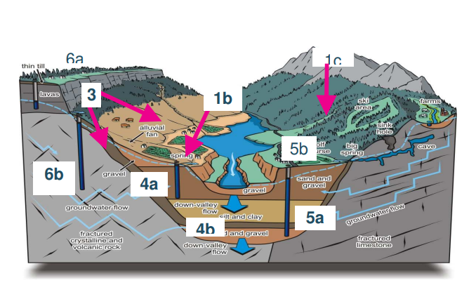
Figure 3.1.1: Diagram of B.C. Aquifer Subtype Classification in the Fraser Valley ***.
The B.C. Aquifer subtype classification system was utilized to account for differences between unconfined with hydrologic connection, confined, karst and bedrock aquifers (Figure 3.1.1 and Appendix 9.1) by assigning each a different subtype****. Following the aquifer subtypes were further grouped into “aquifer groups” – Aquifer group 1 (AG1: unconfined with Aquifer subtype 1a, 1b, 1c, 2, 3 and 4a), Aquifer Group 2 (AG2: confined with Aquifer subtype 4b and 4c), Aquifer Group 3 (AG3: bedrock/fractured aquifers with Aquifer subtype 5a, 6a and 6b) and Aquifer Group 4 (AG4: karst based on Aquifer subtype 5b). This grouping is based on general aquifer similarity and similarities of hydraulic connection (Table 3.1.1) ****.
Table 3.1.1: B.C. preliminary framework for determining a hydraulic connection*****.
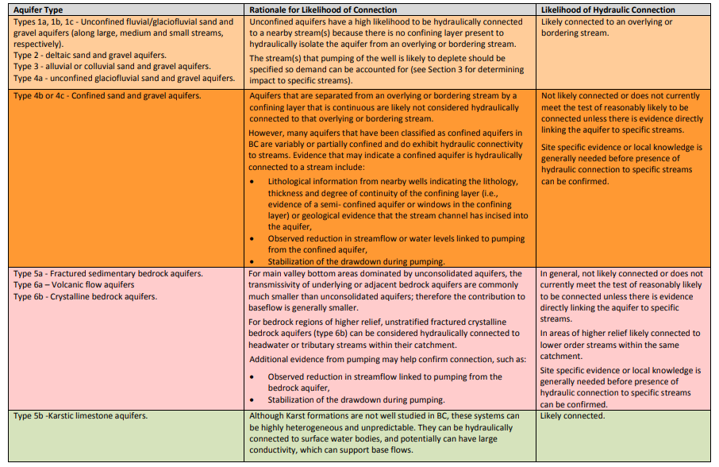
Further in-depth lithology information was inaccessible due to database issues and therefore not incorporated. Furthermore, most well characteristics, including depth, water level, etc. were sparse and individually linked often on separate pdfs; therefore, other well characteristics were kept only to facilitate later research. Then well data were downloaded via “Well Search” from “The B.C. Groundwater Wells and Aquifers” portal with OBS well numbers, environmental monitoring station ID (EMS ID), corresponding aquifer ID number and well license number ****. Aquifer data, including aquifer ID number, and corresponding aquifer type were downloaded via the “Aquifer Search” from “The B.C. Groundwater Wells and Aquifers”. Following both datasets were ‘cleaned’ via Power BI, a business analytics software in Power Query and the aquifer data was merged with well ID data via aquifer ID.
OBS wells that were missing EMS ID and aquifer IDs were mapped and both databases were manually checked to identify any information on corresponding aquifers and wells in those locations. For OBS with unknown aquifers, descriptions of well lithology and nearby aquifers were utilized to determine the potential aquifer type. Table 9.1.1 in Section 9.1 (Appendix) shows the missing OBS well data, indicating how aquifer types were determined, and assumptions made. Furthermore, the linked dataset was downloaded from Power BI and merged into corresponding concentrations via OBS well number in Jupyter and posted in GitHub.

Addition of Data Indicating Temperature and Precipitation
Maximum daily temperature, minimum daily temperature and daily precipitation were downloaded from Pacific Climate Impacts Consortium’s “BC Station Data” portal for date ranges between 01-02-1985 to 31-08-2022, since these data corresponded to well sampling dates along with a weather station metadata file*****.
- Only stations that had corresponding climatology and observations were included in the assembly of temperature and precipitation. Soil temperature, soil liquid water contents, rainfall, rainfall 24-hour, rainfall 1 hour and 1 hour precipitation were excluded since there are very few data monitoring stations near the well stations. Furthermore, future research exploration might consider how metal concentration may be affected by 1 and 24-hour precipitation, as those conditions would be more representative of flooding.
- Datasets from the B.C. Ministry of Forest were also excluded due to poor matching format. This data seemed to be designed for the purpose of fire monitoring, therefore stations were operational 8 months out of a year and had slightly different parameters.
- Snow-water equivalents and snowfall quantities were also excluded from the data set. This was due to the balance between flooding conditions, drought conditions and due to the difficulty in accounting for inconsistent measured data. Moreover, this acknowledged bias means that drought conditions may not be predicted as accurately as climate change reduces the water from spring runoffs and multiple classifications of droughts are based on said data ****. However future research studies could account for changes in snowfall to achieve better and more consistent results.
A second python script with Jupyter notebooks was created to link weather data to water quality measures in the well data.
- The closest OBS well monitoring station was then matched with the closest weather station data that was operating during the sampling date via looping the station metadata with corresponding concentration station ID and OBS well data set.
- Stations that have large gaps in operating time were removed from the original station metadata file and the loop was run again.
- Afterwards, Linked station ID was extracted and merged again with an inner left (not sure what inner left means) to join and extract historic ID, operation network name, and other identifying data sets to form a third metadata file.
- The downloaded files containing the individual weather station data sheets with unmatched weather stations were deleted to increase computational speed. In addition, the datasets kept were from BC Hydro (BCH) and Environmental Canada (EC).
- BCH data sheets had to be re-assessed using a power query and pivot table in excel as the timing of sampling switched from daily to multiple times per day throughout the data set. Therefore, collected results were merged to get “mean” daily temperatures and sum of daily precipitations. Following, the resultant data BCH data sheets were inputting into a Python dataframe containing the weather data.
- Both BCH and EC data were then being merged with their corresponding metadata. The data were Furthermore concatenated into two dictionaries with the historic ID, station name, native ID, latitude and longitude from the third metadata file.
- The following data, namely one day rain, snow and ambient air temperature data were removed, and both dictionaries were concatenated together.
- The monthly sum of one day precipitation, monthly mean of maximum temperature and the monthly mean of minimum temperature were established using Panda's date time. Then remerged with the third reference frame again.
Similarly, the corresponding climatology data set was downloaded from Pacific Climate Impacts Consortium’s “BC Station Data” portal for date ranges and inputted to a Jupyter Pandas dataframe.
- The resulting data frame was then merged with the precipitation climatology data set via the matching station and month, to create a working data set.
- Missing values for precipitation, Min temp and Max temp were then extracted, removed from the first weather station metadata and the process was run again.
Figure 3.1.2 demonstrates the data model used.
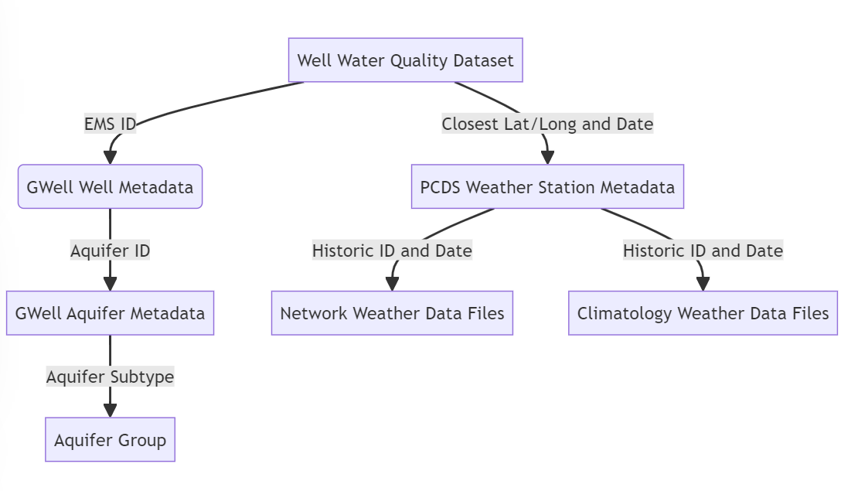
Figure 3.1.2: Snowflake data schema model.

Methodology for Preliminary Exploratory Data Analysis

Metals Preliminary Exploratory Data Analysis
Power BI was utilized for the initial exploratory data analyses due to its ability to rapidly explore data structures via ‘filters’ and ‘slicers’.
- Each metal of interest (Metals: As, Cd, Mn, Pb, and U) had their respective concentration magnitudes alongside the Canadian drinking water standard limits plotted against “Other” corresponding factors that influence metal contamination. ‘Others’ include Alkalinity, Fe, K, N, Ca, P, Sulfate, hardness and pH. This was to assess any influence of Others and was accomplished using scatter plots. Numbers from previous missing values filter.
- In addition, each metal listed with the respective Canadian drinking water standard limits were plotted against the seawater intrusion factors (SWI: Chloride, Residual non- Filterable 1 ug, Specific Conductance) and the corresponding cut off for seawater intrusion (Chloride => 150 mg/L, Specific Conductance => 1000 µS/cm, residual non filterable = >700 mg/L) in scatter plots *******. This was to understand the influence of saltwater intrusion on said metals. Further discussion of this is in Appendix 9.4 and in Section 4.1.
- Each unfiltered variable of Others, SWI and metals were then plotted against its own count to characterize the distribution of the data. The data was heavily skewed right in most variables.
- Scatter plots of each concentration of others, metals and SWI against time (in years) were made as well to understand variations throughout time. Further discussion of this is in Appendix 9.4 and in Section 4.1.
- To further assess temporal variations, line graphs of metals and others, these were plotted against time in years with data summation set on “mean”. Further discussion of this is in Appendix 9.4 and in Section 4.1. SWI line graphs for time were created with data summation set on “max” as “mean” values do not account for wells with seawater intrusion. The average well does not have SWI and thus using mean instead of Max will not show anything.
- Duplicate line graphs for others and metals vs time and drilled down to “month” to observe any potential seasonality differences. Further discussion of this is in Appendix 9.4 and in Section 4.1.
Both scatter and line graphs were then filtered by “aquifer groups” to observe the differences between different aquifer types. Further discussion of this is in Appendix 9.4 and in Section 4.1.
Likewise, both scatter and line graph were filtered with the following:
- Chloride ≥ 150 mg/L,
- Specific Conductance ≥ 1000 µS/cm
- residual non filterable ≥ 700 mg/L
- The metals of interest are ≥ the respective Canadian drinking water standard.
The results of these were discarded as the exploratory data analysis had better methods to characterize patterns.

Second Preliminary Exploratory Data Analysis
The final data set was further processed in Power Bi’s Power Query.
- The time of sampling was split from the date of sampling, as linking done via sampling date was infrequent in the exact time.
- The precipitation monthly climatology was subtracted from actual precipitation monthly values to account for flooding/droughts (‘FD’).
- The minimum temperature climatology was subtracted from the mean monthly minimum temperature to obtain a representation of increased minimum temperature due to climate change (‘MT’). The maximum temperature climatology was subtracted from mean monthly maximum temperature to obtain a representative with the potential rising maximum temperatures via climate change (‘HW). Both minimum and maximum temperature were used because minimum temperatures seem to be asymmetrically more affected by climate change and the decrease in diurnal temperature range is indicative of climate change impacts. ****
- Following a final star schema table was created by removing the dataset of most unused identification IDS for clarity.
The climatology values used to indicate climate change effects were simulated for the year 2000 despite global warming being far noticeable before then. This is due to PCBC’s climatology modeling. In further studies, there may be reasons to consider better simulated values***. Furthermore, the method to account for precipitation and temperature was chosen because it was determined as the best way to include geography. However, the effect of one- or two-week heat waves is minimized using this procedure**. Future exploratory analyses should include more localized time series to better account for heat waves. In addition, future exploratory research may furthermore benefit by accounting for the more than month-long effects of droughts on wells and the groundwater system in general.
Power BI was utilized to further extend the data analyses due to its ability to rapidly explore data structures via ‘filters’ and ‘slicers’. Further discussion of the results is in Appendix 9.4 and in Section 4.1
- Other factors were graphed against precipitation, mean minimum monthly temperature (min temp), mean maximum monthly temperature (max temp), FD, MT and HW using scatter plots.
- Metals along with the corresponding Canadian drinking water standard limits were graphed versus precipitation, mean minimum monthly temperature, mean maximum monthly temperature, FD, MT and HW, in scatter plots.
- SWI factors along with corresponding seawater intrusion cut offs were graphed against precipitation, mean minimum monthly temperature, mean maximum monthly temperature, FD, MT and HW in scatter plots.
- Scatter plots and line plots with data summation set on ‘mean’ were made for precipitation, FD, MT, and minimum temperatures plotted against time. (not sure what is meant here)
- Scatter plots and line graphs with data summation set on ‘max’ were made for Maximum temperature and HW, were then plotted against time to show the temperature effects of climate change over time.
- The line graphs time for precipitation, FD, HW, MT, max temperature and min temperature which were changed to ‘month’ to identify the presence of any potential seasonality patterns.
- Precipitation, FD, HW, MT, and minimum temperature were subsequently plotted against their own data count to view the data distribution. The data in this case was reasonably distributed.
Both scatter and line graphs were then filtered by “aquifer groups” to observe the differences between different aquifer groups with climate change. Further discussion of this is in Appendix 9.4 and in Section 4.1.
Likewise, both scatter and line graph were filtered with the following:
- Chloride ≥ 150 mg/L,
- Specific Conductance ≥ 1000 µS/cm
- residual non filterable ≥ 700 mg/L
- The metals of interest are ≥ the respective Canadian drinking water standard.
The results of these were discarded as the exploratory data analysis had better methods to characterize patterns.

Methodology for Exploratory Data Analysis

Data Processing
The remainder of the exploratory data analyses were completed using Jupyter notebook via python libraries. Python was chosen over R due to the ease of optimizing the processing speed and due to the seaborne library. Furthermore, Aquifer subtype was classified into three aquifer groups described in 3.1. No observation wells were identified as being on karstic limestone aquifers.
Furthermore, summary statistics were calculated for the entire dataset. This meant, the mean, variance, standard deviation, maximum value, minimum value, skew, median and kurtosis, along with the 10%, 50% and 90% percentiles for each variable dimension using both numpy and Pandas libraries were saved as a CSV.
The summary statistics were then used in subsequent analyses to guide the scaling and data analysis techniques used. Following, percentiles of 10%, 50% and 90% elsewhere were chosen as previous Power BI analysis and forewarned of significant skewness, that in certain situations higher values were meaningful.
In addition, lower values may be highly sensitive to database normalization while higher values of metal concentration indicate contamination that could be past Canada’s Drinking Water Standard. For example, uranium, due to the right skew, would have a large proportion of metal concentrations that are low. This is expected but influenced via detection limits and data gathering. Furthermore, to balance that issue while minimizing the effect of scale, extreme outliners needed to be replaced to maximum Canadian water drinking standard. In addition, the 90th percentile served as a check to see if it was above Canadian water drinking standards.

Outlier removal
Outliers were removed next before scaling as some columns/data dimensions (such as max temperature) had impossible values (9999) that indicated equipment failure and therefore called for removal. However, other values such as factors of saltwater intrusion were expected to be higher, and the structure needed to be preserved.
Due to the data set being multidimensional and skewed with large differing scales, most outlier methods and removal methods including that of threshold multipliers and standard deviation were unsuitable. When used, threshold multipliers often remove large chunks of data in pH and similar columns due to the scale and skew of the full data set. Furthermore, the data set, reduced by threshold multipliers or standard deviation methods also indicated that there were no wells with saltwater intrusion. However, the previous Power BI analyses showed otherwise (Section 9.4 Appendix).
The removal method of outliers that gave an appropriate data set was replacing the outliers with interquartile thresholds (IQR). This method removed impossible outliers such as temperature extremes while maintaining outliers of metal concentrations above CDWS limits and SWI values over cutoff limits as indicated by the calculated summary statistics.
- A function was created that calculated the 25th percentile and 75th percentile along with the IQR.
- The upper and lower thresholds were 1.5 * IQR of both quantiles.
- Anything above and below said thresholds was an outlier. Moreover, outliers were replaced with upper and lower thresholds instead of the means to preserve the data structure. This method covers 5 to 95% of the range and is far above the cut offs for saltwater intrusion.
- If the upper threshold was still below a metal of interest’s CWDS limit or SWI intrusion cutoff, it was not replaced.
Potential bias may have occurred as this considers each dimension as a single dimension and some metal concentrations such as uranium may have already been affected due to the right skew given that few were above the Canadian water drinking standard. (you want to show some demonstrations, but don't try to be too exhaustive)

Scaling and Normalization:
The severe right skew of some dimensions is contrary to the assumptions of regular normalization methods. Other dimensions were not as skewed but had a severe difference in scale. Originally, both log and square root transformations were tried, and summary statistics were calculated. However, the skew values of some dimensions increased and were still far above unity.
In addition, monthly precipitation and minimum temperature had negative values. The scale needed to be similar to conserving computer processing time in most all data techniques. Therefore, the Yeo-Johnson Transformation was used for power transformation from Sklearn’s Library. This transformation inflates low variance data and deflates high variance data and creates some additional normalized uniform data set. However, this method also decreases the significance of one dimension over others and makes summary graphs more difficult to read.
Summary statistics were further calculated and saved as CSV with said transformations producing the most appropriate skewness for each dimension/variable.

Correlations
The Pearson correlation coefficient Matrix was calculated and saved as a CSV file to assess the linear relationship between variables. Likewise, the Kendall correlation matrix was calculated to identify the ranking of how each individual variable influences each other variable. Lastly, the Spearman rank correlation matrices were calculated and saved as a CSV to assess nonlinear increases/decreases between each variable.

Mahalanobis method for multivariate outliers
To assess multivariant outliers, the Manhalanobis method utilized SciPy. Therefore, Aquifer groups were encoded utilizing ‘one hot encoding’ (Needs definition) to account for non-ranking, categorical variables. Then the inverse of the covariance matrix and the data center was identified. Following, the data was regularized by adding a small constant to the day and the mean was identified.
An empty list was then created to store the Manhalanobis distances and the distance for each row was calculated utilizing the Manhalanobis row means, and inverse coefficient. Said distances were added to the data frame and the 99% cut-off for two-tailed chi-square test was found.
Outliers were then identified to be where the Manhalanobis distance was above said threshold. Without previous IQR outlier removal, this method removed over 50% of the data. With both previous transformation and previous outlier removal, 30 rows were removed which consisted of 3% of the data set. These data values were left in the data for future analyses to avoid over fitting.
Once the corresponding quantiles plot was plotted, with the Manhalanobis distances and then, calculated normal quantiles were given a normal distribution: Section 9.2 (Appendix) shows the resultant figure. This resulted in skewness and nonlinearity which could result in overfitting, therefore, was discarded.

Plot Generation
Plots that were too difficult to quickly create in Power BI were then generated via seaborn (Appendix 9.2 and Section 4.3).
- A graph was used to display the count of well samples per year and month for each aquifer group which was generated.
- along with the graph and the count of well aquifer samples per OBS well for each aquifer group. (This isn’t going to be easily understood, if possible, need more explanation to explain what this means)
- A data frame called ‘metals total’ which included As, Cd, Mn, Pb, U and aquifer group was created and a scatterplot (pairplot), histogram pairplot, and kernel density estimator (KDE) pairplots were generated.
- Another data frame for Precipitation factors [Precipitation, Min_Temp, Max_Temp, MT, HW, FD, Aquifer Group], then a scatterplot pairplot, histogram pairplot and kernel density estimator (KDE) pairplots were generated.
- A data frame called OthersD was created with 'Alkalinity Total 4.5', 'Ca-T', chloride ('Chlorid:D'), 'Fe-T’, ‘Mn-T', 'N.Kjel:T', 'P--T', 'Residue Filterable 1.0u', 'Specific Conductance', 'Sulfate:D', 'pH', 'Hardness Total (T)', 'K--T', and 'Aquifer Group'. Then a scatterplot pairplot, histogram pairplot and kernel density estimator (KDE) pairplot were generated.
- Boxplots of each metal in each aquifer group were generated as well utilizing the scaled and transformed data.
- Scatter plots of each metal with the maximum limit for the Canadian water drinking standard over time was then generated from the unscaled data.
- The count of the total amount of well samples for each above the standard was then determined.
- Sea water intrusion factors were graphed with the corresponding maximum for seawater intrusion throughout time in scatterplots from unscaled data.
- The count of the total number of well samples for each, above the seawater intrusion, was then determined.
- Heatmaps of the maximum temperature per well over time in years, the minimum temperature per well over time in years, HW per well over time in years, MT per well over time in years, nearby precipitation per well over time in years and FD per well over time in years were generated.
- In addition, heatmaps for seawater intrusion per well over time were generated utilizing specific conductance, chloride and Residue Filterable 1.0u'.

Methodology for Exploratory Data Analysis of Climate Change Factors

Potential Flood, Drought and Temperature Increases
Analyses of climate change factors were carried out in Python via the 4th Jupyter notebook.
For flooding, rows were taken in which FD > zero.
- The number of wells above the Canadian water drinking water standard were calculated for As, Mn, Pb and U (Section 4.2).
- The total wells above seawater intrusion cut off limits were calculated for chloride, residue filterable 1.0u and specific conductance.
- Outliers from the data set were removed as explained above and data was scaled via Yeo Johnson method using power transformer.
- Summary statistics, Pearson matrix, Kendall's rank matrices, and Spearman correlation matrix were calculated and saved as CSV.
- Furthermore, similar scatter, histogram, and KDE pairplots for ‘Other, metals and precipitation factors as previously described were generated.
- Scatter Plots comparing each metal of interest with each variable/factor were generated via looping throughout the data set.
The resultant plots for flooding are shown in Appendix 9.2 and discussed in Section 4.3. Furthermore, Spearmen correlation matrices and additional summary statistics were deemed redundant and excluded.
A fifth Jupyter notebook which ran the same process was used where FD < 0 to analyze potential drought conditions. Alongside the effect of increasing temperature rise was analyzed by a sixth and seventh Jupyter notebook running the same process as above. The sixth notebook analyzed rows with HW > 0 to determine how the datetime temperature could influence potential contamination. The seventh notebook analyzed rows with MT > 0 to analyze any potential patterns between increasing nighttime temperature and other factors.

Exploratory Data Analysis for Sea Water Intrusion
The eighth Jupyter script took rows with ‘Residue Filterable 1.0u' > 750 to analysis the effect of it on different factors and to figure out how accurate of a predictor it is for seawater intrusion.
- The number of samples for As, Mn, Pb and U, that were above their respective Canadian water drinking standards limit was calculated.
- The amount of additional saltwater intrusion factors such as chloride and specific conductance above the respective cut off values for saltwater intrusion were additionally calculated.
- Outliers were removed and the data set was transformed as previously described.
- Following summary statistics, Pearson correlation matrices, Spearman's correlation matrix, and Kendall's rank matrices were calculated and saved as CSVs.
- Scatter pairplots, histogram pairplots and KDE pairplots were calculated for metals [As, U, Pb, Mn, Cd, Aquifer Group],
- Scatter pairplots, histogram pairplots and KDE pairplots were calculated for OthersD [OthersD: 'Alkalinity Total 4.5', 'Ca-T', 'Fe-T', 'N.Kjel:T', 'P--T', 'Sulfate:D', 'pH', 'Hardness Total (T)', 'K--T', 'Aquifer Group'].
- Scatter pairplots, histogram pairplots and KDE pairplots were calculated for sea water intrusion factors (SWI: 'Chlorid:D', 'Residue Filterable 1.0u', 'Specific Conductance', 'Aquifer Group').
- Scatter pairplots, histogram pairplots and KDE pairplots were calculated for climate factors (Prep: ‘FD', 'HW', 'MT', 'Aquifer Group', 'PRECIPITATION', 'MAX_TEMP', 'MIN_TEMP').
- Scatter plot graphs of As, Mn, Pb, U against each variable/dimension were as well created.
- Then scatterplots of Cd, U, Pb, and Mn and respective drinking water standard limits were plotted against time for each aquifer group.
- Chloride and specific conductance were as well plotted against time for the aquifer group to understand any potential change in variables in wells that already were consistent with saltwater intrusion.
- The number of samples over the Canadian water drinking standard limit for As, Mn, Pb and U and the number of samples of chloride and specific conductance that were above the seawater intrusion cut off were calculated as a check to evaluate the effects of outlier removal.
- Heatmaps of specific conductance and chloride throughout the years per well were then generated to further visualize the effects of seawater intrusion.
Additional Jupyter scripts ran similar analysis that focused on different combinations of sea water intrusion indicators:
- The ninth Jupyter script took rows with ‘chloride'> 150 to analyze the effect of it on different factors and to figure out how accurate of a predictor it is for seawater intrusion. The number of samples for As, Mn, Pb and U that were above their respective Canadian water drinking standards limit was calculated. Then the amount of additional saltwater intrusion factors such as chloride and specific conductance above the respective cut off values for saltwater intrusion were also calculated. Scatterplots of Cd, U, Pb, and Mn and respective drinking water standard limits were plotted against time for each aquifer group.
- The same process as the 8th script was then repeated with Residue Filterable 1.0u replacing Chloride in scatterplots and the heatmap.
- The 10th Jupyter script took rows with specific conductance > 1000 to analyze the effect of it on different factors and to figure out how accurate of a predictor it is for seawater intrusion. It replaced specific conductance with chloride in the scatterplots and heatmaps.
- Jupyter script 11 took rows with specific conductance > 1000 or ‘chloride' > 150 to analyze whether both factors should be considered.
The key results are summarized in Section 4.3 and Appendix 9.3 focusing on IV. as other combinations were deemed to have an insufficient amount of data.
Jupyter script 12 was used to further identify the underlying data structures of multiple seawater intrusion factors/identifiers.
- Data rows in which all three seawater intrusion measures were above the respective seawater intrusion limit were filtered into a data frame (DataAll) and the number of samples with As, Mn, Pb or U over the respective limits were calculated.
- A data frame with rows where both the chloride and residue filterable over their respective sea water intrusion cut off was created and the number of samples with As, Mn, Pb or U over the respective limits were calculated.
- Another data frame consisting of the rows in which both specific conductance and residue filterable were over their seawater intrusion cut offs, was created and the number of samples with As, Mn, Pb or U over their respective limits, along with chloride were calculated.
- Lastly a data frame where both specific conductance and chloride were over their respective limits, (DataSCCl) was created and the number of samples with As, Mn, Pb or U over their respective drinking water limits along with residual filterable 1u were calculated.
- Outliers were removed as previously described and Pearson correlation matrices, Kendall's rank matrices, and spearman's correlation matrices were calculated for both DataAll and DataSCCl script.
- The script did not transform data due to the low amount of data set.
- Scatter, Histogram, and KDE pairplots were run for metals, (not sure what this means) Prep, SWI factors and others as previously described from DataAll.
- Metals were then plotted in a scatter plot through time with the respective limit from the Canadian drinking water standard for both DataAll and DataSCCl.
- The concentration of metals over said limit was then recalculated to check on the effects of outlier removal.
- A heat map was then generated for concentration of manganese well throughout the year as it tended to exceed the drinking water standards limit more than the other metals.
The key results are summarized in Section 4.3 and Appendix 9.3. The heat maps and plots were deemed redundant due to having too few datapoints and hence omitted.

Initial Exploratory Data Analysis Using Power BI
The figures in Section 9.3, Appendix show the greatest degree for arsenic of its variable, filtered for Aquifer group 1***. Further the wells that were above the Canadian drinking water standards were turbid, more than those of sea water intrusion. However, the well samples did not have much chloride or specific conductance. Those samples all had high alkalinity (>150 mg/L)*** but did not exhibit high levels of chloride, sulfate, or nitrogen. The graphs for power BI show no specific pattern and incomplete data therefore as a result the metal was discontinued for further analysis.
B.C.’s groundwater alkalinity is predominantly a function of geology and aquifer materials. While northeastern B.C tends to have higher alkalinity over 200 mg/L due to Carbonate rich bedrock such as limestone and dolostone while groundwater interacting with volcanic rocks in southwestern B.C. is far lower ***. The increase of specific conductance may possibly be indicative of dissolved bicarbonates/carbonates, this would further increase the total alkalinity and pH buffering capacity of groundwater****. Presumably very few increases of this could be explained by saltwater intrusion due to the low chloride concentration. However more feasibly the common aquifer geology contains carbonate rich aquifer mineralogy that is conductive to arsenic release under alkaline reducing conditions***. Possible past flow paths might additionally have transported arsenic rich waters with alkalinity, which over time was isolated from other ionic sources. Further research should view the relative ratios of chloride, sulfate and bromide to match that of seawater to determine if it is saltwater intrusion****.
Manganese over the Canadian water drinking standards of *** against other factors are shown in Section 9.3, Appendix. In aquifer group 1, manganese levels all had high iron levels, low phosphorus levels and high levels of water hardness. These levels furthermore had moderate specific conductance, but not at the cut off for seawater intrusion and low turbidity.
The geochemistry of Mn and Fe in groundwater is closely linked due to both existing in various redox states with groundwater chemistry microbially mediated****. Low reducing conditions indicate soluble Mn+2 and Fe+2, while Mn+4/Fe+3 is from insoluble iron hydroxides ***. The metals absorb to/coat sentiment grains during recharge areas. Further sedimentary aquifers and those with volcanic voices show elevated Mn and Fe. Whereas granitic and metamorphic terrains yield lower due to less contact time with Mn/Fe bearing minerals****. This is presumably the case for aquifer group 1.
In addition, lead above the Canadian drinking water standard of **** against all other factors from aquifer group 1 are shown in Section 9.3, Appendix and follow a similar pattern to manganese. Low specific conductance, low turbidity and very low chloride levels were apparent patterns along with higher lead concentrations leading to limited extent of hardness. Meanwhile uranium had few levels above the Canadian water drinking standards of ***** (Section 9.3, Appendix). However, an apparent pattern was shown when it came to, rising concentrations with rising specific conductance, hardness, calcium, dissolved sulfate, alkalinity, PH, and turbidity.
higher lead concentrations in groundwater combined with low specific conductance, turbidity and chloride levels possibly indicate lead being mobilized from groundwater pipes and well fixtures instead of being leached from aquifer materials. While localized contamination plumes from past industrial use of leaded petroleum and mining waste possibly have an explanation as well for the raised lead, although not for other specific parameters.***
Likewise, the relationship between higher Uranium and rising specific conductivity, total hardness, calcium, dissolved sulfate, alkalinity, pH and turbidity indicate that ions released are coupled to increasing rock water interactions that are influenced by evolving ion geochemistry ****. Groundwater interactions with rock sediments containing carbonate sulfate and clay minerals release entrapped uranium ions and the solubility equilibrium is impacted by changes in pH, redox and ionic interactions. The specific conductance, hardness and turbidity increase due to the dissolution of the native materials and as reactions consume carbonate buffering over time***. This might as well indicate that intrusion of saline waters created more oxidizing conditions****.
The line graphs of aquifer Group One (Section 9.3, Appendix) shows a downward trend of iron. Nonetheless it is difficult to tell if a yearly trend exists or if it is purely based on sampling frequency and distance. Furthermore, lead goes down slightly as does arsenic, while there is a spike in uranium. Although uranium could be due to growing interest in testing. Moreover, seasonality is difficult to determine given that samples were taken in different places. However specific conductance, turbidity and chloride show somewhat of a potential distinct seasonality pattern. In addition to the above analysis for saltwater intrusion, not enough data is available to make numerous or if any conclusions.
Increased changes in runoff and rainfall patterns might alter groundwater flow gradients and changed geochemical conditions to that of oxidizing conditions, removing iron from the water***. Specific conductance and chloride show seasonal pattern due to well pumping in aquifers that show saltwater intrusion. Likewise, turbidity would display a pattern due to seasonality, resulting soil and groundwater interactions.
Section 9.3, Appendix shows the different metals along with their Canadian water drinking standard limit against precipitation for Aquifer group 1, Cd, Pb, As. Which all were low precipitation predominantly the ones above CWD standards. Mn above the drinking water standards was slightly related to low concentrations. Furthermore, higher specific conductance, turbidity and chloride above the saltwater intrusion cut off was showing to be related to low precipitation. Along with hardness related slightly to low precipitation and higher nitrogen, sulfate and alkalinity which had lower precipitation levels. Meanwhile Fe tended to slightly increase with higher precipitation.
The mobilization of these metals indicates reducing conditions brought on by less precipitation and less flushing, longer flow paths, and extended groundwater residence time ***.
The climatology monthly precipitation values were subtracted from precipitation to get the difference between the actual and predicted values (‘FD’). Values above Zero were taken to be flooding conditions, while values below 0 were taken to be drought conditions. For Aquifer group 1, no pattern was observed for alkalinity, calcium, sulfate, Fe, PH, P and hardness. Considering most of the above were associated with low precipitation values. This might indicate that the well is in an already dry area or wet area when it came to Fe. Further uranium over the drinking water standard, demonstrated a higher relationship with drought conditions. The higher amount of uranium in drought conditions is expected as results of the concentration effects. Flooding conditions were more associated with nitrogen, Cd over drinking water standards, Mn over drinking water standards, turbidity, and surprisingly chloride.
Arsenic slightly over drinking water standards were related to flooding conditions as well. Aquifer Group 1 has a greater hydraulic connectivity to overland water bodies and a relationship to surface contamination. The associations with those contaminants may be due to these relationships. Furthermore, the slight relationship to Arsenic and flooding would presumably result to runoffs of anthropogenic sources.

Minimum temperature (Section 9.3, Appendix) Aquifer Group 1 was associated with increasing alkalinity, nitrogen, potassium, chloride and specific conductance that were over the seawater intrusion cut off and Cd, Pb, and As. Following Mn above the Canadian water drinking water standards was associated with increasing minimum temperature. The difference between the minimum temperature and the stimulated minimum temperature, (Section 9.3, Appendix) was plotted against the four medals of interest and all other factors. Higher temperature differences imply a relationship to an increase of Lead and manganese, above their Canadian drinking water standard limits. Meanwhile Cd and arsenic imply having a relationship to lower temperature differences. While iron and chloride above the saltwater intrusion cut off increased with the higher temperature differences.
Accelerated weathering reactions that occur with higher temperatures more rapidly dissolved carbonates, K, and N within aquifer materials. Indirectly, the shifts in precipitation impact groundwater geochemistry and directly impact microbial mechanisms. Said warmer conditions increase microbial metabolisms in soils and aquifers, altering the nitrogen cycle through nitrogen and denitrification to release more dissolved nitrogen***. In addition, earlier snow melt and spring runoff could introduce more land surface ions through fractured flow pathways, especially given aquifer group one which has a larger hydraulic connection to overland flows than any other aquifer groups***. Additionally change from vegetation could impact the soil organic matter that enters groundwater recharge and result in an associated biogeochemical process ***.
Maximum average monthly temperature for Aquifer group 1 was graphed against all other factors (Section 9.3, Appendix). Turbidity, nitrogen, iron, and uranium increased with the maximum temperature. Meanwhile the difference between average maximum temperature and simulated maximum temperature showed an increase of Cd over CWDS maximum standards, with chlorine and turbidity over saltwater intrusion cut offs.
Turbidity and chloride over saltwater intrusion cut offs would presumably be influenced by anthropogenic origins of more pumping on existing saltwater intruded or vulnerable groundwater wells during hotter weather for both agriculture and household use.
The time frames on the line graphs (***) show that there is a significant influence of geography as indicated by the variation of climatology, simulated values and seasonality in all temperature and precipitation factors that were apparent.
Aquifer Group 2 consisted of around 330 data samples. Line and seasonality graphs of the data variables indicated significant sampling errors with calcium, alkalinity, and hardness (Section 9.3, Appendix). Sulfate, specific conductance, and dissolved chloride indicated significant seasonality. However, the rest was difficult to identify between an actual seasonal pattern verse sampling and distant effects. Specific conductance indicated a slight decrease throughout time. Moreover, TDS and sulfate involved a noticeable increase.
Sulfate might be a result of biological processes and specific conductance along with dissolved chloride which might result to groundwater usage habits as Aquifer Group 2 is primarily consisted of confined aquifers, the increase in sulfates and TDS might be due to overdrawing or contamination.
Uranium for Aquifer Group 2 (Section 9.3, Appendix) did not have any concentrations above the Canadian water drinking standard. However, a similar but smaller trend observed in Aquifer Group 1 was observed. Following lead concentrations above the Canadian drinking water standards for Group 2 was partially related to alkalinity, while other factors contained no supporting patterns. Manganese samples that were over the Canadian water drinking standard had high alkalinity, low phosphorus, high potassium, and high hardness. With arsenic above the Canadian water drinking standard, against all other variables for Aquifer Group 2 had high turbidity and no other indication of patterns.
Furthermore, lead and alkalinity may indicate higher concentration in confined aquifers that have a longer residential times with more opportunities for rock-water interactions that leech lead***. Reducing conditions are more common in low oxygen confined aquifers and as a result solubilize previously bound lead***. Last, any disturbance to confining layers from human activity could expose confined aquifers to lead sources at the surface.
High Mn levels with high Fe, low turbidity, low phosphorus and high hardness potentially indicates aquifer materials that contain crystalline iron and manganese oxide/hydroxide minerals, under reducing conditions****. Furthermore, it indicates that a longer set residence time allows the complete dissolution of oxides and settlement to settle moving turbidity***** . (Not sure what is intended regarding the asterisks. You just need to wrap things up, for a portion of what you’ve done, to have a very good masters thesis) Therefore, historically is reduced in undergoing organic redox processes instead of microbial mediation. This is due to the low phosphorus availability ****. As well it indicates there is a significant distance from the region zones that maintain persistent reducing conditions for soluble Fe and Mn. Furthermore, hardness is dominated by calcium/magnesium ions from carbonate mineral weathering rather than manganese/iron oxides.
Precipitation for Aquifer Group 2 was graphed against all factors (Section 9.3, Appendix) Cd, Pb, As; and as shown above, CWDS and chloride, turbidity, and specific conductance above saltwater intrusion cut off limits were associated with lower precipitation. Manganese above the Canadian water drinking standard cut off was slightly associated with lower precipitation. Furthermore, the differences between actual monthly precipitation and simulated monthly precipitation was then compared to all other factors to simulate flood drought conditions. Drought like conditions were related to lead and arsenic above the Canadian water drinking standards. As well, flood like conditions were related to P and arsenic below the Canadian water drinking standards.
Drought like conditions for lead and arsenic could relate to the draw down from underlying or above late aquifers***. Metals indicate significant saltwater intrusion given that this aquifer group consists of confined coastal aquifers. Further manganese could easily be due to a concentration effect. While flood like conditions related to phosphorus (both of these are influenced by the iron content – i.e. highly related as to how much iron is present) and arsenic may be due to contamination of the Wellhead or surrounding well heads***.
Minimum monthly mean temperature for Aquifer Group 2 was graphed against all other factors (Section 9.3, Appendix). This showed a related increase in chlorides, As, Cd and Mn over CDWS limits. The difference between minimum temperature and predicted minimum temperature showed an increase of chloride and specific conductance over the water intrusion cut off limit and As, Mn over CDWS limits. Furthermore, uranium and sulfate increased as well with minimum temperature difference. While maximum monthly mean temperature had similar patterns to the minimum monthly mean temperature. Additionally, the differences between mean maximum monthly temperatures and simulated maximum monthly temperatures plotted against all other factors showed an increase of chloride and specific conductance over the saltwater intrusion limit, slight turbidity and Cd over the Canadian water drinking standard maximum.
Chloride, uranium, and As over CDWS limits increased over time for Aquifer Group 2 with all factors showing significant seasonality along with indications of the impact of geography.
Aquifer Group 3 had about 300 samples. While arsenic above the Canadian water drinking standard against all other factors (Section 9.3, Appendix) showed the height of turbidity as being low with specific conductance and low chloride. Cadmium had no patterns again.
Low permeability fractured flow with minimal water rock interactions tended to produce clearer, lower ion concentrated groundwater. Furthermore, deep buried sediments in fractured sedimentary offers have undergo lithification and reduce fracture porosity where rock water interactions are limited****. Similarly, in flatline volcanic flows, gentle topography results in laminar flow through well connected black fractures with less turbulent mixing****. Additionally phreatic zones are below the influences of most surface water processes****.
Manganese above the Canadian water drinking standards (Section 9.3, Appendix) for Group 3 showed high alkalinity, calcium, iron, potassium and hardness, following a similar concentration pattern to Aquifer Group 1. Additionally, it showed lower specific conductance and turbidity. Meanwhile lead samples above the Canadian water drinking standards for Group 3 (Section 9.3, Appendix) were mostly alkaline while the specific conductivity followed a similar pattern to manganese. Furthermore, uranium did not have many values above the Canadian water drinking standard. However, a smaller similar pattern for Aquifer Group 3 was observed to Aquifer Group 2.
Higher magnesium, with higher alkalinity, calcium iron, potassium and hardness indicate an extended long rock- water interaction over long flow paths and stagnant water stagnation zones within the fracture network*** and upwelling of formations after circulation brings the ions to surface***.
Line graphs indicate many sampling errors in Aquifer Group 2 (Section 9.3, Appendix). Furthermore, chloride and specific conductance had a noticeable increase along with variations that suggested potential seasonality.
Monthly precipitation was plotted against all other values for Aquifer Group 3 (Section 9.3, Appendix]. N, Cd, and pH increased with increasing precipitation, while As, U and Fe increased with decreasing precipitation. Furthermore, the differences between simulated and actual monthly precipitation were also plotted against all other values. Flooding showed a similar pattern in Aquifer Group 2. Meanwhile, droughts showed an increase for Ca, specific conductance over the saltwater intrusion cut off, and Mn, As above the CDWS limits.
The increased precipitation from higher recharge and rising water tables expands the saturation zone and increases the height storage capacity. This may dilute to a certain amount above the concentration of dissolved Iron by flushing and mixing***. Meanwhile droughts shift aquifers to a closed system and change the geochemistry through continued rock-water exchange without replenishment***. The increased recharge allows more oxygen exchange in the vadose zone and changed redox conditions that may be impacting solubility of Fe.
Minimum mean monthly temperature was plotted against all other factors for Aquifer Group 3 (Section 9.3, Appendix). A decrease in alkalinity, Ca, K, P, hardness, U, and As was showing. Meanwhile sulfates, Cd, Mn and Pb showed an increase. Following, the differences between the actual and simulated minimum mean monthly temperatures plotted against all other factors showed an increase in Cd and a decrease in Fe. Maximum mean monthly temperature showing similar patterns to minimum mean monthly temperature, as did the difference between actual and simulated maximum monthly temperatures.
The line graphs timelines increase in the difference between the minimum temperature and the simulated minimum temperature, and all graphs showed significant seasonality.

Descriptive and Summary Statistics
Given that most values are scaled to be centered around zero and the smallest, this means the coefficients of variance is quite large (Section 9.5, Appendix). Variance and standard deviation were also fairly large, which indicated that there is a large spread of data. This is expected due to certain wells being over the contamination standards, while others are not, due to groundwater chemistry in different geology and other factors.
The bar graph of aquifer samples (Section 9.2 Appendix) indicates that primarily aquifer sampling was concentrated in Aquifer Group 1, with occasionally being concentrated in Aquifer Group 2. Box plots (Section 9.2 Appendix) demonstrate that for Cd, Pb, U, and Mn there is a large variation for Aquifer Groups 2 and 3. A moderate amount of variation was showing for arsenic in Aquifer Groups 1, 2, and 3 and for manganese in Aquifer Group 1. Uranium, lead and cadmium were usually low but had a lot of extreme outliers indicating potential well contamination.
Pearson, Kendall and Spearman correlations matrices were calculated for the entire dataset, drought dataset, flood dataset, rising minimum temperature dataset, rising maximum temperature dataset and seawater intrusion dataset. Pearson and Kendall correlations were focused on as the first represents linear correlations and the second is similar to Spearman's representing nonparametric correlations but considered to be more stringent***. The full Kendall's correlation for the entire data set is shown in the appendix (Section 9.5 Appendix). Matrices did not take aquifer types into account and thus this may be an area for further study.
Table *** displays both the Kendall’s rank correlation and Pearson correlation for the entire data set, flood data set and drought data set with a cut off of P >= 0.5. Heavy metals of interest and nitrogen as it has been extensively studied in these types of conditions were looked at. Both arsenic and nitrogen showed no significant correlation to any variables in all three data sets. This goes against previous studies which demonstrate both N and As correlation ****. Said lack of correlation may also be due to lack of consistent sampling methods which is often demonstrated in large groundwater databases.
Manganese had a weak relationship to iron in the normal data set which remained somewhat consistent in the flooded data set but deteriorated in drought conditions. During flood and normal conditions, the water table is consistent and higher, with widespread reducing conditions comparatively with drought conditions. Flooding conditions lead to precipitation of both Mn and Fe.
The relationship between manganese and iron is explained in the previous section. Flooding data maintained similar Pearson coefficient. This is likely due to the fact that flooding creates uniformly distributed reduction states and thus geochemical co-precipitation. In drought data that relationship is uncoupled because the lowering of the water table creates local oxidized environments which spatially uncouple the uniform relationship. These shifts in redox conditions often cause the divergence of each concentration.
Lead had an extremely strong linear correlation with cadmium and a moderately nonparametric correlation with cadmium as well. Both these correlative relationships weakened in droughts. In floods however, the linear correlation decreased but the parametric relationship remained somewhat consistent. This combination is usually anthropogenic and probably influenced linearly by geochemistry ****.
Lead and cadmium show a strong Pearson correlation and a moderate Kendall correlation. This relationship has various natural sources and therefore the relationship is difficult to determine as BC has various natural sources of Cd and lead, variable aquifer lithology, and has high areas of both mining, industrial activity and petroleum mining. This relationship is typically in scene in well water fixtures. Furthermore, given that the observation well stations are governmentally run and undergo regular periods of maintenance, a high relationship is unlikely due to well water fixtures. The Kootney region has historical lead contamination due to the joint emissions from decades of anthropogenic activity. Likewise, the Trail, BC operation smelter in southern BC admitted both lead and Cd into the surrounding air, soil and water for over a hundred years. Therefore, spatial auto correction would reveal more about this relationship.
Moreover, the difference in Pearson’s is measured in linear correlations and is highly influenced by measurement errors while Kendall measures monotonic increase or decrease that could or possibly could not be linear. This could account for the different scene between the Kendall’s and Pearson relationship in cadmium, arson and lead. The Pearson coefficient for flood conditions is possibly due to sediment interactions and the difference in transport and deposition rates caused by said flooding. Furthermore, sediment and depositional environments would indicate that there would be a varying and non-uniform contaminate that would delink the observed relationship in droughts.
Uranium had a weak relationship with hardness and calcium that deteriorated in flood conditions and further deteriorated in drought conditions. These relationships were more likely linear due to the lower Kendall’s values.
There is a moderate linear relationship between uranium and cadmium in the regular data. These relationships seem to be slightly weaker in the flooded data set and completely uncoupled in drought data sets. This weak relationship could be due to aquifer geology as uranium commonly occurs in calcium, and rocks and minerals such as limestone release uranium via weathering process. As well, BC has areas of carbonate bedrock. Therefore, these two elements correlated due to longer groundwater residential times and perhaps anthropogenic activities. Furthermore, flooding could slightly weaken the relationship via increased erosion and runoff that transport uranium in pathways independent of calcium in groundwater. This again will slightly decouple their concentration lowering the Pearson correlation. However, droughts may indicate that the mobility of uranium and calcium are governed by distinct geochemical factors such as redox conditions, mineral equilibria and microbial activity. This would de-couple them causing no statistical correlation to be observed.
Table 4:1: Pearson (cutoff p ≥ 0.5) and Kendall rank correlations for each element of interest (As, Mn, Pb, U) and N for the entire dataset, flood dataset and drought dataset.
Element of Interest | Related Element | Normal |  | Flood |  | Drought
Element of Interest | Related Element | Pearson | Kendall | Pearson | Kendall | Pearson | Kendall
As | - | - | - | - | - | - | -
Mn | Fe | 0.5168 | 0.4111 | 0.5175 | 0.4092 | - | -
N | - | - | - | - | - | - | -
Pb | Cd | 0.9534 | 0.5630 | 0.7089 | 0.5768 | 0.6691 | 0.4870
U | Ca | 0.5670 | 0.3620 | 0.4978 | - | - | -
 | Hardness | 0.5610 | 0.3977 | - | - | - | -

The correlations from minimum temperature rise and maximum temperature rise data sets for As, Mn, N, Pb, and U are showing in Table ****. Arsenic and nitrogen had no correlations. Following, the weak correlation between manganese and iron deteriorated with both increasing minimum and maximum temperatures. This again could be due to lack of data, or it could indicate different rock geochemical processes.
Relationships between manganese and iron with increasing maximum and minimum temperatures are somewhat equivalent to that of droughts. Although, with the rising minimum temperature, it causes an indication that soils and sediments are dried out therefore resulting in oxidation like conditions. Furthermore, rising maximum temperatures often are indicators of drought, accelerated microbial metabolism and redox plateaus and limit the seasonality in which influence ideal redox reactions. During spring and fall in some aquifers it indicates a transitional level between high and low for temperature and oxygen which provides a more stable intermediate redox zone for Mn and Fe coprecipitation. However, temperatures limit this influence.
Increasing maximum and minimum temperature for U demonstrated a similar relationship to droughts. This again could be due to redox changes; uranium solubility is more redox sensitive while calcium is relatively stable. Drying soils and increased redox reactions from temperature would release the two elements via different processes.
In further research it would be advised to explore the relationship of Uranium and drought in depth over other areas and data sets. Likewise, further research could investigate the weak relationship between uranium and deteriorated hardness that caused no correlation in both increasing minimum and maximum day temperature data sets.
Both the linear and parametric correlation between lead and cadmium deteriorated with similar values of drought, both having minimum and maximum temperature rise. However, the need to intensify this could be due to increased evaporation during a hotter period. This is because concentrate lead and Cd are different due to variations in solid reality, which could as well be due to extreme and frequent redox shifts from the higher temperatures that metal mobilizations or fluctuating soil moistures are transporting both contaminations differently via particulate and solution-based pathways.

Table 4:2: Pearson (cutoff p ≥ 0.5) and Kendall rank correlations for each element of interest (As, Mn, Pb, U) and N for the entire dataset, dataset with rising minimum temperatures and dataset with rising maximum temperatures.
Element of Interest | Related Element | Normal |  | Minimum Temperature Rise |  | Maximum Temperature Rise
Element of Interest | Related Element | Pearson | Kendal | Pearson | Kendal | Pearson | Kendal
As | - | - | - | - | - | - | -
Mn | Fe | 0.5168 | 0.4111 | - | - | - | -
N | - | - | - | - | - | - | -
Pb | Cd | 0.9534 | 0.5630 | 0.6692 | 0.4870 | 0.6566 | 0.4816
U | Ca | 0.5670 | 0.3620 | - | - | - | -
 | Hardness | 0.5610 | 0.3977 | - | - | - | -

Kendall and Pearson correlation for normal and seawater intrusion data sets, As, Mn, N, Pb and U are showing in Table *** . Arsenic and nitrogen have no correlations. The correlation of lead with cadmium drops to a somewhat strong linear correlation, but the parametric correlation in the saltwater intrusion data set is similar to that of drought in the saltwater intrusion data set.
The weak interrelationship between lead and Cd in saltwater intrusion could be due to multiple factors. The first would be co-precipitation promoted by saltwater mixing of iron oxide / hydroxide which can as well co-precipitate with Pb and mechanical link their transport. Likewise legacy sources of iron and Lead contamination May be immobilized that U saltwater intrusions, as well have more shared marine and rock sources of iron and Lead which would promote their association during intrusion episodes.
The relationship between iron and Mn is completely decoupled in saltwater intrusion. This could be due to different geochemical controls, competing ions from seawater that interfere with the Mn/Fe binding behaviors and soil and aquifers, redock shifts from oxygenated seawater and kinetic factors as intrusion relatively to groundwater flow could affect the degree of geochemical relief equilibrium between the two.
Negative weak linear and parametric correlations were as well showing for uranium in seawater intruded well data sets. This could be due to location or sampling biases.
Correlation between uranium and calcium disappear in the saltwater intrusion data set. instead, weak negative linear correlations between chloride were showing. This Relationship was solely linear as the Kendall correlation was lower than expected. (doesn’t seem like the correct interpretation)
A weak negative relationship between lead and uranium showed in the saltwater intrusion data set. This could have had a parametric or additional complexities due to the similarity in Kendall scores. Meanwhile the relationship between lead and uranium was inverse with that of lead-iron saltwater intrusion. This again could be partially due to the changing redox conditions by saline metals from previous legacy sources. Furthermore, uranium weakly competes for subs and sites and readily deserved well pressure from intruding saline ions which can squeeze out cation-bound uranium.
The relationship between uranium and calcium in the main dataset seem to be replaced by a similar relationship between uranium and potassium. Hardness remained nearly unchanged. However, alkalinity showed a somewhat higher weak correlation in the saltwater intrusion data set.
The hardness relationship heavily mimics that of flooding conditions. This specifies that the same issues of sediment disposal and redox conditions could remain despite the addition of different ions; consistent with the addition of Ca in saltwater replacing magnesium concentrations. Furthermore, competition effects from intruded Mg/Na could display Ca from exchange sites compared to Mg and elevate the Mg concentration with uranium. Likewise, dissolution of calcite versus dopamate will release different ratios of Ca:Mg when that is coupled strongly to U dissolution from carbonates.
Alkalinity is influenced by bicarbonate and carbonate ions which buffer pH changes. Saltwater intrusion induces extra calcium and slightly raises pH through ion exchange and carbonate mineral dissolution. In the intern a cascade of more calcium ions release and push the inorganic carbon equilibria towards increasing bicarbonate and carbonate ions. The higher alkalinity and higher pH favor increased aqueous complexions of UO2 2+ and calcium through carbonate and hydroxide species and creates the observed positive correlation during intrusion episodes. Cation exchange is less sensitive to small variations in alkalinity and pH in regular water compared to sea water mixing and occurrence sampling issues might be a problem due to the small amount of saltwater intrusion data.
Intruded potassium competes with exchange sites for Ca/Mg/Na that may previously immobilized U and liberate it into the groundwater where minimal complexes of chloride occur. Uranium’s negative correlation with lead and chloride may indicate natural sources of Cl/ Pb from immobilized sediments, decreasing the solubility due to the precipitation of chlorides, and so a complex at higher ionic strengths. Meanwhile, under more stable freshwater conditions without geochemical /transport perturbation, subtle factors controlling uranium’s association would be outweighed by intrinsic noise.

Table 4:3: Pearson (cutoff p ≥ 0.5) and Kendall rank correlations for each element of interest (As, Mn, Pb, U) and N for the entire dataset, and with noticeable sea water intrusion.
Element of Interest | Related Element | Normal |  | Sea Water Intrusion
Element of Interest | Related Element | Pearson | Kendal | Pearson | Kendal
As | - | - | - | - | -
Mn | Fe | 0.5168 | 0.4111 | - | -
N | - | - | - | - | -
Pb | Cd | .9534 | .5630 | 0.7810 | 0.4870
Pb | Fe | - | - | 0.5940 | 0.4338
Pb | U | - | - | -0.5228 | -0.4382
U | Ca | .5670 | .3620 | - | -
U | Cl | - | - | -0.5538 | -0.3452
U | Pb | - | - | -0.5128 | -0.4382
U | K | - | - | 0.5514 | 0.3521
U | Hardness | 0.5610 | 0.3977 | 0.5536 | 0.3399
U | Alkalinity | - | - | 0.6212 | 0.3873

Table *** shows the metals of interest that are above the limits set by the Canadian drinking water standard guidelines in addition to saltwater intrusion factors above the respective cutoffs. Uranium above cut-offs is scarce mainly as testing for it seems to be more recent and this might also be the reason why most of it is associated with rising temperatures and droughts. Arsenic above CDWS limits seem to have no clear pattern as it occurs in both flood and drought data sets, along with rising minimum and maximum temperatures. This might be due to increased anthropogenic means in combination with pure climate change effects. Lead above CDWS cut off limits was found in 289 samples. Datasets that had higher minimum or maximum temperatures than expected often had a higher proportion of lead above its limits. Manganese had the most samples above recommended guidelines of 344. Most of those data points occurred in droughts, rising minimum temperatures and rising maximum temperatures. Sea water intrusion factors such as turbidity, specific conductance and chloride had a higher occurrence in drought, rising minimum temperatures and rising maximum temperatures. This makes sense as those increase demand on vulnerable aquifers and thus lead to over pumping.
Saltwater intrusion factors such as specific conductance, turbidity, residue filterable and chloride are known to increase with droughts, rising minimum temperatures, and rising maximum temperatures due to over pumping of wells and overuse of groundwater. Manganese above Canadian drinking water standards is often seen in drought, rising minimum temperature and rising maximum temperature data, likely due to the lowering of the water tables, oxidation of sediments, less recharge, longer residence time and greater biological and chemical reaction rates. Uranium above CWDS has only a few values so it's difficult to determine if the there is an underlying general correlation or relationship or if it's just due to spatial factors. Potential lead and arsenic relationships with droughts, minimum temperature, and maximum temperature are discussed in the previous chapter.
Table 4:4: Metals of interest that are above the limits set by the Canadian Drinking Water guidelines in addition to saltwater intrusion factors above their respective cutoffs for the full, drought, flood, rising minimum temperature, and rising maximum temperature datasets
 | As Above Limit | Pb Above Limit | Mn Above Limit | U Above Limit | Specific Conductance over cutoff | Residue Filterable 1.0u over cutoff | Chloride over cutoff | Total Data Points
Full Dataset | 81 | 289 | 344 | 6 | 107 | 79 | 52 | 1147
Drought Dataset | 37 | 138 | 162 | 4 | 69 | 49 | 29 | 530
Flood Dataset | 31 | 124 | 135 | 1 | 32 | 22 | 18 | 455
Dataset with Minimum Temperature Rise | 46 | 170 | 208 | 3 | 75 | 52 | 38 | 713
Dataset with Maximum Temperature Rise | 38 | 151 | 190 | 4 | 66 | 44 | 31 | 611
Chloride or Specific Conductance | 71 | 26 | 41 | 0 | 99 | 70 | 47 | 106

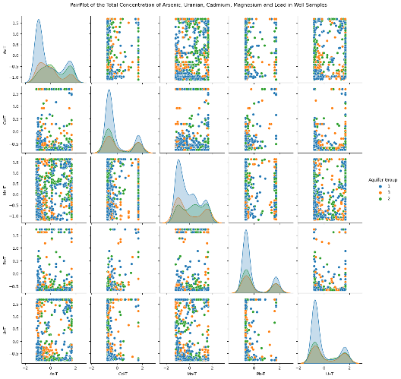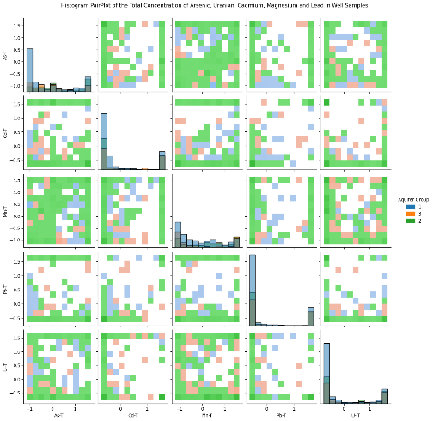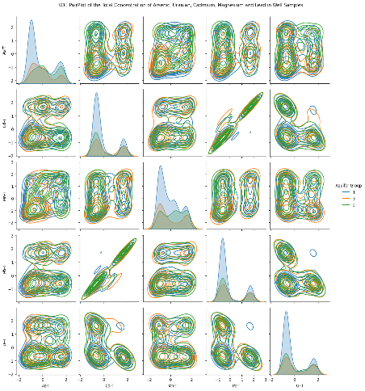
B)
C)
A)
Figure 4.1: A) From Left to right: A) pairplot, B) hisplot and C) KDE plots of the relationship between metals of interest for the full dataset.
Figure 1 shows the pair plot, histogram, and kernel density estimator (KDE)All the metals of Interest. Uranium's relationship with cadmium is seen on both the pair plot and KDE. Manganese and arsenic show no apparent pattern. A slight relationship between cadmium and lead is observed in the KDE plot and histogram plots along with manganese and cadmium.
Relationships of precipitation factors and other variables seem to display similar relationships to that showing with the correlation plots (Section 9.2 Appendix). There are no notable differences between the drought, flood, maximum temperature, or rising minimum temperature in comparison to the entire data set. Lesser or greater variations of the same pattern are shown. Heat maps show increasing temperature/ temperature differences, somewhat decreasing precipitation/precipitation differences and increasing turbidity over the years per well location (Section 9.2 Appendix).

Saltwater Intrusion Exploratory Data Analysis
Table 7 (Section 9.3, Appendix) shows various combinations of different saltwater intrusion cutoffs and the resultant data points, Metals of Interest and saltwater intrusion factors. From this, the best data set can be found by using the cutoff for chloride of 150 micrograms per liter or a specific conductance of 1,000. This gives a data set of 106 points that has no uranium over limits, few manganese over limit and few lead over limit. However, 71 of 81 samples of arsenic in the total data set also appeared in the saltwater intrusion dataset with these criteria.
Table 7 (Section 9.3, Appendix) shows the metals above Canadian Drinking Water Standards with saltwater intrusion. A high amount of arsenic above CDWS occurs in the data set with chloride or specific conductance over saltwater intrusion limits, but not in the data set with both specific conductance over the saltwater intrusion cutoff. Despite not showing any Pearson or Kendall's correlation in our previous analysis, arsenic could be due to ready mobilization from competing ions and reducing environments. Previously observed positive correlations of arsenic in saltwater intrusion with chloride or specific conductance has been observed by *****.
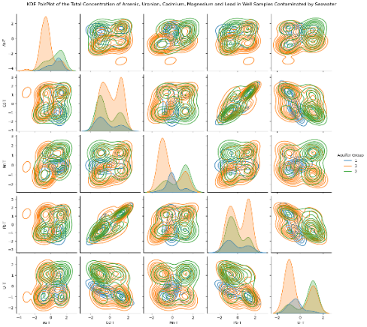
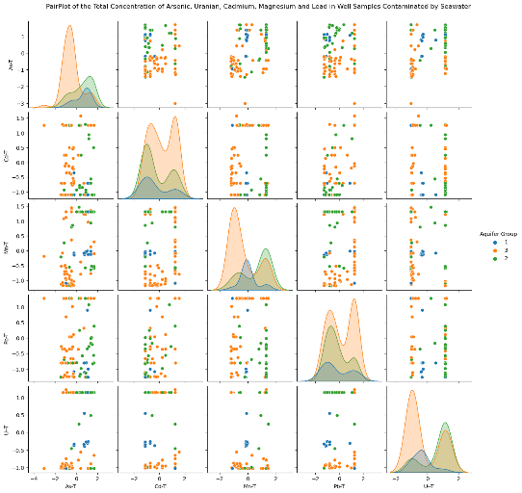
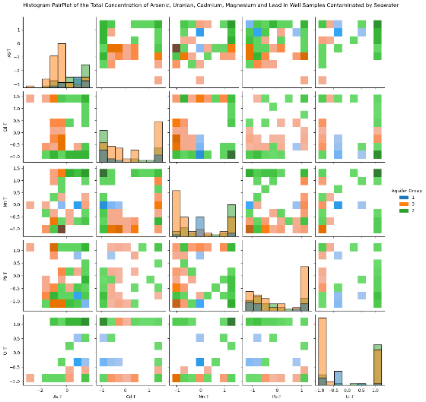
A)
B)
C)

Figure 4.2: A) From Left to right: A) pairplot, B) hisplot and C) KDE plots of the relationship between metals of interest for SWI dataset where specfic conductance ≥ 1000 or chloride ≥ 150 μg/L.
Figure *** shows the relationship between different Metals with saltwater intrusion for each aquifer group. Some of the weak correlations are shown between uranium and lead. It also shows that a lot of the aquifer types with saltwater intrusion are Aquifer Group 2. Figures in the appendix show expected or undetermined relationships for seawater intrusion variables, temperature and precipitation variables and all other variables (Section 9.3, Appendix)

Further Description of British Columbia

Figure 5.1: Power Bi Map of observation well stations in British Columbia.
Figure **** shows the OBS Wells throughout British Columbia. The corresponding weather stations and closer views of OBS Well locations are seen in appendix **. The well and weather stations have differing locations that will introduce inaccuracy. Future research should evaluate this level of inaccuracy on QGIS or ArcGIS. Time constraints meant both well data could not be spatially autocorrected. Satellite imaging picture research would do well to utilize both Queens and Warren's autocorrection as well as the correct version of Kringing for more accurate information. Likewise, time clustering algorithms and special clustering algorithms such time space cube and dbscan could help further differentiate between actual factors, and properties of one of the most complex unique hydrological provinces in Canada. Spatial auto correction would be useful as it would identify underlying patterns such as sites that are solely to monitor industrial activity or mines; versus an underlying pattern in bedrock and geology.
The 100 and 10 year peak flows are shown in Appendix **. The maximum while the maximum of precipitation for each well is shown in appendix **. Though not all of the monthly precipitation will go into runoff, it does give an indicator that in a lot of cases the 10- and 100-Year Peak flows would have been exceeded at times. These indicate the severity of flooding. 100 Year Peak flow lines are higher magnitudes and may overwhelm flood protection barriers such as Lucky's; and burns for wastewater lagoons and landfills, which would allow more contamination to enter aquifers. Also, larger Peak flows enable contamination to be transported further laterally during overland flooding, exposing a broader area of subsurface to potential contamination. Recurrence intervals of the 10-year flood means that flooding is more frequent, so aquifers are exposed to emanations from flooding more often, leading to a cumulative impact over time from less concentrated sources. Future research areas could be to include Peak flow and more of the hydraulic connectivity to groundwater pollution during flooding for a better understanding of these dynamics.
Low flow zones and annual runoffs are showing in the appendix **. British Columbia is divided into eight different low flow hydrology zones that are representative of the lowest flow rate during the corresponding driest seasons. These are broadly representative of water flow regimes, focused during drought, and based on average daily flow. These can coincide with decreased water table pressures, lower hydraulic pressure, and impacts the connected groundwater via reduced recharge. This again increases the concentration effect. It also can affect shallow aquifers connected to intermittent streams or surface water through contamination infiltration during drought receptions. Reduced over bank flooding diminishes the flushing out of normal contaminates under normal flow conditions.


Figure 0.2: Map of B.C. hydrologic zones from iMAP B.C ****.
Figure# shows the previous British Columbia hydrologic zones in British Columbia while the updated zones are shown in Appendix **. Hydraulic zones are smaller defined places that take into account climate, terrain, geology, precipitation and other factors to provide more context for regional water patterns. Hydraulic zones allow baseline assumptions to be made for hydrology within the same area. Most of the well stations occur in the nine to ten hydraulic zones in the south. The Fraser Plateau had braided* outwash channels that transport sediments from place or contamination from mining over large distance. Meanwhile, fractured basal causes in the Thompson region transport uranium and arsenic from mineral spread. Likewise, said zones indicate if the contamination is pluvial, nevial or mixed recharge. Appendix** and Figure # shows the example of hydrogeologic boundaries mapping the effect of something like mountain pine beetle on the flow watershed. It is necessary to link spatially the flow streams and watershed basins to aquifer contamination.


Figure 0.3: Map of geological terranes of British Columbia ****.
Appendix** shows the map of geo aquifer regions along with observations and characteristics. It is seen that mapping only extends to highly industrialized or highly populated areas. This indicates lack of data that future modeling objectively could produce with the influence of both groundwater hydraulic and water contamination data. The geological map, geological era of rock map and quaternity geology map of rock in British Columbia are showing in the Appendix**.
The LG map will demonstrate where sedimentary, volcanic, metaphoric and intrusive rocks are located and what their dominant underlying structure is along with the corresponding timeline. This can indicate where some places might get potential groundwater contamination. Due to the complexity of this map, the following figures provide a better explanation##.

Quaternary geology is the geology that happened from 2.58 million years ago to today. Quaternary geology is primarily influenced during the Quaternary, a period consisting of numerous interglacial cycles. A lot of this geology is dominated by the retreat of the Cordilleran ice sheet and Winstonian glaciation. This again will affect groundwater due to mineral deposits left behind by the formation, movement and dynamics of different ice sheets. Appendix** and figure## show locations where dominant quaternary geology factors exist.
Geological age appendix and terrains figure, commonly resemble themselves and represent the retreat outward of the coast from tectonic plate removals over the years. this in the significantly influences aquifers as it indicates dominant metals that can be found, trapped seawater intrusion from throughout the millennia, And formations of different aquifer heterogeneity. Figure# also shows fault lines which do indicate slips and different geological influences of different Parks and influencing infiltration and how the geology Groundwater chemistry influences the aquifer and potential release.


Figure 0.4: Soil parent materials in British Columbia. *******
Figure# and appendices** represent the soil groups as specified by the Canadian soil classification that are dominant in BC and the parental material of said soil groups. Furthermore, the permeability of some soils, such as brunisolic soils and Orthic Humo-Ferric Podzols, transport pollutants into bedrock aquifers while the acidic conditions of punzelic soil mobilize metals. Gleysolic soils may act as aquatards but may as well transport contaminations within saturated lowland conditions (i.e. Saltspring Island Aquifier). Brunisolic soils The variable oxidative conditions to mobilize Mn naturally and podzolic soils low ph enhancesMetal migration. Mn Above guidelines are frequently seen in fabric blogs underline by fibrosick peaks in Northern Vancouver Island. Likewise in the Quesnel highland, uraniferous zones leach uranium into shallow dug wells that are partially controlled by the redox conditions in the brunisolic regolith.
Further the parent materials of the resulting soil groups in British Columbia are shown in Figure #**. Alluvium/colluvium are highly permeable materials that transport contaminants rapidly if near or over contaminated sites and can transport metals like Mn from mineralized outcrops into aquifers. Moreover, organic compounds such as bogs release dissolved organic compounds and leech metals like manganese under anaerobic conditions. Meanwhile morainal (glacial drift) deposits containing heterogeneous mixtures of material that can provide multiple float paths with course sediments, transport contaminants and find sediment trapping plumes. With Glacial Fluvial outwash, for example sands and gravels can spread plumes over long distance especially in the Nelson region. However, Residual soils can mean that weathering will mobilize arsenic in central BC from mineralized bedrock. Morainal Closet have heterogeneity of retards that controls contaminant Mobility, trapping contaminants through absorption, or facilitating plumes through provincial preferential flow pass via more sediments such as kames or eskers. saturation zones Within moraines can also mobilize sequence contamination and change redox conditions.

Factor Analysis
  - Factor Analysis Methodology
    - Data Processing
The analyses were done via python on a Jupyter notebook. The libraries factor analyzer and Pingouin’ were installed via pip. Data was then processed similar to that previously done in Power BI. In addition:
- Climatology data was dropped from the dataset to avoid too many correlations.
- Latitude and longitude were accounted for via equivalent distances calculated by the haversine formula(Rapp, 1991). A reference latitude and longitude were the means. Both latitude and longitude were converted into radians and the ‘x’ and ‘y’ distance in kilometers were calculated from the reference coordinates. Longitude and latitude were then dropped from the data frame.
- Aquifer groups were converted into columns via one hot encoding.
- Furthermore, date was converted into numerical form by the months between each sample and the first sample taken.
Outliers were removed via IQR method and replaced threshold values (would be useful to have a reference as to what this involves). Only lower outliers of Uranium were removed to account for potential contamination above drinking water standards. Data was scaled via Yeo-Johnson method via Sklearn.
    - Initial Factor Analysis Setup
Multiple functions were created, the first function was called “analyze_continous_data to check the suitability of the data for factor analysis and utilized calculate_kmo and calculate_Bartlett_sphericity from factor_analyzer. This calculated the p and chi square and calculates the value which should be zero and tests if said the corresponding correlation matrix is an identity matrix with unique variables (Mulaik, 2009). Due to a larger dataset this outcome was expected but still run as a check. Then the Kaiser-Meyer-Olkin (KMO) values would be calculated for all variables. Furthermore, the overall KMO is printed as is the KMO for each sampling variables. The KMO is a measure of sampling adequacy and answers closer to one are ideal (Lorenzo-Seva & Ferrando, 2021).
The second function, perform_factor_analysis did the first step of factor analysis. It specifically fits factor analyzer to the data and calculates eigenvalues. Following it then prints the number of eigenvalues greater than one and the ratio of the sum of eigenvalues greater than 1 to the total sum of eigenvalues to represent how much of the data said factor will cover (Hair et al., 2019). Lastly it prints a scree plot of the data. This function covered two main methods of finding the number of factors to use - the number of eigenvalues greater then 1 and the number of factors that corresponds to the greatest drop on the scree plot.
    - Preliminary Factor Analysis
For the first step of the primary factor analysis, the function perform_factor_analysis_and_plot was created.
- This was essentially an intermediate factor analysis utilizing factor analyzer and ‘varimax’ rotation (an orthogonal rotation used to maximize each variance between factor loadings, hence simplifying the analysis).
- Further a heatmap was generated between the factors and the variables.
- This function would then combine the calculated uniqueness and communality for each variable in a data frame, along with the proportional and cumulative variance for each factor/variable and would save as a CSV. This was designed as to allow for quicker factor elimination via excel column sorting.
- Lastly a heatmap of each variable’s uniqueness and communality was generated along with the total variance as a check (communality + uniqueness = 1) (Mulaik, 2009). Said figure was designed to allow for a visual representation to determine which variables could potentially be eliminated.
The function analyze_continuous_data was run on the primary dataset. A KMO result of .72 indicated that factor analysis was somewhat suitable for said dataset. Perform_factor_analysis with n_factors = 28 (data columns) showed 9 eigenvalues greater than 1 which composed of 75.5% of the total sum. The scree plot showed that anywhere between 7-9 was appropriate. Afterwards perform_factor_analysis_and_plot with 9 factors was run on the dataset.
FD, MT, HW and Hardness were eliminated regardless of the above results for the fact they have already been composed partially of other factors and led to the process being run with better fitting KMO scores and factors.
The CSV generated was opened. Any variable with < |.40| (above is strong correlation (Hair et al., 2019)) for no factors was considered a candidate for elimination. Further visual analysis was that two factors might potentially be eliminated due to none of them having a high enough correlation value. Lastly the difference between community and uniqueness was inspected. Variables with high uniqueness and low community could be elimination candidates based on factor scores alone, K, Fe, P, N, pH, y, and precipitation were eliminated. The results are discussed in Section 6 and Appendix 9.7.
    - Primary Factor Analysis
The perform_factor_analysis_and_plotpro function was made to perform second step of the primary factor analysis. This followed the same steps as perform_factor_analysis_and_plot except using the Promax method of rotation. Said rotation is oblique and allows for factors to be correlated and often better represents real world data(Mulaik, 2009). However, it does require previous orthogonal processing to be legible.
The variables in the data frame were not raised to any power (not sure what this means) as doing so dropped the KMO value to an unsuitable score. The functions analyze_continuous_data and Perform_factor_analysis with n_factors = 16 were run again. Both the eigenvalue method and the scree plot indicated anywhere between 5 to 6 factors being appropriate. Perform_factor_analysis_and_plotpro was then run. The csv generated was opened and variables >|.4| for each factor were put in a separate data frame.
A residue Matrix was then calculated with the residues from the observed and predicted correlations from factor analysis with Promax rotation as a check.
The library pingouin furthermore, was utilized to calculate the Cronbach alpha for factors that only had positive correlations (F1 and F3). All results are discussed in Section 6 and Appendix 9.7.
    - Factor Analysis Focused on Metals of Interest
The function, perform_factor_analysis_and_plotOBS was created to directly analyze different conditions of wells. Said function is the same as the previous two except uses oblique rotational methods. An oblique rotation method that allows for correlation, but furthermore is used to maximize differences between factors (Mulaik, 2009). It is a balance between representing the realistic data structure and interpretability.
Additionally, four data frames for As, Mn, Pb and U were created to focus on which factors may potentially influence each metal. The variables FD, HW, MT and Hardness were dropped to avoid correlation along with the three metals not in focus. For each data frame, analyze_continous_data was performed and had a KMO value around ~.70 which signaled that it was okay to proceed. Afterwards perform_factor_analysis was run for each, with n_factors specified as 21 (number of columns) to get the number of factors for use in the next step which was chosen as the number of eigenvalues greater than 1. Then perform_factor_analysis_and_plotOBS was run for each data frame. Resultant values are discussed in Section 6 and Appendix 9.7.
    - Factor Analysis Focused on Climate Change Variables
Two data frames were created to look at further analyzation in the effect of climate change factors on the entire dataset - one specifically was with the metals, nitrogen, aquifer groups, temperatures, distances, months and precipitation. While the second involved metals, nitrogen, saltwater intrusion factors, distances, months and aquifer groups. The function analyze_continuous_data was run on both, however the KMO score was too low to justify further analysis.
    - Factor Analysis Focused on Climate Change Events
Five additional data frames were created to analyze the effect of Climate change effects on data sets with determined climate events.
- DatatSWI took any row where the chloride concentration was above 150 mg/L or where the specific conductance was above 1,000 uS/cm and was created to specifically analyses factors where wells had seawater intrusion.
- Then data drought took rows where FD < 0.
- data flood took rows with FD > 0 to analyse the effects of precipitation.
- DatatHW took values where HW > 0.
- Lastly, DatatMT took values where MT >0. these were to analyze the effects of rising maximum and minimum temperatures due to potential climate change.
Furthermore, the functions analyze_continuous_data, perform_factor_analysis with n_factors=24, and analyze_continuous_data with the factors found from the previous function was then run on all 5 datasets. Figures and values obtained are discussed in Section 6 and Appendix 9.7.
As this is an exploratory factor analysis and not confirmatory, further calculation of Cronbach’s alpha was deemed unnecessary.

  - Primary Factor Analysis
Exploratory factor analysis can identify important predictor variables, elucidate underlying processes and guide future predictive model structures. It can also highlight sampling needs or where more data needs to be collected. This is a step above both Kendall and Pearson correlations because correlations generally measure the strength and direction of linear relationships between two variables while factor analysis looks at all the variables simultaneously. Moreover, Kendall's is a pairwise relationship while measuring rank nonparametric statistics. As this data is highly normalized it is better to follow with a deeper factor analysis to see the underlying multivariate structure. Factor loading represents the original correlation between the original variable and underlying factors while major correlation matrices only show the original correlations directly. Factors analysis looks at common underlying variables and multicollinearity.
Section 9.7, (Appendix) shows the original Bartlett’s and tests homoscedasticity. Due to the sample size, P values were expected to be 0 and the chi Tri square value to be extremely large. Hardness and climatology data were removed from the data set so to prevent further bias. The Kaiser-Meyer-Olkin (KMO) for the data set was 0.7526, which is average and acceptable for exploratory factor analysis but not as stringent for modeling. This indicates an average strength of partial correlations.
Sections in the appendix (Section 9.7, Appendix) show the results of the initial factor analysis with varimax rotation. Kaiser's rule was generally used to determine the number of factors. Variables that did not have any factor loading ≤ .4 of a factor were removed***. This eliminated precipitation and arsenic. Likewise, variables that were .4 ≤ and ≤ .7 were then evaluated and those with high uniqueness/low community were removed. This eliminated both distance factors. The primary data set had 16 variables and a KMO = 0.7481. Five factors were identified (Section 9.7, Appendix). The secondary factor analysis performed via promax rotation had a cumulative variance of .70.
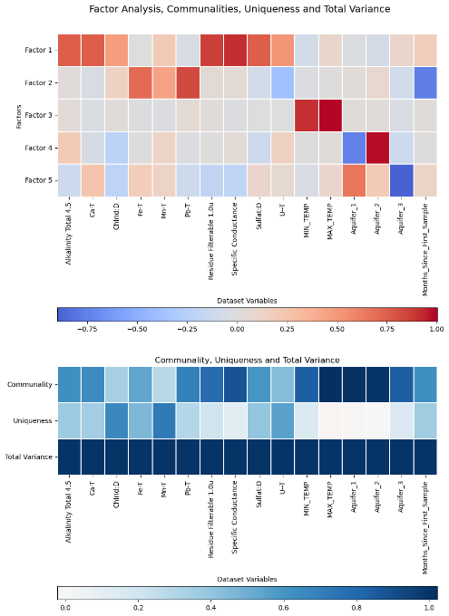
Figure 5.1: Final promax factor analysis on the complete dataset
The first factor [F1] composed 24.4% of the proportional variance and seemed to be that of saltwater intrusion (Section 9.7, Appendix). The largest variables were specific conductance [loading = 0.9167], residue filterable [0 .8647], Ca [0.7572], alkalinity (alkalinity total 4.5) [0.75720], and sulfate [0.7530]. Uranium and chloride had a weaker makeup of said factor.
Specific conductance, residue filterable, calcium, alkalinity and sulfate suggest a representation of saltwater intrusion or previously buried saltwater intrusion from different coastlines at different geological ages. Specific conductance indicates potential groundwater chemistry. Potential other reasons for high levels of specific conductance would be geological factors including coastal sedimentary rocks like limestone, past seawater intrusion during periods of high sea level rises and buried residual salts along with saline fossil groundwater. Even in the Northern British Columbia region a similar pattern with deeper wells is demonstrated due to past seawater intrusion and upward migration of older saline basal brines.
The specific parameters loading strongly suggest ion exchange, saline intrusion or disillusion as possible processes, but this content will need to be fully evaluated with more geological and hydrological factors to further determine more underlying relationships. To understand the underlying driving mechanisms, future research should correlate scores to pumping rates, distance to the coastline, recharge rates and overlay scores with aquifer properties and surface maps. Better accuracy might be obtained by separating hydraulic zones and geoclimatic zones as well as more geological factors such as carbonate and evaporate deposits.
Factor 1 may be influenced by evaporate deposits, carbonate rock, superficial geology, and structural geology as faults connects as conduits which bring up deeper saline fluids from subsurface evaporate deposits. Future research should look at these specific lithological features.
Factor 2 [F2] consisted of Pb [0. 8249], Fe [0.7101] and a negative relationship to time (Months_Since_First_Sample) [-0.7700]. There was also a weak proponent of Mn.
Factors 2 is about 13.63% of the proportional variance. Time loads of very strongly negative correlation suggests some temporal changes in water quality over time in DC. Metals such as Mn, Fe and Pb are positive loading and are often associated with redox reactions that can change with the biogeochemical conditions over time. This might indicate a temporal component involving redox conditions. Another possible explanation could be anthropogenic means, as lead and iron are common pollutants in well water fixtures. Special auto corrections and comparison to other redox sensitive variables like nitrogen or sulfate could help validate or understand said underlying suppose conditions. Furthermore, bootstrap resampling methods would be able to generate competent intervals around trends to test stability.
Factor 3 [F3] is 11.5 % of the proportional variance and has minimum and maximum average monthly temperature as the major proponents. This is the factor likely for climate change effects. Maximum temperature is >1.0 indicating that it is highly correlated with minimum temperature.
The factor 3 loadings indicates a very large temperature effect. Lack of research indicates that the factor 3 loadings cannot be directly confirmed and could indicate just the fluctuations of temperature alone. Due to Yoho Johnson scaling, this might be unlikely, and may indicate interannual variations in groundwater heat driven by surface temperature fluctuations due to seasonality. Minimum and maximum temperatures are tightly paired and indicate the obvious common driver which may be climate change. Future research should include well depth, and more indication of thermal patterns.
Factor 4 and Factor 5 relate to the aquifer groups and therefore represent a combination of hydraulic connection and geology or geography. These two factors compose about 20% of the proportional variance.
Represents the category there cables of groundwater connections. often for group one encompasses generally unconfined shelves send and gravel aquifers with direct surface connectivity to streams rivers and recharge. Meanwhile aquifer group 2 represents confined sand and gravel aquifers including some with just glacial marine influence near the coast. This factor differentiates between geochemical signatures of unconfined aquifers combined/deeper aquifer types. Unconfined aquifer types likely experience more oxygenated modern recharge and pull a negative loading. Meanwhile confined aquifer types interact less with the surface and retain older alternative chemistry and result in positive loading. This factor appears to capture distinction between shallow and uncombined deeper aquifers based on divergent geochemical imprint. This is seen in further factor analysis as confined and unconfined aquifers have different properties.
Aquifer Group 3 loads extremely negatively, and represent primarily crystalline Bedrock and fractured aquifers. Aquifer Group 1 loads positively, and represents those with hydraulic connectivity and shallow sand and gravel. This distinguishes between geochemical signatures of shallow alluvial aquifers versus deeper fractured crystalline bedrock aquifers. Aquifer Group 1 likely shows modern surface influences and pulls the loading positive. Meanwhile aquifers with fractured Bedrock reflect longer flow paths interacting with host crystalline minerals and fluids; and can pull the positive loading to negative. Correlating these factor scores to independently mapped geochemical factors or overlaying against ends topography would be useful for future research to determine exactly . Factify appears to delineate different geochemical facies separating alluvial settings from deeper Bedrock dominating environments.
Inadequate sampling to look solely at both the metals of interest and either the saltwater intrusion variables, or the precipitation and temperature variables as KMO was < .7. Saltwater intrusion also had inadequate sampling.
  - Factor Analysis with Climate Change Conditions
Data sets to represent drought, flood, increasing maximum temperature, and increasing minimum temperature who created as in a similar way to the exploratory data analyzes. Implement rotation was used to balance understanding a correlated data set with analyzes.
The supplementary data for the drought data set is showing in Section 9.7 (Appendix). This resulted in six factors (F1_{D}, F2_{D,} F3_{D} , F4_{D}, F5_{D}, F6_{D} ) that made up 57% of the total proportional variance. F1_{D} again was indicative of saltwater intrusion and made up for 19% of the entire cumulative variance. F1_{D} consisted of specific conductance (0.9592), Residue Filterable 1.0u (0.8999), Alkalinity (0.7639), Sulfate (0.7152). Relation was a weak correlation involving chloride and calcium. F2_{D} add a strong negative correlation for time (-0.8908), a positive relation for Pb (0.9083) and a weak correlation for iron and consists of a 9% proportional loading. F3_{D} was about 9% of the proportional loading and indicated climate change variables strongly composed of min_temp (0.9420) and max_temp (0.9793). F4 _{D} represented aquifer types. Meanwhile F5_{D} consisted of 7% of the proportional variant and only had weaker loading of aquifer groups, Mn and K. F6_{D} made up 5% the proportional variance and was composed of weak relationships to X, U and inversely chloride.
Given that the cumulative variance of the factor analysis for Drought is 0.5778 and is below the acceptable cut off of 0.60, the observations provide useful information of the underlying structure of the relationship, but still need more data to be a guiding influence for future protective models. British Columbia has complex geology and hydrogeology patterns across different regions and thus a cumulative variance of 58% might be moderate but does indicate some reasonable interconnectivity between variation and does indicate some dominant underlying insights.
F1_{D} to F3_{D} capture the dominate natural influence of geology/hydrogeology, temporal water quality changes and climate/meteorology. F1_{D} shows similar direction variables to that of the main data except with stronger loadings and with the addition of potassium and without alkalinity. This indicates that this loading likely represents rock geochemistry - including saltwater intrusion and conductivity/ion patterns. This is further indicted as total dissolved solids/conductivities are primary natural factors influencing groundwater composition.
Meanwhile F2_{D} again showed either indication of temporal influence of water quality. It had the same indication of Factor 2 in the main data except with a weaker factor loading of iron. Positive loading for iron also makes sense as even the correlation between iron decreases during drought situations. The potential implications for this suggest a longer residual time with more mobilization of contaminate and more seasonal fluctuation.
The third Factor has a moderate negative loading with precipitation and suggests that this Factor represents climatic and meteorological influences on groundwater property. Negative loading of precipitation implies a greater influence of meteorological conditions during drier climatic periods with less water recharge. Again, less recharge during low precipitation means longer residual times and more localized rock water interactions.
Factor 4 again shows the difference between confined and unconfined aquifers especially unconfined aquifers connected to a strong hydraulic connection. This Factor highly correlates with confined aquifer settings of geochemical and resident time influences. Aquifer 2 promotes longer flow pass, other rock interaction times and likely captures higher ionic concentrations and specific ions like Ca, Mg, and bicarbonate. Moreover, this would indicate less of a linear correlation due to heterogeneity which would be further demonstrated in drought like data correlations.
Factor 5 has weak loadings of aquifer group 2, Mn and K along with negative weak loadings of precipitation and Aquifer group 3. Interestingly, Aquifer group 2 is a replacement for Aquifer group 1. enough that says that there's a negative loading for Bedrock aquifer that drive water through fractures and conducts And a positive loading for aquifers that interact more with aquifer sediments. Bedrock tends have lower ion / solute content due to limited rock water content. Likewise sedimentary aquifers provide more opportunities for ionic exchange dissolution and for Mn contamination from weathering. This captures geological influence related to water chemistry on Bedrock, versus glacial settlement, aquifer settings.
F6_{D} has negative influence of chloride and positive influences of distance in latitude and uranium. This could indicate anthropogenic or land uses on the groundwater composition, as road salts and agriculture fertilizer or underlying geology and hydrogeology.
Supporting factor analysis for flooded data are shown in Section 9.7 (Appendix) and consistent of 60% of the cumulative variance and seven factors (F1_{F}, F2_{F}, F3_{F}, F4_{F}, F5_{F}, F6_{F}, F7_{F}). F1_{F} again seemed to indicate drought variables with lower values of most and proportional variance of 15.5. Residual filterable, specific conductance and chloride (0.7402) had a strong loading relationship while alkalinity and sulfate had a similar weaker relationship. F2_{F} demonstrated a similar relationship with F2_{D} of drought with a stronger relation for Pb (0.9527) but a slightly less inverse correlation to time. F3_{F} and F4_{F} are similar to that of drought. F5_{F} consisted of weak relationships from X, y, U and was inversely related to precipitation. F6_{F} had weak relationships of Mn and Fe along with an inverse weak relationship to aquifer group 3. Factor 7 (F7_{F}), which made up 5% of proportional variance had a strong relationship to arsenic (.8069) and a weak relationship to P.
Factor 7 is unique to flooded data and has the moderate variable loadings for arsenic and phosphorus. Both these can be natural or anthropogenic contamination sources as they are both used in land and industrial use. However, the variable loading pairs solely due to flooding indicates anthropogenic over natural contamination as there would be some relationship in the main factor analysis if said attributions for geogenic. arsenic and phosphorus have previously been under observed making up factors of other Factor analyzes in*******.
The data set for rising maximum temperatures showed similar patterns to that of the drought data set with the cumulative variance, F1_{Max}, F2, F3 and F4 displaying similar trends (Section 9.7 Appendix). However, F5, F6 and F7 displayed a similar pattern to that of the flooded data set.
The factor analysis with increasing maximum temperatures resulted with a total variance of 0.5792 thus requires more research for definite conclusions. Factor 1 again had high loadings for specific conductance, residue filterable and chloride; with moderate loadings for the remaining variables and consists of 0.1409 (%?) of the proportional variance. To flooding which is similar to the flooding Factor analysis. No and cumulative variance both the proportional cumulative variance indicate that there are very complex underlying factors of play rather than one dominant driver and thus further techniques like clustering should be used for better a more in-depth analysis. This could be due to further issues with geoclimatic regions or hydrology regions as increasing maximum temperature would lead to increasing runoff instead of snowmelt in some areas.
Maximum temperatures Factor 2 of the increasing maximum temperature factor analysis had variance and loading similar to that of the flooded data set. Meanwhile, Factor 3 of the increasing maximum temperature factor analysis had the similar loadings and variances of Factor 4 from the flooded data set. These represent contamination and perhaps potential metal groundwater chemistry along with ambient temperature profiles.
Factor 4 of increasing maximum temperature factor analysis was similar to Factor 5 of the main factor analysis with the inverse loading of pH. As aquifer Group 1 is a mainly unconfined fluvial/alluvial sand and gravel aquifer group while aquifer group 3 is a fractured sedimentary and crystalline Bedrock aquifer group. This could indicate a potential likelihood of temperature having a more pronounced effect on gravel/ sand than bedrock. Further research is needed to confirm this.
Factor 5 had very similar loadings and variations as Factor 5 from the flooded data. The variable y is missing, however y distance also has a high uniqueness and would have made it a potential candidate for elimination. Meanwhile Factor 6 is similar to that of Factor 5 for drought data. This again distinguishes between bedrock aquifers versus confined gravel aquifers based on base metal contact and their influence in fluctuating increasing maximum temperatures. this might also There's a temperature effect on confined more than bedrock (?)
Factor 7 is similar to Factor 6 of the drought data set. This again points to anthropogenic or east/west hydrogeochemical differences means as the effects of increasing temperature versus the effects of droughts would be similar in that means**.
Meanwhile data set for rising minimum temperatures displayed a variance of 57%, displayed similar trends to that of flooded data set for F1, F2, F3, F4 and F7 while displaying a similar pattern to the drought data set for F5. F6 had a strong inverse relationship with aquifer group 3 and a weak relationship with Fe.
Minimum temperature factor analysis with increasing minimum temperature only made up about 0.58 and thus again can only be used for moderate characterization and requires more research to further determine underlying structures. Factor 1 had similar factor loadings to that of first factor from the analysis with flooded data sets. This is further indication that minimum and maximum temperature are very correlated and have similar effects. Factor 2 of increasing minimum and maximum temperature is similar to Factor 2 from flooded factor analysis while Factor 3 is similar to that of Factor 3 from rising maximum temperature. Unlike rising maximum temperature, increasing minimum temperature has a factor that is very similar to Factor 3 from the flooded data set.
(Ask about confinement)
Factor 5 from increasing minimum temperature has a similar variance loadings for Factor 5 in increasing maximum temperature. This makes sense as said factor is more due to latitude and the differences between minimum and maximum temperatures may not be as contrasted as much.
Factor 7 of the factor analysis for increasing minimum temperature is similar to Factor 7 in flooding except with a high loading of potassium. Given this combination with the same underlying control/source without any other anthropogenic measures, this contamination source is likely due to a geogenic processes. Potassium and phosphorus are major rock forming elements naturally elevated in certain lithologies. Said positive relationship to increasing minimum temperature also fits to interpretation as lithology-controlled water chemistry.
  - Factor Analysis For Each Individual Metal of Focus
To understand how each particular metal of interest is affected by the data set, other metals of interest were removed and an oblimin factor analysis was performed.
Figures and tables for the factor analysis focusing on arsenic can be found in Section 9.7 (Appendix). Figure *** shows the results. Six factors with a cumulative variance of 57%. F1 represented about 20% of the cumulative variance and consisted of saltwater intrusion variables. It was influenced strongly by Specific Conductance [0.9453], Residue Filterable [0.8944], Alkalinity [0.7637], Sulfate [0.7223] and Ca-T [0.7038] while having a weak influence of chloride and K. Two were highly similar to the main factor analysis and consisted of maximum temperature. F3 and F4 consisted of aquifer groups. F5 had a strong relationship with iron [0.7581], and an inverse relationship with time while F6 had a weak inverse relationship with chloride. Arsenic was not a heavy underlying consideration in any of the factors.
The factor analysis focused on As only covered 0.5736 cumulative variance thus can be used for generalizations but any findings should be confirmed with more data.
Factor 1 (F1_{As}) made up 0.2070 remains somewhat consistent to Factor 1 in the main factor analysis without uranium and with the addition of potassium. Potassium can be correlated with the overall mineralization but may indicate some unique influences beyond dissolved solids. British Columbia is too diverse for potassium to be defined as a characteristic of a hydrochemical facies.
F2 _{As}, F3 _{As}, and F4 _{As} are equivalent to F3, F4, and F5 of the main factor analysis with their proportional variances differing due to the removal of other metals of focus. F5 _{As} of the factor analysis focused on arsenic was equivalent to that of F2 of the main factor analysis - with the removal of Mn and Pb and perhaps indicates weathering. Factor 6 is equivalent to F6 of the drought data without uranium and indicate that distance (latitude) is highly correlated with Uranium given its absence.
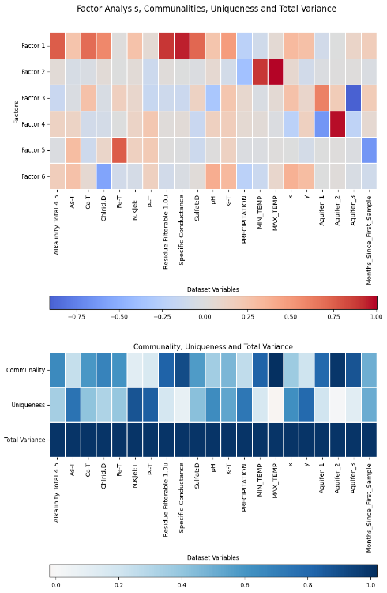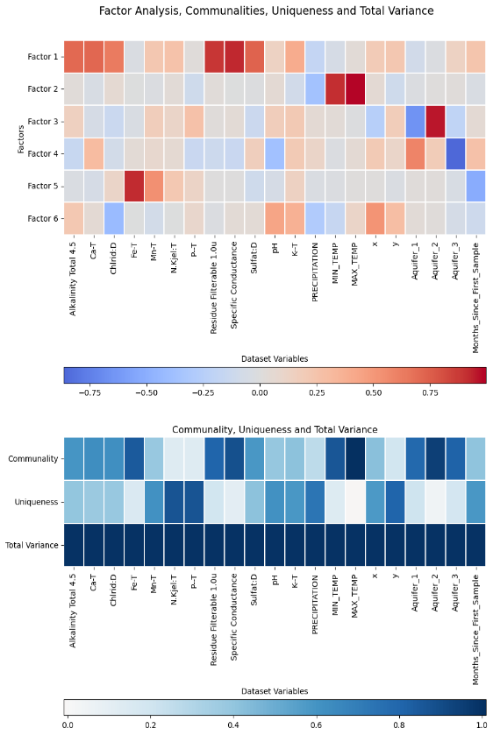
A)
B)
Figure 5.2) A) Factor analysis with oblimin rotation on a dataset with only As as the metal of interest. Community, Uniqueness and Total Variance are also graphed.
B) Factor analysis with oblimin rotation on a dataset with only Mn as the metal of interest. Community, Uniqueness and Total Variance are also graphed.

the factor analysis focused on manganese is showing in Fig *** and Section 9.7 (Appendix). Tim loading of 58%. F1, F2, F3, and F4 showed a similar trend to that of the factor analysis focused on arsenic. F5 had a weak inverse relationship with time and Mn in addition a strong relationship to Fe (0.9201). F6 showed a weak inverse relationship to chloride, a weak relationship to pH and X.
The factor analysis focused on Mn only covered 0.5783 cumulative variance therefore can be used for generalizations, but any findings should be confirmed with more data. The same pattern was observed for F1, F2, F3, and F4 as the factor analysis focused on As. Meanwhile, with the relationship between Fe and Mn observed in the main factor analysis and in the correlation, matrices are again displayed in F5 Mn. F6 Mn has chloride, x and pH as variable loadings. The influence of pH in this case would work for both anthropogenic as mining/industrial activities do result in soil acidity and groundwater chemistry.
Fig *** and Section 9.7 (Appendix) shows the factor analysis performed focused on lead data and made up 61% of cumulative variances. The First Factor followed a similar pattern to the previous metals and indicated saltwater intrusion variables that were strongly influenced by specific conductance, residue filterable, alkalinity and sulfate while being weakly influenced by K, chloride and ca. F2 presented 10% of the proportional variance and was strongly influenced by Pb (0.9200), inversely strongly influenced by time and weekly influenced by iron. F3, F4, and F5 followed a similar relationship to the other metal profiles. F6 showed a weak inverse relationship to Chloride and a weak relationship to X.
The factor analysis focused on Pb (Factor Pb) only covered 0.6070 cumulative variance and thus is an acceptable variance to provide demonstrate some underlying structural patterns. F1Pb, F3 Pb, F4 Pb, and F5 Pb are similar to F1 Mn, F2 Mn, F3 Mn and F4 Mn.
Meanwhile F6 Pb is similar to F6 Mn but without X - signifying that Pb influence isn’t as spatially located and could be more anthropogenic. F2Mn had a similar pattern to F2main, signifying the previously discussed temporal dependence of Pb and Fe.
The underlying factor analysis focusing on U is shown in fig*** and Section 9.7 (Appendix), consisting of 40 57% of the total proportional variance of the data set. F1 represented Saltwater intrusion factors with about 19% of the cumulative variance. It was strongly influenced by specific conductance and residue filtrable with weak influence from Ca and sulfate as previous data sets were. Conversely F1 was also strongly influenced by chloride [.7431] while being weakly influenced by alkalinity. F2, F3 and F4 were also influenced like the previous metals. F5 was weakly inversely related to chloride and weakly related to X and UT in a similar manner to flood data factor analysis. F6 had a strong relationship to time (0.7409), a weak relationship to U and an inverse weak relationship to Fe.
The factor analysis focused on U (Factor U) only covered 0.5783 cumulative variance thus can be used for generalizations but any findings also should be confirmed with more data. F2u, F3u and F4u were similar to the other metals of focus factor analyses. F5u mimics that of F6 Drought - also signifying that this is geologically based. F1u is made up of the similar variables but with different loadings - chloride is higher while alkalinity, Ca and sulfate are lower. Through the fundamental rock-water interactions governing major ion geochemistry, uranium seems to be more sensitive to saltwater intrusion factors. Uranium was also shown in the main factor analysis to make up the variance in that of the factor representing groundwater geochemistry and long-term mineralization.
F6u is the supposed equivalent to F2 main, however without Pb and Mn, U takes a moderate negative relationship to Fe while time takes a strong positive relationship. This was the temporal relationships representing groundwater chemistry. Increasing uranium may be inversely related to iron removal due to evolving geochemistry. This previously could indicate the residual time but due to the positive loading, it also could provide clues about the transient geochemical processes that mobilize uranium.
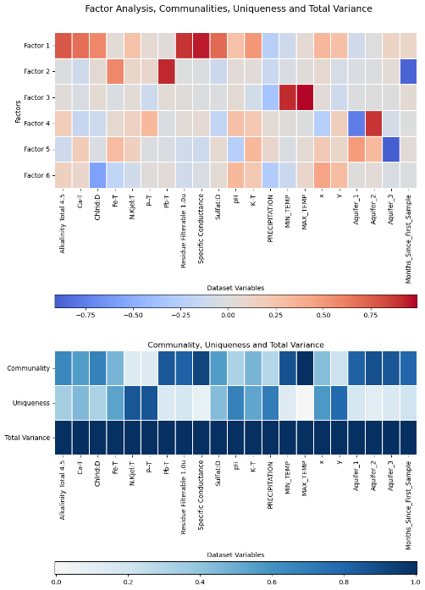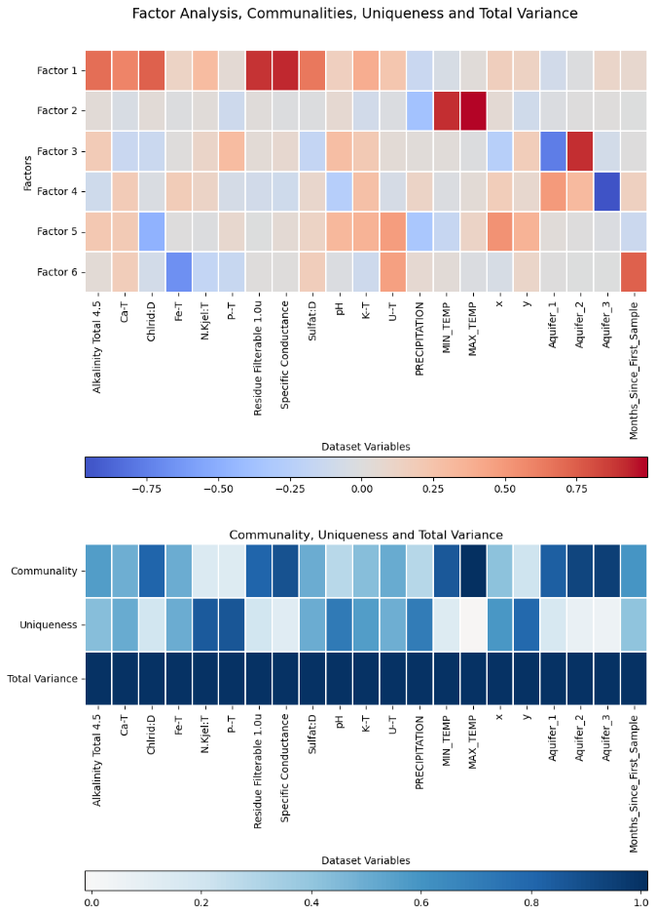
A)
B)
Figure 5.3: A) Factor analysis with oblimin rotation on a dataset with only Pb as the metal of interest. Community, Uniqueness and Total Variance are also graphed.
B) Factor analysis with oblimin rotation on a dataset with only U as the metal of interest. Community, Uniqueness and Total Variance are also graphed.

Regression Analysis
  - OLS Regression Modelling Methodology
    - Preprocessing data for OLS regression
Ordinary Least Squares (OLS) regression models were performed to determine potential future predictors. Data Curation was completed via:
- The raw data was imported into a Pandas DataFrame and cleaned by removing unnecessary columns, renaming columns, and engineering new features representing temporal dynamics, along with categorical data which was encoded into dummy variables.
- Latitude and longitude were accounted for via equivalent distances calculated by the haversine formula (Rapp, 1991). A reference latitude and longitude were the means. Both latitude and longitude were converted into radians and the ‘x’ and ‘y’ distance in kilometers were calculated from the reference coordinates. Longitude and latitude were then dropped from the data frame.
- Then the following temporal information was extracted, and redundant raw date columns were removed.
- Numeric columns were screened for outliers using a two-step procedure. Upper and lower outliers were first capped using the interquartile range method. Remaining outliers were then replaced with threshold values derived from the median absolute deviation. This approach retained data distribution properties while limiting the influence of extreme values.
- To normalize the distribution of continuous variables, a Yeo-Johnson power transform was applied to selected numeric predictors. This transformation helped stabilize variance and reduce skewness.
The preprocessed data was explored by computing a correlation matrix between variables.
Further analysis employed multiple linear regression with arsenic, manganese, lead, and uranium concentrations as target variables. To identify important explanatory variables, each model underwent sequential feature selection with 30-fold cross-validation. Final regression models were fitted on the selected subsets of predictors.
    - OLS regression model for the main dataset
Feature Selection for the OLS regression model for the main dataset was performed as follows:
- The preprocessed dataset was already split into predictors (Xa) and response variables (arsenic, manganese, lead, uranium). No further splitting is done.
- A linear regression model was fit on the full dataset Xa for each response variable.
- Following, backward sequential feature selection for each metal of interest (As, Mn, Pb, U) was performed using 30-fold cross-validation (r-squared). For each step, the feature with lowest importance was based on reduction in cross-validated R2 and was eliminated. Furthermore, selection was terminated when R2 started to decrease (Michael Brydon, 2021; Qingkai Kong et al., 2020). The best subset was chosen based on the highest cross-validated R2.
- A plot was generated showing the performance of each number of the feature.
Final OLS models for each metal of interest were fit for via:
- A linear regression model was fit on the best feature subset specified previously with the help of the performance plot for each response variable using stats models OLS.
- Model summary statistics, coefficients, and diagnostics which were obtained.
- Then coefficients with P>0.05, t < 2.0 and that had a zero in the confidence interval were removed [11].
- No formal model evaluation or testing were performed.
Details of these are displayed in Appendix 9.9 and Section 7.
    - OLS regression model for Saltwater intrusion, drought, flooding, increasing minimum temperatures and increasing minimum and maximum temperatures.
Datasets for Saltwater intrusion, drought, flooding and increasing minimum and maximum temperature were prepared as previously discussed in Section 3.2.
- MT, HW, FD, and Hardness were dropped afterwards to lessen multicollinearity.
- Following outliers were removed from each dataset as previously discussed.
- As well as each dataset was scaled as previously discussed.
- For each contaminant variable (As, Mn, Pb, U) of each dataset, a Pandas DataFrame was created from the preprocessed dataset by dropping the other 3 contaminant columns. This avoided multicollinearity between contaminant predictors in the regression models.
- Column headers were standardized by applying Pandas .str.replace() to remove spaces, dashes, colons, and periods for each dataset.
Models for each climate change dataset (Saltwater intrusion, drought, flooding and increasing minimum and maximum temperature) were fit by:
- For each contaminant (As, Mn, Pb, and U), a linear regression model was specified using the Stats models formula API with the response variable. Along with the contaminant column and the same set of 15 predictor variables including water chemistry, climate, geography, and time variables.
- Furthermore, an ordinary least squares model was fitted for each contaminant using the Stats models smf.ols() function.
- The fitted model.summary() method was called to extract the regression statistics including model coefficients, p-values, and overall fit metrics such as R-squared and F-statistic for each contaminate.
- Coefficients with P>0.05, t < 2.0, those that had a zero in the confidence interval and that had a standard error greater than the respective confidence intervals were removed for each contaminant datasets [11].
- The smallest coefficients were then eliminated if the number of features were above that specified by the respective performance plots generated for each metal in the steps for the OLS regression model with main data.
Residual Diagnostics plots were created for each climate change dataset [11]:
- For each metal of interest (As, Pb, Mn, and U): Histogram plots of the residuals were generated with a normal curve overlay to assess residual normality using Seaborn's distplot().
- Residual Q-Q plots for each metal of interest (As, Pb, Mn, and U) were created to compare residuals versus theoretical normal quantiles using Statsmodels sm.qqplot().
- Residual boxplots for each metal of interest (As, Pb, Mn, and U) were plotted using Seaborn's boxplot () to check for heteroscedasticity.
- Seaborn jointplots() were used to check for residual autocorrelation with each predictor variable.
The thorough residual analysis was aimed at validating the linear regression assumptions for each contaminant prediction model. Results of these are displayed in Appendix 9.9 and Section 7.

  - Ordinary Least Squares Auto Regression Models
Ordinary least squares regression models were performed due to the flexibility of said model. This method can determine the linear coefficients of equations. Judging by the Pearson correlations there are more vital than parametric equations. Future research might want to look at these relationships in the general additive model.
Ordinary least squares regression models were performed as an exploratory analysis test. This can be used as a preliminary step to identify potential predictors and response variables and how strong the linear relationship is before them. Significant predictors and trends discovered also can help for new hypothesis and guide future focuses of rigorous confirmatory analysis and future research. These models also are known to help detect with future late which feature selection as it shows which variables have the best predictive our based-on metrics while reducing the risk of overfitting. Future research should include a generalized additive model and detrending time series the trend and be trending analysis. these were originally planned for the report however had to be cut out due to lack of time.
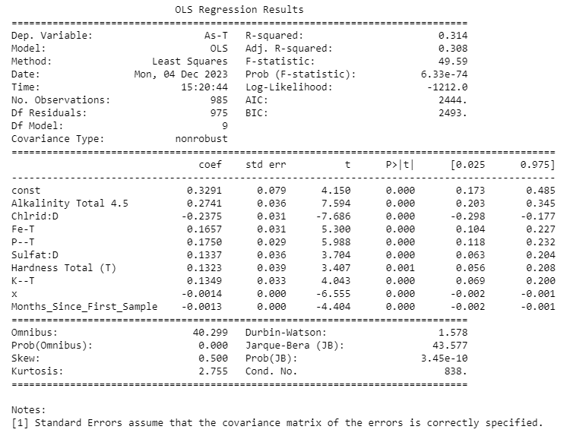
Figure 6.1: Summary of Ordinator Least Squares (OLS) auto-regression for As with the full dataset with 9 features.
Four auto regressive models for As, Mn, Pb and U were performed. The performance plots of each iteration are showing in Section 9.9, (Appendix). Figure 1 shows the OLS Auto regression for As. Nine features were found to optimize the model: 'Alkalinity', Chloride, 'Fe', 'P, 'Sulfate', 'Hardness Total (T)', 'K, 'x' and 'Months_Since_First_Sample’ with a summarized score of 0.1239. The adjusted r squared That said variables can explain 31% of As variance. The F statistics of 49.59 and extremely small p-value suggests that the group of predictors do add some statistically significant explanatory than compared to a model with no predictors. The Akaike information criteria (AIC) and Bayesian information criterion (BIC) are extremely high thus signifying that this model may not have good generalizability to other situations. Future research should further explore better predictors for more accurate model selection.
The standard error in most cases is less than the Interval confident intervals and thus indicates the likelihood of these predictors. Office this test the T hypothesis test shows larger values larger then 2 t values with p-values are less than 0.05. theoretically this should mean that the predictors to statistically significant however, as both AIC and BIC are large it may only be sticks statistically significant for this data set.
The residual tests such as skew and kurtosis indicate a slight right skewness. Both omnibus and Jarque Bera tests are tests for normality of the residuals and as the probability of both are close to zero, it indicates that these residuals are not normally distributed. The Durban Watson value is 1.578 and suggests that there is a slight positive autocorrelation, and the conditional number is not excessively large which suggests that there are not any serious multicollinearity issues.
Arsenic from exploratory data regression analysis was primarily influenced by alkalinity, chloride, iron, phosphorus, sulfate, hardness, potassium, and weekly by time and aquifer confinement. Hydraulic connectivity and bedrock interestingly seem not to show any influence. This contradicts a lot of studies done in specific sites. The best explanation for this is assuming that arsenic comes from both natural and anthropogenic means thus negating effect of one or the other. Alkalinity was the next impactful variable and matches expected geochemical relationships that influence arsenic as it impacts the redox reactions that influence the absorption and absorption of As. Alkalinity is likely demonstrated over pH as pH is more of a non-monotonic / threshold like relationship. Fe(III) I’m pretty absorbs as Fe(V). Phosphate often reflects soil or anthropogenic contamination and still influences or facilitates or competes with arsenic sorbption depending on the P:Fe ratio. Can stimulate reductive dissolution of e oxide. Potassium is not a major groundwater contamination but may indicate anthropogenic or weathering influences. Given the small amount of latitude, it indicates anthropogenic as the Centurion calculated would indicate Wells near the Southwestern portion of BC. Negative correlation of chloride Processes aligns with no one geochemical processes such as trivalent arsenic complexes that can immobilize and precipitate arsenic out of groundwater with higher Cl:As ratios. This runs counter to what is seen in the exploratory data analysis were a lot of As above CDWS were in the dataset with SWI. A possible explanation is that this could be due to anthopogenic means.

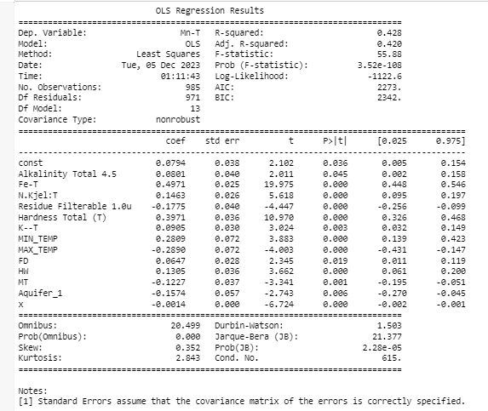
Figure 6.2: Summary of Ordinator Least Squares (OLS) auto-regression for Mn with the full dataset with 12 features.
The OLS regression results for manganese are showing in figure ****. Performance plot indicated that there is an optical number of 13 features: ‘Alkalinity Total 4.5’, ‘Fe-T’, ‘Total nitrogen’, ‘Residue Filterable 1.0u’, ‘Hardness Total (T)’, ‘K—T’, ‘MIN_TEMP’, ‘MAX_TEMP’, ‘FD’, ‘HW’, ‘MT’, ‘Aquifer_1’, and ‘x’ with a total score of 0.2229. Well fitted model Did a relatively well fitted model. Mn variance was explained by Said predictors by 42% (adjusted R-squared). That is f statistic is 55.88 with an associated extremely small p-value that signifies group of predictors add statistically significant explanatory power as compared to a model with no predictors. Which indicates that a generalized the additive model may have been a better choice for the data. AIC and B I C values are still relatively High thus indicating that this baby that these results may be specific to own this model only and it not generalizable.
The of each variable the standard area was not greater than the count of confidence intervals, the t-test Were considerably High, and all of the p-values were less than 0.05 indicating that the predictors are statistically significant. Interestingly enough total nitrogen Is a predictor despite it not showing up as a factor in the factor analysis or as any correlation. Alkalinity turned up both as a weak correlation and as a factor in the factor analysis but does have the greatest p-value which at 0.045 may not meet the cutoffs for more stricter standards.
Askew and kurtosis Hit the distribution of the residuals and show that it is a bit right skewed and a light tail relative to the normal distribution. The Omnibus and Jarque-Bera tests are also normality tests for the residuals and as the probabilities of both are close to zero, it is indicated that the residuals are not normally distributed. The Durban Watson value was 1.503 and suggest that there is a slight positive correlation in the residuals and the conditional number is 615 which is not excessively large and thus indicates that there are no serious multicollinearity issues.
Magnesium exploratory data regression analysis demonstrated multiple multicollinearity factors. Minimum temperature has a positive coefficient while the climate change effect for minimum temperature, Mt, had a negative coefficient. However, maximum temperature had the similar coefficient but negative and slightly greater as minimum temperature, and a greater positive coefficient for HW, which is the climate change effect on maximum temperature. This first could be due to measurement errors or inconsistency in the modeling data. Moreover, the seasonal and special aspects captured by Mt verse HW may have stronger influences on the complex biogeochemical cycles than direct thermodynamics controls. Thus, areas with less temperature variability (-’ve Mt), could still have high Mn for other reasons. Minimum temperature directly reflects the ambient thermal conditions at night and that could impact kinetics and solubility in general. While most general minimums increase Mn mobility up to an optimal temperature range and thus may have more of a simple linear correlation to solubility based on temperature kinetic controls. Mt shows the indirect climatic influence through temperature fluctuation impacts rather than just thermodynamics. Less temperature positive Mt values could indicate areas with greater seasonal temperature fluctuation. More dynamic freeze/thaw cycling could solubilize and immobilize Mn to a greater degree over different temperature seasonal impacts. Future research should seasonably adjust the time series data in order to negate the facts of seasonal cycling and to slowly focus on the effects of climate change.

Seasonal and special impacts of Mt versus HW may have stronger influences on the complex biochemical Mn cycle than direct thermodynamic controls. air along with non-linear mature response curves might apparently explain contradicting Mills if the characteristic geochemical thresholds exceeded by Mn verse HW. Maximum temperature is the monthly mean maximum temperature or daytime temperature. Higher temperature might increase mineral dissolution and magnesium mobilization to a point after which Mn will precipitate out. This might explain why there's a negative correlation despite a positive one. This coefficient might reflect locations with temperatures at the upper threshold where magnesium solubility decreases again due to enhanced precipitation. HW is the difference between the actual and predicted maximum temperatures, and thus indicates former aquifer regimes thermodynamically suited to higher manganese levels and perhaps more indicative of long-term climate change fluctuations. This indicates areas that are higher than expected maximum modeled value, and that are geographically or geologically distinctly conductive to sustained temperatures and longer reaction time. Prolonged warmer conditions seem to fight me solubility. HW also avoids saturation effects by only noticing relative increases of temperatures. HW isolates the climactic influences with a spatial factor and eliminates the special discrepancy that points to regional scale controls on manganese.
Iron, alkalinity and hardness represent the Rock geochemistry reactions. As previously stated, alkalinity and carbonate levels can influence Mn solubility through complex absorption processes. Iron is again closely tied to Mn geochemically and shown in the previous chapter to have a high relationship with Mn as they occur together in minerals and exhibit similar redox behavior. Potassium is not a major control on magnesium however it may serve as a proxy of mineral weathering over time and perhaps anthropogenic contamination. In this thesis, this is the first time Nitrogen is recommended as a significant factor. Nitrogen either acts as an indirect indicator of land use or anthropogenic influence on groundwater quality. Nitrogen is also a key nutrient influencing microbial activity and biogeochemical cycling in groundwater systems thus may be promoting ideal biogeochemical conditions through microbial radiation rather than direct control on Mn.
FD, or the representation of flood and drought, does show what was demonstrated before with a positive coefficient thus stating the same thing that happens during flooded as a raised Baseline flow, hydraulic hydrological settings conducting to mobilizing and transporting dissolved Mn and more groundwater weathering. Hydraulic connectivity had a negative coefficient. In this case, it could be due to topography, as topography and thinner saturated zones could result in more channelized vertical flow with less lateral mixing. Likewise, hydraulic connectivity could mean that there are more shallow, flushed and transmissive aquifers with less residence time and limited water Rock reaction.
Residue filterable has a negative correlation to Mn. This is somewhat demonstrated by the factor analysis however showing a negative coefficient instead of a positive coefficient. This might be due to its relationship to the saltwater intrusion factor in the factor analysis. Likewise, highly filterable residue waters have essentially flushed more mayonnaise from their aquifer media over longer time scales through continued rock water exchange. Turbidity itself would deteriorate that. Areas with elevated filterable residues likely experience more rock water interactions driven by factors like thicker and saturated zones, longer and carbonated rates geologies.

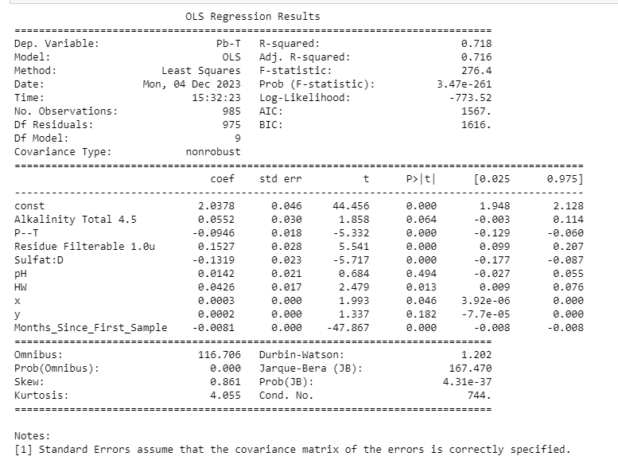
Figure 6.3: Summary of Ordinator Least Squares (OLS) auto-regression for Pb with the full dataset with 8 features.
Results for OLS regression for lead is shown in figure *****. The model was found to have nine features: ’'Alkalinity Total 4.’',‘'—-’',‘'Residue Filterable 1.0’',‘'SulfatE’',‘'pH’',‘'HW’',‘'x’',‘'y’', and time with a total score of -9.3453 (Section 9.9, Appendix). These predictors accounted for 72% of the variance of PB. The F statistic and associated p-value are very small signifying that these predictor groups add statistically significant explanatory power to the model. The log likelihood is less negative than other previous models and indicates that this is a better fit compared to the other metals. A i c and b i c are still quite smaller than other metal models and indicate that this may be more generalizable to other data.
P-value for total alkalinity and pH is above 0.05 and thus is not statistically significant. Meanwhile, the values for phosphorus, residue filterable, and sulfate show smaller standard errors than their confidence intervals and statistically significant T and p values. HW did show a significant p-value, however, the standard error nearly exceeded that of its confidence interval. “X” and time again did show statistically significant P values but an extremely small confidence interval that included zero and thus is likely suspicious.
Residual tests showed a light right skewness and heavy-tailed relative to a normal distribution with a kurtosis of 4.055. the Omnibus and Jarque Bera test respective probabilities are close to zero, indicating that the residuals are not normally distributed. The conditional number is not excessively large, thus there is no severe serious multicollinearity issues. The Durban Watson value of 1.202 suggests there's a positive or autocorrelation in the residuals.
The lead linear regression model demonstrated alkalinity, pH, X and Y are not statistically significant coefficients for that model. This presents an issue given that alkalinity is often used to engage rock geochemistry. Negative coefficients for phosphate and sulfate could be explained by multiple explanations, such as precipitation reactions from phosphate and sulfide ions forming insoluble precipitates with dissolved lead, such as lead sulfate or lead phosphate. Processes, such as geochemical processes as created by sulfate and phosphate reducing bacteria which result in an opposite condition where lead, sulfide or phosphate minerals are more stable. Residual filterable residual had a positive coefficient and indicated an association with higher lead concentrations. This is in accordance to what was found in the factor analysis. Content as this could be due to sediment composition as regions with salt and mineral or residuals might happen to have aquifer sediments with more natural pH bearing minerals to be solubilized under rock water interactions, pH buffering from ions like carbonates and bicarbonates Or that higher tedious might provide more ions available for kid on cation exchange processes on the mineral surfaces and facilitate the absorption and release of previous absorbed lead into groundwater. Time has a negative c coefficient and could be due to anthropogenic means with stronger pollution laws and better well maintenance. This indicates that less lead would be in groundwater over the last 25 years. HW or increasing maximum ambient monthly temperatures also had a slight positive coefficient. Higher daytime maximums drive faster weathering and Pb mobilizations compared to minimums temperature. Lead also had a strong seasonal component with water and thus the effect might not be at the point where it is disrupted by climate change. Likewise, this indicates that lead might tolerate higher absorption temperatures than manganese.
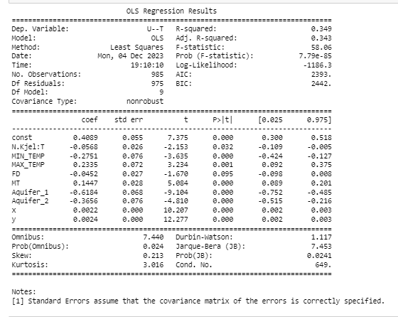
Figure 6.4: Summary of Ordinator Least Squares (OLS) auto-regression for U with the full dataset with 8 features.
The auto regressive model for Uranium was optimized with nine independent variables: 'N.', 'MIN_TEMP', 'MAX_TEMP', 'FD', 'MT', 'Aquifer_1', 'Aquifer_2', 'x', 'y' with a summed score of -1.8067 (Section 9.9, Appendix). Adjusted r squared is 0.34 + accounting for 34% of the variance of UT from these variables. The F statistic is 58.06 and associated p-value is extremely small suggested that these group predictors add statistical significant explanatory power to the model compared to something without any predictors. The log likelihood is still extremely high which does call into question the accuracy as there are a ton of residuals. AIC and B I C are extremely large and thus may not be ideal or generalizable for other data sets.
Nitrogen has a t value around -2.15 and p-value of 0.032 which makes it somewhat statistically significant. This did not appear in the factor analysis or in any correlation. Maximum temperature, minimum temperature, minimum temperature difference (MT), One aquifer group one and aquifer group 2 both have significant T values, p-values And standard errors that are less than their confidence intervals thus suggesting that they add statistical significance. X distance and y distance have significant T and P values, no standard errors and a very small confident interval which could indicate significance or could indicate potential errors. FD or the difference in expected and stimulated precipitation was a major factor behind 10 model however it's p-value is 0.095 and less is not statistically significant.
The residual tests indicate that the distribution of residuals is slightly right skewed (skew .2013) and has a light tail relative to a normal distribution. the Omnibus and JB tests along with their respective probabilities are both less than 05 and indicate that the residuals are not normally distributed. The Durbin Watson values 1.1171 suggests positive Orc autocorrelation in the residuals and a moderate conditional number of 649 suggests that there is no serious multicollinearity issue.
Uranium in groundwater for British Columbia had nine predictor variables: nitrogen, minimum temperature, maximum temperature, mt, aquifer Group 1, aquifer group 2, X, y, and FD. FD was not statistically significant. Nitrogen had a negative coefficient, and this is associated with lower uranium concentrations. This may be due to a possible few explanation. Make participate in redox reactions that immobilize uranium Nitrate can complex and with and immobilize uranium ions (UO2(NO3)2. Areas with anthropogenic nitrogen could promote competing microbial processes that outcompete uranium mobilization. Microorganisms can also involve in denature vacation can also utilize nitrate and instead of oxygen as their final electron acceptor and reduce the oxidizing conditions needed to keep uranium soluble.
Aquifer group 2, aquifer Group 1 and aquifer group 2 both have negative coefficients. The negative coefficient for aquifer Group 1 maybe due to multiple reasons. One is that there's a greater potential for oxid conditions in shallower aquifers that promote uranium precipitation and immobilization. Likewise, they increase microbial activities in the toxic near surface zones and may promote more immobilizing uranium reduction pathways. Higher permeability and porosity allow for more rapid groundwater flow and can transport uranium out of the system before a buildup of concentration. The shallower depth can also result in less geochemical buffering of reducing conditions that favor dissolve uranium. Aquifer group 2 represents confined aquifers. The consignment might isolate aquifer water from rapid recharge events that transport U throughout the system and can prevent anthropogenic uranium contamination from entering the aquifer. Likewise, there could be a special component as U is more favored in more Bedrock fractured aquifers. Competition with other redox active solutes in late due to Due to longer residence time. Shared loading variations in the sediment and let the lithology Chemistry Between the confined and confined aquifers might impact you search and mechanisms. Previous glacial loading cycles may have compacted and cemented combined sediments and hampering the pour water and thus you Mobility. Last hydraulic heterogeneity is reduced due to the lack of mixing with shallow groundwater.

Both X and Y which are the cartesian equivalents of latitude and longitude had a negative loading. This could be due to anthropogenic means as the Southwest would be more heavily polluted due to population in previous industry. It could also mean a potential difference in Bedrock and groundwater and Bedrock materials. Partial auto correction could help add further information to understand if this is an actual pattern or due to basic geology and geography.

Minimum temperature had a negative coefficient for uranium OLS regression models while maximum temperature had a positive coefficient along with mt. *****Ask About this?****

  - Ordinary Least Squares Auto Regression Models with Climate Change Events

Auto regressive OLS models similar to the ones used in R were used to analyze data sets for different climate change events or all four metals of Interest (Section 9.9, Appendix). Included are the entire 18 or 19 independent variables.
    - Ordinary Least Squares Auto Regression Models with Saltwater Intrusion, Drought, Flooding, Increasing Minimum Temperature and Increasing Maximum Temperature for As
Table 6:1: Statistically significant predictors from OLS regression models for As in B.C. groundwater. + represents a positive coefficient, – represents a negative coefficient while * represents variable only included in the regression model for the main data. Note that the model for the main dataset was done via a two-step autoregressive technique while SWI, drought, flood, Rising Maximum °C and Rising Minimum °C utilized an R like formula..
 | Main | SWI | Drought | Flood | Rising Maximum °C | Rising Minimum °C
Alkalinity | + |  | + | + | + | +
Chloride | - |  | - |  | - | -
Fe | + | + | + | + | + | +
P | + |  | + |  | + | +
Sulfate | + | + | + |  | + | +
Hardness* | +
K | + | - | + |  | + | +
pH |  |  | +
Residue Filterable |  |  |  | +
Time | - |  |  |  | -
x | - | - |  |  |  | -
N |  | - |  |  |  | -
Aquifer_1 |  | + | + | + | + | +
Aquifer_2 |  |  | + | + | +
Aquifer_3 |  | - |  | +
Precipitation |  |  |  | -
Maximum °C |  |  |  | -
Minimum °C |  |  |  | +

For Arsenic in SWI adjusted R2 values was 0.486 (Section 9.9, Appendix). The data set for saltwater intrusion had a large difference between the adjusted and regular R Square value thus indicates that a lot of the predictors might not be contributing significantly to the model. The F statistic was 6.5 and only small and p-value was extremely small suggesting that said predictors as a group statistically add significant explanatory power to the model in comparison without any predictors. The log likelihood is still negative and thus adds concern to these findings, but the AIC and BIC are far lower and thus indicates a better fit than the entire data set. Only iron, nitrogen, Potassium, sulfate, Aquifer Group 1, aquifer group 3, and X distance Create add appropriate t, p, and confidence intervals. The distance was extremely small and thus insignificant. The residual data statistics showed that the distribution of residuals was slightly and had a heavy tail relative to the normal distribution. the German Watson statistic suggests there's a slight positive autocorrelation in the residuals. Given that the probability of both the old omnibus and Jacques-Bura were greater than 0.05 and indicates somewhat more of a normal distribution. However, the large conditional number suggests serious multicollinearity issues.
An OLS regression for arsenic with saltwater intrusion gave 7 key predictors: iron, nitrogen, sulfate, potassium, aquifer Group 1, aquifer group 3 and X which is the Cartesian equivalent of latitude. Sulfate and iron are consistent throughout the OLS regressive models for the main data set and for each of the climate change events. This is likely due to general rock geochemistry. Nitrogen has a negative coefficient and this may be due to the organic nitrogen which influences subsurface biogeochemistry. Microbes may actively respire as(V) over other metals under nitrogen-rich conditions which effectively immobilizes some arsenic through intracellular incorporation. During droughts or floods, the redox conditions influencing arsenic may be dominated more by changes in oxygen, iron or sulfate levels rather than microbial nitrogen processes.

The coefficient for potassium is negative for As in groundwater with saltwater intrusion. At higher potassium levels, pH and alkalinity is increased by carbonate weathering and favors the absorption of arsenic ions onto iron oxide surfaces. Mineral alteration reactions driven by potassium could also liberate iron from silicate minerals and enhance the precipitation of f e o h 3 that co-precipitates arsenic. Higher potassium concentrations could also shift the redox buffering in a way that preserves iron as Fe(III) Arsenic which retains arsenic instead of the mobilizing Fe(II). Last, this could also be due to aquifer lithology differences that correlate with k. Phosphorus is not a predictor perhaps due to data limitations as there's insufficient special temporal measurements and perhaps just lack of synoptic sampling with P and As that obscure a statistical relationship.
Aquifer groups had a unique relationship with arsenic in groundwater with saltwater intrusion. the coefficient for aquifer Group 1 was higher than other regressive models for other climate change factors. These aquifers are primarily unconfined Fluvial and glacial Fluvial sediments that often interact directly with surface water. these aquifers are more vulnerable to tidal pumping effects from The Saltwater interface and hence that could drive more redox fluctuations. Aquifer group 3 at a negative coefficient as the Fluctuation driven by tides and pumping are attenuated aquifer type 3 and preserve the more oxid conditions that favor cynic retention. Sedimentary and crystalline Bedrock is also located in higher elevations and therefore likely to experience less title influence and mixing. Group 2 is not a predictor aquifer group 2 is not a predictor perhaps due to the special resolution of well data which would fail to sufficiently characterize heterogeneity behavior with saltwater intrusion in confined aquifers. X, which is the Cartesian version of latitude, has a negative relationship stating that it has to be proximal to the coastline.
Ordinary least squares regressive models for droughts and arsenic had an adjusted R square value accounting for 34% of the variance of As (Section 9.9, Appendix). F statistic was large, and the probability of f statistic was close to zero thus indicating that the model is more statistically significant with the predictors than without. The log likelihood was negative and far larger than saltwater intrusion as was the aicnbic which indicates that said model might not be accurate for other data sets and as predictors. Alkalinity, chloride, phosphorus, sulfate, pH, potassium, aquifer group 1, aquifer group 2, and X distance all had statistically significant p-values, appropriate T values, appropriate and appropriate confidence intervals. the residual statistics indicate that this is slightly right skewed and has a very strong tail and slight relationships between the predictors. the probability of the Omnibus and JW are close to zero and indicate that the residuals are not normally distributed. the conditional number is extremely large and the smallest and value is 5.8 e -30 Indicate that there are strong multicollinearity problems.
The OLS regression model for arsenic and groundwater during droughts had nine predictors: alkalinity, chloride, iron, phosphorus, sulfate, pH, potassium, aquifer Group 1 and aquifer Group 2. Aquifer Group 1 had a positive coefficient as lowering of the water table will introduce more arsenic containing rock to oxidation. At higher pH levels, arsenite and arsenate are more soluble and mobile in water. Lower pH favors absorption of arsenic onto metal hydroxide surfaces. The oxidation of iron minerals during drought releases previously sequestered arsenic which would be more soluble at higher pH prevailing in the aquifer. Aquifer group 2 is a positive but low coefficient and represents aquifer confinement. This might be due to mineralogical factors as the confined nature and relational sediments of the aquifer group 2 may contain higher levels of arsenic bearing minerals like sulfides compared to aquifer 1 sediments, which would be more likely to degrade and release arsenic under drought stress. Aquifer group 3 may not be a significant predictor because of aquifer heterogeneity, and this should be investigated in future research. Is commonly associated with bicarbonate ions and suggests a potential shared geochemical control. Bicarbonate is also associated with higher arsenic. More data and analysis on this relationship should be a focus with future research for predictive modeling. Last, chloride had a negative coefficient syndicating longer residential times and may signify more rapid flushing throughout the aquifer. It is likely that there could also be a geochemical or microbial influence prevented by chloride.
Flood data OLS regression for arsenic using flood data had similar results to wrote data to drought data (Section 9.9, Appendix). The predictors that had appropriate P, t, and confident intervals were alkalinity, chloride, nitrogen, phosphorus, sulfate, Aquafer Group 1, X distance and time. X distance and time had very small coefficients. Like the drought model, the residuals were skewed, had a high tail, and a non-normal distribution. And small a high conditional number and small engine value of 9.3e-30 indicated significant multicollinearity problems.
The OLS regressive model for arsenic in BC groundwater with flooding conditions had nine key predictors: Alkalinity, iron, residue filterable, precipitation, minimum temperature, maximum temperature, aquifer Group 1, aquifer group 2, and aquifer group 3. All three aquifer groups have similar positive coefficients that were greater than that in drought. This might be due to floods drastically altering hydraulic low paths and residence times within the aquifers. This destructive flushing will mobilize arsenic for more sources and also bring in anthropogenic Nick from the surface. Floods also increase weathering and can increase biological activity due to bringing in Greater nutrients. Alkalinity had a positive coefficient that isn't as high as droughts or other climate change events perhaps due to the dilution effect of floods. Sulfate, potassium, and phosphorus are not predictors in Arsenic with flooded groundwater. this might be due to the weekend relationship with alkalinity as all three are found with the bicarbonate and carbonate reactions. residual filterable has a positive coefficient and that might be due to it serving as a substrate vehicle for arsenic transportation during flooding either from natural weathering sources and sediments or anthropogenic contaminated soils. precipitation has a negative coefficient due to the dilution effect by incoming rainfall. more data and studies are necessary to understand specific mechanisms of precipitation on arsenic. Minimum temperature had a positive coefficient well maximum temperature had a negative coefficient. this indicates a very complex relationship between the Arsenic and temporal factors that will require future research to unravel. it could be that maximum temperature introduces more snow melt and run off the encouraging the dilution effect. well minimum temperature indicates more gradual warming and increases redox reaction rates.
Ordinary least squares regression model for arsenic with rising maximum temperatures had a similar model data for arsenic in the flood and drought data (Section 9.9, Appendix). Alkalinity, chloride, iron, sulfate, potassium, Aquifer Group 1, X distance and time had significant t and p-values with appropriate confident intervals. Aquifer Group 2 had appropriate t and p values but had confident intervals that passed zero. X distance and time also have very small coefficients. The residue data was slightly skewed and highly tailed. The Omnibus and JB probabilities indicate that the data is not normal and the high conditional values along with the smallest eigenvalue indicates that there is a strong multicollinearity problem with this model. Rising minimum temperature for all metals contain and follow the similar trend to that of rising maximum temperatures (Section 9.9, Appendix).
The OLS regression model for arsenic in groundwater with increasing maximum temperatures had nine key predictors: alkalinity, chloride, iron, phosphorus, sulfate, potassium, Aquifer Group 1, Aquifer Group 2 and time. While OLS regressive model for arsenic in BC groundwater with increasing minimum temperature also had nine key predictors: alkalinity, chloride, iron, nitrogen, phosphate, potassium, Aquifer Group 1, and X. Aquifer Group 1 is shallow, unconfined and hydraulically connected to water, hence probably more affected by Rising surface temperature.
    - Ordinary Least Squares Auto Regression Models with Saltwater Intrusion, Drought, Flooding, Increasing Minimum Temperature and Increasing Maximum Temperature for Mn
Table 6:2: Statistically significant predictors from OLS regression models for Mn in B.C. groundwater. + represents a positive coefficient, – represents a negative coefficient while * represents variables only included in the regression model for the main data. Note that the model for the main dataset was done via a two step autoregressive technique while SWI, drought, flood, Rising Maximum °C and Rising Minimum °C utilized an R like formula.
 | Main | SWI | Drought | Flood | Rising Maximum °C | Rising Minimum °C
Alkalinity | + | - |  | + | + | +
Chloride |  | -
P |  | +
Specific Conductance |  | + | + |  | + | +
Residue Filterable | - |  |  |  | -
pH |  | - | - |  | - | -
Fe | + |  | + | + | + | +
K | + | + | + | + | + | +
N | + |  | + | + | + | +
x | - | - | - | - | - | -
y |  | - |  |  |  | +
Aquifer_1 | -
Aquifer_2 |  | +
Aquifer_3
Maximum °C | - |  |  | - | -
Minimum °C | + |  |  |  | +
Hardness* | +
FD* | +
HW* | +
MT* | -

Manganese for saltwater intrusion had an adjusted r squared of 0.64, with the similar differences as in the Arsenic model (Section 9.9, Appendix). It had an F statistic of 11.34 and an extremely associated small p-value, suggesting that there's a significant explanatory power to the model using the predictors as a group, however not all predictors might be contributed significantly to said model. The log likelihood was still negative but less so than arsenic along with lower AIC and BIC values. Alkalinity, fluoride, specific conductance, pH, potassium, Aquifer Group 2, Y distance and X distance all had statistically significant p-values, T values, appropriate standard error and contra confidence intervals. X and Y distance did not significantly contribute to the model. The tests of residuals indicated that there was a slight right skewness with a heavy tail relative to normal distribution. The Durban Watson statistic was 1.412 and suggested a slight positive or autocorrelation. Both the probability of the Omnibus and JB tests were greater than 0.05 and indicated a normal distribution for the residuals. However again the conditional number extra was extraordinarily large and thus there might be serious multicollinearity issues. There are squared and previous models, the more predictors might suggest the model being overfitted.
Manganese contamination in groundwater with saltwater intrusion had a different set of conditions compared to regular data. This is due hardness and HW or Mt being dropped from the data set to minimize multicollinearity issues and to the differing method of regression used. The main data set used a two-step auto regression model while the methodology for the climate change factors used R like formulas. The saltwater intrusion data set was significantly smaller compared to the main data set with all characteristics. This may explain why there are more larger coefficients and different characteristics in the saltwater intrusion data set. A lot of the variables in the had high p-values. The coefficients of both rising minimum and maximum temperatures seem to be very similar to the coefficients of the drought model without pH. The subtle coefficient difference between minimum and maximum temperatures may be due to lack of data and do require further research. However, this model indicates that maximum and minimum temperatures do have subtle influences over biogeochemical and biological mechanisms of arsenic contamination in groundwater. Maximum and minimum temperatures could influence arsenic mobility through different geochemical or biological pathways operating at different intensities. Maximum temperatures might also be influential in short-term processes like oxidations while minimum temperatures might influence more weathering. Similarly, non-linear response of arsenic to temperature would have different optimal ranges for maximum and minimum values that would only be partially captured by the model. Seasonality and spartial patterns will be an issue for interactions.
Alkalinity and potassium continued to be a key variable in the saltwater intrusion regression model. Other rock chemistry factors were replaced by pH, phosphorus, specific conductance, and chloride; all saltwater intrusion variables. Specific conductance and chloride are an inverse of each other and could represent the difference between saltwater intrusion influence and regular rock geochemistry. Negatively correlated and thus perhaps carbonate geochemistry in more mineralized water favored Mn immobilization. pH once more had a negative effect, with lower pH solubilizing Mn and saltwater intrusions buffing pH upwards. Both X and Y, which represents latitude and longitude, are variables that could represent distance to the coastline due to the negative value. Aquifer Group 2 represents confinement and is perhaps more indicative of saltwater intrusion rather than hydraulic connectivity.
Manganese concentrations in drought showed a regression model that had an adjusted r squared of 0.64 and a strong indication that not all model predictors contributed to the model (Section 9.9, Appendix). The F statistic was 11.35 with probability less than zero, signifying that this group of predictors were still more statistically significant than nothing. The log likelihood was less negative than the arsenic model and the AIC and B I C were comparatively lower than, indicating that this model is still a better fit compared to arsenic. Alkalinity, chloride, pH, potassium, Aquifer Group 2, X distance and Y distance all had acceptable t, P-values, and confident intervals. Specific conductance, maximum temperature and phosphate had relevant P intervals but confidence intervals that either included zero or were less than the standard error. X distance and Y distance were extremely insignificant due to the low coefficient. The residual plot showed slight skewness, a very strong tail, and normal distribution given the probability of the Omnibus and JB statistics. The conditional number was extremely large and the smallest eigenvalue was 3.46e-31 and indicated strong multicollinearity problems.
Manganese with drought data for the OLS model showed similar values of Fe, N, K, and residual non- filterable as the main Mn models, specifying that there were still some underlying groundwater mechanisms and weathering mechanisms. As X was the substitute for latitude the data may indicate a special trend of low-lying wetland areas with longer saturation or mixing of surface groundwater. Interestingly enough hydraulic connectivity and aquifer confinement didn't seem to be as influential with coefficients. This might be due to the lack of data. pH and specific conductance followed similar trends to that of saltwater intrusion and along with K, were positively associated to drought influences and point to drought preferably impacting permanent permeable marginal zones with enhanced activity and weathering potential.
OLS regression for Mn with flooded data again had similar results to drought data (Section 9.9, Appendix). Predictors that had appropriate p, t, and confidence intervals were alkalinity, chloride, nitrogen, phosphorus, sulfate, pH, potassium, Aquifer Group 1, and X distance. X distance and time had significantly smaller coefficients. The residual distribution are similar of that as arsenic with strong multicollinearity t problems.
In flood, Mn regression models showed the same coefficients as drought values for Fe, N, and K. These coefficient values along with alkalinity being positively correlated, suggest that floods shifted favourable redox conditions in Mn solubility via mineral weathering and microbial processes. Reduced recharge allows for longer rock water interaction time and potentially leaching cations will initiate reducing conditions. Maximum temperature however has a negative effect, potentially reflecting the increased Mn precipitation and absorption under concentrated conditions.
Manganese with rising temperatures follow the same pattern as compared to the OLS regression model of drought data (Section 9.9, Appendix). Rising minimum temperature for all metals contain and follow the similar trend to that of rising maximum temperatures (Section 9.9, Appendix).
The regression model with increasing maximum temperature That of drought. and flooding. with the Maximum temperature increasing, both flooding and drought-like events occur due to run off and precipitation pattern changes. Therefore, it was difficult to discern and differentiate groundwater mechanisms. Minimum temperature had a positive coefficient reflecting the ambient thermal conditions controlling reaction kinetics, warmer minimum temperatures and solubility up to an optimal point. Meanwhile, maximum temperature influenced kinetics but exceeded the inflection point where increased precipitation and absorption of manganese dominates. Maximum temperature captures temperatures where inhibition effects could occur while minimum temperature only isolated seasonal low points with favorable solubility.
The increasing minimum temperature data set gave similar results to the increasing maximum temperature data set but without temperature as coefficients perhaps due to modeling limitations. Y, which represents the cartesian equivalent for longitude, is also a factor and could indicate how increased ambient temperatures are more affected by climate change in more northern areas
Ordinary Least Squares Auto Regression Models with Saltwater Intrusion, Drought, Flooding, Increasing Minimum Temperature and Increasing Maximum Temperature for Pb
Table 6:3: Statistically significant predictors from OLS regression models for Pb in B.C. groundwater. + represents a positive coefficient, – represents a negative coefficient while * represents variable only included in the regression model for the main data. Note that the model for the main dataset was done via a two-step autoregressive technique while SWI, drought, flood, Rising Maximum °C and Rising Minimum °C utilized an R like formula.
 | Main | SWI | Drought | Flood | Rising Maximum °C | Rising Minimum °C
P | -
Residue Filterable | + |  | + | + | + | +
Sulfate | - | - | - |  | - | -
HW* | +
Time | - | -
Fe |  | + | + | + | + | +
K |  | - | - |  | - | -
Aquifer_1 |  | + | + | + | + | +
Aquifer_2 |  | + | + | + | + | +
Aquifer_3 |  | + | + | + | + | +
N |  |  | -
Precipitation |  |  | - | - | - | -
Specific Conductance |  |  |  | -
Minimum °C |  |  |  | +
Maximum °C |  |  |  | -
pH |  |  |  |  | + | +

Nitration model for lead had less of a distance between r squared and adjusted r squared and accounted for about 76% of the variance (Section 9.9, Appendix) for SWI. The F statistic and the probability of that statistic was extremely low and thus suggested that there was a statistical significance of all of the predictors versus no predictors on the variance of PB. Iron, sulfate, potassium, Aquifer Group 1, Aquifer Group 2, Aquifer Group 3 and time had appropriate t, P-values and confidence intervals. The residual statistical descriptions were similar however strong multicollinearity problems were indicated by the conditional number and the fact that the smallest eigenvalue was 3.46 e -31.
OLS regressive model for lead in wells with saltwater intrusion had seven variables: iron, sulfate, potassium, Aquifer Group 1, Aquifer Group 2, Aquifer Group 3 and time. Time was explained in the main analysis. Iron is consistent throughout all models for different climate change factors and seems to be related to general groundwater chemistry when it comes to association with lead. This was previously supported in the exploratory data analysis.
The coefficient for potassium is relatively large for the Pb regression model with saltwater intrusion compared to the regression models of other climate change factors. This might be due to precipitation effects as in saltwater, lead sulfate and lead carbonate precipitates and potassium promotes the carbonate alkalinity supporting the carbonate precipitation of lead. Ion screening from elevated potassium levels promoting the de-absorption of lead may also be an explanation. Precipitation is an indirect influence and may already act through other drivers such as dissolution rates or redox conditions and thus do not show as a main predictor. In general for Aquifer Group 1, the hydraulic connection to the surface in unconfined settings influence geochemical fluctuations that affects Pb solubility. Increased sediment water interactions leaching lead from deposits over time, can introduce anthropogenic lead sources easily, and lower streams and beds may drain natural landscapes with higher lead into the aquifer. As showing in Mn, Aquifer Group 1 has a far smaller coefficient than the other OLS models for other climate change factors. This is as the hydraulic connectivity is not as influential on saltwater intrusion compared to those without.
The regression of lead followed a similar pattern as the regression of Mn with the flood data set but without less of a difference between the R squared and adjusted R square value (Section 9.9, Appendix). This signifies that not all of the predictors make up most of the model. The AIC and BIC values were significantly larger while the log likelihood was significantly negative thus indicating a potential poor fit or poor generalizability. Nitrogen, iron, potassium, precipitation, Aquifer Group 1, Aquifer Group 2, Aquifer Group 3, and time had appropriate T values, statistically significant P-values and appropriate confidence intervals. Y distance and residue filterable had appropriate P-values but confidence intervals that included zero. Likewise, there's some linearity with the Durban Watson test and the residue is right skewed with a very strong tail, and highly unlikely to be normal due to the probability of both the Omnibus and JB statistics being close to zero. The conditional number is extremely high, and the smallest eigenvalue is 5.8 e - 30 and indicated strong multicollinearity problems.
Modeling for lead in groundwater with flood conditions gave nine key predictors: residual filterable, specific conductance, precipitation, maximum temperature, minimum temperature, Aquifer Group 1, Aquifer Group 2 and Aquifer Group 3. Sulfate and potassium are not predictors potentially due to modeling. Other explanations could be that flooding introduced large pulses of sulfate from soils and sediments but it may not behave conservatively without prolonged contact time for reactions. The reducing conditions that sulfate requires to precipitate lead may not develop rapidly enough either.
Potassium impacts are also more gradual through competition and iron shielding at Mid mineral surfaces over a longer time scale then sliding. Likewise, the dilution effect from higher water flows may dilute point sources of sulfate and potassium before they can significantly modify Pb values. Specific conductance had a moderate negative coefficient to lead regression model. Waters with higher conductivity have greater buffering capacity against pH changes caused by floods and thus maintain in less soluble forms. Flooding can transport lead which is intuitive more quickly through natural treatment functions in more mineral-rich waters that are indicated by higher specific conductance values
Iron as a predictor for lead in flooded groundwater is lower and has a lower coefficient than other climate change regression models. This might be due to the fact that most iron enters aquifers as insoluble oxides and hydroxide that slowly dissolve over longer times time scales than a flooding event. The recharge water carrying iron are flush through more quickly under high flow conditions and have limited rock water interaction times. Aquifer Group 3 had a higher coefficient than other OLS models for the other climate change influences. The influence of fractured bedrock on lead for concentrations during floods might be due to connectivity as the dense fracture network allows for flood waters. Rapid deep infiltration to mobilize and transport lead over graded greater distances Within bedrock. flux and also with high hydraulic conductivity and actress concentrates the flow and associate in contaminate loading through bedrocks. and despite conducts, water resides intensively in Bedrock matrices allowing for more complete PB dissolution from minerals and fractures. Wells, production wells tapping fractures face also an elevated risk of direct contamination from flood borne plumes.
Minimum temperature has a positive coefficient while maximum temperature has a negative coefficient for lead in flooded groundwater. Iron maximum temperature can promote late enhanced Pb precipitation by pushing geochemical conditions towards less soluble phases. Higher solubility and a negative temperature fit a negative correlation. Lead also has a seasonal fluctuation and the metal requires Pb to transition between solubility regions each cycle. Peak solubility often occurs at immediate rather than extreme high/low temperatures. Likewise, plant and microbial activity that is attenuating Pb might be higher at an optimal temperature range and decline at very low/high maximum extremes. Minimum temperatures have a positive coefficient and promotes solubility factors that are perhaps more apparent with climate change.
OLS regression for lead in drought data follow the same pattern as regression in flooded data with similar model statistics (Section 9.9, Appendix). Iron, nitrogen, phosphorus, residual filterable, specific conductance, pH, precipitation, Max temp, Min temp, all three aquifer groups, X distance and time had acceptable t, P, and confidence intervals. X distance and time had very small coefficient so this can be excluded, and alkalinity had a standard error that was greater than its country confidence interval. Minimum and maximum temperatures were inverse of each other. The residue data was similar to that of drought conditions and showed strong multicollinearity problems.
The OLS regressive model for lead in groundwater undergoing droughts had nine predictors: iron, nitrogen, residue filterable, sulfate, potassium, precipitation, Aquifer Group 1, Aquifer Group 2, and Aquifer Group 3. Residual field triple filterable may be due to groundwater properties with concentration effects. Nitrogen has previously been shown to correlate with drought. To lower this may lead to lower Pb concentration in groundwater either due to geochemistry or biological means. Nitrate reducing bacteria could create more reducing conditions and favor for the precipitation of insoluble lead sulfides or mobilized nitrates could act as alternative centers for microbial reactions and reduce the oxidative dissolution of Pb bearing solid bases. Higher nitrogen also may signify agriculture anthropogenic influences which come with more introduced organic ligands that form complexes with immobilized ions. Nitrogen rich, especially nitrate rich waters may be more buffered and help maintain a Ph range where lead minerals have low solubility despite the increased rock water interactions during drought.
Rising minimum temperature for all metals contain and follow the similar Trend to that of rising maximum temperatures (Section 9.9, Appendix).
OLS regression model for lead with increasing maximum monthly temperatures had nine key predictors: iron, residue filterable, sulfate, pH, potassium, precipitation, Aquifer Group 1, Aquifer Group 2, and Aquifer Group 3. pH could possibly influence lead levels under increasing temperatures as the pH of absorption to aquifer solids generally decrease with higher pH since surfaces become more negatively charged. As temperature rises equilibria generally shifts to consume more hydrogen ions and indirectly raises pH through increased alkalinity. Higher pH could also mean that there was a shift in the microbial community at higher temperatures that disrupted demobilization.
Aquifer Group 2 was consistent throughout different scenarios. Confined settings mean less fluctuation in the geochemical and hydraulic conditions compared to unconfined aquifers and may result in longer residence times to facilitate continuous rock water reactions, lower permeability, concentrate solutes like Pb and higher late sediments with higher natural Pb. This represents more of the geochemical processes over time rather than transient factors that most influence elevated Pb levels. The regression model influencing minimum temperature for lead is very similar to that of maximum monthly temperature.
The residual plots show said skews and show especially the extreme right skew with lead. The box plots demonstrate the variability of the data, and the quantile plots indicate the likelihood of the fit (Section 9.9, Appendix). Lead itself has very poor fitting
    - Ordinary Least Squares Auto Regression Models with Saltwater Intrusion, Drought, Flooding, Increasing Minimum Temperature and Increasing Maximum Temperature for U
Table 6:4: Statistically significant predictors from OLS regression models for U in B.C. groundwater. + represents a positive coefficient, – represents a negative coefficient while * represents variable only included in the regression model for the main data. Note that the model for the main dataset was done via a two-step autoregressive technique while SWI, drought, flood, Rising Maximum °C and Rising Minimum °C utilized an R like formula.
 | Main | SWI | Drought | Flood | Rising Maximum °C | Rising Minimum °C
Alkalinity |  | + |  | + | + | +
Sulfate |  | + | + | + | + | +
Chloride |  |  | - |  | - | -
K |  |  | + | + | + | +
Fe |  |  |  | - |  | -
N | - |  |  | -
X | +
y | + |  |  | +
Precipitation |  |  | - |  | - | -
pH |  | -
Time |  | + | + | +
Aquifer_1 | - | - | - | - | - | -
Aquifer_2 | - |  | - |  | - | -
Aquifer_3 |  | + | + |  | + | +
Min Temp | -
Max Temp | +
MT* | +

Uranium regression models for saltwater intrusion showed a similar pattern to lead (Section 9.9, Appendix). Alkalinity, sulfate, pH, Aquifer Group 1, Aquifer Group 3, and time should appropriate P and t values with competent intervals. Residual summary statistics were similar to that of the previous two metals. The strong conditional number and the fact that the smallest eigenvalue is 3.46e- 31Multicolineary problems. The residual matrices of all four metals were plotted in histogram form, box plots and in Quantal-quantal forms. Normal distribution was seen in all of them and most generally met expected QQ plots.
The OLS regression model for uranium with saltwater intrusion had seven statistically significant predictors: alkalinity, sulfate, pH, Aquifer Group 1, Aquifer Group 3, and time. Sulfate seems to be a predictor for all climate change variables and thus must be due to general groundwater chemistry. Time is a positive coefficient and states that uranium concentration increases with longer sampling time. This is consistent throughout the other climate change regression models and perhaps the difference of that in comparison to the general uranium OLS regression model is due to the methodology. This can be as described before or groundwater circulation allowing for more complete mass transfer of uranium in mobile aqueous complexes. Aquifer Group 1 had a higher negative coefficient than that of other climate change influencers and showed regression models for uranium but it's similar to that of the main uranium OLS regressive model. Sandy and gravely settlements especially with great hydraulic hand activity has greater surface area per volume for Uranium ions to absorb onIn comparison to other geological factors in aquifers experiencing title fluctuations or saline incursion.. Reactive iron/manganese oxyhydroxide and clays precipitated into pour space can provide abundant nanoscale absorption sites. The final grain in textures and pour water chemistries altered by seawater mixing also provide highly reactive conditions that favor uranium absorption and precipitation from groundwater over time. Aquifer Group 3 represents more fractured and bedrock aquifers and has a positive coefficient. Fractured bedrocks have fewer available sites for uranium absorption than sediments due to its smaller surface area to volume flow through. This allows intrusion-driven geochemical changes within fractured networks to liberate uranium from stagnant zones that flush through cyclic flows. Saltwater intrusion can alter bedrock geochemistry over a long-time scale which could encourage uranium release from fractured coatings or low permeability matrix zones. Other changing geochemical conditions driven by intrusion fluctuations may induce periodic dissolution / representation of uranium among migration in pathways in the bedrock.
In contrast to a lot of the factor analysis for U, alkalinity only appears for saltwater intrusion as an OLS regression predictor. This might be due to the dynamic geochemical change caused by fluctuating saline conditions that promote continued rock water interactions and carbonate mineral dissolution over the long-term in a way that static freshwater does not, or the unique biogeochemical conditions selected for brackish mixing optimizing U microbial uranium-alkalinity transformation. pH as a negative coefficient suggested that uranium preferentially partitions out of solutions under alkaline conditions. In carbonate rich environments impacted by saltwater intrusion, a more alkaline pH promotes uranium precipitation as part of the carbonate hydroxide phases. Saltwater intrusion mixes with fresh water and I'll see my magnesium are replaced by sodium through ion exchange reactions which release protons and lower the ph. acidic conditions favor uranium existing in the more mobile U02 form. Aquifer Group 2 was not a predictor. Fine grain sediments, silts and clays have properties intermediate between croissants and gravels and fractured bedrocks in terms of reactive surface area and groundwater flow patterns. The behavior concerning uranium absorption and the absorption dynamics and mobilization propensity during an intrusion event may not differ markedly compared to the other two aquifer groups. Chemical and geochemical reactions influencing uranium solubility and transports in silts and clays could also be more temporal Transit and kinetically complex than other lithologies.
Uranium followed a similar pattern to lead with both the model and residue residual regression results (Section 9.9, Appendix) for drought. Chloride, sulfate, potassium, minimum temperature, Aquifer Group 1, Aquifer Group 2, Aquifer Group 3, and X-distance along with time had appropriate standard errors, T values, P-values and appropriate confidence intervals. The residual is slightly right skewed, highly tailed and likely more normalized due to the probability of Omnibus and JB tests being greater than 0.05. The conditional number is extremely large and the smallest eigenvalue is extremely small indicating significant multicollinearity problems.
Kohl's are seen on the residual plots the strong Tales are seen on the residual plots along with the variances and the until Quantum plots for all four metals for drought. note that Is somewhat linear but slightly off (Section 9.9, Appendix).
The OLS regression model for uranium in drought like conditions had 8 key predictors: chloride, sulfate, potassium, precipitation, aquifer Group 1, aquifer group 2, aquifer group 3, and time. Tends to concentrate Shows that drought appears to concentrate uranium by limiting recharge and promoting geochemical conditions uranium the precipitating uranium isotopes. chloride sources from weathering of silicate minerals and halite dissolution can be concentrated in drug like conditions. in more General redox/ph conditions uranyl chloride complexes (i.e. Na2[UO2(CO3)3]) May form removing you from solution. actually, variable ethology will control natural chloride sources and transport for influence localized uranium behaviors under drought stresses. Positive relationship with uranium potassium has a positive relationship with uranium and higher levels of that may indicate more weathering of silicate minerals that release uranium. Precipitation has a negative coefficient and this could be due to the lowering watering table and reduction of dilution and flushing of uranium out of aquifers. this leads to the concentration effects dominating over any geochemical influence is from rainfall that might precipitate uranium.
uranium Mobility is also governed by aquifer lithology. For both OLS regression models, the main data set, drought, And both increasing minimum and maximum temperature a negative had a negative coefficient for aquifer group 2. these are summarized as fine grained sedimentary aquifers like silts and Clays that are confined. fine grain sediments provide more abundant substrates for Ural ion to absorb on to Via Electrostatic electric attraction and precipitation compared to bedrock. the high specific surface area and reactivity enhances uranium sequence equation under concentrated drought geochemistry. this might also indicate that future research should look at repeated wet-dry cycling and to see if uranium absorption and desorption waves onto sediments over seasonal or multi-year time scales following a drought.
likewise the OLS model for uranium in drop That a flood data followed a similar pattern to that of flooded data (Section 9.9, Appendix). alkalinity, iron, nitrogen, sulfate, potassium, aquifer Group 1, why distance and time had acceptable standard errors, T values, p-values and confidence intervals. x distance how to confidence interval that involves zero and hence indicates an unlikely predictor and why with time both had small coefficients. the residual data was similar to that of uranium from flooded data showing a non normal skewed with a high tail data set that is highly likely to have strong multicollinearity problems.
For uranium in flooding conditions, the OLS regression model had eight key predictors: alkalinity, iron, nitrogen, sulfate, potassium , aquifer type 1, Y, and time. nitrogen and iron both have negative coefficients nitrogen and iron both have negative coefficients. anthropogenic nitrogen can be introduced with flooding. Nitrogen can boost the microbial or activity that biological chemically reduces uranium into a less soluble form through denitrification and reduction pathways. likewise nitrogen can also stimulate iron reducing bacteria. anaerobic conditions proliferate in the saturated zone and Trigger biogeochemical uranium immobilization Pathways that are linked to iron and nitrogen. Floods elevated iron mobilized during floods can precipitate uranium as uraninite (UO2) or other minerals through reduction immobilization processes. the dissolved and particular iron from soil and sediments that are introduced by flooding can serve also as an electron donor for microbial uranium reduction.

Note: Organic carbon also influence it.
Y is the Cartesian equivalent for longitude and has a small positive coefficient. given that a lot of the observation Wells are located near the Vancouver and Island area which is a temporal rainforest, this could be a possible explanation. future research should utilize special auto correction to account for topography geology and different climatic zones. aquifer group two is not a statistically significant predictor of uranium concentrations in floods. this might be due to flooding introducing a high flow conditions that any localized effects from variable sediments and Bedrock characteristics on uranium behavior that is prevalent under normal flows. fine grain faces are also likely heterogeneous across the hydrological terrains of BC that's the predictive influence May average out. Major flood events generate complex hydraulic responses that are dependent on local offer for architecture Beyond Simple lithology and thus would be a consideration for future research. strong biogeochemical immobilization of uranium through iron and nitrogen might obscure any separation of Trends across aquifer facies under flooded redox conditions.The three-dimensional hydraulic conductivity of fractured Bedrock might be to .complex for a simple least Square regression Model and the heterogeneous responses to changing water levels and pressure during flooding will complicate correlations to uranium Mobility compared to uniform sediments. Bedrock mineral geology compositions also influences geochemical buffering in less standardized ways. thus additional research that accounts for the intrinsic Bedrock heterogeneity will be likely needed to understand any predictive power it has on uranium. precipitation is not a predictor when it comes to uranium in groundwater with flooded conditions. this might be due to the fact that flood events are driven more by short-term extreme rainfalls rather than longer term monthly precipitation trends. future research will need to look at this on a shorter time scale.

Uranium also followed the same pattern for increasing maximum temperatures as drought data. Ramen box look exactly similar to that of drug data as well. however the quantum region shows that lead deviate significantly and has a lot of outliers.
Rising minimum temperature For All Metals contain and follow the similar Trend to that of rising maximum temperatures (Section 9.9, Appendix).
for increasing maximum temperature, the OLS regression results are similar to that of drought and consist of eight predictors; Alkalinity, chloride, sulfate potassium, precipitation, aquifer group 1, aquifer group 2, and aquifer group 3. alkalinity is likely due to the carbonate bedrock geochemistry in bc. Time or months since for samples is not a predictor for as pure and oral changes previously have not been shown to overcome geochemical systems in a short period of time. likely changes in air temperatures induced geochemical responses over decades instead of visibly fluctuations per what this model can detect. Legacy effects from past land uses in mining could also maintain elevated uranium independent of short-term sampling schedules.
the OLS regression for uranium with increasing minimum temperatures had similar results and patterns to the OLS regression with uranium for increasing maximum temperatures.

Conclusion

With the initial exploratory data analysis for the entire main data set, it is indicative that future research needs to focus on spatial auto correction to further determine whether the influences of metals are in part due to different geoclimatic zones or localized anthropogenic influences. Detrending for seasonality is a potential indicative for future research in order to determine how vulnerable groundwater is in metal contamination that is caused by secondary climate change effects and to understand more of the resilient risks. Moreover, incorporating GIS would account for temperature and climactic zones while utilizing time space cubes would as well include normal seasonal changes. Initial exploratory data analysis indicated that groundwater contamination is often highly influenced by aquifer and groundwater chemistry especially given the high rate of alkalinity influences on most metal contamination relationships between MN and Fe. Incorporating groundwater levels would as well be a necessity for a future model due to understanding the differences in oxidation states. Furthermore, rising specific conductance and chloride indicates that there is a likely link to saltwater intrusion and elevated metal, especially with U, Mn and As in groundwater. However, as this study is more exploratory, definite conclusions will require more validation with a larger data set. Furthermore, low precipitation seems to demonstrate a concentration effect or perhaps a change in redox chemistry. Although drought like conditions showed a stronger but still not above relationship between uranium over the drinking water standard. Meanwhile higher temperatures were very in late related to increased temperatures and increased saltwater intrusion, except did not show a strong enough relationship to determine if leaching and mobilization were enhanced and was more likely due to changes in microbial influences or redox. In addition, flooding often resulted in a dilution effect in a lot of chemist contamination.
The descriptive and summary statistics for the initial exploratory data analysis should indicate more parameters that characterize well mythology and well type. Future research would be best advised to be a GIS analysis that will account for topography and also better link aquifer lithology. The relationship between metal contaminations and other factors seem to be slightly lessened with flooding conditions and completely decoupled due to droughts. This was indicative of Manganese and iron, lead and cadmium, and uranium and calcium or hardness; which was presumably due to flooding keeping the same aim of spread of all plumes and groundwater geochemistry while drought making more localized geochemical reactions matter. This does indicate leeching and mobilization of some metals and the future risks of contaminations within droughts. Further Pearson coefficients for rising minimum and maximum temperature were similar to that of drought and does indicate that there is some sort of leaching that might be decoupled from regular groundwater geochemistry. Moreover, saltwater intrusion completely changed the relationships between geochemical metals and often indicated a lead iron relationship and a relationship between hardness, alkalinity and increased uranium contamination. Lead and manganese were above the Canadian Water Drinking Limit and were indicative of the drought data set and the data set with temperature rise. The saltwater intrusion showed a high amount of samples with lead above Canadian Water Drinking Standard cutoffs but will require more research to verify. This was best characterized by using the sample cut off above 1,000 for specific conductance or above 150 for chloride.
These again are observations that need to be verified against the hydraulic zones of BC, the low flow zones and aquifer lithology along the soiled ill in a special data auto correction preferably with queens and Morris and cringing.
Factor analysis was distracted a great deal by lack of data and smaller sampling sizes. Furthermore, there was a large indication that other variables should be included. Future research should incorporate larger data sets especially when it comes to analyzing the data sets for climate change effects. Factor analysis with the main factor analyzes the largest factor influencing the data set was that of saltwater intrusion and rock geochemistry. This indicates that saltwater intrusion does have an impact on the overall data set and on metal contamination. Further research is needed to verify, especially with a confirmatory factor analysis and to determine how much can be used to assess vulnerability and risk factor of contamination and uranium is as well an influencing factor there. Further a maximum and minimum of another Factor consist of another Factor and therefore indicates that there could be an effect of temperature rise on metal fluctuation in groundwater. Hydraulic connectivity and other aquifer characteristics have a stronger influence than peer precipitation which did not show up as a variable for any of the factors and thus any secondary effects might need a more specific analysis such as non-negative factorization to distinguish further vulnerability and pure temperature effects.
A factor analyzes for saltwater intrusion should be done as future research as the current data set did not have enough sample data. With droughts there is indication that the groundwater chemistry slightly shifts with longer resident times for localized rock water interactions. This may indicate a higher vulnerability to groundwater contamination. Further research is still required to understand the differences of hydraulic connections and generalized groundwater. Drought also seems to have more of an indication for anthropogenic activity affecting groundwater contamination. For groundwater the factors for saltwater intrusion and groundwater geochemistry for flooding were composed of slightly different variable proportions indicating flooding does have some influence on groundwater geochemistry. Lead and arsenic also consisted of variables making up the factors and indicated that there could be a strong anthropogenic factor or even related contamination with the influx of sediments from floods. Future studies should overlay these results with the different hydrological zones and low flow zones or any indication of peak flows to fully assess the generalized vulnerability of groundwater with flooding. On the factor analysis with rising minimum temperature and increased maximum temperature were similar however minimum temperature seem to follow more similarities to that of the factor analysis of flooding well maximum temperature had more similarity to that of factor analysis for drought. This indicates that there might be more complex patterns associated with both those two temperatures despite how correlated they are. Future studies could include landsat or a lot of GIS data to be analyzed along with temperature and determine the relationship between them.
Ordinals Least Squared regression models were performed for an exploratory step to determine the underlying predictors. Are there assessment ability in perhaps even build onto the knowledge for future research, and underlying generalized additive Model should be made and multicollinearity issues should be reduced, and these results need to be verified with different data sets and Via bootlegging Ensemble for and random Forest regression models. This will allow for the generalized accuracy of the predictors and also see if more variance is covered without overfitting. Time series the trending should have been done to determine the impact of time trends versus climate change trends.

Arsenic was primarily influenced by alkalinity chloride, iron, phosphorus, sulfate, hardness, and potassium, without any hydraulic connectivity, or bedrock influences. This might suggest again that arsenic does have an anthropogenic root, influenced by rock water chemistry and that saltwater intrusion may have a negative influence with chloride and arsenic. Manganese concentration was influenced positively by minimum temperature and negatively by increasing minimum temperature is due to climate change but was negatively influenced by maximum temperature. This positively influenced by increasing maximum temperature due to climate change. This indicates that the relationship between magnesium groundwater contamination and temperature is a bit more complex than simply increasing weathering and that seasonal redox Cycles and solubility controls may play an intricate role. Future research is needed to observe and understand the differences of seasonality on groundwater versus pure climate change effects. Manganese was also positively influenced by flooding perhaps due to a raised base flow and more groundwater weathering.
Ordinals Least Square regression models review for lead revealed that potential rock geochemistry and increasing maximum temperatures due to climate change have positive influences on the concentration. This might be due to weathering effects and increased solubility. Lead was also negatively impacted by nitrogen which may be a secondary characteristic of increased climate change effects via biogeochemical reactions. Uranium had a similar interaction with temporal events as manganese. These might indicate potential vulnerabilities to groundwater systems especially when it comes to manganese and lead contamination.

Further analysis with arsenic in different climate change data sets for British Columbia indicated that it had very similar predictors that were focused on increased redock effects are increased geochemical effects . In regards to flooding seem to be highly influenced it by weathering and sedimental influx well while drought should an increase via localized special oxidation and geochemical reactions. saltwater intrusion showed us different geochemical reactions that may be influencing the concentration of arsenic and wealth and also more of an anthropogenic effect. Manganese had similar Influential predictors when it came to rising minimum temperature and rising maximum temperature as the main data set. Indicated different absorption effects or indicated by drought and flooding. Saltwater intrusion indicated a completely different geochemistry that affected groundwater contamination of arsenic. LED in groundwater with rising minimum and rising maximum temperatures had the exact same predictors. Flooded ground water let it contamination with flooded groundwater had effects of precipitation and temperature perhaps due to increased flow and more redox. and more groundwater influence with route and indication of anthropogenic influences with drought while saltwater intrusion had a different geochemistry. Last, uranium with both rising minimum and rising maximum based on groundwater geochemistry. Flooding seem to have an effect based on potential settlement deposit while drought had the effects of oxidation due to lowering watering tables. saltwater intrusion for your uranium or uranium with late in groundwater with saltwater intrusion had different rock water interactions. These provide insights into potential mechanisms of contamination in different climate change events so that future models can better assess vulnerability to contamination.

References

