
Product Requirements Document
Version 0.3

Revision History:
Date | Version | Comment
7/24/2006 | - | Started
7/28/2006 | - | Added screenshots
9/4/2006 | - | Separated sections for “Phase 1 – Brightcove functionality” and “Phase 2 – Full functionality”, edited.
9/11/2006 | 0.1 | Completed and sent for quote.
9/18/2006 | 0.2 | Created a prioritized list of features in order to accommodate a phased development schedule
10/5/2006 | 0.3 | Integrated section on full video player based on agreement with Engine37 for development.  - Removed mention of Brightcove from Terminology section  - Removed “Phase 1” and Phase 2” distinctions  - Added “Competition” section  - Clearly define the “Subtitles” section  - Added to browser requirements  - Updated Player image  - Updated Interactive Panel image  - Added new Production Sponsor level and associated description  - Updated commercial algorithm  - Further explain full-screen mode
10/10/2006 | 0.3 | Further refine the PRD for Engine37

TABLE OF CONTENTS

Company Background 4
Overview 4
Our Mission 4
Competition 4
Terminology 4
The Product 5
Issa.TV Website 5
Overview 5
The End User Experience 5
Account Creation / Edit 6
User Homepage 6
Discussion Groups 6
Issa.TV Player 7
Video Panel 8
Browser Panel 10
Interactive Panel 10
Issa.TV Administration 19
Create / Update / Remove Admin Accounts 19
Create / Update / Remove Episodes & Programs 19
Miscellaneous Critical Features 20
Commercials 20
Commercial Algorithm 22
Reports 25
Priority 26

Company Background

Overview
Issachar Broadcasting LLC is a television broadcasting network offering original programming that is smart, thought-provoking, and touches the heart of the human spirit. Our belief is that television programs can be wholesome and moral, and still be exciting, captivating, dramatic, funny, and even suspenseful. Our original programs aim to appeal to non-Christians as they subtly inject a Christian worldview. Our goal is not to make available overtly religious programs, but to create programs that stir up spirited questions and incite dialog among our viewers regarding their faith and spirituality.

Our Mission
For viewers, our mission is to bring to homes all over the world television programs that are intelligent, captivating, and entertaining without the use of profanity, sex, and violence.
For writers and producers, our mission is to provide an alternative outlet to showcase their creative works that are inspirational, moral, and spiritually uplifting, while generating income to support their continued mission.

Competition
Other video players exist in the marketplace. Some of the better players that should be referenced and reviewed are:
- ABC.com’s Video Launcher (http://dynamic.abc.go.com/streaming/landing#)
- CBS.com (http://www.cbs.com/innertube/player.php?cat=all&vid=&format=&auto=0)
- NBC.com (http://video.nbc.com/player.html)
- Yahoo TV (http://tv.yahoo.com)
- MTV.com - in terms of technology, not content (http://www.mtv.com/overdrive/?&launchedFrom=/)

Terminology
The definition of terms in terminology between Issa.TV and Brightcove must be clearly understood. These are:

Issa.TV | Definition | Brightcove
Programs or Shows | An original programming with characters and storyline. A program is made up of 10-15 episodes. | Lineups
Episodes | A 30 or 60-minute showing of a program, often with the same characters and/or location. An episode is made up of 3 or 4 segments. | Titles
Segments | A logical segment of video. Several segments make up an episode of a program. | -

The Product
Phase 1 The product includes 3 parts: The Issa.TV User Website The Administration Website, and The Issa.TV Player.

Issa.TV Website

Overview
The website should contain information about the programs available. Users can click on the shows to read more about the program descriptions, the premise, the cast, the producer and director. Users are also allowed and encouraged to sign up for a free account. In order to watch the shows, the users must have a valid account.

The End User Experience
The following are steps with which the end user follows to launch the player and view the content:
- Navigate to www.issa.tv (website)
- Login to their account. If they don’t have an account, they may create one. (website)
- Launch the player by selecting “Watch TV”. (website)
- The player loads and displays the user’s personalized channel lineup (subscribed programs), with unwatched episodes of the subscribed program indicated. (player)
- Click “Play” to watch the episode of the video. (player)
- An episode can only be played back when the previous episode has been played back, or specifically designated by the viewer as “viewed”. (player)
- Sponsorships are announced at the beginning of the episode playback. 30-second commercials are played back at different intervals during the episode, and cannot be skipped. (player)
- Viewers can post and discuss on bulletin boards while watching episodes. (player & browser)
- Viewers can purchase related merchandise while watching the episodes. (player & browser)
- After playback of the episode is completed, the next program in the user’s personalized channel lineup is played back automatically. (player)
- Episodes are subtitled to Spanish, German, and Chinese. (player)

Account Creation / Edit
When creating an account, users are asked for the following information:
- First Name
- Last Name
- Email Address
- Age (range)
- Sex
- Income Level (range)
- City
- State
- Zip-code
- Country
- Primary Language
- Other Languages
- Users of account: Self, Self & Significant Other, Self & Family, Other (specify)
- Genre Preferences

User Homepage
The homepage of a valid system user must contain the following access paths:
- See announcements from Issa.TV
- My Account / Preferences
- Watch TV – this launches the Issa.TV Player
- Discussion Group
- Invite a friend

Discussion Groups
Use an off-the-shelf package, or open-source software. The discussion groups should be accessible from the website and through the link from the Issa.TV Player. Only logged in users can access discussion group. From the website, logged in users are taken into the top level, which displays links to each of the shows. The link for the shows then displays the discussions for each episode in their individual threads.
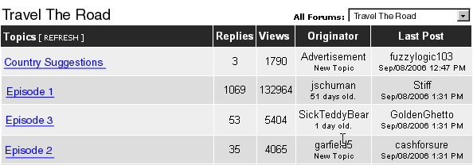

Issa.TV Player
The product we are building is a video playback interface. For this phase, Brightcove’s functionality will not be used. Instead, w We need to build a new administration website with our own hosting and administrator functionality, and a modified player to playback our videos.

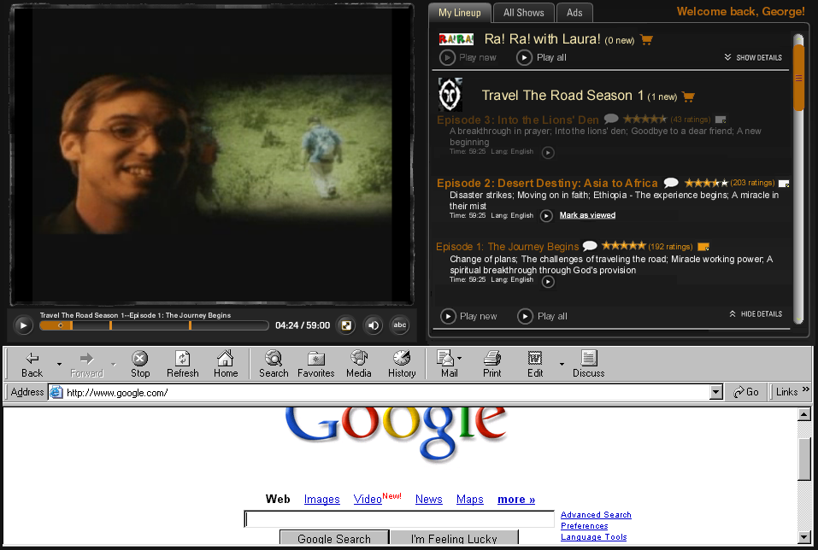
Video Panel
Interactive Panel
Browser Panel

Each panel may alter the contents of another, depending on the action triggered.

For this first phase, we will leverage the existing functionality of Brightcove’s free Commerical Preview feature. (http://www.brightcove.com/resources/teaser-page.cfm) As such, this project will provide a front end to interface with Brightcove’s video hosting and streaming capability. The administration of content is provided by the Brightcove engine. The new front end (as knows as the player) consists of 4 main panels – Video, Title, Interactive, and Browser.

<<image deleted>>

These 3 panels compose the Issa.TV Player interface. This player interface must be full screen. This must not be a separate application that requires a separate install using InstallShield or the like. Instead, the Issa.TV Player must be a browser-based window, capable of being launched directly from the browser. (browser requirements: IE, Firefox, Maxthon, Opera, Safari)

Video Panel
The video panel displays the video of the content. This video is playback in Flash. As such, requirements of the playback include:
- If necessary, short loading time in the beginning of the playback. Absolutely no pausing the video playback due to re-buffering during playback.
- High quality video – see www.ihd.org
- Smooth transition of fullscreen / standard video size
- Shows streaming video using Flash player (can we leverage BrightCove somehow?)
- Controller on the bottom of the video panel. Controls include:
  - Play / Pause button – - During playback, the button displays a Pause button. When the video is stopped, the button displays a Play button.
  - Video Title – - Displays the title of the video in the following combination – “Program Title” + “--” + “Episode Title”
  - Current Time & Playback Duration - - Displays the time of the current playback location and the total video playback time (does not include commercial breaks)
  - Fullscreen / Restore - - toggles the video between fullscreen mode and standard 3-panel mode. The fullscreen mode would take up the entire monitor real-estate, hiding the Interactive Panel as well as the Browser Panel. The fullscreen mode auto-hides the Controller after 5 seconds of mouse cursor inactivity. Once the mouse is moved, the Controller automatically reappears.
  - Volume - - Adjusts the volume of the video playback. When selected, a pop-over is displayed. 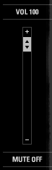 Also shows the mute / unmute function.
  - Subtitles - - Turns on/off the subtitle function and allows the user to select the subtitle of the video playback. Once the new subtitle is selected, prompt the user to save this subtitle as default in his account info. The subtitling should function similar to that of a DVD player – when user selects a language in the middle of the playback, the subtitle appears, without pausing or stopping or restarting the playback.
  - Timeline - - The playback timeline shows several items that are important.
    - Current location - - Shows the current location on the playback timeline
    - Commercial Indicators - - Indicates where in the timeline are the commercial breaks. Commercial breaks also indicate the start of the logical segment of the playback.
    - Playback Segment - - The entire video playback is composed of playback segments. These segments are separate individual videos, and are proceeded by a commercial video (with the except of the first playback segment which is not always proceeded by a commercial video). In order to fast forward a playback, the user can use the mouse cursor to select the location on the timeline where he wants to start the playback. If the new location is within the same playback segment as he is on currently, the fast forward takes place and the user to brought to the new location designated by the mouse cursor. If the new location is in a different playback segment as he is on currently, the commercial that proceed the playback segment is played first, then beginning of the playback segment. The user must use the mouse cursor to select the desired location one more time in order for the playback to begin at the desired location. The current playback segment is shaded like such: . Previous played segments are also shaded to indicate that segment has already been played back.

Video Panel
The video panel is Brightcove’s video player. See Brightcove’s Free Commerical Preview at http://www.brightcove.com/resources/teaser-page.cfm. The specific video player is called “Single Title Player”. There is a specific URL associated with each video clip. The current intention is that each segment of an episode is an individual video with an associated unique URL. Each commercial video is also an individual video with an associated URL. This panel plays back the videos.

During commercial playback in the video panel, list a countdown of the 30-second commercial. At the end of the 30 seconds, change the countdown to a button that users can select to continue to the next segment. Without a user clicking the button, the commercial continue to play to until the end, at which time, or the player sits idle until the viewer clicks on the continue button.
Commercial countdown - - appears in the video panel during the commercial break.
Continue playback - - appears in the video panel at the end of the 30 seconds of a commercial break.

Title Panel
This panel displays the title of the video in the following format:
Program Title” + “--” + Episode Title + “--” + Segment Title + “(“ + Order of Segment in Episode + “/” + Total Number of Segments in Episode + “)”
If the title is too long such that it displays off the screen, perform a horizontal auto-scroll.

Browser Panel
This panel is simply the default browser on the users’ desktop, resized to fit into the space of this panel. (is this doable?) Thus, if the default browser is IE, a new IE window is resized to be placed in this panel. If Firefox is the default browser, the Firefox window is resized to fit into this panel. All functionality, including tabbed interface and mouse gestures, is maintained in this panel based on the native browser.

Interactive Panel
This is the heart of the Issa.TV Player. The functions in this panel must be flash and/or Ajax based. The top right corner of the panel displays a greeting message such as “Welcome back, USER!” There are 3 main tables within this panel: My Lineup, All Shows, Ads. The default view is always My Lineup.

- My Lineup
This tab displays all programs the user is subscribed to. There are two modes with which the programs can be displayed.
  - Details Hidden – This is the default view for all shows in the My Lineup tab where the program details are hidden for a clean interface.
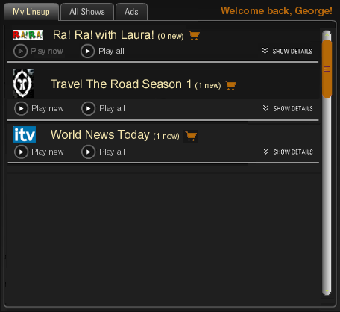
In this view, only the following are displayed for the program:
    - Icon of program - - Defined at the time of the program definition. The icon must have a maximum size of AxB.
    - Title of program - - Defined at the time of the program definition.
    - Number of new / unviewed episodes in the program - - The total number of unviewed episodes in this program for the specific user. An episode is considered viewed after the user starts playing it back. (it is considered viewed even if the user plays back for 1 second and stops)
    - Icon that leads to the merchant store - - when this is selected, the Browser panel displays the merchant store page with the provided URL. This icon is only visible when a URL for the shopping card is entered for the program.
    - Play new button - - Button to play all unviewed episodes in the program, starting with the earliest new episode. If there are no unviewed episodes, this button is disabled.
    - Play all button - - Button to play all episodes in the program, started with the earliest episode, including all viewed and unviewed episodes.
    - Show details option - - when this is selected, the Details Hidden view for the program is expanded to display the Details Shown view. When the details are shown, this button is changed to a “Hide Details” button
  - Details Shown – This view shows the details of a specific program. In order to maintain a clean interface, only one specific program can be in Details Shown mode at any time. If one program is in Details Shown mode, and the user select to “Show Details” for another program, the first program is collapsed to Details Hidden mode, and the new program is expanded to Details Shown mode. 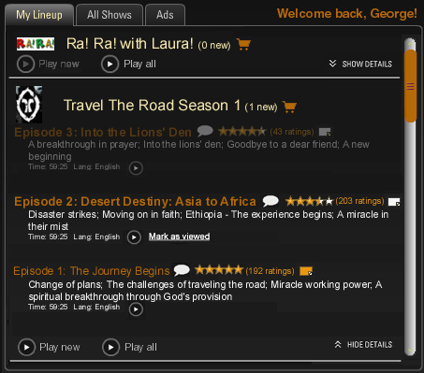

In this view, information for individual episodes is displayed. Episodes are enabled / disabled for playback based on the following rules:
- If episode has been viewed, then enable for playback.
- If episode has not be viewed and episode is the earliest unviewed episode for the program, then enable for playback and allow for user to “Mark as viewed”.
- If episode has not been viewed and episode is not the earliest unviewed episode for the program, then disable for playback.
(Enabling for playback means the episode is not faded, and the dropdown list to select the segment to playback and subtitle to show and all associated options are selectable: play button, rating stars, discussion groups, notes. the play button is enabled to be selected. Disable for playback means all the information for the episode is “grayed out”, and none of the associated options are selectable: dropdown list for segment playback, dropdown list for subtitle, play button, rating stars, discussion groups, notes.)

The following episode elements are shown for the specified program in addition to the program icon and program title and number of new episodes for the program.
- Episode Title - - Displays the episode title. All unviewed episode titles are in bold. All viewed episode titles are in regular style font.
- Episode Discussion - - When this is selected, the Browser Panel is directed to the website with the related program-episode discussion group. If the browser is a tabbed browser, a new tab is created. If the browser is a single window browser, the existing browser is used to open the discussion group URL.
- Episode Rating - - Shows the overall rating for the episode in the number of star, along with the total number of votes received. Each user account can only rate an episode once. When the mouse cursor is not over the rating stars, this displays the total ratings in yellow stars. When the mouse cursor is over the ratings star, two scenarios may occur:
  - If the user has not rated the episode, and the user move the mouse cursor over the stars, the stars dynamically highlight in red, moving in steps of ½ a star. (rating changes as mouse cursor moves) When the left mouse is clicked, the user’s vote is selected. 
  - If the user has already rated the episode, and when the user move the mouse cursor to the stars, his rating is shown by red stars. As the cursor moves over the stars, the stars do not dynamically highlight as the cursor moves. The user may left mouse click over the stars to change his rating at anytime.
- Notes - - These are personal notes that I can take regarding a specific episode. These notes are not shared in anyway, and is only viewable by the user. A white note indicates an empty note. A yellow note indicates the user did enter a note for the episode. To add or edit or view a note, click on the icon. Using Ajax (?), open a text box to edit the note for the episode without creating a new application window.
- Episode Description - 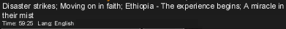 - displays the description of the episode. On a new line at the end of the episode description, indicate the total time of the episodes (sum of duration from all segments of the episode – does not include time from commercials), and the original language of the episode.
- Episode Segment Playback Dropdown List - - When the dropdown list is opened, it shows the segments of the episode. 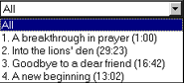 The user can select a particular segment of the episode to be played back. If so, only the associated segment and the proceeding commercial are played back. The episode is considered to be “viewed”. The default option is to play all segments. This option may be disabled if the episode is disabled for playback.
- Episode Subtitle Playback Selection – When the dropdown list is opened, the options for subtitles for this episode are listed. 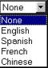 The user can select a particular subtitle to display while playing back the episode. The default is “None”. This option may be disabled if the episode is disabled for playback.
- Play Button - - Enables the playback of the episode. This option may be disabled if the episode is disabled for playback.
- Mark As Viewed - - This option only appears for episodes that are unviewed and enabled for playback. Once selected, the option is removed, and the episode is treated as though it was viewed. (e.g. not bolded, the next episode is enabled for playback) Note: there is no “mark as unviewed” option. Users can use the notes feature to remind them something of the episode.

- All Shows
This tab displays all programs that are available from Issa.TV.
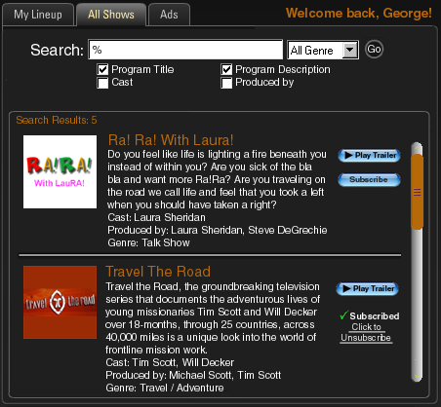
The All Shows tab contains the following components:
- Search -  - This allows the user to search through the database of shows, based on the following selectable criteria:
  - Program Title
  - Program Description
  - Cast
  - Produced by
  - Genre – this is a dropdown list
A wildcard character can be used - % - to allow users to search for sub-strings. The default is a wildcard search of all shows. The result of the search is shown in the table below the search box.
- Search Result / Program Listing – This table lists all search results from our programming database. This listing is scrollable. For each program, the following elements are listed:
  - Icon -  - Shows a 75x75 image of the program.
  - Title - - Full title of the program
  - Details -  - which includes:
    - Program Description
    - Cast Listing
    - Produced by Listing
    - Genre Category
  - Play Trailer Button - - Plays the trailer for the program in the Video Panel.
  - Subscription Option
    - If the user is not subscribed to the program, display the Subscribe button - - By selecting this button, the following happens:
      - The program is added to the “My Lineup” tab for the user
      - In the details of the program in “My Lineup”, all available episodes are listed. (enabled / disabled episodes according the rules of viewed episodes on Page 13)
      - If the user is re-subscribing to the program (e.g. subscribed to the program before but then unsubscribed), then keep his previous settings for the rules of viewed episodes.
    - If the user is subscribed to the program, display the text that the program has been subscribed, then provide a link to unsubscribed. -  - When the user clicks on this link to unsubscribe, provide a dialog window that prompts “Are you sure you want to unsubscribe ‘Program Title’?” with Yes/No buttons. If No, then close dialog window and do nothing. If Yes, then perform the following:
      - Remove the program and episode details from “My Lineup”.
      - Keep his viewed episode data for future use.
- Ads
All commercials (flash videos) have an associated companion ad (flash or JPG). There may also be advertisements served during a show (flash or JPG). These advertisements will appear in this tab. This tab views the currently served ad, as well as the history of ads that were served to the user.
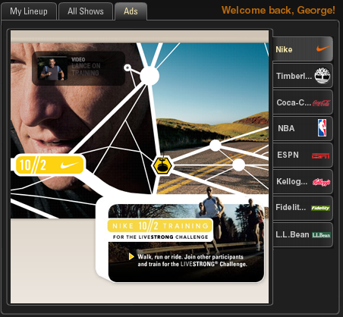
Elements on this page include:
- Advertisement Tabs - 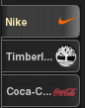 - These are tabs associated with each advertisement. These tabs include the name for the company, as well as a logo for the company. The logo is 25x25 in size. If the company name does not fit into the tab, a “…” is used. When the mouse cursor stops above the tab, cursor bubble displays the entire name. 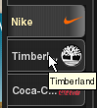
- The ads are of size 340x360 (width x height)
- The order of the tabs are determined by display time of the advertisement. For example, the above graphic shows Nike being the current ad. If a Staples ad is now displayed, the order of tabs now becomes: 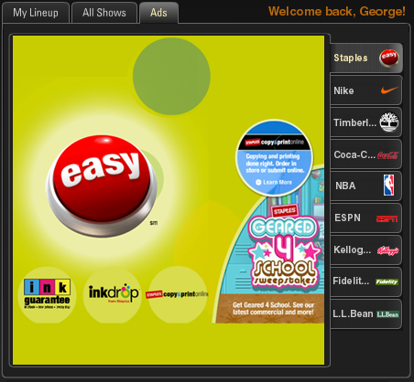
If now a Pepsi ad is displayed sometime after the Staples ad, the tab order now becomes: 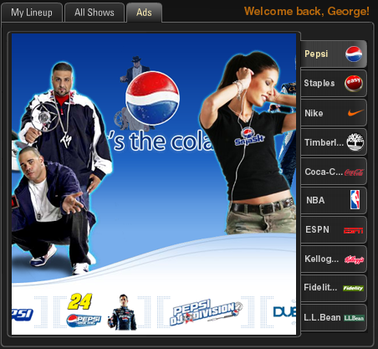
- A maximum of 10 advertisement history tabs are displayed. The 11th most recent ad goes off the history tab and is no longer displayed unless the ad is displayed again.
- If there are repeat commercials, display a new tab if the current tab is not the same commercial.
- If the ad is JPG, allow the designation of a URL for the ad for when the user clicks on it. If the ad is Flash, URLs are defined at the time of Flash creation.
- If the user is on a different tab in the Interactive Panel (either My Lineup or All Shows), and a commercial is served at that particular point in time, make the Ad tab the active tab and display the advertisement.

Issa.TV Administration
The administration website must only be accessed by admin login, which is only accessible by Issa.TV personnel. The following are functions that a Issa.TV admin must be able to perform.

Create / Update / Remove Admin Accounts
There is one super-user of the account who cannot be deleted. Otherwise, all other admin accounts can be created, updated, and deleted by another admin. (cannot delete self account)

Create / Update / Remove Episodes & Programs
There must be a way to define, updated, and delete the episodes and programs and their relations with each other in the administration level. Specifically, the properties for Programs are:
Table: Programs
- ID (PK)
- Title
- Description
- Cast
- Produced by
- Genre
- Logo – 75x75
- Store URL
- Program Trailer URL

Properties for Episodes are:
Table: Episodes
- Episode ID (PK)
- Programs.ID (FK)
- Order
- Title
- Description
- Duration (automatically calculated based on Flash properties)
- Subtitles (is this a new video flash file? Or just an overlay)
- Original Language – English, Spanish, French, Chinese
- URL of Discussion Group
- Survey URL (if any) – shows the survey at the end of the episode playback

Because we are using Brightcove’s ability to host the videos for this phase, we will need the following properties for video segments as well.
Table: Episode Segments
- Segment ID (PK)
- Episode ID (FK)
- Order
- URL of video player in Brightcove

Miscellaneous Critical Features

Commercials
There must also be a collection of commercials (a type of videos) from which the system may select to broadcast during episode playback. That is, commercials must be defined, then as episode segments are played back, the system must select the appropriate commercials to playback during commercial breaks.

Properties for commercials are:
Table: Commercials
- Commercial ID (PK)
- Commercial Type (Platinum, Gold, Specific, General)
- Program ID (if any)
- Commercial Break Number (if any)
- Title
- Description
- Maximum Impressions (if any)
- Duration (automatically calculated based on Flash properties)
- URL of commercial via video player in Brightcove
- Companion advertisement (JPG or Flash - 340x360 (width x height))
- Icon Logo (JPG 25x25)
- Sponsor introduction video URL in Brightcove (sponsors only)
- Platinum sponsor grouping code (Platinum sponsors only)

There are the following types of commercials:
- General – By default, all commercials are of this type. General commercials can be used at any commercial break for any program. The “Program ID” and “Commercial Break Number” properties are not required nor used for this type. The “Maximum Impressions” property can be used for this commercial type.
- Program-Specific – This type of commercial is broadcasted only during specific programs. The “Program ID” property is required for this type of commercial to define the program these commercials will be broadcasted. The “Commercial Break Number” property is not required, but may be used. The “Maximum Impressions” property can be used for this commercial type.
- CB-Specific – This type of commercial is broadcasted during a specific program and for a specific commercial break (CB) during that program. The “Program ID” and “Commercial Break Number” properties are required and used for commercials of this type. The “Maximum Impressions” property can be used for this commercial type.
- Gold Sponsor – Gold sponsors are introduced during the sponsor introductions (see below for commercial algorithm for multiple sponsors for a show), and have their commercials shown during the first commercial break of the episode playback. The “Program ID” is required to identify the program being sponsored. The “Commercial Break Number” is not used since all Gold Sponsor commercials are always shown during the first commercial break. The “Maximum Impressions” property isn’t used for Gold Sponsors.
- Platinum Sponsor – Platinum sponsors are introduced during the sponsor introductions (see below for commercial algorithm for multiple sponsors for a show), and have their commercials shown during ALL commercial break of the episode playback. The “Program ID” is required to identify the program being sponsored. The “Commercial Break Number” property is not used since all Platinum Sponsors commercials are always shown during ALL commercial breaks. The “Maximum Impressions” property isn’t used for Platinum Sponsors. Different versions of commercials are used based on the “Platinum sponsor grouping code”.
- Production Sponsor – Production sponsors are sponsors who help fund the production of the episodes. They are allowed to have product placements within the episodes of the program. As such, we need the ability to trigger new advertisements in the Ads tab based on a time-code within the episode. While the episode is playback, at the specified time-code, a new advertisement appears in the Ads tab, and the playback continues uninterrupted.

For 30-minute programs, there are 1 sponsor introduction and 2 commercial breaks.
Order of playback for a 30-minute program:
- Sponsor Introduction (if any) – Sponsor Introductions have a maximum 10-seconds in length.
- Segment 1
- Commercial Break 1 (around 10 minutes or whenever the closest logical break in episode)
- Segment 2
- Commercial Break 2 (around 20 minutes or whenever the closest logical break in episode)
- Segment 3
- Survey – If there is a survey, display the survey at the end of the program in the Browser panel.

For 60-minute programs, there are 1 sponsor introduction and 3 commercial breaks.
- Sponsor Introduction (if any) – This is seen at this beginning of playback, and before the
- Segment 1
- Commercial Break 1 (around 15 minutes or whenever the closest logical break in episode)
- Segment 2
- Commercial Break 2 (around 30 minutes or whenever the closest logical break in episode)
- Segment 3
- Commercial Break 3 (around 45 minutes or whenever the closest logical break in episode)
- Segment 4
- Survey – If there is a survey, display the survey at the end of the program in the Browser panel.

Commercial Algorithm
The commercial algorithm is a method with which to figure out how the commercials are served for each program playback by a viewer. These algorithms must be designed with easy methods to upgrade and change should there be a need to alter the algorithm.

The way to calculate which commercial to playback for any program is determined by the following:
- Sponsor Introduction (SI)
  - If there are no program sponsors, do not display any SI – start Seg1 immediately.
  - If there is one gold sponsor for the program, always display that sponsor’s SI.
  - If there is one platinum sponsor for the program, always display sponsor’s SI.
  - If there are multiple gold sponsors and no platinum sponsors for the program, evenly split the displaying of the gold sponsors for all program playbacks.
  - If there are no gold sponsors and multiple platinum sponsors, evenly split the displaying of the platinum sponsors for all program playbacks.
  - If there are at least one gold sponsor and at least one platinum sponsor, split the displaying of SI 75%/25% (Platinum/Gold) for all program playbacks.
- Segment 1 (Seg1)
- Commercial Break 1 (CB1)
  - If there was SI for this playback, then
    - 100% = Show commercial for the same SI sponsor for CB1.
  - If there was no SI for this playback (no sponsors for the program),
    - If there are “CB-Specific” commercials for CB1 for this program and there are “Program Specific” commercials for this program, then
      - 85% = evenly split the displaying of “CB-Specific” commercials for this program’s CB1 playback.
      - 10% = evenly split the displaying of “Program Specific” commercial playback for CB1.
      - 5% = evenly split the displaying of “General” commercial playback for CB1.
    - If there are “CB-Specific” commercial for CB1 for this program and there are no “Program Specific” commercials for this program, then
      - 90% = evenly split the displaying of “CB-Specific” commercials for this program’s CB1 playback.
      - 0% = “Program Specific” commercial playback for CB1.
      - 10% = evenly split the displaying of “General” commercial playback for CB1.
    - If there are no “CB-Specific” commercials for this program and there are “Program Specific” commercials for this program, then
      - 0% = “CB-Specific” commercials for this program’s CB1 playback.
      - 90% = evenly split the displaying of “Program Specific” commercials for this program’s CB1 playbacks.
      - 10% = evenly split the displaying of “General” commercial playback for CB1.
    - If there are no “CB-Specific” commercials for this program, and there are no “Program Specific” commercials for this program, then
      - 100% = evenly split the displaying of “General” commercials for this program’s CB1 playback.
- Segment 2 (Seg2)
- Commercial Break 2 (CB2)
  - If the SI was from a Platinum Sponsor, then
    - 100% = Show commercial for the same SI sponsor for CB2.
  - If there was no SI (no sponsors for the program), OR if the SI was from a Gold Sponsor,
    - If there are “CB-Specific” commercials for CB2 for this program and there are “Program Specific” commercials for this program, then
      - 85% = evenly split the displaying of “CB-Specific” commercials for this program’s CB2 playback.
      - 10% = “Program Specific” commercial playback for CB2.
      - 5% = evenly split the displaying of “General” commercial playback for CB2.
    - If there are “CB-Specific” commercials for CB2 for this program and there are no “Program Specific” commercials for this program, then
      - 90% = evenly split the displaying of “CB-Specific” commercials for this program’s CB2 playback.
      - 0% = “Program Specific” commercial playback for CB2.
      - 10% = evenly split the displaying of “General” commercial playback for CB2.
    - If there are no “CB-Specific” commercials for this program and there are “Program Specific” commercials for this program, then
      - 0% = “CB-Specific” commercial playback for CB2.
      - 90% = evenly split the displaying of “Program Specific” commercials for this program’s CB2 playbacks.
      - 10% = evenly split the displaying of “General” commercial playback for CB2.
    - If there are no “CB-Specific” commercials for this program, and there are no “Program Specific” commercials for this program, then
      - 100% = evenly split the displaying of “General” commercials for this program’s CB2 playback.
- Segment 3 (Seg3)
- Commercial Break 3 (CB3)
  - If the SI was from a Platinum Sponsor, then
    - 100% = Show commercial for the same SI sponsor for CB3.
  - If there was no SI (no sponsors for the program), OR if the SI was from a Gold Sponsor,
    - If there are “CB-Specific” commercials for CB3 for this program and there are “Program Specific” commercials for this program, then
      - 85% = evenly split the displaying of “CB-Specific” commercials for this program’s CB3 playback.
      - 10% = “Program Specific” commercial playback for CB3.
      - 5% = evenly split the displaying of “General” commercial playback for CB3.
    - If there are “CB-Specific” commercials for CB3 for this program and there are no “Program Specific” commercials for this program, then
      - 90% = evenly split the displaying of “CB-Specific” commercials for this program’s CB3 playback.
      - 0% = “Program Specific” commercial playback for CB3.
      - 10% = evenly split the displaying of “General” commercial playback for CB3.
    - If there are no “CB-Specific” commercials for this program and there are “Program Specific” commercials for this program, then
      - 0% = “CB-Specific” commercial playback for CB3.
      - 90% = evenly split the displaying of “Program Specific” commercials for this program’s CB3 playbacks.
      - 10% = evenly split the displaying of “General” commercial playback for CB3.
    - If there are no “CB-Specific” commercials for this program, and there are no “Program Specific” commercials for this program, then
      - 100% = evenly split the displaying of “General” commercials for this program’s CB3 playback.
- Segment 4 (Seg4)

Reports
The following must be reports that Issa.TV administrators can retrieve from the system in real-time. All reports must be viewable with a browser, and exportable to CSV format.
- User Report – includes number of user accounts, all user demographics, date/time last logged in, date/time of last playback, episodes played back per login session.
- User Viewing History – a history of a user’s viewing and subscription. Allow the grouping by user demographic.
- Episode Playback Report – number of playbacks, users of playbacks, their demographics, including episodes, programs, date/time, # of playbacks that stopped in Seg1, CB1, Seg2, CB2, Seg3, CB3, Seg4, 100% complete
- Trailer Playback Report – number of trailer playbacks, which programs, and number of subscriptions that result
- Commericals Report – number of commercials served, during which programs / episodes, date/time, by commercials, which commercial break (SI, CB1, CB2, CB3), number of click-throughs,
- Program / Episode Report – number of subscriptions, number of episodes played back, number of unsubscribed & date/time, users who subscribe / unsubscribe.

Priority
The following is a list of priorities for this development project.
(1 = Must Have, 2 = Important to Have, 3 = Nice to Have)
Issa.TV Website
- Account Creation / Edit - 1
- User Homepage - 1
- Discussion Groups - 3
Issa.TV Player
- Video Panel - 1
- Title Panel - 1
- Browser Panel - 2
- Interactive Panel
  - My Lineup
    - Icon of program – 1
    - Title of program – 1
    - Number of new / unviewed episodes in the program – 1
    - Icon that leads to the merchant store – 1
    - Play new button – 2
    - Play all button – 2
    - Show details option – 1
    - Episode title – 1
    - Episode discussion – 3
    - Episode rating – 2
    - Notes – 3
    - Episode description – 1
    - Episode segment playback dropdown list – 1
    - Episode subtitle playback selection – 2
    - Play button – 1
    - Mark as viewed – 2
  - All Shows
    - Search – 1
    - Search Results
      - Icon – 1
      - Title – 1
      - Details – 1
      - Play Trailer button – 1
      - Subscription – 1
  - Ads
    - Ads - 1
    - Advertisement Tabs – 2
Administration Website
- Create / Update / Remove Admin Accounts - 1
- Create / Update / Remove Episodes & Programs - 1
- Commercial & Commercial Algorithm - 1
- Reports – 1

