INVENTORY

Below is feedback from second inventory review
3.2 – FYI - The drop down for “Change Community” will be available for Super Users and people that are managing more than one property for a developer. This will be a very small percentage of all the Users.
ED 08/25 для программеров

3.3 – Search results will toggle between 3.4.e view (now changed to 3.4.c) and “list view”. Each floor plan will be in a box just like you have it, the only difference is that the boxes can be sized down so that four can fit into one screen; two high and two across.
Have the function of the button in the bottom right (Switch to matrix View) be accessed in the “View Options” button at the top. - You can select Matrix View or List View by accessing ‘View Option” at the top.
ED 08/25 (не поняла, где это так уменьшить)
ED 08/25 “View Options” – это другое, это определение параметров, какие именно будут в результатах поиска. Так нельзя сделать, это называется смешивать мух и котлеты.

How does User see current Search results? Maybe there is a “View Search” button right next to “Add To Search”.
ED 08/25 To view search results, the user clicks "View List"

3.4 - Only the floor that the mouse is over shows you the Stats when it is a High-Rise; just like 3.4.d. On other project types the color coding will be over the entire site on the first view level; but for High-Rises it cannot be. Only show the floor stats if the mouse is over that floor.
ED 08/25 для программеров

3.4.a - - Based on what you have written in the box for this window I cannot understand if we are talking about the same thing. I think I confused you. 3.4.a. will show you ONE floor at a time on this screen. Scrolling will move one floor at a time or you can use the selector you have to the right (very nice).
Once you see a floor you would like while in the First view Level “View Project”, you click it and that will bring you to the next view level. See Below.
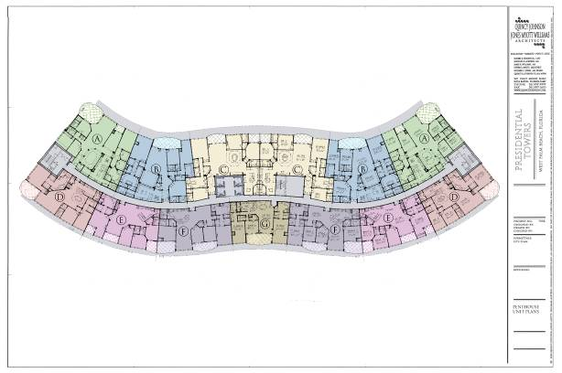
-This level shows the Prices for every available Unit and Unit details whenever User puts the mouse over a particular Unit. User can Zoom in and move around this view like Google Maps.
ED 08/25 OK

3.4.c – This view should be like 3.4.e. That would of course render 3.4.e not needed.
ED 08/25 OK

3.4.d – This is not what a stacking plan (Matrix) looks like. I attached a fax copy of a stacking plan to the email that this document was sent with.. Under “View Options” there will be a Change Matrix Data selection. This will bring up a box just like the one that was faxed with the Matrix (stacking plan). The box will have all the selections in that box on the fax plus: Degrees and Premiums.
ED 08/25 OK.

- Be sure to have the color coded Legend shown in the fax as well. That is was I was referencing in the document on page 34. The Legend will stay at the top of the screen when User scrolls through the pages of Matrix information. Each piece of the Legend is Color-coded and the entire Matrix is color-coded according to the Legend.
ED 08/25 OK

Below is feedback from initial inventory pages

Combine 3.4.a.3 with 3.4.a.2 & 3.4.a.1. Both Hold Float and Hold Lock should have the Sum field and the Print Reservation Button. “Sum” will be called “Deposit”. Hold Lock Price and Hold Float Price will have two different Reservation Forms to print.

3.4 – The section called General Unit Information will have the following fields in it:
Unit Number
Building Number
Floor Number
Price
Total Premium In Price – this is the total $ of premiums in the Price
Type – Floor Plan Type
Name – Floor Plan Name
Square Feet
Status
Front Door Direction – Example 90 degrees or 125 degrees etc.
- The fields above are only populated when a unit is selected form the map. If the unit is blocked for example – than “Write Contract” will not be enabled, etc.
- This section will be called “Selected Unit Information”.
- There needs to be a Button called “Add To Search” (or something) this gives the user the ability to individually select Units one at a time and collect them into a Search Result and then Print or Save the results in the context of a map as described in the last paragraph of page 34.

- Just above the Selected Unit Information box will be a box called Inventory Status that will simply show the number for the following categories: Total Units, Available Units, Sold Units, Closed Units, Developer Units (blocked).

-. The Inventory page has a “View Matrix” button and a “View List” so you can look at the community inventory as a Matrix (stacking plan) or a Spread Sheet List.

- Instead of “Overall” “Prices” “Floor Plan” “Floor Status” there will be “View Project” and “View By Floor”. The way User gets to the third level view is by going though one of first views or by conducting a Search.

3.4.d – These “Floor Stats” will not be its own view level. These will be what you see when
you put your mouse over the graphic of the entire building in the first view level.
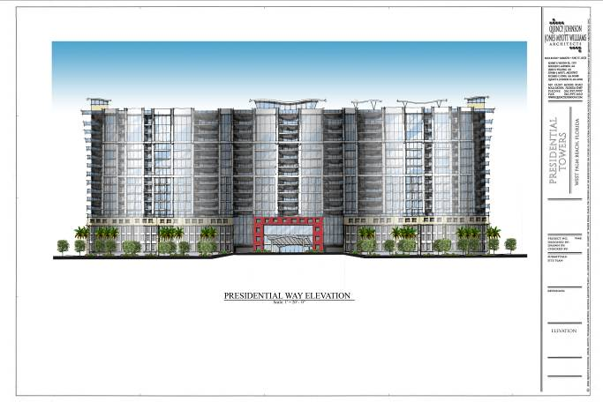
User can Zoom or move around the entire graphic from ALL view levels like google maps. These stats are what you need to determine which floor you want to choose. In addition to the stats you have please include:
Number of 1-BR – Number Available
Number of 2-BR – Number Available
Number of 3-BR – Number Available
Number of 4-BR – Number Available
- Only the floor that the mouse is over shows you the Stats. Once you see a floor you would like, you click it and that will bring you to the next view level.
-This level shows the Prices for every available Unit and Unit details whenever User puts the mouse over a particular Unit. User can Zoom in and move around this view like Google Maps.
- If User selects a particular Unit than the Details populate the Selected Unit Information Fields to the left of the graphic and the Unit floor plan graphic appears with all the basic details inside the graphic as drawn out on page 3 of my previous fax document called “Inventory PAGE - Advanced Inventory Search PAGE - Search Results PAGE”
- There is a “Return to Previous View” button.
- Once a floor is selected as shown above; there will be Next and Previous Floor (drop down selectable as well); and there will be Next and Previous Building (drop down selectable as well).

3.2 – Inventory Search doesn’t need any Construction criteria except General Status.
When User is looking at Details of a particular Unit, Construction Details will be available there.
3.3 – Inventory Searched will default to the graphic of the floor plans.
- You can select Matrix View or List View by clicking those buttons.
- You can only Search for Units in the Community for which you are currently logged into. There is no need for Location Criteria in the Search.
- Rental Unit is actually two choices; Tenant or Vacant.
- Add the following to the criteria: Model, Attached Garage. Detached Garage, Car Port, Degree Range (i.e. 90 degrees to 280 degrees).
- Remove the following: Building Name, Building Type, Exposure.
- Put all the Premiums under a Heading called Premiums: they are:
Pool, Mountain, Green, Ocean, Corner
This list will change with every project.
- Put all the location related criteria under a Heading called Location, they are:
Community Street, Public Street, Alley, Interior, North, South, East, West, North East, North West, South East, South West,

3.4.b – Just a reminder of previous discussion; User needs to be able to ADD a New Buyer
from this Screen. Once the New Buyer has been Added, User is returned to this screen.
- “Unit Information” will include the following fields:
Unit Number
Building Number

- This screen is arrived at from these conditions:
User has selected a Specific Unit from Inventory and click on Write Contract
User has a specific Buyer Selected and clicks on Write Contract. (This case will add one addition step to the process of selecting the Unit number form a drop down of the available Units.)

3.4.b.1 – Just a reminder of previous discussion; User needs to be able to ADD a New Broker
or Agent or Lender from this Screen. Once the New Broker or Agent has been Added, User is returned to this screen.
- Salesperson is editable with only the Salespersons Registered with the Listing Broker for this particular project; otherwise it Auto-pops with the Salesperson that is actually entering the information.
- The Agent is selectable from a drop down of the Agents that are associated with the Selected Broker.
- Lender contact is selectable from a drop down of the Agents that are associated with the Selected Broker.
- Add “Property Use to” this Step – it is a Lender related question.
Property Use – Drop down selections: Primary Resident, Second Home, Investment
- Add Commission breakdown to this step:

Edit Commissions (if selected below appears, if not below is hidden)

Splits – if selected, below is required; if not HIDE
Salesperson #1 – XX.XX% (Salesperson is selectable from Drop-down)
Salesperson #2 – XX.XX% (Salesperson is selectable from Drop-down)
Salesperson #3 – XX.XX% (Salesperson is selectable from Drop-down)
Selling Commission editable by Sales Manager
Selling Agent Bonus – Auto-pop but editable (set in Admin)
Additional Selling Agent Bonus – Auto-pop but editable (set in Admin)

3.4.b.2 – This step is laid out in the following way with the following fields and will be the LAST STEP before Review Submit. (Most of the time the fields below will all auto-pop and will not need to be edited):

Upgrade Level: drop down selectable: As-Is, Standard, Premium, Green
Base Price: Auto Pop – not editable here - edit buy upper management in Pricing
As-Is Credit: Auto-pop based on Upgrade Selection
Other Credit 1: Typable – functions as a negative number
Description - typable - 50 characters max
Other Credit 2: Typable – functions as a negative number
Description - typable - 50 characters max
Upgrade Amount: Auto-pop based on Upgrade Selection
Garage Amount: Auto-pop based on Parking Selection – see below
Storage Amount: Auto-pop based on Storage Selection
Additional Amount 1: Typable – functions as a positive number
Description - typable - 50 characters max
Additional Amount 2: Typable – functions as a positive number
Description - typable - 50 characters max
Total Purchase Price: (total of above) **not a typable field**
Earnest Money Deposit Required: Auto-pop – editable only by upper management
Earnest Money Deposit MADE THIS DAY: Auto-pop – editable by Salesperson
Earnest Money Balance Owed – Auto-pop difference of above two lines.
Earnest Money Balance Due By: drop down calendar*required if money is due*
Additional Deposit MADE THIS DAY: Typable
Balance Due: (TPP less EM Made and Add Dep) **not a typable field**

New Step before 3.4.b.2
There needs to be an additional step before “Review and Submit”. It will include the following:
Buyer Signature YES – NO
Rescission End Date: Auto-pop (set in Admin) – editable by Salesperson
Closing Date: Drop down calendar – TBD is an option
Parking : (Dollar amounts Auto-pop and are editable. *Not Required*
Detached Garage $XXX,XXX.XX Assign: Selectable or TBD
Attached Garage $XXX,XXX.XX Assign: Selectable or TBD
Car port $XXX,XXX.XX Assign: Selectable or TBD

Storage Unit $XXX,XXX.XX Assign: Selectable or TBD
Description: (50 Characters max) – Auto-pop to Paper Contract

Above is feedback from initial inventory pages

One of the options under the PRINT button on the Inventory Page will be called “Quick Sales Summary”.

2.2b - Make sure that User can move around the Map. It can not just be a picture. It fuction like the Map screen of MapQuest or Google-Maps.

