Schedule A
Top Level Design

API
Ruby on Rails also allows CanvasBand to have it’s own API and allow project owners to interface with it’s features in ways not presented through our interface. This could be an important element for larger studios such as Electronic Arts, Industrial Light and Magic, and Disney. Such studios already have asset management software and may want to combine CanvasBand’s communication features with such software.

Adobe Air features are discussed later in this document specifically.

Amazon Web Services
CanvasBand relies heavily on Amazon’s webservices from a technical and also a business development standpoint. When CanvasBand was first designed 4 years ago there was a huge problem with how to handle the amount of necessary bandwidth and cpu usage that CanvasBand expects to see by utilizing the existing Highend3d network of users. Studios such as Electronic Arts, Weta, Digital Domain, Disney, Colorado University, Gnomon School of Visual Effects and others have already shown large interest in using the service. Just one of these accounts could instantly require CanvasBand’s bandwidth and cpu to be 10-50x what it was one day prior.

With Amazon this is no longer a problem. The entire CanvasBand application is built utilizing Amazon Elastic Compute Cloud (Amazon EC2), Amazon Simple Storage Service (Amazon S3), and Amazon Flexible Payments Service (Amazon FPS). This combination allows CanvasBand to have unlimited bandwidth, unlimited cpu usage, and send files from one of the largest and fastest networks on the Internet. Thus a user in China will ensure his files as stored on servers in China and not in Los Angeles. From a business staind point this means even if CanvasBand has 20,000 accounts (the total of year 3 in the excel sheet) there will be no additional cost or need for system administrators, servers, or networks from the initial launch of the website. Amazon charges on a pay per use system which we will directly offset to the users. This cost is also the least expensive method available today. Amazon also has built in redundancy on it’s networks.

Local Network or Remote Options
All CanvasBand projects, elements, and scenes have an option to be local network or remote. This feature allows major studios who already have storage servers and security concerns the ability to simply point other team members to files on their own network and utilize CanvasBand’s communication features without having to use it’s storage.

Secure Encryption
All projects and communications are completely secured with 128bit encryption.
Home Page

The homepage focuses on simplicity to quickly let users know what CanvasBand. It also has a clear link to the Public Projects tab. Tabs at the top are added for active projects when a user is logged in and has joined projects.

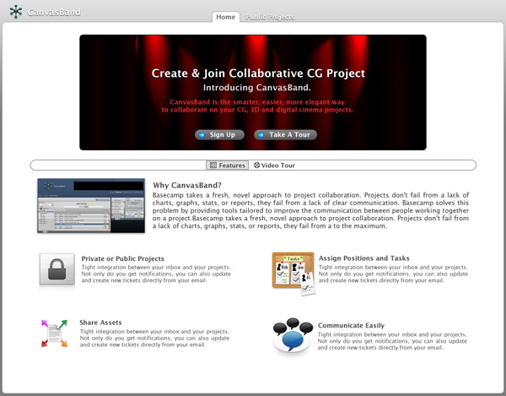

Projects Types

CanvasBand offers Public Projects and Private Projects with security. The Public Projects tab allows users to view existing projects on CanvasBand with many different viewing options. The first option shown below is “Top Ranked” projects. These are projects that are set “Publicly viewable” by it’s owners.

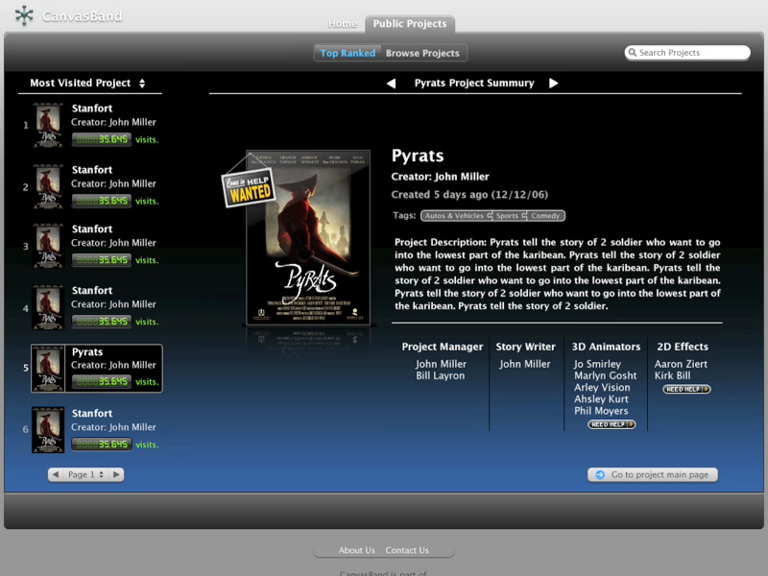

Projects that are Recruiting have an icon “Need Help” in the positions columns.

Browsing Public Projects

In the browse public projects page users can view public projects with many options:

- Search Tags
- Results Per Page
- Sort by: Project Name, Creator, Visits, Date Created, Status
- Help Wanted (On/Off and Position Name)
- Advanced Search

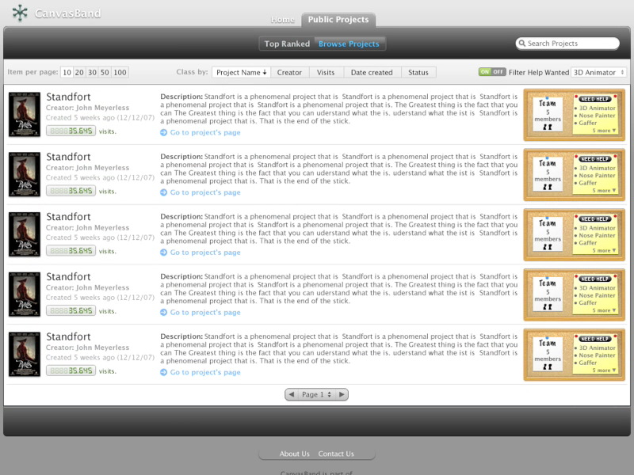

Creating a Project

CanvasBand makes creating projects very simple for the user. Its done in one page and allows the user to create a domain based project such as myproject.canvasband.com

There are multiple subscription types a user can take part in. The differences start with file storage and additional options such as the Adobe Air (Apollo) instant messenger client and the number of projects one can participate in. Users can also later feature their projects for an additional fee.

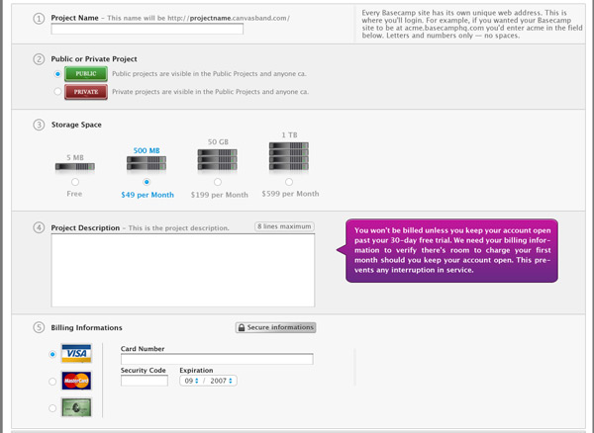

Private Projects (sample project “Pyrats”)

When a user creates a project it will show at the top of the page in it’s own tab. A user can be part of as many projects as they wish if they have purchased a subscription account allowing that number.

Tasks

When a user is logged in they are taken to the project of theirs with the latest activity in the Tasks Menu. The first screen in their project will show them their My Tasks and Other Tasks for that project. This screen gives an overview of all tasks for the project including status of tasks, due date, users assigned, priority, and the ability to Add, Edit, and Delete tasks based on permissions allowed for the user.

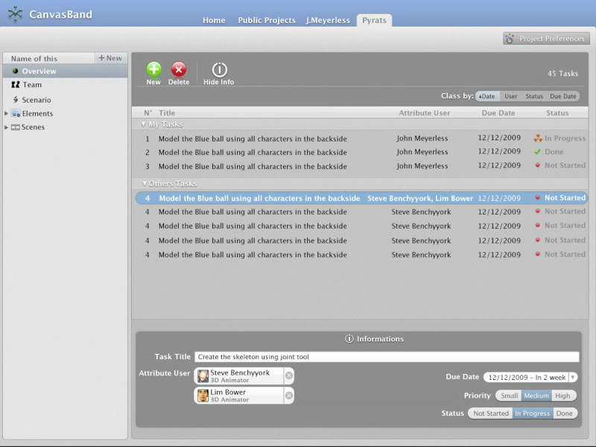

Group Calendar

The calendar section allows team members to add in calendar events unrelated to tasks already assigned. Such as in person meetings, voice conferences, etc. Each item can also have notes associated.

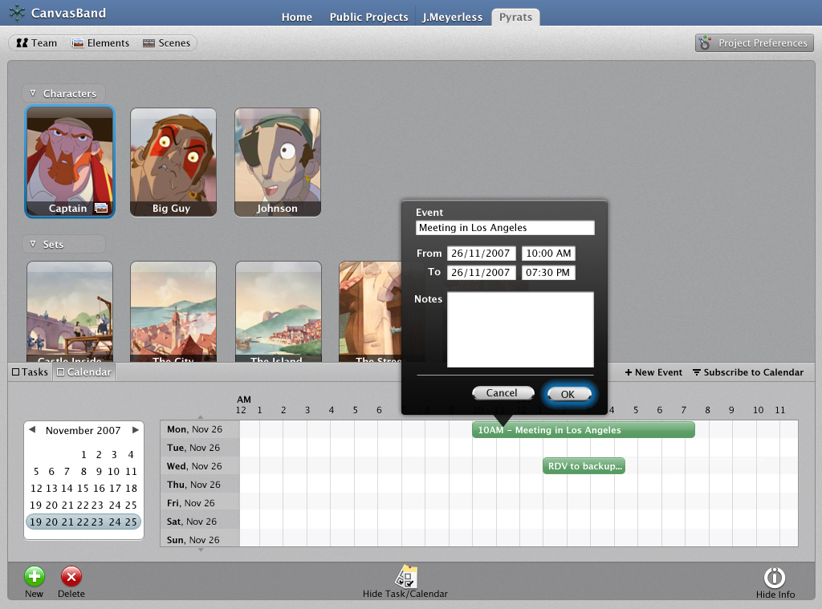

Menu Navigation

Navigation for each project is done through the left menu. There are default items such as Tasks, Team, Scenario, Elements, and Scenes. New menu items can be added and assigned permissions via our API. Elements and Scenes have distinct properties that differentiate them by the features offered for anything entered into them. These terms on the menu can also be changed and are translated for 30 languages.

This gives projects owners the ability to change something like Scenario to Project Description. Some groups may have a term that refers to Elements as Objects, and Scenes as Shots. CanvasBand gives complete flexibility to the user.

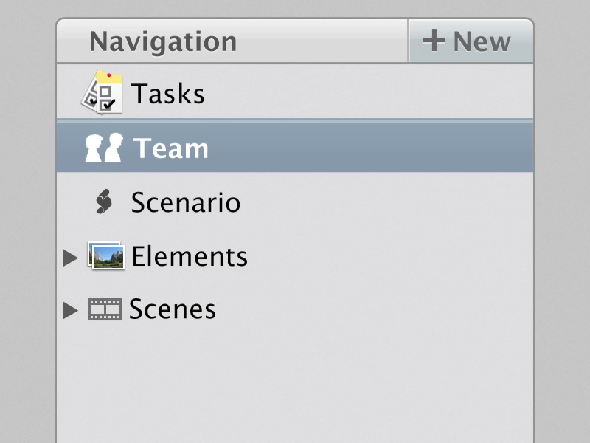

Team Page

Each project has a team page. This section lets the project owners to various tasks including:

- Assign titles
- Assign roles
- Add members
- Review applicants and approve / deny
- Delete members
- Invite members
- Add recruitment specifications.
- Online Status of Members / Message Team Members
- Link to team profiles
- Search members

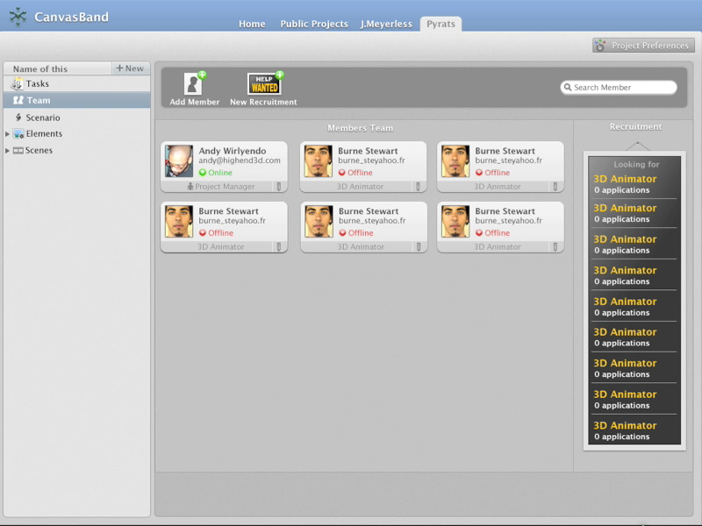
Elements

Elements are pieces of the project that are needed to complete scenes. In the example below we use the “Captain” element which is an element inside of “Primary Characters” element folder in the “Pyrat” project. We also show “Sets and Lights” as an example of another element group.

This is where the benefit of CanvasBand really shows its power. In the past when trying to describe a character you would have no way to organize the images and conversations about this element. CanvasBand organizes it and offers features not available in any other software or service

Options available for elements include:
- Hierarchical menu structure
- File Upload
- Description
- Images/movies for element with Version Control
- Threaded Comments/Discussions per Image/movie
- Visual Notes
- Search within Element

Below is an image showing the “General” tab of Captain Element with description and tasks

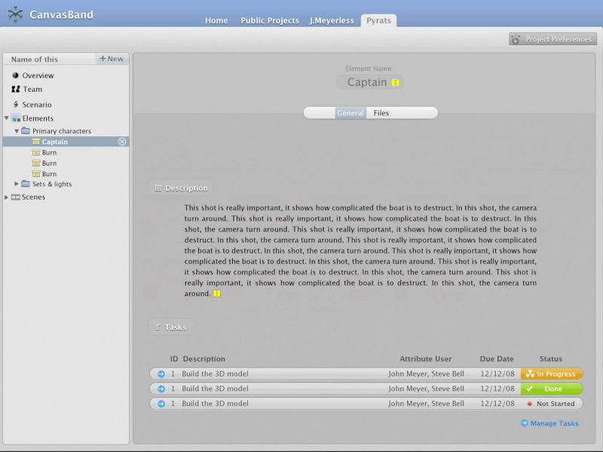
Example of different images with version control for the captain character

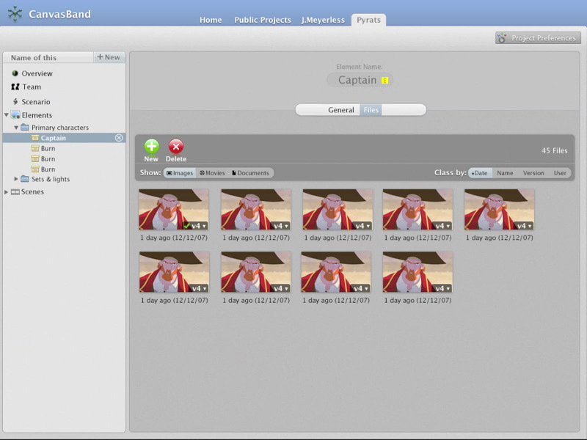

By clicking on the down arrow on an image it exposes the version history for quick viewing of changes. You can also set the image status to Final or Delete.

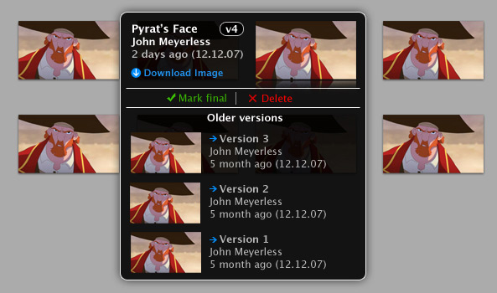
Details of one image from above and threaded comments on it. You can see older versions of the image as well. This is where version history is important.

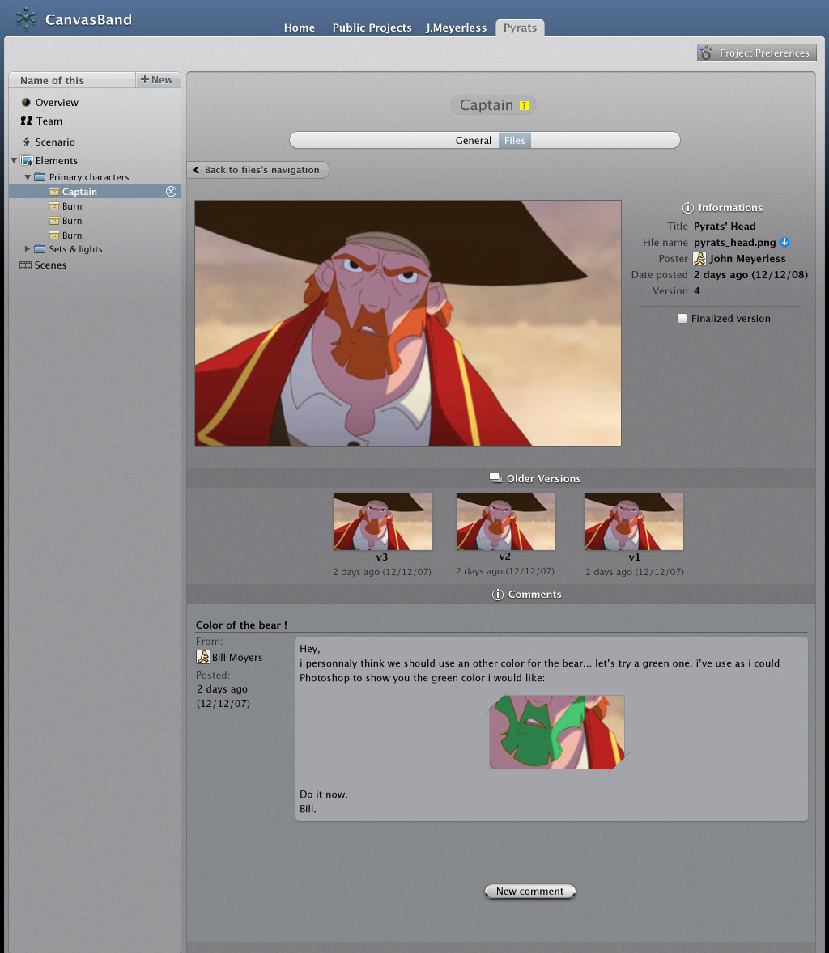
Adding Visual Notes (freehand draw, circle marquee or square marquee).

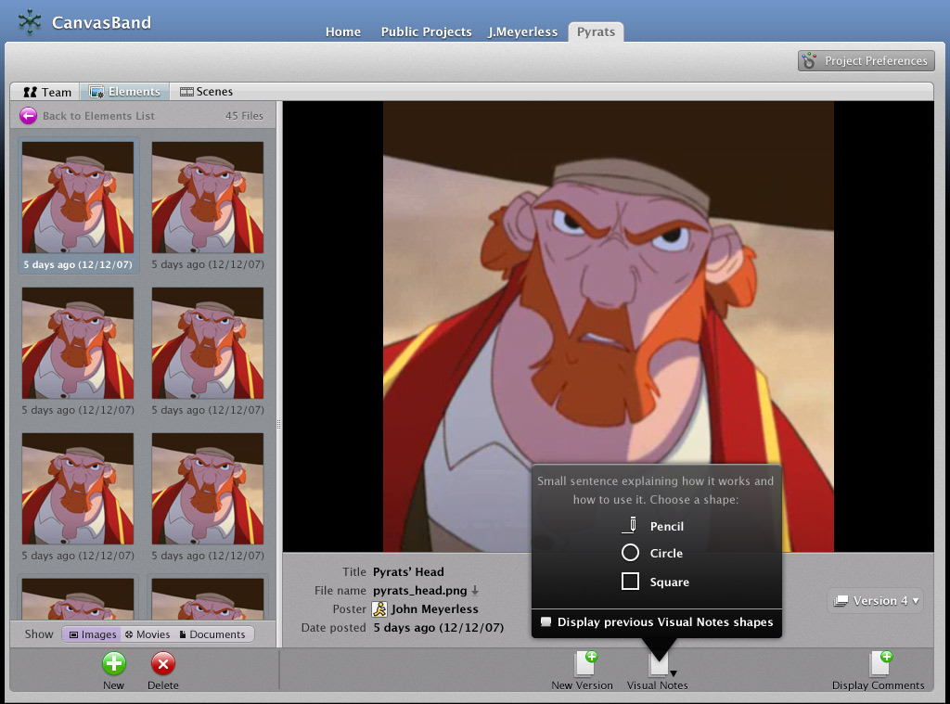

CanvasBand functions more as an application then a website. You can add and delete objects with javascript popups so that you do not need to leave the page to manage your project:

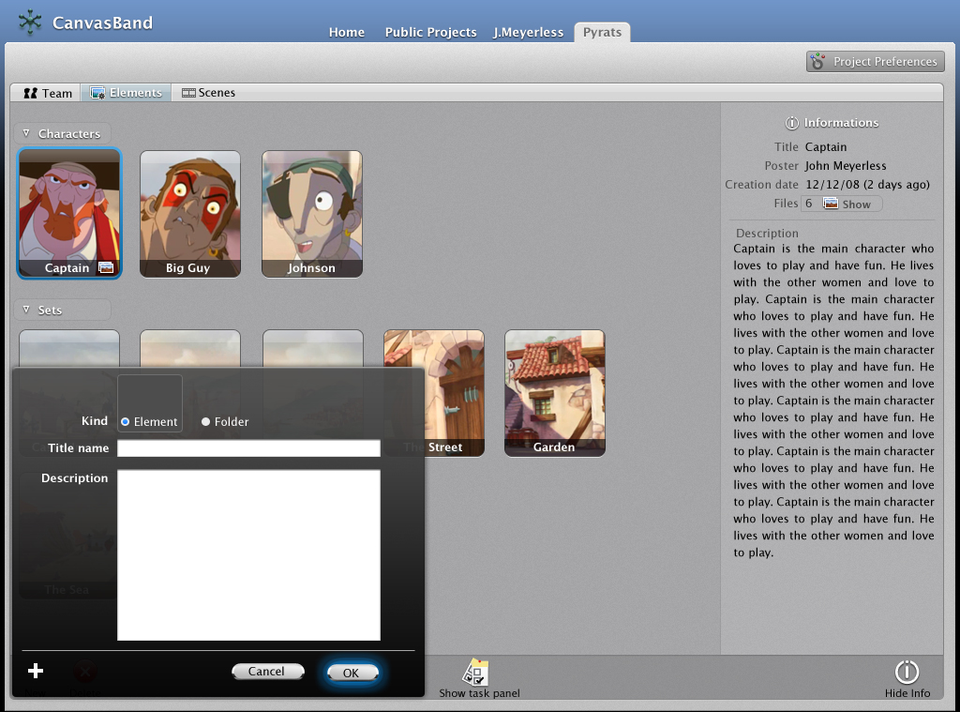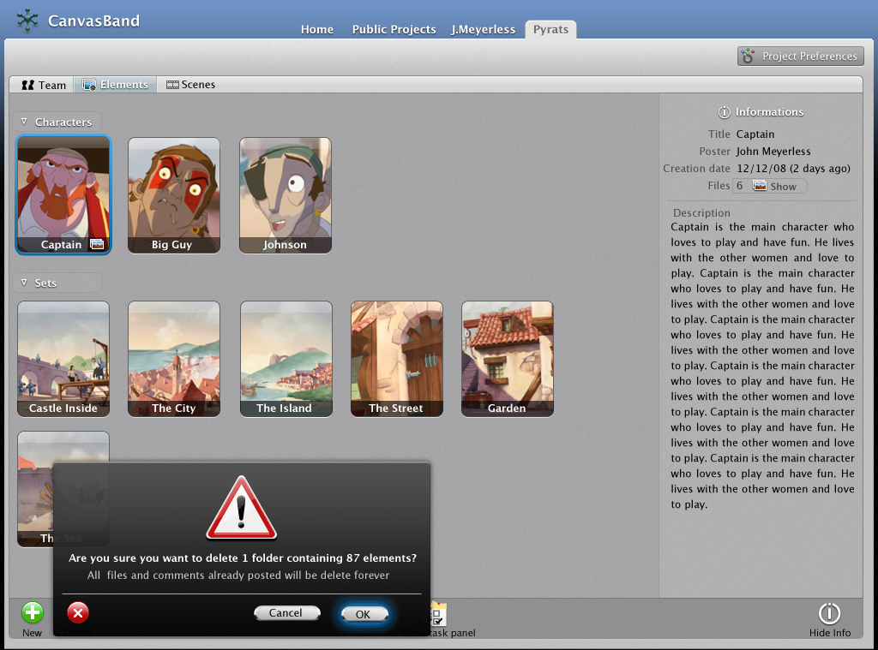
Scenes

Much like elements, Scenes gives you the ability to add folders and items under the folders. Again the terminology for any folder or item can be changed via the user. One of the distinct differences between Scenes and Elements is Scenes contains the Storyboards and Shots features. The storyboard system allows the user to either upload a zip, rar, or sit file containing image sequences that form a storyboard, or using the Adobe AIR (Apollo) application designate a folder on their hard drive for storyboards.

Shots and each image or movie in the storyboard can have a description, and a dialogue specified. For each there are also threaded discussions and version history for changes.

There is also a flash image player that will play storyboards as a slideshow.

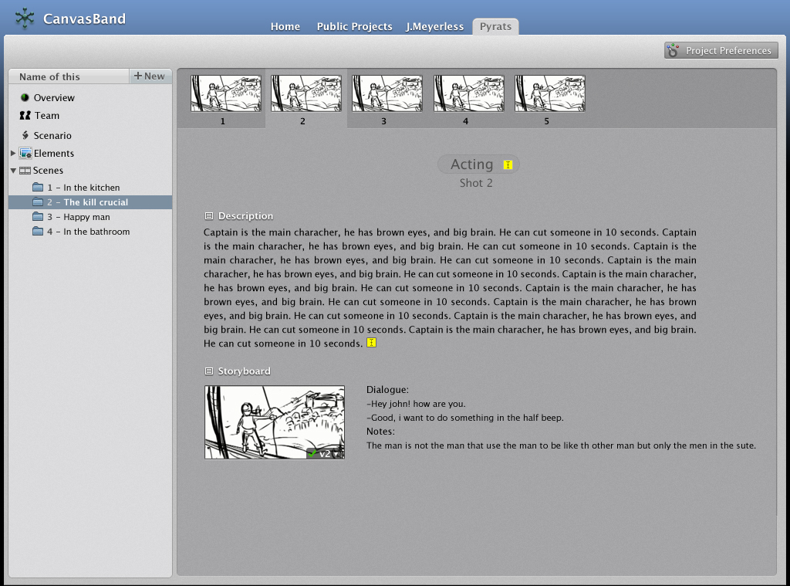
Each Scene and Shot within that Scene have the ability to contain also general information, storyboards, and any necessary files associated with it. They can be filtered in the viewport by image, movies, documents and sorted by date, name, version or user.

Example of files for Shot 3 titled “Come Back” under “The Crucial Kill” Scene:
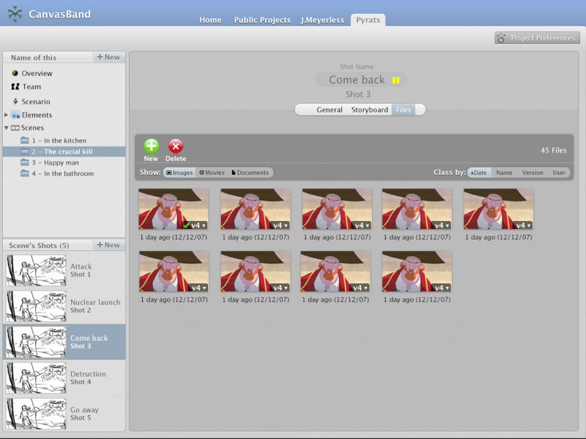
Adobe AIR (Apollo) Applications

CanvasBand utilizes Adobe’s new technology AIR (was named Apollo) for various features when using a project. The CanvasBand AIR application offers the following features on a users desktop on all platforms (windows, mac, linux, irix, iphone):

  - Instant Messenger Client: CanvasChat (one on one and group chat)

    - Filed Conversations: Unlike other messenger conversations once the conversation is finished the users are asked if they want to file this conversation to a particular project element, scene, shot or image. This ensures the entire team is looped into discussions that do not take place on the website

    - File and Filed Sharing: Unlike regular file sharing done through instant messaging clients, all files shared are not only posted to the users in the conversation but are prompted to be stored into a particular project element, scene, shot or image on CanvasBand. They can be referenced locally on a network or Remotely on CanvasBand.

    - PhotoShare and Visual Notes: CanvasChat gives users the ability to instantly share images which again can be filed to their projects on CanvasBand. They can drag and drop images to the client and the other users in the conversation will see it instantly. They can also use the “Visual Notes” option to specify areas on the image for conversation and those will be uploaded to CanvasBand accordingly.

    - Multiclient connectivity: CanvasChat uses web standards to allow connectivity not only to CanvasBand project teams but also to other IM clients such as AIM, GTalk, Yahoo, ICQ, and MSN. If a user invokes CanvasBand features to a user who is using another client, CanvasChat will invite the user to join CanvasBand and download CanvasChat (subscription required).

    - Whiteboarding: CanvasChat has whiteboarding features similar to Yahoo’s Doodle but far more advanced. It gives users the ability to create real time collaborative storyboards or sketches and then of course file then to their project on CanvasBand saving them as jpgs in the background.

    - Security: All conversations, files shared, and whiteboarding are encrypted to offer CanvasBand and CanvasChat users the highest level of security.

    - Auto Updates and Project Information: Because CanvasChat is based on Adobe AIR technology we can automatically update the client, as well as display project information in a tab of CanvasChat.
  - Desktop Background Server: CanvasDesk

CanvasDesk is one of the most important pieces of CanvasBand and one of the most unique innovative examples of the power of Adobe Air

CanvasDesk is installed with CanvasChat and is an application server that sits quietly on the users computer using very little memory. It is only apparent as a small icon on the desktop or tray or when it displays “Notifications”

    - Project Directories: CanvasDesk logs a user into their CanvasBand account and downloads project information connecting the user’s computer and their CanvasBand accounts. A user can drag files or for example set a program to render 3000 frames to a CanvasDesk directory and as the images hit these folders CanvasDesk will be interactively automatically uploading them directly to the CanvasBand account. If a user has chosen a project to be “local” then CanvasDesk will upload a pointer and file information so other CanvasBand members on the same network can access this file directly and not use CanvasBand’s bandwidth (no uploading/downloading).

    - Notifications: CanvasDesk sends out notifications as small popups on all members desktops. This allows busy artists to not have to check back to the CanvasBand website in order to be notified of changes and additions to their projects. In fact in combination with project directories one member will be notified of images in real time as they are being rendered on another member’s computer. This is a perfect example of how a director or supervisor can streamline production by seeing an image they want changed instantly on their own computer, then using CanvasChat to send that member a message asking them to stop the render and make the change. In the past this lack of organization could lose hours per change, with CanvasBand this will no longer be the case.

Notifications are sent on all actions associated with the project including additions, deletions, changes, team member logins, team member logouts, private messages received, private messages read, and more.

