Frittering

The TABLETOP rule set by Forrest H Lowe 2024  
Version alpha 2.0 Rev.3

Frittering is a tabletop RPG with three classes. It’s a rogue like, with tile-based movement, and a glorious game play loop that will entrap you like the filthy little sub you are.

**DISCLAIMER:** Due to the early nature of the game, there are a ton of “rough edges” that may hinder enjoyment. Ultimately this is a tabletop RPG, which means that it is only as fun as your game master can make it. As the game master you will improvise an absolute metric ton, until the game has reached a more finished state. With that, the game will be receiving very frequent rule changes. You may find that the rules that you liked have been changed, so please be sure to double check your current version against the latest version for any changes.

It is recommended that players keep a white board or piece of paper handy, I personally give my players a small white board tile from my dungeon tile set. Players will have a lot of information to keep track of and trying to track it mentally would be far too taxing.

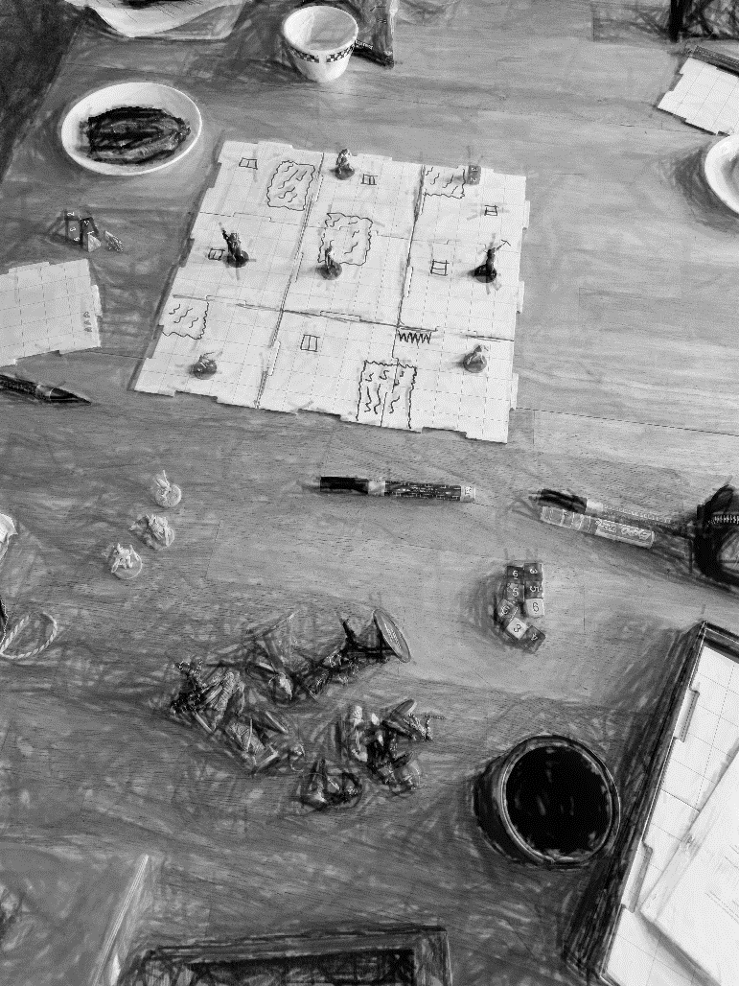  
Above you see what a game might look like.

## Playing the game

##### The Core rules

Players start the game with 20 points. If these points hit or fall below zero that player loses. If there are multiple players and only 1 player has lost, then that player may skip their next turn and restart. Restarting entails losing all items, levels, and deaths, then returning to the spawn point for the active level.

Each character has 6 actions per turn. And at the end of a *players* turn the players subtract 6 from their score total. The following is a table of possible actions characters may take:

|  |  |
| --- | --- |
| Push | Roll a d6, for every 2 you may move the opponent 1 tile opposite of your character. If you roll a 1 that is a failure, and you may not move the target.  If an opponent cannot move farther due to a wall but has more movement left, they simply take 1 damage and stop in place. |
| Attack | Up to 3 actions per turn may be used to commit attacks.  Roll a d6 equal to the level of the attack you’re using. For ex. If you are attacking as a level 3 wizard, you would use 3d6 whereas if you were attacking with your level 1 warrior you would use 1d6.  If your accumulative roll is higher than the target’s armor class it will deal 1 damage.  A critical is when you roll your highest possible roll, for ex. The level 1 warrior’s highest possible roll would be a 6. Critical hits deal an additional 1 damage, assuming that your roll still hits the opponents armor class. |
| Move | Move 1 tile in any of the 8 directions. |
| Heal | Return to 3 hearts by paying the **return to life cost**. |
| Fortify | Use up to 3 action points to raise your armor class by 2 per action point spent. |
| Throw/Jump | Roll a d6, for every 2 you may move the item thrown 1 tile. If you roll a 1 the item falls at your feet. |

There are also free actions that you may take. You can place something where you stand, cast a scroll, or open a chest any of which would not cost you an action point.

Every character has 3 health. When you are hit you lose 1 health. If you reach 0 health, you may pay the **return to life cost** to continue or succumb to death and restart.

**Return to life cost** is a fee you must pay to return to your starting health. The fee is equal to 10 * (1 + number of deaths). To explain that further, you must pay 10 to heal, or to return to life. But after you have died once you now must pay 20 to heal, or to return to life.

##### Classes:

|  |
| --- |
| Warrior can attack anything within 1 tile. Warriors may slash up to 3 tiles within range, all characters within the range of that slash may be hit. Each character within a slash counts as their own attack roll, roll separately for each opponent.  **Weapon bonus:** If a warrior is holding a weapon the opponent must roll a d6, if the roll is a 3 or lower the opponent becomes *confused*. Warriors have the “lunge” ability, allowing them to jump once for free.  Has a base armor class of 4.  At level 2 armor class increases to 6. At level 3 armor class increases to 9. |
| Wizard can attack anything within 4 tiles. *Disadvantage* on attacks within 2 tiles. Wizard uses electricity to attack; thus, they can roll d4’s equal to their level to dictate the range of their chain attack. *(For ex. I hit a foe within range, and as a level 2 wizard I roll 2d4 and I achieve a 7, which I then use to count 7 tiles to another foe.)* If you can reach another character, you would subtract 1d4 from your next roll, then roll again. Two important rules apply here, this happens in an instant so your lightning may not hit the same enemy more than once, and you may not split your roll among multiple characters.  **Weapon bonus:** If a wizard is holding a weapon, they gain +1d4 to their chain range.  Has a base armor class of 2.At level 2 armor class increases to 4.At level 3 armor class increases to 6. |
| Ranger can attack anything within 6 tiles. *Disadvantage* on attacks within 3 tiles. On hit the foe must roll a 4 or higher on a d6 or become entangled.  **Weapon bonus:** If a ranger is holding a weapon their entanglement attack becomes an area of effect, effecting 1 tile in every direction from the target hit, each of which would have to roll a d6 or become entangled  Has a base armor class of 3. At level 2 armor class increases to 5. At level 3 armor class increases to 7. |

**Levels** are achieved either by selecting a class at the beginning of a game, or by choosing to pay to increase your level. You may pay **50** points to become level 1 in another class. To level up any class from 1 to 2 you must pay **100** points. To level up to level 3 in any class you must pay **200** points. If you choose to multi-class your armor class is the highest available armor class to your character. Your attacks are whichever class attack you wish to use in the moment, with the advantages and disadvantages that come with that class. You may not use multiple classes to attack in a single action.

##### Disadvantage

Disadvantage is an addition to your roll when attacking. An enemy within disadvantage range has +2 * *tiles in range* to their armor class. Below is an example of how this would be illustrated with a disadvantage range of 1.

|  |  |  |
| --- | --- | --- |
| **+2** | **+2** | **+2** |
| **+2** | **You** | **+2** |
| **+2** | **+2** | **+2** |

And below is an example of disadvantage range of 2.

|  |  |  |  |  |
| --- | --- | --- | --- | --- |
| **+2** | **+2** | **+2** | **+2** | **+2** |
| **+2** | **+4** | **+4** | **+4** | **+2** |
| **+2** | **+4** | **You** | **+4** | **+2** |
| **+2** | **+4** | **+4** | **+4** | **+2** |
| **+2** | **+2** | **+2** | **+2** | **+2** |

And finally, a disadvantage range of 3.

|  |  |  |  |  |  |  |
| --- | --- | --- | --- | --- | --- | --- |
| **+2** | **+2** | **+2** | **+2** | **+2** | **+2** | **+2** |
| **+2** | **+4** | **+4** | **+4** | **+4** | **+4** | **+2** |
| **+2** | **+4** | **+6** | **+6** | **+6** | **+4** | **+2** |
| **+2** | **+4** | **+6** | **You** | **+6** | **+4** | **+2** |
| **+2** | **+4** | **+6** | **+6** | **+6** | **+4** | **+2** |
| **+2** | **+4** | **+4** | **+4** | **+4** | **+4** | **+2** |
| **+2** | **+2** | **+2** | **+2** | **+2** | **+2** | **+2** |

Hopefully this is rather self-explanatory. The opponent would receive a bonus of +X to their armor class depending on where they stand within your disadvantage range. If they are outside your disadvantage range, then they receive no bonus to their armor class.

##### Items

**Chests** when opened the user must roll 1d6 refer to the table below for loot:

|  |  |
| --- | --- |
| 1-2 | Weapon |
| 3 | 1d4 Armor |
| 4 | Bomb |
| 5-6 | Scroll |

Bombs deal 1 damage to all 8 surrounding tiles and the tile it sits on at the end of the turn of whoever placed the bomb.

Armor acts as temporary hit points, hits against an armored opponent take away armor not health.

Weapons add 2 to any attack roll. If you roll your lowest possible roll your weapon breaks. Weapons do not stack; however, you can hold multiple weapons in your inventory at once.

Scrolls roll 1d6 and refer to the table below:

|  |  |
| --- | --- |
| 1 | +2 Temporary hit points |
| 2 | Contract (freely deal 1 damage to anything within 6 tiles of you) |
| 3 | Teleport (move your character anywhere within 6 tiles of you) |
| 4 | Confuse |
| 5 | Rejuvenate (can be used in place of a life cost) |
| 6 | Fireball (lob a ball of fire which acts identical to a bomb anywhere within 6 tiles of you) |

**Earning points** can be achieved by opening chests or killing foes. Killing foes and trapped chests will net you *12 + 3d6*. For chests you open that is not trapped you receive *24 + 4d6*. Trapped chests act as enemies for rewards.

**Trapped chests** do not contain items, but do have points, see above. A trapped chest will have the game master rolling a d6, if it is a 4 or higher you do not take damage, otherwise the character takes one damage.

##### Status effects

**Confusion** will cause a character to skip their turn. The character does not have to subtract 6 at the end of this turn as no actions were taken.

**Entangled** is an effect that removes 2 action points from the target. If you start your turn with 3 levels of entanglement, you will simply end your turn having lost 6 points. Those 2 action points would be spent on removing yourself from the entangling.

**Falling into a trap** will cause a character to take 1 damage, followed by rolling a d6. Unless specified by the game master you must roll a 4 or higher to get out of the trap, and land on the nearest tile. If you roll a 3 or lower you take a point of damage and roll again, repeat until you are dead or out of the trap. This does not cost an action.

## Game master's guide

A game master's perspective is that of the foes in Frittering. You have the biggest role, as you decide who lives and who dies. A key take away when playing as the game master is to remember that all characters, foes and players alike follow the same rule set. The only change to the players’ rule set is the addition of points. Foes do not have to follow the points rule, as they are not undead. To prevent unfairness, you should generally target users dealing the most damage, or closest. Do not punish players. In the end this is a game, and if the players aren’t having fun, there is no point. If you can’t find a way to achieve your goal without punishing the players, it may not be a valid goal and you should find another avenue.

Initiating a round starts with everyone rolling a d6. Each player and the game master all roll 1d6 each. Turns are taken in a clockwise manner around the table starting with whoever rolls the highest. The game master takes all monster turns consecutively. For ex. Each player takes their turn, then each monster takes their turn.

Once the player has cleared your dungeon's creatures, you should take the creature’s turn to spawn a high-level enemy at the dungeon entrance. This foe should seem unbeatable and encourage the players to leave the dungeon faster.

After 3 dungeon levels the player should be at a high enough level to take on a boss. A boss would have 24 total hit points, you may split this by 2 creatures, or a single creature with high hit points. This creature has 6 total levels and may be split amongst the classes however you wish. If the boss has been defeated, it’s not uncommon for the players or the game master to feel burned out by the game. You may choose to end the game here by describing the dungeon collapses around the players. Alternatively, if you and your players are okay to continue you would simply start back at level one and keep going until you do feel like stopping.

Generating dungeons by hand is the current most frustrating element of Frittering. You must generate dungeons by hand; however, I’ve developed a few steps to ease that process. As a general rule you should use your best judgment and manipulate the dungeons to make them more compelling (or possible) for your players. Again, this is only a template to aid in dungeon creation, you can create your own dungeons as you please. [I recommend using tiles similar to these.](https://www.amazon.com/dp/B075X1Z2F5/ref=sspa_dk_detail_1?psc=1&pd_rd_i=B075X1Z2F5&s=toys-and-games&sp_csd=d2lkZ2V0TmFtZT1zcF9kZXRhaWw)

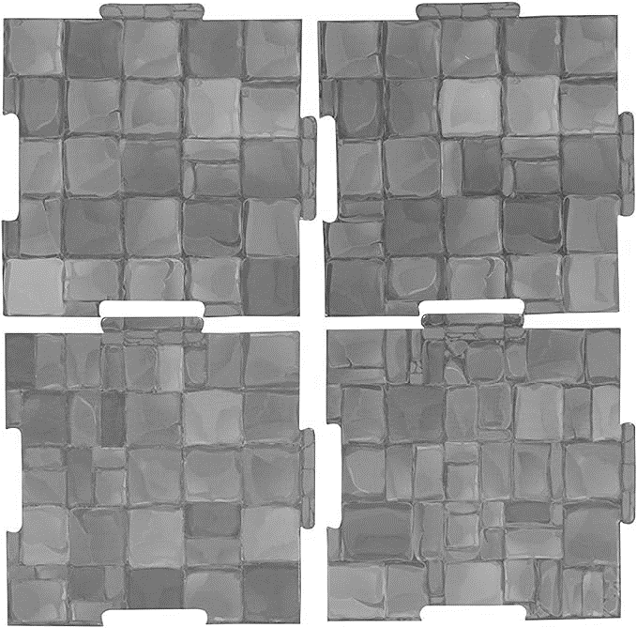

The dry erase aspect is the most important one, personally I do not use textured ones, but rather plain white ones.

**Step 1.** Layout 9 5x5 tile blocks, laying out a map total of 15x15 tiles.

**Step 2.** Roll a d6 for each 5x5 tile block.

A separation would be the [absolute] blocks roll minus the neighboring blocks roll. If there is a separation of 1 or less then that room and its neighbor are joined, and there is no wall. If there is a separation of 5 then there is a wall, and no door. Anywhere in between is a wall with a door. Please use your own discretion to make sure that the entire dungeon is traversable.

**Step 3.** Roll an additional d6 for each 5x5 tile block. Refer to the table below for what exists in that room. Repeat this step as many times as you like, however I prefer to use the rule of 2 + dungeon level.

**Step 4.** Place entrance and exit anywhere, as far away from each other as possible.

Dungeon contents:

1-3 = Trap (lava, spikes, trapped chests, what have you)

4 = Chest

5-6 = Enemy

If your dungeon is not interesting at this point you should go through it by hand and manually decide what needs to change to make the dungeon more interesting.