AUTOMATED UBUNTU SERVER PROVISIONING
Author: Israel Olawuni
Date: August, 2026

Project Overview
This project replaces manual point-and-click VM installation with Infrastructure as Code (IaC) using Vagrant. A single configuration file combined with a shell provisioning script automatically builds a complete, reproducible Ubuntu Server 22.04 environment with one command: vagrant up. This mirrors how real-world DevOps and Site Reliability Engineering teams provision servers at scale.

Infrastructure as Code
Infrastructure as Code (IaC) is the process of managing and provisioning computer infrastructure through machine-readable text files rather than physical hardware or manual configuration

Why Infrastructure as Code is Important
1. Consistency: Every environment built from the same file is identical. This prevents errors caused by manual setup differences.
2. Speed: Systems deploy in minutes instead of hours or days.
3. Version Control: Infrastructure files can be stored in systems like Git. You can track changes, review updates, and roll back errors easily.
4. Scalability: You can spin up multiple identical servers or environments with a single command.

How Vagrant Implements IaC
- The Vagrantfile: Vagrant uses a single text file called a Vagrantfile. This file describes the operating system, memory size, network settings, and software needed for the project.
- Declarative Setup: You write what you want the environment to look like inside the file, rather than clicking through a graphical menu to build it.
- Automated Provisioning: Typing the command vagrant up reads the file and builds the entire virtual machine automatically.
- Shared Environments: You can send the Vagrantfile to team members. They run the same command to get an exact copy of your development environment on their own computers.

Research Process
My research began with Vagrant's official documentation and the HashiCorp download page to understand installation requirements. I then looked at example Vagrantfiles to understand the syntax such as, how config.vm.box, config.vm.network, and config.vm.provision work together. The most challenging part was understanding how Vagrant's Host-Only networking related to what I had already learned about VirtualBox's network adapters from earlier tasks, I had to confirm that Vagrant's private_network setting maps directly onto a VirtualBox Host-Only adapter, just configured through a different interface. A second challenge was debugging why my first vagrant up attempt downloaded the wrong Ubuntu version entirely.

Manual vs. Automated Comparison
The manual installation process I used earlier for DC01 and DNS01 required navigating installer screens, manually selecting options, and configuring networking after the fact through Netplan or Windows adapter settings. It gave me a deeper understanding of what each step actually does, which was valuable for learning. However, it is slow, error-prone, and recreating that exact VM requires repeating every manual step correctly.
The Vagrant approach is dramatically faster once Vagrantfile is written; a single vagrant up produces an identical, fully configured server every time, with zero risk of a misclicked setting. The tradeoff is that the learning happens once, upfront, in writing the Vagrantfile and provisioning script, rather than being reinforced every time you build a server. For a student learning fundamentals, manual installation teaches more. For production operations at scale, automation is the only viable approach.

Networking
NAT routes VM traffic through the host's network connection using a hidden internal IP range (e.g., 10.0.2.0/24 in VirtualBox). It provides internet access but isolates the VM from other devices on the host's network.
Bridged networking connects the VM directly to the physical network as if it were a separate device with its own IP on the same subnet as the host. It is not appropriate for lab environments handling in-progress configuration because it has full network visibility also with full exposure.
Host-Only networking creates an isolated virtual network shared only between the host and its VMs, with no external connectivity by default.
I used Host-Only for dns02, assigned 192.168.56.20. I chose Host-Only because it matches the task's explicit requirement for a 192.168.56.0/24 static IP, and because it keeps the Vagrant VM isolated and safe for experimentation, consistent with how I configured DC01 and DNS01 earlier in the program.

Automation Benefits
In a real enterprise environment, Vagrant (or a similar tool) would let a team provision servers consistently without depending on any one engineer clicking through the same steps repeatedly. If I needed 100 Ubuntu servers instead of one, manually installing each would take weeks and would almost certainly introduce inconsistencies between them. With a single Vagrantfile, I could either loop the configuration to create 100 VMs at once
Security Considerations
The provisioning script implements several security measures: UFW firewall enabled with only SSH and ICMP explicitly allowed, SSH root login disabled, empty password authentication disabled, and public key authentication enabled. The original SSH configuration is backed up before modification, so changes can be reverted if needed.
For a genuine production environment, I would add: fail2ban to block repeated failed login attempts, automatic security updates via unattended-upgrades, a non-default SSH port, mandatory SSH key-only authentication (removing password authentication entirely), and centralized logging to a SIEM for monitoring suspicious activity.
Environment Specification
Setting | Value
VM Name | dns02
Base Box | ubuntu/jammy64 (Ubuntu Server 22.04 LTS)
Static IP | 192.168.56.20 (Host-Only network)
RAM | 2048 MB
CPUs | 2
Provider | VirtualBox
Provisioning | Shell script (provision.sh)

Network Diagram
The Vagrant-provisioned VM (dns02) sits alongside the existing manually-built lab VMs on the host machine, each on its own isolated Host-Only network segment.

dns02 was placed on a separate subnet: 192.168.56.0/24 (Vagrant's default range). Both networks are independent Host-Only segments managed by VirtualBox, with no routing between them by default.
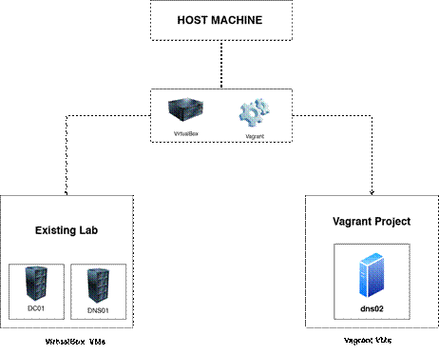

How to Run This Project
Prerequisites
VirtualBox 6.1 or higher installed
Vagrant 2.3 or higher installed
At least 4GB RAM and 20GB free disk space
Internet connection (for downloading the base box on first run)

Step 1
Place Vagrantfile and provision.sh in the same folder, e.g.:
C:\VirtualMachines\SIWES_Lab\vagrant-dns02\

Step 2
cd C:\VirtualMachines\SIWES_Lab\vagrant-dns02
vagrant up

This single command downloads the Ubuntu 22.04 box (first run only), creates the VM, assigns the static IP, and runs the full provisioning script automatically.

Step 3
vagrant ssh

Step 4
health-check.sh

Reports uptime, disk usage, memory usage, CPU load, network IP, firewall status, and SSH service status

Some important commands
1. vagrant halt: Shuts down the VM, keeps it on disk
2. vagrant destroy: Completely removes the VM
3. vagrant up: Rebuilds it identically, any time
4. vagrant reload: restarts VM and applies any new changes to vagrantfile
5. vagrant provision: runs the configuration scripts and tools on running VM without restarting it.
6. vagrant suspend: pauses your active virtual machine and saves its exact current state to disk
7. vagrant snapshot: manages point-in-time copies of a virtual machine's state so you can quickly save, test, and restore your environment

What the Provisioning Script Does
The provision.sh script runs automatically the first time the VM boots. It performs six steps:
1. Runs apt-get update and apt-get upgrade to ensure the latest packages
2. Install Essential Tools such as: net-tools, curl, wget, nano, vim, htop, unzip, ufw, openssh-server, tree
3. Configure Firewall (UFW): allows SSH and ICMP, then enables the firewall non-interactively
4. Disables root login, disables empty passwords, enables public key authentication, backs up the original config before editing
5. Installs a custom health-check.sh to /usr/local/bin/ for on-demand server diagnostics
6. Executes the new health check script immediately so the VM's status is visible the moment provisioning finishes

Troubleshooting Process
Wrong Box Downloaded (ubuntu/trusty64 instead of ubuntu/jammy64)
Running vagrant up from PowerShell showed 'Checking if box ubuntu/trusty64 version 20191107.0.0 is up to date' and 'Machine already provisioned’

Cause: vagrant up was executed from the wrong directory which contained a leftover Vagrantfile and .vagrant state folder from an unrelated. Vagrant always uses the Vagrantfile in the current working directory, not a specific file by name.

Fix: Navigated to the correct project folder before running vagrant up again. This time the correct ubuntu/jammy64 box downloaded and provisioning completed successfully.

Verification Results
Static IP assigned
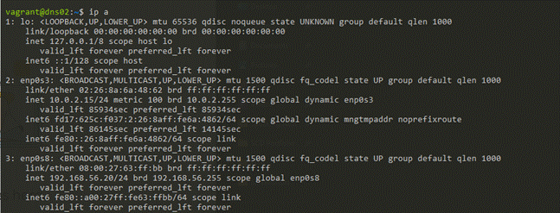
Firewall active
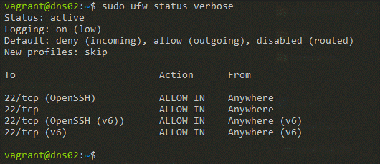
SSH hardened

Health check script
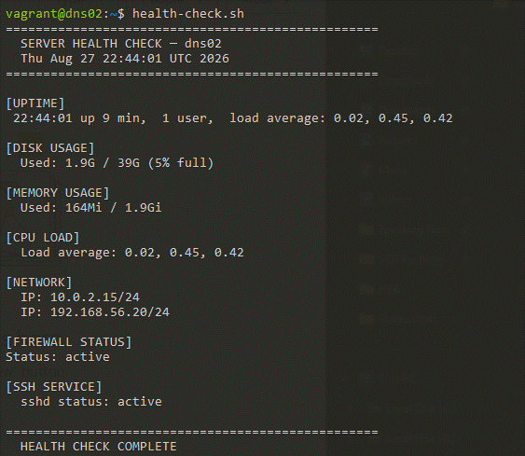

Connectivity check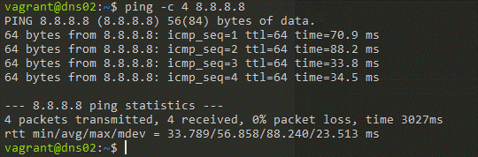
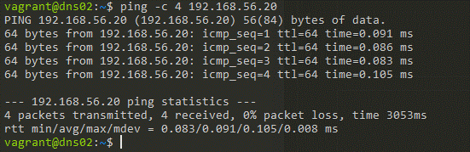

Conclusion
This project demonstrated the core principle of Infrastructure as Code: an environment defined entirely in version-controllable text files (Vagrantfile and provision.sh) that can be destroyed and rebuilt identically at any time, with zero manual clicking.
The most valuable skill I gained from this project was thinking about infrastructure as something that should be written down and reproducible. This directly prepares me for real-world IT and cybersecurity roles, where a security incident response often requires rebuilding a compromised server quickly and correctly, and a documented, automated provisioning process makes that possible in minutes rather than hours.

