**Description**

There is a possibility to change the default webroot settings of a module using property:

**<extname>.webroot=/webroot**

**Solution**

To change default HAC and HMC URLs to be “/admin” and “/manage” respectively we need:

1. Add next lines to ${HYBRIS_CONFIG_DIR}/local.properties:

**######## WEB-ROOT SETTINGS ##########**

**hac.webroot=/admin**

**hmc.webroot=/manage**

2. Rebuild and restart hybris server to apply provided configuration changes.

3. Now we can access HAC using context “/admin”

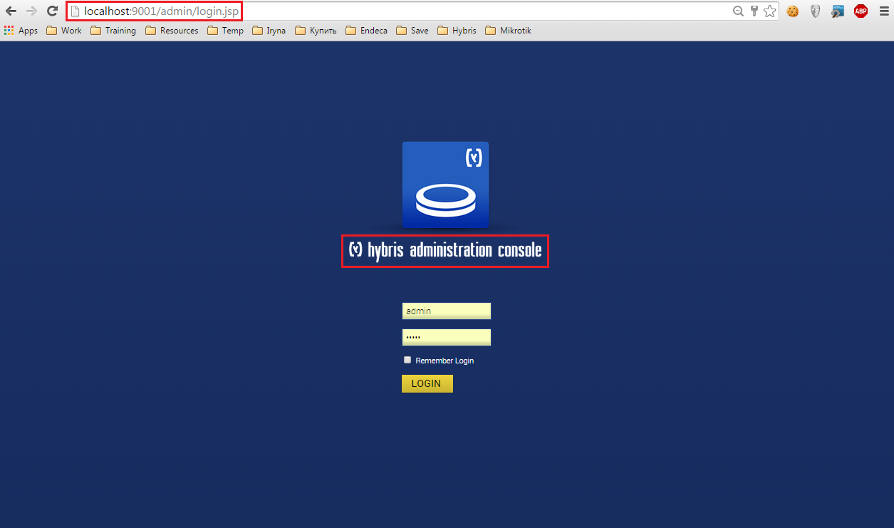

And HMC using context “/manage”

