**Description**

Hybris works with HSQL db by default but it supports MySQL.

**Solution**

To run Hybris on MySQL instead of HSQL DB:

1. Create new schema named **hybris_university** in MySQL:

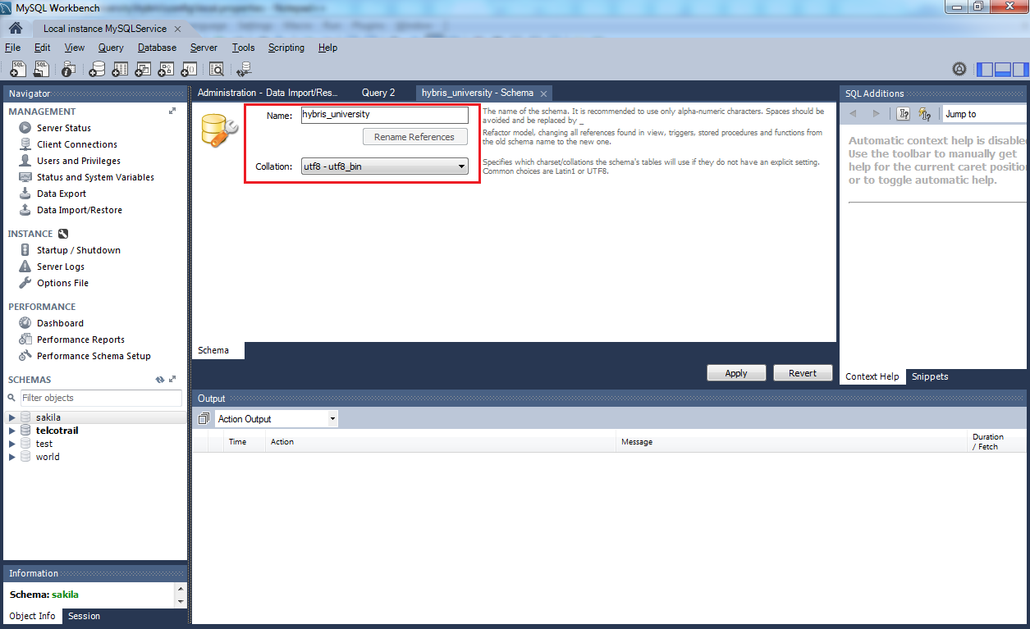

1. Create a user **hybris/hybris** with privileges to previously created schema **hybris_university.**

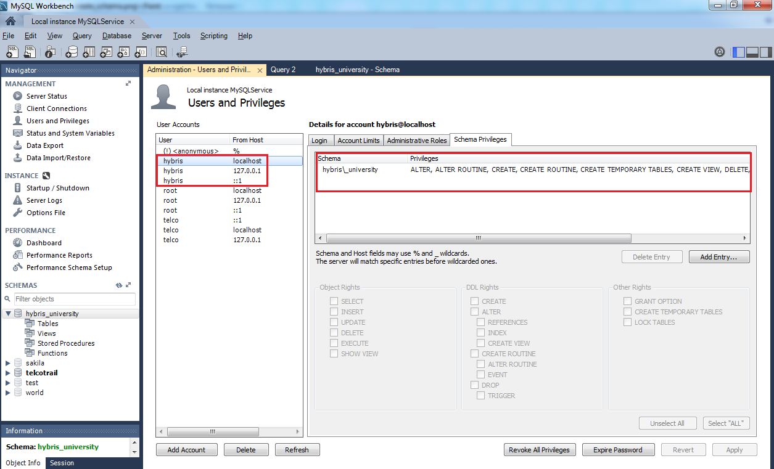

1. Add next configuration to **${HYBRIS_CONFIG_DIR}/localextensions.xml**:

# database configuration

db.url=jdbc:mysql://localhost/hybris_university?useConfigs=maxPerformance&characterEncoding=utf8

db.driver=com.mysql.jdbc.Driver

db.username=hybris

db.password=hybris

db.tableprefix=

mysql.optional.tabledefs=CHARSET=utf8 COLLATE=utf8_bin

mysql.tabletype=InnoDB

1. Download, unpack and copy the driver lib **mysql-connector-java-X.X.XX-bin.jar** into the directory **hybris/bin/platform/lib/dbdriver**
2. Rebuild and restart hybris server
3. Initialize system using hybris administration console.

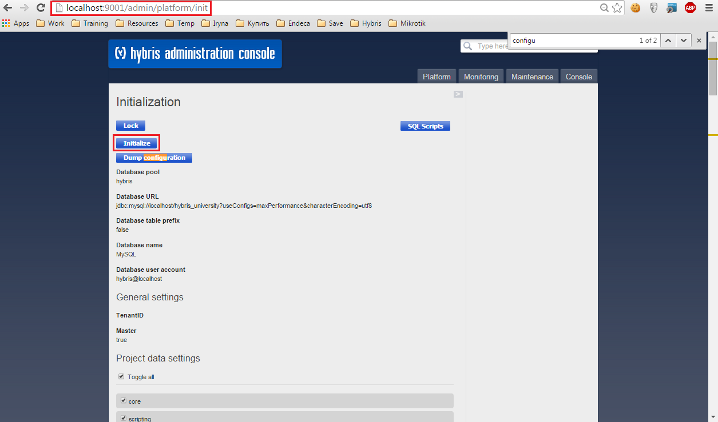

When initialization process is finished we may proceed to use hybris platform.