**Description**

There is a possibility to update existing item types in hybris. For that we need to edit *-items.xml file.

**Solution**

As we use **customtelcoaccelerator** extenstion based on telco accelerator template, so to add new attribute “additionalDescription” to exising item type “Product” we need add next snippet to **customtelcoacceleratorcore-items.xml**:

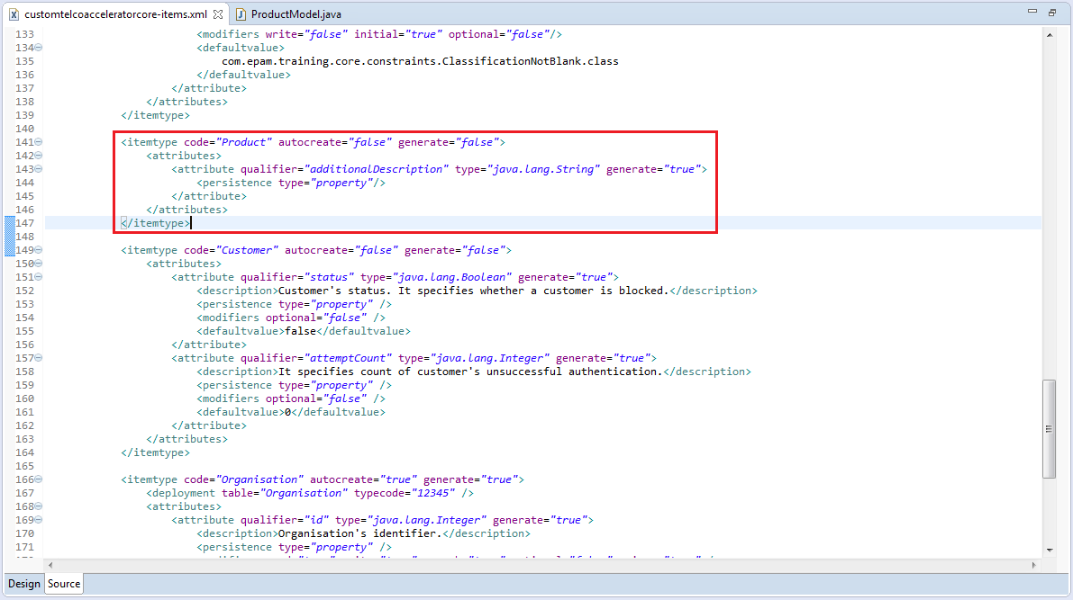

After rebuild we will see added property in **ProductModel**

