**Description**

There is a possibility to update existing item types in hybris. For that we need to edit *-items.xml file.

**Solution**

To create a "ProductBundle" type that is a product itself and may hold references to the other products we need:

1. Edit **customtelcoacceleratorcore-items.xml.** Add collection type:

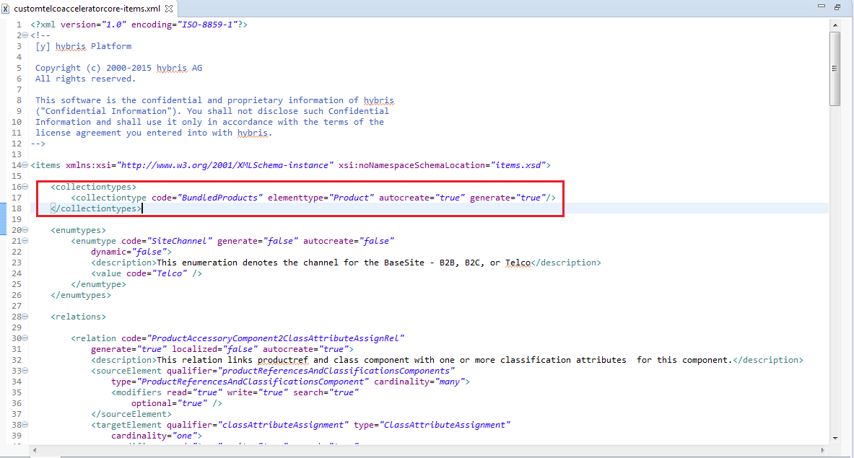

1. Edit **customtelcoacceleratorcore-items.xml.** Add new "ProductBundle" type:

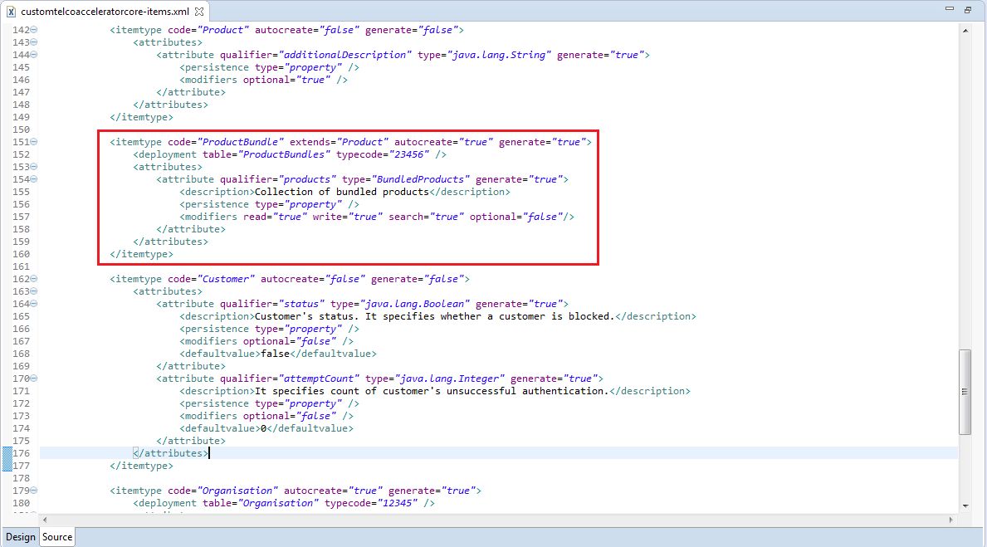

1. Rebuild and update system using HAC

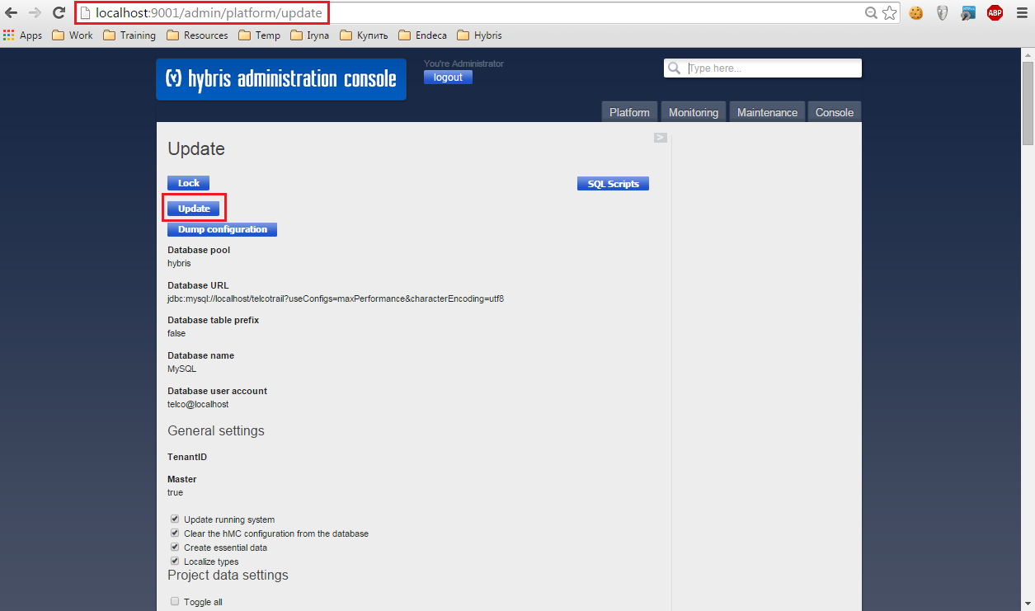

Now we can import computers data using ImpEx Import Console in HAC. See computers.impex file for details.