Delta Team

Ryan Norrbom, Gerardo Cordero, Eric Williams-Phillips, Bayleigh Kelton

CSD310

Assignment 9.1

Feb 24th, 2024

Milestone 1: Outland Adventures - Updates & Collaboration

On Delta Team, we have decided to use Discord as our primary mode of communication. The Link was posted to the Group discussion board and provided at the bottom of this document. Once we had aligned on our primary method of communication, we determined that we were adequately resourced to tackle the Outland Adventures case study.

* **Business Rules**:
  + Customer Management:
    - Each customer must have a unique identifier, name, email, and phone number.
  + Trip Organization:
    - Trips are uniquely identified and have a destination, difficulty level, and duration in days.
    - Trips are tracked by attendance.
    - Trips have assigned difficulty for proper resource assignment.
  + Equipment Handling:
    - Equipment is tracked with a unique identifier, type, purchase date, and price.
    - Equipment can be purchased or rented.
  + Booking System:
    - Bookings link customers to trips, each booking recorded with a unique identifier, the IDs of the customer and trip, and the booking date.
  + Sales Tracking:
    - Sales transactions are logged with a unique identifier, including the equipment sold, customer ID, sale date, and quantity.
  + Inventory Management:
    - Inventory records tie back to equipment and track the quantity available for each item.
    - Inventory is tracked by date of purchase for aging
    - Inventory Quantities can increase and decrease from rentals and sales.

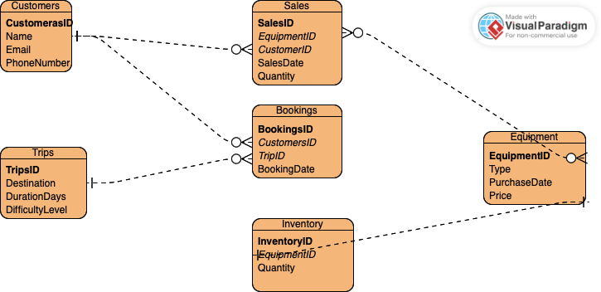

Figure 1: ERD for Outland Adventures

Discord Invite URL: <https://discord.gg/wqpx4NU4>

Ryan Norrbom GitHub Repository URL: <https://github.com/GeraltOfCodea/csd-310>

Eric Williams-Phillips GitHub Repository URL: <https://github.com/EricsMemory/csd-310>

Gerardo Cordero GitHub Repository URL: <https://github.com/onetimesomeday/csd-310>