ON-THE-JOB TRAINING EXPERIENCES AT INFORMATION TECHNOLOGY DEPARTMENT, CAVITE STATE UNIVERSITY - NAIC

Narrative Report
Submitted to the Faculty of
Information Technology Department
Cavite State University Naic
Bucana, Naic, Cavite

In partial fulfillment
of the requirements for the program
Bachelor of Science in Computer Science

ANGELITO P. DECATORIA III
August 2025



Republic of the Philippines

CAVITE STATE UNIVERSITY NAIC
(Formerly CAVITE COLLEGE OF FISHERIES)
Bucana Malaki, Naic, Cavite
www.cvsu-naic.edu.ph

INFORMATION TECHNOLOGY DEPARTMENT

Narrative Title: ON-THE-JOB TRAINING EXPERIENCES AT INFORMATION TECHNOLOGY DEPARTMENT, CAVITE STATE UNIVERSITY - NAIC

Name of Author: ANGELITO P. DECATORIA III

Degree Program: BACHELOR OF SCIENCE IN COMPUTER SCIENCE

Michelle C. Tanega, DIT  Technical Critic |  | _____  Date | MICHELLE C. TANEGA, DIT  OJT Coordinator/ITD Chairperson | _____  Date

ARMINA B. PUGAY, MSc _______
Campus Administrator Date

BIOGRAPHICAL DATA

Mr. Angelito P. Decatoria was born on May 26, 2004, in Libjo, Surigao del Norte. He is the son of Mr. Angelito M. Decatoria Jr. and Mrs. Margie G. Paso and has two siblings, Jayann Jane P. Decatoria and Kristel Jane P. Decatoria. He currently resides in Ternate, Cavite, together with his family.
He completed his elementary education at Sapang Elementary School, where he graduated in the school year 2015–2016 with the award of Second Honorable Mention. He then pursued his secondary education at Ternate West National High School, graduating in the school year 2019–2020 with honors; however, there was no formal graduation ceremony due to the COVID-19 pandemic.
For his senior high school education, he attended Western Colleges Inc., where he graduated in the school year 2021–2022 with honors. Currently, he is continuing his academic journey at Cavite State University – Naic, where he is pursuing a Bachelor of Science in Computer Science, dedicated to achieving his goals and building a successful future.

ACKNOWLEDGEMENT

The trainee wishes to express his heartfelt gratitude to all the individuals who supported and guided him throughout the course of his On-the-Job Training, making the experience meaningful and successful.
First and foremost, he extends his deepest thanks to the Almighty God for His unwavering guidance, strength, and blessings that sustained him throughout this journey.
He would like to sincerely acknowledge his beloved family for their unconditional love, understanding, and constant encouragement. Special appreciation is given to Dr. Michelle C. Tanega, Chairperson of the Information Technology Department and OJT Coordinator, for her invaluable guidance, supervision, and support in making this training possible. Her insightful feedback and professional advice greatly contributed to his growth and improvement during the internship.
He also wishes to thank Sir Angelito “Jonjie” Catajan for his generosity and for making the internship experience more enjoyable and energizing by providing meals and encouragement.
Lastly, gratitude is extended to all faculty members, staff, and colleagues who shared their knowledge and assistance, helping to make this training a rewarding and productive experience.

the authors

TABLE OF CONTENTS

Page

BIOGRAPHICAL DATA iii
ACKNOWLEDGMENT iv
TABLE OF CONTENTS v
LIST OF FIGURES vii
LIST OF APPENDICES viii
LIST OF APPENDIX FIGURES…………………………………………….…….… ix
INTRODUCTION 1
Objectives of the On-The-Job Training 2
Significance of On-The-Job Training 2
Time and Place of On-The-Job Training 3
THE LINKAGE ESTABLISHMENT 4
Background/Profile of the Establishment 4
Location of the Establishment 5
Vision and Mission Statements of the Establishment 7
Goals and Objectives of the Establishment 10
Over-all Organizational Structure and Function of the Establishment 11
THE TRAINING AREA 12
Organizational Structure and Function of the Department 13
Department Function 13
Facilities 14
Equipment 17
Standard Operating Procedures 19
THE TRAINING EXPERIENCE 21
Task Performed/Specified Activities Assigned 21
Observed Strengths and the Training Area 21
Insights 22
SUMMARY 25
REFERENCES 26
APPENDICES 27

LIST OF FIGURES

Figure Page
- Location of the Institution 6
- Over-all organizational Structure 10
- Human Resource Management Office Department 12
- Employees Working Desk 14
- Intern Desk 15
- City Government of Imus Building 16
- Working Laptop 17
- Printer 18
- WIFI 19

LIST OF APPENDICES

Appendix Page
- Application Letter 28
- Resume 29
- Recommendation Letter 31
- Memorandum of Agreement 32
- Trainee-Industry Agreement Liability Waiver 30
- Location of the Linkage Establishment …………………………………… …34
- Certificate of Completion 38
- Accomplishment Evaluation Form 39
- Identification Card 40
- Daily Time Record 41
- Daily Journal 46
- Training Schedule Form 66
- Photo Documentation 67
- Routing Slip 75

LIST OF APPENDIX FIGURES

Appendix Page
Figure

- City Government of Imus (Close up Location) 37
- Identification Card 40
- Log Book/Daily Time Record 41
- Daily Time Record from October to November 42
- Daily Time Record November 43
- Daily Time Record December 44
- Daily Time Record from December to January 45
- Encoding 67
- Troubleshooting/Connecting Printer to Laptop 68
- Sorting Documents 69
- Fixing Attendance for Orientation 70
- Shredding 71
- Christmas Party 72

ON-THE-JOB TRAINING EXPERIENCES AT INFORMATION TECHNOLOGY
DEPARTMENT, CAVITE STATE UNIVERSITY NAIC

ANGELITO P. DECATORIA III

A narrative report submitted to the faculty of the Information Technology Department, Cavite State University Naic, Bucana Malaki, Naic, Cavite in partial fulfillment of the requirements for the degree of Bachelor of Science in Computer Science prepared under the supervision of Dr. Michelle C. Tanega

INTRODUCTION

On-the-job training (OJT) is a practical way of teaching employees the skills and knowledge needed to successfully carry out their job responsibilities. It's a "learning by doing" technique where trainees use their knowledge in practical situations under the supervision of knowledgeable instructors.
One of the most special stages of a trainee's journey is OJT, where educational knowledge is put to the test and turned into real-world abilities. In addition to developing technical abilities, this route needs on the trainee to develop resilience, adaptability, and a professional mindset. Moving from learning to doing can come with challenges, unexpected experiences, and opportunities for personal development.
According to Garavan et al., on the job training represents a set of processes that happen within a specific organizational context and involve assimilating and acquiring integrated clusters of values, skills, knowledge, and feelings that lead to fundamental changes in behaviors of a worker or teams (Nakahara & Matsuo, 2013).
Senior High School students needed to have an OJT training especially when you are in college degree. Students are not allowed to have their certificate that proves they finished their schooling era. One of the curriculums here in the Philippines is by taking the OJT. This was supposed to be a training for all those students to train their ability, capacity of their knowledge and how they are going to handle the problem they face in the real industry. This report helps track what students learn and achieve during their OJT.

Objectives of On-the-Job Training
The On-the-Job Training aims to provide students the capstone experience of the necessary competencies on the operational aspects of the linkage establishment. Specifically, at the end of the training, the trainee should be able to:
  - identify and comprehend the standard operational procedures and techniques of the section or department where the trainee is assigned;
  - associate key positions of the chosen establishment and related operations to their corresponding tasks and responsibilities;
  - perform specific tasks required in the sections or the department assigned;
  - evaluate operational procedures in the assigned section or department;
  - recommend appropriate course of action to improve the prescribed operations
  - prepare a narrative report that summarizes all the activities performed;
  - develop interpersonal and other communication skills needed for success in the assigned section or department of the establishment;
  - appreciate the importance of efficient operational policies and procedures in relation to the overall management of the related areas of the establishment; and
  - relate to theories the actual experience gained from the training.

Significance of On-the-Job Training
The significance of OJT is found in its ability to give trainees real-world, practical abilities that are directly related to their duties at work. Employees that learn on the job get real-world knowledge that enhances their ability and self-confidence in performing responsibilities. OJT improves up learning by allowing employees apply what they have learned to use quickly, leads to skill development and improves job performance. Because it removes the need for professional training programs and helps employees in avoiding theoretical knowledge that may not be useful to the job, this training approach is also reasonable for companies. Additionally, because OJT gives direct instruction, develops relationships, and supports advancement in employment, it increases employee engagement and retention. Additionally, by combining education with practical employment, OJT guarantees that the training quickly helps achieve improved efficiency and productivity by being in accordance with the requirements and goals of the organization. In the long run, getting on-the-job training is essential for personal development and organizational success because this develops an educated, focused workforce that is prepared for the demands of the job.

Time and Place of On-the-Job Training
The trainee completed his On-the-Job Training (OJT) with the Information Technology Department of Cavite State University - Naic. The trainee’s work schedule generally ranged from 7:00 a.m. to 6:00 p.m., although the starting time occasionally varied between 7:00 a.m. and 8:30 a.m. The OJT period commenced on July 17, 2025, and concluded on August 29, 2025.

THE LINKAGE ESTABLISHMENT

Background/Profile of the Establishment
The Cavite school of Fisheries was created under Republic Act No. 2661, sponsored by Cong. Justiniano Montano, the congressman for the lone district of Cavite, with initial appropriation of P 200,000.00, which was approved by congress on June 18, 1960. Its implementation in 1961 seems to have a very slim chance due to financial constraints of the National Government. It was due to the efforts of Dr. Perdo G. Guiang, the Asst. Director of Public Schools, who made representation to the budget commission to revert some reserve funds of other fishery schools that an initial amount of P40, 000.00 was made available for Cavite School of Fisheries.
Plans and budgetary Proposals were prepared in July 1961. The item of one principal, three fishery Technologist and one clerk were created. The amount of P22, 000.00 was set aside for the construction of the school building and the balance for supplies, materials and equipment. Initial operation of the school begun in June 4, 1962, with an enrollment of one hundred and seventy-five first year students under Secondary Fishery education Curriculum and with an additional appropriation of P100, 000.00 Classes were initially conducted in the old municipal building located right in the heart of the town of Naic. After a year, the school was transferred to its present site Bucana, a coastal Barangay of Naic, Cavite School of Fisheries was converted to college in 1970, offering two and a half-year Technical Education Curriculum with fifty students enrolled.
Since then, there was a continuous marked increase in enrollment, number of teaching and facilitative personnel, equipment and other instructional facilities in both secondary and technical fishery Education Curricula. At the start of school year 1974-75, the three-year Fishery Education Curriculum leading to a diploma in Fishery Technology was offered, then on June 30, 1975, DECS approved the offering of the four-year Technological Curriculum leading to a Bachelor of Science in Fisheries (BSF). In SY 1992-93 additional short-term courses were offered, namely; the two-year Food and beverage Preparation Services and the six-month Basic Seaman Training Course. In 1997-98 additional two courses were approved by CHED, namely: Associate in Hotel and Restaurant Management and Associate in food Technology, both laderized programs leading to Bachelor’s degree. The bachelor of Secondary education (BSE) with three major areas of specialization was approved in the same school year.
The year 2001 marks another milestone in the history of college when it was officially integrated to the Cavite State University (CvSU) System through RA #8292; by virtue of Board Resolution # 2 dated February 6, 2001. The integration of the college, present known as CvSU-Naic campus, marks a new beginning. It has a broaden its perspective to include Research, extension and production in addition to the lone instruction function the campus has been used to. Likewise new opportunities were opened for the campus to offer more courses, improve its faculty and staff, improve its facilities, develop and improve its RD and E endeavor in response to the growing demand of the society.

Location of the Establishment
The trainee conducted their On-the-Job Training at Information Technology Department in Cavite State University-Naic located at Bucana Malaki, Naic, Cavite
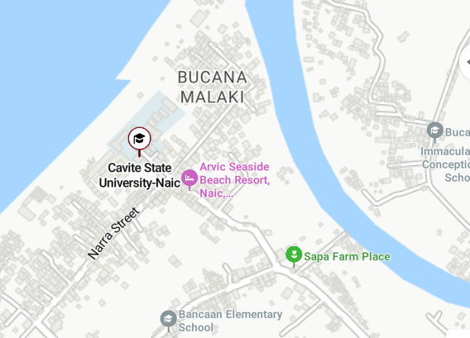

Figure 1. Location of the Institution

The location map of Cavite State University Naic Campus (CvSU-Naic) see Figure 1, situated along Bucana Malaki Naic, Cavite Road near the coastline. Key nearby landmarks include Seaside Beach Resort to the west, Bucana Elementary School to the northeast, and Bancaan Catholic Church to the south. The surrounding area features a mix of community facilities, local businesses, and resorts, connected by accessible road networks in a coastal, semi-urban setting.

Vision and Mission Statements of the Establishment
University Vision
Cavite State University shall provide excellent, equitable and relevant educational opportunities in the arts, sciences and technology through quality instruction and responsive research and development activities. It shall produce professional, skilled and morally upright individuals for global competitiveness.
University Mission
The premier university in historic Cavite globally recognized for excellence in character development, academics, research, innovation and sustainable community engagement.
Goals and Objectives of the Establishment
CvSU Naic shall endeavor to achieve the following goals:
- To produce technically competent and scientifically oriented graduates who are imbued with strong entrepreneurial spirit; possesses strong social consciousness; and guided by the positive values and high ethical standards;
- To conduct relevant research and development activities along fisheries, education, business, information technology, arts and sciences that would contribute to sustainable development in its service areas;
- Implement effective training and outreach programs that emphasize self-help, critical thinking and life-long learning;
- Manage fishery and other enterprise projects to promote economically viable and environment-friendly approaches and techniques; and
- Establish strong linkage with non-governmental organizations, other government entities and the basic sector for the realization of common goals.
Over-all Organizational Structure and Functions of the Establishment
Over-all Organizational Structure
The organizational structure of Cavite State University Naic Campus serves as a framework for defining authority, responsibilities, and communication flow within the institution. It reflects how administrative and academic functions are systematically arranged to promote efficiency, accountability, and coordinated decision-making across all divisions.
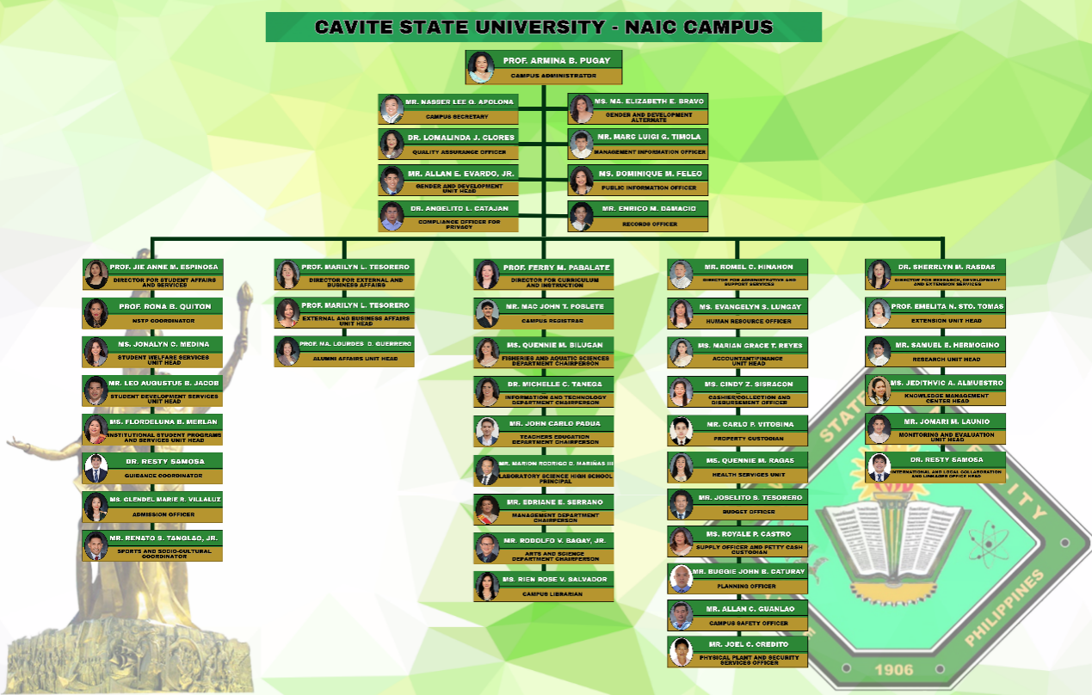
Figure 2. CvSU Naic Campus Over-all Organizational Structure

The organizational chart is present in Figure 2, of Cavite State University Naic Campus, outlining its administrative hierarchy under Campus Administrator Prof. Armina B. Pugay. The structure is organized into five main divisions: Student Affairs and Services, External and Business Affairs, Curriculum and Instruction, Administration and Finance, and Research, Extension, and Development. Each division is headed by a director and supported by unit heads responsible for specific functions such as academic departments, student welfare, external partnerships, financial management, research initiatives, and campus operations. This framework ensures efficient coordination, service delivery, and alignment with the university’s mission to address educational and community needs.

Functions of the Establishment
Guided by the University’s vision and mission, CvSU shall be true to the client it has vowed to serve. One of the major functions of the university is community service to entrepreneurs, farmer, rural women, fishers and out-of-school youth. It shall produce professional, skilled and morally upright individuals for global competitiveness.

Responsibilities of the Management
Department Chairpersons and unit heads shall:
    - Take charge of planning, development and supervision of their respective units;
    - Prepare budgetary estimates of their respective units in coordinate with college deans/division directors; and
    - Propose new and appropriate rules and regulations affecting their respective units;

THE TRAINING AREA

Organizational Structure and Function of the Department
The organizational structure and function of the department define the hierarchy, roles, and responsibilities of its members. It ensures efficient coordination, proper task delegation, and smooth workflow to achieve the department’s goals.
Information Technology Department
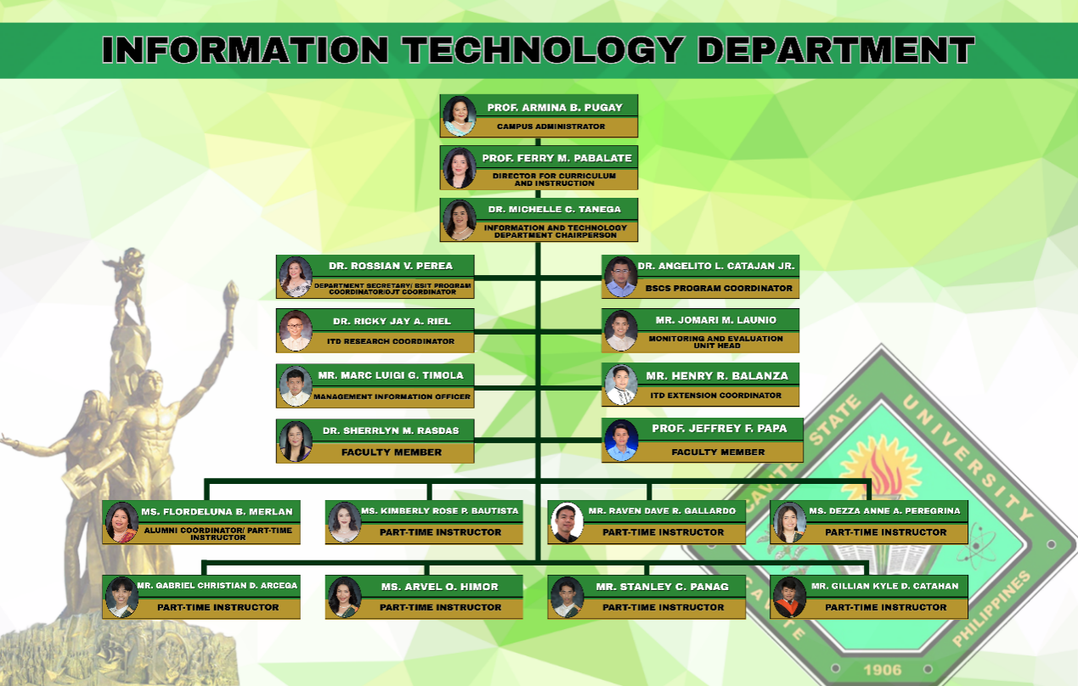
Figure 3. Information Technology Department Organizational Chart

The organizational structure of the Information Technology Department at Cavite State University Naic Campus is illustrated in Figure 3. The department is headed by the Department Chairperson, under the supervision of the Director for Curriculum and Instruction and the Campus Administrator. Key positions include the Department Secretary, BSIT Program Coordinator, OJT Coordinator, BSCS Program Coordinator, ITD Research Coordinator, ITD Extension Coordinator, Monitoring and Evaluation Unit Head, and Management Information Officer. Faculty members support various academic and administrative functions, while part-time instructors contribute to teaching and alumni coordination. This structure ensures the department’s efficient operation and the delivery of quality education.

Department Function
The following are the function of Information Technology Department:
- Proficient in designing and developing solutions;
- Conduct relevant researches and development activities in the field of computer science and allied fields.
- Promote the development and transfer of appropriate information technology and;
- Practice the principles of good governance and professional and ethical standards in the workplace.
- Well – versed on application, installation, operation, development, maintenance and administration of computers;
- Conduct relevant researches and development activities in the field of information technology and allied fields;
- Promote the development and transfer or appropriate information technology and;
- Practice the principles of good governance and professional and ethics standards in the work place.

Facilities
The facility houses essential office equipment that supports documentation and record-keeping needs. Among these is the ring binder machine, which ensures organized and professional presentation of files and reports.

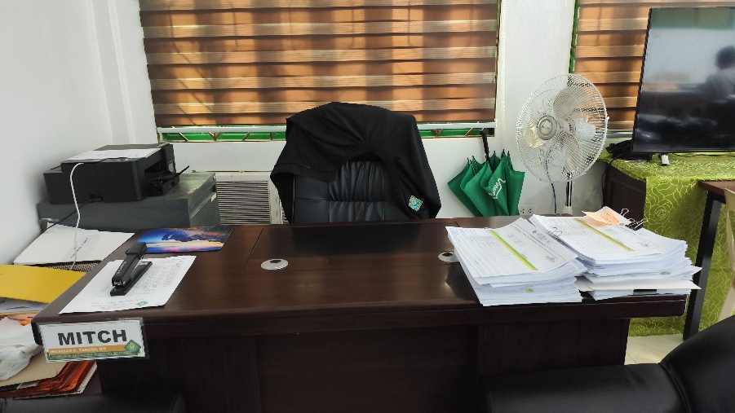
Figure 4. Employees Working Desk

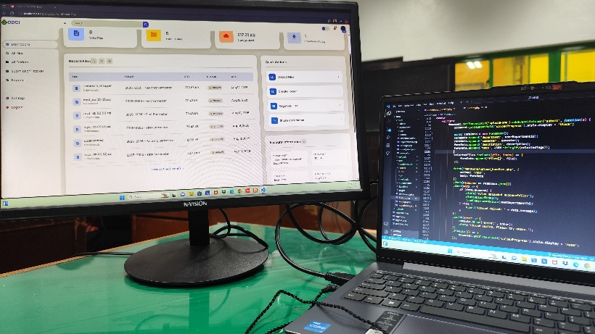
Figure 5. Intern Desk

This “Intern Desk” shown in Figure 5, represents a typical entry-level workspace. It has essential tools (PC, printer, keyboard/mouse) and reflects a basic, functional office environment. The BIOS error on the monitor suggests the PC needs technical attention something interns might encounter or report in real-world office settings.
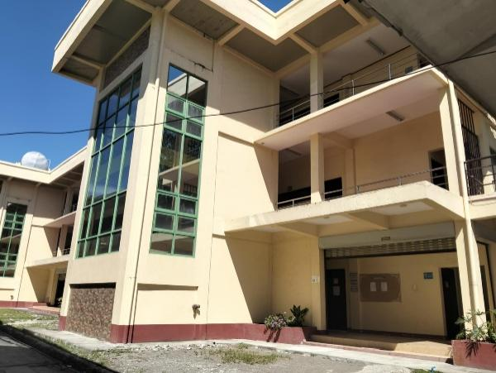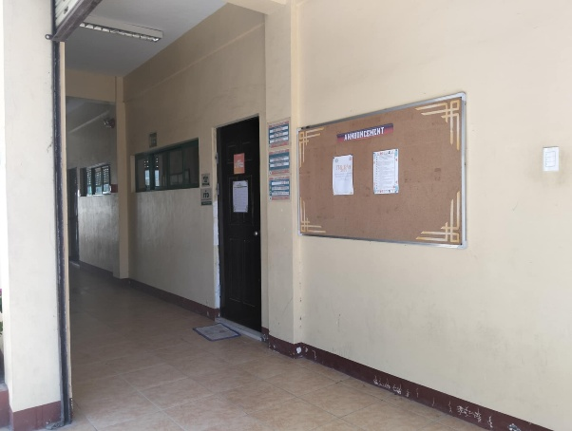
Figure 6. STAR Building at Cavite State University Naic

The STAR Building located at Cavite State University Naic Campus is shown in Figure 6, which serves as the home of the Information Technology Department (ITD). The building features multiple floors with spacious classrooms, computer laboratories, and faculty offices dedicated to the instruction and support of IT-related programs. It provides a conducive environment for learning, teaching, and administrative tasks. The department operates within this building to accommodate both students and staff, offering technical assistance, academic consultations, and hands-on learning experiences. As the central location for ITD activities, the STAR Building plays a vital role in supporting the university’s mission to deliver quality education and technological advancement.

Equipment
The equipment used in the Information Technology Department of CvSU Naic plays a vital role in supporting both academic and administrative functions. Each device, from laptops to printers and binding machines, ensures smooth operations, efficiency, and productivity in daily departmental tasks.
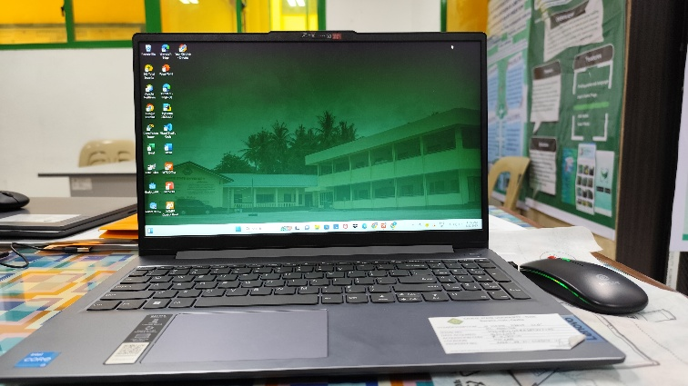
Figure 7. Working Laptop

The personal laptop shown in Figure 7 is used in the Information Technology Department of CvSU Naic. This Acer device, powered by an Intel Core i3 processor and running Windows 11, is used by student assistants and interns for report preparation, data encoding, layout design, and digital file management. Equipped with software like Microsoft Office, Canva, and other productivity tools, it supports academic and technical work. As a shared resource maintained by the department, the laptop helps ensure smooth operations while enhancing the skills and productivity of student assistants and trainee.

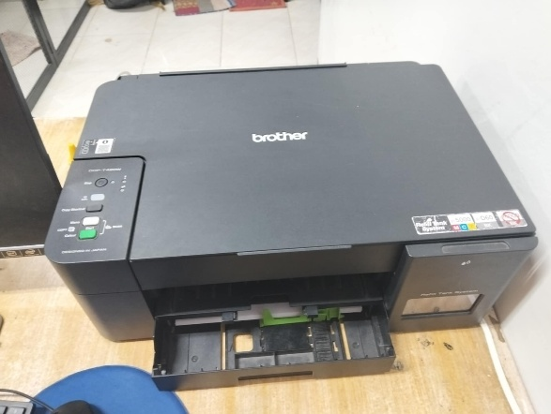
Figure 8. Printer

The printer shown in Figure 8 is used in the Information Technology Department of CvSU Naic. The Brother DCP-T420W is used for printing technical reports, memos, project proposals, and other academic or administrative documents. Its fast, reliable performance supports daily operations, providing hard copies for meetings, submissions, and recordkeeping. The Refill Tank System reduces costs and ensures continuous use. Shared by staff and students, the printer helps maintain efficiency and productivity in the IT office.
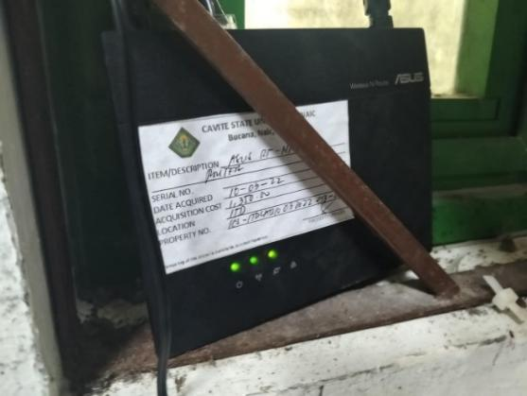
Figure 9. WIFI
The Wi-Fi router shown in Figure 9 is used in the Information Technology Department of CvSU Naic. The ASUS Wireless N Router provides a stable internet connection for staff, faculty, and student assistants. It supports access to online platforms, cloud services, research databases, and administrative systems for communication, data management, online meetings, and digital learning, helping maintain the department’s productivity.

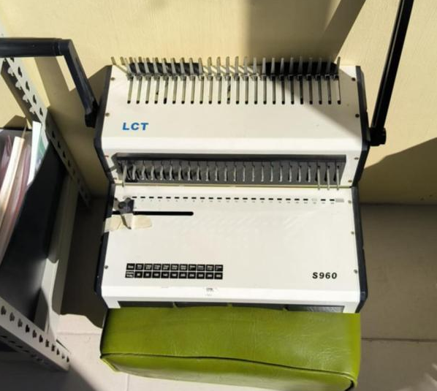

Figure 10. Ring Binder
The ring binder machine (LCT S960), shown in Figure 10 is used for punching holes in paper and binding them with plastic comb rings to create booklets or reports.

Standard Operating Procedures (SOPs)
System Management
The System Management SOP provides both users and management with an overview of the key features of the IT system they interact with regularly. It also includes documentation on the system's infrastructure and outlines the data structures involved in processing information. Additionally, this type of SOP covers important topics such as preventive system maintenance, the differences between batch and real-time processing modes, and the resources required for effective daily system management.
Security
This SOP focuses on IT security and outlines guidelines for protecting system applications and controlling access to digital resources. In the training area, faculty and staff are provided with passwords to access the Wi-Fi network, ensuring that connectivity is restricted to authorized personnel. To maintain data security, students are not permitted to use the computers assigned to the department, as these devices contain important files and information intended exclusively for faculty and staff use. This measure helps safeguard sensitive data and maintain the integrity of departmental resources.
Data Recovery
The Data Recovery SOP outlines the procedures to be followed in the event of a system crash to ensure important data can be restored. It details various types of data recovery methods, including full, incremental, and selective recovery, along with the utility programs used to carry them out. This SOP may also include guidelines for backing up data using system devices such as tape drives, CD-ROMs, or disk drives, as part of a proactive approach to data protection and recovery.

THE TRAINING EXPERIENCE

Task Performed / Specific Activities Assigned
The trainee benefits from on-the-job training (OJT) by experiencing the workplace culture firsthand, which helps prepare them for future employment.
The Information Technology Department's (ITD) OJT trainee gained responsibility for the tasks that were given to them. They also learned to value the time spent on completed tasks. The trainee was given a variety of duties to complete, including, encoding, organizing files both manually and digitally, designing, editing, filing, printing, scheduling, binding files, and scanning files.
OJT assists trainee in learning how to properly manage their work. The level of expertise and professionalism the trainee learned will be beneficial to them when they apply companies in the future.

Observed Strengths and Weaknesses of The Training Area
Strengths of the Training Area
The strengths of the training area include its well-maintained equipment, stable internet connection, competent faculty, and supportive staff. Working in a clean and well-organized environment enables trainees to perform their tasks efficiently. In addition, the presence of centralized air conditioning provides a comfortable workspace that minimizes stress, while the faculty staff remain attentive in guiding trainees on the proper execution of their tasks.
Weaknesses of the Training Area
Some of the weaknesses of the training area include the lack of properly functioning comfort rooms. While a restroom is available, it is neither clean nor in good working condition. In addition, although equipment is provided, some are not working properly. There is also insufficient space for the trainees, which at times requires them to sit at the faculty staff desks.
Insights
The 24-day On-the-Job Training experience proved to be meaningful and effective for the trainee. She developed social skills, learned to respect others, and gained a deeper understanding of the importance of building a career and becoming a competent individual. Throughout the training, they observed both the strengths and weaknesses of the workplace. She realized that working involves more than just completing assigned tasks it also requires professionalism and effective communication. The trainee also learned how to manage interactions with office staff and co-workers in a formal setting. Overall, the experience helped her grow personally and professionally, preparing her for a better future and bringing her closer to achieving her goals.
a. Problem encountered
During the training, the primary problems encountered were the inadequate condition of the comfort rooms, the presence of malfunctioning equipment, and the limited workspace available for trainees, which at times required them to share desks with faculty staff.
  - Suggestions for Self-improvement
The trainee suggested that she should arrive at the training area earlier and take the initiative to ask her supervisors for tasks when there is nothing to do. She also emphasized the importance of enhancing her learning experience and developing skills for future career growth through proactive efforts. This includes maintaining a curious mindset, asking questions when in doubt, and being open to learning. She is also encouraged exploring her creativity, actively listening to instructions from supervisors or mentors, staying positive, and believing in herself in every situation.
  - Suggestions for Program Development
The primary suggestion is to improve the internet connection by providing a faster and more stable network that can accommodate multiple users simultaneously without interruption. A reliable connection is essential for completing tasks efficiently, particularly when accessing online platforms, downloading files, or communicating with supervisors and colleagues. Enhancing network performance would significantly support productivity and ensure a smoother workflow within the department. In addition, it is recommended that regular troubleshooting and preventive maintenance of the equipment be conducted to ensure functionality and minimize disruptions.
d. Suggestions for Institutional Development
To support the continued growth and improvement of the institution, we recommend several steps for institutional development. First, upgrading internet connectivity is essential to ensure smooth and uninterrupted access for all users, especially in departments where online tasks and communication are constant. Improving and maintaining basic facilities, such as clean and functional comfort rooms, also contributes to a more comfortable and professional environment for both staff and trainees. Additionally, investing in updated equipment and software can enhance productivity and learning opportunities for students and employees alike. Regular training or workshops for staff and interns can also help improve skills and keep everyone aligned with current industry standards. These improvements can strengthen the overall efficiency of the institution and create a more supportive space for academic and professional development.

SUMMARY

During my On-the-Job Training at the Information Technology Department, I engaged in a wide range of tasks that enhanced my technical, organizational, and collaborative skills. Initially, I assisted with departmental organization, inventory management, and document filing, which strengthened my attention to detail and understanding of office operations. I contributed to multimedia projects by creating and editing PowerPoint presentations and Audio-Visual Presentations (AVPs), improving my creativity and proficiency in design tools.
I gained hands-on experience in software installation, data encoding, and creating computer lab layouts, which developed my technical accuracy and planning abilities. A significant part of my internship involved system development projects, such as designing an Enrollment Management System and leading the creation of an ODCI Record Management System with multiple user roles. This role expanded my knowledge of Laravel, user interface design, and role-based access control. Additionally, I participated in installing Linux operating systems in computer labs, honing my problem-solving skills through independent troubleshooting.
I learned to manage time effectively and collaborate within a team to complete large-scale projects. Overall, this internship allowed me to apply classroom knowledge in real-world settings, develop technical expertise, and build essential soft skills for my future career in information technology.

REFERENCES

Online References:
Introduction
Garavan, T., Heraty, N., & Barnicle, B. (1999). Human resource development literature: Current issues, priorities and dilemmas. Journal of European Industrial Training, 23(4/5), 169–179.
CVSU NAIC history.
(2018, January). Retrieved August 4, 2025, from https://www.cvsu-naic.edu.ph/cvsu-naic-history/
Cavite State University Naic campus history Bingn.d.).
Retrieved from
https://www.bing.com/search?q=%20Cavite%20State%20University%20Naic%20campus%20history&qs=n&form=QBRE&sp=-1&ghc=1&lq=0&pq=%20cavite%20state%20university%20naic%20campus%20history&sc=12-44&sk=&cvid=26D99027E51F4DF79BFCB7E90E350446
Mission, Vision and goals.
(2018, January). Retrieved August 4, 2025, from https://www.cvsu-naic.edu.ph/about-us/

APPENDICES
Appendix 1. Application Form

Appendix 2. Resume


Appendix 3: Trainee-Industry Agreement Liability Waiver


Appendix 4: Recommendation Letter
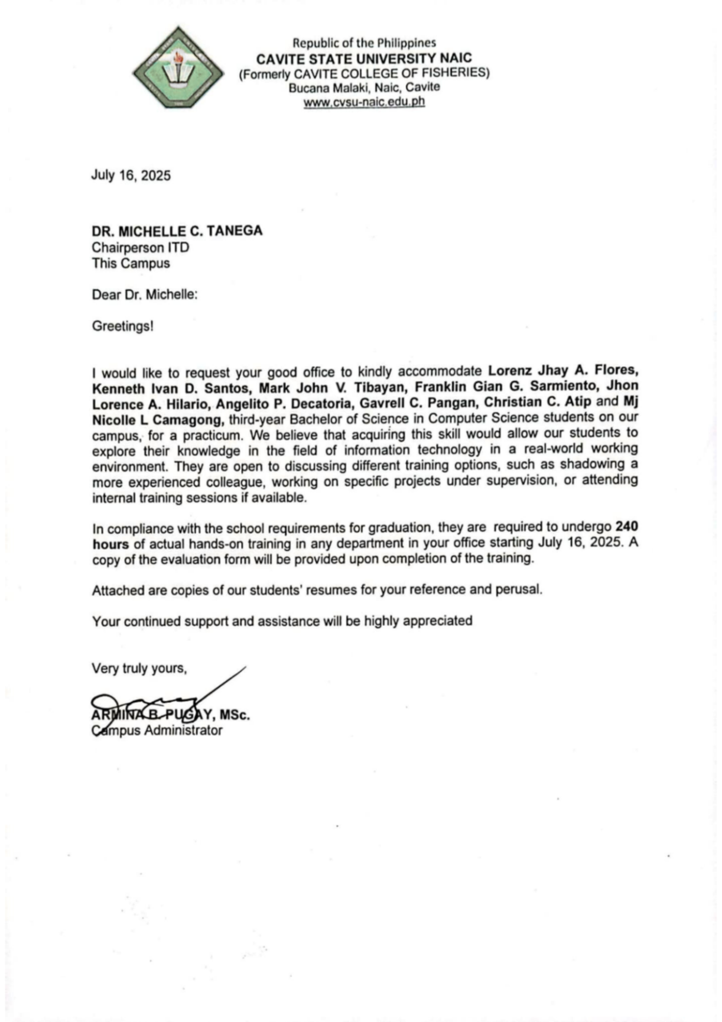

Appendix 5: Location of the Linkage Establishment
The location of Cavite State University Naic Campus (CvSU-Naic) in Naic, Cavite. It is situated along Bucana Malaki Road, near the coastline. Nearby landmarks include Seaside Beach Resort, Bucana Elementary School, Bancaan Catholic Church, and several local businesses and resorts. The campus is located in a coastal, semi-urban area with accessible roads and community facilities.

Appendix 6: Certificate of Completion
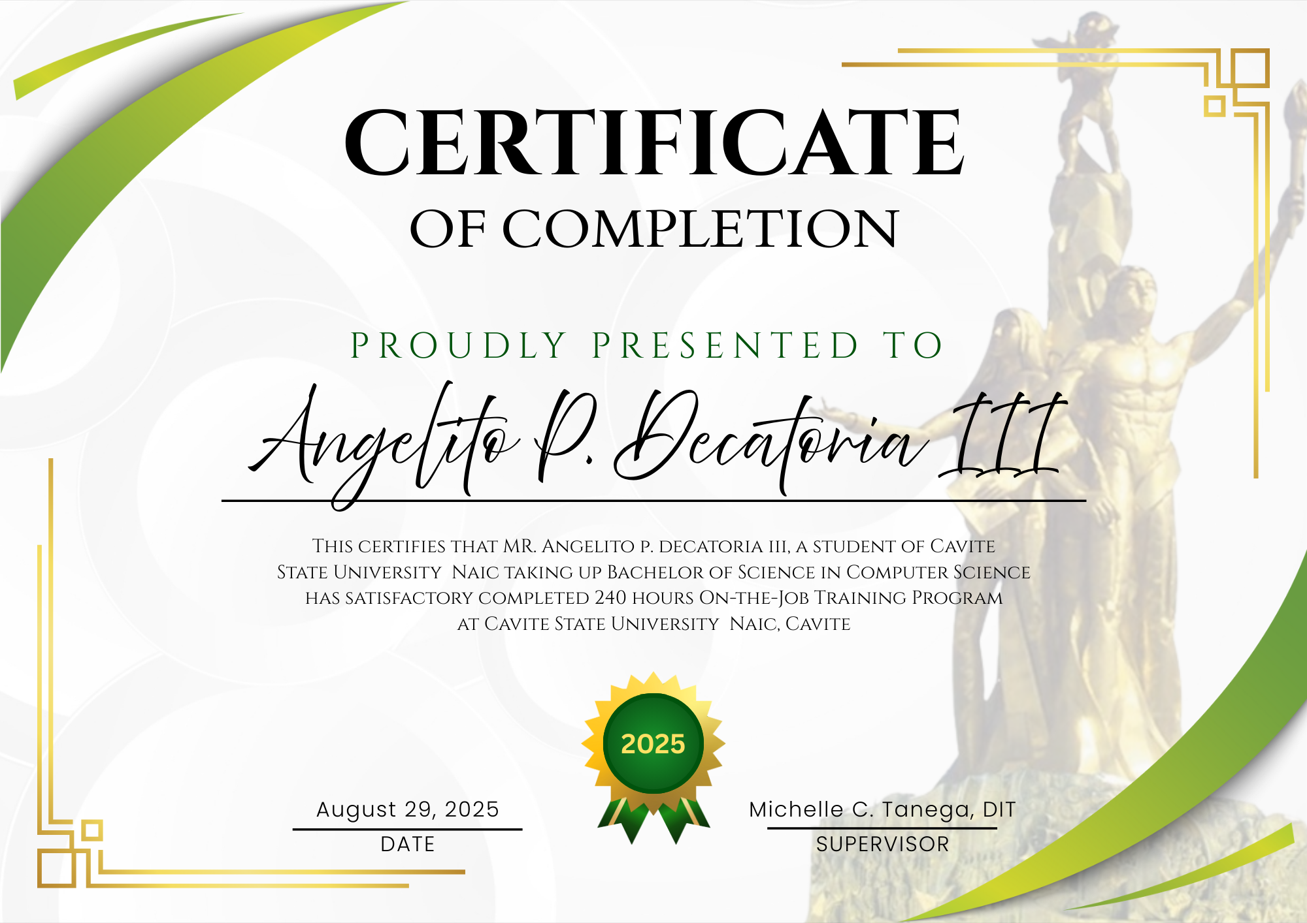
Appendix 7: Accomplished Evaluation Form

Appendix 8: Identification Card

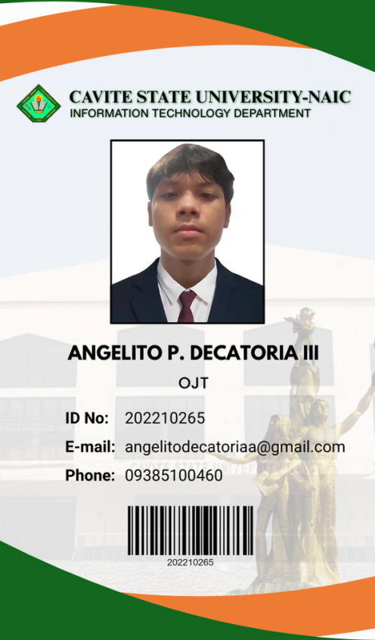

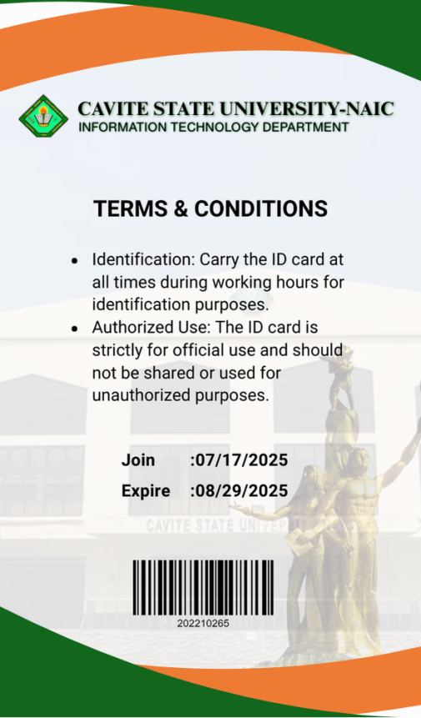

Appendix 9: Daily Time Record

Appendix 10: Daily Journal
Day 1: 17 July, 2025

On my first day as an OJT trainee in the Information Technology Department, we were assigned various tasks that helped me become familiar with the work environment. I assisted in cleaning and reorganizing the entire faculty room by repositioning desks and arranging furniture to create a more visually appealing and orderly space. I also helped sort manuscript and thesis papers related to the IT Department, and took part in conducting an inventory of the department’s stock supplies. Additionally, our supervisor oriented us on departmental policies, responsibilities, and expectations. This initial experience gave me a deeper understanding of the importance of organization, professionalism, and proper record management in supporting the department's daily operations.

Day 2: 21 July, 2025

On my second day of training at the Information Technology Department, I continued with cleaning tasks and assisted in sorting manuscript and thesis papers. I also encoded data into Excel files and supported minor office tasks, which gave me hands-on experience in data organization and office operations. These activities improved my attention to detail, organizational ability, and technical proficiency.

Day 3: 22 July, 2025

On my third day of training at the Information Technology Department, we were assigned to create a PowerPoint presentation as a foundation for an upcoming Audio-Visual Presentation (AVP). Our main focus was editing the PowerPoint slides, ensuring the content was organized and visually appealing despite its length since the AVP goal is only 10 minutes. This task helped me enhance my creativity, attention to detail, and proficiency in presentation design.

Day 4: 23 July, 2025

On my fourth day of training at the Information Technology Department, we continued working on the PowerPoint presentation, which had numerous slides and extensive content. We encountered challenges in editing, organizing information, and applying animations to make it visually appealing. Since our professor needed the presentation for an upcoming event and an AVP had to be created afterward, we prioritized completing the PowerPoint, which improved my time management, problem-solving, and design skills.

Day 5: 24 July, 2025
On my fifth day of training at the Information Technology Department, we continued editing the PowerPoint content to reflect changes in ideas, design, and layout. This required revising the slides, adjusting formatting, and ensuring that the presentation remained clear and professional. The task enhanced my adaptability, attention to detail, and ability to work collaboratively under evolving requirements.

Day 6: 25 July, 2025

On my sixth day of training at the Information Technology Department, we finalized the PowerPoint presentation and began creating the Audio-Visual Presentation (AVP) through video editing. This process involved organizing media elements, applying transitions, and ensuring smooth flow in the presentation. The experience strengthened my technical skills in multimedia editing and improved my ability to work efficiently under deadlines.

Day 7: 28 July, 2025
On my seventh day of training at the Information Technology Department, I performed data encoding, cleaned the storage room, and installed software on the department’s laptops. We focused on setting up open-source applications that could support teaching and enhance classroom instruction. This task helped me develop technical proficiency in software installation and reinforced the importance of maintaining organized and functional workspaces.

Day 8: July 29, 2025
On my eighth day of training at the Information Technology Department, we continued installing additional software on the department’s laptops. Due to the slow internet connection and the limited number of team members, the process took considerable time. Alongside this, I encoded the laptops’ serial numbers and the installed applications for documentation purposes. We were also tasked to create a computer laboratory numbering layout to ensure proper organization and identification of the workstations. This experience improved my patience, technical accuracy, and design planning skills.

Day 9: July 30, 2025

On my ninth day of training at the Information Technology Department, we continued with encoding tasks and updating the inventory. This involved organizing data systematically to ensure accurate records of equipment and resources. The activity enhanced my attention to detail and reinforced the importance of proper documentation in maintaining departmental efficiency.

Day 10: 31 July, 2025
On my tenth day of training at the Information Technology Department, we were tasked to develop an Enrollment Management System using the Laravel framework. We began by setting up the Laravel environment to prepare for the project. This task introduced me to modern web development practices and enhanced my technical skills in framework configuration.

Day 11: 02 August, 2025

On my eleventh day of training at the Information Technology Department, we were tasked to design an IT/CS department logo and create certificates of participation for the school’s TechBridge seminar. This activity allowed me to apply creativity and design skills while ensuring the outputs were professional and aligned with the event’s theme.

Day 12: 04 August, 2025
On my twelfth day of training at the Information Technology Department, we were tasked with editing an AVP and creating a script based on the professor’s revisions. This required attention to detail and creativity to ensure the video aligned with the updated content and presentation goals. The task further enhanced my video editing and content development skills.

Day 13: 05 August, 2025
On my thirteenth day of training at the Information Technology Department, we worked on designing a PowerPoint presentation and creating an AVP video. This task focused on improving the visual quality and structure of the presentation while ensuring the video was engaging and professional. It enhanced my skills in multimedia design and video editing.

Day 14: 06 August, 2025
On my fourteenth day of training at the Information Technology Department, we continued designing a PowerPoint presentation, and I was also tasked by our professor to organize and file scanned documents. This activity improved my organizational skills and attention to detail while maintaining efficiency in handling digital files.

Day 15: 07 August, 2025
On my fifteenth day of training at the Information Technology Department, we were tasked to develop a Record Management System for ODCI. The goal was to address their issue of storing paperwork exclusively on Google Drive, which was nearing capacity. Alongside this, we continued designing the PowerPoint presentation, further improving my skills in both system development and design work.

Day 16: 08 August, 2025
On my sixteenth day of training at the Information Technology Department, we proposed expanding the Record Management System to benefit all departments, not just ITD. This required planning for multiple user roles, including user, admin, and super admin, which added complexity to the development. The task enhanced my understanding of system design and role-based access control.

Day 17: 11 August, 2025
On our seventeenth day of training at the Information Technology Department, we continued developing the Record Management System as it was a large-scale project. I was specifically assigned to work on the ‘User’ panel, collaborating with two other team members. Additionally, we were tasked to clean the PCs and check if the monitors were functioning properly.

Day 18: 12 August, 2025
On my eighteenth day of training at the Information Technology Department, we continued developing the ODCI Record Management System as it was a major project. I completed the creation of department folders, which included features for file uploads, and set up the structure for the dashboard, settings, and a submission tracker as suggested by our professor. This task strengthened my skills in system functionality and user interface design.

Day 19: 13 August, 2025
On my nineteenth day of training at the Information Technology Department, we were tasked to install Linux in the computer laboratory by formatting and setting up PCs, as all units were previously running on Windows. We were given the opportunity to figure out the process on our own, which allowed us to learn how to format and configure Linux independently. Completing this task successfully was very rewarding and significantly improved my technical and problem-solving skills.

Day 20: 14 August, 2025
On my twentieth day of training at the Information Technology Department, we continued installing Linux on the computers in Lab C, as there were still many PCs to configure. We also installed essential software on the operating system, which required working with multiple terminal commands. The process was challenging and confusing at times, but researching solutions helped us successfully complete the task, strengthening our problem-solving and technical skills.

Day 21-22: 15/16 August, 2025
On my twenty-one and twenty-two days, our professor allowed us to work on the system from home to ensure a more convenient and focused environment. During these two days, we made significant progress, completing almost half of the system’s features. This productive session demonstrated the benefits of a distraction-free workspace and strengthened our teamwork and development skills.

Day 23: 18 August, 2025
On my twenty-second day, I continued working on the ODCI Record Management System from home. We made substantial progress, completing nearly half of the system’s features, including improvements to the dashboard and file management functionality. This experience improved my time management and strengthened my coding and problem-solving skills in a collaborative setting.

Day 24: 19 August, 2025
On my twenty-third day, I focused on further developing the ODCI Record Management System, ensuring proper integration of key features and refining the user interface. My role included implementing additional functions and testing existing ones to ensure smooth operation. This task deepened my understanding of system development and quality assurance.

Day 25: 21 August, 2025
On my twenty-fourth day of training at the Information Technology Department, I continued working on the ODCI Record Management System. My tasks included adding new features, refining the user interface, and ensuring system functionality aligned with the project requirements. This activity further enhanced my technical expertise in system development and strengthened my problem-solving skills in improving system performance.
Day 26: 22 August, 2025
On my twenty-fifth day of training at the Information Technology Department, I worked on the final revision of the PowerPoint slides for the faculty accreditation narrative, ensuring that the content was accurate, well-structured, and visually professional. After completing the revisions, I started drafting my narrative report to document my OJT hours and experiences. This day strengthened my attention to detail, presentation design skills, and ability to prepare professional documentation.
.
Day 27: 23 August, 2025
On my twenty-sixth of training at the Information Technology Department, I completed the final revisions and finished the content of the PowerPoint presentation for the faculty professor’s accreditation narrative. After completing the slides, my other OJT schoolmates began working on its Audio-Visual Presentation (AVP). Additionally, I started drafting my narrative report to document my OJT hours. This day strengthened my skills in presentation design, collaboration, and time management.

Appendix 11: Training Program
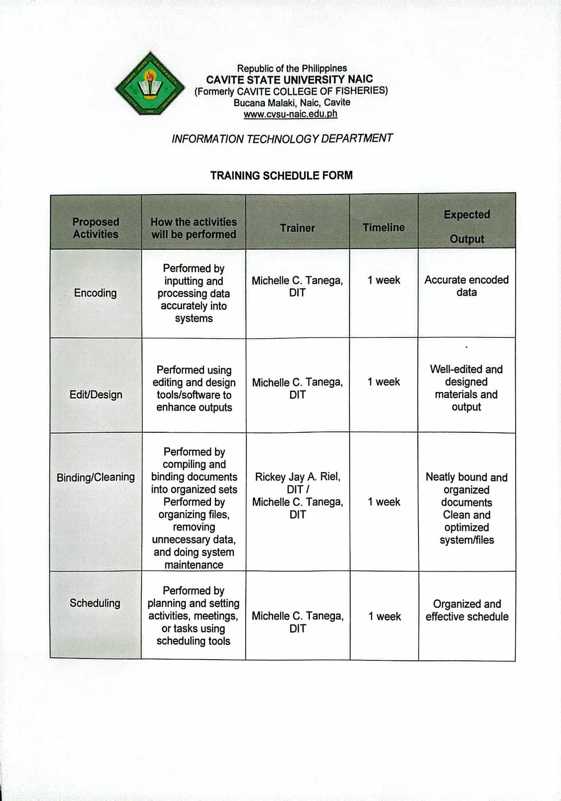

Appendix 12: Photo Documentation
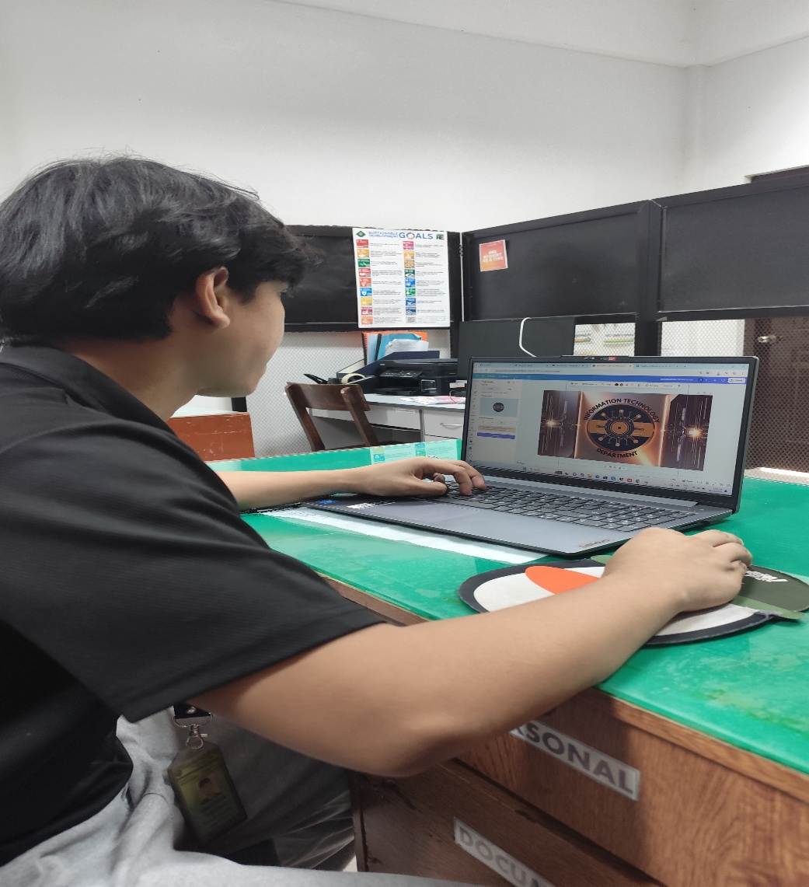
Appendix Figure 1. Creation of the IT/CS Logo
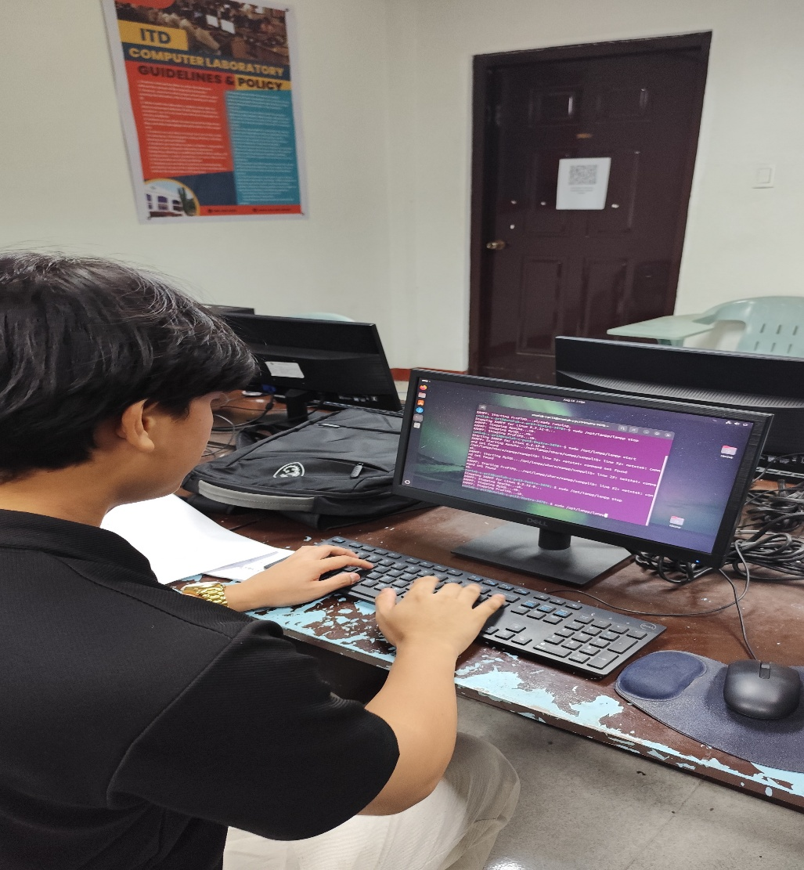
Appendix Figure 2. Installation of Linux in Comlab C
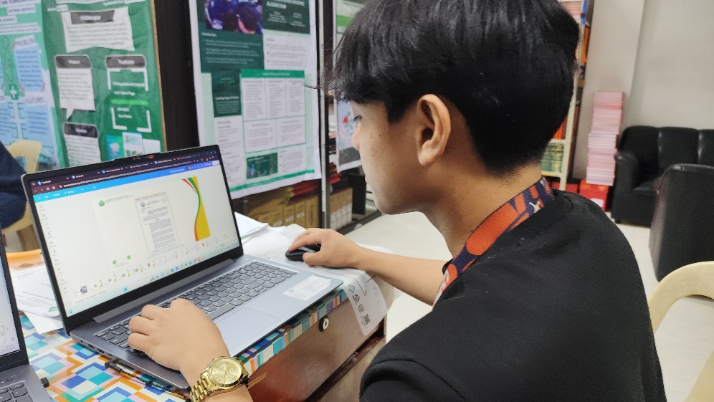
Appendix Figure 3. Development of an AVP for Accreditation
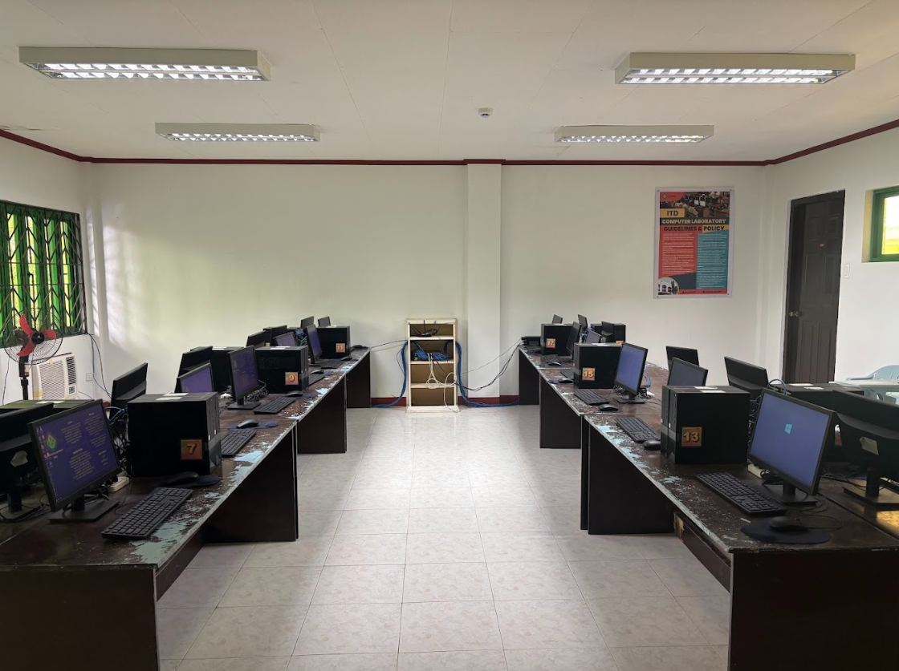
Appendix Figure 4. Computer Cleaning in COMLAB C
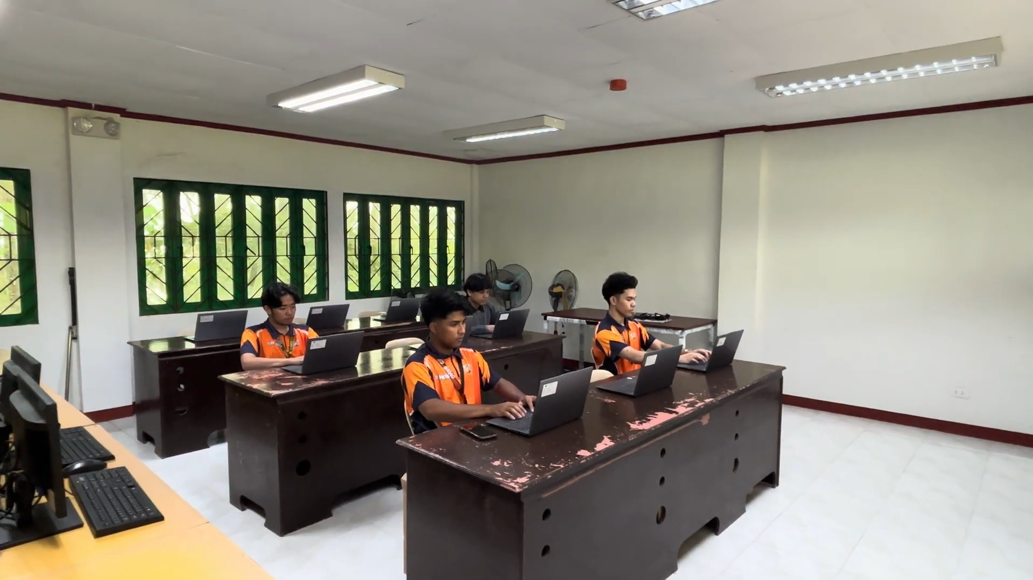
Appendix Figure 5. Software Installation on an ITD Laptop

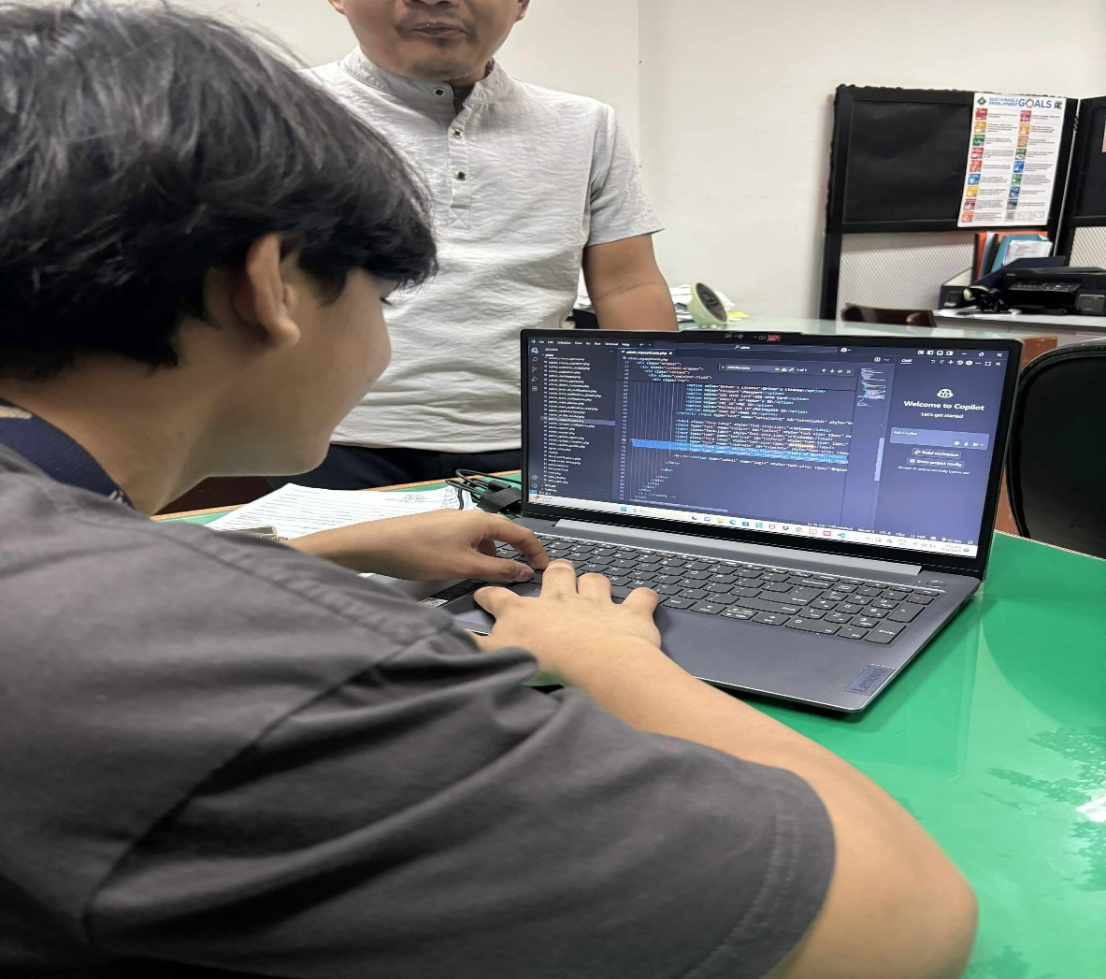
Appendix Figure 6. Development of a Record Management System

