ON-THE-JOB TRAINING EXPERIENCES AT INFORMATION TECHNOLOGY DEPARTMENT, CAVITE STATE UNIVERSITY - NAIC

Narrative Report
Submitted to the Faculty of
Information Technology Department
Cavite State University Naic
Bucana, Naic, Cavite

In partial fulfillment
of the requirements for the program
Bachelor of Science in Computer Science

ANGELITO P. DECATORIA III
August 2025



Republic of the Philippines

CAVITE STATE UNIVERSITY NAIC
(Formerly CAVITE COLLEGE OF FISHERIES)
Bucana Malaki, Naic, Cavite
www.cvsu-naic.edu.ph

INFORMATION TECHNOLOGY DEPARTMENT

Narrative Title: ON-THE-JOB TRAINING EXPERIENCES AT INFORMATION TECHNOLOGY DEPARTMENT, CAVITE STATE UNIVERSITY - NAIC

Name of Author: ANGELITO P. DECATORIA III

Degree Program: BACHELOR OF SCIENCE IN COMPUTER SCIENCE

Michelle C. Tanega, DIT  Technical Critic |  | _____  Date | MICHELLE C. TANEGA, DIT  OJT Coordinator/ITD Chairperson | _____  Date

ARMINA B. PUGAY, MSc _______
Campus Administrator Date

BIOGRAPHICAL DATA

Mr. Angelito P. Decatoria was born on May 26, 2004, in Libjo, Surigao del Norte. He is the son of Mr. Angelito M. Decatoria Jr. and Mrs. Margie G. Paso and has two siblings, Jayann Jane P. Decatoria and Kristel Jane P. Decatoria. He currently resides in Ternate, Cavite, together with his family.
He completed his elementary education at Sapang Elementary School, where he graduated in the school year 2015–2016 with the award of Second Honorable Mention. He then pursued his secondary education at Ternate West National High School, graduating in the school year 2019–2020 with honors; however, there was no formal graduation ceremony due to the COVID-19 pandemic.
For his senior high school education, he attended Western Colleges Inc., where he graduated in the school year 2021–2022 with honors. Currently, he is continuing his academic journey at Cavite State University – Naic, where he is pursuing a Bachelor of Science in Computer Science, dedicated to achieving his goals and building a successful future.

ACKNOWLEDGEMENT

The trainee wishes to express his heartfelt gratitude to all the individuals who supported and guided him throughout the course of his On-the-Job Training, making the experience meaningful and successful.
First and foremost, he extends his deepest thanks to the Almighty God for His unwavering guidance, strength, and blessings that sustained him throughout this journey.
He would like to sincerely acknowledge his beloved family for their unconditional love, understanding, and constant encouragement. Special appreciation is given to Dr. Michelle C. Tanega, Chairperson of the Information Technology Department and OJT Coordinator, for her invaluable guidance, supervision, and support in making this training possible. Her insightful feedback and professional advice greatly contributed to his growth and improvement during the internship.
He also wishes to thank Sir Angelito “Jonjie” Catajan for his generosity and for making the internship experience more enjoyable and energizing by providing meals and encouragement.
Lastly, gratitude is extended to all faculty members, staff, and colleagues who shared their knowledge and assistance, helping to make this training a rewarding and productive experience.

ANGELITO P. DEcatoria III

TABLE OF CONTENTS

Page

BIOGRAPHICAL DATA iii
ACKNOWLEDGMENT iv
TABLE OF CONTENTS v
LIST OF FIGURES vii
LIST OF APPENDICES viii
LIST OF APPENDIX FIGURES…………………………………………….…….… ix
INTRODUCTION 1
Objectives of the On-The-Job Training 2
Significance of On-The-Job Training 2
Time and Place of On-The-Job Training 3
THE LINKAGE ESTABLISHMENT 4
Location of the Establishment 4
Background/Profile of the Establishment 5
Vision and Mission Statements of the Establishment 5
Goals and Objectives of the Establishment 6
Over-all Organizational Structure and Function of the Establishment 7
THE TRAINING AREA 10
Department Function 10
Organizational Structure and Function of the Department 10
Facilities 12
Equipment 13
Standard Operating Procedures 19
THE TRAINING EXPERIENCE 20
Task Performed/Specified Activities Assigned 20
Observed Strengths and the Training Area 20
Insights 21
SUMMARY 23
REFERENCES 24
APPENDICES 25

LIST OF FIGURES

Figure Page
- Location of the Institution 4
- CvSU Naic Campus Over-all Organizational Structure 8
- Information Technology Department 11
- Employees Working Desk 12
- Intern Desk 12
- STAR Building at Cavite State University - Naic 13
- Working Laptop 14
- Printer 14
- WIFI 15
- Ring Binder 16
- Network LAN Tester 16
- RJ45 Crimping Tool 17
- Baofeng UV-5R 17
- ICT Server 18

LIST OF APPENDICES

Appendix Page
- Application Letter 28
- Resume 29
- Recommendation Letter 31
- Memorandum of Agreement 32
- Trainee-Industry Agreement Liability Waiver 30
- Location of the Linkage Establishment …………………………………… …34
- Certificate of Completion 38
- Accomplishment Evaluation Form 39
- Identification Card 40
- Daily Time Record 41
- Daily Journal 46
- Training Schedule Form 66
- Photo Documentation 67
- Routing Slip 75

LIST OF APPENDIX FIGURES

Appendix Page
Figure

- Creation of the IT/CS Logo 43
- Installation of Linux in Comlab - C 43
- Development of an AVP for Accreditation 44
- Computer Cleaning in Comlab - C 44
- Software Installation on an ITD Laptop 45
- Development of a Record Management System 45
- PC Reformatting Process 46
- Ethernet Cable Setup Using Color Coding 46
- Computer Cleaning in Cisco/Comlab - D 47

ON-THE-JOB TRAINING EXPERIENCES AT INFORMATION TECHNOLOGY DEPARTMENT, CAVITE STATE UNIVERSITY NAIC

ANGELITO P. DECATORIA III

A narrative report submitted to the faculty of the Information Technology Department, Cavite State University Naic, Bucana Malaki, Naic, Cavite in partial fulfillment of the requirements for the degree of Bachelor of Science in Computer Science prepared under the supervision of Dr. Michelle C. Tanega

INTRODUCTION

On-the-job training (OJT) is a practical way of teaching employees the skills and knowledge needed to successfully carry out their job responsibilities. It's a "learning by doing" technique where trainees use their knowledge in practical situations under the supervision of knowledgeable instructors.
One of the most special stages of a trainee's journey is OJT, where educational knowledge is put to the test and turned into real-world abilities. In addition to developing technical abilities, this route needs on the trainee to develop resilience, adaptability, and a professional mindset. Moving from learning to doing can come with challenges, unexpected experiences, and opportunities for personal development.
According to Garavan et al., on the job training represents a set of processes that happen within a specific organizational context and involve assimilating and acquiring integrated clusters of values, skills, knowledge, and feelings that lead to fundamental changes in behaviors of a worker or teams (Nakahara & Matsuo, 2013).
Senior High School students needed to have an OJT training especially when you are in college degree. Students are not allowed to have their certificate that proves they finished their schooling era. One of the curriculums here in the Philippines is by taking the OJT. This was supposed to be a training for all those students to train their ability, capacity of their knowledge and how they are going to handle the problem they face in the real industry. This report helps track what students learn and achieve during their OJT.

Objectives of On-the-Job Training

The On-the-Job Training aims to provide students the capstone experience of the necessary competencies on the operational aspects of the linkage establishment.
Specifically, at the end of the training, the trainee should be able to:
  - identify and comprehend the standard operational procedures and techniques of the section or department where the trainee is assigned;
  - associate key positions of the chosen establishment and related operations to their corresponding tasks and responsibilities;
  - perform specific tasks required in the sections or the department assigned;
  - evaluate operational procedures in the assigned section or department;
  - recommend appropriate course of action to improve the prescribed operations
  - prepare a narrative report that summarizes all the activities performed;
  - develop interpersonal and other communication skills needed for success in the assigned section or department of the establishment;
  - appreciate the importance of efficient operational policies and procedures in relation to the overall management of the related areas of the establishment; and
  - relate to theories the actual experience gained from the training.

Significance of On-the-Job Training

On-the-Job Training (OJT) is significant because it equips trainees with hands-on experience that directly connects to their future work responsibilities. It bridges the gap between theory and practice by enabling learners to immediately apply the knowledge and skills they acquire in real workplace settings. This process builds competence, strengthens confidence, and enhances overall job performance. For organizations, OJT is also practical and cost-efficient, as it reduces reliance on external training programs and ensures employees focus on relevant, job-specific tasks. In addition, it promotes stronger workplace relationships, increases employee motivation, and supports career advancement, which in turn improve retention rates. By aligning learning with the actual needs of the workplace, OJT contributes to higher productivity and efficiency. In the long term, it plays a vital role in both personal growth and organizational success by developing a workforce that is skilled, adaptable, and prepared to meet the demands of the profession.

Time and Place of On-the-Job Training

The trainee completed his On-the-Job Training (OJT) with the Information Technology Department of Cavite State University - Naic. The trainee’s work schedule generally ranged from 7:00 a.m. to 6:00 p.m., although the starting time occasionally varied between 7:00 a.m. and 8:30 a.m. The OJT period commenced on July 17, 2025, and concluded on August 29, 2025.

THE LINKAGE ESTABLISHMENT

Location of the Establishment
The trainee conducted his On-the-Job Training at Information Technology Department in Cavite State University-Naic located at Bucana Malaki, Naic, Cavite
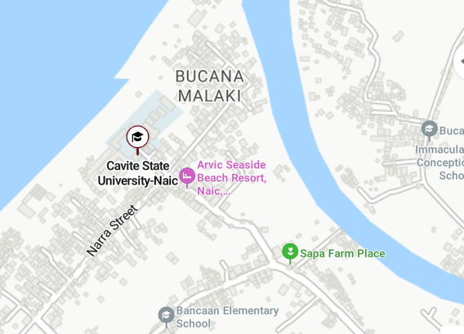

Figure 1. Location of the Institution
The location map of Cavite State University Naic Campus (CvSU Naic) see Figure 1, situated along Bucana Malaki Naic, Cavite Road near the coastline. Key nearby landmarks include Seaside Beach Resort to the west, Bucana Elementary School to the northeast, and Bancaan Catholic Church to the south. The surrounding area features a mix of community facilities, local businesses, and resorts, connected by accessible road networks in a coastal, semi-urban setting.

Background/Profile of the Establishment

The Cavite school of Fisheries was created under Republic Act No. 2661, sponsored by Cong. Justiniano Montano, the congressman for the lone district of Cavite, with initial appropriation of P 200,000.00, which was approved by congress on June 18, 1960. Its implementation in 1961 seems to have a very slim chance due to financial constraints of the National Government. It was due to the efforts of Dr. Perdo G. Guiang, the Asst. Director of Public Schools, who made representation to the budget commission to revert some reserve funds of other fishery schools that an initial amount of P40, 000.00 was made available for Cavite School of Fisheries.
Plans and budgetary Proposals were prepared in July 1961. The item of one principal, three fishery Technologist and one clerk were created. The amount of P22, 000.00 was set aside for the construction of the school building and the balance for supplies, materials and equipment. Initial operation of the school begun in June 4, 1962, with an enrollment of one hundred and seventy-five first year students under Secondary Fishery education Curriculum and with an additional appropriation of P100, 000.00 Classes were initially conducted in the old municipal building located right in the heart of the town of Naic. After a year, the school was transferred to its present site Bucana, a coastal Barangay of Naic, Cavite School of Fisheries was converted to college in 1970, offering two and a half-year Technical Education Curriculum with fifty students enrolled.
Since then, there was a continuous marked increase in enrollment, number of teaching and facilitative personnel, equipment and other instructional facilities in both secondary and technical fishery Education Curricula. At the start of school year 1974-75, the three-year Fishery Education Curriculum leading to a diploma in Fishery Technology was offered, then on June 30, 1975, DECS approved the offering of the four-year Technological Curriculum leading to a Bachelor of Science in Fisheries (BSF). In SY 1992-93 additional short-term courses were offered, namely; the two-year Food and beverage Preparation Services and the six-month Basic Seaman Training Course. In 1997-98 additional two courses were approved by CHED, namely: Associate in Hotel and Restaurant Management and Associate in food Technology, both laderized programs leading to Bachelor’s degree. The bachelor of Secondary education (BSE) with three major areas of specialization was approved in the same school year.
The year 2001 marks another milestone in the history of college when it was officially integrated to the Cavite State University (CvSU) System through RA #8292; by virtue of Board Resolution # 2 dated February 6, 2001. The integration of the college, present known as CvSU Naic campus, marks a new beginning. It has a broaden its perspective to include Research, extension and production in addition to the lone instruction function the campus has been used to. Likewise new opportunities were opened for the campus to offer more courses, improve its faculty and staff, improve its facilities, develop and improve its RD and E endeavor in response to the growing demand of the society.

Vision and Mission Statements of the Establishment

University Vision
The premier university in historic Cavite globally recognized for excellence in character development, academics, research, innovation and sustainable community engagement.
University Mission
Cavite State University shall provide excellent, equitable and relevant educational opportunities in the arts, sciences and technology through quality instruction and responsive research and development activities. It shall produce professional, skilled and morally upright individuals for global competitiveness.
Goals and Objectives of the Establishment
CvSU Naic shall endeavor to achieve the following goals:
- To produce technically competent and scientifically oriented graduates who are imbued with strong entrepreneurial spirit; possesses strong social consciousness; and guided by the positive values and high ethical standards;
- To conduct relevant research and development activities along fisheries, education, business, information technology, arts and sciences that would contribute to sustainable development in its service areas;
- Implement effective training and outreach programs that emphasize self-help, critical thinking and life-long learning;
- Manage fishery and other enterprise projects to promote economically viable and environment-friendly approaches and techniques; and
- Establish strong linkage with non-governmental organizations, other government entities and the basic sector for the realization of common goals.
Over-all Organizational Structure and Functions of the Establishment

Over-all Organizational Structure
The organizational structure of Cavite State University Naic Campus serves as a framework for defining authority, responsibilities, and communication flow within the institution. It reflects how administrative and academic functions are systematically arranged to promote efficiency, accountability, and coordinated decision-making across all divisions.
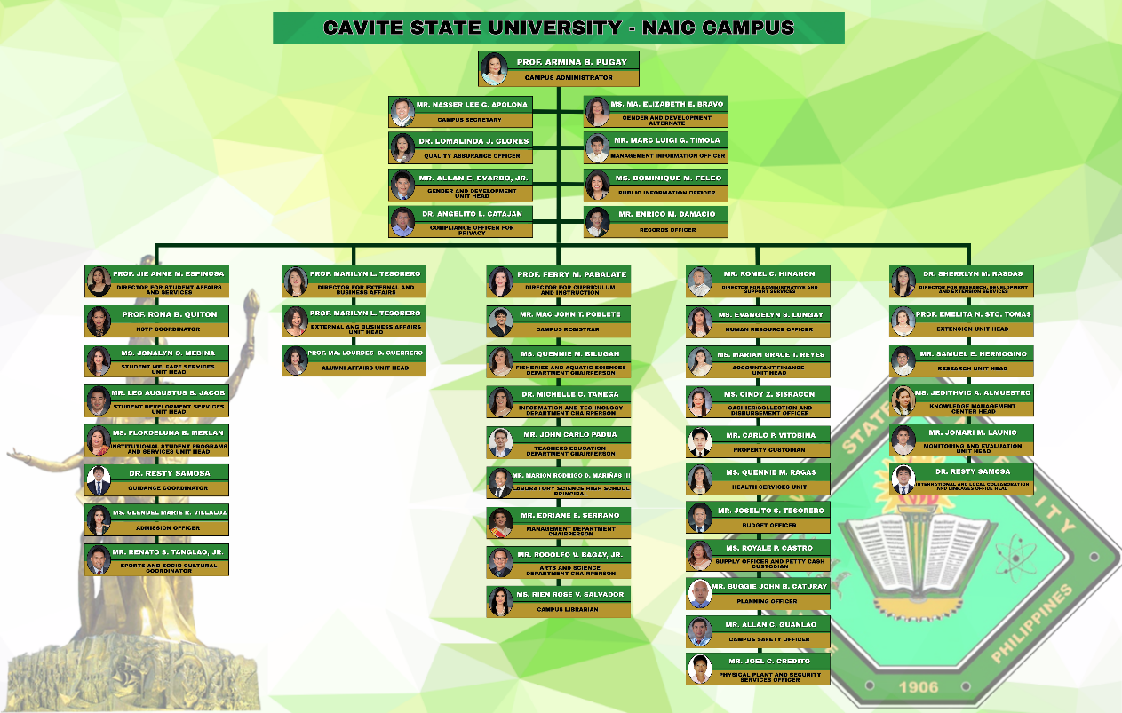

Figure 2. CvSU Naic Campus Over-all Organizational Structure
The organizational chart is present in Figure 2, of Cavite State University Naic Campus, outlining its administrative hierarchy under Campus Administrator Prof. Armina B. Pugay. The structure is organized into five main divisions: Student Affairs and Services, External and Business Affairs, Curriculum and Instruction, Administration and Finance, and Research, Extension, and Development. Each division is headed by a director and supported by unit heads responsible for specific functions such as academic departments, student welfare, external partnerships, financial management, research initiatives, and campus operations. This framework ensures efficient coordination, service delivery, and alignment with the university’s mission to address educational and community needs.

Functions of the Establishment
Guided by the University’s vision and mission, CvSU shall be true to the client it has vowed to serve. One of the major functions of the university is community service to entrepreneurs, farmer, rural women, fishers and out-of-school youth. It shall produce professional, skilled and morally upright individuals for global competitiveness.

Responsibilities of the Management
Department Chairpersons and unit heads shall:
    - Take charge of planning, development and supervision of their respective units;
    - Prepare budgetary estimates of their respective units in coordinate with college deans/division directors; and
    - Propose new and appropriate rules and regulations affecting their respective units;

THE TRAINING AREA

Department Function
The following are the function of Information Technology Department:
- Proficient in designing and developing solutions;
- Conduct relevant researches and development activities in the field of computer science and allied fields.
- Promote the development and transfer of appropriate information technology and;
- Practice the principles of good governance and professional and ethical standards in the workplace.
- Well versed on application, installation, operation, development, maintenance and administration of computers;
- Conduct relevant researches and development activities in the field of information technology and allied fields;
- Promote the development and transfer or appropriate information technology and;
- Practice the principles of good governance and professional and ethics standards in the work place.

Organizational Structure and Function of the Department

The organizational structure and function of the department define the hierarchy, roles, and responsibilities of its members. It ensures efficient coordination, proper task delegation, and smooth workflow to achieve the department’s goals.

Information Technology Department
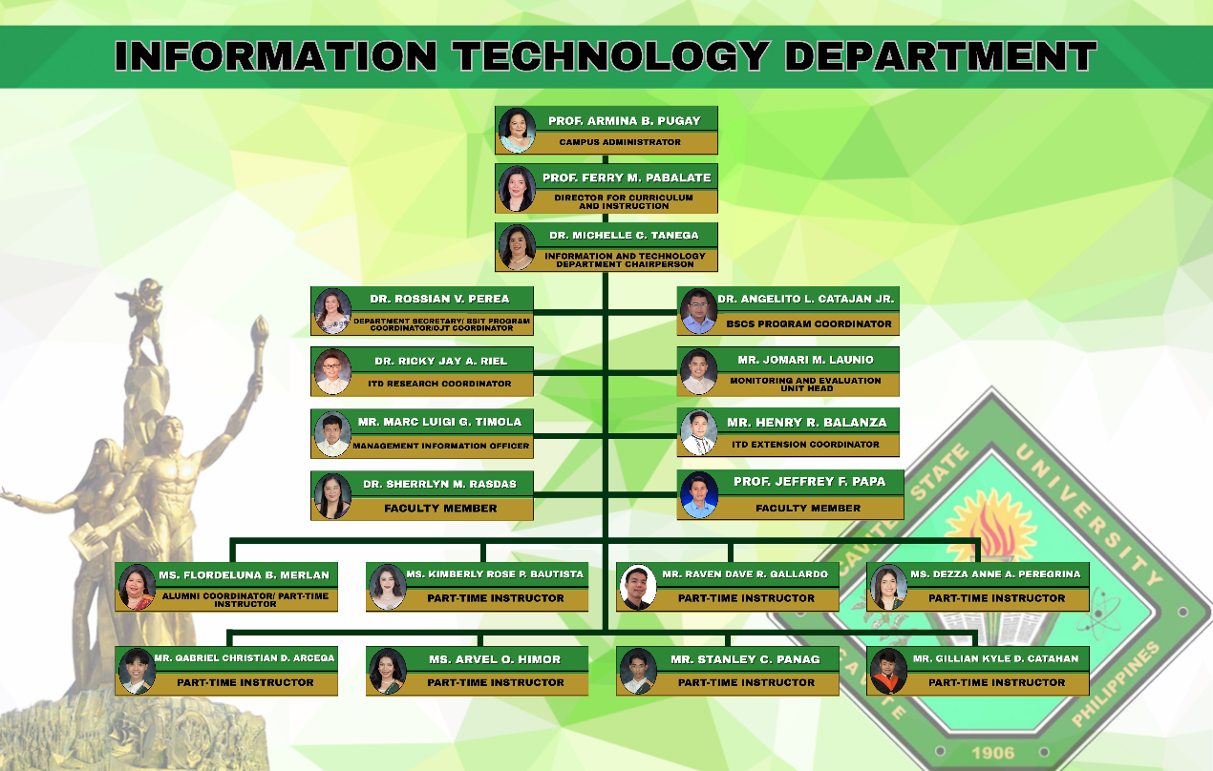

Figure 3. Information Technology Department Organizational Chart
The organizational structure of the Information Technology Department at Cavite State University Naic Campus is illustrated in Figure 3. The department is headed by the Department Chairperson, under the supervision of the Director for Curriculum and Instruction and the Campus Administrator. Key positions include the Department Secretary, BSIT Program Coordinator, OJT Coordinator, BSCS Program Coordinator, ITD Research Coordinator, ITD Extension Coordinator, Monitoring and Evaluation Unit Head, and Management Information Officer. Faculty members support various academic and administrative functions, while part-time instructors contribute to teaching and alumni coordination. This structure ensures the department’s efficient operation and the delivery of quality education.

Facilities

The Information Technology Department at CvSU Naic provides well-equipped facilities that support both employees and trainees in performing their tasks effectively. These resources create a productive environment for training, collaboration, and professional growth

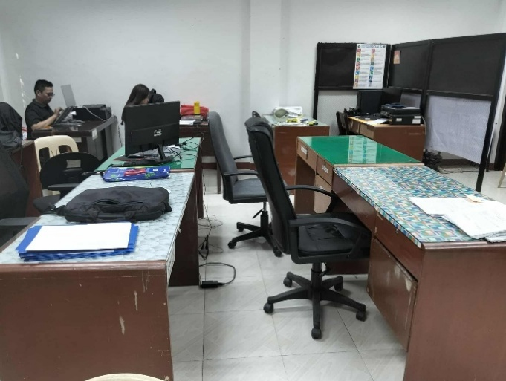

Figure 4. Employees Working Desk
The Employees Working Desk is shown in Figure 4. the workstation setup for employees, including desks, chairs, computers, and other office equipment arranged to support productivity and ergonomic comfort.

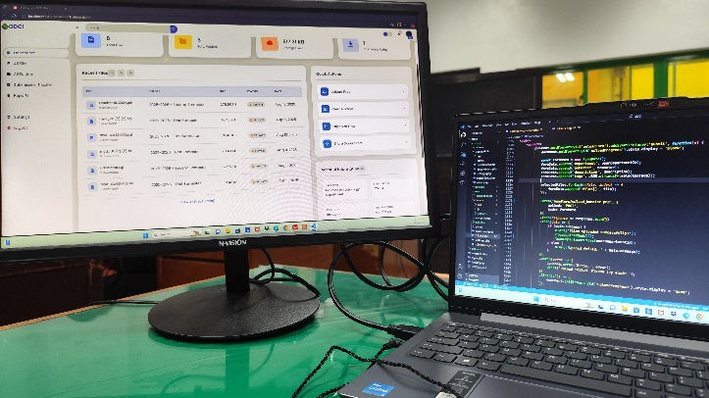

Figure 5. Intern Desk
The “Intern Desk” shown in Figure 5 includes a monitor and a faculty laptop from the IT Department, which I used during my OJT hours. This workspace served as my station for various tasks such as data encoding, developing the ODCI Record Management System, designing the IT/CS logo, and other assigned activities. It reflects the functional setup that supported my daily responsibilities and skill development throughout the training.
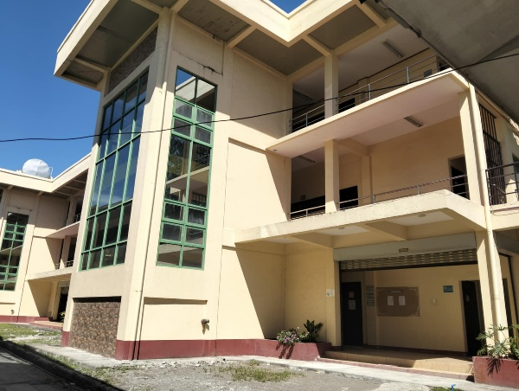
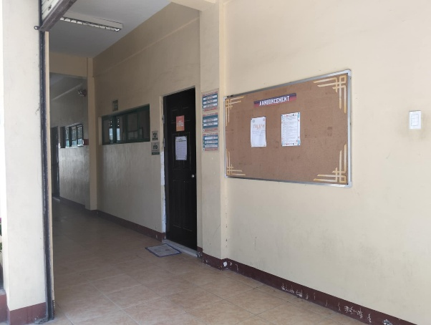

Figure 6. STAR Building at Cavite State University Naic
The STAR Building located at Cavite State University Naic Campus is shown in Figure 6, which serves as the home of the Information Technology Department (ITD). The building features multiple floors with spacious classrooms, computer laboratories, and faculty offices dedicated to the instruction and support of IT-related programs. It provides a conducive environment for learning, teaching, and administrative tasks. The department operates within this building to accommodate both students and staff, offering technical assistance, academic consultations, and hands-on learning experiences. As the central location for ITD activities, the STAR Building plays a vital role in supporting the university’s mission to deliver quality education and technological advancement.

Equipment

The equipment used in the Information Technology Department of CvSU Naic plays a vital role in supporting both academic and administrative functions. Each device, from laptops to printers and binding machines, ensures smooth operations, efficiency, and productivity in daily departmental tasks.

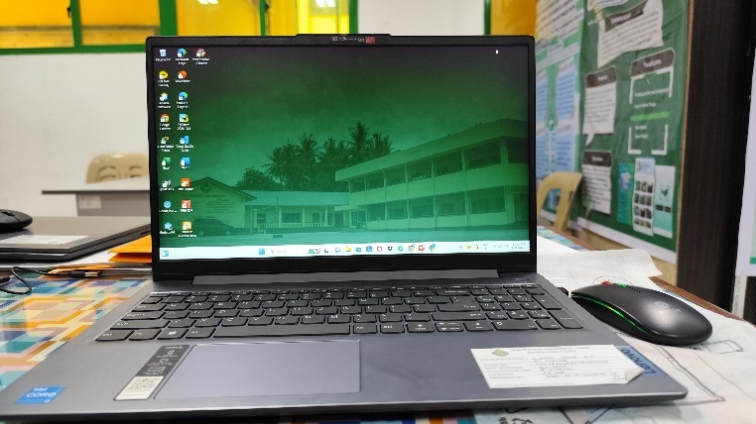

Figure 7. Working Laptop
The laptop shown in Figure 7 is used in the Information Technology Department of CvSU Naic. This Lenovo device, powered by an Intel Core i3 processor and running Windows 11, is used by student assistants and interns for report preparation, data encoding, layout design, and digital file management. Equipped with software like Microsoft Office, Canva, and other productivity tools, it supports academic and technical work. As a shared resource maintained by the department, the laptop helps ensure smooth operations while enhancing the skills and productivity of student assistants and trainee.

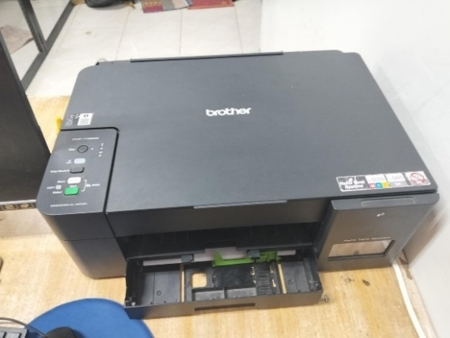

Figure 8. Printer
The printer shown in Figure 8 is used in the Information Technology Department of CvSU Naic. The Brother DCP-T420W is used for printing technical reports, memos, project proposals, and other academic or administrative documents. Its fast, reliable performance supports daily operations, providing hard copies for meetings, submissions, and recordkeeping. The Refill Tank System reduces costs and ensures continuous use. Shared by staff and students, the printer helps maintain efficiency and productivity in the IT office.

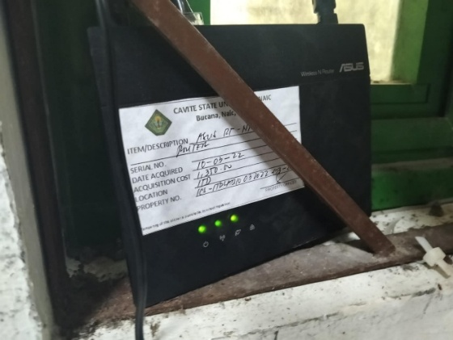

Figure 9. WIFI
The Wi-Fi router shown in Figure 9 is used in the Information Technology Department of CvSU Naic. The ASUS Wireless N Router provides a stable internet connection for staff, faculty, and student assistants. It supports access to online platforms, cloud services, research databases, and administrative systems for communication, data management, online meetings, and digital learning, helping maintain the department’s productivity.
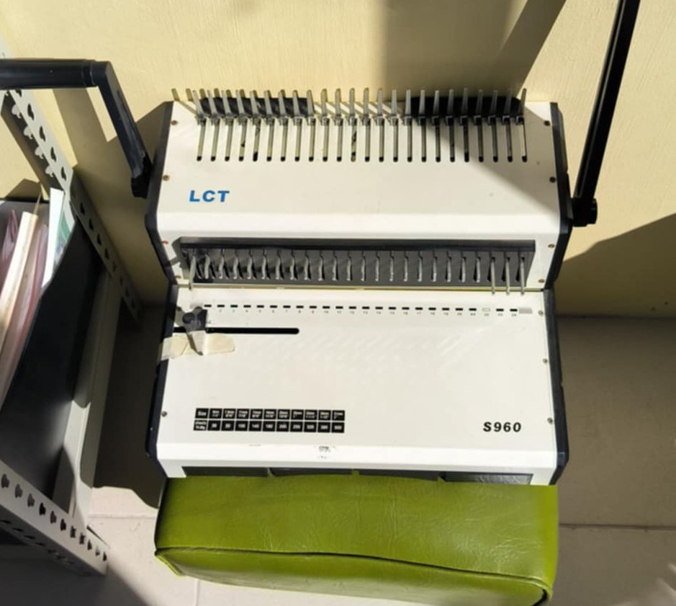

Figure 10. Ring Binder
The ring binder machine (LCT S960), shown in Figure 10 is used for punching holes in paper and binding them with plastic comb rings to create booklets or reports.

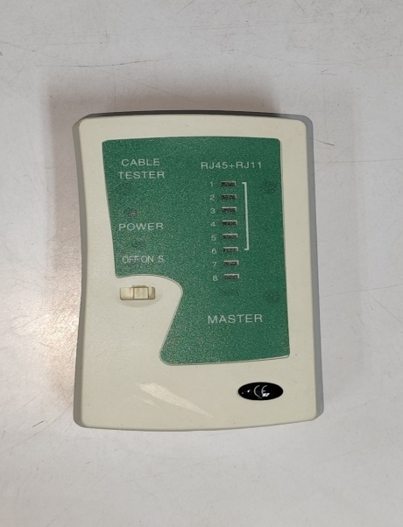

Figure 11. Network LAN Tester
The Network LAN Tester, shown in Figure 11, is used for testing Ethernet cables to ensure proper connectivity and performance. It detects common wiring issues such as open circuits, short circuits, crossed wires, and split pairs, helping to verify that cables are correctly installed for reliable network communication.

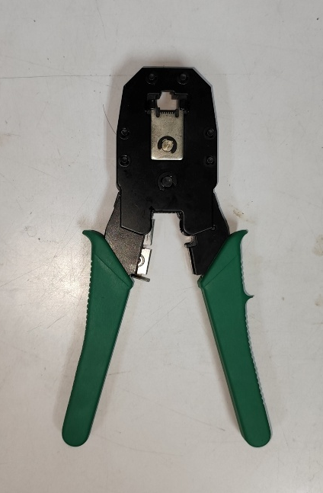

Figure 12. RJ45 Crimping Tool
The RJ45 Crimping Tool, shown in Figure 12, is used for attaching connectors (such as RJ45) to the ends of network cables. It firmly presses the connector’s metal pins into the cable’s wires, ensuring a secure connection for data transmission in LAN setups.

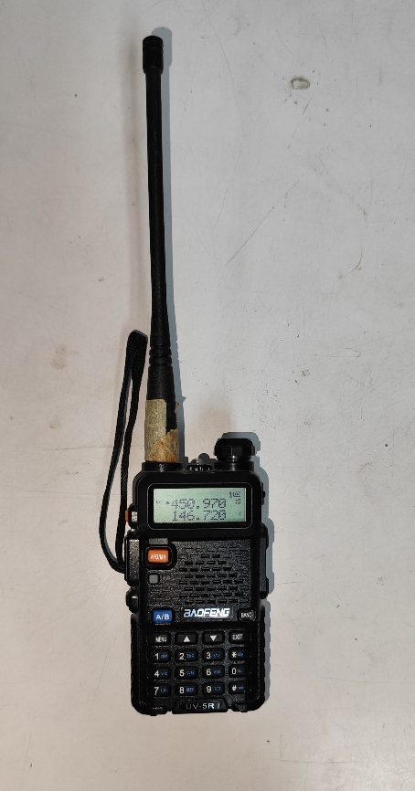

Figure 13. Baofeng UV-5R
The Baofeng UV-5R, shown in Figure 13, is a portable two-way radio transceiver used for communication on VHF and UHF frequency bands. It is commonly used in security, emergency response, and outdoor activities, providing reliable long-range communication with features such as dual-band operation, rechargeable battery, and programmable channels.

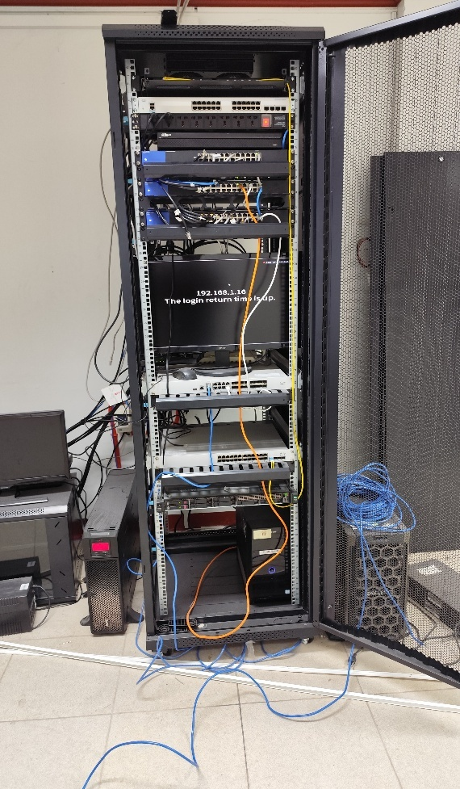

Figure 14. ICT Server
The ICT Server, shown in Figure 14, is a central computer system used to manage, store, and distribute data, applications, and resources across a network. It provides services such as file storage, database management, website hosting, and user authentication, making it an essential component for efficient information and communication technology operations.
Standard Operating Procedures (SOPs)

System Management
The System Management SOP provides both users and management with an overview of the key features of the IT system they interact with regularly. It also includes documentation on the system's infrastructure and outlines the data structures involved in processing information. Additionally, this type of SOP covers important topics such as preventive system maintenance, the differences between batch and real-time processing modes, and the resources required for effective daily system management.
Security
This SOP focuses on IT security and outlines guidelines for protecting system applications and controlling access to digital resources. In the training area, faculty and staff are provided with passwords to access the Wi-Fi network, ensuring that connectivity is restricted to authorized personnel. To maintain data security, students are not permitted to use the computers assigned to the department, as these devices contain important files and information intended exclusively for faculty and staff use. This measure helps safeguard sensitive data and maintain the integrity of departmental resources.
Data Recovery
The Data Recovery SOP outlines procedures to follow during a system crash to restore important data. It covers recovery methods such as full, incremental, and selective, along with the utility programs used. It may also include backup guidelines using devices like tape drives, CD-ROMs, or disk drives as a proactive data protection measure.
THE TRAININGEXPERIENCE

Task Performed / Specific Activities Assigned

On-the-job training (OJT) allows a trainee to immerse himself in workplace culture, providing valuable preparation for future employment.
At the Information Technology Department (ITD), he was entrusted with various responsibilities and developed an appreciation for the importance of time management in completing tasks. His assignments included encoding, organizing both digital and physical files, designing, editing, filing, printing, scheduling, binding, and scanning documents.
Through these experiences, he strengthened his ability to manage work efficiently while gaining skills and professionalism that will serve as an advantage in his future career.

Observed Strengths and Weaknesses of The Training Area

Strengths of the Training Area
The strengths of the training area include its well-maintained equipment, stable internet connection, competent faculty, and supportive staff. Working in a clean and well-organized environment enables trainee to perform his tasks efficiently. In addition, the presence of centralized air conditioning provides a comfortable workspace that minimizes stress, while the faculty staff remain attentive in guiding trainee on the proper execution of their tasks.
Weaknesses of the Training Area
Some of the weaknesses of the training area include the lack of properly functioning comfort rooms. While a restroom is available, it is neither clean nor in good working condition. In addition, although equipment is provided, some are not working properly. There is also insufficient space for the trainee, which at times requires him to sit at the faculty staff desks.
Insights
The 25-day On-the-Job Training (OJT) proved to be a valuable and rewarding experience for the trainee. He enhanced his social skills, developed respect for others, and gained a clearer understanding of the importance of building a career and becoming a competent professional. During the training, he observed both the strengths and areas for improvement in the workplace. He realized that work goes beyond completing tasks, it also requires professionalism and effective communication. He also learned how to interact appropriately with office staff and colleagues in a formal environment. Overall, the training contributed to his personal and professional growth, better preparing him for future opportunities and bringing him closer to achieving his goals.
a. Problem encountered
During the training, the main challenges included poorly maintained comfort rooms, faulty equipment, and insufficient workspace, which occasionally forced trainees to share desks with faculty members.
Suggestions for Self-improvement
The trainee recommended arriving at the training area earlier and taking the initiative to ask supervisors for tasks during idle time. He stressed the value of maximizing the learning experience and developing skills for future career growth through proactive efforts such as staying curious, asking questions when uncertain, and being open to new knowledge. He was also encouraged to nurture creativity, listen attentively to mentors, remain positive, and believe in himself in every situation.
  - Suggestions for Program Development
The main recommendation is to upgrade the internet connection, ensuring a faster and more stable network capable of supporting multiple users at the same time without disruptions. A dependable connection is crucial for accomplishing tasks effectively, especially when using online platforms, downloading resources, or coordinating with supervisors and peers. Improving network reliability would greatly enhance productivity and ensure a smoother workflow within the department. In addition, it is recommended that regular troubleshooting and preventive maintenance of the equipment be conducted to ensure functionality and minimize disruptions.
d. Suggestions for Institutional Development
To foster the institution’s growth and advancement, several measures are recommended. Enhancing internet connectivity is a priority to provide reliable and uninterrupted access, particularly in departments that rely heavily on online tasks and communication. Equally important is the upkeep of basic facilities, such as maintaining clean and functional comfort rooms, to create a more professional and comfortable environment for both staff and trainees. Updating equipment and software will further improve productivity and broaden learning opportunities for students and employees. Moreover, conducting regular training and workshops for staff and interns can strengthen skills and ensure alignment with current industry practices. Collectively, these initiatives will improve institutional efficiency and build a more supportive environment for academic and professional development.

SUMMARY

During my On-the-Job Training at the Information Technology Department, I engaged in a wide range of tasks that enhanced my technical, organizational, and collaborative skills. Initially, I assisted with departmental organization, inventory management, and document filing, which strengthened my attention to detail and understanding of office operations. I contributed to multimedia projects by creating and editing PowerPoint presentations and Audio-Visual Presentations (AVPs), improving my creativity and proficiency in design tools.
I gained hands-on experience in software installation, data encoding, and creating computer lab layouts, which developed my technical accuracy and planning abilities. A significant part of my internship involved system development projects, such as designing an Enrollment Management System and leading the creation of an ODCI Record Management System with multiple user roles. This role expanded my knowledge of Laravel, user interface design, and role-based access control. Additionally, I participated in installing Linux operating systems in computer labs, honing my problem-solving skills through independent troubleshooting.
I learned to manage time effectively and collaborate within a team to complete large-scale projects. Overall, this internship allowed me to apply classroom knowledge in real-world settings, develop technical expertise, and build essential soft skills for my future career in information technology.

REFERENCES

Online References:
Introduction
Garavan, T., Heraty, N., & Barnicle, B. (1999). Human resource development literature: Current issues, priorities and dilemmas. Journal of European Industrial Training, 23(4/5), 169–179.
CVSU NAIC history.
(2018, January). Retrieved August 4, 2025, from https://www.cvsu-naic.edu.ph/cvsu-naic-history/
Cavite State University Naic campus history Bingn.d.).
Retrieved from
https://www.bing.com/search?q=%20Cavite%20State%20University%20Naic%20campus%20history&qs=n&form=QBRE&sp=-1&ghc=1&lq=0&pq=%20cavite%20state%20university%20naic%20campus%20history&sc=12-44&sk=&cvid=26D99027E51F4DF79BFCB7E90E350446
Mission, Vision and goals.
(2018, January). Retrieved August 4, 2025, from https://www.cvsu-naic.edu.ph/about-us/

SUM

APPENDICES

Appendix 1. Application Form

Appendix 2. Resume


Appendix 3: Trainee-Industry Agreement Liability Waiver


Appendix 4: Recommendation Letter
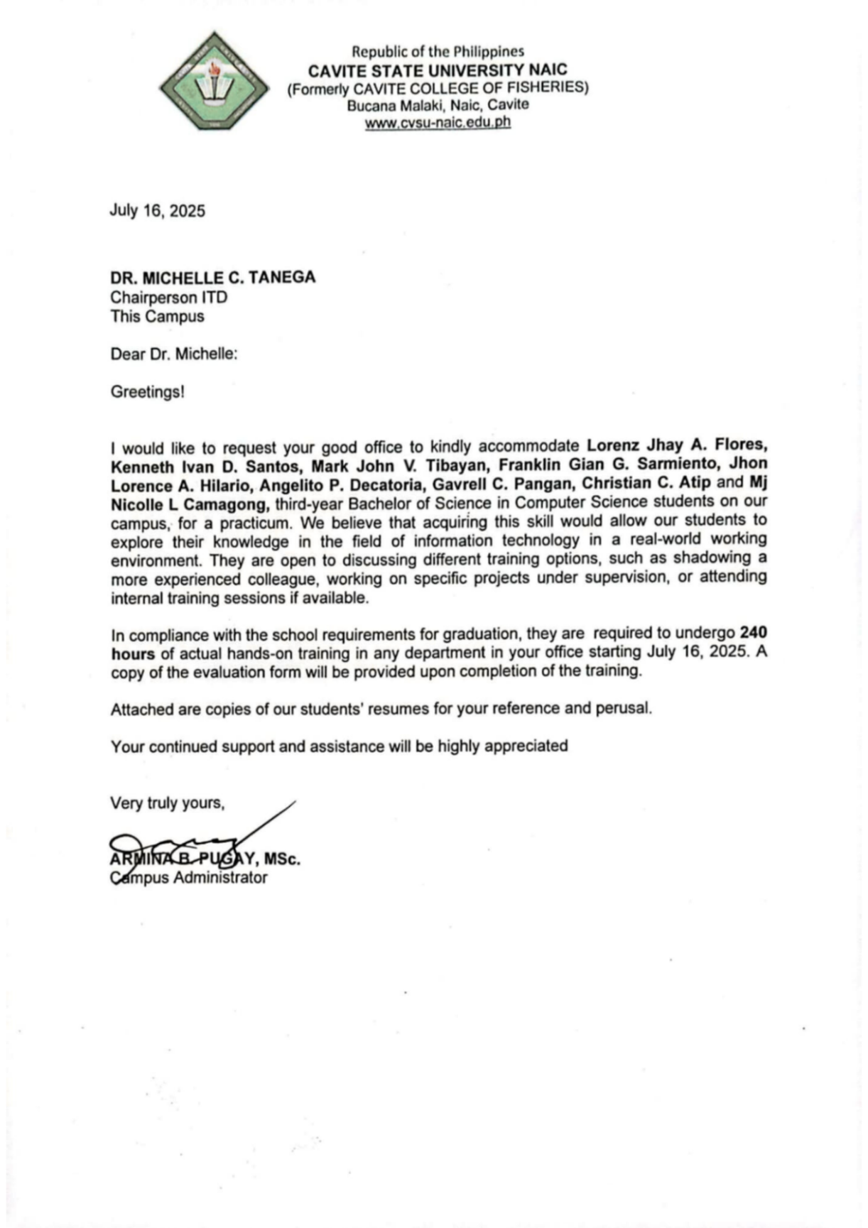

Appendix 5: Location of the Linkage Establishment
The location of Cavite State University Naic Campus (CvSU-Naic) in Naic, Cavite. It is situated along Bucana Malaki Road, near the coastline. Nearby landmarks include Seaside Beach Resort, Bucana Elementary School, Bancaan Catholic Church, and several local businesses and resorts. The campus is located in a coastal, semi-urban area with accessible roads and community facilities.

Appendix 6: Certificate of Completion
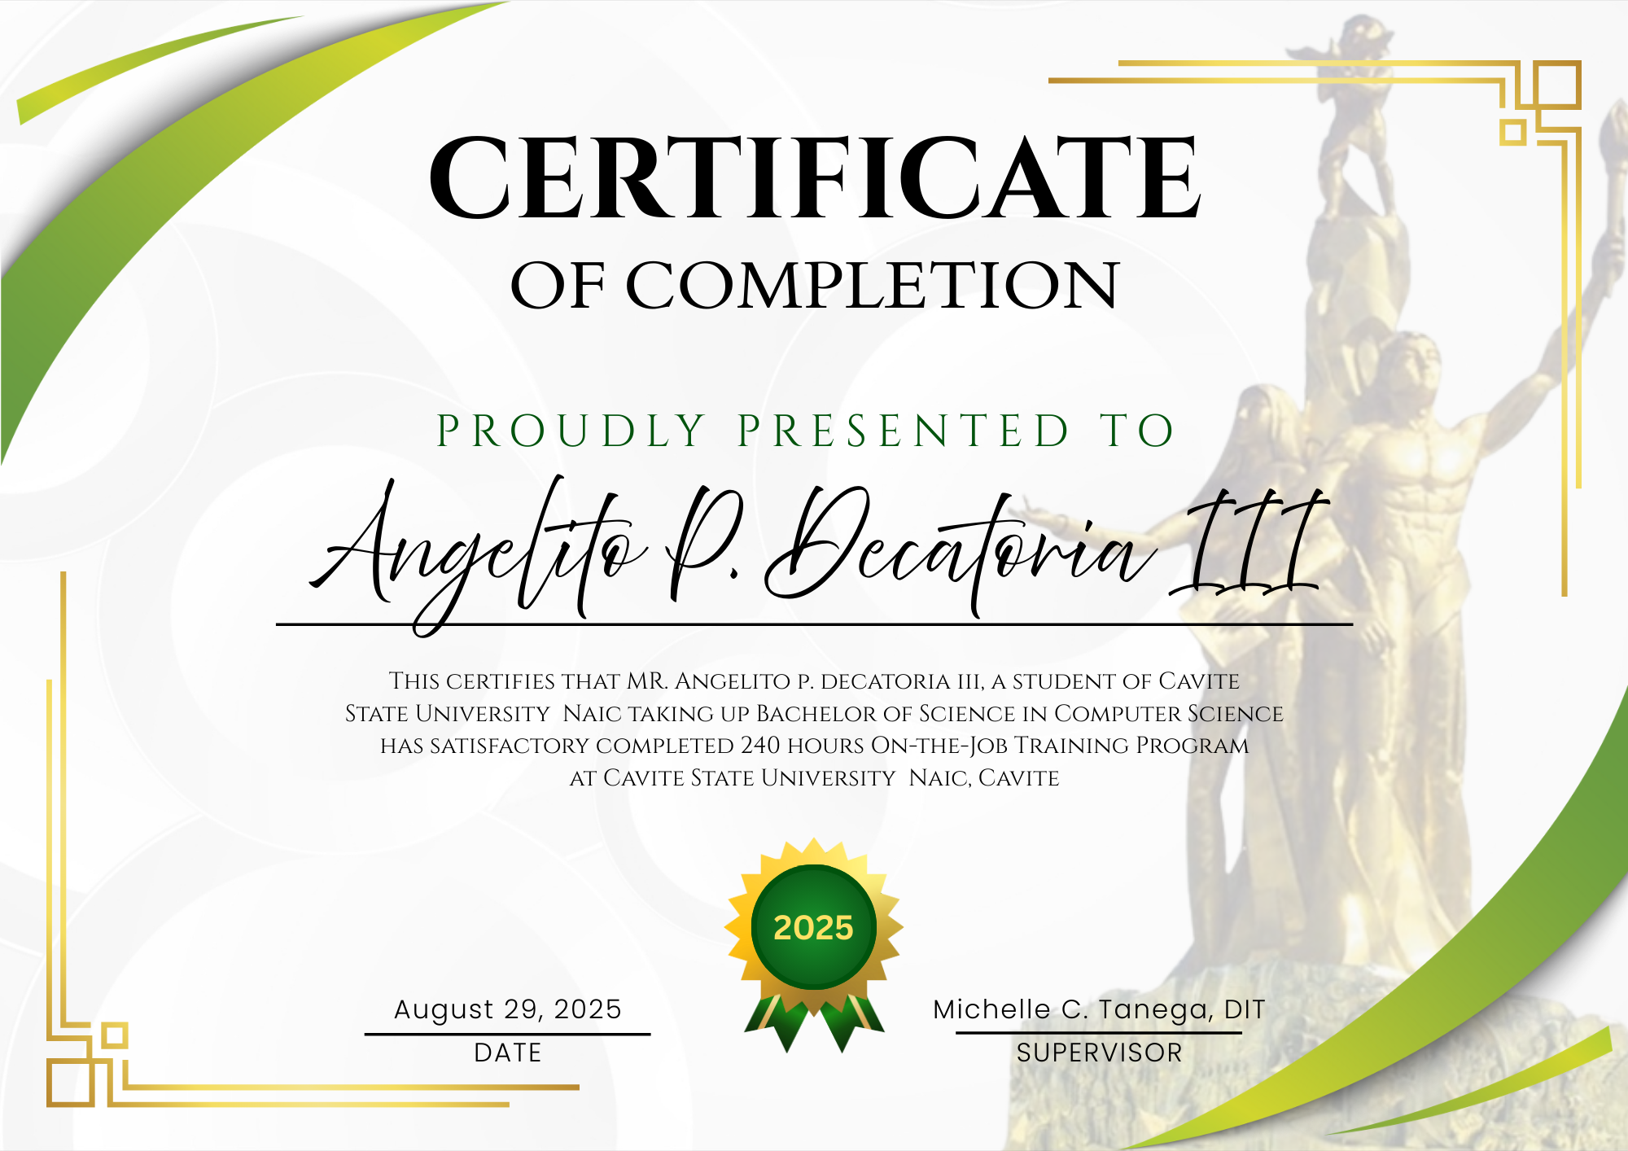
Appendix 7: Accomplished Evaluation Form
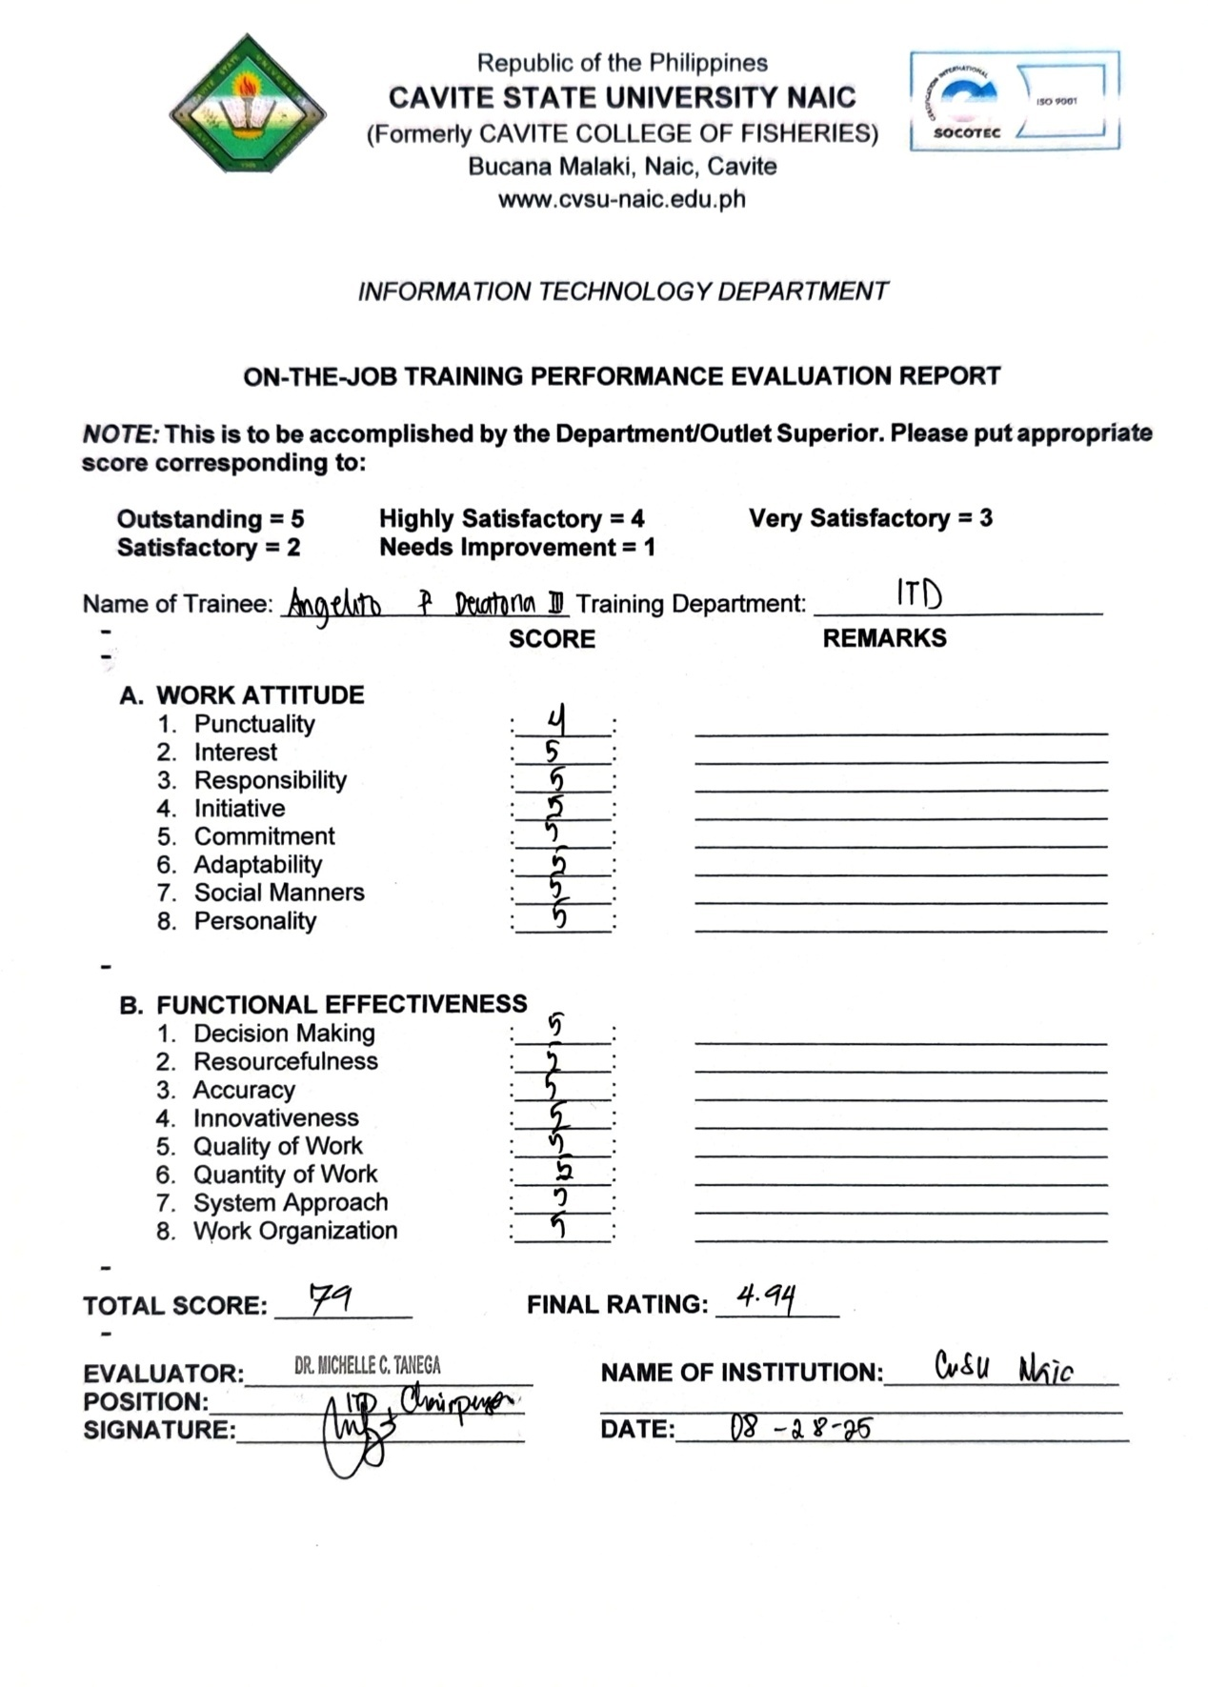

Appendix 8: Identification Card

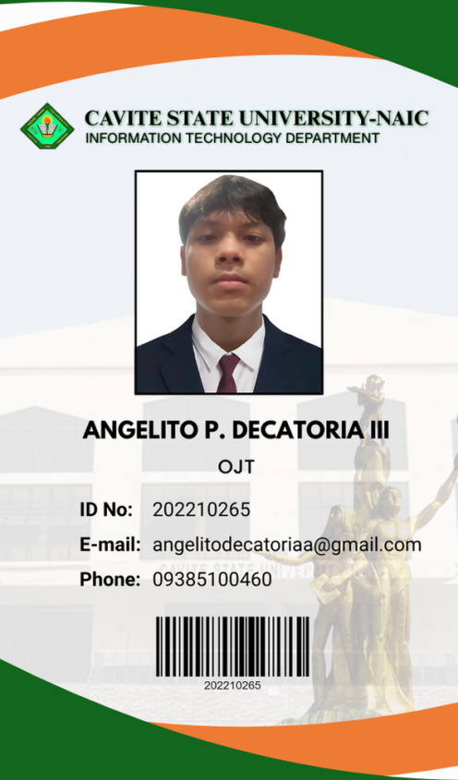

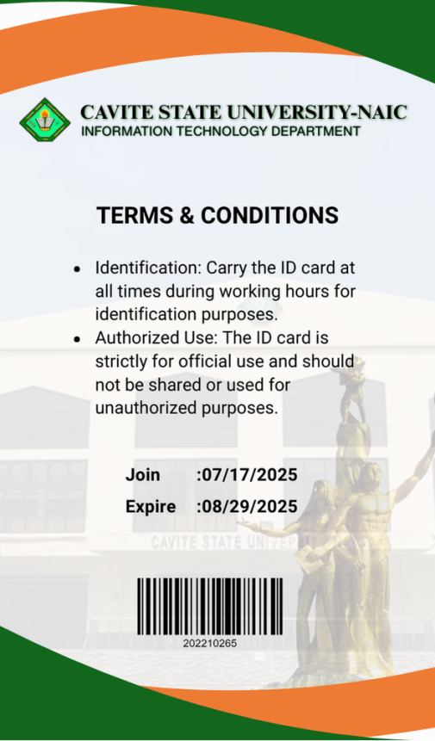

Appendix 9: Daily Time Record

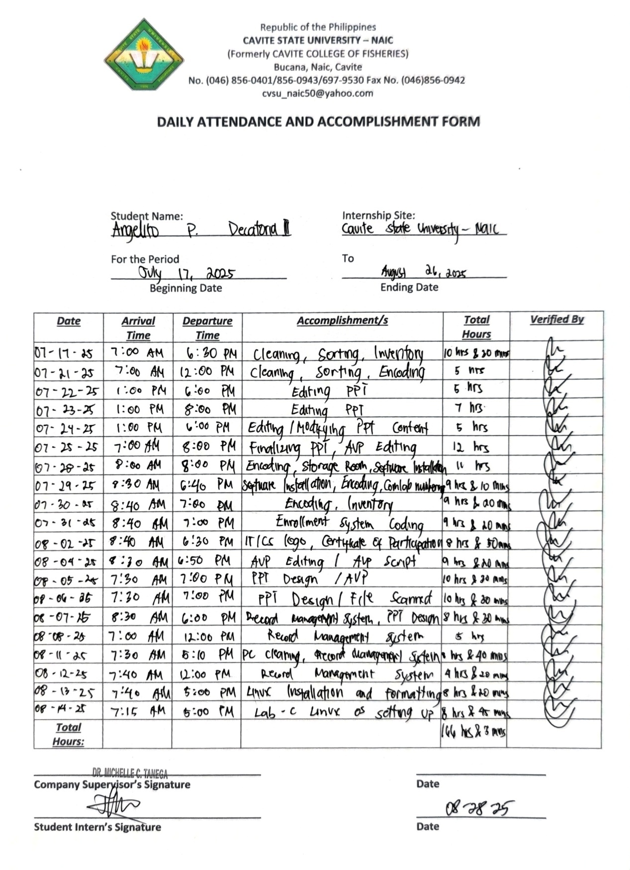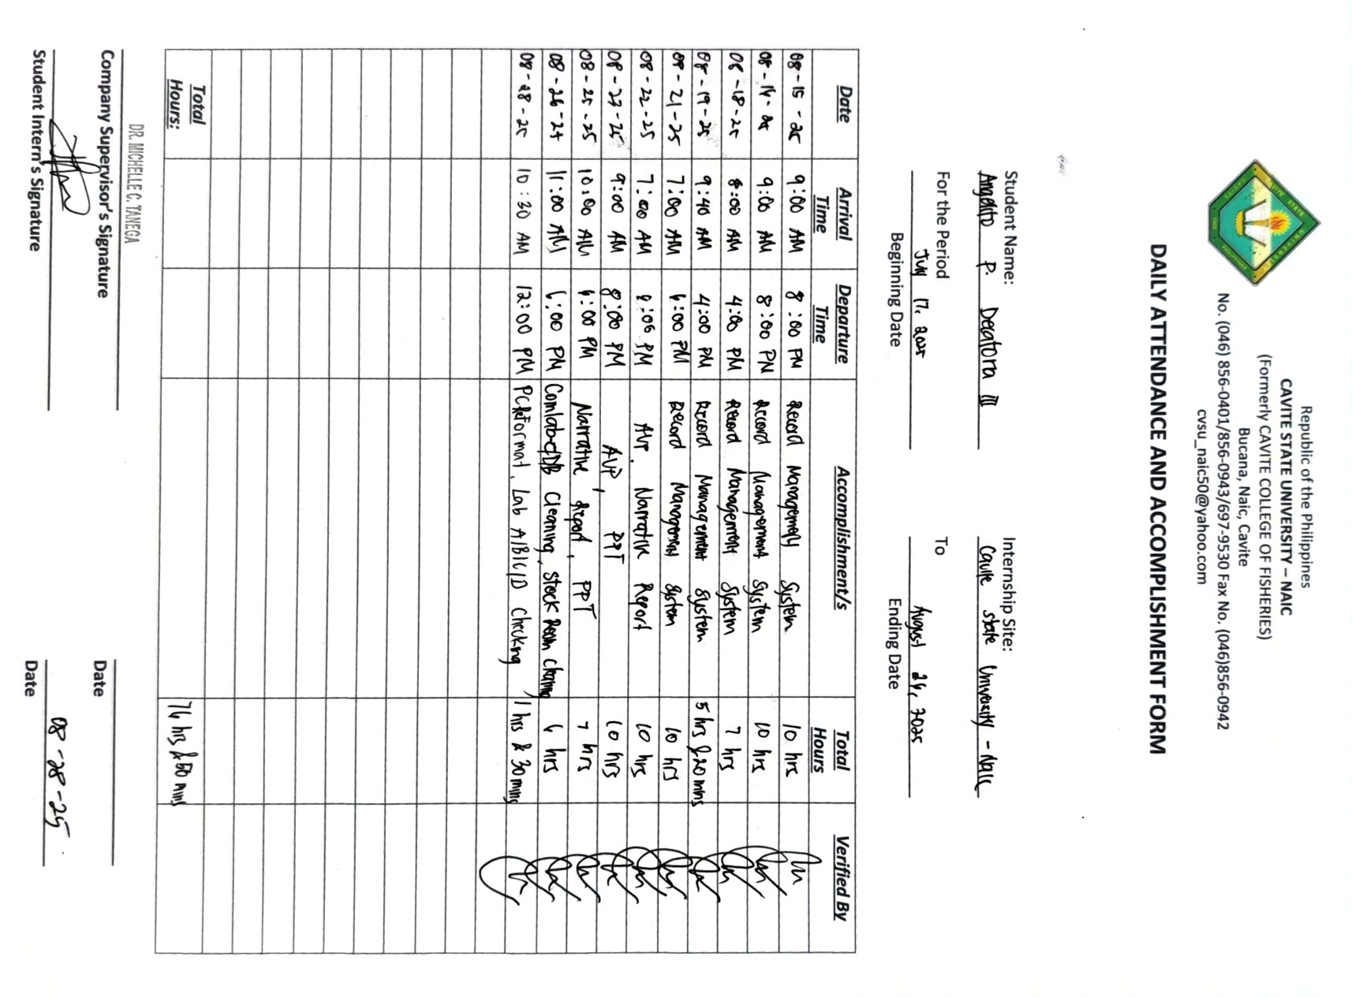

Appendix 10: Daily Journal
Day 1: 17 July, 2025

On my first day as an OJT trainee in the Information Technology Department, we were tasked with general cleaning of the faculty office. My first responsibility was to create an inventory of the ITD supplies using Microsoft Excel, which helped me track and organize the items systematically. I also assisted in arranging the faculty office by cleaning and repositioning materials. Lastly, I sorted thesis papers on the shelves by date and program, which improved accessibility and organization. This initial experience taught me the importance of teamwork, orderliness, and attention to detail.

Day 2: 21 July, 2025

We continued our cleaning and organization tasks in the ITD faculty. I specifically worked on sorting thesis manuscripts and narratives, carefully compiling and arranging them on the shelves. I also updated the supplies inventory in Excel, ensuring accuracy and completeness. This task allowed me to strengthen my organizational and clerical skills while contributing to the department’s efficiency.

Day 3: 22 July, 2025

Our professor tasked us to prepare a PowerPoint presentation for accreditation purposes. I took the lead in designing and creating the slides, ensuring that the content was well-structured and visually engaging. This activity helped me practice my technical and creative skills while learning the importance of preparing professional presentations for academic evaluations.

Day 4: 23 July, 2025

I continued working on the accreditation PowerPoint presentation. Since it was a lengthy presentation with numerous details, I carefully reviewed the narratives and ensured that the slides aligned with the required 10-minute time frame. The task tested my patience, precision, and ability to follow instructions accurately.

Day 5: 24 July, 2025
Revisions were made to the accreditation presentation as our professor suggested changes to the content. I worked on modifying and updating the slides accordingly. This day highlighted the importance of adaptability and attention to detail when handling revisions in professional work.

Day 6: 25 July, 2025

We finalized the accreditation PowerPoint presentation and began creating an Audio-Visual Presentation (AVP). I assisted in editing the AVP to meet the required 10-minute length, ensuring it complemented the PowerPoint presentation. This task improved my technical editing skills and teamwork coordination.

Day 7: 28 July, 2025

I was assigned to encode additional supplies into the inventory system. We also cleaned the storage room and installed open-source applications on the ITD laptops. This activity taught me the importance of software accessibility and maintaining updated systems for departmental use.

Day 8: July 29, 2025
We continued installing necessary software on the ITD laptops, which took longer due to slow internet connection. I also recorded the details of each laptop, including its brand, serial number, and assigned number, into Excel. Additionally, I created a numbering system for the computer laboratory units to make them easier to identify and manage.

Day 9: July 30, 2025

My task was mainly focused on updating and encoding inventory records once again. This consistent task reinforced my familiarity with systematic documentation and inventory management.

Day 10: 31 July, 2025
We were tasked to explore Laravel as preparation for creating an Enrollment Management System. Although it was not immediately required, I used the opportunity to study the framework and understand its potential for system development. This activity enhanced my technical learning and software development skills.

Day 11: 02 August, 2025

Even though it was a Saturday, we reported for OJT to assist our professor. I was tasked to design a logo for IT/CS orientation and create certificates of participation for the TechBridge program. This activity helped me apply my creativity in graphic design while supporting departmental events.

Day 12: 04 August, 2025
I worked on revising the AVP and script for our professor’s accreditation presentation, correcting errors and ensuring that it met the required 10-minute duration. This task improved my skills in editing, revising, and aligning content with given requirements.

Day 13: 05 August, 2025
I assisted in designing PowerPoint slides and editing the AVP. My focus was on ensuring that the presentation was visually professional and aligned with the accreditation requirements.

Day 14: 06 August, 2025
I continued improving the PowerPoint design. Additionally, one of the part-time faculty members requested my help in scanning and digitizing files. This taught me the importance of balancing multiple tasks while maintaining quality.

Day 15: 07 August, 2025
Our professor introduced us to a new project: developing a system for ITD to manage their transactions and files more efficiently. Currently, they only use Google Drive, so we were tasked to conceptualize a more organized Record Management System. This gave me the opportunity to apply system development concepts in a real-world setting.

Day 16: 08 August, 2025
We expanded the system proposal to cover not just ITD but all departments of the school. We also suggested integrating a social feed feature to allow faculty communication and posting. This broadened the scope of our project and challenged us to think of practical innovations.

Day 17: 11 August, 2025
We performed PC maintenance by cleaning the units. I also worked on developing the proposed Record Management System (ODCI). This day helped me balance both technical maintenance tasks and system development work.

Day 18: 12 August, 2025
Our system development continued. Since we were divided into teams, my specific responsibility was to create the User Panel of the Record Management System. This challenged me to focus on interface functionality and user experience.

Day 19: 13 August, 2025
We were tasked by our ICT teacher to install Linux (Ubuntu) in the ComLab C computers. I learned how to create a bootable USB and perform installation, which expanded my technical knowledge of operating systems.

Day 20: 14 August, 2025
We continued the Linux installation on more laboratory computers, as we were unable to finish all units the previous day due to limited time. This activity further developed my troubleshooting and technical installation skills.

Day 21: 15 August, 2025
I focused on working on the Record Management System, completing most of the folder management features used for faculty tracking. This progress improved my skills in database connection and system organization.

Day 22: 16 August, 2025
I successfully completed the folder management features and connected the system to the database. I then began working on the Submission Tracker feature to monitor faculty file submissions.

Day 23: 18 August, 2025
I finished the Submission Tracker and polished the design and functionality of the system. This gave me a sense of fulfillment, seeing the project gradually come together.

Day 24: 19 August, 2025
I worked on creating the Settings and Profile System features. For instance, if the logged-in user belongs to ITD, the system automatically indicates their respective folders and profile. This strengthened my knowledge in role-based system development.
Day 25: 21 August, 2025
I finalized the system’s functions and designs, resolving minor errors and ensuring that all roles were properly connected. This marked a major milestone in the project’s completion.

Day 26: 22 August, 2025
We returned to AVP editing and narrative report revisions for our professor’s accreditation presentation, ensuring accuracy and proper flow.

Day 27: 23 August, 2025
I worked on improving the PowerPoint design by refining transitions, numbering pictures, and polishing the overall layout. This task emphasized creativity and detail orientation.

Day 28: 25 August, 2025
We finalized the PowerPoint and AVP presentation and submitted them to our professor. I also began writing my OJT narrative report, which served as preparation for our final OJT requirements.

Day 29: 26 August, 2025
This marked the official last day of our OJT. We performed general cleaning of ComLab B, C, and D, as well as the stock room. This activity wrapped up our OJT journey with teamwork and responsibility.

Day 30: 27 August, 2025
Although our OJT hours were finished, we volunteered to assist further. I helped format PCs and checked all computer laboratories (A, B, C, and D) in preparation for the upcoming accreditation visit. We also finalized our narrative reports and assisted in completing all necessary OJT documents.

Appendix 11: Training Program
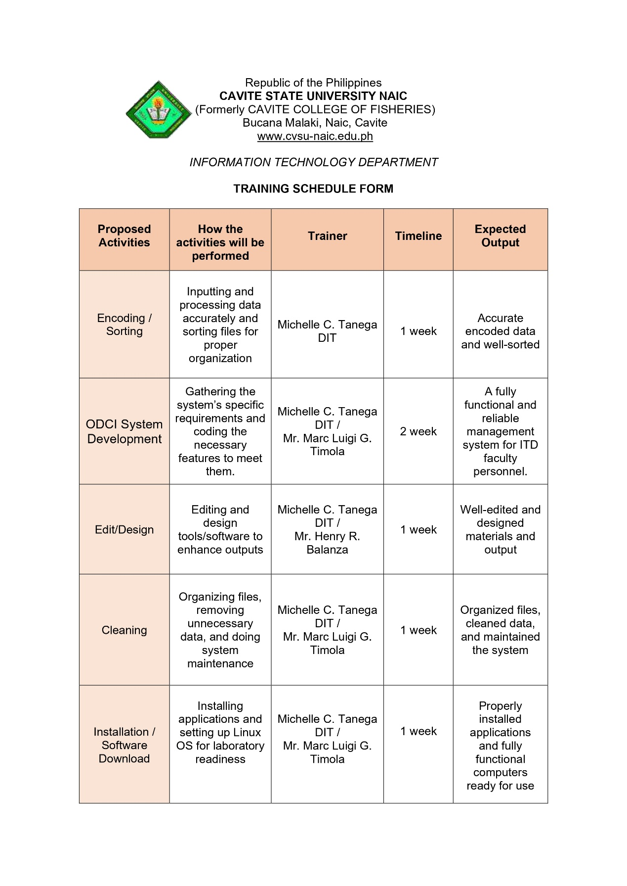

Appendix 12: Photo Documentation
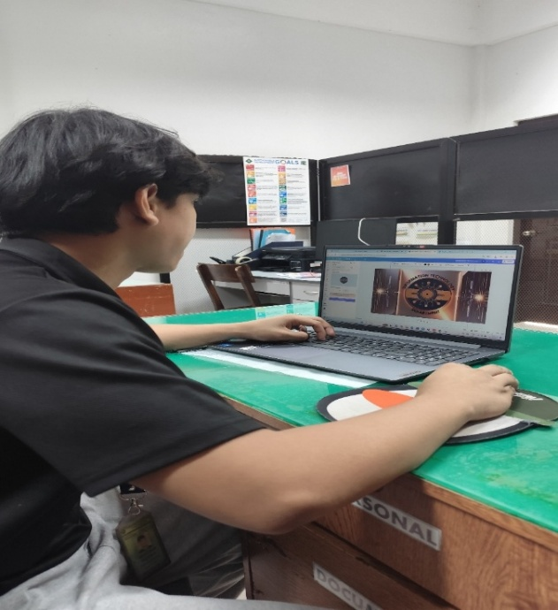

Appendix Figure 1. Creation of the IT/CS Logo

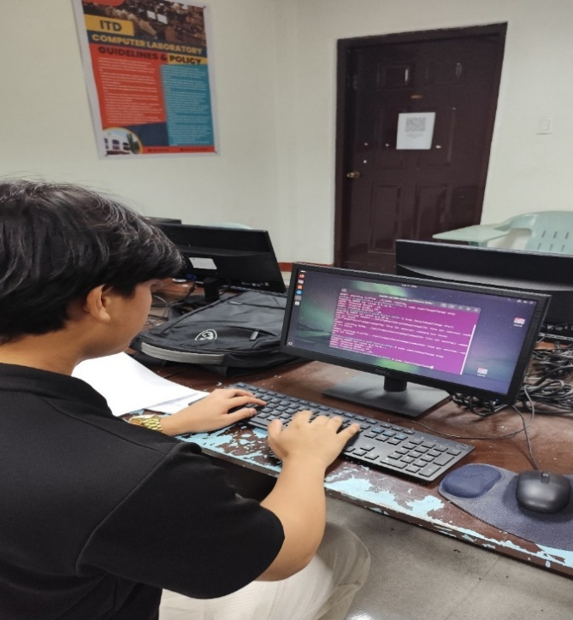

Appendix Figure 2. Installation of Linux in Comlab - C
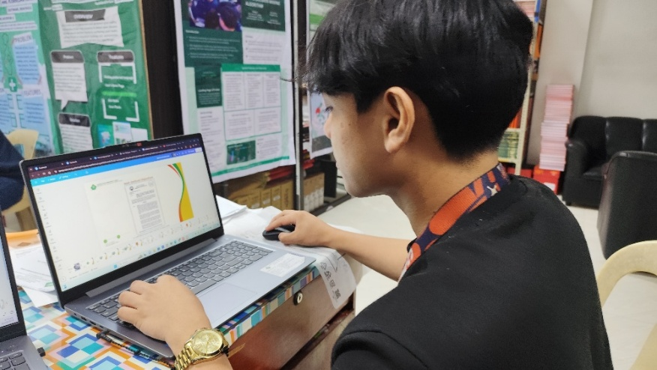

Appendix Figure 3. Development of an AVP for Accreditation
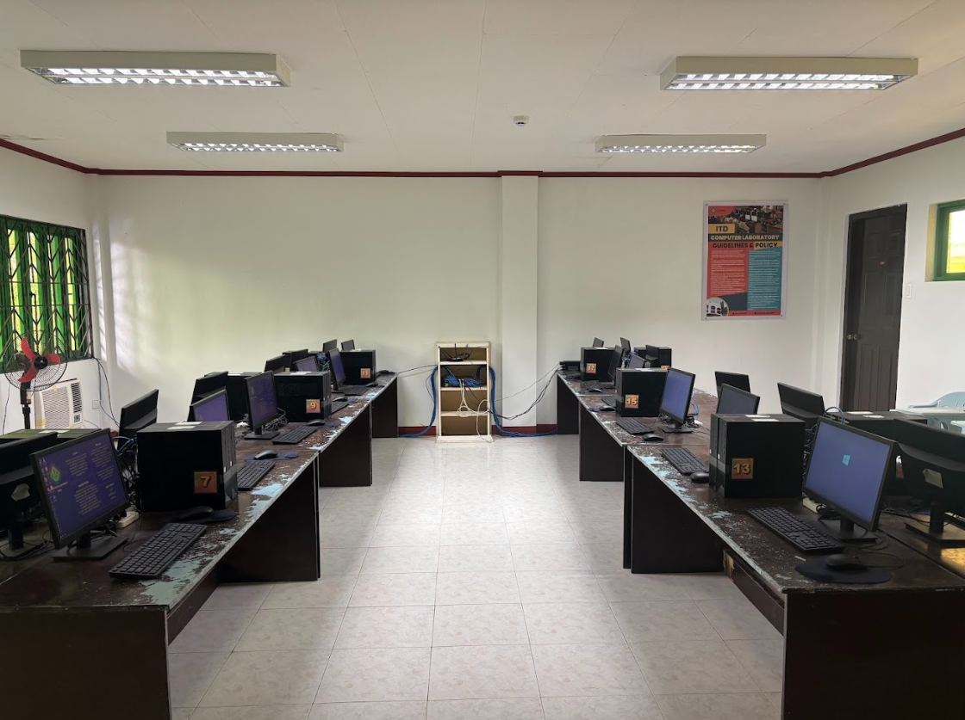

Appendix Figure 4. Computer Cleaning in Comlab - C
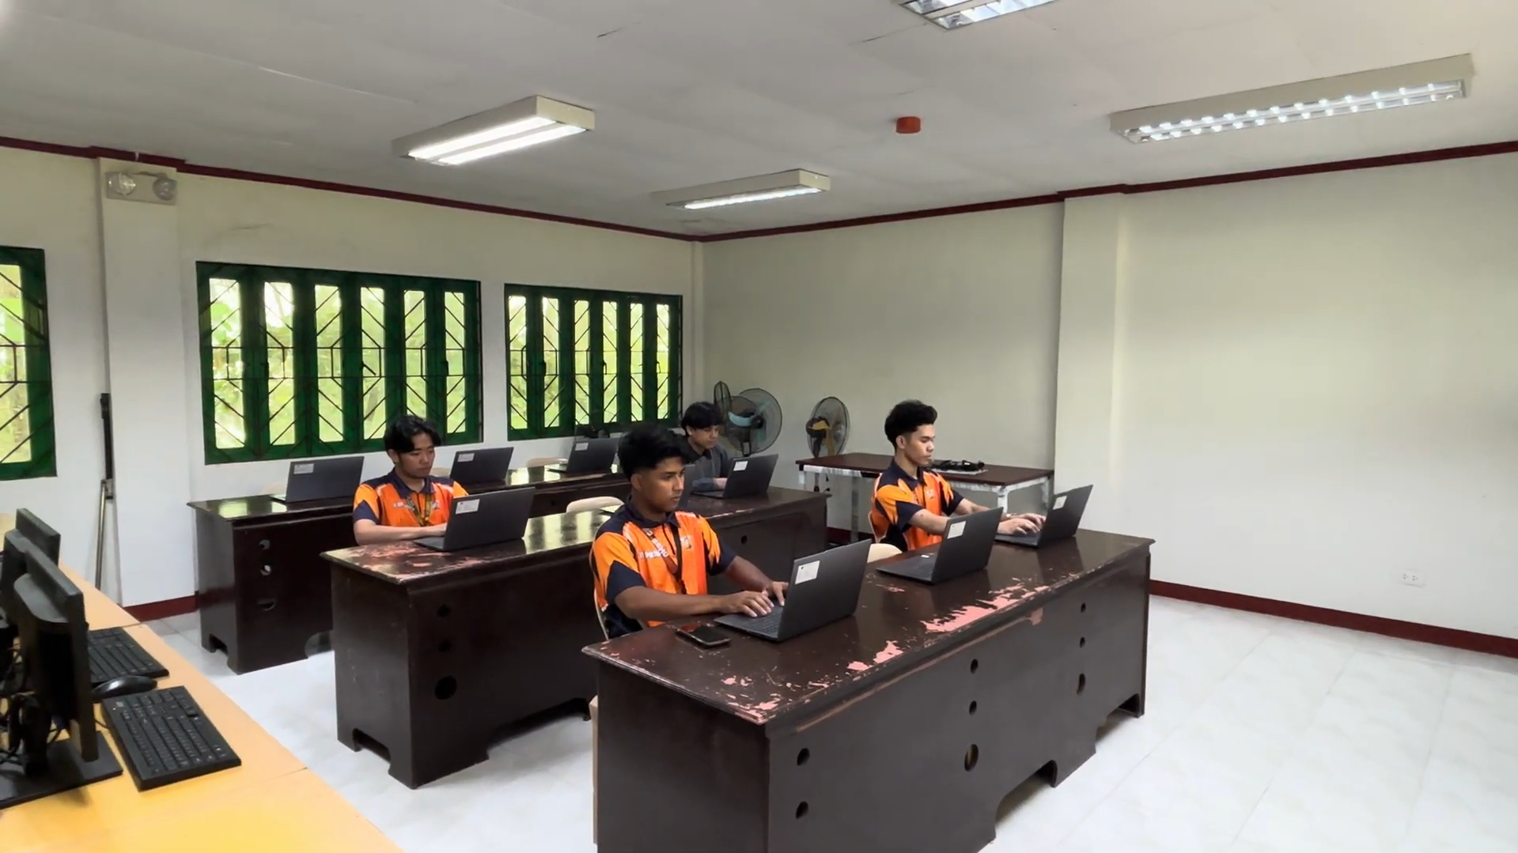

Appendix Figure 5. Software Installation on an ITD Laptop

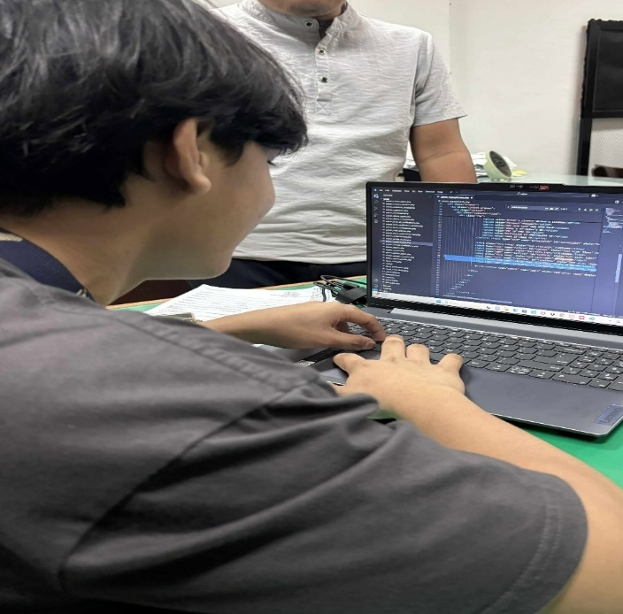

Appendix Figure 6. Development of a Record Management System

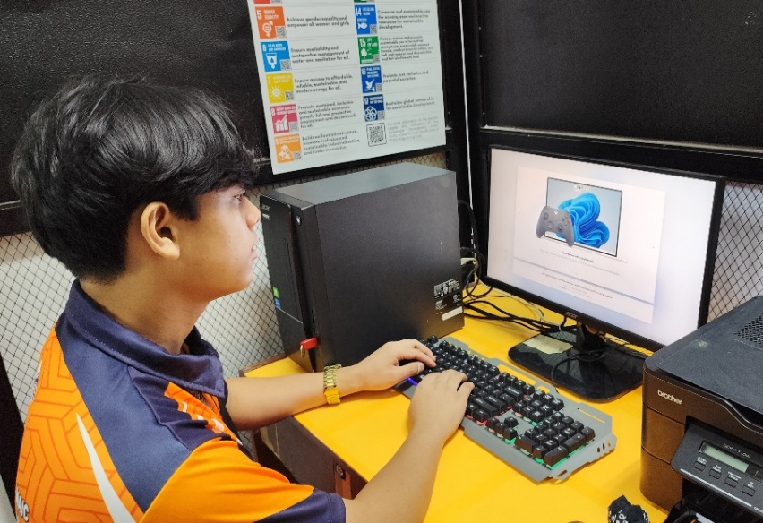

Appendix Figure 7. PC Reformatting Process

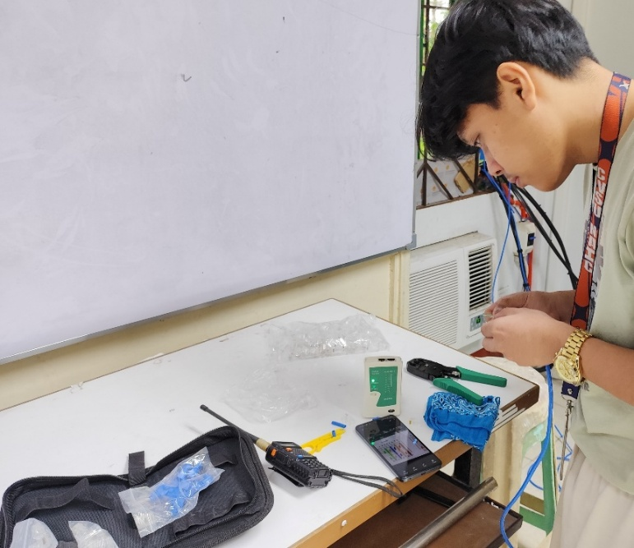

Appendix Figure 8. Ethernet Cable Setup Using Color Coding

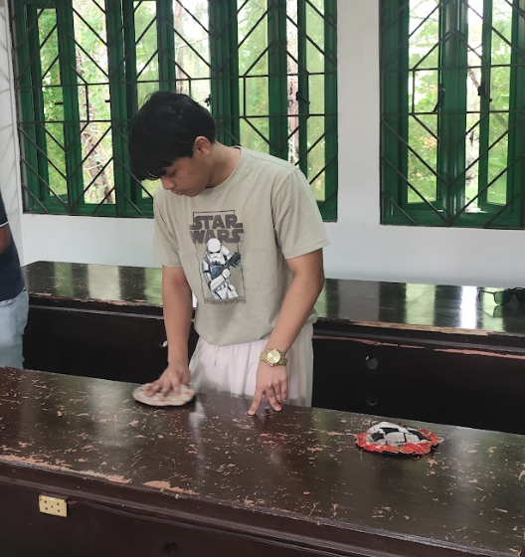

Appendix Figure 9. Computer Cleaning in Cisco/Comlab - D

