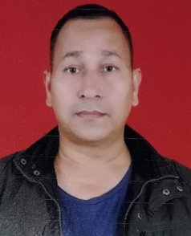**CURRICULUM VITAE**

**APPLICANT : - MR GOPAL SILWAL**

**D.O.B : - 04-FEB-1971**

**Mobile Number : - +91-7499620629**

**ABOUT MYSELF**

To work with an organization where I’ll be able to help in the growth of the organization and to increase profit ability with my skill in turn get an opportunity to gain exposure that would help me to build a strong and successful career.

**PERSONAL INFORMATION**

FATHER NAME : - GOVIND SILWAL

MARITAL STATUS : - MARRIED

GENDER : - MALE

NATIONALITY : - HINDU

LANGUAGE : - NEPALI, HINDI & ENGLISH

HEIGHT : - 5.8 “

WEIGHT : - 75 KG

ACADEMIC : - MATRIC PASS

**EXPERICENCE**

* 6 Year in Nepal Army
* 5 year Security Guard in Malasiya

I **certified that the above information is correct & complete to the best of my knowledge and nothing has been concealed or distorted.**