Identifying Biodiversity and DSI Entities using ISIC

## Introduction

This section is concerned with the question of how Parties can identify entities in economic sectors and sub-sectors of relevance to the multilateral mechanism. We propose that Parties may wish to use the existing United Nations family of statistical classifications that inform economic reporting and the System of National Accounts (the SNA). In particular, we recommend the following classifications as a starting point:

* The International Industrial Classification of All Economic Activities (ISIC, currently Revision 4)
* The Central Product Classification (CPC) of products, services and intellectual property
* The Harmonised System (HS) for classification of goods in trade of the World Customs Organization.

We focus here on the International Standard Industrial Classification (ISIC) and how it can be used to identify entities by sector using the UK as the example. We then examine how the sectors and sub-sectors in the recommendation from the Second Meeting of the A*d Hoc Open-ended Working Group on Benefit-Sharing from the Use of Digital Sequence Information on Genetic Resources* can be mapped to ISIC categories.

**Identifying Entities**

The *International Standard Industrial Classification of All Economic Activities* (ISIC) was established in 1948 and is regularly updated. ISIC is designed to cover the full spectrum of entities engaged in economic activity and defines them by their type of activity. ISIC is not confined to companies.

ISIC Revision 4 (ISIC4) is the current ISIC and has recently been superseded by ISIC Revision 5 (ISIC5). ISIC5 will become fully operational in national and regional systems from 2024 to 2027. We should therefore expect that countries will progressively transition their systems from ISIC4 to ISIC5 in the next few years.

Countries and regions around the world use ISIC as part of the organisation of information about entities within their administrative and economic reporting systems. ISIC is divided hierarchically into Sections, Divisions, Groups and Classes. Classes represent the most detailed level of the classification.

Individual countries and regions have developed their own classifications that link to ISIC. These classifications typically offer a greater level of detail in defining entities than ISIC. For example, the European Union has elaborated its own more detailed version of ISIC (currently NACE2). The classification used in North America (Canada, Mexico and the United States) is the North American Industry Classification System (NAICS). The different classifications are mapped to ISIC using correspondence tables.

Revisions to ISIC are organised by the United Nations Statistical Commission and are informed by a global consultation process with member states.[1] For example, consultations for the development of ISIC5 included questions on how to address cloud computing, databases and artificial intelligence.

ISIC4 and the new ISIC5 were manually reviewed for sectors and sub-sectors identified in the work of the Working Group on DSI. We recommend that additional input is sought from the UNSD and other relevant statistical authorities in any future work on ISIC. However, our review suggests that there are 7 main ISIC sections of relevance to debates on digital sequence information as set out in **Table X**.

| Section | Title |
| --- | --- |
| A | Agriculture, forestry and fishing |
| C | Manufacturing |
| G | Wholesale and retail trade |
| K | Telecommunications, computer programming, consultancy, computing infrastructure, and other information service activities |
| N | Professional, scientific and technical activities |
| Q | Education |
| R | Human health and social work activities |

### A worked example

The easiest way to engage with ISIC is using a worked example. We will start with pharmaceuticals. The ISIC hierarchy for pharmaceuticals is shown below.

* Section C = Manufacturing
  + Division 21 = Manufacture of basic pharmaceutical products and pharmaceutical preparations
    - Group 210 = Manufacture of pharmaceuticals, medicinal chemistry and botanical products
      * Class 2100 = as above
      * National/Regional details (see below)

What this means is that if we want to identify pharmaceutical companies within a national economy we need to focus on division 21 and specifically class 2100.

The ISIC, or its national and regional equivalents, is normally used at the time of legal registration of an entity. In the UK it is not possible to register as an entity without providing a relevant code to UK Companies House at the time of registration. The UK Companies House offers a [lookup tool](https://resources.companieshouse.gov.uk/sic/) and instructions to assist applicants.

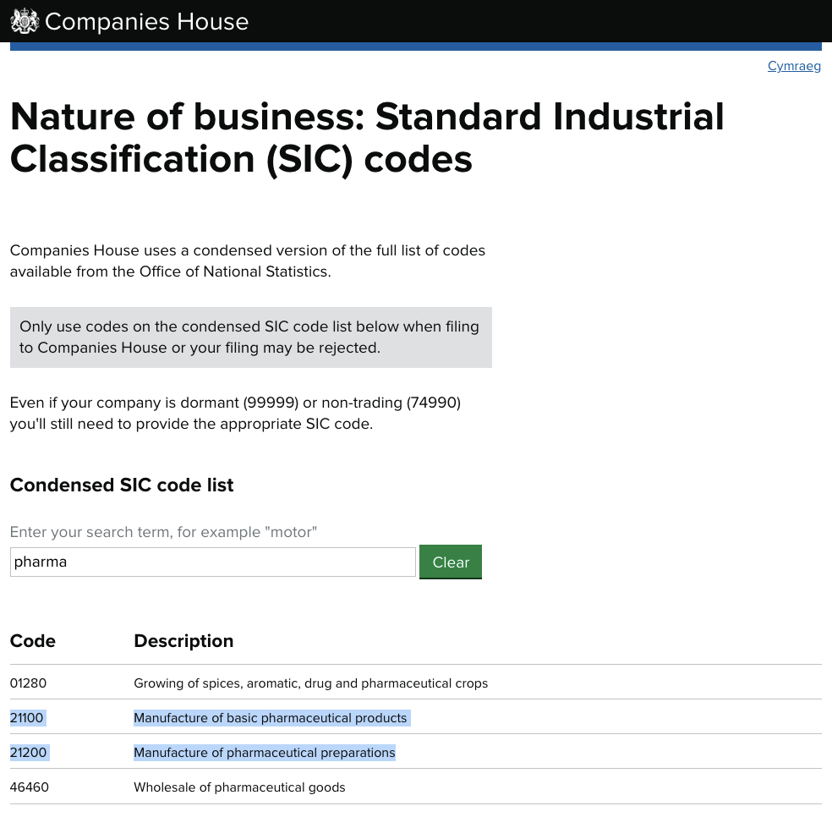

We can see here that pharmaceutical companies appear in Division 21 (the first two digits of the code represent the division level). In the UK there are two codes, 21100 for ‘Manufacture of basic pharmaceutical products’ and a second code also in Division 21 for 21200 ‘Manufacture of pharmaceutical products’. The reason for this is that UK along with the EU uses a more detailed classification. The classification links to ISIC with codes 21100 and 21200 reconciling to 2100 in ISIC4. These technical details are handled using correspondence tables.[2]

Taking biotechnology as a second sector we can also look up the the relevant code.

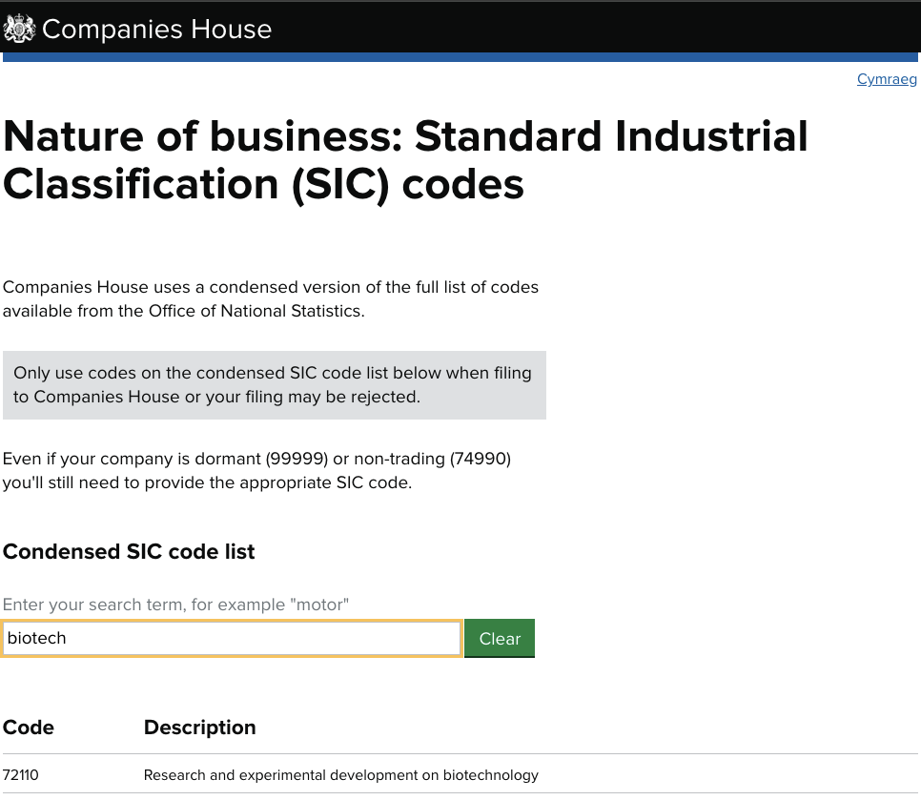

This tells us that biotechnology falls into Division 72 of ISIC and in particular under Class 7210 for *Research and experimental development on natural sciences and engineering* with the UK and EU providing further detail under subclass 72110.

As we become more familiar with the classification we would learn that in very basic terms: Agriculture = Division 1; Biotechnology = Division 72; Cosmetics = Division 20; Food & Beverages = Division 10 and 11; Information and Services = Division 62 and 63 and so on.

When the relevant codes have been identified it becomes possible to retrieve information about the entities that fall into the sectors or sub-sectors. For UK registered entities Companies House provides an Application Programming Interface (API) to allow for programmatic retrieval of this information. Commercial databases and open access databases such as ORBIS and Open Corporates also provide means for retrieving company information using ISIC codes. In this case we have geocoded the data from Companies House for the two sample sectors of activity. This data can be searched and explored [online](https://public.tableau.com/app/profile/one.world.analytics/viz/biopharma/Overview).

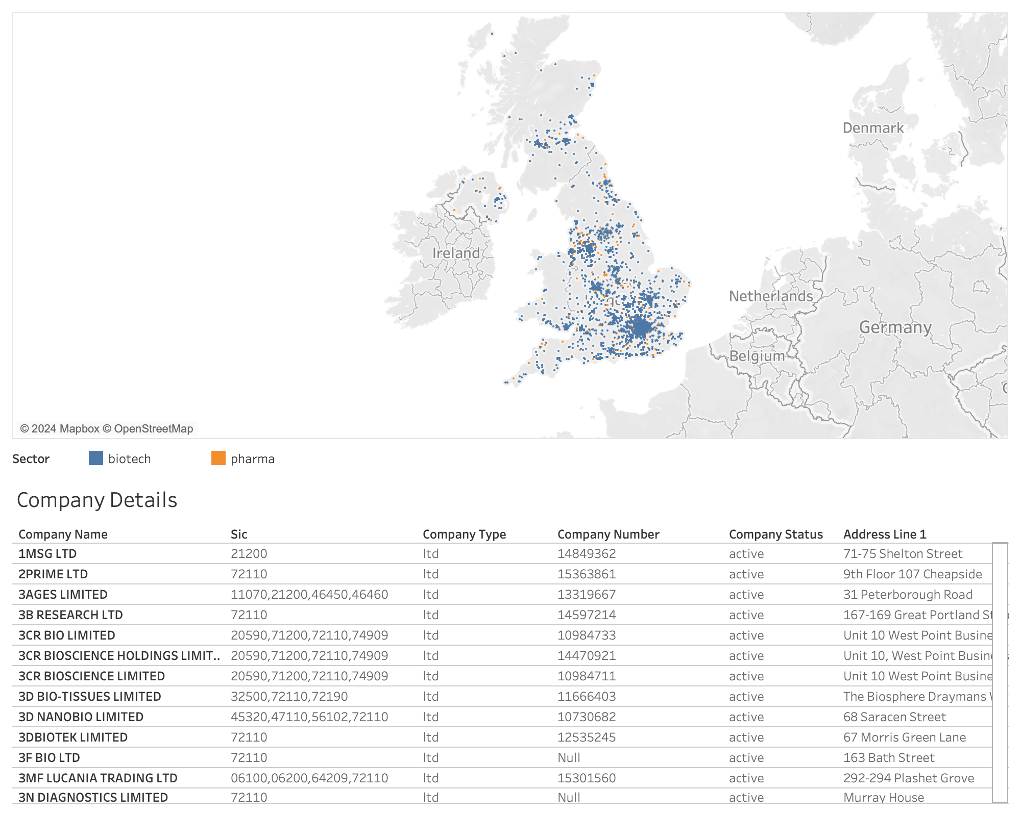

This example demonstrates that it is possible to use ISIC classifications to identify companies by sector. Information of this type will ordinarily be held by government entities responsible for maintaining national registers (such as Companies House in the UK) and it would be matter for Parties to identify the relevant authority within their jurisdictions.

For the UK (and EU) among other countries if we were seeking to identify sectors such as cosmetics we would find them in Division 20 *under Class 20420 for Manufacture of perfumes and toilet preparations* (the latter terminology reflecting the use of rather archaic language in classification systems). This process can be repeated for other sectors and sub-sectors of interest.

We now demonstrate the application of this approach to sectors and sub-sectors identified by the Working Group on DSI.

## Working Group on DSI: Sectors and sub-sectors

The recommendation of the Second Meeting of the A*d Hoc Open-ended Working Group on Benefit-Sharing from the Use of Digital Sequence Information on Genetic Resources* makes reference to a number of sectors and sub-sectors that either “directly or indirectly benefit from” or are in some way “reliant on” digital sequence information (CBD/WGDSI/REC/2/1, Enclosure A).

The entire text of the draft recommendation to COP16 is currently in brackets. However, we can discern the following concepts in relation to sectors and sub-sectors of activity in the Annex, notably in Enclosure A.

Our aim is to link the sectors and sub-sectors to the ISIC. No judgement is implied on whether a particular sector or sub-sector should be included as that is a matter for Parties. The objective is simply to start identifying relevant ISIC classifications:

Agriculture (Enclosure A para 1 (d)):

1. Plant breeding (para 1d)
2. Animal breeding (para 1d)
3. Agricultural biotechnology (para 1d), (see also Biotechnology heading below)
4. Agricultural technology (including plant breeding and crop modification) (para 1d)
5. Genetic modification of livestock (para 1d)
6. Support activities for plant production (para 1d)
7. Veterinary pharmaceuticals (para 1d)
8. Crop protection products (para 1d)

Biotechnology (Enclosure A)

1. Agricultural biotechnology (para 1d)
2. Industrial biotechnology (para 1e)
3. Life Science Research (para 1a)

Cosmetics (Enclosure A)

1. Cosmetics (including through synthetic means) (para 1c)

Education (Annex)

1. Academic Institutions (Annex para. 8)

Equipment (Enclosure A)

1. Laboratory equipment associated with sequencing (including reagents and supplies) (para 1f)

Food (Enclosure A)

1. Nutraceuticals (food and health supplements) (para 1b)
2. improving food safety (para 1d)

Information, scientific and technical services (Enclosure A)

1. software (para 1g)
2. artificial intelligence used to characterise analyse or store big data (para 1g)
3. industrial sequencing (para 1g)
4. characterising digital sequence information for third party producers in other sectors/sub-sectors (para 1g)
5. databases (Annex para 1, 8, 9, 9a, 9d, 10, 12, 15)

Pharmaceuticals (Enclosure A)

1. Pharmaceuticals (including biopharmaceuticals) (para 1b, 1d, 1g)

Retail (Annex)

1. Retail products and services (Annex, para 3, Option C)

### Mapping Sectors to ISIC

The above working list of sectors and sub-sectors from the WGDSI can be mapped to ISIC as follows. Note that the transition is now taking place between ISIC4 and the now operational ISIC5. ISIC5 includes explanatory notes regarding sequencing, artificial intelligence and cloud computing of direct relevance to debates on DSI. However, these typically form part of notes on the use of the classification rather than the introduction of new classification codes.[3] During the transition the Guide to ISIC5 (dated March 11 2024) remains in draft form.[4]

As noted above, the ISIC is organised into Sections, Divisions, Groups and Classes. The listing below seeks to identify the most appropriate level. For example, the group level for perennial crops will include a range of perennial crops and is therefore recorded at that level. In contrast, in Manufacturing it is appropriate to use specific classes (e.g. for pesticides, herbicides, cosmetics etc.) to be as specific as possible.

Agriculture

Section A Agriculture, Forestry and Fishing

Division 1: Crop and animal production, hunting and related service activities

1. Group 11 Growing of non-perennial crops
2. Group 12 Growing of perennial crops
3. Group 13 Plant propagation
4. Group 14 Animal production
5. Group 15 Mixed farming
6. Group 16 Support activities to agriculture and post-harvest crop activities

Of potential relevance from Section A but not explicitly referenced by the WGDSI:[5]

Division 2: Forestry and Logging

* Group 21 Silviculture and other forestry activities
* Group 23 Gathering of non-wood forest products
* Group 24 Support services to forestry

Division 3: Fishing and Aquaculture

* Group 31 Fishing
* Group 32 Aquaculture
* Group 33 Support activities for fishing an aquaculture

Section C Manufacturing

Division 20: Manufacture of Chemical Products

1. Class 2012 Manufacture of fertilizers and nitrogen compounds
2. Class 2021 Manufacture of pesticides and other agrochemical products

Biotechnology

Class 7210 is the ISIC classifier for biotechnology entities. The explanatory notes for ISIC Rev. 5 clarify that “This class includes also - DNA sequencing for general research on biological processes”.

Section N Professional, scientific and technical activities

Division 72 Scientific Research and Development

1. Class 7210 Research and experimental development on natural sciences and engineering.[6]

Cosmetics

Section C Manufacturing

Division 20 Manufacture of chemicals and chemical products

1. Class 2023 Manufacture of soap and detergents, cleaning and polishing preparations, perfumes and toilet preparations.[7]

Education

Section Q Education (ISIC Rev 5)[8]

Division 85 Education

1. Class 8540 Tertiary education

See also entry for Biotechnology in Division 72 Class 7210

Equipment:

Section C Manufacturing

Division 23 Manufacture of other non-metallic mineral products

1. Class 2310 Manufacture of Glass and Class Products[9]

Division 26 Manufacture of computer, electronic and optical products

1. Class 2651 Manufacturing of measuring, testing, navigating and control equipment

Division 32 Other manufacturing

1. Class 3250 Manufacture of medical and dental instruments and supplies

Food (including food safety):

Section C Manufacturing

Division 10 Manufacture of Food Products

1. Class 1010 Processing and preserving of meat
2. Class 1020 Processing and preserving of fish, crustaceans and molluscs
3. Class 1030 Processing and preserving of fruit and vegetables
4. Class 1040 Manufacture of vegetable and animal oils and fats
5. Class 1050 Manufacture of dairy products
6. Class 1061 Manufacture of grain mill products
7. Class 1062 Manufacture of starches and starch products
8. Class 1071 Manufacture of bakery products
9. Class 1073 Manufacture of cocoa, chocolate and sugar confectionery
10. Class 1074 Manufacture of macaroni, noodles, couscous and similar farinaceous products
11. Class 1075 Manufacture of prepared meals and dishes
12. Class 1076 Processing of coffee and tea
13. Class 1079 Manufacture of other food products n.e.c. (not elsewhere classified)
14. Class 1080 Manufacture of prepared animal feeds

Division 11 Manufacture of Beverages

1. Class 1101 Distilling, rectifying and blending of spirits
2. Class 1102 Manufacture of wines
3. Class 1103 Manufacture of beer
4. Class 1104 Manufacture of malt
5. Class 1105 Manufacture of soft drinks; production of mineral waters and other bottled waters

Food Safety

Section N Professional, scientific and technical activities

Division 71 Architectural and engineering activities; technical testing and analysis

1. Class 7120 Technical testing and analysis[10]

Information, scientific and technical services

ISIC5 adds explanatory notes to assist with addressing artificial intelligence, cloud computing and databases. Headings are added using small roman for distinct items under this heading.

Section K Telecommunications, computer programming, consultancy, computing infrastructure, and other information service activities

i) artificial intelligence, machine learning, databases:

Division 62 Computer programming, consultancy and related activities

1. Class 6219 Other computer programming activities (ISIC4, Class 6201).[11]

ii) cloud computing, data storage:

Division 63 Computing infrastructure, data processing, hosting, and other information service activities

1. Class 6310 Computing infrastructure, data processing, hosting and related activities.[12]

iii) industrial sequencing:

The term industrial sequencing is unclear. However, nucleic acids as a product appears in the Central Product Classification (CPC) in CPC Class 34160 as ‘Organo-sulphur compounds and other organo-inorganic compounds; heterocyclic compounds n.e.c.; nucleic acids and their salts’. The CPC to ISIC correspondence table maps nucleic acids to ISIC Class 2011.

Section C Manufacturing

Division 20 Manufacture of chemicals and chemical products

1. Class 2011: Manufacture of basic chemicals

d) characterizing digital sequence information for third party producers in other sectors/sub-sectors:

Section N Professional, scientific and technical activities

Division 71 Architectural and engineering activities; technical testing and analysis

1. Class 7120 Technical testing and analysis[13]

Section R Human health and social work activities

Division 86 Human health activities

1. Class 8699 Other human health activities n.e.c[14]

Pharmaceuticals:

Section C Manufacturing

Division 21 Manufacture of basic pharmaceutical products and pharmaceutical preparations

1. Class 2100 Manufacture of pharmaceuticals, medicinal chemical and botanical products

Retail:

Section G Wholesale and retail trade; repair of motor vehicles and motorcycles

Division 47 Retail trade, except of motor vehicles and motorcycles

1. Group: 471 Retail sale in non-specialized stores
2. Group: 472 Retail sale of food, beverages and tobacco in specialized stores

**Recommendations:**

* Parties may wish to adopt a list of major headings for sectors and sub-sectors linked to the ISIC for further elaboration.
* Parties may wish to request inputs from the United Nations Statistics Division on the use of ISIC Revision 5 and related classifications in the United Nations family of classifications of relevance to the multilateral mechanism on DSI.
* Parties may with to request inputs from national and regional statistical authorities (e.g. Eurostat, ECLA) on the use of the United Nations family of classifications in the economic reporting framework and System of National Accounts (SNA) of relevance to the multilateral mechanism on DSI.
* Parties may wish to initiate work on operationalising approaches to Monetary Contributions for a sub-set of entities falling within specific ISIC codes and, as appropriate, progressively expand the list based on operational experience and lessons learned during the initial phase of operations.

1. See for example: <https://unstats.un.org/unsd/classifications/ISIC/revision>
2. In some cases, such as the EU and UK using NACE2 a greater level of detail is specified. Correspondence tables are available from the [UNSD](https://unstats.un.org/unsd/classifications/Family/Detail/2095) or national/regional statistical authorities.
3. ISIC Rev. 5 Structure with Explanatory Notes <https://unstats.un.org/unsd/classifications/Econ/Download/In%20Text/ISIC5_Exp_Notes_11Mar2024.xlsx>
4. <https://unstats.un.org/unsd/classifications/Econ/Download/In%20Text/ISIC5_Intro_11Mar2024.pdf>
5. These groups are included for the purposes of completeness.
6. ISIC5 explanatory notes record that “This class includes also - DNA sequencing for general research on biological processes”
7. The term toilet preparations encompasses cosmetics.
8. In ISIC5 Section P Education from ISIC4 became Section Q of the same title. ISIC4 Division 85, Class 8530 “Higher education” (ISIC Rev 4) is now part of Class 8540 for Tertiary education in ISIC5. This change was made to adapt ISIC to the new International Standard Classification of Education (ISCED) classification. For details see UNSD *International Standard Industrial Classification of All Economic Activities (ISIC), Revision 5*, page 290 for details.
9. Further clarification of laboratory glassware is merited in any future work.
10. ISIC5 explanatory notes, “This class includes… testing activities in the field of food hygiene, including testing and control in relation to food production, e.g. testing of animals before slaughter”
11. The explanatory notes for ISIC5 explain that “This class includes: - designing the structure and content of, and/or writing, modifying (including updates and patches), customizing, testing and supporting of the computer code necessary to create and implement: * systems software * business, finance, and other software applications (other than video game applications) * machine learning applications * artificial intelligence/machine vision applications * cybersecurity applications * distributed ledger applications * databases * web pages”
12. ISIC5 explanatory notes: “This class includes: - provision of computing infrastructure including cloud infrastructure and platform provision (IaaS, PaaS) - cloud computing (except software publishing and computer systems design), whether or not in combination with infrastructure provision - provision of technical infrastructure related to streaming services - data processing services and related activities: • complete processing of data supplied by clients • generation of specialized reports from data supplied by clients • blockchain/distributed ledger technology (DLT) data processing activities - specialized hosting activities such as: • web hosting • application hosting - general time-share provision of mainframe facilities to clients - digitalisation of files (for further processing of data) - provision of data entry services - data centre colocation activities (i.e., rental of server and networking space in data centres, ) - computer data storage services”
13. ISIC5 explanatory notes, “This class includes… testing activities in the field of food hygiene, including testing and control in relation to food production, e.g. testing of animals before slaughter”
14. Explanatory notes for ISIC5 include “DNA sequencing for ruling out or curing a specific disease, see 8699”. However, the notes for Class 8699 do not make specific reference to this activity. This may merit clarification with UNSD.