Main Key Terms
Part One： IT Project Management

- Introduction To Project Management
project, project management, project attributes, project manager (hard and soft skills), triple constraint, PMI, PMO, PMP

- The Project Management and Information Technology Context
Deliverable, project life cycle, systems development life cycle (SDLC), Organizational Structures (Functional, Project, and Matrix)

- Project Management Process Groups: A Case Study
5 process groups, process groups and KAs mapping, remember all processes in each KA

- Project Integration Management
project integration management processes, project charter, develop project management plan, NPV and Return Of Investment（ROI）calculate, Weighted Scoring Model, Performing Integrated Change Control process, change control board (CCB)

- Project Scope Management
project scope management processes, scope planning, scope control, scope definition, scope statement, work breakdown structure(WBS), WBS dictionary, scope statement, WBS package, scope baseline

- Project Time Management
Project time management processes, Activity definition, activity sequencing (FS,SF,FF,SS), activity resource estimating, activity duration estimating, schedule development, milestone, Gantt chart, critical path analysis, Critical chain scheduling, Schedule network analysis: ES, EF, LS, LF, TF; PERT, network diagram: AOA (ADM), AON network diagram (PDM, Precedence Diagramming Method); types of dependencies between activities, time baseline, shorten a project schedule: Crashing, Fast tracking,

- Project Cost Management
project cost management processes, internal rate of return (IRR), payback period , cost estimating, cost budgeting, sunk cost, Reserves(Contingency reserves, Management reserves), Intangible costs , Tangible costs, Direct costs , Indirect costs, cost baseline

- Project Quality Management
project quality management processes, quality assurance, seven run rule , Six Sigma rule , six 9s of quality rule , 20/80 Pareto analysis, fishbone diagrams, conformance cost, Nonconformance cost

- Project Human resource Management
Project human resource management processes, Acquiring the project team, Developing the project team, Managing the project team, Maslow’s Hierarchy of Needs, Resource Leveling technique , conflict Handling modes

- Project Communications Management
Project communications management processes, Performance Reporting, Communications channels, Effective face-to-face interactions

- Project Risk Management
Project risk management processes, Negative risk, Positive risk, risk utility, risk-averse, Watch list , Decision tree and EMV, Monte Carlo , Contingency plans, Risk identification, Risk register, Top Ten Risk Item Tracking , risk response

- Project Procurement management
Project Procurement management processes, Planning purchases and acquisitions, Request for Proposal (RFP), Requests for Quotes (RFQ), Conducting contracting (5 steps), Controlling the contract, Closing the contract, Contract Statement of Work (SOW), Types of contracts: CPIF, CPFF, CPAF, CPPC, FFP, FPIF

- Project Stakeholder Management
Project stakeholder management processes, Identifying stakeholders, Classifying Stakeholders, Interpersonal Skills of Project Manager,

Part Two: Quality Engineering

- CMMI
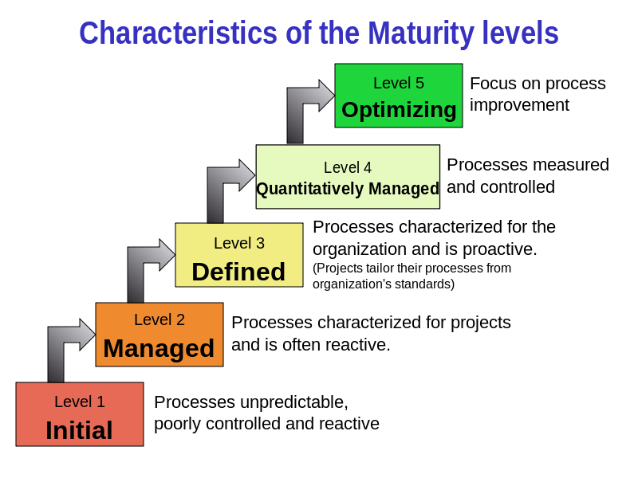

- IOS9001
What is the difference between CMMI and ISO9001

The types of the final test exercises:
- Single Choice
- Comprehensive Question
- Calculation
- Analysis

