诚信应考,考试作弊将带来严重后果！
_____________ ________
…

姓名 学号
学院 专业 座位号
( 密 封 线 内 不 答 题 )
……………………………………………………密………………………………………………封………………………………………线……………………………………线………………………………………

华南理工大学期末考试
《面向对象分析与设计》试卷
注意事项：1. 考前请将密封线内填写清楚；
2. 所有答案请直接答在试卷上(或答题纸上)；
3．考试形式：闭卷；
4. 本试卷共 大题，满分100分， 考试时间120分钟。
题 号 | 一 | 二 | 三 | 四 | 五 | 总分
得 分
评卷人

- Multiple Choice (15 points)
1) During implementation, the development team decides to use a third party utility to provide some of the required functionality. What OOAD artifact would MOST likely reflect this change?
A. Activity diagram
B. Package diagram
C. State diagram
D. Interaction diagram

2) Scenario: Prepare for an Event
In preparation for a party, the chef will look at the menu. The chef requires a shopping list from each recipe on the selected menu. The system generates the shopping list of ingredients that he needs to buy. Then he just crosses off anything that he already has.
Because the chef is picky about his cooking utensils, he brings his own and doesn't like to depend on the clients to supply anything. In order to make sure that he doesn't forget anything, he uses the system to generate the list of utensils that he'll have to bring with him to the party.
He then proceeds to generate a to do list for the day of the party based on the time that the dinner is to be ready. He finds this to be useful so that everything's ready at the specified time, and nothing is forgotten.
When creating the use cases related to the "Prepare for an Event" scenario, which of the following BEST represents the type of terminology that the use cases should contain?

A. Chef, menu, recipes, ingredients
B. End user, bill of fare, cooking specifications, food contents

C. Chef object, menu object, recipe object, ingredient object
D. Person record, menu print stream, recipe container, ingredient array

3) If a use case had a requirement "Calculate account balance," which OOAD artifact would be the BEST source for determining the name of the public method used to invoke the operation?
A. Use cases
B. Interaction diagrams
C. Class diagram
D. Activity diagram

4) Which of the following are TRUE about a deployment diagram? （3 Answers）
A. Since there is always some kind of response to a message, the dependencies are two-way between deployment components.
B. Dependencies between deployment components tend to be the same as the package dependencies.
C. Deployment diagrams can used to show physical modules of code.
D. Deployment diagrams can be used to show the physical distribution of a system across computers.

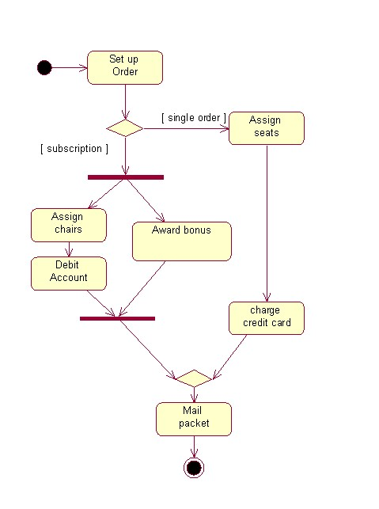
5) Refer to the diagram to answer the question. What is the maximum concurrent threads that is possible in the activity diagram?

A. 3
B. 2
C. 4
D. 1
E. 5

2． Fill the blanks (15 points)
1) Which UML diagram is specifically intended to describe the behavior of a single class? _____________
2) Explain the difference between composition and aggregation. How are each represented in UML.
_______________________________________________________________________
_______________________________________________________________________
- The UML metamodel is defined as one of the layers of a four-layer metamodeling architecture. This architecture is a proven infrastructure for defining the precise semantics required by complex models ,Which include _____________ , ______________, ______________ and user objects .

4) UML provide three extension Extension Mechanisms : ________ , _________, and TaggedValue. These mechanisms can be used separately or together to define new modeling elements that can have distinct semantics, characteristics, and notation relative to the built in UML modeling elements specified by the UML metamodel.

3. Point out the wrong place in the following diagram . (20 points )

Class Diagram: 分析类 / 分析类图
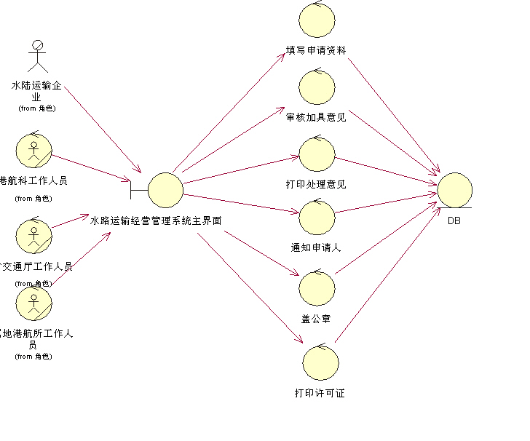

- Answer the following questions (Total 10 point)
(1) Compare the difference between the OOA and traditional structured analysis.

(2) How to discover the objects and actors in system.

5. Design (Total 40 point)
Suppose the shopping process use a terminal in the store.
(a)
Use case : shopping
Actor: buyer, cashier
Description: the buyer bring the goods(商品) to the post (cash desk,收款处). The cashier register the goods information, calculate the amount, receive the cash and give change. Then the buyer leaves with his(her) goods.
(b)
Use case : system managing
Actor: system administrator
Description: the administrator turn on the power, check the date and time, activity the users, and monitoring system status.

Please draw the system use case diagram and system sequence diagrams.

