诚信应考,考试作弊将带来严重后果！
_____________ ________
…

姓名 学号
学院 专业 座位号
( 密 封 线 内 不 答 题 )
……………………………………………………密………………………………………………封………………………………………线……………………………………线………………………………………

华南理工大学期末考试
《软件需求分析、设计与建模》试卷A
注意事项：1. 考前请将密封线内各项信息填写清楚；
2. 所有答案请直接答于答题纸上；
3．考试形式：闭卷；
4. 本试卷共四大题，满分100分，考试时间120分钟。
题 号 | 一 | 二 | 三 | 四 | 五 | 总分
得 分
评卷人

一、单项选择题（本大题共15题，每题2分，共30分）
注：所有的选项中，只有一个答案最符合题目要求，多选、错选均不得分,请将所选的答案依照题号对应填入下表。

1. | 2. | 3. | 4. | 5. | 6. | 7. | 8.
9. | 10. | 11. | 12. | 13． | 14. | 15.

1. Which kind of diagram in UML can be applied to describe external system events that are recognized and handled by system operators in the context of a use case ?
A. Statechart Diagram.
B. Activity Diagram.
C. Sequence Diagram.
D.Collaboration Diagram.

2. Why do we model?
A. Helps to visualize a system.
B. Gives us a template for constructing a system.
C. Documents our decisions.
D. All of the above.

3. What phrase best represents a composition relationship?
A. Is a part of. B. Is a kind of.
C. Is an only part of. D. Is an inheritance of.

4. Which of the following is good practice to use while designing for reuse?
A. Define a persistence framework that provides services for persisting objects.
B. Use design patterns, wherein complete solutions are already defined.
C. Use controller objects to control the flow of processes in the system.
D. Assign responsibilities to classes such that coupling between them remains high.
E. A and B.
F. A, B and C.
G. A, B,C and D.

5. Which of the following statement is Not TRUE?
A. A subsystem is a package that has separate specification and realization parts.
B. A subsystem is a discrete entity that has behavior and interfaces.
C. A subsystem can be identified by the stereotype <<subsystem>>.
D. A subsystem is a package that has specification part only.

6. In an OO system, it is NOT desirable to assign responsibilities:
A. relatively evenly across the classes.
B. more heavily in a few controlling classes.
C. according to interaction diagram messaging.
D. according to the use case diagram.
E．A and B
F．B, C and D

7. For showing how several objects collaborate in single use case, which one of the following OOAD artifacts is the MOST useful?
A. Interaction Diagrams B. Activity Diagrams
C. State Diagrams D. Class Diagrams

8. What methods MUST be implemented by the CreditProcessor class in the payment sequence diagram?
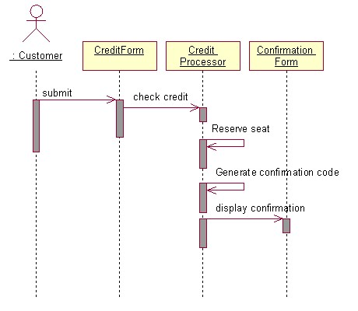
A. checkCredit, generateConfirmationCode, displayCofirmation.
B. checkCredit, generateConfirmationCode.
C. checkCredit, generateConfirmationCode, reserveSeat.
D. checkCredit, reserveSeat, displayCofirmation.

9. Which of the following is TRUE about a deployment diagram?
A. Since there is always some kind of response to a message, the dependencies are two-way between deployment components.
B. Dependencies between deployment components tend to be the same as the package dependencies.
C. Deployment diagrams are NOT to be used to show physical modules of code.
D. Deployment diagrams do NOT show physical distribution of a system across computers.

10. When using OOAD artifacts to organize and assign team responsibilities on a project, it is BEST to:
A. evenly distribute use cases among team members and have them work as independently as possible in order to minimize code dependencies.
B. designate one team for implementing interaction diagrams related to the "common code path" and another team for implementing interaction diagrams related to "code path variations" (for example , conditional or error paths).
C. divide teams according to the layers in the software architecture and have them work as independently as possible in order to minimize dependencies between the layers.
D. divide teams according to package diagram dependencies and utilize use cases to schedule the work for the individual team members.

11. To MOST effectively manage teams working on different packages within a large project, which one of the following should be TRUE?
A. One technical leader should control the project details and communicate decisions to the different teams.
B. The team leaders should focus on which type of database ( DB2 UDB, Oracle, Sybase, or Instant DB ) is used.
C. The team leaders should focus on quality designs for the internals of their packages, mentoring their team members.
D. Communications between the teams should be minimized to reduce overhead burdens while they work on separate, independent use cases for their packages.

12. Use cases CANNOT be used for :
A. modeling the non behavioral aspects such as data requirements, performance and security.
B. capturing behavioral aspect of a system.
C. capturing functional aspect of a system.
D. capturing the business process at high level.

13. What kind of association between the 2 classes described in java below?
public class A{
private ArrayList _Bs=new ArrayList();
public A(_Bs：B){
this._Bs.add(_Bs);
}
}
public class B{
…;
}
A．Inheritance B. Dependency
C．Composition D. Aggregation

14. Referring to the diagram below, which of the following is TRUE?
A．Class "Teacher" is a parent class of class "Professor" and class "Lecturer" .
B．Instance of "Professor" has to realized all of the behavior s of "Teacher".
C．There are instances of "Teacher" in the system.
D．"Professor" is a kind of "Teacher" and so does the "Lecturer".
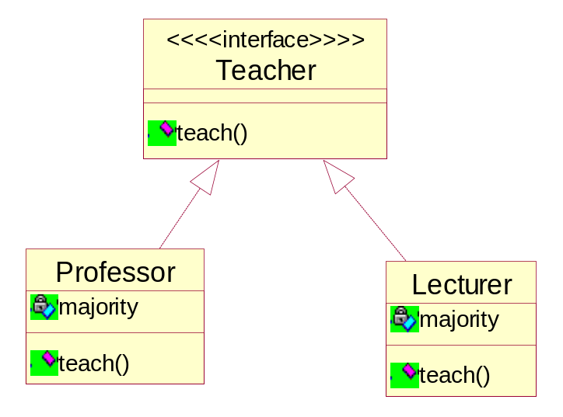

15. During the process of requirement engineering, the software engineer and the user of the system should work together to define
A. visible context of using the system for the user
B． crucial software properties
C． input and output of the system
D. A and B
E. A, B and C

二、填空题 （共10分）
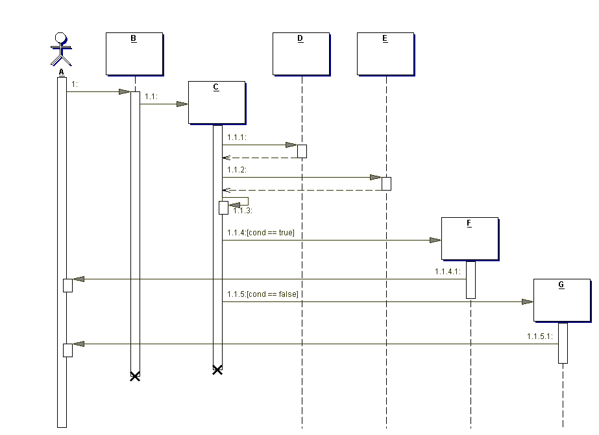
1. A is a(n) ______ _________.
2. B is a(n)____ _____________ object.
3. “1.1.3” is a(n) ____reflexive_________ message
4. “1.1” is a(n) ________create_______ message.
5. The dotted line below the boxes is called the _______生命线___<<lifeline>>__________.
6. The rectangle below the boxes is called the ______控制焦点(focus of control)___________
7. If this system represented part of a web site, what would B most likely represent?
Browser

8. Why is C lower than A, B, D, and E?

9. Why are A through G underlined?

10. Which of the following is an invalid sequence of messages, according to the diagram? ( )
- 1, 1.1, 1.1.1, 1.1.2, 1.1.3, 1.1.4, 1.1.4.1
- 1, 1.1, 1.1.1, 1.1.2, 1.1.3, 1.1.4, 1.1.4.1, 1.1.5, 1.1.5.1
- 1, 1.1, 1.1.1, 1.1.2, 1.1.3, 1.1.5, 1.1.5.1

三、问答题 （本大题共4小题，共25分）
1. Please describe the risks of the software developing and the approaches to avoiding them (Score 8).

Ppt chapter 3 P5

2.Please outline the phases and workflows of RUP (Score 5) .
It is a programming exploitation methodology which is OOT and web-basis.
Inception, Elaboration, Construction, Transition
Inception: Constructing the business cases of system and confirm the edge of the project.
milestone : Lifecycle objective.
Elaboration: Analysis the problem domain.
milestone : Lifecycle architecture.
Construction: Product’s exploitation.
milestone : Initial operation.
Transition: Ensuring the software is usable to the customer.
milestone : Product release.
1． （Business Modeling）
2． （Requirement）
3． （Analysis & Design）
4． （Implementation）
5． （Test）
- （Deployment）
7． Configuration & Change Management
- （Project Management）
9． （Environment）

- Please name and briefly describe the “4+1 view” of software architecture adopted in RUP (Score 5).

Which of the four views are:
Logical View which is the logical relationship around the objects,
Process View which is the view that show the actions of the objects or software actions,
Deployment View which is to show the relationship between the module of the objects
Implementation View which is the software implementations.
And the one view can be Use-Case View.

- Please describe the use case analysis steps in OOA/D (Score 7).

Use-Case Analysis Steps
Supplement the Use-Case Description
For each Use-Case Realization
Find Classes from Use-Case Behavior
Distribute Use-Case Behavior to Classes
For each resulting analysis class
Describe Responsibilities
Describe Attributes and Associations
Qualify Analysis Mechanisms
Unify Analysis Classes
Checkpoints
Use-Case Design Steps
Describe interaction between design objects
Simplify sequence diagrams using subsystems
Describe persistence related behavior
Refine the flow of events description
Unify classes and subsystems

四、判断改错题（本大题共5分）
Suppose the employee of a software company can be classified by some role such as coder、project manager and software engineer.
The UML diagram below is suggested as a solution to meet the change of the role of a company employee. Please judge whether the solution is true or not and explain why you make such a judgment. Please give your correction of the diagram when it is wrong (Score 5).

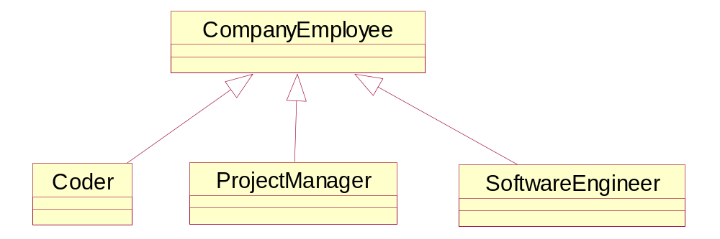

五、建模分析题（本大题共30分）
Suppose you are asked for developing a point of sale (POS) system using OOA/D technologies. A POS system is a computerized application used to record sales and handle payments and it is typically used in a retail store. Processing sale would be one of the key functions that the system has to perform. Please model the key function via the methodology of object-oriented analyze and design.
Suppose the simplified context of processing sale is under-consideration: a customer arrives at a checkout of a retail store with items to purchase. The cashier uses register of the POS system to record each purchased item. Each of the items is described a product specification, which belongs to a product catalogue. The system presents a running total and line-item details. The customer enters payment information, which the system validates and records. The system updates inventory (inventory: The quantity of goods in stock. ). The customer receives a receipt from the system and then leaves with the items and the sale is logged on a ledger with which the manager can checked the information for a period of time.

- Draw a UML use case diagram for the system including their relationships (Score 5).

- Give the class diagram with the analysis classes representing business entities involved in the system (names and brief descriptions only – no attributes or operations), along with their relationships and multiplicities (Score 10).

- Give the boundary classes、control classes and entity classes involved in the system to bear responsibility of “process sale” in the case of J2EE (names and brief descriptions with UML class stereotypes only – no attributes or operations) (Score 5).

- Draw a UML sequence diagram to model the use case of “process sale” in the case of J2EE (Score 10).

