- What is object technology? What do you perceive as object technology’s strength? It’s weakness?
OOT is such a technology that facing the objective world and the question realm and using the generally thinking way of human-beings to acknowledge the nature world to describe some things.
OOT fit the thinking way of human-beings and easy to protect and functions’ addition and decrease are also become more convenient. And OOT’s reusing is more strengthen.
weakness

2. What is UML? List at least three benefits of developing with UML.
UML（Unified Modeling Language）is used to proceeding the visual model of software dense system.
- UML can help to express things exactly.
- UML can help programmer to write a better code.
- UML can accelerate the procedure’s development.

- What process characteristic best fit the UML? Describe each characteristic.

- What is a use-case driven process? What is use-case? What are the benefits of use case?
It is the use-case become a guidance of program.
Use-case is a description of system functions.
Use-case can help us to get a general impression of the determined system.

- What is system’s architecture? What is an architecture-centric Process?
System’s architecture is an overall construction of a system, it include the concept, the requirements and all of the detail in implementing the project. The architecture-centric process is a process that exploit a software use the system’s architecture.

- What is iteration? What are the benefits of Iterative Development?
Iteration is a way of exploiting the software that finishing the software in several steps, and it need the customer present his advices after every step in order to ensure the product can fit to the requirements of the customer’s. Iteration can ensure a lower risk in a large project.

- What are the basic principles of OO technology? Describe each in detail.
Abstraction, it report those important properties connect to the applications.
Encapsulation, it can cover details of implementation and is the basis of the modularity.
Modularity, it break complex part into simple pieces
Hierarchy, it provides a method that can let the son class to get data from father class.

- What is use case model? Which artifacts can be included in a use case model?

- List three types of relationships existed between different use cases and give examples.
Generalization, Include, Extend.
Generalization, apples and bananas can be generalized as fruit.
Include, the banana peel is included in the banana.
Extend, we can eat the banana, but we can also smash it and mixed it with yogurt and drink it, drinking is an extension.

- Explain the following diagram and their elements with examples.
1) Use case diagram 2) Activity diagram 3) Sequence diagram 4) Collaboration diagram
5) Class diagram 6) state chart diagram 7) Deployment diagram
1) 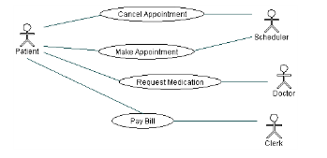
2) 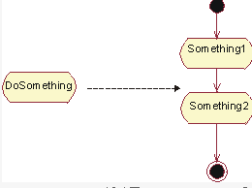
3) 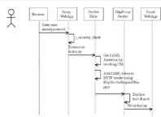
4) 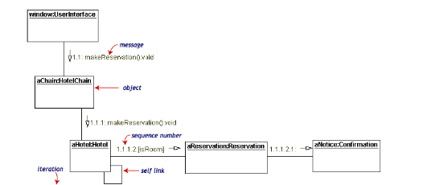
5) 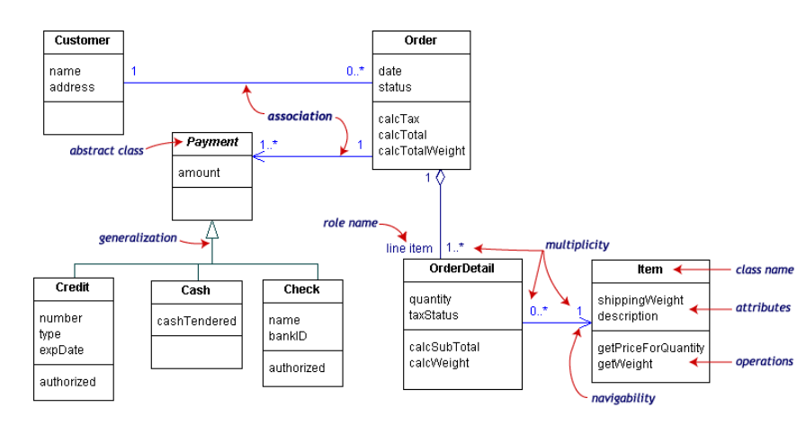
6) 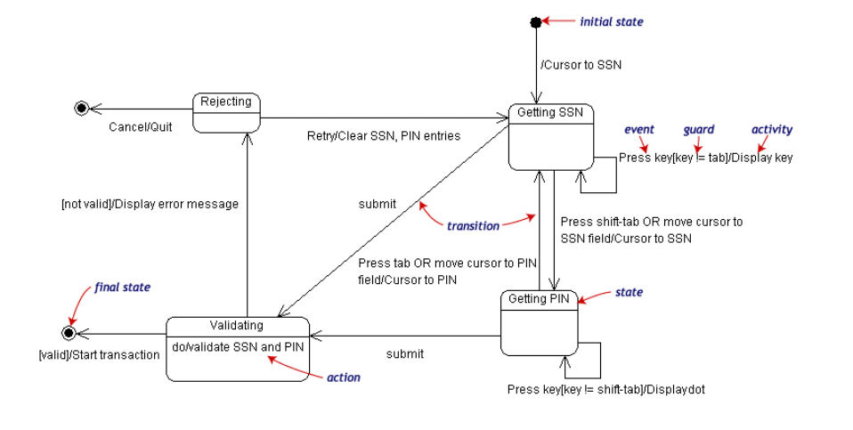
7) 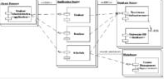

- Describe the similarities and differences between the sequence diagram and collaboration diagram.
They are both interactive diagram, but collaboration diagram don’t care about when the information be transferred.

- Define the different relationships in class diagram: dependency, association, aggregation, composition, generalization.
Dependency, is a connection during two classes, one class depend another class.
Association, it let a class acquire another class’s functions and attributes.
Aggregation, it is the association but those two classes are in different levels, one is entity but the other one is part.
Composition, it is a kind of aggregation, it demands the object that represent the entity in responsible of the life cycle of the object that represent the part.
Generalization, it represents the hierarchy between two classes.

- What is a node in deployment diagram? List two different types of nodes.
Node in deployment diagram always represent a device .

- Describe the extensibility mechanisms of UML.

- What is the function of Stereotypes？Give two examples of stereotypes.

- Explain the six best practices of software engineering.
- Iteration 2)Manage requirements 3)Module-basis architecture 4)visualization modeling
5) software quality’s confirmation 6)Control the changes of software.

- What is RUP? How many phases are there in RUP? Describe each phase’s purpose and milestone :.
It is a programming exploitation methodology which is OOT and web-basis.
Inception, Elaboration, Construction, Transition
Inception: Constructing the business cases of system and confirm the edge of the project.
Lifecycle objective.
Elaboration: Analysis the problem domain.
Lifecycle architecture.
Construction: Product’s exploitation.
Initial operation.
Transition: Ensuring the software is usable to the customer.
Product release.

- Name and briefly describe the “4+1”views of architecture.
Ans:Which of the four views are:
Logical View which is the logical relationship around the objects,
Process View which is the view that show the actions of the objects or software actions,
Deployment View which is to show the relationship between the module of the objects
Implementation View which is the software implementations.
And the one view can be Use-Case View.

- What is the difference between analysis and design?
The analysis focus on understanding of de problem,but the design focus on the understanding of the solution.

- Please describe the whole process of OO analysis and design with UML.
Ans:
- Build the requirement model-the plan for the requirement
- Build the basic model-Class diagram
- Build the assistant diagram
- Design the protocol of the model
- Prototype Development

- What is a layered architecture? Give examples of typical layers.
Ans: A layered architecture can be described as the “separation of responsibility which is to say that each layer is responsible for a finite amount of work.For instance,a company may has its enterprise architecture.The layers of the manager and the layers of the employees.They have the responsibilities themselves and they have their own layers.

- What are analysis mechanisms? What are design mechanisms? Give examples.
Ans:Analysis mechanisms can be a process which may run through the whole analysis.And so does the design mechanisms.For instance,a analysis mechanisms may contains Auditing, Communication and so on.

- What is an analysis class? Name and describe the three analysis stereotypes. Give examples.
Boundary Classes: Behavior that involves communication with an actor
Entity Classes: Behavior that involves the data encapsulated within the abstraction
Control Classes: Behavior specific to a use case or part of a very important flow of events

- What is Use-case realization? What‘s your understandings about the benefit of the use-case realization structure.
Ans:The Use-case realization is a method to realize the problem that we should analyses. The use-case realization structure helps to organize the model elements needed to realize the use cases in the design model.

- Please describe the use case analysis steps in OOA/D
Ans:
Use-Case Analysis may contain five Steps:
- Identify Use Cases, Supplement the Use-Case Description
- Identify Domain Class and relationships
For each Use-Case Realization
Find Classes from Use-Case Behavior
Distribute Use-Case Behavior to Classes
- Define the System Sequence Diagram for each use case,
For each resulting analysis class
Describe Responsibilities
Describe Attributes and Associations
Qualify Analysis Mechanisms
(4)Produce an operation,Unify Analysis Classes
(5)Checkpoints

Use-Case Design Steps
Describe interaction between design objects
Simplify sequence diagrams using subsystems
Describe persistence related behavior
Refine the flow of events description
Unify classes and subsystems

- What’s the package, and why we need package?
Ans:Package is a universal mechanism that organize other elements of the models together.
Why we need?If a system has a lot of structures and we have to know more about the structures,then we should point to the so many elements that the systems or the structures have.And at that time we can find that this may big a complex and hard work.So the package has been developed for this. Package is a universal mechanism that organize other elements of the models together.So we can analyses the system from the bigger layers instead of the great number of the element.

- What is a subsystem? What is an interface? How does a subsystem differ from a package?
Ans: A subsystem is a coherent and somewhat independent component of a larger system.It is an element of the model,and it contains the semantics of the packages and the classes.An interface can be an operation about the subsystem.A subsystem realizes one or more interfaces that define its behavior.

- What is the purpose of describing the run-time architecture? How to model the process view?
Ans:
Describing the run-time architecture’s purpose is:
Analyze concurrency requirements,Identify processes and threads,Identify process lifecycles, Map processes onto the implementation and Distribute model elements among
Processes.
The Process View is an “architecturally significant” slice of the
processes and threads of the Design Model.
Processes can be modeled using:
- Active classes (Class Diagrams) and Objects(Interaction Diagrams)
2.Components (Component Diagrams)

- What is the purpose of describing the distribution? How to model the deployment view?
Ans:The purpose is to Reduce processor load.For the Special processing requirements,Scaling concerns,Economic concerns and Distributed access to the system.
The Deployment View is an “architecturally significant” slice of the Deployment Model.
The deployment view will contain nodes and connections.Connection lines are used to connect the nodes that will be Physical run-time computational resource, Processor node and Device node.And connections may contain Communication mechanism,Physical medium and Software protocol

- Describe the 3 typical distribution patterns, C/S , B/Sand P2P.
Ans:C/S:Client/Server, in network connections pattern, besides coordinated net, but also has another form network, namely client/server net, Client/Server. In the client/server network, the server is the network core, but the client is the network foundation, the client dependence server obtains the network resource which needs, but the server provides the network for the client to resources.
B/S: Browser/Server,is called as Browser/Server patterns.It is developing as the development of Internet,it is improved from the C/S.
P2P: Peer-to-peer network. According to the network in the shared resource way's difference, the local area network has two kind of configurations of organization: One kind is the peer-to-peer network (), another kind is the workstation/server structure. Between peer-to-peer network's computer may correspond mutually and the shared resource (document, peripheral device and so on); But in the workstation/server structure's network may the shared resource place on special purpose computer - server (server), between workstation not mutually direct shared resource.

- What is the difference between the process models of agile and RUP?
Ans: Rational Unified Process is a whole software process,but the process models of agile may be a process in an Architecture or in part of a software.That is to say the RUP may contain the process models of agile.

32
Please outline the phases and workflows of RUP (Score 5) . 10
It is a programming exploitation methodology which is OOT and web-basis.
Inception, Elaboration, Construction, Transition
Inception: Constructing the business cases of system and confirm the edge of the project.
milestone : Lifecycle objective.
Elaboration: Analysis the problem domain.
milestone : Lifecycle architecture.
Construction: Product’s exploitation.
milestone : Initial operation.
Transition: Ensuring the software is usable to the customer.
milestone : Product release.

1． （Business Modeling）
2． （Requirement）
3． （Analysis & Design）
4． （Implementation）
5． （Test）
- （Deployment）
7． Configuration & Change Management
- （Project Management）
9． （Environment）

RUP中有9个核心工作流，分为6个核心过程工作流(Core Process Workflows)和3个核心支持工作流(Core Supporting Workflows)。尽管6个核心过程工作流可能使人想起传统瀑布模型中的几个阶段，但应注意迭代过程中的阶段是完全不同的，这些工作流在整个生命周期中一次又一次被访问。9个核心工作流在项目中轮流被使用，在每一次迭代中以不同的重点和强度重复。
1． 商业建模(Business Modeling)
商业建模工作流描述了如何为新的目标组织开发一个构想，并基于这个构想在商业用例模型和商业对象模型中定义组织的过程，角色和责任。
2． 需求(Requirements)
需求工作流的目标是描述系统应该做什么，并使开发人员和用户就这一描述达成共识。为了达到该目标，要对需要的功能和约束进行提取、组织、文档化；最重要的是理解系统所解决问题的定义和范围。
3． 分析和设计(Analysis & Design)
分析和设计工作流将需求转化成未来系统的设计，为系统开发一个健壮的结构并调整设计使其与实现环境相匹配，优化其性能。分析设计的结果是一个设计模型和一个可选的分析模型。设计模型是源代码的抽象，由设计类和一些描述组成。设计类被组织成具有良好接口的设计包(Package)和设计子系统(Subsystem)，而描述则体现了类的对象如何协同工作实现用例的功能。 设计活动以体系结构设计为中心，体系结构由若干结构视图来表达，结构视图是整个设计的抽象和简化，该视图中省略了一些细节，使重要的特点体现得更加清晰。体系结构不仅仅是良好设计模型的承载媒介，而且在系统的开发中能提高被创建模型的质量。
4． 实现(Implementation)
实现工作流的目的包括以层次化的子系统形式定义代码的组织结构；以组件的形式(源文件、二进制文件、可执行文件)实现类和对象；将开发出的组件作为单元进行测试以及集成由单个开发者（或小组）所产生的结果，使其成为可执行的系统。
5． 测试(Test)
测试工作流要验证对象间的交互作用，验证软件中所有组件的正确集成，检验所有的需求已被正确的实现, 识别并确 认缺陷在软件部署之前被提出并处理。RUP提出了迭代的方法，意味着在整个项目中进行测试，从而尽可能早地发现缺陷，从根本上降低了修改缺陷的成本。测试类似于三维模型，分别从可靠性、功能性和系统性能来进行。
6． 部署(Deployment)
部署工作流的目的是成功的生成版本并将软件分发给最终用户。部署工作流描述了那些与确保软件产品对最终用户具有可用性相关的活动，包括：软件打包、生成软件本身以外的产品、安装软件、为用户提供帮助。在有些情况下，还可能包括计划和进行beta测试版、移植现有的软件和数据以及正式验收。
7． 配置和变更管理(Configuration & Change Management)
配置和变更管理工作流描绘了如何在多个成员组成的项目中控制大量的产物。配置和变更管理工作流提供了准则来管理演化系统中的多个变体，跟踪软件创建过程中的版本。工作流描述了如何管理并行开发、分布式开发、如何自动化创建工程。同时也阐述了对产品修改原因、时间、人员保持审计记录。
8． 项目管理(Project Management)
软件项目管理平衡各种可能产生冲突的目标，管理风险，克服各种约束并成功交付使用户满意的产品。其目标包括：为项目的管理提供框架，为计划、人员配备、执行和监控项目提供实用的准则，为管理风险提供框架等。
9． 环境(Environment)
环境工作流的目的是向软件开发组织提供软件开发环境，包括过程和工具。环境工作流集中于配置项目过程中所需要的活动，同样也支持开发项目规范的活动，提供了逐步的指导手册并介绍了如何在组织中实现过程。

33 Please describe the risks of the software developing and the approaches to avoiding them

For most software development projects, we can define five main risk impact areas:
- The use of new and unproven technologies,
The improper use of new technologies usually leads to project failure.
The knowledge about these technological features can refine predictions about features and minimize the risk connected with the use of these technologies. A software development team should have sufficient knowledge in order to efficiently exploit technological features.

- software system requirements,
It is often very hard to develop the right software solution that absolutely meets users’ expectations.
In order to develop a software solution according to user expectations, a software development team should discover a whole set of user requirements . These requirements, that must guide the entire development process, can be divided into functional and non-functional . it is absolutely necessary to find the right requirements and to manage the change of requirements during a software development project

(3) software system architecture,
It is possible that software architecture defined in the early development phases does not satisfy all of the requirements set on a software solution.
many development processes focus directly on software architecture in order to build a quality software solution according to the defined requirements

- software system performance
In order to satisfy non-functional requirements, a software solution should have satisfactory performance. , but it is too slow to fulfill performance requirements
As a result, development team members, with experience in given technologies, should do performance predictions and assumptions.

(5) organizational and non-functional area.
The risks connected with this area could be described as organizational problems and problems related to the project resources and schedule.
This means that every software development project should have enough project members with the right competencies and all the required resources for the planned completion.

34 分析和设计的区别
Analysis
Focus on understanding the problem
Idealized design
Behavior
System structure
Functional requirements
A small model

Design
Focus on understanding the solution
Operations and attributes
Performance
Close to real code
Object lifecycles
Nonfunctional requirements
A large model

