诚信应考,考试作弊将带来严重后果！
_____________ ________
…

姓名 学号 学院 专业 座位号
( 密 封 线 内 不 答 题 )
……………………………………………………密………………………………………………封………………………………………线……………………………………线………………………………………

华南理工大学期末考试
《 Computer Networks 》A试卷
注意事项：1. 考前请将密封线内填写清楚；
2. 所有答案请直接答在试卷上(注：选择题答案请填入题目前面的表格中)；

3．考试形式：闭卷；
4. 本试卷共五大题，满分100分, 考试时间120分钟。
题 号 | 1 | 2 | 3 | 4 | 5 | 总分
得 分
评卷人
- Select the correct choice. (30 scores, every one is 2 scores)
NO. | 1 | 2 | 3 | 4 | 5 | 6 | 7 | 8 | 9 | 10 | 11 | 12 | 13 | 14 | 15
solution
- It is the architecture for TCP/IP protocol stack, which one below doesn’t belong to the application layer ( )?
A. TELNET B.ICMP C. POP D. SMTP
- Why do HTTP, FTP, SMTP and POP3 run on top of TCP rather than UDP? ( )
A. Reliable data transfer B. Throughput
C. Real-time D. Security
- Suppose Host A wants to send a file to Host B, there are three links between A to B, and the rates of the three links are respectively R1=2 Mbps, R2= 1Mbps, and R3= 4 Mbps. If no any other traffic in the network, what is the throughput for the file transfer? ( )
A. 2 Mbps B. 1 Mbps C. 4 Mbps D. 7Mbps
- Suppose an application generates chunks of 120 bytes of data every second, and each chunk gets encapsulated in a TCP segment and then an IP datagram(no options fields).What percentage of each datagram will contain application data? ( )
A. 80% B. 75% C. 60% D.25%
- The job of delivering the data in a transport-layer segment to the correct socket is called ( ).
A. Demultiplexing B. Multiplexing
C. TDM D. FDM
- Consider sending a 999 byte datagram into a link that has an MTU of 500 bytes , ( )
- 2 fragments are created with offset field value 0,500, respectively
- 3 fragments are created with offset field value 0, 480, 960, respectively
- 3 fragments are created with offset field value 0, 60, 120, respectively
- None of these above
- About the encapsulation relationships of segment、datagram and frame, which of the following is correct? ( )
A. Segment is encapsulated within the frame, and the frame is encapsulated within the datagram.
B. Datagram is encapsulated within the Segment, and the Segment is encapsulated within the frame.
C. Segment is encapsulated within the datagram, and the datagram is encapsulated within the frame.
D. Frame is encapsulated within the datagram, and the datagram is encapsulated within the segment.
- TCP has which of the following characteristics: ( )
A. Flow control B. Connection establishment
C. Congestion control D. All of the above
- What is the ICMP used for ？ ( )
A. Error reporting B. Used by ping C. A and B D. None above.
- A taking-turns MAC protocol has which of the following characteristics: ( )
A. there is no single point failure
B. it does not generate collisions
C. there is no master node
D. all of the above
- In the Ethernet two-layer switches, how is the forwarding table established? ( )
A. Manual configuration B. Self-learning
C. Routing algorithm D. Destination address learning
- Which are the error detection and correction techniques used often in link layer? ( )
A. CRC B. Checksum C. Parity checks D. None of the above
- In routing among ASs, which of the following issues dominants? ( )
A. Routing Policy B. Geographical distance between Ass
C. Current congestion levels in the ASs D. Number of ASs traversed
- An ARP query packet is encapsulated in ( )
A. a link-layer frame addressed to a specific adapter
B. a link-layer broadcast frame
C. an IP datagram
D. none of the above
- Two important reasons that the Internet is organized as a hierarchy of networks for the purposes of routing are ( )
A. Least cost and maximum free circuit availability
B. Message complexity and speed of convergence
C. Scale and administrative autonomy
D. Link cost changes and link failure
- Fill the blank. (10 scores, every blank is 1 score )
  - The task of the data link layer is providing data transmission services between ___________________; The task of the network layer is providing data transmission services between __________________; and the task of transport layer is providing data transmission services between ___________________.
  - The two key functions of network layer are _______________ and __________________.
  - Two routing protocols have been used extensively for routing within an autonomous system in the Internet: RIP protocol and ______ protocol.
  - The header of IP datagram has a ___________ field, when the value of the field is 0, the datagram transmitted will be discarded.
  - RIP advertisements typically announce the number of hops to various destination; BGP updates, on the other hand, announce the ___________________to the various destinations.
  - TCP provides a ________________service to its application to eliminate the possibility of the sender overwhelming the receiver.
  - The tool (command) that can be used to determine the number of hops to a destination and the round trip time (RTT) for each hop is ______________.
- Judge the following questions as true or false. (10 scores, every one is 1 scores)
NO. | 1 | 2 | 3 | 4 | 5 | 6 | 7 | 8 | 9 | 10
Solution(T or F)
  - When a user request a Web page that consists of some text and two images. For this page, the client will send one request message and receive three response message.
  - With a window size of 1, SR, GBN, and the alternating bit protocol are functionally equivalent.
  - When using distance vector route algorithm, the complete network topology information must be known by a router.
  - In a P2P file-sharing application, there is no notion of client and server sides of a communication session.
  - All nodes connected to the Internet must implement UDP.
  - Media Access Control is a function of the data-link layer.
  - Emails are delivered to receiver's server using POP3 protocol.
  - Both CIDR and NAT can lead to much more efficient use of the available IPv4 address space.
  - Collisions will not occur under CSMA/CD MAC protocol.
  - When a TCP segment arrives to a host, the socket to which the segment is directed depends on the destination port number and the destination IP address.

- Answer the following questions briefly. (30 scores, every one is 6 scores)
  - Consider sending a packet from a source host to a destination host over a fixed route.Name the four factors of delay for the packet. Is the delay constant ? Why or why not? Identify which factor will most likely predominate (i.e. ,be the largest factor ) for 1M Byte Packets in a flow on the following different links.
a) 10 Mb/s LAN segment between two PCs in the same building
b) 1 Mb/s geosynchronous-orbit satellite (同步轨道卫星) link between the US and China
c) on the Internet between the US and China

(2) Domain Name System (DNS) uses a distributed approach as opposed to a single server. Why? Assume a client needs to find the IP address of www.newpool.org using the DNS. And assume the client has a local DNS server, but that server does not have any addresses cached. What are the DNS servers that are queried (in order) to find the IP address?

(3) Try to describe the main principles of reliable data transfer for GBN as figure 1.

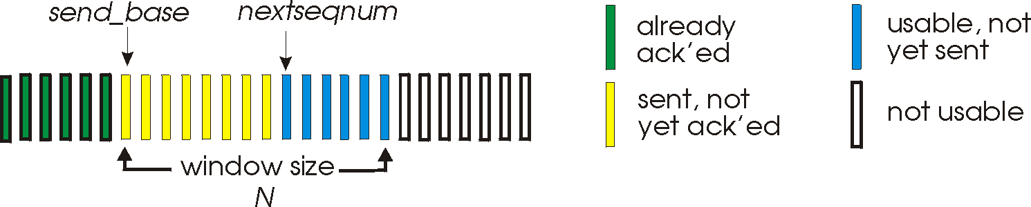

Figure 1 GBN window mechanism

(4) Consider a subnet with prefix 222.201.130.64/26. Give an example of one IP address(of form xxx.xxx.xxx.xxx) that can be assigned to an interface in this network. Suppose an ISP owns the block of addresses of the form 222.201.130.64/26. And suppose it wants to create four subnets from this block, with each block having the same number of IP addresses. What are the prefixes(of form a.b.c.d/x) for the four subnets?

(5) As figure 2, suppose Host A sends a datagram to Host B via router R. Please draw up the source and destination MAC addresses, and source and destination IP addresses in the frame as required below:
      - From A to the R
      - From R to B.
R
1A-23-F9-CD-06-9B
222.222.222.220
111.111.111.110
E6-E9-00-17-BB-4B
CC-49-DE-D0-AB-7D
111.111.111.112
111.111.111.111
A
74-29-9C-E8-FF-55
222.222.222.221
B
222.222.222.222
49-BD-D2-C7-56-2A
88-B2-2F-54-1A-0F

Figure 2

- Comprehensive Questions (20 scores, every one is 10 scores)
(1) Consider the following network. With the indicated link costs, use Dijkstra’s shortest path algorithm to compute the shortest path from x to all network nodes.
While selecting the next node, if several nodes have the same min cost, select the one with lowest id, (e.g., if t and v have the same min cost, then select t).
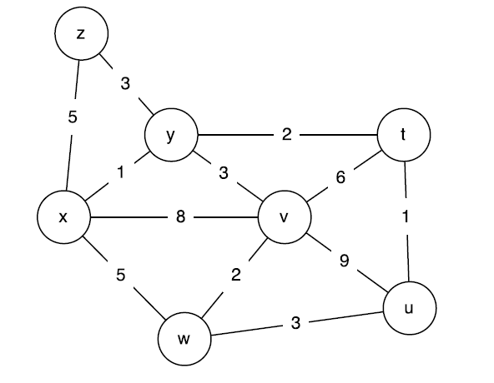

Figure 4

Figure 3

Please show how the algorithm works by filling out the following table.

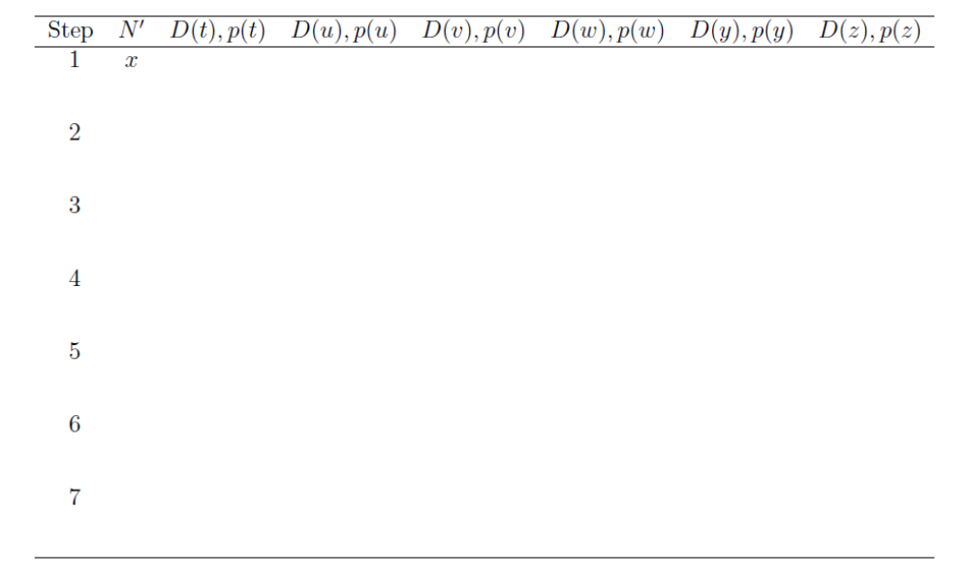

(2) Assume the following graph shows the behavior of a TCP congestion control, answer each question with a short discussion justifying your answer.
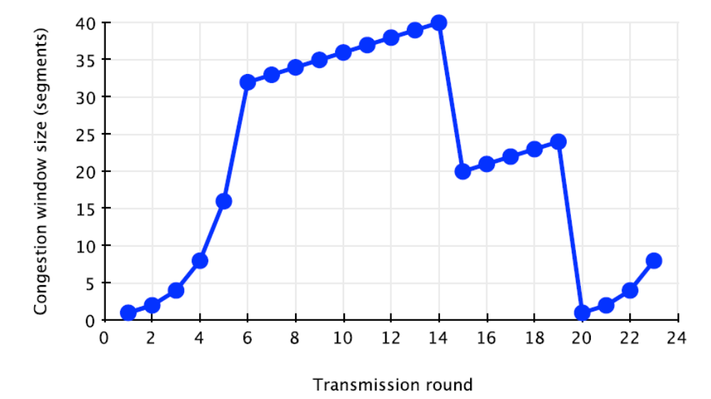
a) Identify the intervals of time when TCP slow start is operating.

b) Identify the intervals of time when TCP congestion avoidance is operating.

c)After 14th transmission round,is segment loss detected by a triple duplicate ACK or by a timeout? And which version of TCP protocol(Reno or Tahoe) is used base on this information?

d) During what transmission round is the 50th segment sent?

e) Assuming a packet loss is detected after the 23rd round by the receipt of a triple duplicate ACKs, what will be the values of the congestion window size and Threshold?

