诚信应考,考试作弊将带来严重后果！
_____________ ________
…

姓名 学号
学院 专业 座位号
( 密 封 线 内 不 答 题 )
……………………………………………………密………………………………………………封………………………………………线……………………………………线………………………………………

华南理工大学期末考试
《 Data Structure 》试卷 B
注意事项：1. 考前请将密封线内填写清楚；
2. 所有答案请答在答题纸上；
3．考试形式：闭卷；
4. 本试卷共十大题，满分100分，考试时间120分钟。
题 号 | 一 | 二 | 三 | 四 | 五 | 六 | 七 | 八 | 九 | 十 | 总分
得 分
评卷人
1. Select the correct choice. (20 scores, each 2 scores)
(1) Pick the growth rate that corresponds to the most efficient algorithm as n gets large: ( )
(A) n⁴log(n³) (B) n⁵ (C) n! (D) 3^{n}
(2) Which statement is not correct among the following four: ( )
- The number of empty sub-trees in a non-empty binary tree is one less than the number of nodes in the tree.
- The Mergesort is a stable sorting algorithm.
- A general tree can be transferred to a binary tree with the root having only left child.
- A sector is the smallest unit of allocation for a record, so all records occupy a multiple of the sector size.
(3) If a data element requires 16 bytes and a pointer requires 4 bytes, then a linked list representation will be more space efficient than a standard array representation when the fraction of non-null elements is less than about: ( )
(A) 4/5 (B) 1/4 (C) 4/7 (D) 3/4
(4) An algorithm must be or do all of the following EXCEPT: ( )
(A) Correct (B) No ambiguous (C) General steps (D) terminate
(5)The linear list (a1, a2, ... an), which is in Sequential Storage, when we delete any node, the average number of moving nodes ( ).
(A) n (B) n/2 (C) (n-1)/2 (D) (n+1)/2
(6) Which of the following is a true statement: ( )
(A) A general tree can be transferred to a binary tree with the root having both left child and right child.
(B) In a BST, the node can be enumerated sorted by a preorder traversal to the BST.
(C) In a BST, the left child of any node is less than the right child, but in a heap, the left child of any node could be less than or greater than the right child.
(D) A heap must be full binary tree.
(7) The golden rule of a disk-based program design is to: ( )
(A) Improve the basic operations. (B) Minimize the number of disk accesses.
(C) Eliminate the recursive calls. (D) Reduce main memory use.
(8) Given an array as A[m][n]. Supposed that A[0][0]is located at 644₍₁₀₎ and A[2][2]is stored at 676₍₁₀₎, and every element occupies one space. “₍₁₀₎” means that the number is presented in decimals. Then the element A[3][2]₍₁₀₎ is at position:
( )
(A) 691 (B) 695 (C) 653 (D) 708

(9)Which is wrong in the following statements ( ).
(A) Each vertex is only visited once during the graph traversal.
(B) There are two methods, Depth-First Search and Breadth-First Search, to traverse a graph.
(C) Depth-First Search of a graph isn't fit to a directed graph.
(D) Depth-first search of a graph is a recursive process.

(10) Assume that we have eight records, with key values A to H, and that they are initially placed in alphabetical order. Now, consider the result of applying the following access pattern: F D F G E G F A D F G E if the list is organized by the Move-to-front heuristic, then the final list will be ( ).
- F G D E A B C H (B)E G F D A B C H
(C) A B F D G E C H (D)E G F A C B D H

2. Fill the blank with correct C++ codes: (16 scores)
(1) Given an array storing integers ordered by distinct value without duplicate, modify the binary search routines to return the position of the integer with the smallest value greater than K when K itself does not appear in the array. Return ERROR if the greatest value in the array is less than K: (12 scores)
// Return position of smallest element >= K
int newbinary(int array[], int n, int K) {
int l = -1;
int r = n; // l and r beyond array bounds
while (l+1 != r) { // Stop when l and r meet
________; // Look at middle of subarray
if (K < array[i]) ; // In left half
if (K == array[i]) ________; // Found it
if (K > array[i]) ________; // In right half
}
// K is not in array or the greatest value is less than K
if ________ // the greatest value in the array is not less than K with r updated
then _________ ; // when K itself does not appear in the array
else return ERROR; // the integer with the greatest value less than K
}

(2)In order to insert a new node s after the node which pointer q points to in a circular doubly linked list, we need to execute the following statements:
s->prior=q;
s->next=q->next;
_____________;
(3)
The height of a complete binary tree with k nodes is _____(1 node tree has hight 1) (2 scores)

3. Prof that exchange sorts (Bubble sort, Selection sort, Insertion sort, etc. ) are 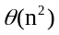 in average amd worst case. (6 scores)

4. Determine Θ for the following code fragments in the average case. Assume that all variables are of type int. (6 scores)
(1) sum=0;
for (i=0; i<5; i++)
for (j=0; j<n; j++)
sum++;

(2) sum = 0;
for(i=1;i<=n;i++)
for(j=n;j>=i;j--)
sum++;

(3) sum=0;
if (EVEN(n))
for (i=0; i<n; i++)
sum++;
else
sum=sum+n;

5. Please draw pictures to show the heaps that results from (6 scores)
1) adding 40 to the following heap；
2) deleting 30 from the following heap；
3) deleting 28 from the following heap.

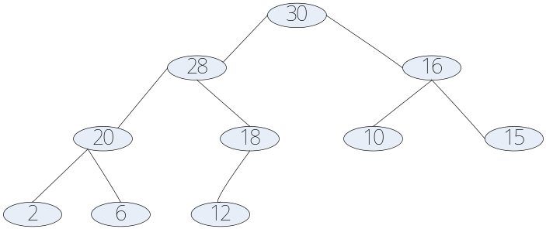

6. Please give the Huffman codes for the letters of the following table, draw pictures to show how to obtain the Huffman tree step by step, and compute the expected bit-length per letter. Please give an example to show the advantage of Huffman code scheme. (9 scores)

Letter | a | b | c | d | e | f | g | h
Frequency | 5 | 25 | 3 | 6 | 10 | 11 | 36 | 4

7. We assume that the size of a disk file, which is to be sorted, is f records, the size of working memory is M records, the initial runs are created by algorithm replacement selection, and the size of block of each run file is s records. To make good use of the working memory, x-way merger should be used？How many x-way mergers are needed to process this disk file on average? Assuming that f=200000，M=100，s=10，and the disk sector size is 2 records, how many times of reading disk in the merger stage at least？(9 scores)

8. Given a hash table of size 11, assume that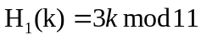and 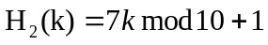are two hash functions, where 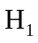 is used to get home position and 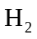 is used to resolve collision for method double hashing. Please insert keys 22, 41, 53, 46, 30, 13, 1, 67 into the hash table in order. (9 scores)

9. Please insert 26，85，7 into the following 2-3 tree. Inserting a key, draw a picture for the resulted 2-3 tree. Thus you should draw 3 pictures. (9 scores)

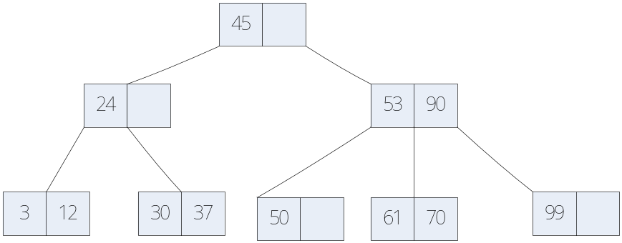

10. List the order in which the edges of the following graph are visited when running Prim's minimum-cost spanning tree algorithm starting at Vertex 1. Show the final MST. (10 scores).

