诚信应考,考试作弊将带来严重后果！
_____________ ________
…

姓名 学号
学院 专业 座位号
( 密 封 线 内 不 答 题 )
……………………………………………………密………………………………………………封………………………………………线……………………………………线………………………………………

华南理工大学期末考试
《Data Structure》试卷 A
注意事项：1. 考前请将密封线内填写清楚；
2. 所有答案请答在答题纸上；
3．考试形式：闭卷；
4. 本试卷共十大题，满分100分，考试时间120分钟。
题 号 | 一 | 二 | 三 | 四 | 五 | 六 | 七 | 八 | 九 | 十 | 总分
得 分
评卷人

1. 1. Select the correct choice. (20 scores, each 2 scores)
(1) An algorithm must be or do all of the following EXCEPT: ( )
(A) Correct (B) Finite (C) Ambiguous (D) Concrete steps
(2) Pick the growth rate that corresponds to the most inefficient algorithm as n gets large: ( )
(A) 2n³ (B) 2^{n} (C) n! (D) 20n²logn
(3) If a data element requires 8 bytes and a pointer requires 4 bytes, then a linked list representation will be more space efficient than a standard array representation when the fraction of non-null elements is less than about: ( )
(A) 1/4 (B) 2/3 (C) 4/5 (D) 3/4
(4) Which statement is not correct among the following four: ( )
- The Quick-sort is an unstable sorting algorithm.
- The number of empty sub-trees in a non-empty binary tree is one more than the number of nodes in the tree.
- The worst case for my algorithm is n becoming larger and larger because that is the slowest.
- A cluster is the smallest unit of allocation for a file, so all files occupy a multiple of the cluster size.
(5) Which of the following is a true statement: ( )
(A) A general tree can be transferred to a binary tree with the root having both left child and right child.
(B) In a BST, the node can be enumerated sorted by a preorder traversal to the BST.
(C) In a BST, the left child of any node is less than the right child, but in a heap, the left child of any node could be less than or greater than the right child.
(D) A heap must be full binary tree.
(6) The golden rule of a disk-based program design is to: ( )
(A) Improve the basic operations. (B) Minimize the number of disk accesses.
(C) Eliminate the recursive calls. (D) Reduce main memory use.
(7) Given an array as A[m][n]. Supposed that A[0][0]is located at 644₍₁₀₎ and A[2][2]is stored at 676₍₁₀₎, and every element occupies one space. “₍₁₀₎” means that the number is presented in decimals. Then the element A[3][3]₍₁₀₎ is at position:
( )
(A) 692 (B) 695 (C) 660 (D) 708
(8) If there is 0.5MB working memory, 4KB blocks, yield 128 blocks for working memory. By the multi-way merge in external sorting, the average run size and the sorted size in one pass of multi-way merge on average are separately ( )?
(A) 0.5MB, 128 MB (B) 2MB, 512MB
(C) 1MB, 128MB (D) 1MB, 256MB
(9) Which algorithm is used to generate runs in classic external sorting? ( )
(A) Quick-sort (B) Bubble sort
(C ) Insertion sort (D) Replacement selection

(10) Assume that we have eight records, with key values A to H, and that they are initially placed in alphabetical order. Now, consider the result of applying the following access pattern: F D F G G F A D F G, if the list is organized by the move-to-front heuristic, then the final list will be ( ).
- G F D A C H B E (B) G F D A B C E H
(C) F D G A E C B H (D) F D G E A B C H
2. A certain binary tree has the preorder enumeration as ABCEDFGHIJ and the inorder enumeration as CEBFDAHGJI. Try to draw the binary tree and give the postorder enumeration. (The process of your solution is required!!!) (7 scores)

3. Fill the blank with correct C++ codes to implement Mergesort algorithm: (12 scores)
template <class Elem, class Comp>
void mergesort(Elem A[], Elem temp[],
int left, int right) {
int mid = ____①_____;
if (____②___) return;
mergesort<Elem,Comp>(A, temp, left, mid);
mergesort<Elem,Comp>(A, temp, mid+1, right);
for (int i=left; i<=right; i++) // Copy
temp[i] = A[i];
int i1 = left; int i2 = mid + 1;
for (int curr=left; curr<=right; curr++) {
if (i1 == mid+1) // Left exhausted
A[curr] = ____③_____;
else if (i2 > right) // Right exhausted
A[curr] = ___ ④_____;
else if (Comp::lt(temp[i1], temp[i2]))
A[curr] = ____⑤___;
else A[curr] = ____⑥___;
}}

4. Show the max-heap that results from running buildHeap with values stored in an array:
10 4 7 13 9 16 8 20 11 25 . (8 scores)
- Inserting the values into the heap one by one.
- Values are available at the same time.

5. Build the Huffman coding tree and determine the codes for the following set of letters and weights:
A | B | C | D | E | F | G | H
15 | 5 | 13 | 26 | 10 | 11 | 16 | 4
Draw the Huffman coding tree and give the Huffman code for each letters. What is the expected length in bits of a message containing n characters for this frequency distribution? (The process of your solution is required!!!) (10 scores)

6. Given a hash table of size 11, assume that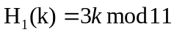and 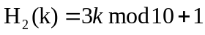are two hash functions, where 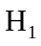 is used to get home position and 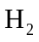 is used to resolve collision for method double hashing. Please insert keys 20, 31, 43, 26, 30, 13, 12, 67, 1 into the hash table in order. (10 scores)

7. Please insert 8，55，17 into the following 2-3 tree. Inserting a key, draw a picture for the resulted 2-3 tree. Thus you should draw 3 pictures. (10 scores)

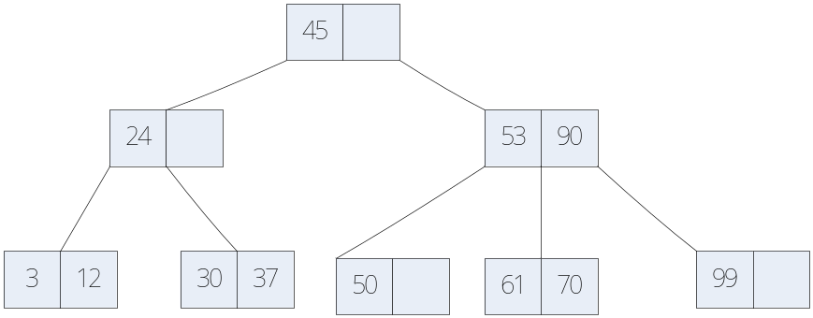

8. List the order in which the edges of the following graph are visited when running Prim's minimum-cost spanning tree algorithm starting at vertex a. Show the final MST. (5 scores).
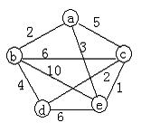
9. Assume a disk drive is configured as follows. The total storage is approximately 1.5G divided among 15 surfaces. Each surface has 512 tracks; there are 256 sectors/track, 1024 byte/sector, and 32 sectors/cluster. The disk turns at 5400rmp (11.1 ms/r). The track-to-track seek time is 20 ms, and the average seek time is 50 ms. Now how long does it take to read all of the data in a 640 KB file on the disk? Assume that the file’s clusters are spread randomly across the disk. A seek must be performed each time the I/O reader moves to a new track. Show your calculations. (The process of your solution is required!!!) (10 scores)

10. Write a program to visit all of the nodes of a Binary Tree in breadth-first search (BFS) order. E.g. the follow Tree, the traversal result is ABCDEFG. (8 scores)

