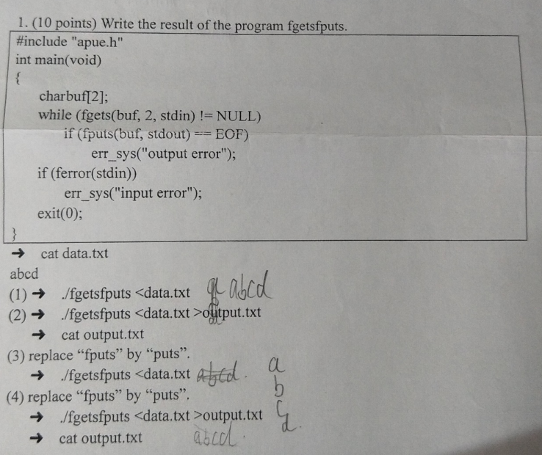
源程序：puts，fputs，gets，fgets：P123
#include "apue.h"
int main(void)
{
/*
* puts与fputs：puts每次输出的时候带有换行符
* gets与fgets：gets不安全，没有指定输入长度，会发生内存溢出问题；fgets每次 *只读取n-1个字符，本道题n=2，每次只读取一个字符
*/
char buf[2];
while(fgets(buf,2,stdin)!=NULL){
if(fputs(buf,stdout)==EOF)
printf("%s","error");
}

if(ferror(stdin))
printf("%s","error");
exit(0);
}
- abcd
- abcd
- a
b
c
d
- a
b
c
d
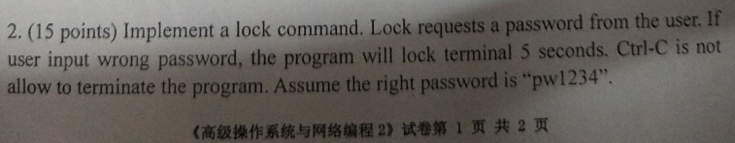
参考：P277
#include "apue.h"
//捕捉信号事件
static void sig_int(int signo){
if(signo==SIGINT){
;
}
}
int main(void)
{
char c[1024];
while(scanf("%s",c)==1){
if(strcmp(c,"pw1234")==0){
printf("pass!\n");
}
else{
printf("Wrong password.\n");
sigset_t newmask,oldmask;
sigemptyset(&newmask);
sigaddset(&newmask,SIGINT);//加入quit信号
if(signal(SIGINT,sig_int)==SIG_ERR){
printf("SIG ERROR\n");
}
if(sigprocmask(SIG_BLOCK,&newmask,&oldmask)){//屏蔽quit信号
printf("SIG_BLOCK ERROR\n");
exit(0);
}
sleep(5);//锁住5秒
}

}

}
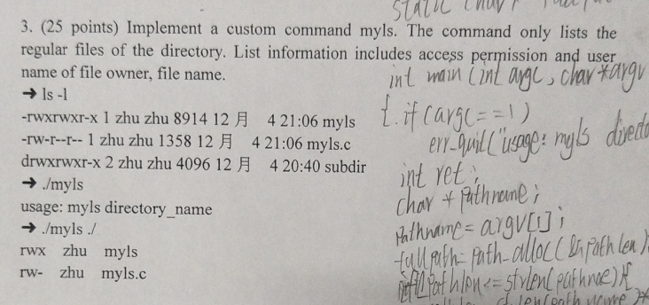
参考：
#include "apue.h"
#include <dirent.h>
#include <pwd.h>
int main(int argc ,char ** argv)
{
if(argc==1){
printf("%s","usage:myls directory_name");
exit(0);
}
DIR *dir;
dir=opendir(argv[1]);//p104
struct dirent * dirlist;
struct stat buf;
char permission[4]="---\0";
while(dirlist=readdir(dir)){
stat(dirlist->d_name,&buf);//p74
mode_t mode=buf.st_mode;
if(S_ISREG(mode)){
uid_t uid;
uid=buf.st_uid;
struct passwd * pwd;
pwd=getpwuid(uid);//p144
char * name= pwd->pw_name;
if(mode & S_IRUSR)
permission[0]='R';
if(mode & S_IWUSR)
permission[1]='W';
if(mode & S_IXUSR)
permission[2]='X';
printf("%s%s%s%s%s\n",permission," ",name," ",
dirlist->d_name);
}

}

}
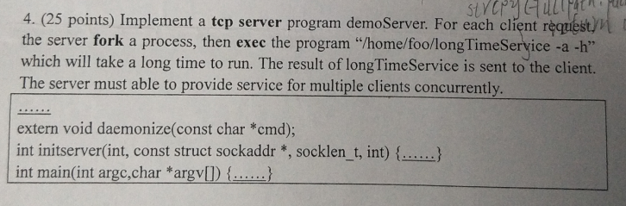
参考：p497
#include <stdio.h>
#include <arpa/inet.h>
#include <syslog.h>
#include <signal.h>
#include <errno.h>
#include <fcntl.h>
#include <netdb.h>
#include <string.h>
#include <stdlib.h>
#include <unistd.h>
#include <sys/wait.h>
#include <sys/socket.h>

#define QLEN 10

#ifndef HOST_NAME_MAX
#define HOST_NAME_MAX 128
#endif
extern void daemonize(const char * cmd);
int initserver(int ,struct sockaddr * ,socklen_t ,int );
void server(int sockfd);
void set_cloexec(int);

int main(int argc,char *argv[])
{
struct addrinfo hint, *ailist, *aip;
int err, sockfd, n;
char *host;
struct sockaddr_in *sinp;
const char *addr;
char abuf[INET_ADDRSTRLEN];

if(argc != 1)
{
fprintf(stderr,"usage:longTimeServer\n");
exit(1);
}

if((n=sysconf(_SC_HOST_NAME_MAX)) < 0)
n = HOST_NAME_MAX;

if((host=malloc(n)) == NULL)
{
perror("malloc");
exit(1);
}

if(gethostname(host,n) < 0)
{
perror("gethostname");
exit(1);
}

//hint内存空间分配
memset(&hint,0,sizeof(hint));

hint.ai_flags = AI_PASSIVE;
hint.ai_socktype = SOCK_STREAM;
hint.ai_canonname = NULL;
hint.ai_addr = NULL;
hint.ai_next = NULL;

if((err=getaddrinfo(host,"ruptime",&hint,&ailist)) != 0)
{
fprintf(stderr,"getaddrinfo : %s\n",gai_strerror(err));
exit(1);
}

for(aip=ailist; aip!=NULL; aip=aip->ai_next)
{
if((sockfd=initserver(SOCK_STREAM,aip->ai_addr,aip->ai_addrlen,QLEN)) >= 0)
{
server(sockfd);
exit(0);
}
}
exit(1);
}
/*
* 初始化服务:
* (1)创建套接字socket()
* (2)socket绑定地址bind()
* (3)监听listen()
* 返回：socket文件描述符
*/
int initserver(int type, struct sockaddr *addr,socklen_t alen,int qlen)
{
int fd;
int err;
if((fd=socket(addr->sa_family,type,0)) < 0)
return -1;
if(bind(fd,addr,alen) < 0)
{
perror("bind");
close(fd);
return -1;
}

if(type==SOCK_STREAM || type==SOCK_SEQPACKET)
{
if(listen(fd,qlen) < 0)
{
close(fd);
return -1;
}
}

return fd;
}

void server(int sockfd)
{
int clfd,status;
pid_t pid;
set_cloexec(sockfd);
while(1){
if((clfd=accept(sockfd,NULL,NULL))){
printf("%s","accept error");
exit(1);
}
if((pid==fork())<0){
printf("%s","fork error");
exit(1);
}else if(pid==0){
//fork()两次，防止僵尸进场
if((pid==fork())<0){
printf("%s","fork error");
exit(1);
}else if(pid>0){
//防止第一代孩子进程不退出
exit(1);
}
//执行longTimeServer
int result=execl("/home/foo/longTimeServer","longTimeServer","-a","-h",(char *)0);
//发送运行结果到客户端
send(clfd,&result,sizeof(result),0);
close(clfd);
exit(1);
}else{//父亲进程
close(clfd);
waitpid(pid,&status,0);
}

}
}
//关闭文件描述符
void set_cloexec(int sockfd)
{
int val;
val = fcntl(sockfd,F_GETFD);
val |= FD_CLOEXEC;
fcntl(sockfd,F_SETFD,val);
}
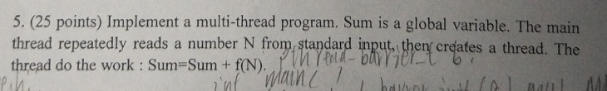
参考:p321互斥变量
#include <apue.h>
#include <stdio.h>
#include <pthread.h>
int total=0;
pthread_mutex_t mutex;
void *tfn(void * arg){
int num=*((int *)arg);
while(1){
//尝试锁住
if(pthread_mutex_trylock(&mutex)==0){
total+=num;
printf("%s","total:");
printf("%d\n",total);
//解锁
pthread_mutex_unlock(&mutex);
//退出循环
break;
}
}

}
int main(int argc, char *argv[])
{
pthread_t tid;
void * tret;
int num;
//初始化
pthread_mutex_init(&mutex,NULL);
while(scanf("%d",&num)==1){
pthread_create(&tid,NULL,tfn,(void *)&num);
}
//摧毁互斥变量
pthread_mutex_destroy(&mutex);
}

