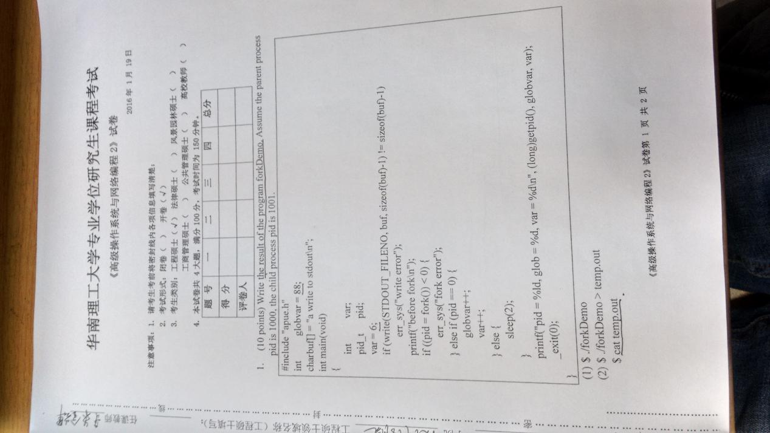
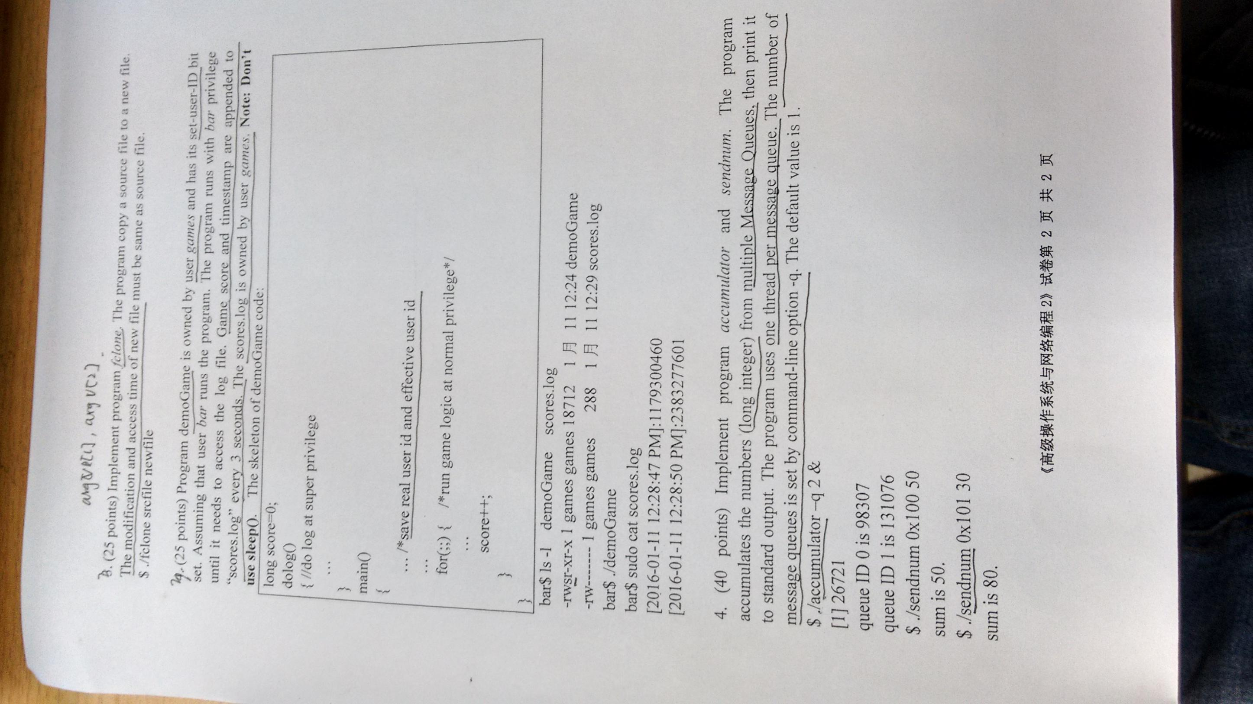

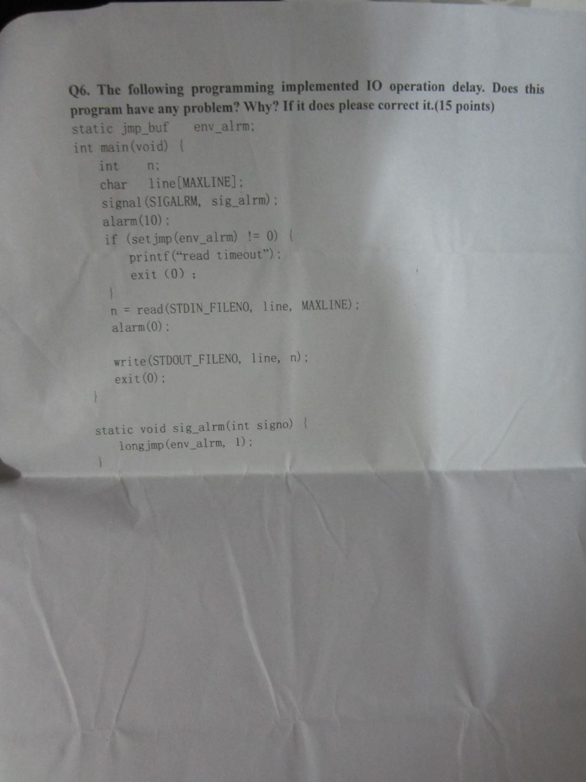
Q1
(1).
a write to stdout
before fork
pid = 1001, glob = 89, var = 7
pid = 1000, glob = 88, var = 6

(2).
a write to stdout
Q2
#include <stdio.h>
#include <fcntl.h>
#include <unistd.h>
#include <sys/stat.h>

#define BUFSIZE 4096

int main(int argc, char ** argv) {
char buf[BUFSIZE];
int n, in, out;
struct stat stat_in;
struct timespec times[2];

if (argc != 3) {
fprintf(stderr, "usage: %s srcfile newfile\n", argv[0]);
return 1;
}

if ((in = open(argv[1], O_RDONLY)) < 0) {
fprintf(stderr, "error: fail to open %s\n", argv[1]);
return 1;
}
if ((out = open(argv[2], O_CREAT | O_WRONLY | O_TRUNC,
S_IRUSR | S_IWUSR | S_IRGRP | S_IROTH)) < 0) {
fprintf(stderr, "error: fail to open %s\n", argv[2]);
return 1;
}

while ((n = read(in, buf, BUFSIZE)) > 0)
if (write(out, buf, n) != n) {
fprintf(stderr, "error: write error\n");
return 1;
}

if (fstat(in, &stat_in) < 0) {
fprintf(stderr, "error: fail to access %s\n", argv[1]);
return 1;
}

times[0] = stat_in.st_atim;
times[1] = stat_in.st_mtim;
if (futimens(out, times) < 0) {
fprintf(stderr, "error: fail to change time of %s\n", argv[2]);
return 1;
}

close(in);
close(out);

return 0;
}
Q3
#include <stdio.h>
#include <time.h>
#include <unistd.h>
#include <fcntl.h>
#include <signal.h>
#include <stdlib.h>
#include <string.h>

long score = 0;
uid_t euid, ruid;

void do_log(int signo);
void game();

int main(void) {
euid = geteuid();
ruid = getuid();

if (signal(SIGALRM, do_log) == SIG_ERR) {
fprintf(stderr, "error: fail to set signal handler\n");
return 1;
}

alarm(3);

if (seteuid(ruid) < 0) {
fprintf(stderr, "error: fail to change ruid\n");
return 1;
}

while (1) {
game();
score++;
}

return 0;
}

void do_log(int signo) {
char buf[32], str[64];
time_t t;
struct tm * tmp;
int fd;

time(&t);
tmp = localtime(&t);
strftime(buf, 32, "%F %r", tmp);
sprintf(str, "[%s]:%ld\n", buf, score);

if (seteuid(euid) < 0) {
fprintf(stderr, "error: fail to change euid\n");
exit(1);
}

if ((fd = open("scores.log", O_WRONLY | O_CREAT | O_APPEND,
S_IRUSR | S_IWUSR)) < 0) {
fprintf(stderr, "error: fail to open scores.log\n");
exit(1);
}

write(fd, str, strlen(str));

close(fd);

if (seteuid(ruid) < 0) {
fprintf(stderr, "error: fail to change euid\n");
exit(1);
}

alarm(3);
}

void game() {

}

Q4
Accumulator
#include <stdio.h>
#include <pthread.h>
#include <unistd.h>
#include <stdlib.h>
#include <sys/types.h>
#include <sys/ipc.h>
#include <sys/msg.h>

long total = 0;

void * thr_fn(void * arg);

int main(int argc, char ** argv) {
int nthread = 1;
long i;
pthread_t pid;

if (argc != 1 && argc != 3) {
fprintf(stderr, "usage: %s [-q nthread]\n", argv[0]);
return 1;
}

if (argc == 3) {
if (argv[1][0] != '-' || argv[1][1] != 'q') {
fprintf(stderr, "usage: %s [-q nthread]\n", argv[0]);
return 1;
} else
nthread = atoi(argv[2]);
}

for (i = 0; i < nthread; i++)
pthread_create(&pid, NULL, thr_fn, (void *)i);

pause();

return 0;
}

void * thr_fn(void * arg) {
long pno = (long)arg, id, buf[2];
key_t key_base = 0x100;
int n;

if ((id = msgget(key_base + pno, IPC_CREAT | 0600)) < 0) {
fprintf(stderr, "error: fail to create MQ\n");
exit(1);
}

printf("queue ID %ld is %ld\n", pno, id);

while ((n = msgrcv(id, buf, sizeof(long), 1, 0)) == sizeof(long)) {
total += buf[1];
printf("sum is %ld\n", total);
}

return NULL;
}
Sendnum
#include <stdio.h>
#include <sys/types.h>
#include <sys/ipc.h>
#include <sys/msg.h>

struct msg {
long mtype;
long value;
};

int main(int argc, char ** argv) {
key_t key;
long value;
int id;
struct msg m;

if (argc != 3) {
fprintf(stderr, "usage: %s key value\n", argv[0]);
return 1;
}

sscanf(argv[1], "%x", &key);
sscanf(argv[2], "%ld", &value);

if ((id = msgget(key, 0)) < 0) {
fprintf(stderr, "error: fail to get MQ\n");
return 1;
}

m.mtype = 1;
m.value = value;
if (msgsnd(id, &m, sizeof(long), 0) < 0) {
fprintf(stderr, "error: fail to send message\n");
return 1;
}

return 0;
}
Q6
static jmp_buf env_alrm;
改为
static sigjmp_buf env_alrm;

if (setjmp(env_alrm) != 0) {
改为
if (sigsetjmp(env_alrm, 1) != 0) {

longjmp(env_alrm, 1);
改为
siglongjmp(env_alrm, 1);

