诚信应考,考试作弊将带来严重后果！
_____________ ________
…

姓名 学号
学院 专业 座位号
( 密 封 线 内 不 答 题 )
……………………………………………………密………………………………………………封………………………………………线……………………………………线………………………………………

华南理工大学期末考试
《软件测试与维护》试卷A
注意事项：1. 考前请将密封线内填写清楚；
2. 前2题答案请直接答在试卷上，第3题答案请答在答题纸上
3．考试形式：闭卷；
4. 本试卷共 三 大题，满分100分， 考试时间120分钟。
题 号 | 一 | 二 | 三 | 总分
得 分
评卷人

- Explain the following concepts in your own words.( 20 points/5 points each)
- W model

- Software Testing

- Static white-box testing

- Test-Driven Development

- Answer the following questions briefly in your own words(32 points)
  - Briefly describe JUnit framework through drawing its structure graph? （6 points）

  - Briefly describe the bug management process through drawing its process graph？（6 points）

  - What the software maintenance and the process of Software Configuration Management. （8 points）

  - How to understand the relationship between specification and bugs? （5 points）

  - Please descricbe the difference between Top-down Integration and Bottom-up Integration through drawing their model graph？ （7 points）

- Please analyse the following questions：（48 points）

- Please describe how to finish Unit Testing? Please draw the program process graph and control flow graph for the following program,and design testcases through using the techniques of the condition combination coverage?（23 points =6 points +17 points）

void Func(int a, int b,int c)

{

if (a>0 and b>1)

{

a=a-b;

if(c>0 and a<0) c=a+b;

else c=c+1;

}

else c=b+1;

}

- (25 points=15points+10points)

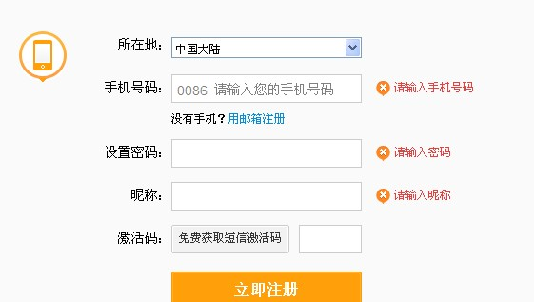
  - The mobile number area consists of three parts,includes:

a. area code, blank or 0086;
b. prefix code,three numeric characters and the first numeric character is ‘1’and the second numeric character is greater than or equal to 3;
c. postfix,eight numeric characters;
The software system accept a correct mobile number input and refuses a wrong mobile number input.Please design testcases to check the mobile number area through using techniques of Equivalence Partitioning and Boundary value. (15 points)

  - According the graph, please give us the Testing Strategy to finish the Testing?（10 points）

