1. CBBBADBABA
2.
(1) (!L1.remove(temp)) L1.next(); L1.insert(temp);
(2) int i = (l+r)/2; r = i; return i; l = i; return l
(3)最矮高度：n=0,1时，答案为n，n大于或等于2时，为2；
最高高度： n

3.
4
4
2
2
2
4
4
4
2
5
5
5
4
2
8
8
3
2
2
2
2

5
3
5
3
5
3
5
3
8
4
8
4
8
4
6
10
8
4
6
10
6
14

4.
A
A
A
A
B
F
B
F
B
F
FHIGJ
E
CD
HIGJ
E
C
G
E
C
G

D
J
HI
D
J
H
EBCD
I
5.
A | B | C | D | E | F | G | H
0110 | 10 | 0000 | 0111 | 001 | 010 | 11 | 0001
4 * 5 + 2 * 25 + 4 * 3 + 4 * 6 + 3 * 10 + 3 * 11 + 2 * 36 + 4 * 4 =257, 257/100=2.57
100
0
1
61
39
1
0
0
1
36
25
22
17
C2
0
0
1
1
7
10
11
11
C7
C5
C6
0
0
1
1
4
3
6
5
C3
C8
C1
C4
6.
72 6 57 88 60 42 83 73 48 85
48 6 57 42 60 88 83 73 72 85
6 42 57 48 60 72 73 85 88 83
6 42 48 57 60 72 73 85 83 88
6 42 48 57 60 72 73 83 85 88

7. The first question is How many tracks are required by the file?
A track holds 144*0.5K = 72K. Thus, the file requires 5 tracks.
The time to read a track is seek time to the
track + latency time + (interleaf factor × rotation time).
Average seek time is defined to be 80 ms. Latency time is 0.5 * 16.7 ms,
and track rotation time is 16.7 ms for a total time to read the first track of
80 + 4.5 * 16.7 ≈ 155 ms.
Seek time for the remaining four tracks is defined to be 20 ms (since they are
adjacent), with identical latency and read times.
Thus, the total file read time is
155 + 4(20 + 4.5 * 16.7) ≈ 536 ms

8.
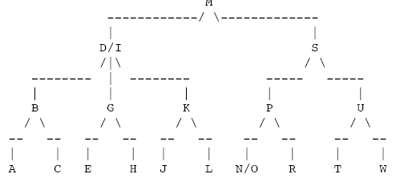

9. H1(22)=0, H1(41)=2 H1(53)=5 H1(46)=6 H1(30)=2 H1(13)=6 H1(1)=3 H1(67)=3 H2(30)=1 H2(13)=2 H2(1)=8 H2(67)=10

22进0, 41进2, 53进5, 46进6, 30进3, 13进8, 1进10, 67进1

