- CBBBADBABD

- (1) (！L1.remove (temp))
L1.next ()
L1.insert (temp)
(2) int i=（l+r）/2
r=i
return i
l=i
return l
(3)n (when n=0 or1) or 2 (when n≥2); n

3.
initial: 72 6 57 88 60 42 83 73 48 85 pivot 60
pass 1: 48 6 57 42 60 88 83 73 72 85 pivot 6 73
pass 2: 6 42 57 48 60 72 73 85 88 83 pivot 57 88
pass 3: 6 42 48 57 60 72 73 85 83 88 pivot 42 85
pass 4: 6 42 48 57 60 72 73 83 85 88
final sorted array:
6 42 48 57 60 72 73 83 85 88

4.
EBCD
FHIGJ
A
A
B
E
F
CD
HIGJ
A
B
E
F
C
D
G
J
HI
A
B
E
F
C
D
G
J
H
I

5.
Huffman tree:
100
61
39
36
25
22
17
7
10
11
11
4
3
6
5
C
H
E
F
A
D
B
G
0
0
0
0
0
0
0
1
1
1
1
1
1
1

Huffman code
A | B | C | D | E | F | G | H
0110 | 10 | 0000 | 0111 | 001 | 010 | 11 | 0001
Total length: 4 * 5 + 2 * 25 + 4 * 3 + 4 * 6 + 3 * 10 + 3 * 11 + 2 * 36 + 4 * 4 = 257
Expected length: 257/100=2.57
6.
The first question is how many clusters the file requires?
A cluster holds 16*0.5K = 8K. Thus, the file requires 320/8=40 clusters.
The time to read a cluster is seek time to the
cluster+ latency time + (interleaf factor × rotation time).
Average seek time is defined to be 80 ms. Latency time is 0.5 * 8.33 ms(60/7200≈8.33ms),
and cluster rotation time is 5 * (16/144)*8.33.
Seek time for the total file read time is
40* (80 + 0.5 * 8.33+ 5 * (16/144)*8.33 ) ≈ 3551.85 ms
which is pretty slow by today’s standards.

7.
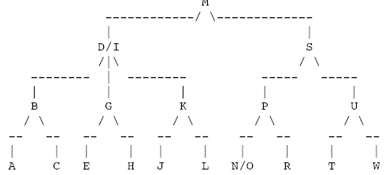

8.
H₁(22)=0, H₁(41)=2, H₁(53)=5, H₁(46)=6, no conflict
When H₁(30)=2, H₂(30)=1 so 30 enters the 3rd slot;
H₁(13)=6, H₂(13)=2 so 13 enters the 8th slot;
H₁(1)=3, H₂(1)=8 so 1 enters 10 (pass by 0, 8, 5, 2 );
H₁(67)=3, H₂(67)=10 so 67 enters 1(pass by 2)

