诚信应考,考试作弊将带来严重后果！
_____________ ________
…

姓名 学号
学院 专业 座位号
( 密 封 线 内 不 答 题 )
……………………………………………………密………………………………………………封………………………………………线……………………………………线………………………………………

华南理工大学期末考试
《Computer Networks》试卷 (B)
注意事项：1. 考前请将密封线内填写清楚；
2. 所有答案请答在答题纸上(注：选择题答案请填入题目前面的表格中)；
3．考试形式：闭卷；
4. 本试卷共 5 大题，满分100分， 考试时间120分钟。
题 号 | 1 | 2 | 3 | 4 | 5 | 总分
得 分
评卷人
- Select the correct choice. (30 scores, every one is 2 scores)
NO. | 1 | 2 | 3 | 4 | 5 | 6 | 7 | 8 | 9 | 10 | 11 | 12 | 13 | 14 | 15
solution
- Suppose Host A wants to send a file to Host B . The path from Host A to Host B has three links , their rates Error: Reference source not found , Error: Reference source not found , and Error: Reference source not found . Assuming no other traffic in the network , what is the throughput for the file transfer ? ( )
A. Error: Reference source not found B.Error: Reference source not found C. Error: Reference source not found D. Error: Reference source not found
- The transfer of a web document from one host to another is : ( )
- loss-intolerant and time insensitive
- loss-tolerant and time sensitive
- loss-intolerant and time sensitive
- none of the above
- Ethernet interface addresses ( )
A. are assigned at manufacturing time. B. are assigned manually or by DNS
C. are generated randomly and checked for uniqueness by broadcasting a message
D. share the same high order bits , which determine the network or subnet in an internetwork.
- Based on TCP/IP architecture ,which of the following protocol belongs to data-link layer ? ( )
A. HTTP B. IP C. UDP D.PPP
- Two important reasons that the Internet is organized as a hierarchy of networks for the purposes of routing are ( )
A. Least cost and maximum free circuit availability
B. Message complexity and speed of convergence
C. Scale and administrative autonomy
D. Link cost changes and link failure
- With an exterior routing protocol , which of the following issues generally dominate the routing decisions ? ( )
- Geographical distance between AS’s
- Policy
- Number of AS’s traversed
- Current congestion levels in the AS’s
- Which range of port number are reserved for services that are commonly used by applications that run on serves ? ( )
A. 0 to 255. B. 0 to 1023.
C. 1024 to 49151. D. 49152 to 65535.
- Which information is contained in the header of Network Layer to help data delivery? ( )
A. port number B. Device physical address
C. Destination host’s IP address D. Virtual connection identifier
- In internet communication ,IP datagram will go through the source host and routers to reach the destination host , usually ( )
A. both source host and routers all know the complete path to the destination host that will be reached by IP datagram.
B. source host knows the complete path to destination host that will be reached by IP datagram , but none the intermediate routers.
C. the intermediate routers know the complete path to destination host that will be reached by IP datagram , but none the source host.
D. neither source host nor the intermediate routers know the complete path to destination host that will be reached by IP datagram.
- Which combination of network id and subnet mask correctly identifies all IP address form 172.16.128.0 through 172.16.159.255 ? ( )
A. 172.16.128.0 255.255.255.224
B. 172.16.128.0 255.255.0.0
C. 172.16.128.0 255.255.224.0
D. 172.16.128.0 255.255.255.192
- What happens when a node on an Ethernet network is creating a frame and it does not have the destination MAC address ? ( )
A. The node drops the frame.
B. The node sends out a layer 3 broadcast messages.
C. The node sends a message directly to the router for the address.
D. The node sends out an ARP request with the destination IP address.
- Suppose an application generates chunks of 120 bytes of data every second, and each chunk gets encapsulated in a TCP segment and then an IP datagram(no options fields).What percentage of each datagram will contain application data? ( )
A. 80% B. 75% C. 60% D.25%
- Which statement is true about the CSMA/CD access method that is used in Ethernet ? ( )
A. when a device hears a carrier signal and transmits , a collision cannot occur. B. A jamming signal causes only devices that caused the collision to execute a back off algorithm.
C. All network devices must listen before transmitting.
D. Devices involved in a collision get priority to transmit after the back off period.
- In the Ethernet two-layer switches, how is the forwarding table established? ( )
A. Manual configuration B. Self-learning
C. Routing algorithm D. Destination address learning
- Consider sending a 999 byte datagram into a link that has an MTU of 500 bytes , ( )
- 2 fragments are created with offset field value 0,500, respectively
- 3 fragments are created with offset field value 0, 480, 960, respectively
- 3 fragments are created with offset field value 0, 60, 120, respectively
- None of these above

- Fill the blank. (10 scores, every blank is 1 score )
  - The most important kinds of delay at each node along the path is nodal processing delay , queuing delay , ________ , ________ .
  - The task of the data link layer is providing data transmission services between ________ ; The task of the network layer is providing data transmission services between ________ ; and the task of transport layer is providing data transmission services between ________.
  - In the TCP , connection establishment of transport layer use method of ________ .
  - The head of IP datagram has a ________ field , when the value of the field is 0 , the datagram transmitted will be discarded .
  - The routing protocol OSPF is recommended for a intra AS , which is based on ________ routing algorithm , and the routing protocol BGP is recommended for inter AS. The routing protocol RIP is based on ________ routing algorithm. RIP use ________ count as a cost metric ; that is , each link has a cost of 1 .

- Judge the following questions as true or false. (10 scores, every one is 1 scores)
NO. | 1 | 2 | 3 | 4 | 5 | 6 | 7 | 8 | 9 | 10
Solution(T or F)

- The Traceroute program in the source host will sent a series of ICMP message to determine the route between source host and destination host.
- At the heart of rdt 3.0’s performance problem is the fact that it is a stop-and-wait protocol.
- When a user request a Web page that consists of some text and two images. For this page, the client will send one request message and receive three response message.
- UDP is the preferred over TCP for transferring a real-time voice over IP networks.
- With a window size of 1, SR, GBN are functionally equivalent.
- When using distance vector route algorithm, the complete network topology information must be known by a router.
- Emails are delivered to receiver's server using POP3 protocol.
- Collisions will not occur under CSMA/CD MAC protocol.
- When a TCP segment arrives to a host, the socket to which the segment is directed depends on the destination port number and the destination IP address of the datagram encapsulated the segment.
- If an Autonomous system learns of 5 different routes to a destination prefix it will announce all 5 routes to its neighbors .

- Answer the following questions briefly. (24 scores)
  - What are the 5 layers in the Internet protocol stack? What are the principal responsibilities of each of these layers? (5 scores)

  - The message D=1010001101 is transmitted using the CRC method described in class using the generator polynomial G=110101 .Please answer the following questions.(5 scores)

  - Suppose Host A sends 4 TCP segments back to Host B over a TCP connection . The first segment has sequence number 56 ; the second has sequence number 216 ; the third has sequence 296 ; the fourth has sequence number 346 with 40 byte of data in it .(5 scores)
        - How much byte of data are in the third TCP segment?
        - Suppose that the first and the fourth segment arrive at B in turn , but the second and the third segments are lost . What will be the acknowledgment number respectively that Host B sends to Host A for each arriving segment ?
        - When Host B receives the second segment and the third segment re-sending by Host A in turn , what will be the acknowledgment number that Host B sends to Host A for each arriving segment.
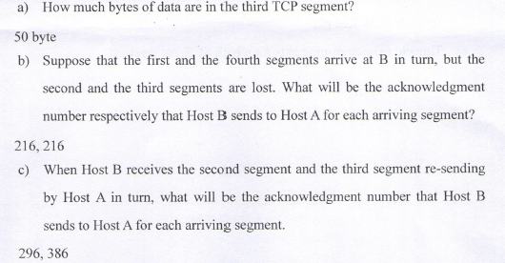

  - Consider a router that interconnects three subnets : Subnet 1 , Subnet 2 , and Subnet 3 .Suppose all of the interfaces in each of these three subnets are required to belong to 192.168.12.0/24 . Also suppose that Subnet 1 is required to support at least 20 interfaces , Subnet 2 is to support at least 60 interfaces , and Subnet 3 is to support at least 90 interfaces . Provide three network addresses (of form a.b.c.d/x) that satisfy these constraints. (9 scores)
192.168.12.000/27
192.168.12.01/26
192.168.12.1/25

- Comprehensive Questions (26 scores)
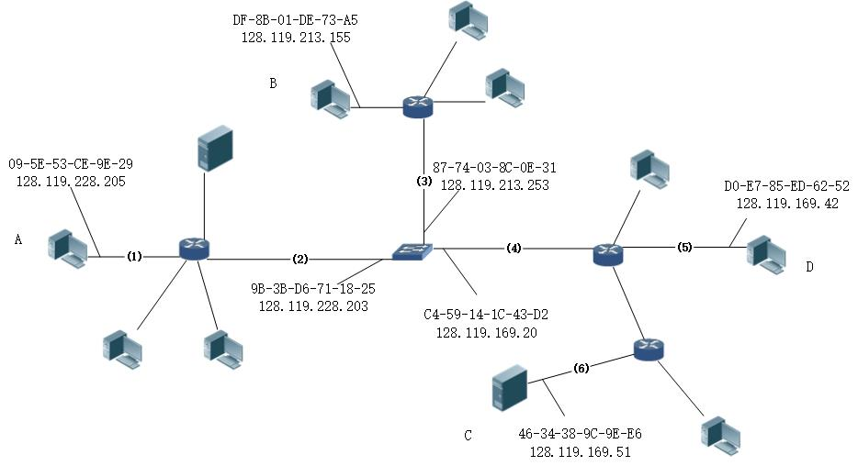
  - Consider an IP datagram being sent from A to B.
Give the service and destination Ethernet address as well as the source and destination address of the IP datagram encapsulated within the Ethernet at points (1),(2),(3) .
源IP和目的IP始终是AB的
- 源MAC：A的 目的MAC：unknown

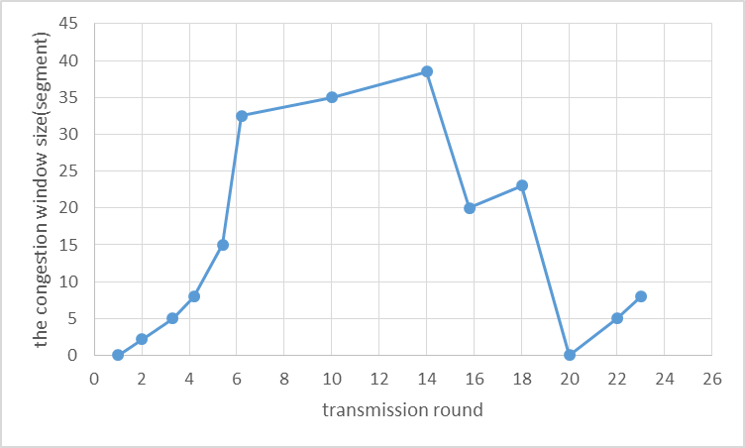
  - Assume the following graph shows the behavior of a TCP congestion control answer each question with a short discussion justifying your answer .
        - Identity the intervals of time when TCP show start is operating .
        - Identity the intervals of time when TCP congestion avoidance is operating .
        - After 14th transmission round is segment loss detected by triple duplicate ACK or by a timeout? And which version of TCP protocol ( Reno or Tahoe ) is used base on this information ?
        - During what transmission round is the 50th segment sent ?
        - Assuming a packet loss is detected after the 23rd round by receipt of a triple duplicate ACKs , what will be the value of the congestion window size and threshold ?
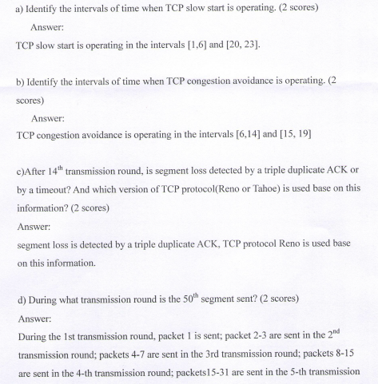
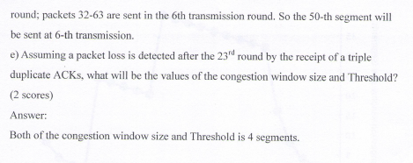

  - 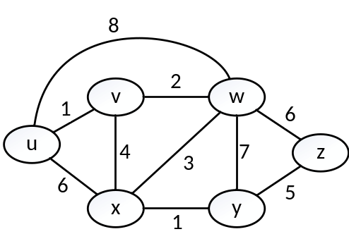Consider the following network with the indicated link cost , use Dijkstra’s shortest-path algorithm to compute the shortest path from node Error: Reference source not found to all network nodes . Show how the algorithm works by drawing a table .

[20自码]一、选择
1-5 CAADC
6-10 B？C[不确定]DC
11-15 DBB[不确定]BC
- 填空
- transmission delay , propagation delay
- neighboring nodes，hosts , processes
- Three way handshaking
- TTL
- LS DV hop//cost metric花费度量
- 判断
- T[?]
- T
- F[request-response是成对的]
- T
- T
- F
- T
- F
- T
- F[热土豆]

