Line Algorithms

- Line Intersection
- Distance Point to Line

Line Intersection
Given this representation, how do we find out if two line segments intersect, ie:
\ / vs \ /
\ / \/
\ / /\
\ /
One way is basically to use school maths (y=mx+c etc) to find the equations, and then intersection points of the lines, and then find out if these intersection points lie 'within' each line.. Another approach, given in Sedgewick, which is introduces ideas useful in other algorithms is as follows.
First define a function that, given three points, tells you whether you have to turn clockwise or counter clockwise when travelling from the first to the second to the third. Call this CCW: it will return TRUE if it is counter clockwise. Now, two lines l1 and l2 will intersect if (CCW(l1.p1, l1.p2, l2.p1) <> CCW(l1.p1, l1.p2, l2.p2)) AND (CCW(l2.p1, l2.p2, l1.p1) <> CCW(l2.p1, l2.p2, l1.p2)). Basically, this just means that both endpoints of each line are on different 'sides' of the other line.
The CCW function can be defined fairly straightforwardly, by calculating the gradient between point 1 and point2, point 2 and point 3, and checking if one gradient is larger than the other. (The implementation must cope with the fact that the slopes may be infinite, or that they are equal, but that's just a minor fiddle - see Sedgewick).
The following gives what might be an initial attempt at both ccw and intersect. I'll leave it as an exercise for the reader to work out how to make it deal with infinite slopes (ie, dx=0), and the case where two lines are collinear.
int ccw(point p1, point p2, point p3)

// Slightly deficient function to determine if the two lines p1, p2 and
// p2, p3 turn in counter clockwise direction}
{
int dx1, dx2, dy1, dy2;
dx1 = p2.x - p1.x; dy1 = p2.y - p1.y;
dx2 = p3.x - p2.x; dy2 = p3.y - p2.y;
if(dy1*dx2 < dy2*dx1) return 1;
else return 0;
}

int intersect(line l1, line l2)
{
return
((ccw(l1.p1, l1.p2, l2.p1) != ccw(l1.p1, l1.p2, l2.p2))
&& (ccw(l2.p1, l2.p2, l1.p1) != ccw(l2.p1, l2.p2, l1.p2)))
}

Geometry Distance
Geometry Line Geometry Lines

Point-Line Distance--2-Dimensional

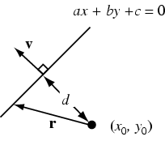
The equation of a line in slope-intercept form is given by
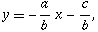 | (1)
so the line has slope . Now consider the distance from a point to the line. Points on the line have the vector coordinates
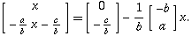 | (2)
Therefore, the vector
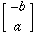 | (3)
is parallel to the line, and the vector
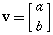 | (4)
is perpendicular to it. Now, a vector from the point to the line is given by
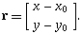 | (5)
Projecting onto ,
 |  | 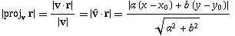 | (6)
 |  | 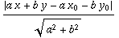 | (7)
 |  | 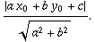 | (8)
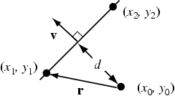
If the line is specified by two points and , then a vector perpendicular to the line is given by
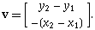 | (9)
Let be a vector from the point to the first point on the line
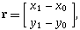 | (10)
then the distance from to the line is again given by projecting onto , giving
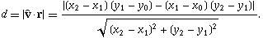 | (11)
As it must, this formula corresponds to the distance in the three-dimensional case
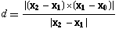 | (12)
with all vectors having zero -components, and can be written in the slightly more concise form
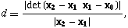 | (13)
where denotes a determinant.
The distance between a point with exact trilinear coordinates and a line is
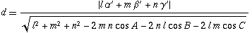 | (14)
(Kimberling 1998, p. 31).

Intersection Point of Two Lines
This note describes the technique and algorithm for determining the intersection point of two lines (or line segments) in 2 dimensions.
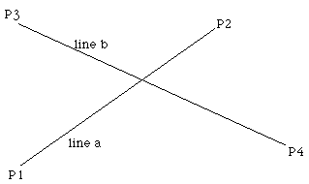
The equations of the lines are
P_{a} = P1 + u_{a} ( P2 - P1 )
P_{b} = P3 + u_{b} ( P4 - P3 )
Solving for the point where P_{a} = P_{b} gives the following two equations in two unknowns (u_{a} and u_{b})
x1 + u_{a} (x2 - x1) = x3 + u_{b} (x4 - x3)
and
y1 + u_{a} (y2 - y1) = y3 + u_{b} (y4 - y3)
Solving gives the following expressions for u_{a} and u_{b}
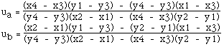
Substituting either of these into the corresponding equation for the line gives the intersection point. For example the intersection point (x,y) is
x = x1 + u_{a} (x2 - x1)
y = y1 + u_{a} (y2 - y1)
Notes:
- The denominators for the equations for u_{a} and u_{b} are the same.
- If the denominator for the equations for u_{a} and u_{b} is 0 then the two lines are parallel.
- If the denominator and numerator for the equations for u_{a} and u_{b} are 0 then the two lines are coincident.
- The equations apply to lines, if the intersection of line segments is required then it is only necessary to test if ua and ub lie between 0 and 1. Whichever one lies within that range then the corresponding line segment contains the intersection point. If both lie within the range of 0 to 1 then the intersection point is within both line segments.

