**Problem Set 1**

**Github repository link:** [**https://github.com/oneyanshi/csc589/**](https://github.com/oneyanshi/csc589/)

**Problem 1: Warm up.**

* 1. **Load the image into your environment:**

image1 = np.float64(misc.imread('images/peppers.png', flatten = 1, mode='F'))

image2 = np.float64(misc.imread('images/cheetah.png', flatten = 1, mode='F'))

* 1. **Blur the image using Gaussian filter:**

gau_image1 = ndimage.gaussian_filter(image1, 3)

gau_image2 = ndimage.gaussian_filter(image2, 3)

* 1. **Display the result:**   
     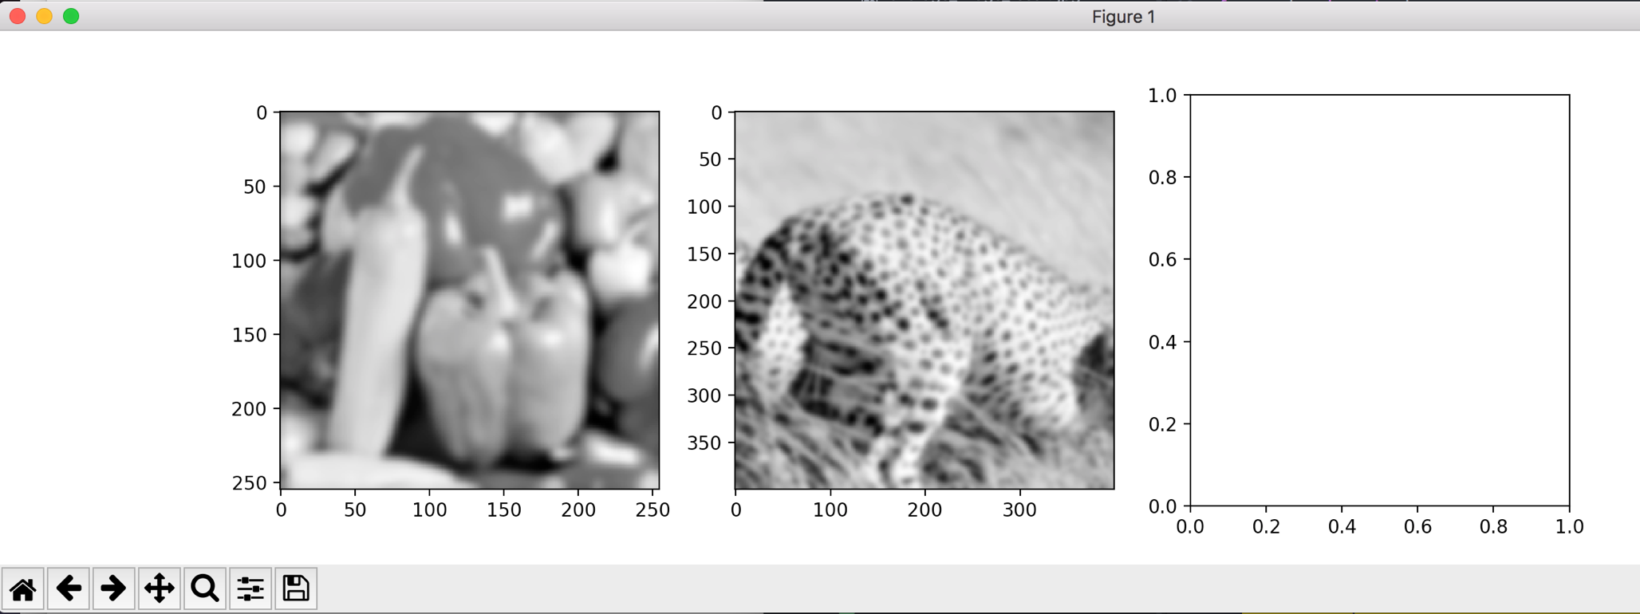
  2. **Compute the DFT (Discrete Fourier Transform) of the image.   
     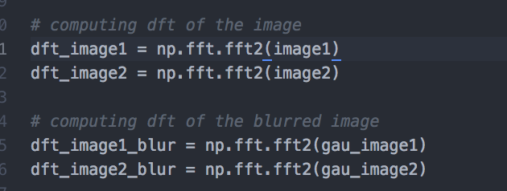**
  3. **Display the magnitude of the DFT.**

In order to properly display the magnitude of the DFT, I had to use np.fft.fftshift() before moving forward to display the magnitude.

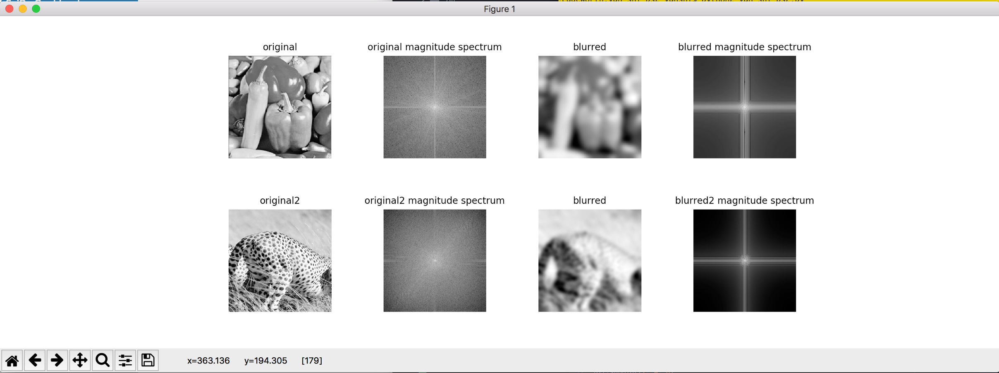

**Problem 2: Histogram equalization.**

**Problem 3: Separable filters.**

**Problem 4.** 