# Tweet Analysis Report

## Sentiment Analysis

The chart is generated with the prune data with only the negative sentiments.

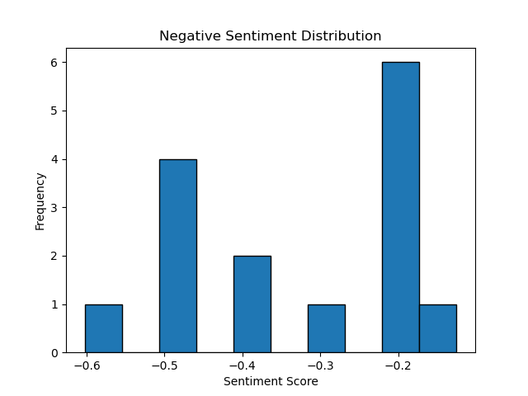

## Word Cloud

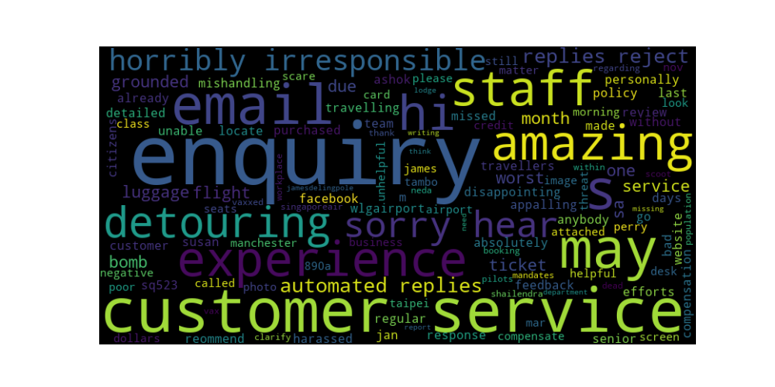

## HuggingFace Results of Reasons for 'What Went Wrong?'

* The feedback and customer service team had made no efforts
* luggage missed
* Singapore Airline is very disappointing
* harassed by Susan -
* Unable to locate on their website
* negative experience with Singapore airline
* Singapore Airline's customer service is horribly irresponsible
* Singapore Airline's customer service is horribly irresponsible
* bomb scare
* Poor customer
* the matter
* a booking with Scoot or with Singapore Airlines
* Singapore Airline 4 pilots dead
* Singapore Airline's customer service is horribly irresponsible
* It's been a month I have been both writing emails

## OpenAI Suggestions

* The few most common gap Singapore Airlines faces are:  
  1. Poor customer service (2) - "Absolutely appalling service by Singapore airline staff" and "Singapore Airline's customer service is horribly irresponsible".   
  2. Inadequate compensation for mishandling luggage (1) - "does Singapore airline have a compensation policy for mishandling luggage?".  
  3. Inability to respond to customer enquiries (2) - "the Singapore airline staff called James Perry unhelpful" and
* The few most common gaps Singapore Airlines faces are:  
  1. Poor customer service (4 times) - "The feedback and customer service team had made no efforts and... does Singapore airline have a compensation policy for mishandling luggage? Singapore Airline's customer service is horribly irresponsible. They are amazing at detouring my enquiry to automated replies and reject email enquiry..."  
  2. Luggage mishandling (3 times) - "Flight No.SQ523, luggage missed. ... does
* The few most common gaps Singapore Airlines faces are:  
  1. Poor customer service (3 times): "The feedback and customer service team had made no efforts and... Absolutely appalling service by Singapore airline staff. Singapore Airline's customer service is horribly irresponsible. Singapore Airline's customer service is horribly irresponsible."   
  2. Inadequate response to complaints (2 times): "Last 3 days no response. Hi Ashok, we are sorry to hear this. Hi Neda, sorry to