XRMS User Manual

DRAFT 1

May 18, 2004

Open Software License
v. 2.0

This Open Software License (the "License") applies to any original work of authorship (the "Original Work") whose owner (the "Licensor") has placed the following notice immediately following the copyright notice for the Original Work:
Licensed under the Open Software License version 2.0

1) Grant of Copyright License. Licensor hereby grants You a world-wide, royalty-free, non-exclusive, perpetual, sublicenseable license to do the following:
a) to reproduce the Original Work in copies;

b) to prepare derivative works ("Derivative Works") based upon the Original Work;

c) to distribute copies of the Original Work and Derivative Works to the public, with the proviso that copies of Original Work or Derivative Works that You distribute shall be licensed under the Open Software License;

d) to perform the Original Work publicly; and

e) to display the Original Work publicly.

2) Grant of Patent License. Licensor hereby grants You a world-wide, royalty-free, non-exclusive, perpetual, sublicenseable license, under patent claims owned or controlled by the Licensor that are embodied in the Original Work as furnished by the Licensor, to make, use, sell and offer for sale the Original Work and Derivative Works.

3) Grant of Source Code License. The term "Source Code" means the preferred form of the Original Work for making modifications to it and all available documentation describing how to modify the Original Work. Licensor hereby agrees to provide a machine-readable copy of the Source Code of the Original Work along with each copy of the Original Work that Licensor distributes. Licensor reserves the right to satisfy this obligation by placing a machine-readable copy of the Source Code in an information repository reasonably calculated to permit inexpensive and convenient access by You for as long as Licensor continues to distribute the Original Work, and by publishing the address of that information repository in a notice immediately following the copyright notice that applies to the Original Work.

4) Exclusions From License Grant. Neither the names of Licensor, nor the names of any contributors to the Original Work, nor any of their trademarks or service marks, may be used to endorse or promote products derived from this Original Work without express prior written permission of the Licensor. Nothing in this License shall be deemed to grant any rights to trademarks, copyrights, patents, trade secrets or any other intellectual property of Licensor except as expressly stated herein. No patent license is granted to make, use, sell or offer to sell embodiments of any patent claims other than the licensed claims defined in Section 2. No right is granted to the trademarks of Licensor even if such marks are included in the Original Work. Nothing in this License shall be interpreted to prohibit Licensor from licensing under different terms from this License any Original Work that Licensor otherwise would have a right to license.

5) External Deployment. The term "External Deployment" means the use or distribution of the Original Work or Derivative Works in any way such that the Original Work or Derivative Works may be used by anyone other than You, whether the Original Work or Derivative Works are distributed to those persons or made available as an application intended for use over a computer network. As an express condition for the grants of license hereunder, You agree that any External Deployment by You of a Derivative Work shall be deemed a distribution and shall be licensed to all under the terms of this License, as prescribed in section 1(c) herein.

6) Attribution Rights. You must retain, in the Source Code of any Derivative Works that You create, all copyright, patent or trademark notices from the Source Code of the Original Work, as well as any notices of licensing and any descriptive text identified therein as an "Attribution Notice." You must cause the Source Code for any Derivative Works that You create to carry a prominent Attribution Notice reasonably calculated to inform recipients that You have modified the Original Work.

7) Warranty of Provenance and Disclaimer of Warranty. Licensor warrants that the copyright in and to the Original Work and the patent rights granted herein by Licensor are owned by the Licensor or are sublicensed to You under the terms of this License with the permission of the contributor(s) of those copyrights and patent rights. Except as expressly stated in the immediately proceeding sentence, the Original Work is provided under this License on an "AS IS" BASIS and WITHOUT WARRANTY, either express or implied, including, without limitation, the warranties of NON-INFRINGEMENT, MERCHANTABILITY or FITNESS FOR A PARTICULAR PURPOSE. THE ENTIRE RISK AS TO THE QUALITY OF THE ORIGINAL WORK IS WITH YOU. This DISCLAIMER OF WARRANTY constitutes an essential part of this License. No license to Original Work is granted hereunder except under this disclaimer.

8) Limitation of Liability. Under no circumstances and under no legal theory, whether in tort (including negligence), contract, or otherwise, shall the Licensor be liable to any person for any direct, indirect, special, incidental, or consequential damages of any character arising as a result of this License or the use of the Original Work including, without limitation, damages for loss of goodwill, work stoppage, computer failure or malfunction, or any and all other commercial damages or losses. This limitation of liability shall not apply to liability for death or personal injury resulting from Licensor's negligence to the extent applicable law prohibits such limitation. Some jurisdictions do not allow the exclusion or limitation of incidental or consequential damages, so this exclusion and limitation may not apply to You.

9) Acceptance and Termination. If You distribute copies of the Original Work or a Derivative Work, You must make a reasonable effort under the circumstances to obtain the express assent of recipients to the terms of this License. Nothing else but this License (or another written agreement between Licensor and You) grants You permission to create Derivative Works based upon the Original Work or to exercise any of the rights granted in Section 1 herein, and any attempt to do so except under the terms of this License (or another written agreement between Licensor and You) is expressly prohibited by U.S. copyright law, the equivalent laws of other countries, and by international treaty. Therefore, by exercising any of the rights granted to You in Section 1 herein, You indicate Your acceptance of this License and all of its terms and conditions. This License shall terminate immediately and you may no longer exercise any of the rights granted to You by this License upon Your failure to honor the proviso in Section 1(c) herein.

10) Termination for Patent Action. This License shall terminate automatically and You may no longer exercise any of the rights granted to You by this License as of the date You commence an action, including a cross-claim or counterclaim, for patent infringement (i) against Licensor with respect to a patent applicable to software or (ii) against any entity with respect to a patent applicable to the Original Work (but excluding combinations of the Original Work with other software or hardware).

11) Jurisdiction, Venue and Governing Law. Any action or suit relating to this License may be brought only in the courts of a jurisdiction wherein the Licensor resides or in which Licensor conducts its primary business, and under the laws of that jurisdiction excluding its conflict-of-law provisions. The application of the United Nations Convention on Contracts for the International Sale of Goods is expressly excluded. Any use of the Original Work outside the scope of this License or after its termination shall be subject to the requirements and penalties of the U.S. Copyright Act, 17 U.S.C. 101 et seq., the equivalent laws of other countries, and international treaty. This section shall survive the termination of this License.

12) Attorneys Fees. In any action to enforce the terms of this License or seeking damages relating thereto, the prevailing party shall be entitled to recover its costs and expenses, including, without limitation, reasonable attorneys' fees and costs incurred in connection with such action, including any appeal of such action. This section shall survive the termination of this License.

13) Miscellaneous. This License represents the complete agreement concerning the subject matter hereof. If any provision of this License is held to be unenforceable, such provision shall be reformed only to the extent necessary to make it enforceable.

14) Definition of "You" in This License. "You" throughout this License, whether in upper or lower case, means an individual or a legal entity exercising rights under, and complying with all of the terms of, this License. For legal entities, "You" includes any entity that controls, is controlled by, or is under common control with you. For purposes of this definition, "control" means (i) the power, direct or indirect, to cause the direction or management of such entity, whether by contract or otherwise, or (ii) ownership of fifty percent (50%) or more of the outstanding shares, or (iii) beneficial ownership of such entity.

15) Right to Use. You may use the Original Work in all ways not otherwise restricted or conditioned by this License or by law, and Licensor promises not to interfere with or be responsible for such uses by You.

This license is Copyright (C) 2003 Lawrence E. Rosen. All rights reserved. Permission is hereby granted to copy and distribute this license without modification. This license may not be modified without the express written permission of its copyright owner.

Table of Contents

Overview 6
Description of Components 7
Manage Customer Profiles 7
Take Actions 7
Generate Reports 8
Top Level Windows 9
Home 9
Activities 10
Companies 10
Contacts 10
Campaigns 10
Opportunities 10
Company and Contacts 12
Administration 13
System Administration 13
Data Management 13
Import Companies/Contacts 14
Export Companies/Contacts 14
User Setup 14
Setup 14
Glossary 15
Appendixes 17
Appendix 1 - Country Code List 17
Appendix 2 - Default Import Formats 17

Overview

XRMS is a fully-integrated suite web-based Customer Relationship Management (CRM), Sales Force Automation (SFA), and business intelligence (BI) tools, allowing companies to integrate and manage their sales, service, and marketing data into a single information store.

It provides the ability to:
- Manage Companies and Contacts within a company.
- Initiate and manage Campaigns.
- Initiate and manage Cases, Opportunities and Activities related to Companies and Contacts.
- Upload files to Campaigns or Cases.
- Generate activity reports.
- Customize and administer the environment.

XRMS runs as a web application and requires PHP and MySQL. It runs in either a Windows or Linux environment.

Description of Components

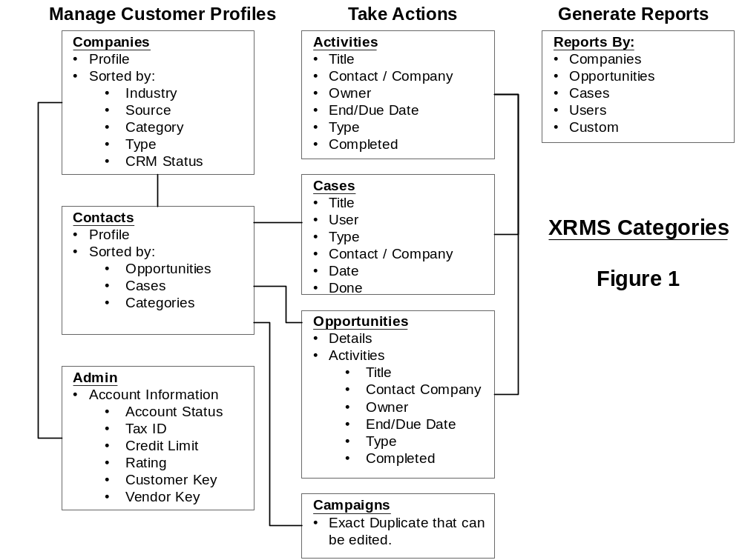

XRMS is arranged in three major categories:
- Management of Customer Profiles.
- Take action on activities. Activity types include Activities, Cases, Opportunities and Campaigns.
- Generate reports. Reports can be generated by Companies, Opportunities, Cases, Users and Custom.

Manage Customer Profiles
The Companies profile is the main contact management section of XRMS for all Company, Contact and Admin (Account) information. Companies can be added and edited.

Contacts can only be added to a Company profile. Contacts must be related to a Company.

The Admin component provides the ability enter a Companies account information which includes Account Status, Tax ID, Credit Limit, Rating, Customer Key, Vendor Key.

Take Actions
The types of actions (activities) that XRMS provides are:
- Activities - which can be any Activity that a User can initiate. Activities do not have to be related to a Company or Contact.
- Cases - which are typically Company/Contact initiated, like service calls. Cases must be associated with a Company and a Contact within a Company. If no Contact is selected the Company default Contact is assumed. Activities can be initiated related to Cases.
- Opportunities - which are typically sales related Opportunities must be related to a Company and a Contact within a Company. If no Contact is selected the Company default Contact is assumed. . Activities can be initiated related to Opportunities.
- Campaigns - which are typically marketing related like a mailing to Companies /Contacts where a fixed length of time and a fixed budget. Opportunities can be associated to a specific Campaign.

Generate Reports
XRMS provides to generate reports by:
- Companies
- Opportunities
- Cases
- Users
- Custom

Top Level Windows

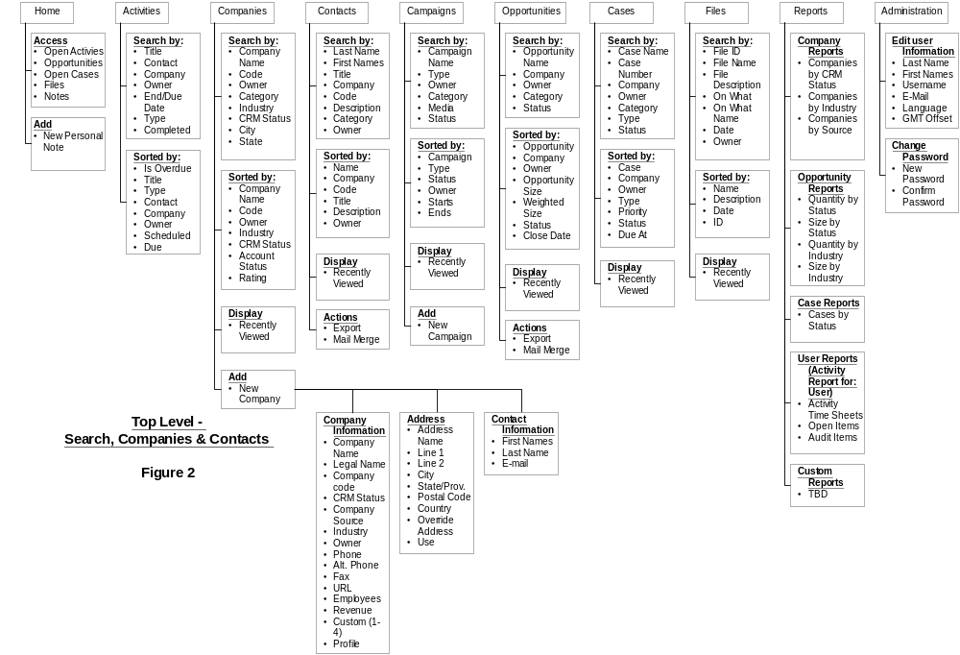

The top tabs to the windows mainly provide the ability to search for a Companies, Contacts, Opportunities, Cases, Files, Reports. All searches can contain multiple criteria's and are exclusively or'ed. The Administration tab provides the ability to customize the various components of XRMS if administrative rights have be granted to the user. If not, the user can only change their profile.

All additions to Companies Contacts and Cases must to done under the Companies tab. Campaigns can be added under the Campaign tab since they are not related to a specific Company.

Home
The Home window provides easy access to a users:
- Opportunities
- Open Cases
- Files
- Notes

The user can access any of the above by clicking on it.

Activities
The Activities window provides the ability to search for Activities by Title, Contact, Company, Owner, End/Due Date, Type or Completed.

Activities can be sorted by Is Overdue, Title, Type, Contact, Company, Owner, Scheduled or Due.

Activities can be independent of Companies / Contacts or associated with Companies / Contacts, Opportunities or Cases.

Companies
The Companies window provides the ability to:
- Search for a company based on variety of search options; Name, Code, Owner, Category, Industry, CRM Status, City, State. The search results are displayed in the same window.
- Add new company.
- Easy access to Recently Viewed companies.
The resulting search list can be sorted by Company Name, Code, Owner, Industry CRM Status, Rating.

Contacts
The Contacts window provides the ability to:
- Search by Last Name, First Names, Title, Company, Code, Description, Category, Owner.

The resulting search can be sorted by Name, Company, Code, Title, Description, Owner.

Recently viewed Contacts are also displayed in this windows.

New Contacts can only be entered under the Companies window by selecting or adding a company and then by adding the Contacts under that company. The system is driven by Companies not Contacts.

Campaigns
The Campaign window provides the ability to:
- Add new campaigns.
- Search for existing campaigns by Campaign Name. Type, Owner, Category, Media, Status.

Recently viewed campaigns are also displayed.

Opportunities
The Opportunities window provides the ability to:
- Search by Opportunity Name, Company, Owner, Category, Status.
- Export the Opportunities into an spreadsheet.
- Create a mail merge from a template. The templates available are a Blank Template, Customer Service Inquiry, Introduction, Sales Pitch or Thanks for Your Business.

Resulting searches can be sorted by Opportunity, Company, Owner, Opportunity Size, Weighted Size, Status, Close Date.

Recently viewed Opportunities are also displayed.

Opportunities can only be added under the Company window.

Company and Contacts

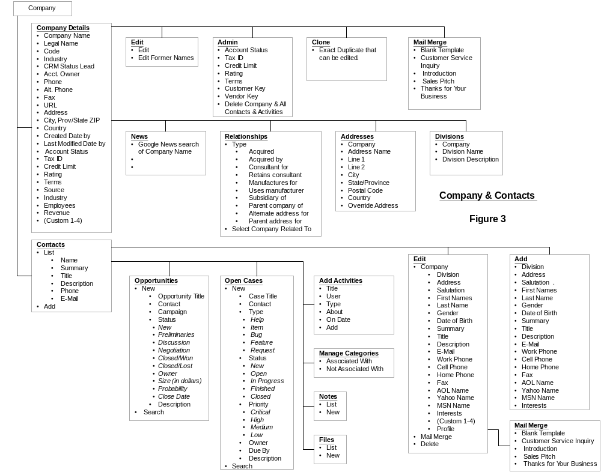
All data management of the Company, Contacts, Opportunities, Cases, Activities, Categories, Notes and Files can be accessed from the Company & Contacts section. This includes editing, deleting, adding or modifying information.

Remember, Contacts are always related to Companies. A Company must to be added to add any Contacts.

Opportunities, Cases, Activities can be added or edited under Contacts for a specific Company. Notes and Files can also be added and attached to Contacts and Companies.

An email can be sent to a Contact with the Mail Merge feature. Boilerplate emails are provided or a Blank Template can be used.

Administration

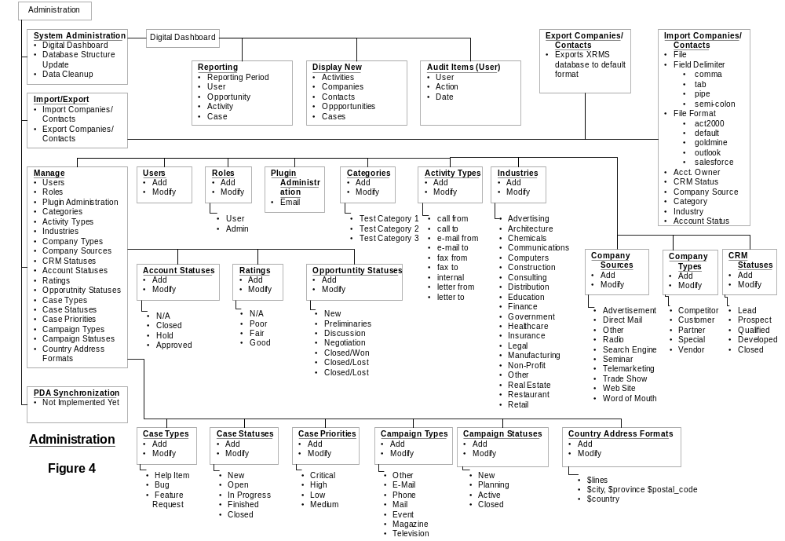

System Administration
System Administration consists of:
- Digital Dashboard:
  - Provides various reports by User, Opportunity, Activity and Case.
  - Displays new Activities, Companies, Contacts, Opportunities and Cases.
  - Displays Audit Reports of Users.
- Database Structure Update - which updates the database structure.
- Database Cleanup - which cleans up the database.

Data Management
XRMS provides the ability to import and export data into the XRMS database.

Import Companies/Contacts
Imports data from a delimited form, comma, tab, pipe or semi-colon. File structures supports supported are act2000, goldmine, salesforce, outlook or the default format of XRMS. The default format is defined in the Appendix 2 - Default Import Formats.

Imported data is imported with the following criteria:
- Acct. Owner
- CRM Status
- Company Source
- Category
- Industry
- Account Status
- Rating

Unless specified, the import of data assigns the default country to be the USA if there is no country indicated in the country field associated with that Company. To change the default country, see Appendix 1 - Country Code List.

The default Gender is male.

The imported data is first displayed so the user can preview the data. You will notice that only one Company record is put into XRMS with the Contacts of each Company related to the Company record.

Once the data is previewed it can be submitted to the XRMS database.

Export Companies/Contacts
Export provides the ability to export all data in the XRMS database to a delimited file. It is exported in the default format.

User Setup
Users can be added to XRMS and granted access or turned off.

Roles can be added or modified. The default Roles are:
- Admin, which provides access to the Administration functions;
- User which does not have Administration functions.

Additional Roles can be added.

Setup
Before starting with XRMS, the various defaults should be reviewed and edited appropriately. The following can be modified, added to or deleted. Once deleted, the action cannot be reversed so be careful, all associations with Companies, Contacts, Cases and Campaigns will be lost.
- Categories,
- Activity Types,
- Industries,
- Company Types,
- CRM Statuses,
- Account Statuses,
- Ratings,
- Opportunity Statuses,
- Case Types,
- Case Statuses,
- Case Priorities,
- Campaign Types,
- Campaign Statuses,
- Country Address Formats,

The defaults provide a basic example of the function of each. There is no limit on the number of items that can added under each group.

Glossary

Term | Association | Description
Account Status | Companies | Status of a Company's account - N/A, Closed, Hold, Approved.
Activities | Activities | Any Activity with a Company - must include description, be assigned to a User, include a Type (call from, call to, e-mail from, e-mail to , fax from, fax to, internal, letter from, letter to), can be associated to a Contact within a Company, can be about a Case, has a start date. Can be completed (grey) or uncompleted (pink).
Activity Time Sheet | Reports | List of Activities by User - lists Start and End Date, Duration, User Name, Company and Contact that Activity was for, link to Activity Detail.
Activity Types | Activities | call from, call to, e-mail from, e-mail to , fax from, fax to, internal, letter from, letter to
Administration | Administration | Administration of XRMS includes the ability customize fields, generate reports and add, modify and delete Users.
Audit Items | Administration | Detailed Audit by user of all actions executed on the XRMS System.
Campaign | Campaigns | Several related operations aimed at achieving a particular goal. Usually for a specified period of time. Usually not related to a specific Company.
Campaign Status | Campaigns | New, Planning, Active or Closed.
Campaign Types | Campaigns | E-Mail, Event, Magazine, Mail, Other, Phone, Television
Case | Cases | An occurrence of something related to a specific Company. Case Types can be Help Item, Feature, Request. Case Types can be added and modified by the Administrator. Activities can be related to a specific Case.
Case Priorities | Cases | Level of urgency - Critical, High, Low, Medium. Case Priorities be added and modified by the Administrator.
Case Status | Cases | New, Open, In Progress, Finished, Closed. Case Status be added and modified by the Administrator.
Category | Companies  Contacts | A custom field that can be related to Contacts, Companies, Campaigns and Cases. Categories can be added and modified by the Administrator.
Company | Companies | Any Company that is in the XRMS database. Contacts can only be associated to Companies. Companies can be associated with Cases and Activities.
Company Code | Companies | A unique code that can be assigned to a Company by any User.
Company Source | Companies | Source where the Company found your business - Advertisement, Direct Mail, Other, Radio, Search Engine, Seminar, Telemarketing, Trade Show, Web Site, Word of Mouth. Company Sources can be added and modified by the Administrator.
Company Types | Companies | Type of company - Competitor, Customer, Partner, Special, Vendor. Company Types can be added and modified by the Administrator.
Country Address Formats | Administration | Format that the address is displayed, varies from
Country Code | Companies | Code identifying the default country. See Country Code List.
Created Date | Companies  Contacts | Date that a Company or Contact profile was created.
Credit Limit | Companies | Credit limit in XRMS. Can be entered and modified by any User.
CRM Status | Cases | Status of a Case - Lead, Prospect, Qualified, Developed, Closed. CRM Status can be added and modified by the Administrator.
Custom | Reports
Custom Reports | Reports
Customer Key | Companies | Unique number that is related to a Company. Can be modified or entered by any User
Digital Dashboard | Reports | Overview screen for Administrators that provides access Reports and displays new Activities, Companies, Contacts, Opportunities and Cases. Also provides audit reports by User.
Divisions | Companies | Divisions within a Company. A Division can have its own address, profile and contact information. It is always linked to a Company.
Employees | Companies | Number of Employees of a Company. Can be edited and entered by any User.
Export | Administration | Ability to export the XRMS database.
Files | Contacts  Campaigns | Any file that is uploaded to XRMS, they can be word documents, spreadsheets, pdf files or any other file type.
Former Names | Companies | A Companies former name(s).
Import | Administration | Ability to import Company and Contact information into the XRMS database.
Industry | Companies | Industry that a Company operates within (i.e. - Automotive, Healthcare, etc.). Industries can be added and modified by the Administrator.
Legal Name | Companies | Companies legal name. Typically the same as Company name but can be different. Can be edited and entered by any User.
Mail Merge | Companies  Contacts | Ability to send emails to a Company or Contact. Boiler plate forms are provided or a Blank Template can be used. Mail Merge can be initiated from Company Details or from an
Modified Date | Companies  Contacts | Date a Company or Contact record was modified.
News | Companies | Initiates Google news search of Company name.
Open Activities | Activities | Activities that are not closed or completed.
Open Cases | Cases | Cases that are not closed or completed.
Open Items
Opportunity |  | An Opportunity with a Company or Contact. Opportunity t
Override Address | Companies | Alternate Company address that is used as the primary address, over-riding the primary address.
Owner | User | Owner of the Company and Contact information. Usually the User who entered or provided the information.
PDA Synchronization | Companies  Contacts | Ability to synchronize Company and Contact information with XRMS. Currently not implemented.
Priority | Case
Profile | Company  Contact | A Companies or Contacts profile.
Rating | Company | A Companies Rating - Fair, Good, Poor, N/A. Typically credit rating.
Reports | Reports | Reports generated by XRMS.
Revenue | Company | Companies annualized revenue.
Roles | User | Type of Users. Standard are Admin User and User where the Admin User can modify the Administration features of XRMS.
Tax ID | Company | Tax ID. Can be added or edited by any User.
Terms | Company | Payment Terms, net xx days. Edited from the Admin panel under Company.
User | User | A XRMS User that can add, modify, delete Companies, Contacts, Cases, Opportunities and Activities.
Vendor Key | Company | Unique field that can be added or modified by a User.

Appendixes

Appendix 1 - Country Code List

Country | Code

Appendix 2 - Default Import Formats

