XRMS Open Source CRM
Administrator Guide v 1.99

Last Saved: 3/28/2006 08:08:22 AM
Copyright Information
Copyright (c) 2005-2006 XRMS Development Team
Some Rights Reserved. Licensed under the GNU Free Documentation License. <http://www.gnu.org/copyleft/fdl.html>

Trademarks
Microsoft, Internet Explorer, and Windows are trademarks or registered trademarks of Microsoft Corporation in the United States and/or other countries.
Other product or company names mentioned herein may be the trademarks of their respective owners.

Table of Contents
1Overview of Administrator Tasks 1
2System Administration 3
3Import/Export 4
3.1Import Companies and Contacts 4
3.2Export Companies and Contacts 6
3.3Export Companies/Contacts as LDAP/LDIF 6
3.4Export Companies with address and phone info 6
4Managing System Parameters 7
4.1ACL 7
4.1.1Manage Roles 8
4.1.2Manage Controlled Objects 10
4.1.3Manage Controlled Object Relationships 10
4.1.4Manage Groups 12
4.1.4.1Select Column Layouts 12
4.1.5Manage Users in a Group 13
4.1.6Manage Groups within a Group 14
4.1.7Manage Group Members 14
4.1.8Manage Permissions 15
4.1.9Manage Role Permissions 16
4.1.10Manage Role Permissions in Grid 18
4.1.11Manage Data Sources 19
4.1.12Test ACL Results 20
4.2Activity Templates 23
4.2.1Add an Activity Template 23
4.2.2View, Edit, and Delete Activity Templates 23
4.3Email Templates 25
4.3.1Manage Email Templates 25
4.3.1.1Add an Email Template 26
4.3.1.2Edit an Email Template 27
4.3.2Manage Email Template Types 27
4.3.2.1Add an Email Template Type 28
4.3.2.2Edit an Email Template Type 28
4.4Change Record Owner 28
4.5Country Localization Formats 29
To specify the Country Address Format 30
4.6System Preferences 31
4.6.1Activities Default Behavior 32
4.6.2Allow Unassigned Activities 32
4.6.3Audit Level 33
4.6.4Default GST Offset 33
4.6.5Display Item Technical Details 34
4.6.6LDAP Version 35
4.6.7Maximum RSS Feed Entries 35
4.6.8Reports - Show No Items Found 36
4.6.9Reports – Use Horizontal Rule 36
4.6.10RSS Feeds Enabled 37
4.6.11Sender Email Address 37
4.7Users 38
4.7.1Add a User 38
4.7.2Edit User Details 39
4.7.3Delete a User 40
5Types and Statuses 42
5.1Add a Default Value 43
5.1.1Defaults that Follow a Common Procedure to Add Values 43
5.1.1.1Opportunity Statuses 44
5.1.1.2Case Priorities 46
5.1.2Defaults that Do Not Follow a Common Procedure to Add Values 47
5.1.2.1Address Types 47
5.1.2.2Case Statuses 48
5.1.2.3Relationship Types 49
5.1.2.4Salutations 50
5.2Edit and Delete Default Values 50
5.2.1Opportunity Statuses 50
5.2.2Activity Types 52
5.2.3Categories 54
6Workflow 57
7Plugins 58
7.1Activating Plugins 58
7.2Plugins Included with XRMS CRM 59
7.3Developing Plugins 61
7.3.1Plugin Architecture 61
7.3.2Writing Plugins 61
7.3.2.1Including Other Files 62
7.3.2.2Hook Types 63
7.3.2.3List of Hooks 64
7.4Manage Info Types [[This link is not seen in the current version ?]] 69
7.4.1Add an Info type 69
7.4.2Editing and Deleting Info Types 69
Appendix 1–List of Country Codes 71
Appendix 2–Default Import Formats 74
Index 75

List of Figures
Figure 1: Administration Screen 1
Figure 2: Import/Export Box 4
Figure 3: Import Screen 5
Figure 4: Manage Box 7
Figure 5: ACL Management Screen 7
Figure 6: Manage Roles Screen 8
Figure 7: Role - Add Name 9
Figure 8: Role - Edit Name 9
Figure 9: Manage Controlled Objects Screen 10
Figure 10: Manage Controlled Object Relationships Screen 11
Figure 11: Manage Groups Screen 12
Figure 12: Select Columns 12
Figure 13: Manage Group Users Screen 13
Figure 14: Manage Group Groups Screen 14
Figure 15: Manage Group Members Screen 15
Figure 16: Manage Permission Screen 16
Figure 17: Manage Role Permissions Screen 17
Figure 18: Manage Permissions for Role Screen 1 18
Figure 19: Manage Permissions for Role Screen 2 19
Figure 20: Manage Data Sources Screen 20
Figure 21: ACL Result Test Screen 21
Figure 22: Check Permission on an Object for a User - Enter ACL Parameters 21
Figure 23: Check Permission on an Object for a User - ACL Results 22
Figure 24: Get List of Objects for a User - ACL Parameters 22
Figure 25: Manage Activity Templates Screen 23
Figure 26: Activity Template Details Screen 24
Figure 27: Manage Templates Box 25
Figure 28: Manage Email Templates Screen 26
Figure 29: Manage Email Template - Add Screen 26
Figure 30: Manage Email Template Types Screen 27
Figure 31: Manage Email Template Types - Add Screen 28
Figure 32: Change Record Owner Screen 29
Figure 33: Country Localization Formats 29
Figure 34: System Preferences Screen 31
Figure 35: System Parameter - Activities Default Behavior 32
Figure 36: System Parameter - Allow Unassigned Activities 32
Figure 37: System Parameter: Audit Level 33
Figure 38: System Parameter - Default GST Offset 34
Figure 39: System Parameter - Display Item Technical Details 34
Figure 40: System Parameter - LDAP Version 35
Figure 41: System Parameter - Maximum RSS Feed Entries 35
Figure 42: System Parameter – Reports -- Show No Items Found 36
Figure 43: System Parameter - Reports -- Use Horizontal Rule 36
Figure 44: System Parameter - RSS Feeds Enabled 37
Figure 45: System Parameter - Sender Email Address 37
Figure 46: Manage Users Screen 38
Figure 47: Add New User Box 39
Figure 48: User Details Screen 40
Figure 49: Change Password Screen 40
Figure 50: Types and Statuses 42
Figure 51: Manage Opportunity Statuses 44
Figure 52: Link Opportunity Status to Workflow Activity Box 45
Figure 53: Manage Case Priorities Screen 46
Figure 54: Case Priorities Box 47
Figure 55: Manage Address Types 47
Figure 56: Address Types Box 48
Figure 57: Manage Case Statuses Screen 48
Figure 58: Manage Relationship Types Screen 49
Figure 59: Manage Salutations Screen 50
Figure 60: Opportunity Status Details Screen 51
Figure 61: Link Workflow Activity to Opportunity Status 51
Figure 62: Manage Activity Types Screen 52
Figure 63: Activity Type Details Screen 53
Figure 64: Edit Activity Participant Position Screen 53
Figure 65: Manage Categories Screen 54
Figure 66: Category Details Screen 55
Figure 67: Plugin Administration Screen 58
Figure 68: Manage Info Types 69
Figure 69: Info Type Details 70

Overview of Administrator Tasks
XRMS Administrators are responsible for five major activity areas that are performed from the Administrator screen. They are:
- System Administration: Used to maintain the structure of the database and for cleaning up the database.
- Import/Export: Used to import and export company data.
- Manage: Used to maintain different aspects of XRMS using access control.
- Types and Statuses: Maintains information seen in the drop-down lists.
- Plugins: Used to add or delete XRMS plugins.
Click the Administration link on the top bar to see the Administration screen.
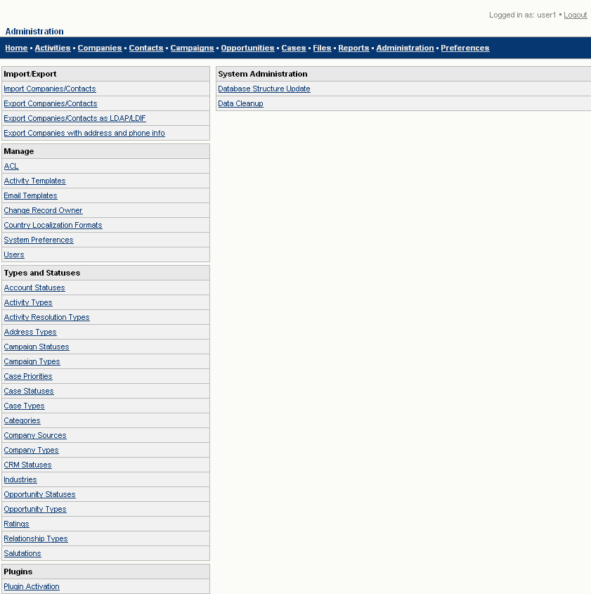
Figure 1: Administration Screen
The five main sets of tasks done by an Administrator are described in detail in the chapters that follow.

System Administration
The features that come under this section: Database Structure Update and Data Cleanup are applicable to users of SQL databases.

Import/Export
Importing and exporting company data is a crucial task for many XRMS users.
The different data types imported to and exported from XRMS are shown in Appendix 2–Default Import Formats.

Import Companies and Contacts
Only a single company record is stored in XRMS with the contacts of each company related to the company record.
Data imported contains the following information:
- Acct. Owner
- CRM Status
- Company Source
- Category
- Industry
- Account Status
- Rating
To import company or contact information into the XRMS database, follow the steps below:
- Click on the Administration link in the XRMS top bar to see the Administration screen (See Figure 1).
- Go to the Import/Export Box.
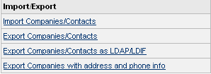
Figure 2: Import/Export Box
- Click the Import Companies/Contacts link to see the Import screen that contains the Import Companies dialog that displays fields to import company data.
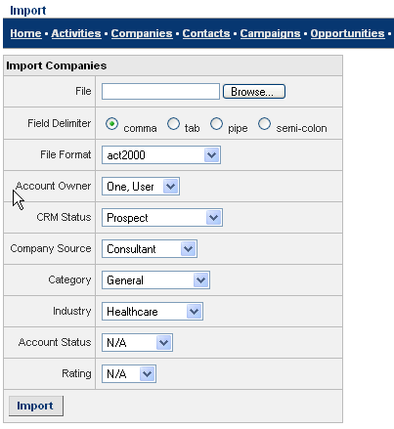
Figure 3: Import Screen
- Enter the fields in the Import Companies box as given in the table below:
File: Enter the path of the file that has to be imported, or click Browse to select the file.
Field Delimiter: Data is imported in a delimited form. The different delimiters are: comma, tab, pipe, or semi-colon. Select the radio button beside a delimiter to choose one.
File Format: Choose the file format from the drop-down list. File structures supported are: act2000, dunn-and-bradstreet, goldmine, salesforce, outlook, or the XRMS default format given in Appendix 2.
Account Owner: Employee assigned to establish a relationship with the company. Select the option from the drop-down list.
CRM Status: Status of the company with regard to its relationship with your company. For example: Lead, Prospect, Active, and so on. Select the option from the drop-down list.
Company Source: Means by which the company was identified. Select the option from the drop-down list.
Category: Choose the category of the company from the drop-down list.
Industry: Industry in which the company operates. Select the option from the drop-down list.
Account Status: Select the appropriate account status from the drop-down list.
Rating: Select the company rating from the drop-down list.
- After you enter all the fields, click Import.
Imported data is displayed in the Preview Data screen where it is previewed and sent to the XRMS database.
NOTE:
- When data is imported and there is no country assigned to the country field then the default value is USA. To change the country default, see Appendix 1–List of Country Codes.
- The default value for gender is male.

Export Companies and Contacts
All XRMS data can be exported to a delimited file. This is exported in the default format – CSV. This applies to all the export features in the Import/Export box.

Export Companies/Contacts as LDAP/LDIF
This option will export an LDIF formatted file of XRMS data to be imported into a corporate LDAP Directory.

Export Companies with address and phone info
This option will export a comma separateed list of company information with address and phone info.

Managing System Parameters
You can define access control details, create activity templates, change a record owner, maintain country localization formats, as well as define system parameters and create and maintain user details from the Manage box in the Administration screen.
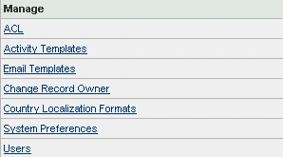
Figure 4: Manage Box

ACL
The Access Control List (ACL) feature is used to restrict access to certain XRMS features to those users who are authorized to perform such tasks.
Navigate to the Administration>ACL link to see the ACL Management screen.
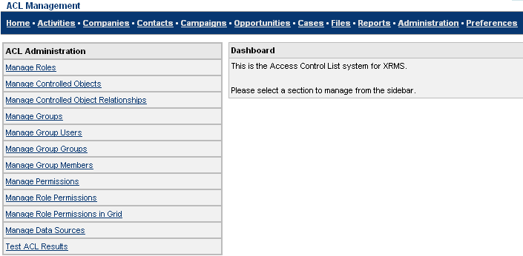
Figure 5: ACL Management Screen
The ACL Management screen has two distinct parts:
- ACL Administration: The right sidebar displays the Access Control List Administration box. This list consists of various elements of XRMS that are defined and controlled by the administrator.
- Dashboard: When you click an item in the Access Control List, the Dashboard displays the different screens.
The following section describes the different items in the Access Control List. The procedure to add and edit is common for all the items on the list. For this reason, the procedure is explained only for one item, Manage Roles.

Manage Roles
The default roles are:
- User: Can perform business-related tasks but not administrative tasks.
- Administrator: Has the authority to perform administrative tasks.
Click the Manage Roles link in the ACL Management Screen, Figure 5. You see the Manage Roles screen.
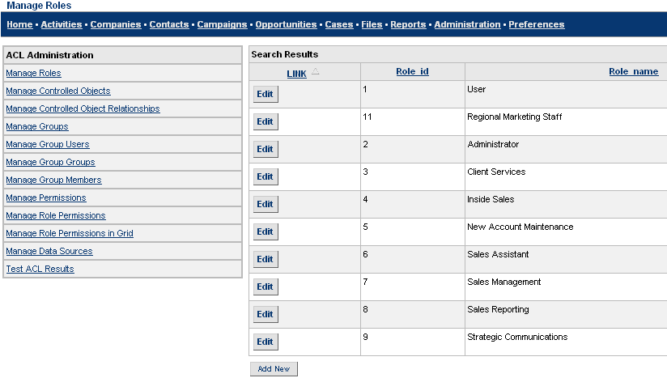
Figure 6: Manage Roles Screen
Adding a Role
A significant Access Control List feature is the ability to add a new role.
To add a role:
- Click Add New in the Search Results table of the Manage Roles screen, Figure 6. The Dashboard displays the Role box.
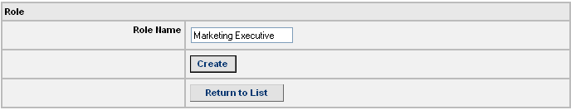
Figure 7: Role - Add Name
- Enter a new role name in the text box beside Role Name.
- Click Create to create a new role name. You then see the new Role Name displayed in a separate screen.
Click Return to List to return to the Search Results table.
Editing a Role
To edit a role, do the following:
- Click the Manage Roles link in the ACL Management Screen, Figure 5 to see the Manage Roles screen (See Figure 6).
- To sort the items in the Search Results table, click on the underlined column headings.
- To select the role that you want to modify, click Edit on that row. You see the Role box.
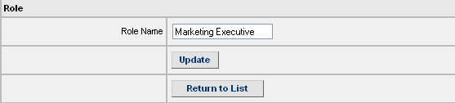
Figure 8: Role - Edit Name
- Change the existing Role Name and click Update to save the changes. You then see the new Role Name displayed on a separate screen.
Click Return to List to return to the Search Results table without creating a new role name.

Manage Controlled Objects
Navigate to the Administration>ACL link and click the Manage Controlled Objects link to reach the Manage Controlled Objects screen.
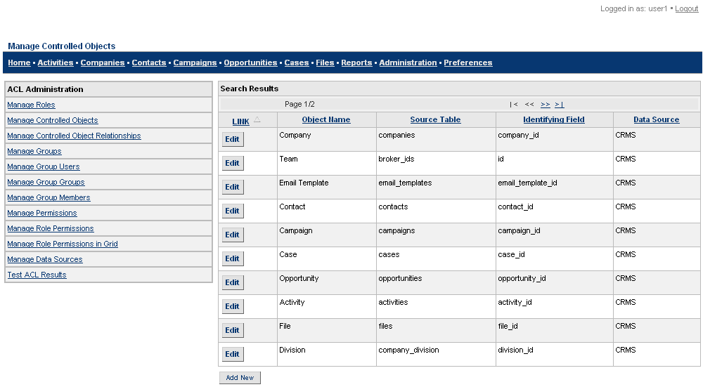
Figure 9: Manage Controlled Objects Screen
For details of the procedure to add or edit a controlled object, see 4.1.1 Manage Roles, which follows a similar procedure for a role.
The different fields involved in the procedure to add or edit are:
Object Name: The name of the new object.
Source Table: The table from which the object is taken.
Identifying Field: The field name in the source table that refers to this object.
user_field: Identifies the field in the table that contains the user id of the owner of this record. If the field is left blank, it defaults to the “user id”.
Data Source: Choose the source of the data from the drop-down list.

Manage Controlled Object Relationships
Controlled object relationships are used to manage the relationship between controlled objects. These relationships are important because they maintain the inheritance between different tables, and are the entities for which permissions are assigned in the Manage Role Permissions feature.
Navigate to the Administration>ACL link and click the Manage Controlled Object Relationships link to reach the Manage Controlled Object Relationships screen.
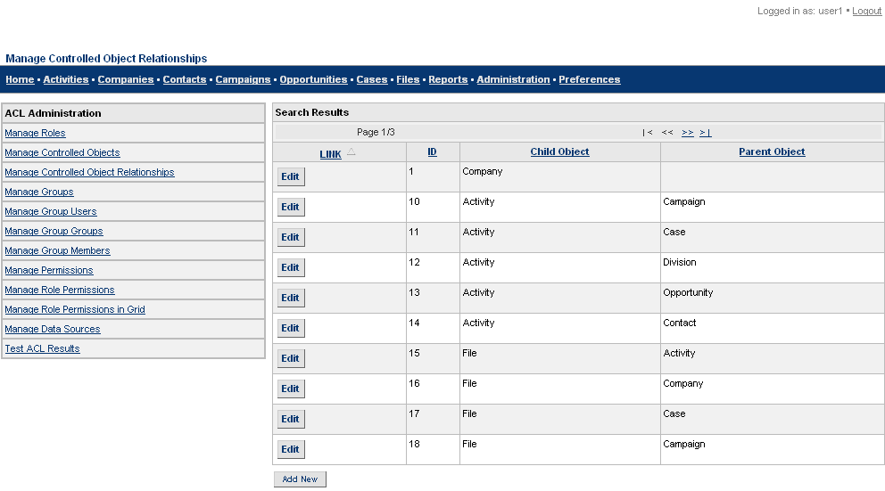
Figure 10: Manage Controlled Object Relationships Screen
For details of the procedure to add or edit a controlled object relationship, see 4.1.1 Manage Roles, which follows a similar procedure for a role.
The fields involved in the procedure to add or edit are:
Child Controlled Object: Is the child object in the relationship. This field must always be set.
Parent Controlled Object: Is the parent object in the relationship. If this field is left blank, the object is considered top level and not considered to be the child of any object.
on_what_child_field: Defines the field in the child table that contains the ID that identifies to which parent object record it belongs. Defaults to the identifying field name in the parent controlled object. A child field must be defined, if a cross table is defined.
on_what_parent_field: Defines the field in the cross table which has the ID of the parent object.
cross_table: The name of the table which relates two control objects. This is a separate table from the parent and child tables which contains a row for each link between the parent and child objects. Defaults to blank, and does not use cross table for the relationship.
singular: Defines whether or not the child table uses the “on_what_table” and “on_what_id” fields to link to a parent object. If set to 1, it uses on_what_table and on_what_id to determine the object relationship with the parent object. Defaults to 0 or blank.

Manage Groups
Navigate to the Administration>ACL link and click on the Manage Groups link. You see the Manage Groups screen.
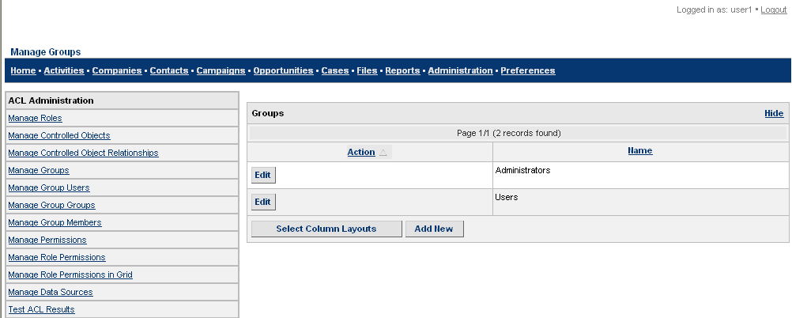
Figure 11: Manage Groups Screen
For details of the procedure to add or edit a group, see 4.1.1 Manage Roles, which follows a similar procedure for a role.
The only field involved in the procedure to add or edit is:
Group Name: The name of the group.

Select Column Layouts
The Select Column Layouts feature is designed so that you can tailor onscreen search result displays according to your needs. Click Select Column Layouts in the Manage Groups screen (See Figure 11) to see the Select Columns box.
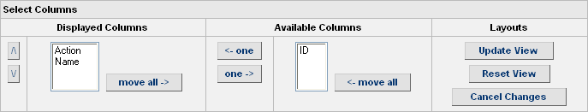
Figure 12: Select Columns
The Available Columns box shows the complete list of column titles to be displayed. The Displayed Columns box shows those columns you wish to have displayed.
- To select the column you require, place the cursor bar over the column name and:
Click ←one to move items to the Displayed Columns text box, one at a time.
Click ←move all to move all the items to the Displayed Columns text box.
Click one→ to move items to the Available Columns text box, one at a time.
Click move all→ to move all the items to the Available Columns text box.
- To specify the order in which the columns should be displayed, click Λ and V beside the Displayed Columns box. The column title at the top of the box will be leftmost in the display and others will follow in the order they are shown in this list.
- You can now:
- Click Update View to see the new column order in the Manage Groups screen (See Figure 11).
- Click Reset View to return to the columns shown in the Available Columns box prior to any updates.
- Click Cancel Changes to discard the updates you made and return to the Manage Groups screen, Figure 11.

Manage Users in a Group
You can enter and edit the details of users in groups from the Manage Group Users screen.
Navigate to the Administration>ACL link and click on the Manage Group Users link to see the Manage Group Users screen.
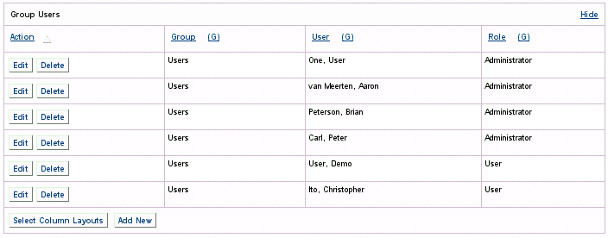
Figure 13: Manage Group Users Screen
For details of the procedure to add or edit a group user, see 4.1.1 Manage Roles, which follows a similar procedure for a role.
The fields involved in the procedure to add or edit are:
Group: Choose the group from the drop-down list.
User: Choose the user from the drop-down list.
Role: Choose the role of the user from the drop-down list.
source: What is this ????
Click Select Column Layouts to change the onscreen display of fields. For details, see 4.1.4.1.

Manage Groups within a Group
Navigate to the Administration>ACL link and click on the Manage Group Groups link to see the Manage Group Groups screen.
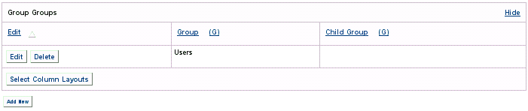

Figure 14: Manage Group Groups Screen
For details of the procedure to add or edit a group within a group, see 4.1.1 Manage Roles, which follows a similar procedure for a role.
The different fields involved in the procedure to add or edit are:
Group: Choose the group from the drop-down list.
Child Group: Choose the group from the drop-down list.
source: What is this ????

Manage Group Members
Navigate to the Administration>ACL link and click on the Manage Group Members link to see the Manage Group Members screen.
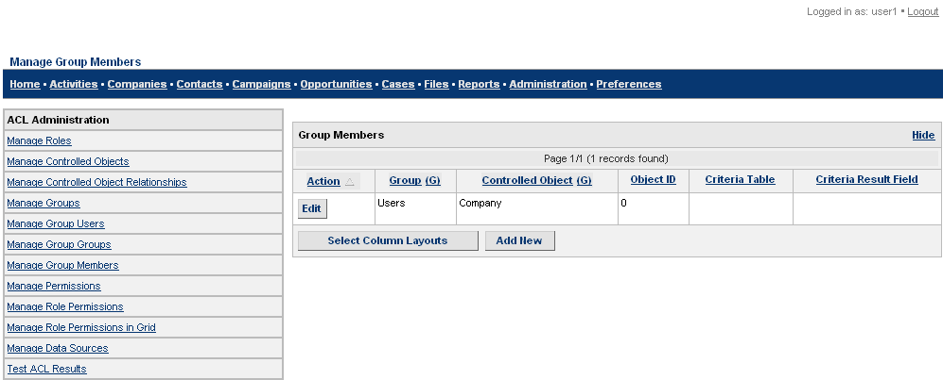
Figure 15: Manage Group Members Screen
For details of the procedure to add or edit a group member, see 4.1.1 Manage Roles, which follows a similar procedure for a role.
The different fields involved in the procedure to add or edit are:
Group: Choose the group from the drop-down list.
Controlled Object: Choose the controlled object from the drop-down list.
Object ID: Database identifier of the controlled object to add to the group.
Click the Hide link if you do not wish to display these columns and associated fields.
Click Select Column Layouts to change the onscreen display of fields. For details, see 4.1.4.1.

Manage Permissions
To ensure the validity of data, different users are given different levels of permissions to manipulate XRMS data. Available permissions include: Create, Read, Update, and Delete.
Navigate to the Administration>ACL link and click the Manage Permissions link to reach the Manage Permission screen.
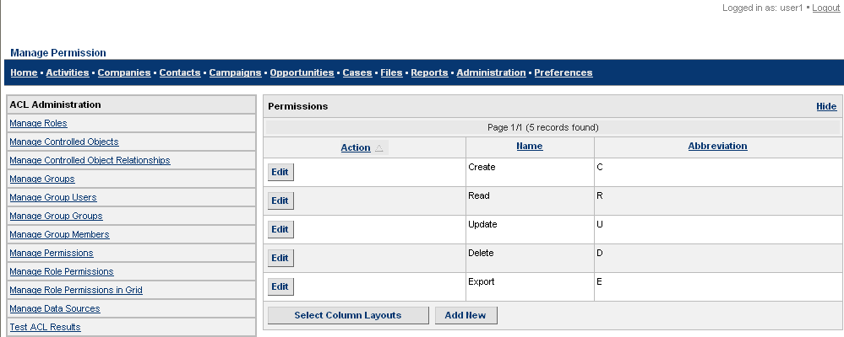
Figure 16: Manage Permission Screen
For details of the procedure to add or edit permissions, see 4.1.1 Manage Roles, which follows a similar procedure for a role.
The different fields involved in the procedure to add or edit are:
Permission Name: The name of the permission, for example, Delete.
Abbreviation: An abbreviation of the permission name.
Click the Hide link if you do not wish to display these columns and associated fields.
Click Select Column Layouts to change the onscreen display of fields. For details, see 4.1.4.1.

Manage Role Permissions
The Manage Role Permissions feature is used to manage the intersection between roles, permissions, and controlled object relationships. A role is assigned a particular permission on a controlled object relationship within a particular scope. The different scope types are:
- User Scope: The role has permission on the child object only if the table has a User field and that field matches the user’s User_ID.
- Group: The role has this permission only for those child objects that fall into the group for which the user has this role (or any child groups of this group).
- World: The role has this permission on all controlled objects that are the child in this relationship.
The entries in the Manage Role Permissions list also match those assigned or viewed with the Manage Role Permissions in Grid feature.
Role permissions can also be set to inherit or not, based on the Inheritance flag. If the Inheritance flag is set to Yes, all objects that have a child in this controlled object relationship (parents) inherit the permission. If inheritance is applied to each top-level object relationship, the role will have this permission on every object in the system. Inheritance defaults to “Yes”.
Navigate to the Administration>ACL link and click the Manage Role Permissions link to reach the Manage Role Permissions screen.
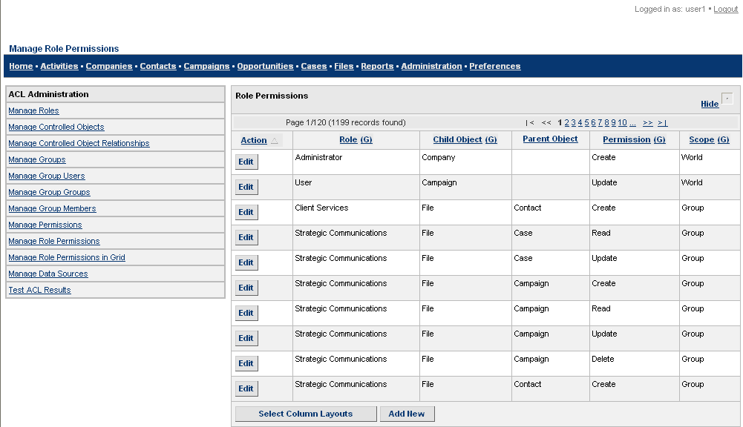
Figure 17: Manage Role Permissions Screen
For details of the procedure to add or edit permissions for a role, see 4.1.1 Manage Roles, which follows a similar procedure for a role.
The fields from which you can add or edit role permissions are:
Role: Choose the role from the drop-down list.
Controlled Object Relationship: Choose the required relationship from the drop-down list.
Scope: Can be User, Group, or World.
Permission: Choose the permission from the drop-down list.
Inheritable Flag: If you need the permission of on a 'parent' or higher level controlled object to not be inheritable, set this value to “No”. In most cases, the default value of “Yes” will be appropriate.
Click Select Column Layouts to change the onscreen display of fields. For details, see 4.1.4.1.

Manage Role Permissions in Grid
The Manage Role Permissions in Grid feature can be used on any role that is defined in XRMS. Roles could be: Administrator, Client Support, Regional Marketing Staff, Strategic Communication, Sales Management, and so on.
To manage role permissions within a grid, follow the steps below:
- Navigate to the Administration>ACL link and click the Manage Role Permissions in Grid link to reach the Manage Permissions for Role screen 1.
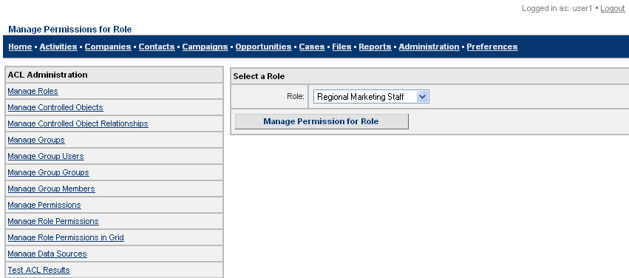
Figure 18: Manage Permissions for Role Screen 1
- Select a role from the Role drop-down list. The default roles are user and administrator.
- Click Manage Permission for Role to see the Manage Permissions for Role screen 2. If you choose Regional Marketing Staff as the role, you see the Manage Permissions for <Role Name> screen on the Dashboard.
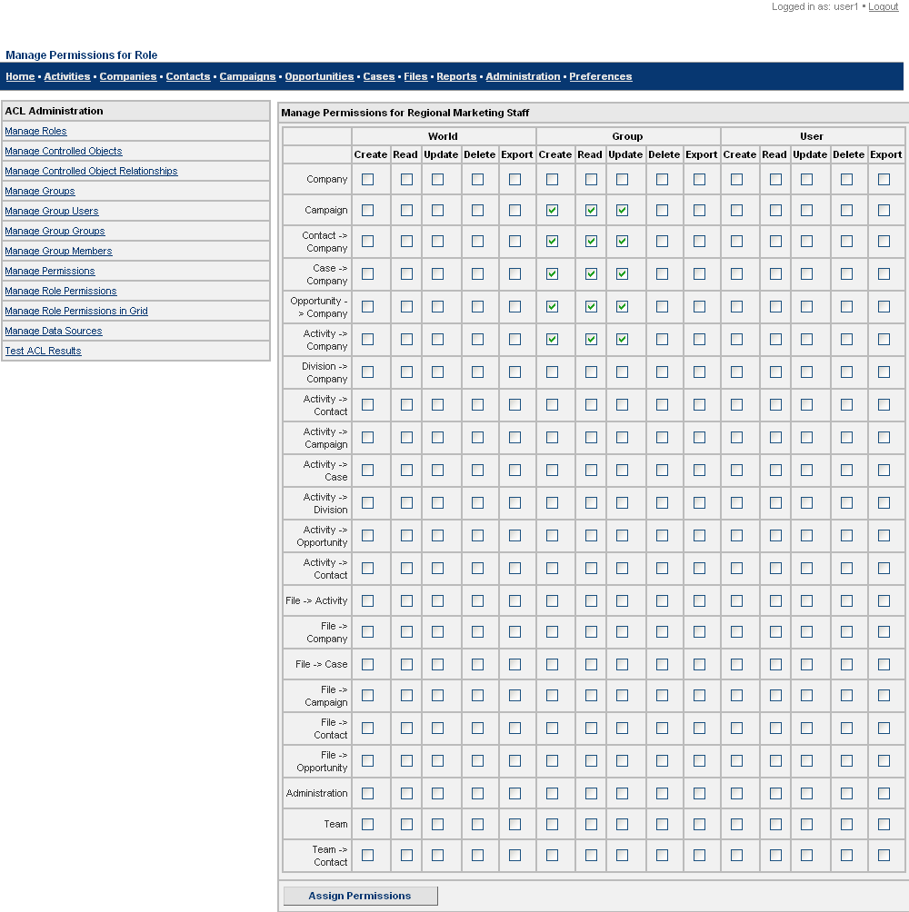
Figure 19: Manage Permissions for Role Screen 2
- Select the appropriate check boxes to give relevant permissions to the user or administrator.
- After you select all the required permissions, click Assign Permissions.

Manage Data Sources
Data sources are used to manage permissions within databases other than the XRMS database. This is only useful if there are plugins that also use the ACL and define new controlled objects using the new data source, new controlled object relationships, and also register a hook in XRMS to provide database access to the ACL object for this data source.
It is recommended that administrators do not change values in Manage Data Sources, unless they are developing a plugin.
Navigate to the Administration>ACL link and click the Manage Data Sources link. You see the Manage Data Sources screen.
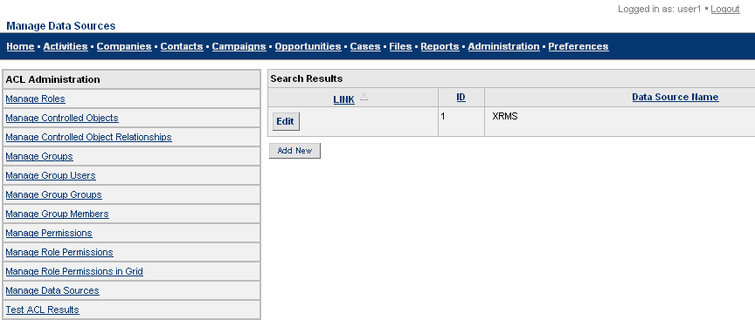
Figure 20: Manage Data Sources Screen
For details of the procedure to add or edit a data source, see 4.1.1 Manage Roles, which follows a similar procedure for a role.
The only field involved in the procedure to add or edit is:
Data Source Name: The name of the data source.

Test ACL Results
The Test ACL Results feature is used to test the results of the ACL configuration that has been just built. This feature can be used in two ways in which ACL is called:
- Return the Permissions on an individual object.
- Return the list of objects on which the user has a particular permission.
Navigate to the Administration>ACL link and click the Test ACL Results link to reach the ACL Result Test screen.
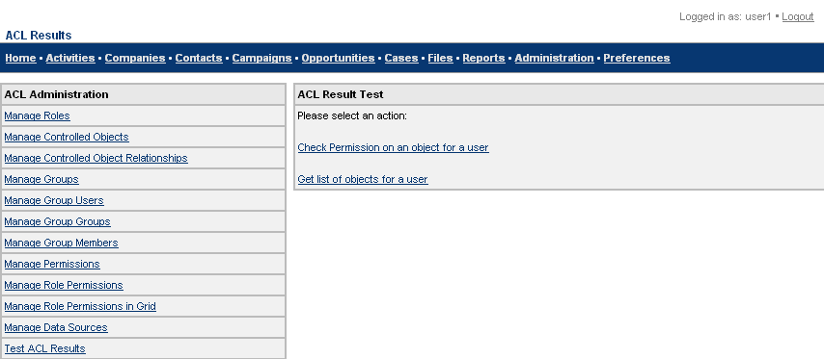
Figure 21: ACL Result Test Screen
You can:
- Check permissions on an object for a user.
- or
- Get the list of objects for a user.
The following paragraphs give details of the procedure for each.
Check Permission on an Object for a User
To check permission on an object for a user, follow these steps:
- Click on the Check Permission on an object for a user link in the ACL Result Test box. You then see the ACL Parameters box.
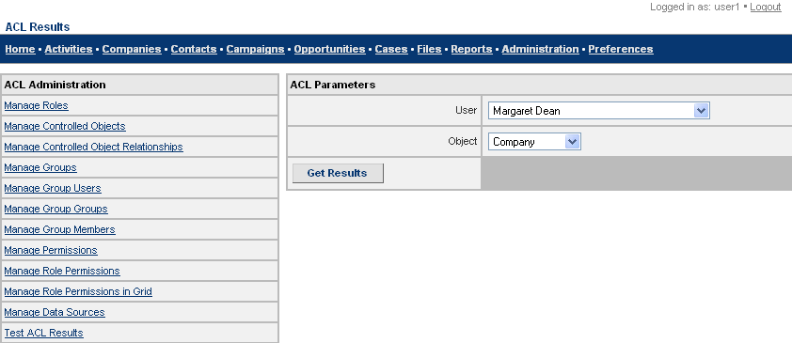
Figure 22: Check Permission on an Object for a User - Enter ACL Parameters
- Choose the user from the drop-down list.
- Choose the object from the drop-down list.
- Click Get Results. You see the Search Results box that shows different user ids and the permissions they have to access different types of data.
- To select the object for which you wish to check permissions, click the radio button in the select on what id column.
- Click Calculate Permissions to see the ACL Results box. The box displays the permissions available to the user for the selected object.
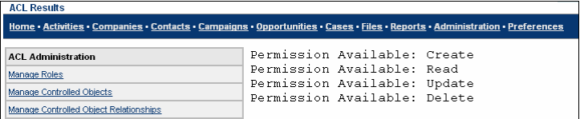
Figure 23: Check Permission on an Object for a User - ACL Results
Get List of Objects for a User
To get a list of objects for a user, follow the steps below:
- Click the Get list of objects for a user link in the ACL Result Test screen (See Figure 21). You see the ACL Parameters box.
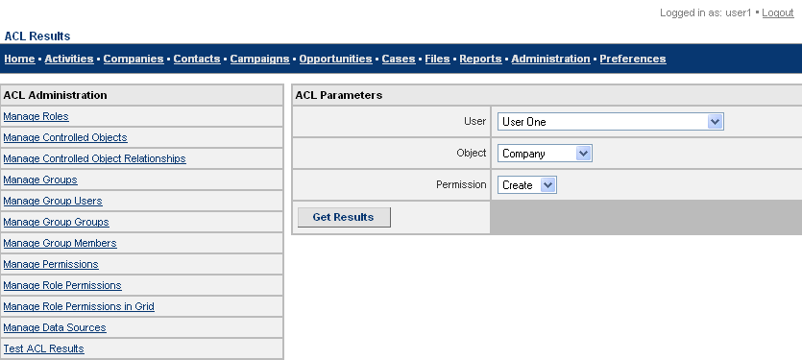
Figure 24: Get List of Objects for a User - ACL Parameters
- Choose the user from the drop-down list.
- Choose the object from the drop-down list.
- Choose the permission from the drop-down list.
- Click Get Results. You see the ACL Results box that shows company ids, user ids, and other company data.

Activity Templates
Activity templates show the workflow that has been defined using Types and Statuses. An activity template is used to create a new activity when the status or type of a case or opportunity changes. Each activity is assigned to that user who has the corresponding role defined in the activity template and has the least number of open activities. For more information on Workflow, see Chapter 6.
Navigate to the Administration>Activity Templates link to reach the Manage Activity Templates screen.
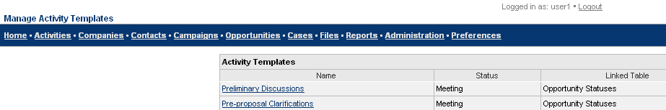
Figure 25: Manage Activity Templates Screen
NOTE: You can only view an activity template if one has been created.

Add an Activity Template
To add an activity template, see 5.2.1 Opportunity Statuses.
The Opportunity Status Details screen provides the option to link activities to opportunity statuses from the Link Activity To Opportunity Status box. When an activity is added to an opportunity status in the Opportunity Status Details screen, the activity is automatically updated to the Manage Activity Templates screen.

View, Edit, and Delete Activity Templates
Go to the Administration link and click Activity Templates to reach the Manage Activity Templates screen (See Figure 25) where the list of activities is shown.
To edit an activity template
Follow the steps below:
- In the Manage Activity Templates screen (See Figure 25), click the name of the activity template you want to edit. You then reach the Activity Template Details: <Activity Name> screen.
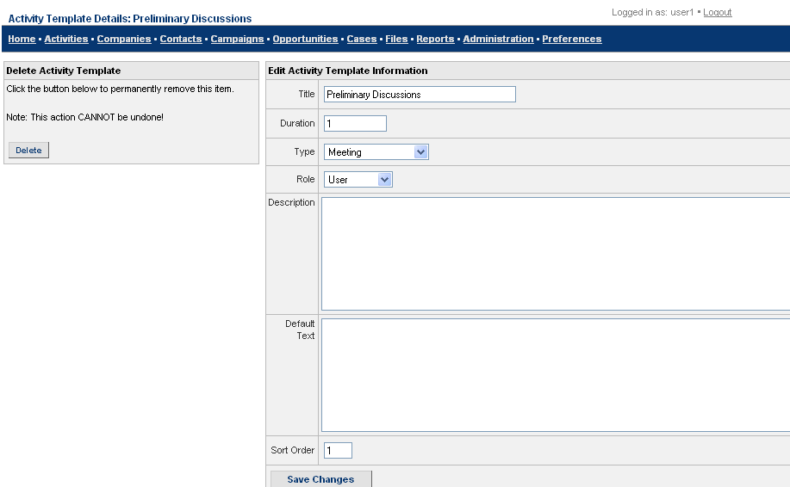
Figure 26: Activity Template Details Screen
- Edit the fields as described in the table.
Title: Enter the title of the activity.
Duration: Enter the time period for the completion of the activity. The default measurement is in days.
Type: Choose the type of activity from the drop-down list.
Role: Select the appropriate option from the drop-down list.
Description: Enter a description about the activity.
Default Text: Standard text about the activity.
Sort Order: Defines the order that activities are created within a workflow. New activities will not be included in a workflow until all activities in the previous sort order are completed.
- After you enter or edit the relevant details, click Save Changes. You return to the Manage Activity Templates screen.
To delete an activity template
Navigate to the Administration>Activity Templates link to reach the Manage Activity Templates screen (See Figure 25) where the list of activities is shown.
- In the Manage Activity Templates screen, click the name of the activity you want to edit. You then reach the Activity Template Details: <Activity Name> screen (See Figure 26).
- Go to the Delete Activity Template box on the left side of the screen. Click Delete to remove the activity template.

Email Templates
Email templates help to save time as they contain relevant information on a particular subject that can be re-used when necessary.
Navigate to the Administration>Email Templates link to reach the Manage Email Templates screen (See Figure 28). You also see a box with the title Manage Templates.
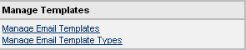
Figure 27: Manage Templates Box
This box has two links:
- Manage Email Templates
- Manage Email Template Types
The way the links function are described in the sections that follow.

Manage Email Templates
This feature helps you to create or edit email templates based on existing template types.
Click the Manage Email Templates link in the Manage Templates box to see the Manage Email Templates screen (See Figure 28) that shows the list of existing email templates. You see this screen by default when you click on the Email Templates link in the Administration screen (See Figure 1).
Click Select Column Layouts in the Manage Email Templates screen to change the onscreen display of fields. For details, see 4.1.4.1.
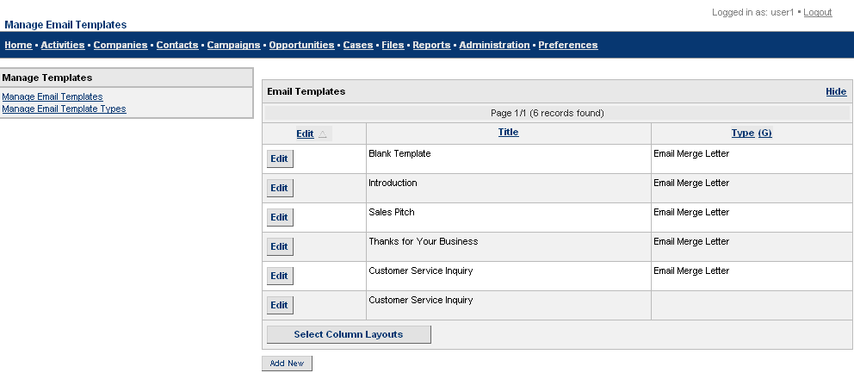
Figure 28: Manage Email Templates Screen

Add an Email Template
To add an email template:
- Click Add New in the Manage Email Templates screen (See Figure 28) to reach the Manage Email Template – Add screen.
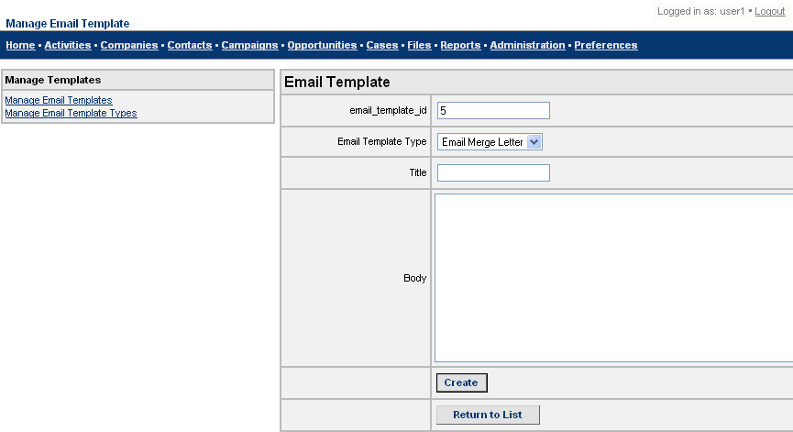
Figure 29: Manage Email Template - Add Screen
- Enter an identification number for the template in email_template_id.
- Select the type of template from the existing types in the Email Template Type drop-down list.
- Enter a name for the template in Title.
- Enter the text of the new template in Body.
- Click Create to create a new email template. This displays a screen with the details of the email template you created.
- Click Return to List to go to the Manage Email Templates screen.

Edit an Email Template
To edit an email template:
- In the Manage Email Templates screen (See Figure 28), click the Edit link corresponding to the required email template in the Title column. You see the Manage Email Template – Edit screen, which is similar to the Manage Email Template – Add screen (See Figure 29). The only difference is that the Update button replaces the Create button in this screen.
- Make changes to the appropriate fields as required.
- Click Update to save and update the edited email template.
- Click Return to List to go to the Manage Email Templates screen.

Manage Email Template Types
This feature helps you to create or edit different types of email templates.
Click the Manage Email Template Types link in the Manage Templates box (See Figure 27). You see the Manage Email Template Types screen (See Figure 30) that shows the list of existing email template types.
Click Select Column Layouts in the Manage Email Template Types screen to change the onscreen display of fields. For details, see 4.1.4.1.
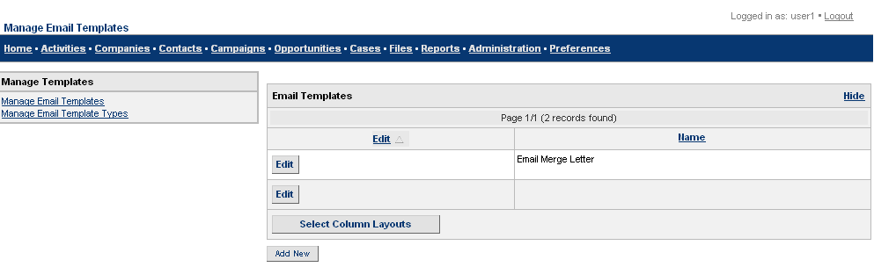
Figure 30: Manage Email Template Types Screen

Add an Email Template Type
To add an email template type:
- Click Add New in the Manage Email Template Types screen (See Figure 30) to see the Manage Email Template Types – Add screen.
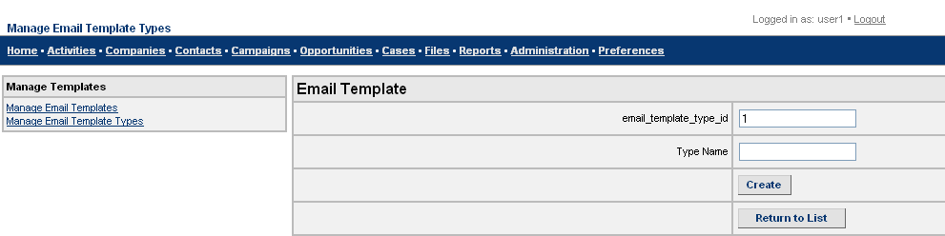
Figure 31: Manage Email Template Types - Add Screen
- Enter an identification number for the type of email template in email_template_type_id.
- Enter a name for the new template type in Type Name.
- Click Create to create a new type of email template. This displays a screen with the details of the email template type you created.
- Click Return to List to go to the Manage Email Template Types screen.

Edit an Email Template Type
To edit an email template type:
- In the Manage Email Template Types screen (See Figure 30), click the Edit link corresponding to the required email template type in the Name column. You see the Manage Email Template Types – Edit screen, which is similar to the Manage Email Template Types – Add screen (See Figure 31). The only difference is that the Update button replaces the Create button in this screen.
- Make changes to the appropriate fields as required.
- Click Update to save and update the edited email template type.
- Click Return to List to go to the Manage Email Template Types screen.

Change Record Owner
To change the owner of open activities, companies, campaigns, opportunities or cases, follow the steps below:
- Click the Change Record Owner link in the Administration screen (See Figure 1), to see the Change Record Owner screen.
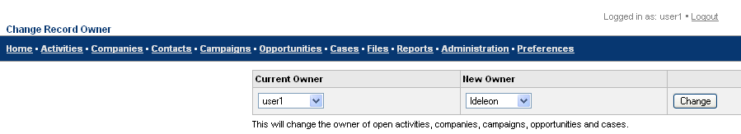
Figure 32: Change Record Owner Screen
- Choose the Current Owner of the activity, company, campaign, opportunity, or case from the drop-down list.
- Choose the New Owner from the drop-down list.
- Click Change to save the New Owner.

Country Localization Formats
To correctly represent different address and phone formats of countries around the world, follow the steps below:
To specify the Phone Format
- Click the Country Localization Formats link in the Administration screen (See Figure 1) to see the Country Localization Formats screen that displays a list of countries in alphabetical order, as well as fields and links from which you can specify telephone and address formats.
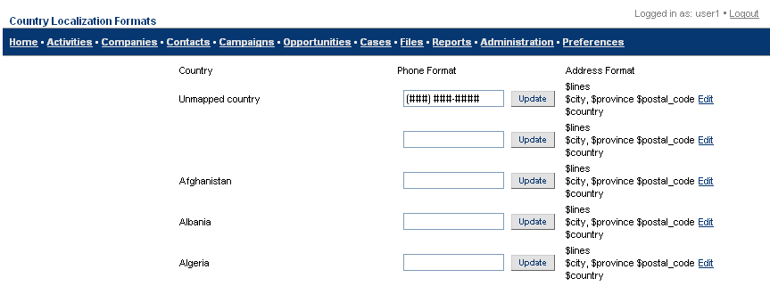
Figure 33: Country Localization Formats
- Scroll through the list of countries till you reach the one for which you would like to specify a phone or address format.
- Enter the telephone number format using hashes to represent each digit in the phone number. For example if the country you wish to provide localization details for has a 4-digit state code and a seven-digit number, the hashes would be as follows: (####) ###-###.
- Click Update.

To specify the Country Address Format
- Click Edit corresponding to the required format in the Address Format column of the Country Localization Formats screen (See Figure 33). You see the Edit Country Address Format screen.
- Update address details as necessary.
- Click Save Changes.

System Preferences
Click the Administration link at the top of an XRMS screen to see the Administration screen (See Figure 1). In this screen, click the System Preferences link in the Manage box - Figure 4. You see the System Preferences screen.
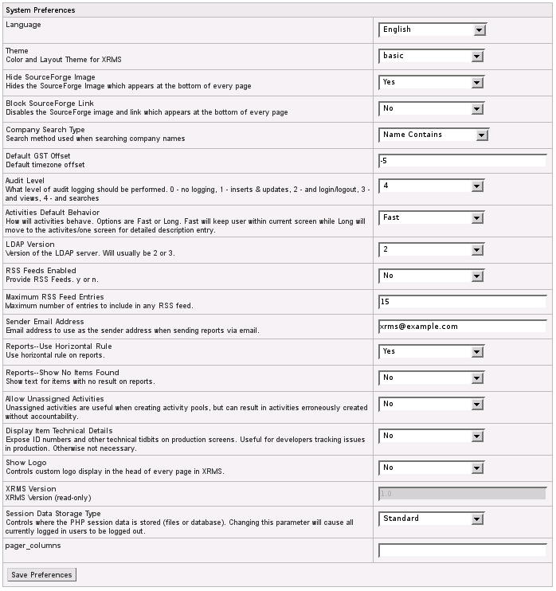
Figure 34: System Preferences Screen
You can select the language of your choice and the theme (UI colors and presentation) from the relevant drop-down lists.
Click Save Preferences to save your choices.
The following sections explain the different system parameters used in XRMS.

Activities Default Behavior
It is possible to define specific behaviors for different system parameters that are listed in the Manage System Parameters screen.
Click the Activities Default Behavior link in Manage System Parameter screen, see Figure 34, to reach the System Parameter: Activities Default Behavior screen.
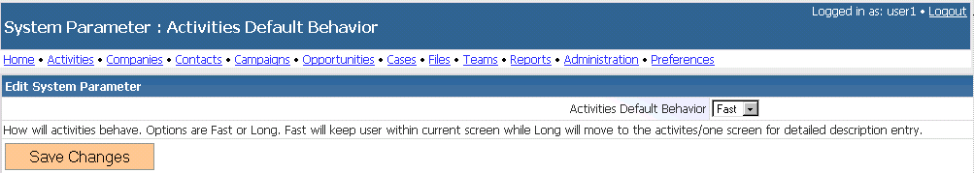
Figure 35: System Parameter - Activities Default Behavior
Choose the relevant option from the Activities Default Behavior drop-down list.
Available options are:
- Fast: The user remains within the current screen.
- Long: The user is taken to the activities/one screen for detailed description entry. This is the recommended value for most uses of XRMS.
After you select the option, click Save Changes to save the default behavior that you set.

Allow Unassigned Activities
This option allows Activities to not be assigned to an individual User of XRMS. In some environments, planned tasks or activities need to be unassigned initially, and will be assigned to particulaafr users later based on a business process. In most cases, it would be better to use Workflow (See Chapter 6) Navigate to Administration>System Parameters and click the Allow Unassigned Activities link to see the System Parameter: Allow Unassigned Activities screen.
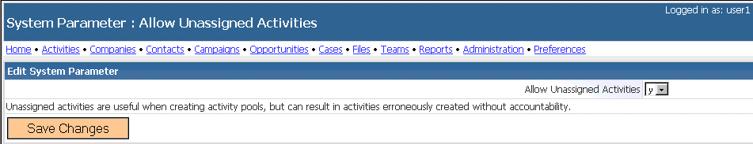
Figure 36: System Parameter - Allow Unassigned Activities
Choose the relevant option from the Allow Unassigned Activities drop-down list.
Available options are:
- y (to allow activities to be created without being assigned to a specific owner)
- n (to disallow an activity to be created without assigning it to a specific owner)
After you select the option, click Save Changes.

Audit Level
Navigate to Administration>System Parameters and click the Audit Level link to see the System Parameter: Audit Level screen.
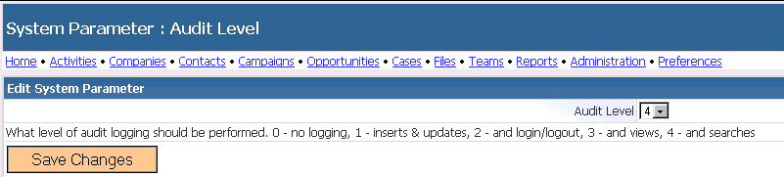
Figure 37: System Parameter: Audit Level
Choose the Audit Level option from the drop-down list.
Possible options and what they signify are:
Option | Description
0-No Logging. | No audit log is created.
1-Inserts and Updates | Audit log created for inserts and updates to the database.
2-Insert and Updates and Login/Logout | Audit log created for inserts and updates to the database as well as logins and logouts.
3-Inserts and Updates, Login/Logout and Views | Audit log created for inserts and updates to the database, logins, logouts, and views.
4-Inserts and Updates, Login/Logout, Views and Searches | Audit log created for inserts and updates to the database, logins, logouts, views, and searches.
After you select the relevant option, click Save Changes.

Default GST Offset
Navigate to Administration>System Parameters and click the Default GST Offset link to see the System Parameter: Default GST Offset screen.
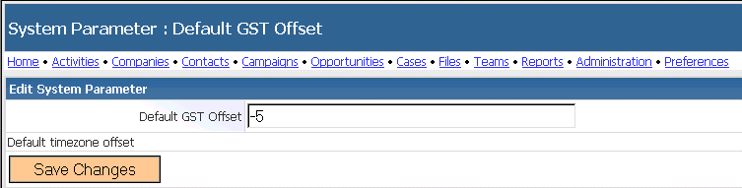
Figure 38: System Parameter - Default GST Offset
Enter a value in the text box beside Default GST Offset. The value you enter should indicate the number of hours ahead of (or behind) Greenwich Sidereal Time (GST). The format to enter this value is: 00:00:00 that corresponds to hours, minutes and seconds respectively.
NOTE: If the offset is negative, enter a minus sign in front of the offset. If the offset is positive, enter a plus sign in front of the offset.
After you enter the value, click Save Changes to store the offset.

Display Item Technical Details
Navigate to Administration>System Parameters and click the Display Item Technical Details link to see the System Parameter: Display Item Technical Details screen.
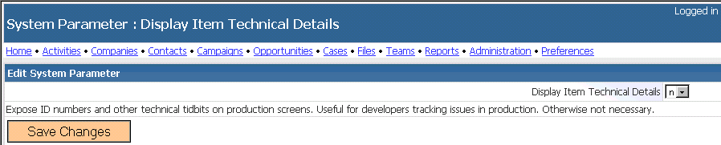
Figure 39: System Parameter - Display Item Technical Details
Choose the relevant option from the drop-down list beside Display Item Technical Details.
The possible options are:
- n ( technical details relevant to the items will not be displayed)
- y (technical details relevant to the items will be displayed)
After you select the option, click Save Changes.

LDAP Version
You can set the appropriate version of the Lightweight Directory Access Protocol (LDAP) server in XRMS. This Internet protocol is used by email programs to look up contact information from a server.
Go to Administration>System Parameters and click the LDAP Version link to see the System Parameter: LDAP Version screen.
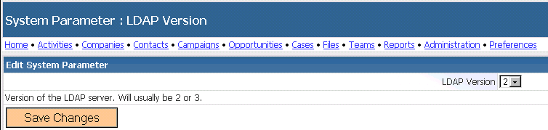
Figure 40: System Parameter - LDAP Version
Choose the appropriate LDAP version from the drop-down list. Current versions provided for in this list are: 2 and 3.
After you select the option, click Save Changes to save the LDAP version to be used.

Maximum RSS Feed Entries
Rich Site Summary or Really Simple Syndication (RSS) is a family of XML file formats used to access Web content available for distribution from an online publisher to Web users. RSS offers brief highlights of Web content with a link to the complete article. Web content made available for distribution online is delivered as an XML file and is called an RSS feed.
Setting the maximum of RSS feed entries allows organizations to define the highest number of RSS entries to be made available to XRMS users at any time. This is of particular relevance when the News plugin is enabled.
To set the maximum RSS feed entries, go to Administration>System Parameters and click the Maximum RSS Feed Entries link to see the System Parameter: Maximum RSS Entries screen.
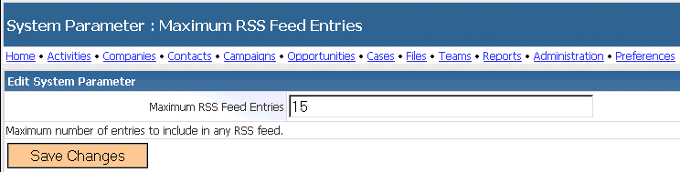
Figure 41: System Parameter - Maximum RSS Feed Entries
Enter the value in the text box beside Maximum RSS Feed Entries.
After you enter the value, click Save Changes.

Reports - Show No Items Found
If a user generates a report and no items are found, it is possible to display a message to this effect. The text of the message would be “No items found.” It is necessary to specify that this message should be displayed.
Go to Administration>System Parameters and click the Reports-Show No Items Found link to see the System Parameter: Reports-Show No Items Found screen.
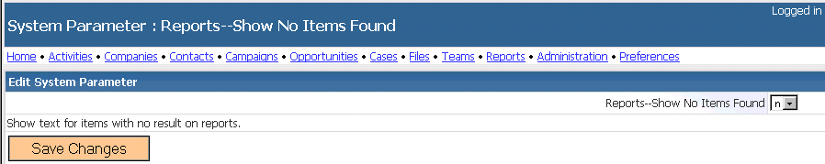
Figure 42: System Parameter – Reports -- Show No Items Found
Choose the relevant option from the drop-down list.
Available options are:
- n (No message is displayed.)
- y (Message “No Items Found” is displayed.)
After you select the option, click Save Changes.

Reports – Use Horizontal Rule
This feature is provided to define the appearance of XRMS reports. If a horizontal line is required at certain locations in a report it is important to set this feature.
Go to the Administration>System Parameters and click the Reports-Use Horizontal Rule link to see the System Parameter: Reports-Use Horizontal Rule screen.
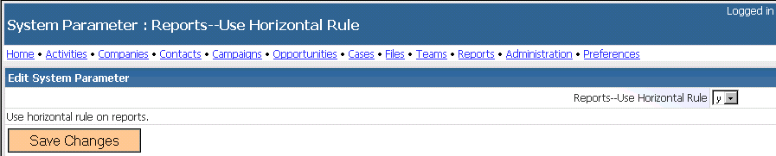
Figure 43: System Parameter - Reports -- Use Horizontal Rule
Choose the relevant option from the drop-down list.
The possible options are:
- n (Use a horizontal line within XRMS reports)
- y (Do not use a horizontal line within XRMS reports)
After you select the option, click Save Changes.

RSS Feeds Enabled
Web content made available for distribution online is delivered as an XML file and is called an RSS (Really Simple Syndication or Rich Site Summary) feed. If such feeds should be accessible from XRMS, it is necessary to enable the program to accept the feeds.
Go to Administration>System Parameters and click the RSS Feeds Enabled link to see the System Parameter: RSS Feeds Enabled screen.
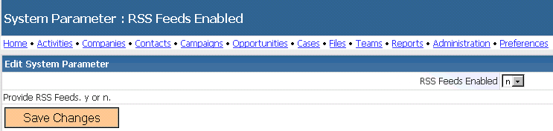
Figure 44: System Parameter - RSS Feeds Enabled
Choose the option from the drop-down list.
Available options are:
- n (Do not allow RSS Feeds)
- y (Allow RSS Feeds)
After you select the option, click Save Changes.

Sender Email Address
When sending reports using email, you can set the email address of the sender using the Sender Email Address parameter.
Go to Administration>System Parameters and click the Sender Email Address link to see the System Parameter: Sender Email Address screen.
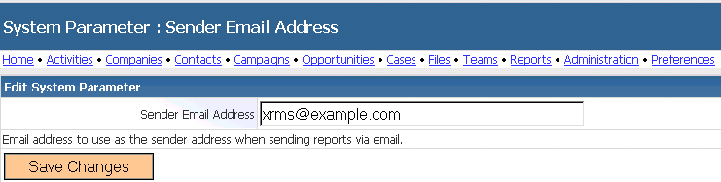
Figure 45: System Parameter - Sender Email Address
Enter the email address that needs to appear in the Sender box for emails in the text box beside Sender Email Address.
Click Save Changes to save the email id you have entered.

Users
You can add and edit user names, passwords, and select roles for users from the Manage Users screen.
Click on the Users link in the Administration screen (See Figure 1) to see the Manage Users screen.
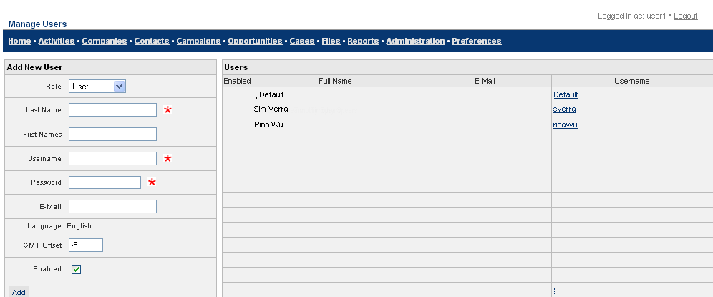
Figure 46: Manage Users Screen

Add a User
- Navigate to the Administration>Manage box.
- Click the Users link to see the Manage Users screen. This screen shows a list of existing users and also displays the Add New User box.
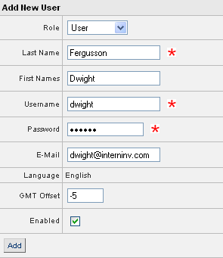
Figure 47: Add New User Box
- In the Add New User box, enter the fields as shown in the table.
Role: Choose the user’s role from the drop-down list.
Last Name: Enter the last name of the user.
First Names: Enter the first name(s) of the user.
Username: Enter a login user name that is unique to this user.
Password: Enter a password for this user.
Email: Enter the email address of the user.
Language: This is a display field and shows the default language set.
GMT Offset: Number of hours added or subtracted from Greenwich Mean Time.
Enabled: Select this check box to activate the user.
- To save the details of the new user, click Add. You see the new user added to the Users box in the Manage Users screen.

Edit User Details
User roles and groups can be managed from the User Details screen. A user can be assigned to roles within groups using the sidebar in the Edit User pages.
- Navigate to the Administration>Manage box and click the Users link to reach the Manage Users screen.
- Review the list of users and their details as shown in Figure 46 and click on the username of the user in the Manage Users screen whose details you want to change. You see the User Details screen.
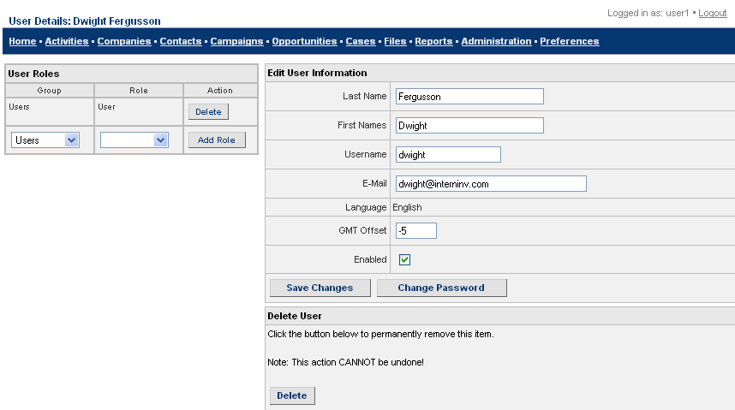
Figure 48: User Details Screen
- All the fields in this screen are the same as in the Add New User box (See 4.7.1 Add a User). The only fields missing here are Role and Password.
- After you make the changes, click Save Changes.
- To change the Password, click Change Password. You see the Change Password screen.
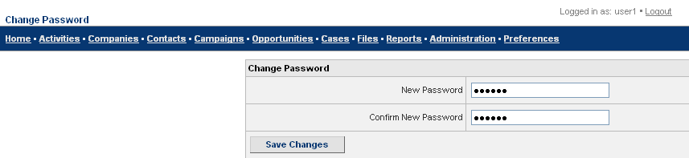
Figure 49: Change Password Screen
- Enter the new password in the fields and click Save Changes.

Delete a User
Follow these steps to delete an XRMS user.
- Navigate to Administration>Manage box and click the Users link to see the Manage Users screen.
- Click on the username of the person whose details you wish to delete to get to the User Details screen (See Figure 48).
- Review details of the user in the User Details screen.
- Click Delete in the Delete User box to delete the details of this user.

Types and Statuses
Before XRMS can be implemented, it is necessary that the various default values to be used are reviewed and edited appropriately. Defaults can be added, modified, or deleted. However, when a default is deleted, it loses all its associations with companies, contacts, cases, and campaigns.
The different XRMS defaults are:
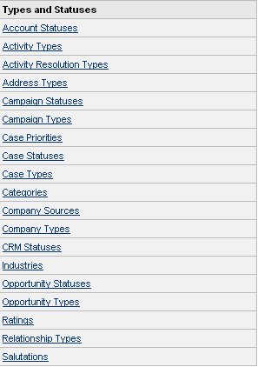
Figure 50: Types and Statuses
There is no fixed limit on the number of items that can be added under a single group.
Types and statuses in Activity Templates are used to define the Workflow. For more details, see Chapter 6 Workflow.

Add a Default Value
This section is divided into two parts. Defaults that:
- Follow a common procedure to add values.
- Do not follow a common procedure to add values.

Defaults that Follow a Common Procedure to Add Values
The defaults that follow a common procedure to add values share many fields in common. The fields present in the different default screens are indicated by check marks in the table below.
XRMS Defaults | Short Name | Full Name | Full Plural Name | Display HTML | Score Adjustment | Description | Open Status
Account Statuses | ✓ | ✓ | ✓ | ✓
Activity Types | ✓ | ✓ | ✓ | ✓ | ✓
Activity Resolution Types | ✓ | ✓
Campaign Statuses | ✓ | ✓ | ✓ | ✓ |  |  | ✓
Campaign Types | ✓ | ✓ | ✓ | ✓
Case Priorities | ✓ | ✓ | ✓ | ✓ | ✓
Case Types | ✓ | ✓ | ✓ | ✓
Categories | ✓ | ✓ | ✓ | ✓
Company Sources | ✓ | ✓ | ✓ | ✓ | ✓
Company Types | ✓ | ✓ | ✓ | ✓
CRM Statuses | ✓ | ✓ | ✓ | ✓
Industries | ✓ | ✓ | ✓ | ✓
Opportunity Statuses | ✓ | ✓ | ✓ | ✓ |  | ✓ | ✓
Opportunity Types | ✓ | ✓ | ✓ | ✓
Ratings | ✓ | ✓ | ✓ | ✓
To add values, click on the Administration link in the top bar to see the Administration screen (See Figure 1).
Go the Types and Statuses box (See Figure 50) to select the items for which you would like to add default values.
Since the procedure to add values is common across the types and statuses we will consider the following two defaults to see how values are added:
- Opportunity Statuses that individually contains the largest number of fields.
- Case Priorities that has some fields not available in Opportunity Statuses.
Together, these two items cover the entire list of fields.

Opportunity Statuses
Opportunity Statuses is a default to create different status levels for opportunities. New, Preliminaries, Discussions, and Negotiations are some examples of status levels.
To create a new opportunity status, follow the steps below:
- Go to Administration>Types and Statuses and click the Opportunity Statuses link to see the Manage Opportunity Statuses screen.
- 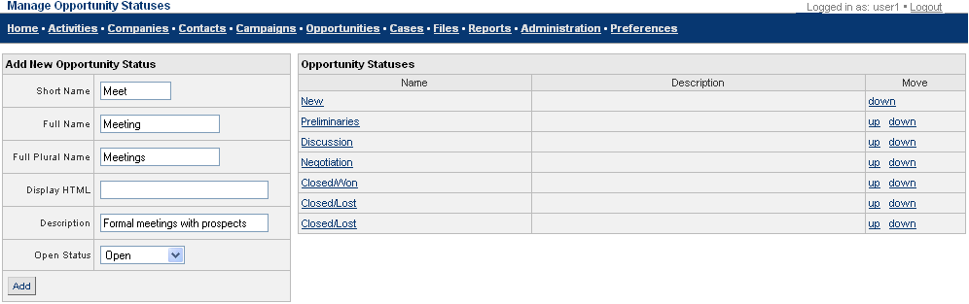
Figure 51: Manage Opportunity Statuses
- Enter the fields in the Add New Opportunity Status box as given in the table below:
Short Name: Enter an abbreviation for the status. For example, OP for open.
Full Name: Enter the complete name of the status. For example, Open.
Full Plural Name: Enter the plural of the status name.
Display HTML: Enter the HTML format of the status name.
Description: Enter a description of the type of status that is being dealt with.
Open Status: Choose the status of the opportunity from the drop-down list. The options are: open, closed and won, closed and lost.
- When you have finished entering the fields, click Add to see the opportunity status added to the Opportunity Statuses table.
To Reorder Items in the Opportunity Statuses table
- Click the up or down link as required in the Move column beside the opportunity status that you wish to reorder in the table.
- The opportunity status moves up or down one row as appropriate.
To link an Opportunity Status to a Workflow Activity
- Click on the name of an Opportunity Status in the Manage Opportunity Status screen, Figure 51. You see the Edit Opportunity Status Information screen with the Link Workflow Activity To Opportunity Status box where you can edit Opportunity Status information and link an Opportunity Status to a workflow activity.
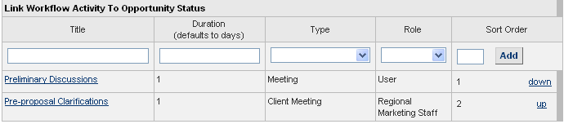
Figure 52: Link Opportunity Status to Workflow Activity Box
- Enter details in the following fields.
Title: Enter the name of the activity to which you wish to link an opportunity status.
Duration: Enter the number of days by which the activity should be complete.
Type: Select the opportunity type from the drop-down list.
Role: Select to which the activity should be assigned from the drop-down list.
Sort Order: Enter the order of display of this item in the table that is created.
- Click Add. This saves the details and displays them in a row in the table below.
To Edit or Delete an Opportunity Status
To edit or delete an activity linked to an opportunity status, click the activity name to see the Activity Details screen. See 4.2.2 View, Edit, and Delete Activity Templates for more details.

Case Priorities
Case Priorities is a default to create different types of priority levels for cases. Low, Medium, High, and Critical are some examples of priority levels.
To create a new type of case priority, follow the steps below:
- Go to Administration>Types and Statuses and click the Case Priorities link to see the Manage Case Priorities screen.
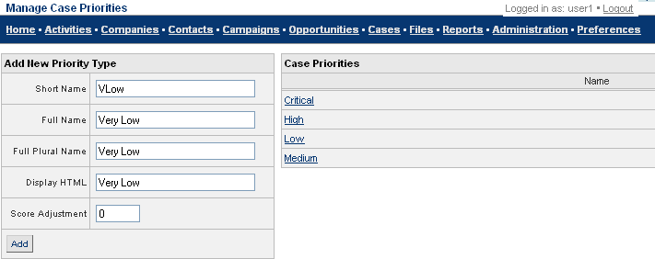
Figure 53: Manage Case Priorities Screen
- Enter the fields in the Add New Priority Type box as given in the table below:
Short Name: Enter a short name for the priority type.
Full Name: Enter the entire name of the priority type.
Full Plural Name: Enter the plural of the name.
Display HTML: Enter the HTML format of the priority name.
Score Adjustment: Deprecated – no longer used
- After you enter values in the fields, click Add. The new value added is shown in the Case Priorities box.
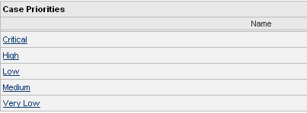
Figure 54: Case Priorities Box

Defaults that Do Not Follow a Common Procedure to Add Values
The defaults that do not follow a common procedure to add values are:
- Address Types
- Case Statuses
- Relationship Types
- Salutations

Address Types
Address Types is a default to create different types of addresses. Commercial and Residential are examples of address types.
To create a new address type, follow the steps below:
- Go to Administration>Types and Statuses and click the Address Types link to see the Manage Address Types screen.
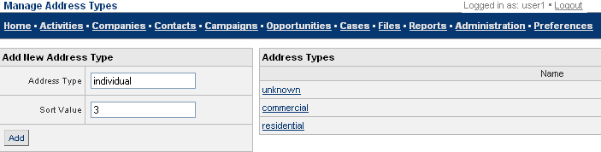
Figure 55: Manage Address Types
- Enter the fields in the Add New Address Type box as given in the table below:
Address Type: Enter the name of the address type. For example, Individual.
Sort Value: Sort order for the address type. The sort order helps you define the order in which the address types are displayed when an address type is created or edited.
- After you enter the fields, click Add. You see the new value displayed in the Address Types box of the Manage Address Types screen
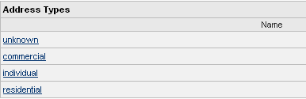
Figure 56: Address Types Box

Case Statuses
Case Statuses are used to create different status levels for different status types.
To create a new case status, follow the steps below:
- Go to Administration>Types and Statuses and click the Case Statuses link to see the Manage Case Statuses screen.
- From the Case Type drop-down list, select the Case Type for which you wish to view, add, edit, or delete a case status. This takes you to the next Manage Case Statuses screen that list case statuses for this case type. You can also add a case status here.
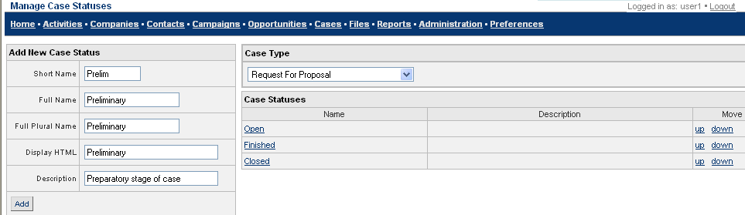
Figure 57: Manage Case Statuses Screen
- Enter the fields in the Add New Case Status box as given in the table below:
Short Name: Enter a short name for the case status.
Full Name: Enter the entire name of the case status.
Full Plural Name: Enter the plural of the case status.
Display HTML: Enter the HTML format of the case status.
Description: Enter a description for the case status that you plan to add.
- After entering all the fields, click Add. You see the new value in the Case Statuses box of the Manage Case Statuses screen.

Relationship Types
XRMS handles different types of relationships between one company and another company, between contacts in different companies, and between a contact and a company, and vice versa. In fact, relationships can be defined between almost any entity in the system: companies, contacts, divisions and so on.
The Relationship Types default is used to create different relationship roles.
To create a new relationship type, follow the steps below:
- Go to Administration>Types and Statuses and click the Relationship Types link to see the Manage Relationship Types screen.
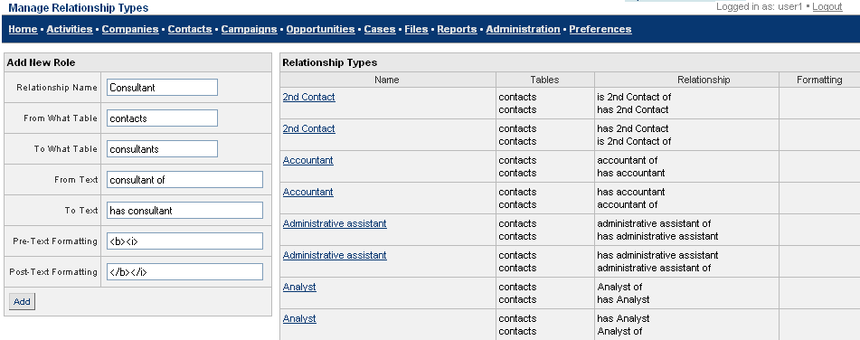
Figure 58: Manage Relationship Types Screen
- Enter the fields in the Add New Role box as given in the table below:
Relationship Name: Enter the name of the relationship. For example, Consultant.
From What Table: Enter the name of the database table from which this relationship is being created.
To What Table: Enter the name of the database table to which the relationship is being created.
From Text: Enter information regarding the relationship in terms of how one entity (contact or company) relates to the other. For example: vendor of, consultant to, or subsidiary of.
To Text: Enter details of how the other entity is related to the first. For example, purchaser of, has consultant, or parent company.
Pre-Text Formatting and Post-Text Formatting: Used before and after the relationship name to result in appropriate HTML markup on the title. Example <b> and </b> in the corresponding fields will make the display of the relationship name bold.
- After you enter the fields, click Add. The new value is shown in the Relationship Types box of the Manage Relationship Types screen.

Salutations
The salutations feature is used to create different forms of addressing a contact.
To create a new salutation, follow the steps below:
- Go to Administration>Types and Statuses and click the Salutations link to see the Manage Salutations screen.
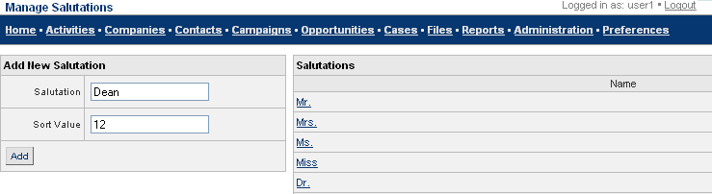
Figure 59: Manage Salutations Screen
- Enter the fields in the Add New Salutation box as given in the table below.
Salutation: Enter the name of the salutation. For example, Dean, Dr., and so on.
Sort Value: Enter the order the salutation should appear in the Salutations list. If you enter 5 here, it appears 5th in the list.
- After you enter the fields, click Add. The new value is shown in the Salutations box and is listed in the order you provided in Sort Value.

Edit and Delete Default Values
You can edit default values in the Default Value Details screen. The procedure to edit and delete a default value is the same for all defaults.
This guide provides the procedure to edit and delete values in Opportunity Statuses, Activity Types, and Categories. This information is presented in the following sections.

Opportunity Statuses
To edit an opportunity status, follow the steps below:
- Go to Administration>Types and Statuses and click the Opportunity Statuses link to see the Manage Opportunity Statuses screen (See Figure 51). The Opportunity Statuses box on the right of the screen lists all the values created for the default.
- Click the status to be edited. For example, Discussion. You would then see the Opportunity Status Details: Discussion screen.
- 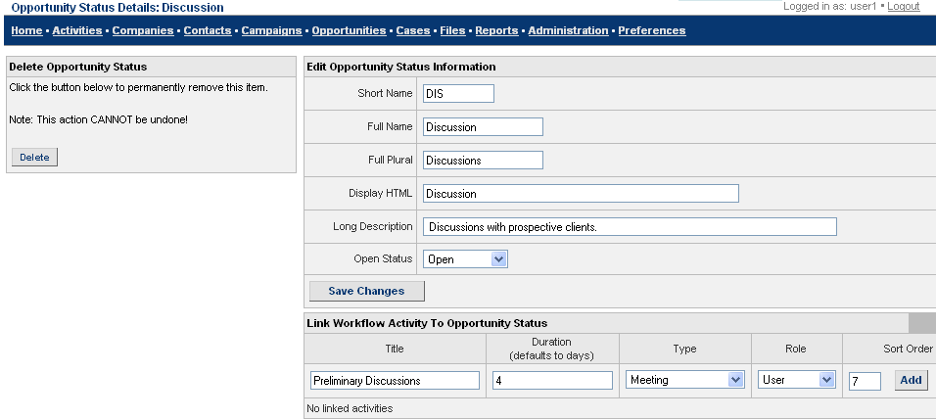
Figure 60: Opportunity Status Details Screen
- To edit information about the Opportunity status, go to the Edit Opportunity Status Information box. All the fields in this box are the same as in Add New Opportunity Status box in Figure 51: Manage Opportunity Statuses.
- After you make the required changes, click Save Changes.
To link a Workflow Activity to an Opportunity Status
You can link a workflow activity to a given opportunity.
- Enter the fields to link an activity as given in the table below:
Title: Enter the title of the activity.
Duration: Enter the duration of the activity.
Type: Choose the type of activity from the drop-down list.
Role: Select the role to be linked to the opportunity from the drop-down list.
Sort Order: Enter the order of this workflow activity.
- Click Add. The activity is displayed below the row of fields that you entered.
Figure 61: Link Workflow Activity to Opportunity Status
To delete an Opportunity Status
To delete an Opportunity Status, click Delete in the Delete Opportunity Status box in Figure 60. This deletes the Opportunity Status from all the drop-down lists in which it currently exists.

Activity Types
Activity Types are used to determine the different types of activities in the system. The activity types provided with XRMS cannot be edited, and are marked as such in the database. Any newly added user activity type could be edited.
To edit an activity type, do the following:
- Go to Administration>Types and Statuses box and click the Activity Types link to see the Manage Activity Types screen.
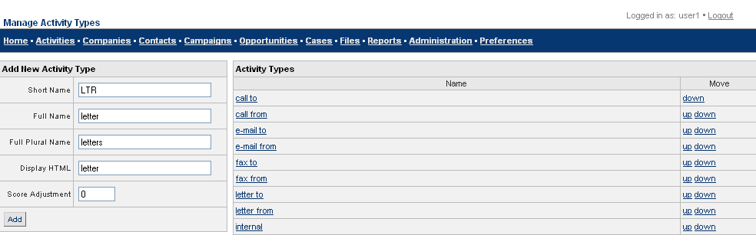
Figure 62: Manage Activity Types Screen
- The Activity Types box lists all the activities created. Click on the activity you wish to edit. For example, Fax. You see the Activity Type Details: Fax screen.
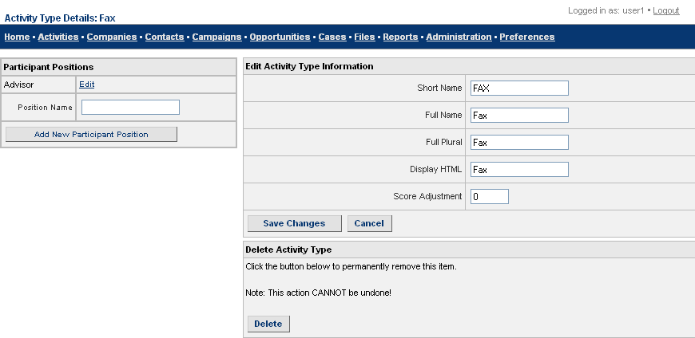
Figure 63: Activity Type Details Screen
- To make changes, go to the Edit Activity Type Information box.
Modify any of the fields as given in the table below:
Short Name: Enter a short name for the activity type.
Full Name: Enter the entire name of the activity type.
Full Plural Name: Enter the plural of the name.
Display HTML: Enter the HTML format of the name.
Score Adjustment: Deprecated – no longer used
- After you make all the changes, click Save Changes.
To add a new Participant Position
Participant positions link contacts to activities. The default position is Participant and exists in each activity type. Other participant positions need to be defined for each activity type. Example: CC and BCC and To and From are all positions defined for email types.
To define a participant position:
- Go to the Participant Positions box in the Activity Type Details screen, Figure 63.
- Enter a new role in the text box beside Position Name.
- Click Add New Participant Position to save the new role.
To Edit an Existing Participant Position
- In the Participant Positions box in the Activity Type Details screen (See Figure 63), click Edit beside the existing position that you wish to edit. You see the Edit Activity Participant Position screen.
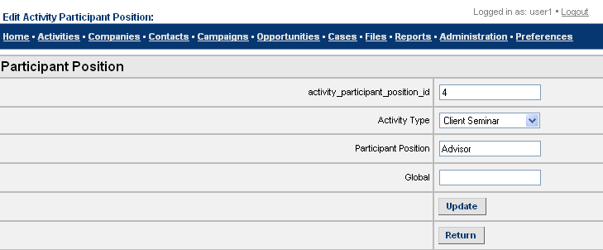
Figure 64: Edit Activity Participant Position Screen
- Make changes to the fields as necessary.
- Click Update to save the edited details and see the Participant Position Details screen.
- Click Return to go back to the Activity Type Details screen.
To delete an Activity Type
To delete an activity type, click Delete in the Delete Activity Type box in Figure 63. This permanently deletes the activity from all screens.

Categories
To edit a category, follow the steps below:
- Go to Administration>Types and Statuses and click the Categories link to see the Manage Categories screen.
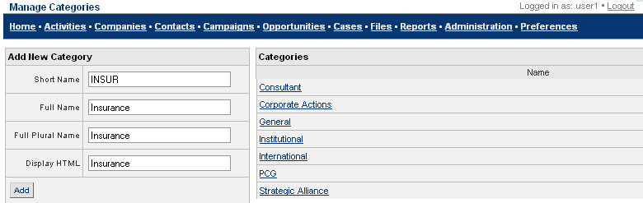
Figure 65: Manage Categories Screen
- The Categories box on the right lists all the values created for the default. Click on the value to be edited. For example, General. You see the Category Details: General screen.
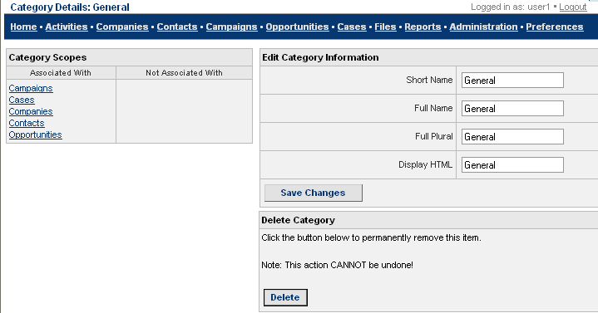
Figure 66: Category Details Screen
- To edit category details, go to the Edit Category Information box.
Modify any of the fields as given in the table below:
Short Name: Enter a short name for the category.
Full Name: Enter the entire name of the category.
Full Plural Name: Enter the plural of the name.
Display HTML: Enter the HTML format of the name.
- After you make all the changes, click Save Changes.
Other Tasks done from the Category Details Screen
Besides the edits mentioned, you can also do the following:
- To | - Do
- Set the scope of the category value in the Category Scopes box  - Items in the Associated With column are related to the category | - Click on an item name in the Associated With column to move the item to the Not Associated With column.  - Similarly, click on an item in the Not Associated With column to move it to the Associated With column.
- Delete a category | - Click the name of the category you wish to delete in the Manage Categories screen (See Figure 65). You will now see the Category Details screen.  - Click Delete in the Delete Category box. This deletes the category from all XRMS screens.

Workflow
Workflow is currently applicable to the Opportunities and Cases features of XRMS. It will eventually apply to the Campaigns feature.
Activity Templates are used to define workflow using Types and Statuses, see Section 4.2 for more details on these templates. An Activity Template is used to create a new activity when the status or type of a case or opportunity changes. Every activity in the Activity Template is assigned to a user with the same role as that defined for the activity in the Activity Template. When numerous users have the same role, the sequence of activity assignment starts from those users with the same role that have the least number of open activities.
The concept of workflow can be represented as follows:
As an Opportunity or Case progresses…  A new Opportunity or Case is created  In next Status of the Opportunity or Case.  \ | Each Opportunity or Case has a “Type”.  Each Opportunity Type and Case Type has a “Status”.  Each Opportunity Status or Case Status has Workflow Activity Templates.  Activity Templates define the standard activities associated with each status.
New Activities are created from the activity templates and assigned based on the Role defined in the activity template.
When the said new activities are completed, further new activities are created from the activity templates and assigned based on the role defined in the activity template.
This cycle of creating new activities from templates, and assigning activities based on roles in the activity template continues until all the activities under a specific status are completed.
The case or opportunity now moves to the next status.

 | - The process of creating new activities from activity templates and assigning them based on roles in the activity template, repeats for the activities in this status.

Plugins
Plugins are a convenient means of adding functionlaity to XRMS CRM or linking to external applications. Plugins can be activated in the XRMS Administration panel and some plugins require that other programs or components be installed.

Activating Plugins
Click on the Plugin Activation link in the Plugin box of the Administration screen (See Figure 1). You see the Plugin Administration screen.
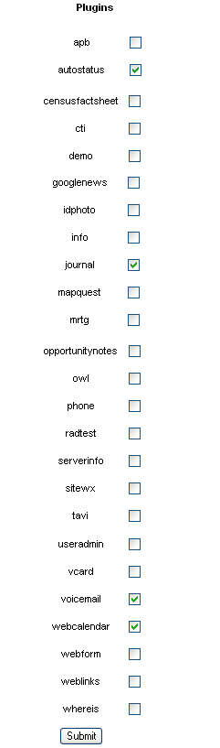Figure 67: Plugin Administration Screen

Plugins Included with XRMS CRM
Included Plugins and related information about them are in the table that follows:
Plugin Name | Activation | Description
Apb | Requires installation of apb. | Active PHP Bookmarks enable users to bookmark websites and share these bookmarks.
Cti | Installation required. | Connection to the Asterisk Open Source PBX http://www.asterisk.org/ voicemail system.
Demo | Administration Panel and addition of a webpage demo.php. | Link to a demo page within XRMS. The demo page would have to be provided.
Dunfinder | Installation required. | Dial-Up Number Finder for the US.
Idphoto
Info | Installation required. | Additional values to track characteristics of computers.
Mapquest | Administration Panel only. | Passes address to mapguest.com to do an address lookup.  Both whereis and mapquest cannot be activated at the same time.
MRTG | Installation required. | Multi Router Traffic Grapher.
opportunitynotes | Administration Panel only. | Add notes to an Opportunity.
owl | Installation required. | Uses OWL for file storage. Features file versioning, hierarchical mini-filesystem with folders, and searching within files.
Phone | Administration Panel. | Searches for phone numbers in Company or Contact.
Tavi
Useradmin | Administration Panel only. | Selecting this plugin is NOT RECOMMENDED.
Vcard | Administration Panel only. | Creates a vcard of the Contact
Webform | Installation required. | Creates a webform on your external website.
Weblinks
Whereis | Administration Panel only. | Passes address to whereis.com.au (Australia) to do an address lookup.  Both whereis and mapquest cannot be activated at the same time.

Developing Plugins
The plugin system in XRMS CRM is derived from the popular webmail system Squirrelmail. See: http://www.squirrelmail.org/ Many thanks to the Squirrelmail development team for creating such a flexible plugin architecture that was so quickly adapted to use in XRMS (less than a day of work was required to add plugin functionality from Squirrelmail into XRMS)
This section of the XRMS Administration Guide is likewise adapted from the Squirrelmail Plugin documentation, which is also released under the GNU Free Documentation License. See: http://www.squirrelmail.org/wiki/DevelopingPlugins The SM pages may provide more detail in some places than this guide, but any incompatibilities will be solely the fault of the XRMS Development team.

Plugin Architecture
The plugin architecture of XRMS is designed to make it possible to add new features without having to patch XRMS itself. Traditionally, because of their position at the core of an enterprise architecture, CRM systems are heavily integrated to other systems.
The Idea
The idea is to be able to run random code at given places in the XRMS code. This random code should then be able to do whatever needed to enhance the functionality of XRMS. The places where code can be executed are called "hooks".
There are some limitations in what these hooks can do. It is difficult to use them to change the layout (this is done using Templates) and to change some core functionality that is already in XRMS.
Some way for the plugins to interact with the help subsystem and translations will be provided in the near future.
The Implementation
The plugin jumping off point in the main XRMS code is in the file plugin.php. In places where hooks are made available, they are executed by calling the function do_hook('hookname'). The do_hook function then traverses the array $xrms_plugin_hooks['hookname'] and executes all the functions that are named in that array. Those functions are placed there when plugins register themselves with XRMS as discussed below. A plugin may add its own internal functions to this array under any hook name provided by the XRMS developers.
A plugin must reside in a subdirectory in the plugins/ directory. The name of the subdirectory is considered to be the name of the plugin. (The plugin will not function correctly if this is not the case.)
When a plugin is registered, the file plugins/plugin_name/setup.php is included and the function xrms_plugin_init_plugin_name() is called with no parameters. That function is where the plugin may register itself against any hooks it wishes to take advantage of.

Writing Plugins
All plugins must contain a file called setup.php and must include a function called xrms_plugin_init_plugin_name() therein. Since including numerous plugins can slow XRMS performance considerably, the setup.php file should contain little else. Any functions that are registered against plugin hooks should do little more than call another function in a different file.
Any other files used by the plugin should also be placed in the plugin directory (or subdirectory thereof) and should contain the bulk of the plugin logic.
The function xrms_plugin_init_plugin_name() is called to initalize a plugin. This function could look something like this (if the plugin was named "demo" and resided in the directory plugins/demo/):

function xrms_plugin_init_demo ()
{
global $xrms_plugin_hooks;

$xrms_plugin_hooks['generic_header']['demo'] = 'plugin_demo_header';
$xrms_plugin_hooks['menuline']['demo'] = 'plugin_demo_menuline';
}
In this example, the "demo" plugin should also have two other functions in its setup.php file called plugin_demo_header() and plugin_demo_menuline(). The first of these might look something like this:
function plugin_demo_header()
{
include_once($include_directory . 'plugins/demo/functions.php');
plugin_demo_header_do();
}

The function called plugin_demo_header_do() would be in the file called functions.php in the demo plugin directory and would contain the plugin's core logic for the "generic_header" hook.

Including Other Files
A plugin may need to reference functionality provided in other files, and therefore need to include those files. Most of the core XRMS functions are already available to your plugin unless it has any files that are requested directly by the client browser (custom options page, etc.). In this case, you'll need to make sure you include the files you need (see below).
Files are included like this:
include_once($include_directory . 'include/validate.php');

When including files, please make sure to use the include_once() or require_once() functions and NOT include() or require(), since these all are much less efficient than include_once() and can have a cumulative effect on XRMS performance. In older versions of PHP (prior to PHP 4.3.11) require_once() was also less efficient than include_once(), but this is not true in newer versions of PHP.
The files that you may need to include in a plugin will vary greatly depending upon what the plugin is designed to do. For files that are requested directly by the client browser, we strongly recommend that you include the file $include_directory.vars.php, since it will set up the XRMS environment automatically. It will ensure the the user has been authenticated and is currently logged in, load all user preferences, include internationalization support, and initialize and include many other basic XRMS resources and functions.

Hook Types
do_hook
-------
Most hook calls don't pass any data and don't ask for anything back. These always use the do_hook call. A limited number of do_hook calls do pass some extra parameters, in which case your plugin may modify the given data if you do so by reference. It is not necessary to return anything from your function in such a case; modifying the parameter data by reference is what does the job (although the hook call itself (in the source) must grab the return value for this to work). Note that in this case, the parameter to your hook function will be an array, the first element simply being the hook name, followed by any other parameters that may have been included in the actual hook call in the source. Modify parameters with care!

do_hook_function
----------------
This hook type was intended to be the main hook type used when the source needs to get something back from your plugin. It is somewhat limited in that it will only use the value returned from the LAST plugin registered against the hook. The source for this hook might use the return value for internal purposes, or might expect you to provide text or HTML to be sent to the client browser (you'll have to look at its use in context to understand how you should return values here). The parameters that your hook function gets will be anything you see AFTER the hook name in the actual hook call in the source. These cannot be changed in the same way that the do_hook parameters can be.

concat_hook_function
--------------------
This is a hook type meant to address the shortcomings of do_hook_function; specifically in that it uses the return values of all plugins registered against the hook. In order to do so, the return value is assumed to be a string, which is just piled on top of whatever it got from the other plugins working on the same hook. Again, you'll have to inspect the source code to see how such data is put to use, but most of the time, it is used to create a string of HTML to be inserted into the output page. The parameters that your hook function will get are the same as for the do_hook_function; they are anything AFTER the hook name in the actual hook call in the source.

boolean_hook_function
---------------------
This hook type is used to let all plugins registered against the hook to "vote" for some action. What that action is is entirely dependent on how the hook is used in the source (look for yourself). Plugins make their "vote" by returning TRUE or FALSE. This hook may be configured to "tally votes" in one of three ways. This configuration is done with the third parameter in the hook call in the source:
> 0 -- Any one or more TRUEs will override any FALSEs
< 0 -- Any one or more FALSEs will override any TRUEs
= 0 -- Majority wins. Ties are broken in this case with
the last parameter in the hook call in the source.
Your hook function will get the second parameter in the hook call in the source as its parameter (this might be an array if multiple values need to be passed).

See below for further discussion of special hook types and the values

List of Hooks
The table below shows all the hooks in XRMS CRM as of the last edit of this document. It describes:
- the name of the hook: this is the hook name that a plugin registers to handle
- any parameters passed to the hook
- the type of hook (do_hook,do_hook_function,concat_hook_function,boolean_hook)
- the source file the hook appears in
Understanding some hooks should be possible just from reading this table. Other hooks will require scrutinizing the code to understand what they are intended to do. Some hooks will expect the plugin author to directly output any data that they wish to display: the sidebar hooks are a good example of this type of hook. Other hooks are deeply integrated into the XRMS code: authentication and file management hooks are a good example of these types of hooks. You will need to understand the requirements of the plugin you wish to create, and decide which hooks best meet your needs. If you are developing a plugin and need a hook somewhere in the code that does not currently have one, please contact the XRMS CRM core development team. We'll be happy to work with you to help you integrate your code.
Hook Name | Parameters | Hook Type | File
activity_content_bottom | $param | do_hook_function | activities/one.php
activity_edit_2 | $param | do_hook_function | activities/edit-2.php
activity_inline_edit' | $activity_rst | do_hook_function | activities/one.php
activity_new_2 | $rec | do_hook_function | activities/new-2.php
activity_sidebar_bottom' | $param | do_hook_function | activities/one.php
admin_user_edit_sidebar | $sidebar_rows | do_hook_function | admin/users/one.php
bodytags |  | do_hook | include/utils-interface.php
change_company_key | $param | do_hook_function | include/utils-companies.php
company_accounting_inline_display | $accounting_rows | do_hook_function | companies/one.php
company_accounting_inline_edit | $accounting_rows | do_hook_function | companies/edit.php
company_accounting_inline_edit_2 | $accounting_rows | do_hook_function | companies/edit-2.php
company_buttons | $company_buttons | do_hook_function | companies/one.php
company_content_bottom | $bottom_rows | do_hook_function | companies/one.php
company_detail |  | do_hook_function | companies/one.php
company_detail |  | do_hook | plugins/phone/companies_one.php
company_edit_2 | $param | do_hook_function | companies/edit-2.php
company_edit_address_2 | $param | do_hook_function | companies/edit-address-2.php
company_edit_address_2 | $param | do_hook_function | companies/one-address.php
company_new_2 | $rec | do_hook_function | companies/new-2.php
company_sidebar_bottom | $sidebar_rows | do_hook_function | companies/one.php
company_sidebar_bottom | $sidebar_rows | do_hook_function | plugins/phone/companies_one.php
contact_accounting_inline_display | $accounting_rows | do_hook_function | contacts/one.php
contact_accounting_inline_edit | $accounting_rows | do_hook_function | contacts/edit.php
contact_custom_inline_edit_display | $contact_custom_rows | do_hook_function | contacts/edit.php
contact_custom_inline_edit_validate | $_POST | do_hook_function | contacts/edit-2.php
contact_custom_inline_new_display | $contact_custom_rows | do_hook_function | contacts/new.php
contact_edit_2 | $param | do_hook_function | include/utils-contacts.php
contact_edit_2 | $param | do_hook_function | include/utils-contacts.php
contact_edit_address_2 | $param | do_hook_function | contacts/edit-address-2.php
contact_new_2 | $contact_data | do_hook_function | include/utils-contacts.php
contact_sidebar_bottom | $sidebar_rows_bottom | do_hook_function | contacts/one.php
contact_sidebar_top | $sidebar_rows_top | do_hook_function | contacts/one.php
contact_transfer_3 |  | do_hook | contacts/transfer-3.php
data_format_phone | $phone_array | do_hook_function | include/utils-misc.php
division_sidebar_bottom' | $sidebar | do_hook_function | companies/edit-division.php
edit_division_form | $edit_division_form_extra | do_hook_function | companies/edit-division.php
edit_division_process | $rec | do_hook_function | companies/edit-division-2.php
end_page |  | do_hook | include/utils-interface.php
file_add_file | $file_plugin_params | do_hook_function | include/utils-files.php
file_add_file | &$file_plugin_params | do_hook_function | files/new.php
file_add_folder | &$folder_plugin_params | do_hook_function | plugins/owl/new_folder-2.php
file_browse_files | $plugin_params | do_hook_function | files/sidebar.php
file_delete_file | &$file_plugin_params | do_hook_function | files/delete.php
file_delete_folder | &$folder_plugin_params | do_hook_function | plugins/owl/delete_folder.php
file_download_file | $plugin_params | do_hook_function | files/download.php
file_get_file_info | &$file_plugin_params | do_hook_function | files/one.php
file_get_one_file_html | &$file_plugin_params | do_hook_function | files/one.php
file_search_files | $file_plugin_params | do_hook_function | files/some.php
file_search_files | $file_plugin_params | do_hook_function | plugins/owl/owl_plugin.php
file_search_files_callback | $file_plugin_params | do_hook_function | files/some.php
file_update_file | &$file_plugin_params | do_hook_function | files/edit-2.php
file_update_file | &$file_plugin_params | do_hook_function | files/edit-2.php
home_docs | $param | do_hook_function | private/home.php
login_before |  | do_hook | login-2.php
login_cookie |  | do_hook | login.php
login_form |  | do_hook | login.php
login_verified |  | do_hook | login-2.php
loginbar |  | do_hook | include/utils-interface.php
logout |  | do_hook | logout.php
menuline |  | do_hook | include/utils-interface.php
new_division_form | $new_division_form_extra | do_hook_function | companies/divisions.php
new_division_process | $rec | do_hook_function | companies/add-division.php
one_contact_buttons | $contact_buttons | do_hook_function | contacts/one.php
one_contact_buttons |  | do_hook | plugins/phone/contacts_one.php
one_contact_left |  | do_hook | contacts/one.php
one_contact_right |  | do_hook | contacts/one.php
opportunity_detail |  | do_hook | opportunities/one.php
opportunity_notes_buttons |  | do_hook | activities/one.php
plugin_admin |  | do_hook | admin/index.php
preference_possible_values | $option_record | do_hook_function | include/utils-preferences.php
private_front_splash |  | do_hook_function | private/home.php
private_body_bottom |  | do_hook_function | private/home.php
private_sidebar_bottom |  | do_hook_function | private/home.php
reports_bottom |  | do_hook | reports/index.php
run_on_completed | $activity_id | do_hook_function | activities/edit-2.php
topofpage |  | do_hook | include/utils-interface.php
workflow_addition | $activity_template_id | do_hook_function | activities/workflow-activities.php
workflow_system | $template_info | do_hook_function | activities/workflow-activities.php
xrms_acl_auth |  | do_hook_function | include/classes/acl/xrms_acl_config.php
xrms_acl_database_access | $options | do_hook_function | include/classes/acl/xrms_acl_config.php
xrms_install | $con | do_hook_function | install/install.php
xrms_test_suite | $suite_array | do_hook_function | tests/xrms_test.php
xrms_update | $con | do_hook_function | admin/update.php
xrms_update | $con | do_hook_function | admin/updateto2.0.php

Manage Info Types [[This link is not seen in the current version ?]]
There are different types of information that need to be maintained to ensure that the XRMS application runs according to user specifications. Administrators can add, edit, and delete fields that need to appear in different screens as well as specify where these fields should be displayed within a given screen.

Add an Info type
To add an info type, do the following:
- Navigate to Administration>Plugins and click the Manage Info Types link to reach the Manage Info Types screen.
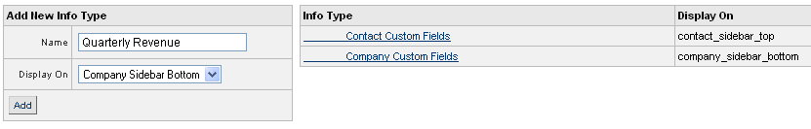
Figure 68: Manage Info Types
- In the Add New Info Type box, enter the fields as given in the table below:
Name: Enter the name of the new info type.
Display On: Choose the position of display of this info type to the user from the drop-down list.
- Click Add to see the new info type added to the list of Info Types on the left side in the Manage Info Types screen.

Editing and Deleting Info Types
To edit an info type, follow the steps below:
- Navigate to Administration>Plugins and click the Manage Info Types link to reach the Manage Info Types screen, see Figure 68.
- From the list of info types on the left side of the screen, click the name of the info type that you want to edit. You see the Edit Info Type Information screen.
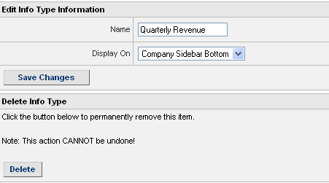
Figure 69: Info Type Details
- To make changes, go to the Edit Info Type Information box. All the fields are explained in Manage Info Types screen, see Figure 68.
- After you edit the fields, click Save Changes.
To delete an info type
Navigate to the Administration>Manage Info Types link to reach the Manage Info Types screen, see Figure 68.
From the list of info types on the left side of the Manage Info Types screen, click the name of the info type that you want to edit. You see the Info Type Details: < Info type> screen, see Figure 69.
In the Delete Info Type box, click Delete to remove the info type.

Appendix 1–List of Country Codes

Country | Code |  | Country | Code
 | 1 |  | Cayman Islands | 41
Afghanistan | 2 |  | Central African Republic | 42
Albania | 3 |  | Chad | 43
Algeria | 4 |  | Chile | 44
American Samoa | 5 |  | China | 45
Andorra | 6 |  | Christmas Island | 46
Angola | 7 |  | Cocos (Keeling) Islands | 47
Anguilla | 8 |  | Colombia | 48
Antarctica | 9 |  | Comoros | 49
Antigua and Barbuda | 10 |  | Congo | 50
Argentina | 11 |  | Cook Islands | 51
Armenia | 12 |  | Costa Rica | 52
Aruba | 13 |  | Croatia | 53
Australia | 14 |  | Cuba | 54
Austria | 15 |  | Cyprus | 55
Azerbaijan | 16 |  | Czech Republic | 56
Bahamas | 17 |  | Democratic People’s Republic of Korea | 57
Bahrain | 18 |  | Democratic Republic of the Congo | 58
Bangladesh | 19 |  | Denmark | 59
Barbados | 20 |  | Djibouti | 60
Belarus | 21 |  | Dominica | 61
Belgium | 22 |  | Dominican Republic | 62
Belize | 23 |  | Ecuador | 63
Benin | 24 |  | Egypt | 64
Bermuda | 25 |  | El Salvador | 65
Bhutan | 26 |  | Equatorial Guinea | 66
Bolivia | 27 |  | Eritrea | 67
Bosnia and Herzegovina | 28 |  | Estonia | 68
Botswana | 29 |  | Ethiopia | 69
Brazil | 30 |  | Faeroe Islands | 70
British Virgin Islands | 31 |  | Falkland Islands (Malvinas) | 71
Brunei Darussalam | 32 |  | Federated States of Micronesia | 72
Bulgaria | 33 |  | Fiji | 73
Burkina Faso | 34 |  | Finland | 74
Burundi | 35 |  | France | 75
?? | 36 |  | France, metropolitan | 76
Cambodia | 37 |  | French Guiana | 77
Cameroon | 38 |  | French Polynesia | 78
Canada | 39 |  | Gabon | 79
Cape Verde | 40 |  | Gambia | 80
Georgia | 81 |  | Lesotho | 118
Germany | 82 |  | Liberia | 119
Ghana | 83 |  | Libyan Arab Jamahiriya | 120
Gibraltar | 84 |  | Liechtenstein | 121
Greece | 85 |  | Lithuania | 122
Greenland | 86 |  | Luxembourg | 123
Grenada | 87 |  | Macau | 124
Guadeloupe | 88 |  | Madagascar | 125
Guam | 89 |  | Malawi | 126
Guatemala | 90 |  | Malaysia | 127
Guinea | 91 |  | Maldives | 128
Guinea-Bissau | 92 |  | Mali | 129
Guyana | 93 |  | Malta | 130
Haiti | 94 |  | Marshall Islands | 131
Holy See | 95 |  | Martinique | 132
Honduras | 96 |  | Mauritania | 133
Hong Kong Special Administrative Region of China | 97 |  | Mauritius | 134
Hungary | 98 |  | Mayotte | 135
Iceland | 99 |  | Mexico | 136
India | 100 |  | Monaco | 137
Indonesia | 101 |  | Mongolia | 138
Iran | 102 |  | Montserrat | 139
Iraq | 103 |  | Morocco | 140
Ireland | 104 |  | Mozambique | 141
Israel | 105 |  | Myanmar | 142
1Italy | 106 |  | Namibia | 143
Jamaica | 107 |  | Nauru | 144
Japan | 108 |  | Nepal | 145
Jordan | 109 |  | Netherlands | 146
Kazakhstan | 110 |  | Netherlands Antilles | 147
Kenya | 111 |  | New Caledonia | 148
Kiribati | 112 |  | New Zealand | 149
Kuwait | 113 |  | Slovakia | 187
Kyrgyzstan | 114 |  | Slovenia | 188
Lao People’s Democratic Republic | 115 |  | Solomon Islands | 189
Latvia | 116 |  | Somalia | 190
Lebanon | 117 |  | South Africa | 191
Nicaragua | 150 |  | Spain | 192
Niger | 151 |  | Sri Lanka | 193
Nigeria | 152 |  | Sao Tome and Principe | 194
Niue | 153 |  | Sudan | 195
Norfolk Island | 154 |  | Suriname | 196
Northern Mariana Islands | 155 |  | Swaziland | 197
Norway | 156 |  | Sweden | 198
Oman | 157 |  | Switzerland | 199
Pakistan | 158 |  | Syrian Arab Republic | 200
Palau | 159 |  | Taiwan | 201
Panama | 160 |  | Tajikistan | 202
Papua New Guinea | 161 |  | Thailand | 203
Paraguay | 162 |  | The Former Yugoslav Republic of Macedonia | 204
Peru | 163 |  | Togo | 205
Philippines | 164 |  | Tonga | 206
Poland | 165 |  | Trinidad and Tobago | 207
Portugal | 166 |  | Tunisia | 208
Puerto Rico | 167 |  | Turkey | 209
Qatar | 168 |  | Turkmenistan | 210
Republic of Korea | 169 |  | Turks and Caicos Islands | 211
Republic of Moldova | 170 |  | Tuvalu | 212
Romania | 171 |  | Uganda | 213
Russian Federation | 172 |  | Ukraine | 214
Rwanda | 173 |  | United Arab Emirates | 215
Reunion | 174 |  | United Kingdom | 216
Saint Helena | 175 |  | United Republic of Tanzania | 217
Saint Kitts and Nevis | 176 |  | United States | 218
Saint Lucia | 177 |  | United States Virgin Islands | 219
Saint Pierre and Miquelon | 178 |  | Uruguay | 220
Saint Vincent and the Grenadines | 179 |  | Uzbekistan | 221
Samoa | 180 |  | Vanuatu | 222
San Marino | 181 |  | Venezuela | 223
Saudi Arabia | 182 |  | Zambia | 227
Senegal | 183 |  | Zimbabwe | 228
Seychelles | 184
Sierra Leone | 185
Singapore | 186
Viet Nam | 224
Yemen | 225
Yugoslavia | 226

Appendix 2–Default Import Formats

Category | Default Import | Column No. | Category | Default Import | Column No.
//company info | company_name | 1 | //contact info | first_name | 22
 | legal_name | 2 |  | last_name | 23
 | division_name | 3 |  | email | 24
 | website | 4 |  | work_phone | 25
 | tax_id | 5 |  | home_phone | 26
 | extref1 | 6 |  | fax | 27
 | extref2 | 7 |  | division | 28
 | extref3 | 8 |  | salutation | 29
 | company_custom1 | 9 |  | date_of_birth | 30
 | company_custom2 | 10 |  | summary | 31
 | company_custom3 | 11 |  | title | 32
 | company_custom4 | 12 |  | description | 33
 | employees | 13 |  | cell_phone | 34
 | revenue | 14 |  | aol | 35
 | credit_limit | 15 |  | yahoo | 36
 | terms | 16 |  | msn | 37
 | company_profile | 17 |  | interests | 38
 | company_code | 18 |  | contact_custom1 | 39
 | phone | 19 |  | contact_custom2 | 40
 | phone2 | 20 |  | contact_custom3 | 41
 | fax | 21 |  | contact_custom4 | 42
 |  |  |  | contact_profile | 43
 |  |  |  | gender | 44
 |  |  | //address info | address_name | 45
 |  |  |  | line1 | 46
 |  |  |  | line2 | 47
 |  |  |  | city | 48
 |  |  |  | state | 49
 |  |  |  | postal_code | 50
 |  |  |  | country | 51
 |  |  |  | address_body | 52
 |  |  |  | use_pretty_address | 53

Index
A
Activity Template 55
Activity Templates 22
Activity Templates
Manage 22
Administrator 8
B
boolean_hook_function 62
C
case status 46
category 52
change record owner 27
check permission 20
concat_hook_function 61
controlled object 10
Controlled object relationships 10
D
default values 48
defaults 40
details
user 38
do_hook 61
do_hook_function 61
E
Email Templates 24
I
Import company data 5
L
list of objects 21
M
Manage Group Groups 13
Manage Groups 12
Manage Permissions 17
O
opportunity status 48
P
participant positions 51
permissions 15
plugin 56
R
relationship type 47
relationships
company 47
contacts 47
role permissions 17
role permissions
inherit or not 16
S
scope types 15
Select Column Layouts 12
status types 46
U
User 8, 36
W
workflow 55

Questions/Comments
Section 3.3 [Export Companies/Contacts as LDAP/LDIF] and 3.4 [Export Companies with address and phone info] - What do we need to explain here??? When we click these options, we get the message Unable to Open File for Writing.
Section 4.1.5 [Manage Users in a Group] and Section 4.1.6 [Manage Groups within a Group] - There is some display error with the screens - Figure 13:Manage Group Users and Figure 14:Manage Group Groups respectively. The screens mention the number of records found but do not display this list of records. Hence we are unable to make the updates to these sections.
Section 4.6 System Preferences - The screen Figure 34:System Preferences has a display error - some drop-down lists are not displayed. Also, the sections under 4.6 have been highlighted in yellow, as the functioning is no longer the same.
Section 7.1 Manage Info Types - This link is not seen in the current XRMS version.

