XRMS
Open Source CRM

User Manual

Version

July 14, 2005

Copyright (c) 2004 Ken Gregoire.
Permission is granted to copy, distribute and/or modify this document under the terms of the GNU Free Documentation License, Version 1.2 or any later version published by the Free Software Foundation; with no Invariant Sections, no Front-Cover Texts, and no Back-Cover Texts. A copy of the license is included in the section entitled "GNU Free Documentation License".

Version 3
- Added Plugin Information

Version 4
- Added ACL – many thanks to Aaron van Meerten for co-authoring this section.

Table of Contents

Overview 4
Description of Components 5
Manage Customer Profiles (Companies and Contacts) 6
Lead Management 7
Generate Reports 8
Top Level Windows 9
Home 9
Activities 10
Companies 10
Contacts 10
Campaigns 10
Opportunities 11
Company and Contacts 12
Administration 13
System Administration 13
Data Management 14
Import Companies/Contacts 14
Export Companies/Contacts 14
User Setup 14
Setup 15
Access Control List (ACL) 16
Overview 16
ACL Relationships 17
ACL Functions 19
Manage Roles 19
Manage Controlled Objects 19
Manage Controlled Object Relationships 19
Manage Groups 20
Manage Group Users 20
Manage Group Groups 20
Manage Group Members 20
Manage Role Permissions 20
Manage Role Permissions in Grid 20
Manage Data Sources 20
Test ACL Results 20
Examples 21
Add a Role with Permissions View Companies and Contacts and Add Activities and Cases. 21
Plugins 22
Glossary 24
Appendixes 28
Appendix 1 - Country Code List 28
Appendix 2 - Default Import Format 31
Appendix 3 - GNU Free Documentation License 32

Overview

XRMS is a fully-integrated suite web-based Customer Relationship Management (CRM), Sales Force Automation (SFA), and business intelligence (BI) tools, allowing companies to integrate and manage their sales, service, and marketing data into a single information store.

It provides the ability to:
- Manage Companies and Contacts within a company.
- Initiate and manage Campaigns.
- Initiate and manage Cases, Opportunities and Activities related to Companies and Contacts.
- Upload files to Campaigns or Cases.
- Generate activity reports.
- Customize and administer the environment.

XRMS runs as a web application and requires PHP and MySQL. It runs in either a Windows or Linux environment.

Description of Components

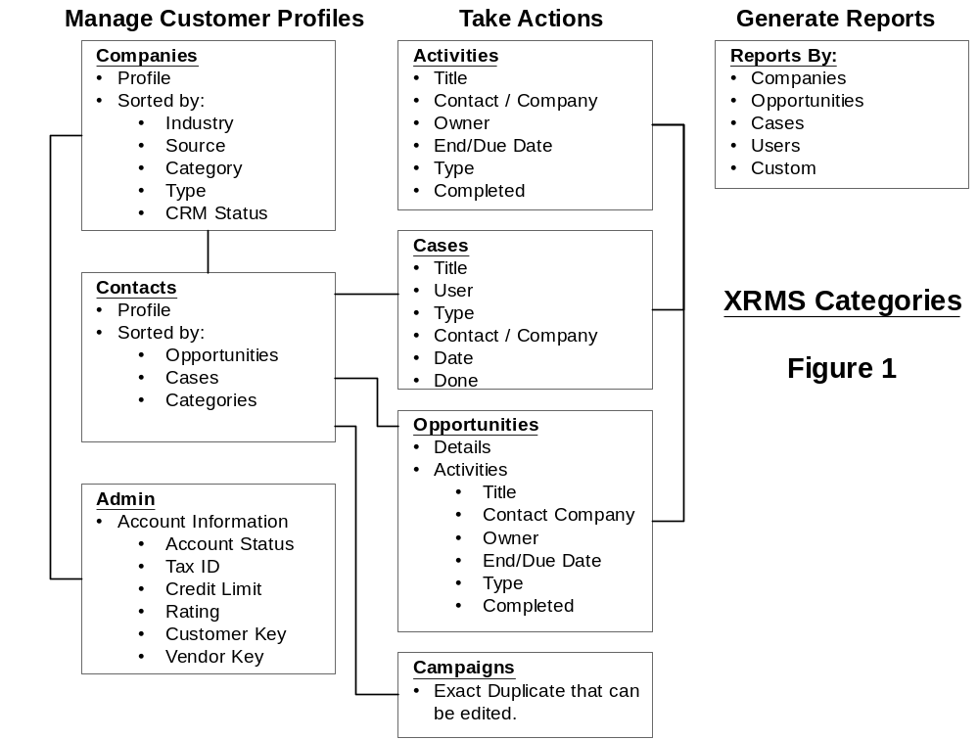

XRMS is arranged in three major categories:
- Management of Customer Profiles.
- Take action on activities. Activity types include Activities, Cases, Opportunities and Campaigns.
- Generate reports. Reports can be generated by Companies, Opportunities, Cases, Users and Custom.

Manage Customer Profiles (Companies and Contacts)
Customers consist of a Company, and Contacts within that Company.

XRMS displays your customers as Companies and Contacts. Company information (Illustration 1) includes the company name, address, telephone, fax, credit worthiness, relationship to other vendors and other information about your company client. Company has eight buttons (Illustration 3) to add, delete or modify information.
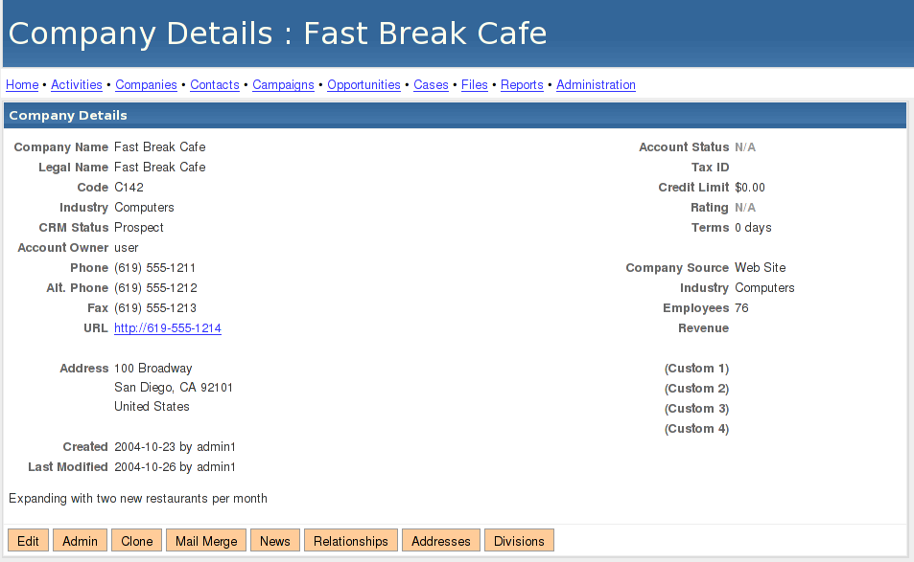
Illustration 1
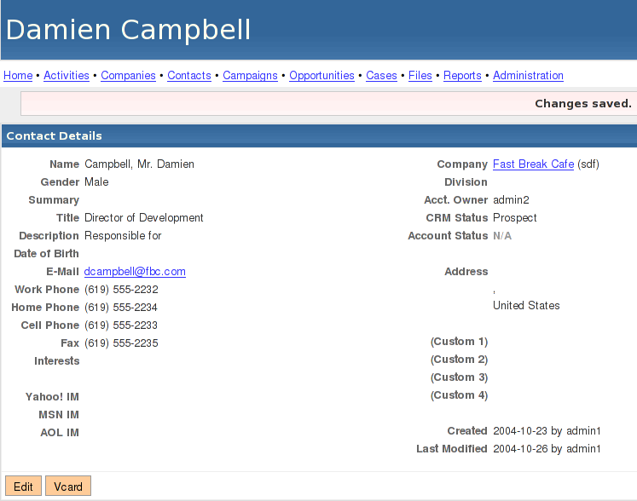
Illustration 2

Illustration 3

Company Configuration Buttons
Edit – Modify the core of the Company information such as the Company name, CRM Status, telephone numbers, URL, etc.
Admin – Modify issues related to credit worthiness such as account status, federal tax ID, credit limit, rating, etc.

Clone – Exact copy of the current company. For use when one client has multiple entities providing different services from the same location, under different names.

Mail Merge – Send emails to the Contacts of this Company using the standard template, or your newly designed template.

News – Google News search for this Company.

Relationships – List associations of this Company to other Companies. Typical examples are that this company is a consultant, supplier for, or subsidiary for another Company. For each XRMS relationship there is an equal, opposite relationship. For example, if this Company shows a relationship of “retains consultant,” the other Company will show a relationship of “Consultant for.”

Addresses – Create and modify addresses for each Company location. Each Company can have an unlimited number of addresses. After Addresses are configured,

Divisions – List and create Divisions for each Company.

Contact information (Illustration 2) lists information about the people that work for the Company. All Contacts are associated with a Company. Contacts cannot exist outside of a Company. The detailed information for Contacts includes the name, address, telephone, fax, title, division and other relevant information.

Lead Management
XRMS provides for several types of actions related to a Contact or Company which include:

- Activities – are actions of a user such as a telephone call or email to a Contact. All Activities are related to a Company or Contact. Activities may also be related to Cases, Opportunities and Campaigns. Activities include making telephone calls, sending emails or letters or having meetings. Activities can be related to a Contact, Company, Opportunity or Case.

- Cases – are used for support issues for a client.

- Cases must be associated with a Company and a Contact within a Company. If no Contact is selected the Company default Contact is assumed. Activities can be initiated related to Cases.

- Opportunities - which are typically sales related Opportunities must be related to a Company and a Contact within a Company. If no Contact is selected the Company default Contact is assumed. . Activities can be initiated related to Opportunities.

- Campaigns - which are typically marketing related like a mailing to Companies /Contacts where a fixed length of time and a fixed budget. Opportunities can be associated to a specific Campaign.

Starts and Ends dates for activities are in days. Either the popup calendar can be used to select Starts and Ends or a user can type in the number of days to Starts or Ends. XRMS will interpret the users input and calculate the correct date. Examples of free form dates that can be entered are:
- 10 (means 10 days)
- 10 days
- 2 weeks
- 1 month
- 1 year
- next Tuesday (in newer versions of PHP)

Generate Reports
XRMS provides to generate reports by:
- Companies
- Opportunities
- Cases
- Users
- Custom

Top Level Windows

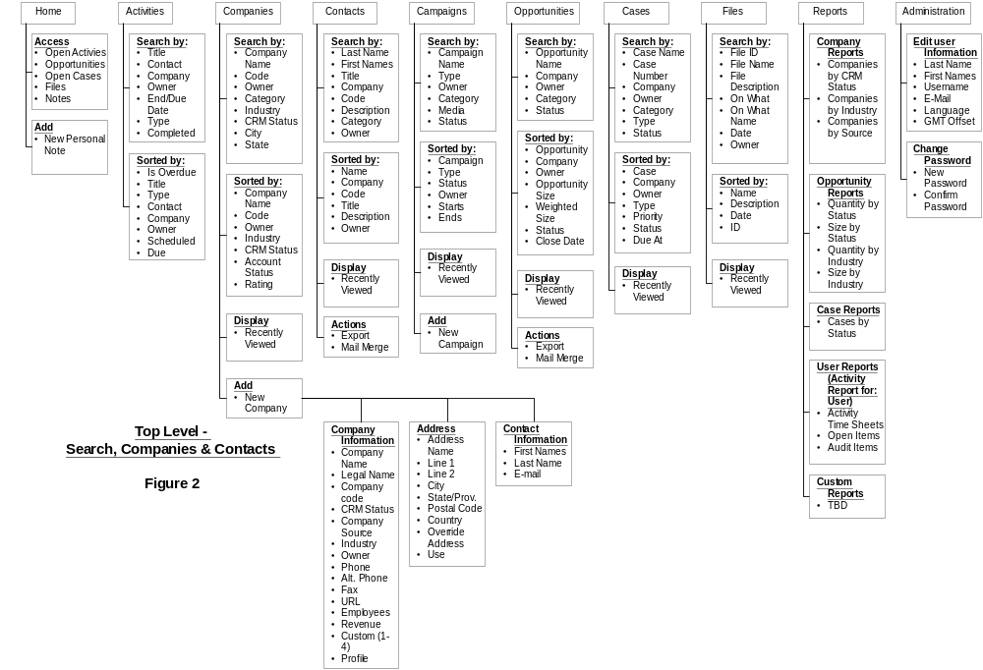

The top tabs to the windows mainly provide the ability to search for a Companies, Contacts, Opportunities, Cases, Files, Reports. All searches can contain multiple criteria's and are exclusively or'ed. The Administration tab provides the ability to customize the various components of XRMS if administrative rights have be granted to the user. If not, the user can only change their profile.

All additions to Companies Contacts and Cases must to done under the Companies tab. Campaigns can be added under the Campaign tab since they are not related to a specific Company.

Home
The Home window provides easy access to a users:
- Opportunities
- Open Cases
- Files
- Notes

The user can access any of the above by clicking on it.

Activities
The Activities window provides the ability to search for Activities by Title, Contact, Company, Owner, End/Due Date, Type or Completed.

Activities can be sorted by Is Overdue, Title, Type, Contact, Company, Owner, Scheduled or Due.

Activities can be independent of Companies / Contacts or associated with Companies / Contacts, Opportunities or Cases.

Companies
The Companies window provides the ability to:
- Search for a company based on variety of search options; Name, Code, Owner, Category, Industry, CRM Status, City, State. The search results are displayed in the same window.
- Add new company.
- Easy access to Recently Viewed companies.
The resulting search list can be sorted by Company Name, Code, Owner, Industry CRM Status, Rating.

Contacts
The Contacts window provides the ability to:
- Search by Last Name, First Names, Title, Company, Code, Description, Category, Owner.

The resulting search can be sorted by Name, Company, Code, Title, Description, Owner.

Recently viewed Contacts are also displayed in this windows.

New Contacts can only be entered under the Companies window by selecting or adding a company and then by adding the Contacts under that company. The system is driven by Companies not Contacts.

Campaigns
The Campaign window provides the ability to:
- Add new campaigns.
- Search for existing campaigns by Campaign Name. Type, Owner, Category, Media, Status.

Recently viewed campaigns are also displayed.

Opportunities
The Opportunities window provides the ability to:
- Search by Opportunity Name, Company, Owner, Category, Status.
- Export the Opportunities into an spreadsheet.
- Create a mail merge from a template. The templates available are a Blank Template, Customer Service Inquiry, Introduction, Sales Pitch or Thanks for Your Business.

Resulting searches can be sorted by Opportunity, Company, Owner, Opportunity Size, Weighted Size, Status, Close Date.

Recently viewed Opportunities are also displayed.

Opportunities can only be added under the Company window.

Company and Contacts

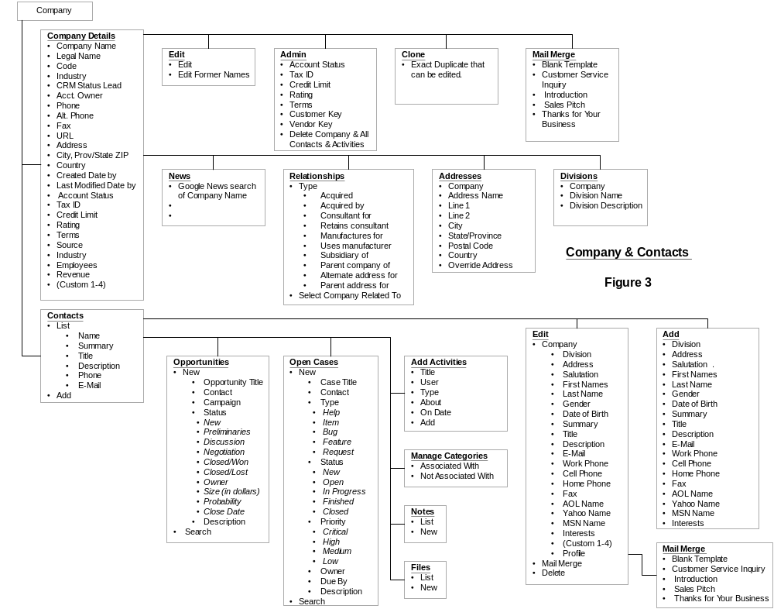
All data management of the Company, Contacts, Opportunities, Cases, Activities, Categories, Notes and Files can be accessed from the Company & Contacts section. This includes editing, deleting, adding or modifying information.

Remember, Contacts are always related to Companies. A Company must to be added to add any Contacts.

Opportunities, Cases, Activities can be added or edited under Contacts for a specific Company. Notes and Files can also be added and attached to Contacts and Companies.

An email can be sent to a Contact with the Mail Merge feature. Boilerplate emails are provided or a Blank Template can be used.

Administration

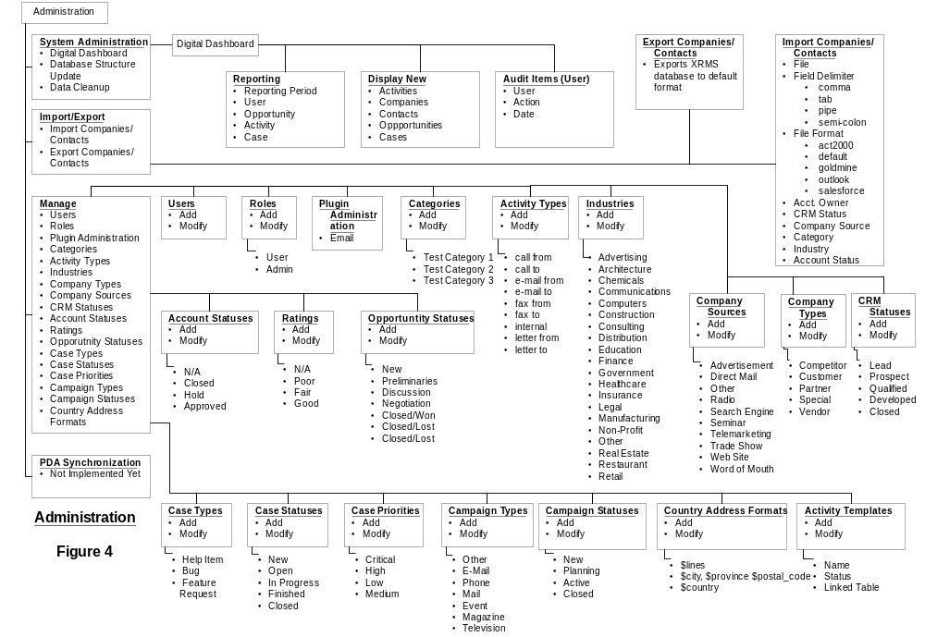

System Administration
System Administration consists of:
- Digital Dashboard:
  - Provides various reports by User, Opportunity, Activity and Case.
  - Displays new Activities, Companies, Contacts, Opportunities and Cases.
  - Displays Audit Reports of Users.
- Database Structure Update - which updates the database structure.
- Database Cleanup - which cleans up the database.

Data Management
XRMS provides the ability to import and export data into the XRMS database.

Import Companies/Contacts
Imports data from a delimited form, comma, tab, pipe or semi-colon. File structures supported are act2000, goldmine, salesforce, outlook or the default format of XRMS. The default format is defined in the Appendix 2 - Default Import Format.

Imported data is imported with the following criteria:
- Acct. Owner
- CRM Status
- Company Source
- Category
- Industry
- Account Status
- Rating

Unless specified, the import of data assigns the default country to be the USA if there is no country indicated in the country field associated with that Company. To change the default country, see Appendix 1 - Country Code List.

The default Gender is male.

The imported data is first displayed so the user can preview the data. You will notice that only one Company record is put into XRMS with the Contacts of each Company related to the Company record.

Once the data is previewed it can be submitted to the XRMS database.

Export Companies/Contacts
Export provides the ability to export all data in the XRMS database to a delimited file. It is exported in the default format.

User Setup
Users can be added to XRMS and granted access or turned off.

Roles can be added or modified. The default Roles are:
- Admin, which provides access to the Administration functions;
- User which does not have Administration functions.

Additional Roles can be added.

Setup
Before starting with XRMS, the various defaults should be reviewed and edited appropriately. The following can be modified, added to or deleted. Once deleted, the action cannot be reversed so be careful, all associations with Companies, Contacts, Cases and Campaigns will be lost.
- Categories,
- Activity Types,
- Industries,
- Company Types,
- CRM Statuses,
- Account Statuses,
- Ratings,
- Opportunity Statuses,
- Case Types,
- Case Statuses,
- Case Priorities,
- Campaign Types,
- Campaign Statuses,
- Country Address Formats,

The defaults provide a basic example of the function of each. There is no limit on the number of items that can added under each group.

Access Control List (ACL)

Overview

The ACL is a set-based permission system. It has individual entities made up of Users, Roles, Groups, Permissions, and Controlled Objects. The intersections of these sets make up the permission system.

Users are assigned a Role in a Group. Users may have more than one Role in any Group, and can be a member of more than one Group. Groups may contain other Groups as members, so if a User has a role in a Group, and that Group also contains a sub-Group, the User has the role in the sub-Group as well.

Groups can also contain Controlled Objects. These are called Group Members. Any Controlled Object that is a member of a Group will get any Group-scoped permissions that are applied to that Controlled Object.

Controlled Objects are the entities which permissions are applied to. These can be table-based entities (like Companies, Contacts, etc) or page/logic entities like Administration.

Controlled Objects are related to one another through Controlled Object Relationships. These describe the type of relationship between the objects. The simplest of these simply specifies which Object is the Parent and which Object is the Child. For instance, a Company is the Parent object to a Contact. Since Company is specified to have an identifying field of ‘company_id’, the ‘company_id’ in Contacts is used to determine which Company Controlled Object to use in determining the permissions.

A more complex Controlled Object Relationship is one called 'Singular'. This denotes the relationship that a Child Object has the 'on_what_table' and 'on_what_id' fields, that can connect it to any other Object, but only one. Marking Singular as one (1) in the interface will cause this relationship to be examined.

Another complex Controlled Object relationship is the cross_table. This allows a relationship with a third table between two other Controlled Objects, where lookups between them can occur. XRMS currently does not implement any cross_table relationships, but they are fully functional.

Permissions are granted to Roles on Controlled Object Relationships. This means that for any given Role, permissions (Create, Read, Update, Delete and Export) can be set on a Controlled Object Relationship, with a scope of World, Group, or User and also marked as inheritable.
An example would be granting World Read on top level Companies. Since Companies are in a Relationship as a Child Object with a NULL parent, this means it is a top level Object. Granting Read on it at the World level means that any Object which is in a relationship that can be traced back up to Company at the top level will also be assigned this permission, as long as the permission is set to be inheritable. All permissions are inheritable by default, and must have inheritance disabled in the Manage Role Permissions interface if inheritance is not desired.

Another example would be to set Group Read on Activities attached to Cases. This would give Read permissions to users with this Role, only on Activities attached to Cases which are in the Group for which they have been assigned this role.

A third example would be to set User Update on Companies. This means that Users with this Role will be given Update permission on those Controlled Objects where the ‘user_id’ field is set to their user ID.

ACL Relationships

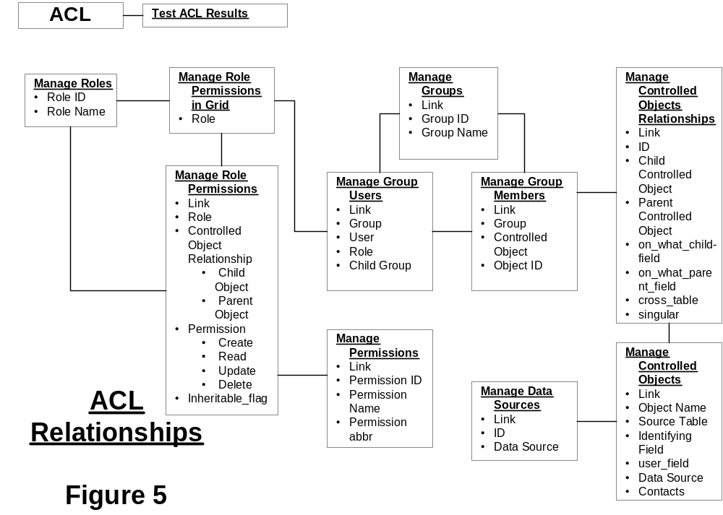

The above Figure 5 defines the relationships between the components of ACL.

The main components of ACL are:
- Roles
- Groups
- Controlled Objects
- Permissions

The relationships are:
- Roles are related to Groups and Permissions.
- Groups are related to Controlled Objects.

XRMS’s ACL provides the ability to assign Permissions by Users and Groups. Permissions can be Create, Update, Read, Export and Delete. It also provides the ability to restrict or add access to Controlled Objects. Controlled Objects that can be restricted are Company, Contact, Campaign, Case, Opportunity, Activity, File, Division and Administration.

To fully understand the power of ACL you must have an understanding of the XRMS database structure since the ACL manages the relationships between the database tables and table fields.

Although restricted access can be set for any Controlled Objects the menu items may still appear. If access has been restricted any action on that Controlled Object will generate a message indicating that the user cannot be authenticated for that action. For example, if a User has only read access to Companies and tries to add a New Company the message “You are not authorized to perform this function.” will be displayed.

ACL Functions

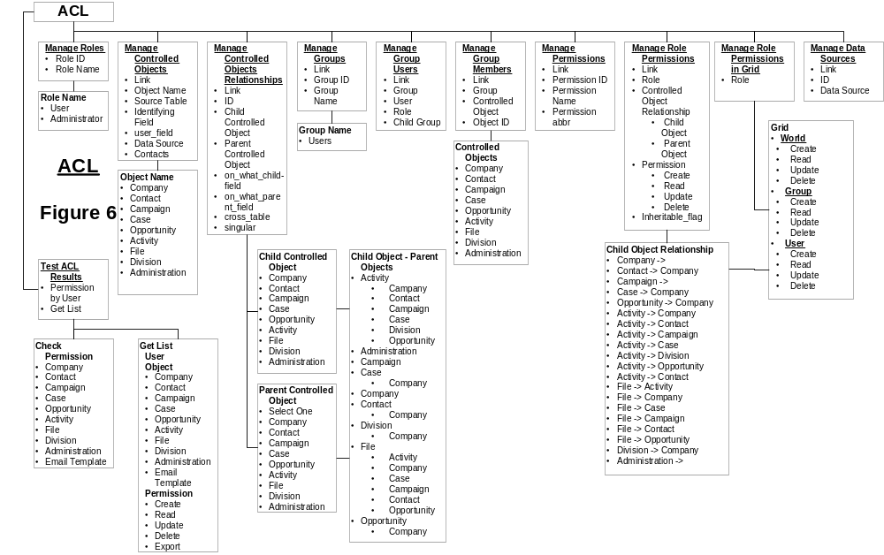

The above, Figure 6, defines the functions available in ACL.

Manage Roles
The standard roles in XRMS are User and Administrator. Here you can add a Role type.

Manage Controlled Objects
Controlled Objects are objects that Access Controls can be assigned too. The default Controlled Objects in listed in the above Figure 6 as Object Name. This function allows you to add additional Controlled Objects and modify the database relationships against the Controlled Objects.

The above list identifies the current Controlled Objects in XRMS and there database relationships.

Manage Controlled Object Relationships
Each Controlled Object can have relationships with other Objects and a Child Relationship can be inherited from a Parent Relationship. For example, a Parent Object – Case is related to Activities and Files.

Manage Groups
The default Group in XRMS is Users. Here you can add additional Groups.

Manage Group Users
This allows you to assign Users and Roles to a Group.

Manage Group Groups
This allows you to assign a Child Group to a Parent Group.

Manage Group Members
This allows you to assign a Group to a Controlled Object.

Manage Role Permissions
This allows you to edit or add Permission types; the standard ones in XRMS are Create, Read, Update, Delete and Export.

Manage Role Permissions in Grid
This provides an easier way to assign Permissions to Roles, displayed in a grid. It lists all the Controlled Objects and their Parent/Child relationships, provides a method to assign Permissions to these Controlled Objects and to assign World, Group and User access. World means that it controls access for both Group and User. This is the best way to setup permissions once you have defined Roles, Controlled Objects, Controlled Object Relationships and Groups.

Manage Data Sources
This allows you to add database sources (databases) to XRMS. These data sources have the unique name which also corresponds to the key in the ACL authentication array, provided at run-time by any plugins which use the ACL, to allow the ACL to query into their data sources.

Test ACL Results
This test function allows you to:
- Check Permissions on an Object for a User.
- Get list of Objects for a user.
This allows you to identify what Permissions a User would have on what Objects. Permissions can be a combination of Create, Read, Update, Delete and Export.

You must have had some activity to test ACL since the test function looks at actual activity of a User.

Examples

Add a Role with Permissions View Companies and Contacts and Add Activities and Cases.

Okay let’s add some new permissions to XRMS. Our example, will add a Role Viewer with the Role having the ability to Read only Companies, add Contracts and update Activities and Cases. The steps are:
- Add a Role – Viewer: ACL → Manage Roles → Add New → Role Name: Viewer
- Edit Permissions for Role – Viewer: Manage Role Permissions in a Grid → Role: Viewer → Manage Permission for Role → Select the following under World – Company → Read; then check the following:
  - Company → Read;
  - Contact->Company → Create, Update;
  - Case->Company → Update;
  - Opportunity->Company → Update;
  - Then save by selecting Assign Permissions.
- Create a New User with the Role = Viewer.

This is a very simple example but should give you a basic understanding of ACL and how it works.

Plugins

Here is a list of the plugins available in XRMS and what they provide. Plugins provide a convenient and easy way to link other applications into XRMS. Plugins are activated in the Administration Panel and some require installation of other programs or components.

Plugin Name | Activation | Stable | Description
apb as of July 14, 2005  - doesn't work | Requires installation of apb. | No | Active PHP Bookmarks provides a function for users to bookmark websites and share these bookmarks.
autostatus | Requires installation of Autostatus. | ?? | Provides status of servers and network devices. This is good to provide a quick status report for users of the critical systems that would impact their operations.
censusfactsheet | Administration Panel only. | Yes | Queries US census website with address information of Contact information.
cti | Installation required. | ?? | Connection to the Asterisk Open Source PBX http://www.asterisk.org/ voicemail system.
demo | Administration Panel and addition of a webpage demo.php | Yes | Provides a link to a demo page within XRMS. The demo page would have to be provided.
dunfinder | Installation required. | Yes | Dial Up Number Finder for the US.
idphoto | Administration Panel only. | Yes | Displays id photo of contact. Upload photos 120x160 with File Upload and name id_photo_### where ### is the contact_id=###
info | Installation required. | No | Additional tables to track characteristics of computers.
mapquest | Administration Panel only. | Yes | Passes address to mapguest.com to provide an address lookup. Cannot have both whereis and mapquest activated at the same time.
mrtg | Installation required. | ??? | Multi Router Traffic Grapher
opportunitynotes | Administration Panel only. | Yes | Adds the ability to add notes to an Opportunity.
phone | Administration Panel | Yes | Search for phone numbers in Company or Contact.
radtest | ?? | ?? | Uses freeradious.org to authenticate dialup users.
serverinfo |  |  | Obsolete Plugin replaced by info plugin.
sitewx | Requires installation and weather station hardware connection. | ?? | Weather station plugin to provide real-time and graphical weather information.
tavi |  |  | Wiki
useradmin | Administration Panel only. | No | User admin plugin - NOT RECOMMENDED SINCE CREATES A SECURITY RISK.
vcard | Administration Panel only. | Yes | Creates a vcard of the Contact
voicemail | Installation of voicemail system required. | ?? | Provides link to a voicemail web page.
webcalendar  Discontinued by development team. | Requires installation of Webcalendar. | Yes | Link to Webcalendar - Webcalendar is a shared calendar application - very nice.
webform | Installation required. | Yes | Creates a webform on your external website.
Weblinks | Administration Panel only. | Yes | Provides links to google and googlenews from the Company page.
Whereis | Administration Panel only. | Yes | Same as mapquest but link to whereis.com.au - Australia  Cannot have both whereis and mapquest activated at the same time.
Owl Integration | Installation of Owl required. | Yes | OWL is a document management system. This will add a link to the Owl application within XRMS.

Glossary

Term | Association | Description
Account Status | Companies | Status of a Company's account - N/A, Closed, Hold, Approved.
Activities | Activities | Any Activity with a Company - must include description, be assigned to a User, include a Type (call from, call to, e-mail from, e-mail to, fax from, fax to, internal, letter from, letter to), can be associated to a Contact within a Company, can be about a Case, has a start date. Can be completed (grey) or uncompleted (pink).
Activity Time Sheet | Reports | List of Activities by User - lists Start and End Date, Duration, User Name, Company and Contact that Activity was for, link to Activity Detail.
Activity Types | Activities | Call from, call to, e-mail from, e-mail to, fax from, fax to, internal, letter from, letter to.
Administration | Administration | Administration of XRMS includes the ability customize fields, generate reports and add, modify and delete Users.
Audit Items | Administration | Detailed Audit by user of all actions executed on the XRMS System.
Campaign | Campaigns | Several related operations aimed at achieving a particular goal. Usually for a specified period of time. Usually not related to a specific Company.
Campaign Status | Campaigns | New, Planning, Active or Closed.
Campaign Types | Campaigns | E-Mail, Event, Magazine, Mail, Other, Phone, Television
Case | Cases | An occurrence of something related to a specific Company. Case Types can be Help Item, Feature, Request. Case Types can be added and modified by the Administrator. Activities can be related to a specific Case.
Case Priorities | Cases | Level of urgency - Critical, High, Low, Medium. Case Priorities be added and modified by the Administrator.
Case Status | Cases | New, Open, In Progress, Finished, Closed. Case Status be added and modified by the Administrator.
Category | Companies  Contacts | A custom field that can be related to Contacts, Companies, Campaigns and Cases. Categories can be added and modified by the Administrator.
Company | Companies | Any Company that is in the XRMS database. Contacts can only be associated to Companies. Companies can be associated with Cases and Activities.
Company Code | Companies | A unique code that can be assigned to a Company by any User.
Company Source | Companies | Source where the Company found your business - Advertisement, Direct Mail, Other, Radio, Search Engine, Seminar, Telemarketing, Trade Show, Web Site, Word of Mouth. Company Sources can be added and modified by the Administrator.
Company Types | Companies | Type of company - Competitor, Customer, Partner, Special, Vendor. Company Types can be added and modified by the Administrator.
Country Address Formats | Administration | Format that the address is displayed, varies from
Country Code | Companies | Code identifying the default country. See Country Code List.
Created Date | Companies  Contacts | Date that a Company or Contact profile was created.
Credit Limit | Companies | Credit limit in XRMS. Can be entered and modified by any User.
CRM Status | Cases | Status of a Case - Lead, Prospect, Qualified, Developed, Closed. CRM Status can be added and modified by the Administrator.
Customer Key | Companies | Unique number that is related to a Company. Can be modified or entered by any User
Digital Dashboard | Reports | Overview screen for Administrators that provides access Reports and displays new Activities, Companies, Contacts, Opportunities and Cases. Also provides audit reports by User.
Divisions | Companies | Divisions within a Company. A Division can have its own address, profile and contact information. It is always linked to a Company.
Employees | Companies | Number of Employees of a Company. Can be edited and entered by any User.
Export | Administration | Ability to export the XRMS database.
Files | Contacts  Campaigns | Any file that is uploaded to XRMS, they can be word documents, spreadsheets, pdf files or any other file type.
Former Names | Companies | A Companies former name(s).
Import | Administration | Ability to import Company and Contact information into the XRMS database.
Industry | Companies | Industry that a Company operates within (i.e. - Automotive, Healthcare, etc.). Industries can be added and modified by the Administrator.
Legal Name | Companies | Companies legal name. Typically the same as Company name but can be different. Can be edited and entered by any User.
Mail Merge | Companies  Contacts | Ability to send emails to a Company or Contact. Boiler plate forms are provided or a Blank Template can be used. Mail Merge can be initiated from Company Details or from an
Modified Date | Companies  Contacts | Date a Company or Contact record was modified.
News | Companies | Initiates Google news search of Company name.
Open Activities | Activities | Activities that are not closed or completed.
Open Cases | Cases | Cases that are not closed or completed.
Open Items | Cases | Activities or Cases that still require Activities to complete and Close.
Opportunity | Companies | An Opportunity with a Company or Contact.
Override Address | Companies | Alternate Company address that is used as the primary address, over-riding the primary address.
Owner | User | Owner of the Company and Contact information. Usually the User who entered or provided the information.
PDA Synchronization | Companies  Contacts | Ability to synchronize Company and Contact information with XRMS. Currently not implemented.
Priority | Case
Profile | Company  Contact | A Companies or Contacts profile.
Rating | Company | A Companies Rating - Fair, Good, Poor, N/A. Typically credit rating.
Reports | Reports | Reports generated by XRMS.
Revenue | Company | Companies annualized revenue.
Roles | User | Type of Users. Standard are Admin User and User where the Admin User can modify the Administration features of XRMS.
Tax ID | Company | Tax ID. Can be added or edited by any User.
Terms | Company | Payment Terms, net xx days. Edited from the Admin panel under Company.
User | User | A XRMS User that can add, modify, delete Companies, Contacts, Cases, Opportunities and Activities.
Vendor Key | Company | Unique field that can be added or modified by a User.

Appendixes

Appendix 1 - Country Code List
Country | Code |  | Country | Code
 | 1 |  | Cape Verde | 40
Afghanistan | 2 |  | Cayman Islands | 41
Albania | 3 |  | Central African Republic | 42
Algeria | 4 |  | Chad | 43
American Samoa | 5 |  | Chile | 44
Andorra | 6 |  | China | 45
Angola | 7 |  | Christmas Island | 46
Anguilla | 8 |  | Cocos (Keeling) Islands | 47
Antarctica | 9 |  | Colombia | 48
Antigua and Barbuda | 10 |  | Comoros | 49
Argentina | 11 |  | Congo | 50
Armenia | 12 |  | Cook Islands | 51
Aruba | 13 |  | Costa Rica | 52
Australia | 14 |  | Croatia | 53
Austria | 15 |  | Cuba | 54
Azerbaijan | 16 |  | Cyprus | 55
Bahamas | 17 |  | Czech Republic | 56
Bahrain | 18 |  | Democratic People's Republic of Korea | 57
Bangladesh | 19 |  | Democratic Republic of the Congo | 58
Barbados | 20 |  | Denmark | 59
Belarus | 21 |  | Djibouti | 60
Belgium | 22 |  | Dominica | 61
Belize | 23 |  | Dominican Republic | 62
Benin | 24 |  | Ecuador | 63
Bermuda | 25 |  | Egypt | 64
Bhutan | 26 |  | El Salvador | 65
Bolivia | 27 |  | Equatorial Guinea | 66
Bosnia and Herzegovina | 28 |  | Eritrea | 67
Botswana | 29 |  | Estonia | 68
Brazil | 30 |  | Ethiopia | 69
British Virgin Islands | 31 |  | Faeroe Islands | 70
Brunei Darussalam | 32 |  | Falkland Islands (Malvinas) | 71
Bulgaria | 33 |  | Federated States of Micronesia | 72
Burkina Faso | 34 |  | Fiji | 73
Burundi | 35 |  | Finland | 74
C?d?Ivoire | 36 |  | France | 75
Cambodia | 37 |  | France, metropolitan | 76
Cameroon | 38 |  | French Guiana | 77
Canada | 39 |  | French Polynesia | 78

Country | Code |  | Country | Code
Gabon | 79 |  | Liberia | 119
Gambia | 80 |  | Libyan Arab Jamahiriya | 120
Georgia | 81 |  | Liechtenstein | 121
Germany | 82 |  | Lithuania | 122
Ghana | 83 |  | Luxembourg | 123
Gibraltar | 84 |  | Macau | 124
Greece | 85 |  | Madagascar | 125
Greenland | 86 |  | Malawi | 126
Grenada | 87 |  | Malaysia | 127
Guadeloupe | 88 |  | Maldives | 128
Guam | 89 |  | Mali | 129
Guatemala | 90 |  | Malta | 130
Guinea | 91 |  | Marshall Islands | 131
Guinea-Bissau | 92 |  | Martinique | 132
Guyana | 93 |  | Mauritania | 133
Haiti | 94 |  | Mauritius | 134
Holy See | 95 |  | Mayotte | 135
Honduras | 96 |  | Mexico | 136
Hong Kong Special Administrative Region of China | 97 |  | Monaco | 137
Hungary | 98 |  | Mongolia | 138
Iceland | 99 |  | Montserrat | 139
India | 100 |  | Morocco | 140
Indonesia | 101 |  | Mozambique | 141
Iran | 102 |  | Myanmar | 142
Iraq | 103 |  | Namibia | 143
Ireland | 104 |  | Nauru | 144
Israel | 105 |  | Nepal | 145
Italy | 106 |  | Netherlands | 146
Jamaica | 107 |  | Netherlands Antilles | 147
Japan | 108 |  | New Caledonia | 148
Jordan | 109 |  | New Zealand | 149
Kazakhstan | 110 |  | Nicaragua | 150
Kenya | 111 |  | Niger | 151
Kiribati | 112 |  | Nigeria | 152
Kuwait | 113 |  | Niue | 153
Kyrgyzstan | 114 |  | Norfolk Island | 154
Lao People's Democratic Republic | 115 |  | Northern Mariana Islands | 155
Latvia | 116 |  | Norway | 156
Lebanon | 117 |  | Oman | 157
Lesotho | 118 |  | Pakistan | 158

Country | Code |  | Country | Code
Palau | 159 |  | Switzerland | 199
Panama | 160 |  | Syrian Arab Republic | 200
Papua New Guinea | 161 |  | Taiwan | 201
Paraguay | 162 |  | Tajikistan | 202
Peru | 163 |  | Thailand | 203
Philippines | 164 |  | The former Yugoslav Republic of Macedonia | 204
Poland | 165 |  | Togo | 205
Portugal | 166 |  | Tonga | 206
Puerto Rico | 167 |  | Trinidad and Tobago | 207
Qatar | 168 |  | Tunisia | 208
Republic of Korea | 169 |  | Turkey | 209
Republic of Moldova | 170 |  | Turkmenistan | 210
Romania | 171 |  | Turks and Caicos Islands | 211
Russian Federation | 172 |  | Tuvalu | 212
Rwanda | 173 |  | Uganda | 213
R鵮ion | 174 |  | Ukraine | 214
Saint Helena | 175 |  | United Arab Emirates | 215
Saint Kitts and Nevis | 176 |  | United Kingdom | 216
Saint Lucia | 177 |  | United Republic of Tanzania | 217
Saint Pierre and Miquelon | 178 |  | United States | 218
Saint Vincent and the Grenadines | 179 |  | United States Virgin Islands | 219
Samoa | 180 |  | Uruguay | 220
San Marino | 181 |  | Uzbekistan | 221
Saudi Arabia | 182 |  | Vanuatu | 222
Senegal | 183 |  | Venezuela | 223
Seychelles | 184 |  | Viet Nam | 224
Sierra Leone | 185 |  | Yemen | 225
Singapore | 186 |  | Yugoslavia | 226
Slovakia | 187 |  | Zambia | 227
Slovenia | 188 |  | Zimbabwe | 228
Solomon Islands | 189
Somalia | 190
South Africa | 191
Spain | 192
Sri Lanka | 193
Sao Tome and Principe | 194
Sudan | 195
Suriname | 196
Swaziland | 197
Sweden | 198

Appendix 2 - Default Import Format

Category | Default Import | Column # | Category | Default Import | Column #
//company info | company_name | 1 | //contact info | first_name | 22
 | legal_name | 2 |  | last_name | 23
 | division_name | 3 |  | email | 24
 | website | 4 |  | work_phone | 25
 | tax_id | 5 |  | home_phone | 26
 | extref1 | 6 |  | fax | 27
 | extref2 | 7 |  | division | 28
 | extref3 | 8 |  | salutation | 29
 | company_custom1 | 9 |  | date_of_birth | 30
 | company_custom2 | 10 |  | summary | 31
 | company_custom3 | 11 |  | title | 32
 | company_custom4 | 12 |  | description | 33
 | employees | 13 |  | cell_phone | 34
 | revenue | 14 |  | aol | 35
 | credit_limit | 15 |  | yahoo | 36
 | terms | 16 |  | msn | 37
 | company_profile | 17 |  | interests | 38
 | company_code | 18 |  | contact_custom1 | 39
 | phone | 19 |  | contact_custom2 | 40
 | phone2 | 20 |  | contact_custom3 | 41
 | fax | 21 |  | contact_custom4 | 42
 |  |  |  | contact_profile | 43
 |  |  |  | gender | 44
 |  |  | //address info | address_name | 45
 |  |  |  | line1 | 46
 |  |  |  | line2 | 47
 |  |  |  | city | 48
 |  |  |  | state | 49
 |  |  |  | postal_code | 50
 |  |  |  | country | 51
 |  |  |  | address_body | 52
 |  |  |  | use_pretty_address | 53

If you wish to use the default template, name the columns in your .csv file as the columns are named above. Don't worry if your file doesn't have all the columns, or if the columns are in a different order.
The import routine uses the column names to determine which fields to map things to, but it doesn't assume 'perfect data'. Company names are required. If you want to import an address, City is required. All other data will be handled safely if it is missing (we think).
You may also create your own templates, and submit them for inclusion with XRMS.

Appendix 3 - GNU Free Documentation License

GNU Free Documentation License
Version 1.2, November 2002

Copyright (C) 2000,2001,2002 Free Software Foundation, Inc.
59 Temple Place, Suite 330, Boston, MA 02111-1307 USA
Everyone is permitted to copy and distribute verbatim copies
of this license document, but changing it is not allowed.

0. PREAMBLE

The purpose of this License is to make a manual, textbook, or other
functional and useful document "free" in the sense of freedom: to
assure everyone the effective freedom to copy and redistribute it,
with or without modifying it, either commercially or noncommercially.
Secondarily, this License preserves for the author and publisher a way
to get credit for their work, while not being considered responsible
for modifications made by others.

This License is a kind of "copyleft", which means that derivative
works of the document must themselves be free in the same sense. It
complements the GNU General Public License, which is a copyleft
license designed for free software.

We have designed this License in order to use it for manuals for free
software, because free software needs free documentation: a free
program should come with manuals providing the same freedoms that the
software does. But this License is not limited to software manuals;
it can be used for any textual work, regardless of subject matter or
whether it is published as a printed book. We recommend this License
principally for works whose purpose is instruction or reference.

1. APPLICABILITY AND DEFINITIONS

This License applies to any manual or other work, in any medium, that
contains a notice placed by the copyright holder saying it can be
distributed under the terms of this License. Such a notice grants a
world-wide, royalty-free license, unlimited in duration, to use that
work under the conditions stated herein. The "Document", below,
refers to any such manual or work. Any member of the public is a
licensee, and is addressed as "you". You accept the license if you
copy, modify or distribute the work in a way requiring permission
under copyright law.

A "Modified Version" of the Document means any work containing the
Document or a portion of it, either copied verbatim, or with
modifications and/or translated into another language.

A "Secondary Section" is a named appendix or a front-matter section of
the Document that deals exclusively with the relationship of the
publishers or authors of the Document to the Document's overall subject
(or to related matters) and contains nothing that could fall directly
within that overall subject. (Thus, if the Document is in part a
textbook of mathematics, a Secondary Section may not explain any
mathematics.) The relationship could be a matter of historical
connection with the subject or with related matters, or of legal,
commercial, philosophical, ethical or political position regarding
them.

The "Invariant Sections" are certain Secondary Sections whose titles
are designated, as being those of Invariant Sections, in the notice
that says that the Document is released under this License. If a
section does not fit the above definition of Secondary then it is not
allowed to be designated as Invariant. The Document may contain zero
Invariant Sections. If the Document does not identify any Invariant
Sections then there are none.

The "Cover Texts" are certain short passages of text that are listed,
as Front-Cover Texts or Back-Cover Texts, in the notice that says that
the Document is released under this License. A Front-Cover Text may
be at most 5 words, and a Back-Cover Text may be at most 25 words.

A "Transparent" copy of the Document means a machine-readable copy,
represented in a format whose specification is available to the
general public, that is suitable for revising the document
straightforwardly with generic text editors or (for images composed of
pixels) generic paint programs or (for drawings) some widely available
drawing editor, and that is suitable for input to text formatters or
for automatic translation to a variety of formats suitable for input
to text formatters. A copy made in an otherwise Transparent file
format whose markup, or absence of markup, has been arranged to thwart
or discourage subsequent modification by readers is not Transparent.
An image format is not Transparent if used for any substantial amount
of text. A copy that is not "Transparent" is called "Opaque".

Examples of suitable formats for Transparent copies include plain
ASCII without markup, Texinfo input format, LaTeX input format, SGML
or XML using a publicly available DTD, and standard-conforming simple
HTML, PostScript or PDF designed for human modification. Examples of
transparent image formats include PNG, XCF and JPG. Opaque formats
include proprietary formats that can be read and edited only by
proprietary word processors, SGML or XML for which the DTD and/or
processing tools are not generally available, and the
machine-generated HTML, PostScript or PDF produced by some word
processors for output purposes only.

The "Title Page" means, for a printed book, the title page itself,
plus such following pages as are needed to hold, legibly, the material
this License requires to appear in the title page. For works in
formats which do not have any title page as such, "Title Page" means
the text near the most prominent appearance of the work's title,
preceding the beginning of the body of the text.

A section "Entitled XYZ" means a named subunit of the Document whose
title either is precisely XYZ or contains XYZ in parentheses following
text that translates XYZ in another language. (Here XYZ stands for a
specific section name mentioned below, such as "Acknowledgements",
"Dedications", "Endorsements", or "History".) To "Preserve the Title"
of such a section when you modify the Document means that it remains a
section "Entitled XYZ" according to this definition.

The Document may include Warranty Disclaimers next to the notice which
states that this License applies to the Document. These Warranty
Disclaimers are considered to be included by reference in this
License, but only as regards disclaiming warranties: any other
implication that these Warranty Disclaimers may have is void and has
no effect on the meaning of this License.

2. VERBATIM COPYING

You may copy and distribute the Document in any medium, either
commercially or noncommercially, provided that this License, the
copyright notices, and the license notice saying this License applies
to the Document are reproduced in all copies, and that you add no other
conditions whatsoever to those of this License. You may not use
technical measures to obstruct or control the reading or further
copying of the copies you make or distribute. However, you may accept
compensation in exchange for copies. If you distribute a large enough
number of copies you must also follow the conditions in section 3.

You may also lend copies, under the same conditions stated above, and
you may publicly display copies.

3. COPYING IN QUANTITY

If you publish printed copies (or copies in media that commonly have
printed covers) of the Document, numbering more than 100, and the
Document's license notice requires Cover Texts, you must enclose the
copies in covers that carry, clearly and legibly, all these Cover
Texts: Front-Cover Texts on the front cover, and Back-Cover Texts on
the back cover. Both covers must also clearly and legibly identify
you as the publisher of these copies. The front cover must present
the full title with all words of the title equally prominent and
visible. You may add other material on the covers in addition.
Copying with changes limited to the covers, as long as they preserve
the title of the Document and satisfy these conditions, can be treated
as verbatim copying in other respects.

If the required texts for either cover are too voluminous to fit
legibly, you should put the first ones listed (as many as fit
reasonably) on the actual cover, and continue the rest onto adjacent
pages.

If you publish or distribute Opaque copies of the Document numbering
more than 100, you must either include a machine-readable Transparent
copy along with each Opaque copy, or state in or with each Opaque copy
a computer-network location from which the general network-using
public has access to download using public-standard network protocols
a complete Transparent copy of the Document, free of added material.
If you use the latter option, you must take reasonably prudent steps,
when you begin distribution of Opaque copies in quantity, to ensure
that this Transparent copy will remain thus accessible at the stated
location until at least one year after the last time you distribute an
Opaque copy (directly or through your agents or retailers) of that
edition to the public.

It is requested, but not required, that you contact the authors of the
Document well before redistributing any large number of copies, to give
them a chance to provide you with an updated version of the Document.

4. MODIFICATIONS

You may copy and distribute a Modified Version of the Document under
the conditions of sections 2 and 3 above, provided that you release
the Modified Version under precisely this License, with the Modified
Version filling the role of the Document, thus licensing distribution
and modification of the Modified Version to whoever possesses a copy
of it. In addition, you must do these things in the Modified Version:

A. Use in the Title Page (and on the covers, if any) a title distinct
from that of the Document, and from those of previous versions
(which should, if there were any, be listed in the History section
of the Document). You may use the same title as a previous version
if the original publisher of that version gives permission.
B. List on the Title Page, as authors, one or more persons or entities
responsible for authorship of the modifications in the Modified
Version, together with at least five of the principal authors of the
Document (all of its principal authors, if it has fewer than five),
unless they release you from this requirement.
C. State on the Title page the name of the publisher of the
Modified Version, as the publisher.
D. Preserve all the copyright notices of the Document.
E. Add an appropriate copyright notice for your modifications
adjacent to the other copyright notices.
F. Include, immediately after the copyright notices, a license notice
giving the public permission to use the Modified Version under the
terms of this License, in the form shown in the Addendum below.
G. Preserve in that license notice the full lists of Invariant Sections
and required Cover Texts given in the Document's license notice.
H. Include an unaltered copy of this License.
I. Preserve the section Entitled "History", Preserve its Title, and add
to it an item stating at least the title, year, new authors, and
publisher of the Modified Version as given on the Title Page. If
there is no section Entitled "History" in the Document, create one
stating the title, year, authors, and publisher of the Document as
given on its Title Page, then add an item describing the Modified
Version as stated in the previous sentence.
J. Preserve the network location, if any, given in the Document for
public access to a Transparent copy of the Document, and likewise
the network locations given in the Document for previous versions
it was based on. These may be placed in the "History" section.
You may omit a network location for a work that was published at
least four years before the Document itself, or if the original
publisher of the version it refers to gives permission.
K. For any section Entitled "Acknowledgements" or "Dedications",
Preserve the Title of the section, and preserve in the section all
the substance and tone of each of the contributor acknowledgements
and/or dedications given therein.
L. Preserve all the Invariant Sections of the Document,
unaltered in their text and in their titles. Section numbers
or the equivalent are not considered part of the section titles.
M. Delete any section Entitled "Endorsements". Such a section
may not be included in the Modified Version.
N. Do not retitle any existing section to be Entitled "Endorsements"
or to conflict in title with any Invariant Section.
O. Preserve any Warranty Disclaimers.

If the Modified Version includes new front-matter sections or
appendices that qualify as Secondary Sections and contain no material
copied from the Document, you may at your option designate some or all
of these sections as invariant. To do this, add their titles to the
list of Invariant Sections in the Modified Version's license notice.
These titles must be distinct from any other section titles.

You may add a section Entitled "Endorsements", provided it contains
nothing but endorsements of your Modified Version by various
parties--for example, statements of peer review or that the text has
been approved by an organization as the authoritative definition of a
standard.

You may add a passage of up to five words as a Front-Cover Text, and a
passage of up to 25 words as a Back-Cover Text, to the end of the list
of Cover Texts in the Modified Version. Only one passage of
Front-Cover Text and one of Back-Cover Text may be added by (or
through arrangements made by) any one entity. If the Document already
includes a cover text for the same cover, previously added by you or
by arrangement made by the same entity you are acting on behalf of,
you may not add another; but you may replace the old one, on explicit
permission from the previous publisher that added the old one.

The author(s) and publisher(s) of the Document do not by this License
give permission to use their names for publicity for or to assert or
imply endorsement of any Modified Version.

5. COMBINING DOCUMENTS

You may combine the Document with other documents released under this
License, under the terms defined in section 4 above for modified
versions, provided that you include in the combination all of the
Invariant Sections of all of the original documents, unmodified, and
list them all as Invariant Sections of your combined work in its
license notice, and that you preserve all their Warranty Disclaimers.

The combined work need only contain one copy of this License, and
multiple identical Invariant Sections may be replaced with a single
copy. If there are multiple Invariant Sections with the same name but
different contents, make the title of each such section unique by
adding at the end of it, in parentheses, the name of the original
author or publisher of that section if known, or else a unique number.
Make the same adjustment to the section titles in the list of
Invariant Sections in the license notice of the combined work.

In the combination, you must combine any sections Entitled "History"
in the various original documents, forming one section Entitled
"History"; likewise combine any sections Entitled "Acknowledgements",
and any sections Entitled "Dedications". You must delete all sections
Entitled "Endorsements".

6. COLLECTIONS OF DOCUMENTS

You may make a collection consisting of the Document and other documents
released under this License, and replace the individual copies of this
License in the various documents with a single copy that is included in
the collection, provided that you follow the rules of this License for
verbatim copying of each of the documents in all other respects.

You may extract a single document from such a collection, and distribute
it individually under this License, provided you insert a copy of this
License into the extracted document, and follow this License in all
other respects regarding verbatim copying of that document.

7. AGGREGATION WITH INDEPENDENT WORKS

A compilation of the Document or its derivatives with other separate
and independent documents or works, in or on a volume of a storage or
distribution medium, is called an "aggregate" if the copyright
resulting from the compilation is not used to limit the legal rights
of the compilation's users beyond what the individual works permit.
When the Document is included in an aggregate, this License does not
apply to the other works in the aggregate which are not themselves
derivative works of the Document.

If the Cover Text requirement of section 3 is applicable to these
copies of the Document, then if the Document is less than one half of
the entire aggregate, the Document's Cover Texts may be placed on
covers that bracket the Document within the aggregate, or the
electronic equivalent of covers if the Document is in electronic form.
Otherwise they must appear on printed covers that bracket the whole
aggregate.

8. TRANSLATION

Translation is considered a kind of modification, so you may
distribute translations of the Document under the terms of section 4.
Replacing Invariant Sections with translations requires special
permission from their copyright holders, but you may include
translations of some or all Invariant Sections in addition to the
original versions of these Invariant Sections. You may include a
translation of this License, and all the license notices in the
Document, and any Warranty Disclaimers, provided that you also include
the original English version of this License and the original versions
of those notices and disclaimers. In case of a disagreement between
the translation and the original version of this License or a notice
or disclaimer, the original version will prevail.

If a section in the Document is Entitled "Acknowledgements",
"Dedications", or "History", the requirement (section 4) to Preserve
its Title (section 1) will typically require changing the actual
title.

9. TERMINATION

You may not copy, modify, sublicense, or distribute the Document except
as expressly provided for under this License. Any other attempt to
copy, modify, sublicense or distribute the Document is void, and will
automatically terminate your rights under this License. However,
parties who have received copies, or rights, from you under this
License will not have their licenses terminated so long as such
parties remain in full compliance.

10. FUTURE REVISIONS OF THIS LICENSE

The Free Software Foundation may publish new, revised versions
of the GNU Free Documentation License from time to time. Such new
versions will be similar in spirit to the present version, but may
differ in detail to address new problems or concerns. See
http://www.gnu.org/copyleft/.

Each version of the License is given a distinguishing version number.
If the Document specifies that a particular numbered version of this
License "or any later version" applies to it, you have the option of
following the terms and conditions either of that specified version or
of any later version that has been published (not as a draft) by the
Free Software Foundation. If the Document does not specify a version
number of this License, you may choose any version ever published (not
as a draft) by the Free Software Foundation.

ADDENDUM: How to use this License for your documents

To use this License in a document you have written, include a copy of
the License in the document and put the following copyright and
license notices just after the title page:

Copyright (c) YEAR YOUR NAME.
Permission is granted to copy, distribute and/or modify this document
under the terms of the GNU Free Documentation License, Version 1.2
or any later version published by the Free Software Foundation;
with no Invariant Sections, no Front-Cover Texts, and no Back-Cover Texts.
A copy of the license is included in the section entitled "GNU
Free Documentation License".

If you have Invariant Sections, Front-Cover Texts and Back-Cover Texts,
replace the "with...Texts." line with this:

with the Invariant Sections being LIST THEIR TITLES, with the
Front-Cover Texts being LIST, and with the Back-Cover Texts being LIST.

If you have Invariant Sections without Cover Texts, or some other
combination of the three, merge those two alternatives to suit the
situation.

If your document contains nontrivial examples of program code, we
recommend releasing these examples in parallel under your choice of
free software license, such as the GNU General Public License,
to permit their use in free software.

Potential security risk since uses register_globals=On

