Name: Ong Di Sheng

Student ID: 31109667

Lab: 6

Tutor: Dr Grace

Screenshot

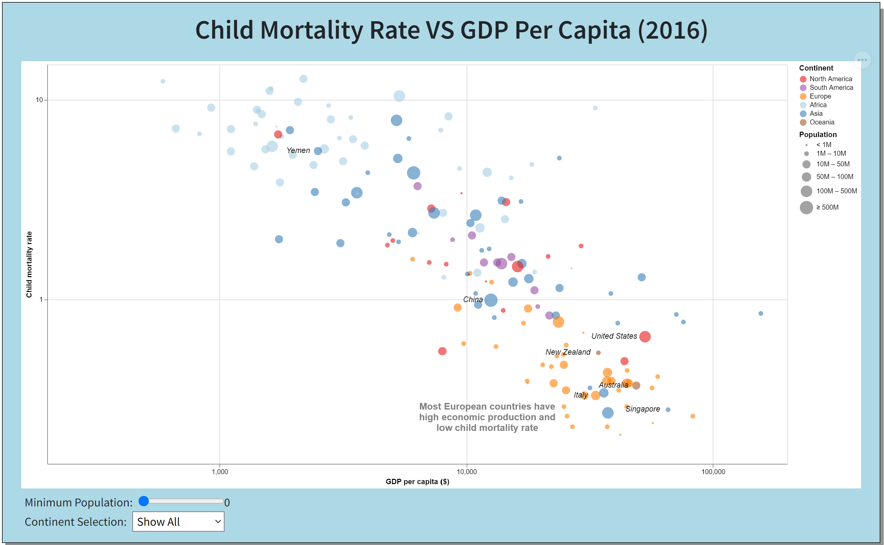

URL

<https://ongdisheng.github.io/FIT3179/>

1. Domain of visualization

* Child mortality around the world

1. Visualised dataset

* Attribute 1: Child mortality rate
* Attribute 1 type: Quantitative
* Attribute 2: GDP per capita
* Attribute 2 type: Quantitative
* Attribute 3: Population
* Attribute 3 type: Quantitative
* Attribute 4: Continent
* Attribute 4 type: Nominal
* Source: UN Inter-agency Group for Child Mortality Estimation
* Author: World Development Indicators - World Bank

1. Justification of using bubble plot

* Because bubble plot is able to encode 2 quantitative attributes which are child mortality rate and GDP per capita in this case with an additional size channel that is used to encode the population attribute as well as a color channel to encode the continent attribute.
* Bubble plot can be used to identify the correlation between child mortality rate and GDP per capita effectively in this case. From the visualization, we can see that child mortality rate decreases as the GDP per capita increases.