**FIT3179 Data Visualization 1**

**Report**

Name: Ong Di Sheng

Student ID: 31109667

Title: Food Waste

Tutor: Dr Grace Ting

Lab: Tutorial 06

Tableau URL: <https://public.tableau.com/views/Viz1_16614226302240/Dashboard1?:language=en-US&:display_count=n&:origin=viz_share_link>

Number of words: 989

**Domain, Why and Who**

Food waste is a growing issue globally but it is not getting enough attention by the community (Grimwood, 2017). Therefore, I decide to grab this opportunity by using this visualization project as a platform to raise public awareness on the food waste crisis. This can be done by first investigating the different stages along the food supply chain that causes loss of food as well as analyzing the amount of food wasted by various countries and regions. With this in mind, we are able to figure out which food supply stage should be more focused on and which country should step up in leading the change in dealing with this issue.

**What**

The data is taken from Food and Agriculture Organization of the United Nations official online database. The database contains the details of food waste across major types, supply stages and countries from 1965 to 2022, which are collected from various open sources including academic studies and reports from reputable organizations such as World Bank (FAO, 2022). Besides that, three additional data sources which contain region (World Bank, 2022a), population information (World Bank, 2022b) as well as gdp details for each country (World Bank, 2022c) are needed in one of the visualizations.

**Why and How**

The rationales for choosing the idioms used in the project are listed down below:

1. Line chart – Useful in identifying trend of food waste value (quantitative) over the year (ordinal) by looking at the line connection (mark) along vertical position (channel)
2. Word cloud – Useful in identifying which food (qualitative) is wasted the most by looking at the word with the largest size which indicates frequency (quantitative)
3. Alluvial diagram – Useful in showing the flow for the wastage of major food type (qualitative) from each supply stage (qualitative) by looking at the size (channel) of proportional lines for nodes arranged along vertical lines (mark)
4. Radial bar chart – Useful in comparing food loss value (quantitative) among supply stage (qualitative) by looking at the length (channel) of lines (mark)
5. Stacked bar chart – Useful in identifying which major food type (qualitative) is wasted the most in each region (qualitative) by comparing the length (channel) of the glyphs (mark)
6. Bubble plot – Useful in finding correlation between population of countries (quantitative) and food waste value (quantitative) by looking at the points (mark) along horizontal and vertical position (channel) with varying size (channel) that indicates gdp
7. Donut chart – Useful in comparing proportion of food loss (quantitative) among the top 5 countries (qualitative) by looking at the angle (channel) for each sector

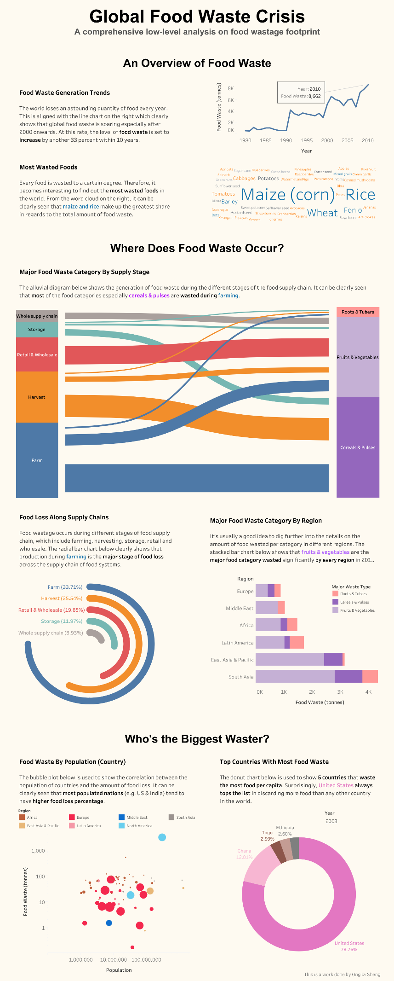

Figure 1: Overall visualization showing details of food waste

The description for the features used in the visualization as shown in Figure 1 is listed down below:

1. When the user hovers over any sections of the vertical bar in the alluvial diagram, the flow corresponding to the selected section of the bar will be automatically highlighted.
2. When the user selects any countries in the donut chart, the country corresponding to the user selection will be displayed in the bubble plot.
3. The viewers can observe the differences in both donut chart and bubble plot with respect to year by using the slider.

**Design**

1. Layout – The overall layout is split into two columns and multiple rows. Besides that, the layout also seems to be balanced in overall, with most of the white space being found at the left and right of the headings. The sight lines are mostly horizontal between the three different sections, except for one vertical sight line that is used to split each section into two columns. The headings of each section are aligned to the center so that the visualization will be more balanced towards the center.
2. Color – All the color chosen in the visualizations do not involve a combination of red and green as they can be a potential nightmare for the color-blind viewers. Instead, a color-blind friendly palette is chosen to allow them to differentiate supply stages in the visualizations easily. Different food supply stages are represented by using color hue, which is perfectly fine as the food supply stages are qualitative data attributes. The label color for each supply stage matches the color used in bars of radial bar chart, which enables the viewers to navigate better in the visualization.
3. Figure-ground – The alluvial diagram which is being aligned at the center of the layout that spans across the two columns is used to signify to the viewers that this is the most important visualization which acts as a foreground as compared to other charts due to the visual center property. Besides that, the stacked bar chart is sorted in which the most wasted food type is placed at the bottom to indicate their majority presence to the viewers.
4. Typography – The typeface and font used in the headings of the visualization are sans serif and arial respectively. Arial is a common font choice widely used in the headings as they appear bolder as compared to the typical serif typeface, which helps to draw the attention of the viewers towards the headings. Meanwhile, tableau medium font is used in the text paragraph as it is highly readable due to its minimalist nature. The main title and subheadings have a larger font size and weight as compared to the text paragraph to indicate their importance and form a hierarchy. There is also a spacing in between the subheadings and the text paragraph to minimize the cluttering feel in the text layout.
5. Storytelling – The visualizations are shown in a predefined order, which is from left to right and top to bottom. There is also a scrollbar for the viewers to navigate vertically, which acts as a form of scrollytelling. The text paragraph found either beside or on top of the visualizations is used to further explain the details which will give the viewers an idea of the meaning behind those charts.

**References**

Grimwood, P. (2017, March 10). *The food waste solution that isn’t getting enough attention*. Retrieved from https://www.linkedin.com/pulse/food-waste-solution-isnt-getting-enough-attention-paul-grimwood

FAO. (2022). *Food and Agriculture Organization of the United Nations Food Waste Data.* Retrieved form https://www.fao.org/platform-food-loss-waste/flw-data/en/

World Bank. (2022a). *WDI - The World by Income and Region*. Retrieved from https://datatopics.worldbank.org/world-development-indicators/the-world-by-income-and-region.html

World Bank. (2022b). *Population, total | Data*. Retrieved from https://data.worldbank.org/indicator/SP.POP.TOTL

World Bank. (2022c). *GDP per capita (current US$) | Data*. Retrieved from https://data.worldbank.org/indicator/NY.GDP.PCAP.CD