Visualization 1: The Best Funded Startup in Each State of USA

Link: <https://www.visualcapitalist.com/best-funded-startup-state/>

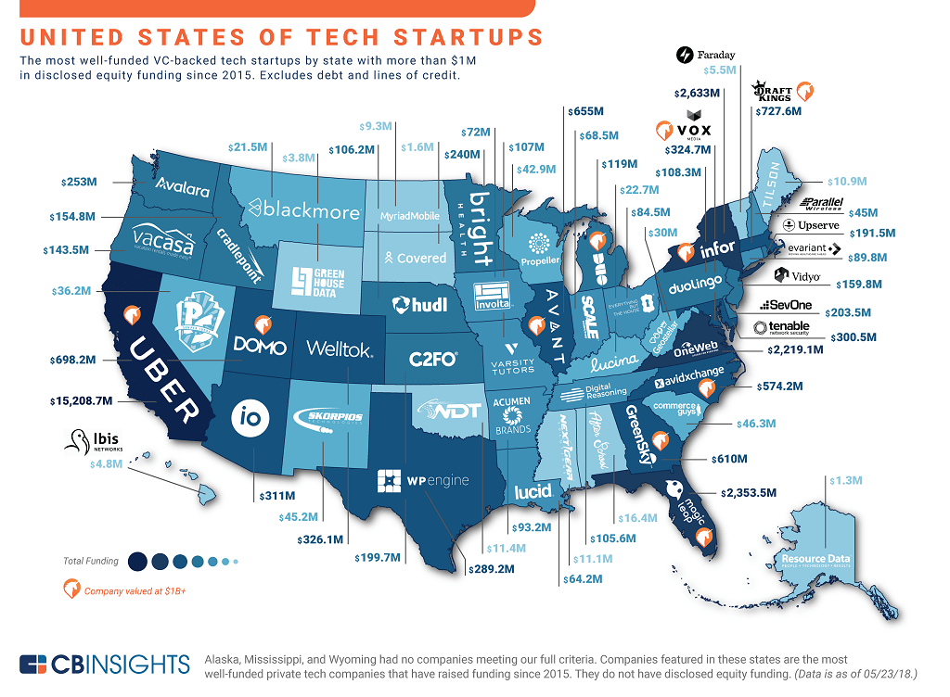

Dataset Type

* Table
* Items
* Attributes
* Geometry
* Items
* Positions

Data Attribute Type

* Qualitative
* States
* Company
* Quantitative
* Equity Funding

Mark

* Areas
* Text

Channel

* Color Value

Visualization 2: Higher Risk of Job Automation in Lower Paying Jobs

Link: <https://uploads.toptal.io/blog/image/129366/toptal-blog-image-1552462641307-b11747c8661cfc8e57a43dbdae79fba4.png>

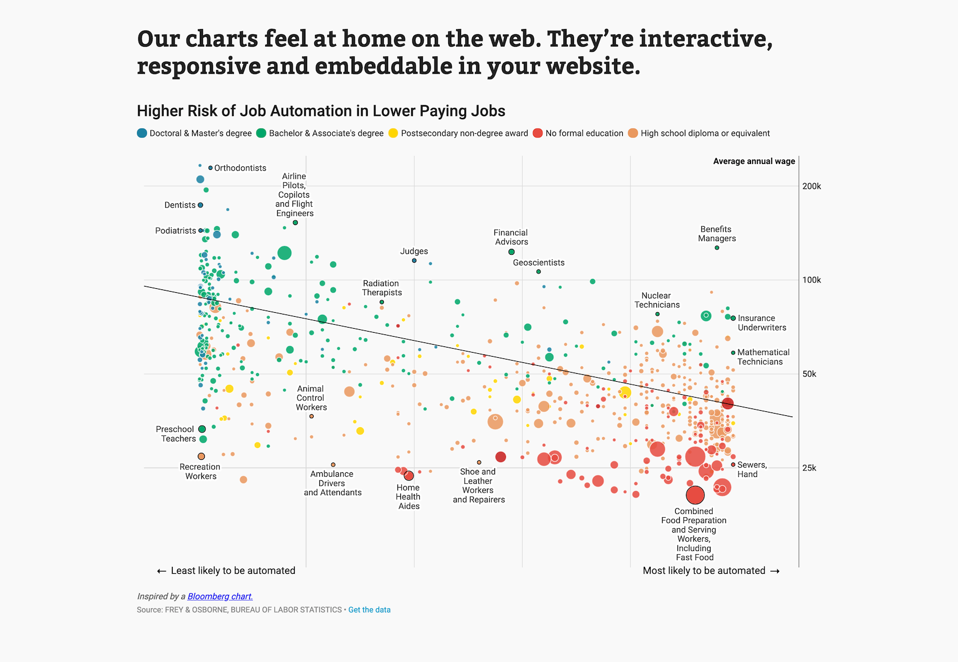

Dataset Type

* Table
* Items
* Attributes

Data Attribute Type

* Qualitative
* Jobs
* Ordinal
* Education Level
* Quantitative
* Average Annual Wage
* Percentage to be Automated

Mark

* Point

Channel

* Position
* Color Hue
* Size