Name: Ong Di Sheng

Student ID: 31109667

Lab: 6

Tutor: Dr Grace

Screenshots:

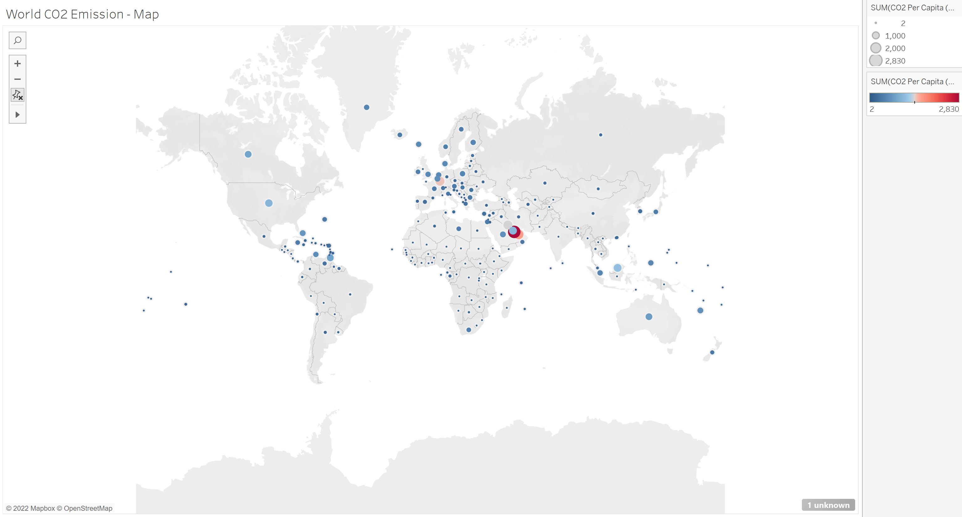

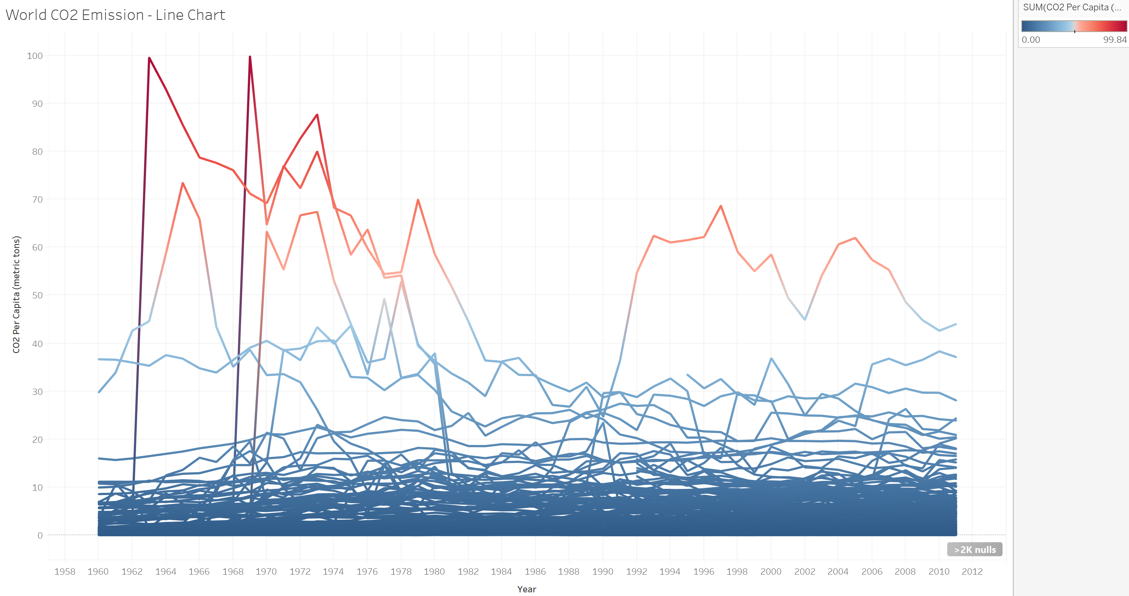

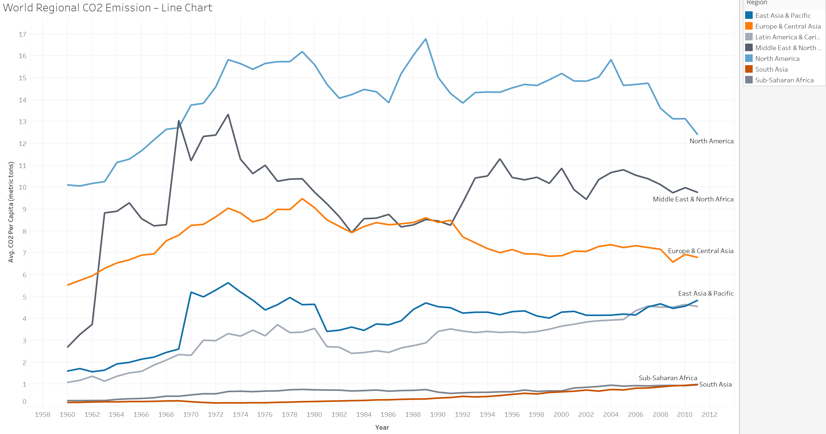

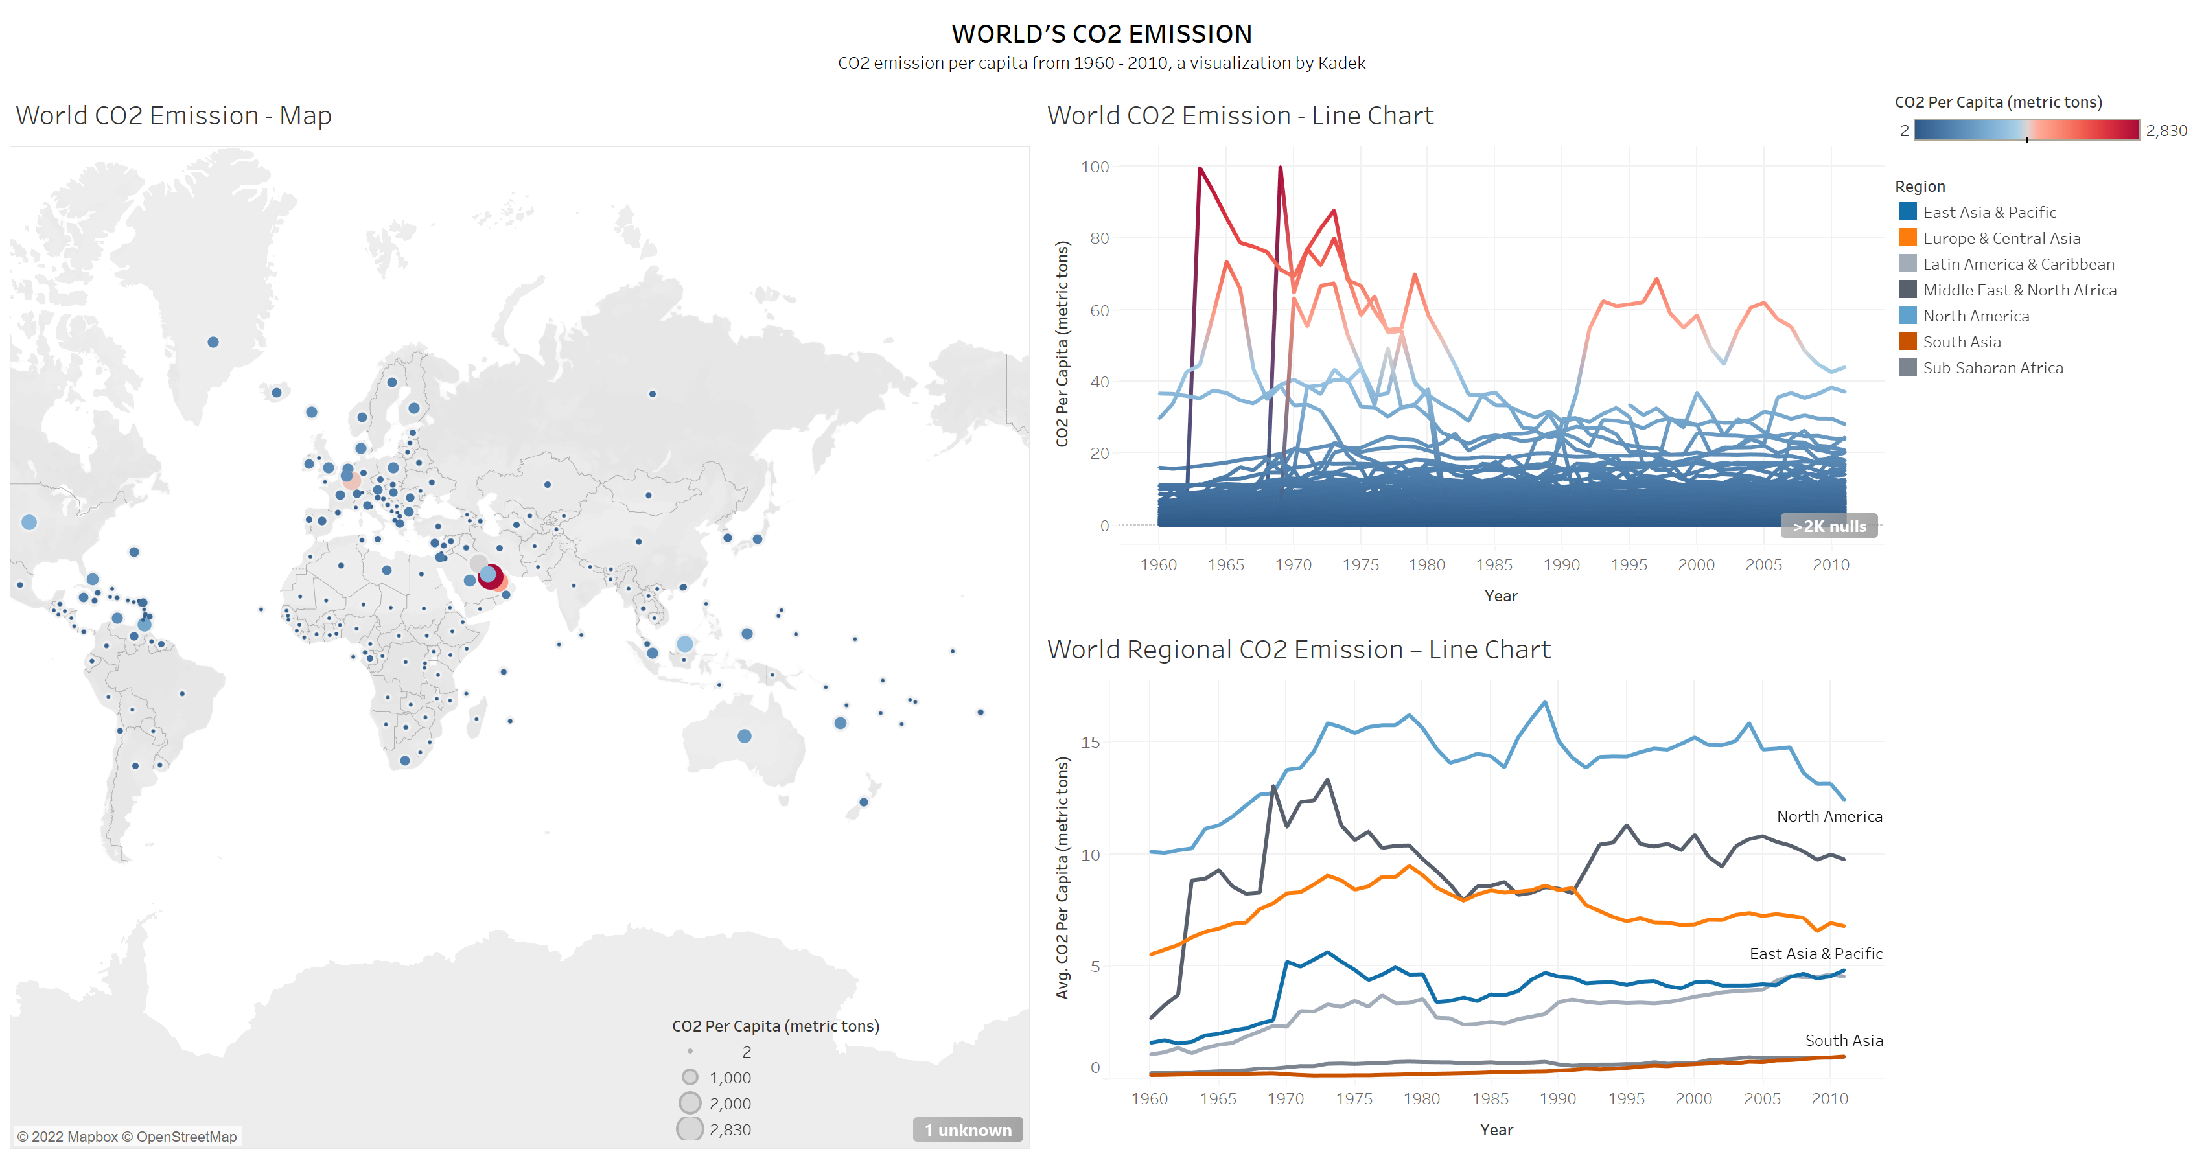

Tableau URL: <https://public.tableau.com/views/HomeworkWeek5_16613295126820/Dashboard1?:language=en-US&:display_count=n&:origin=viz_share_link>

OR

<https://public.tableau.com/app/profile/ong.di.sheng/viz/HomeworkWeek5_16613295126820/Dashboard1>