**Homework Week 9**

Name: Ong Di Sheng

Student ID: 31109667

Lab: 6

Tutor: Dr Grace

URL: <https://ongdisheng.github.io/FIT3179/>

Screenshot:

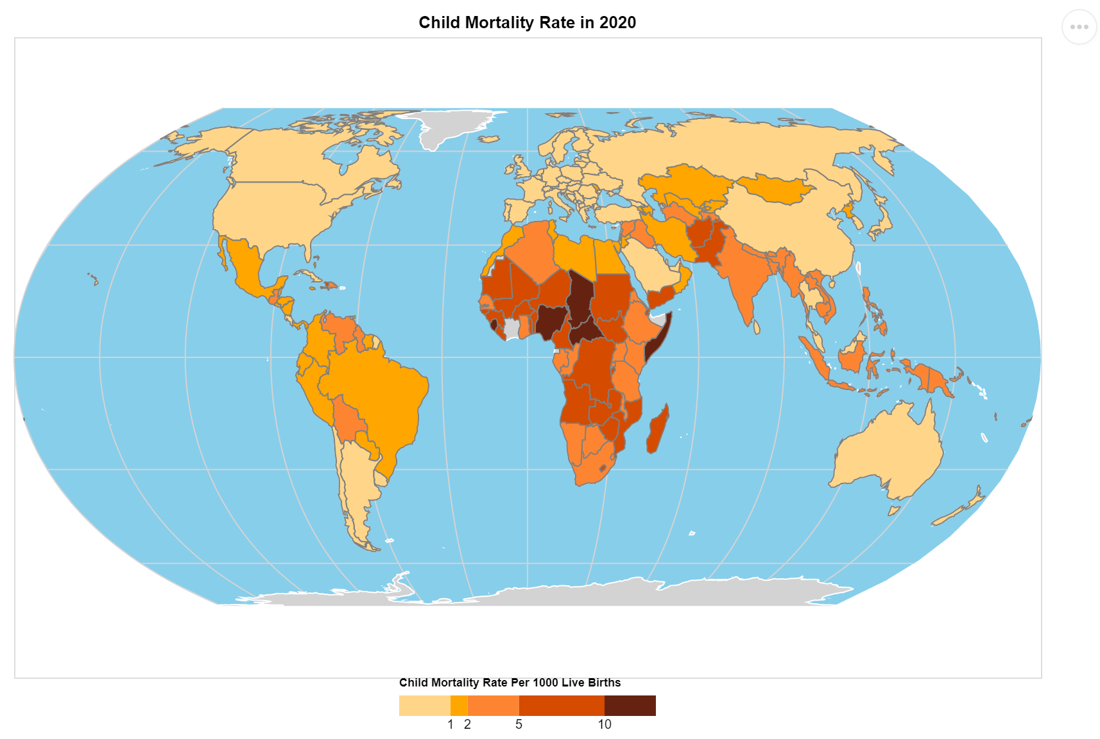

1. Domain of visualization

* Child mortality around the world

1. Visualized dataset

* Attribute: Child mortality rate per 1000 live births
* Attribute types: Quantitative
* Source: UN Inter-agency Group for Child Mortality Estimation
* Author: World Development Indicators - World Bank

1. Data transformation

* Normalization of child deaths by live births has been done by the provider of the dataset

1. Justification of using choropleth map

* The viewers can observe the difference in child mortality rate between countries easily through the color luminance of choropleth map.
* Proportional symbol map is not suitable as most of the neighboring countries in Europe have similar child mortality rate encoded by length of bar chart or size of circle mark, which is not easy for the viewers to differentiate among them.