ALL EPIC STORIES:

**Customer Online Order (COO):**

As a customer I should be able to choose my food and drinks online, customize the ingredients and then be notified when the order is ready so I can collect it.

**Staff Service Order (SS0):**

As a staff member, I should be able to view all the online orders and be able to accept new orders and update the order's status once the order is ready.

**Staff Maintenance Inventory (SMI):**

As a staff member, I should be able to have inventory levels displayed to me so I know when I need to refill the stock. Inventory levels should also be automatically adjusted as orders are made and when ingredients run out customers shouldn't be able to order them.

Note: 1 Story Point (1 SP) = 1/4 of a day

# Epic Story 1:

**As a customer I should be able to choose my food and drinks online, customize the ingredients and then be notified when the order is ready so I can collect it.**

|  |  |
| --- | --- |
| ID | UC1 |
| Name | Website connection |
| Description | As a customer I want to be able to view the food items online so that I decide which items I want to buy. |
| Acceptance Criteria | Test1 - Typing in the company web address into a connected internet browser should load the web page.  Test2 - The homepage should have a link that once clicked leads to a page which allows the customer to view items. |
| Priority | 1 |
| Size | 2 SP |

|  |  |
| --- | --- |
| ID | UC2 |
| Name | Food variety |
| Description | As a customer I should be able to order multiple items of food and drink so I can consume what suits my needs. |
| Acceptance Criteria | Test1 - Clicking on different tabs of "mains, sides, and drinks" should load up separate pages displaying different categories of food.  Test2 - The user should be able to select however many items he wants and in whatever quantity if ingredients are available and item is valid.  Test3 - Clicking add to order will add any selected items into my order.  Test4 – Create an order a beef burger on white bread with cheese and a tuna wrap with cheese, lettuce, onion and avocado and appropriate ingredients are subtracted. |
| Priority | 1 |
| Size | 4 SP |

|  |  |
| --- | --- |
| ID | UC3 |
| Name | Ingredient options |
| Description | As a customer I want to be able to customize the ingredients on my order so I can have as much control over the food to be ordered. |
| Acceptance Criteria | Test1 - When building the main (burger or wrap) ingredients should have the option to be added.  Test2 - Option to add or remove ingredients should be taken away if there's too little or too many ingredients of the same type.  Test3 - When building the main (burger or wrap) ingredients should have the option to be Taken away. |
| Priority | 2 |
| Size | 3 SP |

|  |  |
| --- | --- |
| ID | UC4 |
| Name | Size options |
| Description | As a customer I want to be able to select different sizes of drinks and sides so I can order a size that suitably satisfies my appetite. |
| Acceptance Criteria | Test1 – drinks can be added to an order in size small  Test2 – drinks can be added to an order in size medium  Test3 – drinks can be added to an order in size large  Test4- a small medium and large drink can be added to the same order  Test5- Asking for a size not on the menu returns the error “invalid size”  Test6- Cannot add a drink to an order that isn’t on the menu  Test7-Drinks can be removed from an order  Test8-Drinks have a specific cost associated with them.  Test9-Sizes of drinks require different amounts of stock in inventory |
| Priority | 3 |
| Size | 2 SP |

|  |  |
| --- | --- |
| ID | UC5 |
| Name | Generate order ID |
| Description | As a customer I want to receive an order ID so I can view my order status. |
| Acceptance Criteria | Test1 – When a first order is created it has ID 0  Test2 – when a second order is created it has ID 1  Test3 – Appending the order ID to the web address should bring up a session with the details of that order.  Test4 – Giving an invalid order ID will return a message “Order Not Found” |
| Priority | 4 |
| Size | 2 SP |

|  |  |
| --- | --- |
| ID | UC6 |
| Name | View current order |
| Description | As a customer I want to be able to view my order so I can see what I am going to order and its costs. |
| Acceptance Criteria | Test1 - Clicking on the order should bring up a new page showing all items in the order |
| Priority | 8 |
| Size | 3 SP |

|  |  |
| --- | --- |
| ID | UC7 |
| Name | Edit cart |
| Description | As a customer I want to be able to remove things from my order individually so that it is easy to edit my order. |
| Acceptance Criteria | Test1 - On the order page, each item in the order should be able to be removed.  Test2 – Removing an item will result in a reduce of the total cost of an order.  Test3 – Removing an item from an order will result in the item no longer being in the order.  Test4 – Removing an item from an order will result in its corresponding ingredients incrementing appropriately. |
| Priority | 9 |
| Size | 2 SP |

|  |  |
| --- | --- |
| ID | UC8 |
| Name | Payment finalisation |
| Description | As a customer I want to receive a final total before finalising the transaction so I can determine if the final cost meets my budget. |
| Acceptance Criteria | Test1 - When finalising payment a detailed breakdown and total cost should be displayed.  Test2 - Any taxes or service charges should also be displayed on this order. |
| Priority | 7 |
| Size | 1 SP |

|  |  |
| --- | --- |
| ID | UC9 |
| Name | Display costs |
| Description | As a customer I want to view the cost of every item displayed so I can know its cost before adding it to my order. |
| Acceptance Criteria | Test1 – The cost of an item is displayed after selecting necessary options for the item. |
| Priority | 5 |
| Size | 1 SP |

# Epic Story 2:

**As a staff member, I should be able to view all the online orders and be able to accept new orders and update the order's status once the order is ready.**

|  |  |
| --- | --- |
| ID | UC10 |
| Name | View orders |
| Description | As a staff member I should be able to access a staff only version of the system so I know which orders need to be fulfilled. |
| Acceptance Criteria | Test1 - URL link provided should display staff-only version of the website.  Test2 - Dashboard on the website should display a link named "Incomplete orders".  Test3 - Dashboard on the website should display a link named "complete orders".  Test4 - Dashboard on the website should display a link named "View All Orders |
| Priority | 4 |
| Size | 2 SP |

|  |  |
| --- | --- |
| ID | UC11 |
| Name | Accept new orders |
| Description | As a staff member I want new orders to be put into the list of orders so I can keep track of all incoming orders. |
| Acceptance Criteria | Test1 – Submitted orders should appear on the list of incomplete orders.  Test2- A newly submitted orders status is “Submitted” |
| Priority | 2 |
| Size | 4 SP |

|  |  |
| --- | --- |
| ID | UC12 |
| Name | Update order status |
| Description | As a staff member I want to be able to update the order's status once it's cooked so we know we can starting preparing another order. |
| Acceptance Criteria | Test1- when an order is being prepared it has the status “Preparing order”  Test2 - Order's status should change to "completed" when updated.  Test3 - Order should be removed from the list of incomplete orders and moved to list of completed orders.  Test4 - Attempting to update the status of an order that doesn’t exist generates the error message “Order status error” |
| Priority | 3 |
| Size | 2 SP |

# Epic Story 3:

**As a staff member, I should be able to have inventory levels displayed to me so I know when I need to refill the stock. Inventory levels should also be automatically adjusted as orders are made and when ingredients run out customers shouldn't be able to order them.**

|  |  |
| --- | --- |
| ID | UC13 |
| Name | View Stock |
| Description | As a staff member, I should be able to view my stock levels so I can refill stock if needed. |
| Acceptance Criteria | Test1 – Staff should be able to view inventory levels. |
| Priority | 2 |
| Size | 3 SP |

|  |  |
| --- | --- |
| ID | UC14 |
| Name | Decrement stock |
| Description | As a staff member, I want the system to automatically decrement stock levels of the required ingredients of an order when the order is placed so I can accurate account for the stock levels. |
| Acceptance Criteria | Test1 -When an order is placed, stock levels of the ingredients used in the order should be decremented accordingly. |
| Priority | 1 |
| Size | 3 SP |

|  |  |
| --- | --- |
| ID | UC15 |
| Name | Prevent unavailable orders |
| Description | As a staff member, I want the system to prevent customers from placing orders requiring unavailable ingredients so they don't place an order that can't be provided for. |
| Acceptance Criteria | Test1 - When a customer attempts to select an item that has ingredients that are unavailable the system prevents the order and displays “Not enough {ingredient} in stock.” |
| Priority | 3 |
| Size | 1 SP |

|  |  |
| --- | --- |
| ID | UC16 |
| Name | Stock drinks and sides by volume and weight |
| Description | As a staff member, I want certain items to be stocked by volume or weight so that I can serve them in varying sizes. |
| Acceptance Criteria | Test1 - The system should respectively display the volume/weight of each type of drink/side that is in stock.  Test2 - The system should correctly decrement the correct volume/weight of an item in stock when an order is placed. |
| Priority | 4 |
| Size | 4 SP |

|  |  |
| --- | --- |
| ID | UC17 |
| Name | Sundaes |
| Description | As a customer I should be able to order Sundaes and so I can have a dessert to go with my meal |
| Acceptance Criteria | Test1 – Clicking on “chocolate sundae” will add a chocolate sundae to my meal.  Test1 – Clicking on “Strawberry sundae” will add a chocolate sundae to my meal.  Test2 – Sundaes are listed as a side on the website.  Test3 – Sundaes can be added to my cart in size small and the cost of my cart will be updated  Test4 – Sundaes can be added to my cart in size medium and the cost of my cart will be updated  Test5 – Sundaes can be added to my cart in size Large and the cost of my cart will be updated |
| Priority | 10 |
| Size | 2 SP |

|  |  |
| --- | --- |
| ID | UC18 |
| Name | Default Burger |
| Description | As a customer I should be able to order a Default burger without having to select any ingredients so I can get an order quickly and easily |
| Acceptance Criteria | Test1 – Clicking on Default burger will add a Beef burger on white bread with lettuce to my meal.  Test2- attempting to add A default burger to an order with no lettuce in stock will generate an error saying “this item is unavailable”  Test3- Adding a Default burger to a meal will increase the cost of an order by $8 |
| Priority | 9 |
| Size | 3 SP |

# OO Diagram

# ER Diagram

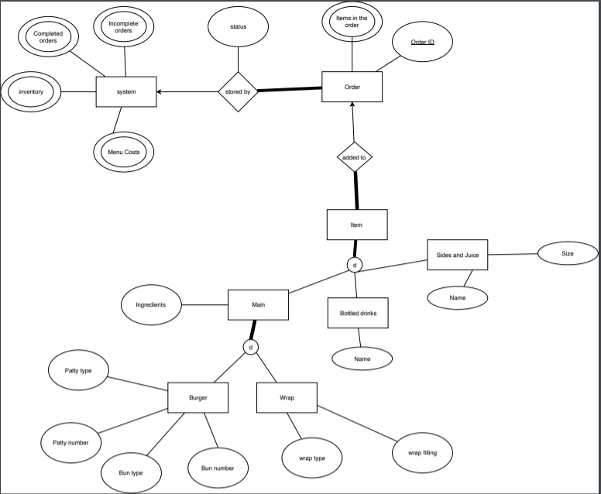

# Log Book

**Meeting 04/03/19**

-team members gathered and discussed the assignment

-Defined our epic user stories as a group

-explored how to use github with different branches and pushing and pulling

-decided on Wednesday afternoon as a free day for meeting up if needed.

-Method of communication will be Facebook

Tasks for next meeting

-Jack: Create Customer user stories

-Sandeep: Create Service User stories

-Zen: Create Maintain inventory user stories

Notes:

-see usersStories.txt for draft user stories

**Meeting 11/03/19**

Milestone 1 submitted

Reflection

The user stories went well, each group member fulfilled their role as expected and completed all the tasks given to them.

Obstacles

Working on our various branches to much without pushing and pulling to master resulted in a large amount of conflict issues that required time to fix so we can merge again.

-Focused on lab work.

-Jack put in charge of log book

**Meeting 18/03/19**

-Sandeep not present

-received feedback on user stories

Issues

more focus on acceptance criteria needed

some of the priorities need changing

change the ID's for the User stories

**Meeting 25/03/19**

-crc cards made: see CRC appendix

-Created a basis for the UML Diagram

-Sandeep left the group

-Decided on menu and ingredients to be used as standard: see Dictionary_of_ingrediants.txt

Tasks to be completed.

-Zen: UML Diagram touch up, CODE: Staff, customer, order

-Jack, work on logbook, CODE: system, food drinks and sides

**1/04/19**

Received feedback on UML Diagram

Issues

food items should not be in abstract class

menu and ingredients should available to the whole system

customer and staff classes are not needed.

Notes on Functions

System

submit order check ingredients number > inventory

generate id based on lists and add to ID

prepare order changes status but still in incomplete

complete order moves it to completed order list update status

view all orders prints/returns incomplete list and complete list.

Order

items list of items

id set id when made

status, oreder, preparing complete

calculate cost-add cost of every item in item

add to order add item to list

remove removes

set name appends it to customer list

Tasks to be completed:

Zen: make edits to UML Diagram, code item and its inheritance

Jack: Code System and Order

**3/04/19**

UML Diagram presented by Zen

Discussed the messiness of the GitHub and decided to sort lab work and assignment work into folders

**8/04/19**

Presentation of milestone 2 Went well

Issues

-Have less hard coding in things like sides and prices.

-Need better use of GitHub branches.

-Branches should be made and then deleted when finished with them.

Focused on Lab work

**15/04/19**

Discussed roles for the front end implementation

Tasks to complete

-Jack: ER Diagram, Report and implementation of staff front end.

-Zen: Implementation of order front end and combing the work done.

Obstacles

-Not sure how to implement persistence.

# Velocity Chart

# CRC Cards

|  |  |
| --- | --- |
| Name: System | Name: Order |
| Responsibilities:  Create An Order  Delete An Order  Submit An Order  move an order to prepared status  mark an order as complete  Check the status of an order  View all current orders  View all Incomplete Orders  View all CompleteOrders  add more stock to the system  create a new menu item  display the menu  get an order with a specific ID | Responsibilities:  Create an item  delete an item  calculate the cost  add an item to an order  remove an item from an order  display an order |
| Knows:  Menu  Inventory  Mains  Sides  Drinks  Completed orders  Incomplete orders | Knows:  Menu  Inventory  items in the order  order ID  status of the order |
| Collaborators:  Order | Collaborators:  system  items |

|  |  |
| --- | --- |
| Name: Item | Name: Main |
| Responsibilities: | Responsibilities:  set other ingrediants |
| Knows:  Menu  inventory | Knows:  added ingrediants |
| Collaborators:  order  mains  bottled drinks  sides and fountain drinks | Collaborators:  Items  wraps  burgers |

|  |  |
| --- | --- |
| Name: Burgers | Name: Wraps |
| Responsibilities:  set number and type of buns  set number and type of pattys | Responsibilities:  set number and type of wrap  set number and type of filling |
| Knows:  patty number  patty type  buns number  buns type  Cost of ingredients | Knows:  filling type  wrap type  Cost of ingredients |
| Collaborators:  Mains | Collaborators:  Mains |

|  |  |
| --- | --- |
| Name: Bottled drinks | Name: Fountain drinks and sides |
| Responsibilities: | Responsibilities:  set size of drink |
| Knows:  type of drink | Knows:  type of drink/side  size of the drink/side |
| Collaborators:  Items | Collaborators:  Items |