##### BAIT1023 Web Design and Development

**Assignment**

|  |
| --- |
| **Programme : BAIT1023 Web Design and Development** |
| **Tutorial Class : REIS3G1** |
| **Practical Tutor Name: Mr.Chong Kah Shiu** |
| **Website Title: SportoSense** |
| |  |  |  |  |  |  |  |  | | --- | --- | --- | --- | --- | --- | --- | --- | | **No.** | **Student Name** | **Student ID** | **Module In Charge** | **Signature** | **Part A**  **(30%)** | **Part B**  **(70%)** | **Total**  **(100%)** | | **1** | **Darren Ong Jungai** | **2102991** | **Product, Clothing** | **DOJ** |  |  |  | | **2** | **Chuang Kian Hui** | **2102235** | **Home, About Us, Wishlist, FAQ** | **KH** |  |  |  | | **3** | **Jason Lee Yip Siong** | **2102260** | **Shoes, Login** | **Lee** |  |  |  | | **4** | **Soh Chiu Yi** | **2103828** | **Accessories, Promotion, Membership, SignUp, Terms and Conditions** | **chiuyi** |  |  |  | | **5** | **Tee Pei Wen** | **2102604** | **Cart, Checkout, Payment** | **daphne** |  |  |  | |
| **Date of Submission:16/4/2022** |

**Assessment Rubrics – Assignment Part 1 (30 marks)**

|  |  |  |  |  |  |
| --- | --- | --- | --- | --- | --- |
| **CLO2: Present the design and implementation of a Website by applying the acquired knowledge and skills in a team. (A2, PLO4)** | | | | | |
| **Criteria** | **Marks** | **Good** | **Average** | **Poor** | **Score** |
| Planning   * Description of the organization * Web site objectives * Potential users * Information the users need * Proposed deliverable | 8 | Correctly & clearly define all of the required information.  (7 – 8) | Correctly define most of the required information. Few are either incorrect or missing.  ( 5– 6) | Most of the information is missing, incomplete or incorrect.  (0 – 4) |  |
| Analysis   * Functions or modules | 6 | Excellently define all the required information of web site modules correctly & clearly.  (5 – 6) | Correctly define most of the required information web site modules correctly. Few are either incorrect or missing.  (3– 4) | Most of the web site module information is incomplete or incorrect.  (0 – 2) | |  |  | | --- | --- | | Name | Mark | | 1. Darren Ong Jungai |  | | 2.Chuang Kian Hui |  | | 3.Jason Lee Yip Siong |  | | 4.Soh Chiu Yi |  | | 5.Tee Pei Wen |  | |
| Design   * Web page layout design | 6 | Excellently define all the required information. All sketches are clear and easy to read.  (5 – 6) | Correctly define most of the required information. Few are either incorrect or missing. Some sketches is not clear/hard to read.  (3 – 4) | Most of the information is missing, incomplete or incorrect, most sketches are not clear/ hard to read.  (0 –2) | |  |  | | --- | --- | | Name | Mark | | 1. Darren Ong Jungai |  | | 2.Chuang Kian Hui |  | | 3.Jason Lee Yip Siong |  | | 4.Soh Chiu Yi |  | | 5.Tee Pei Wen |  | |
| Web development management | 10 | Work together with different team member in completing web site and system documentation effectively and on time.  (8-10) | Work together with different team member in completing the completing web site and system documentation on time.  (5– 7) | Work together with different team member in completing web site and system documentation  ineffectively and late.  (0 – 4) |  |
| Comments (if any): | | | | | |  |  | | --- | --- | | **Name** | **Total Mark (Part 1)** | | 1. Darren Ong Jungai |  | | 2.Chuang Kian Hui |  | | 3.Jason Lee Yip Siong |  | | 4.Soh Chiu Yi |  | | 5.Tee Pei Wen |  | |  |  | |

**Assessment Rubrics – Assignment Part 2 (70 marks)**

|  |  |  |  |  |  |
| --- | --- | --- | --- | --- | --- |
| **CLO1: Build a website with HTML, Cascading Style Sheets (CSS) , JavaScript and web development tools. (P4, PLO3)** | | | | | |
| **Criteria** | **Marks** | **Good** | **Average** | **Poor** | **Score** |
| Functionality & Complexity of the Overall Web Site using the following elements**:**   * Media elements (text, graphic, audio, video and animation) * Hypertext and hypermedia * List * Formatting * Hotspot / image map * Table * Form * CSS for all of the GUI design (use External Style Sheet effectively) * JavaScript | 40 | Excellently completed more than 80% of the required functionalities correctly using all the listed elements.  (30 – 40) | Averagely completed more than 50% of the required functionalities with some minor errors. Only used some of the listed elements.  (16 – 29) | Not able to complete most of the required functionalities correctly. Only used few of the listed elements.  (0 – 15) |  |
| Usability & User Interface Features | 30 | Good design consistency and interface usability, visual effect and interactivity.  (23 – 30) | Average design, consistency and interface usability, visual effect and interactivity  (12 – 22) | Poor design, consistency and interface usability, visual effect and interactivity.  (0 –11) | |  |  | | --- | --- | | Name | Mark | | 1. Darren Ong Jungai |  | | 2.Chuang Kian Hui |  | | 3.Jason Lee Yip Siong |  | | 4.Soh Chiu Yi |  | | 5.Tee Pei Wen |  | |
| Comments (if any):  **______________________________________________________________________________________** | | | | | |  |  | | --- | --- | | **Name** | **Total Mark (Part 2)** | | 1. Darren Ong Jungai |  | | 2.Chuang Kian Hui |  | | 3.Jason Lee Yip Siong |  | | 4.Soh Chiu Yi |  | | 5.Tee Pei Wen |  | |  |  | |

**1.0 Planning**

**Description of the organization**

SportoSense is a new sportswear retail brand that cooperates mainly with Adidas to promote and sell their sportswear including sports shirts, pants, shoes and accessories. We have our own professional team in charge of marketing and sales to have an effective plan and develop a website to attract consumers’ attention and increase product sales. We highly emphasize our consumers’ experience and always work hard to provide the best products and services to them. As sports play an important role in more and more people's lives, the need or demand for good sportswear is also increasing. Our main focus is to introduce the best quality Adidas sportswear to the consumers in order for them to do their favorite sports in comfort and have the best experience with them. Our mission is to become one of the best sportswear retail brands in the industry.

**Website Objectives**

The main objective of this website is to build a brand. The brand is a set of unique values for an organization, it represents the reputation of the business. For a start, we will create a logo, which is the symbol of our brand. We will put out our products, the design of the products, the messages that we want to deliver to the website users, and our organizational culture on the website. On the whole, the output is called a brand. Besides that, this website will help to improve the business process automation by establishing a strong connection between the marketing team and sales team which will enable the business operation to be made seamless online using the website platform. Moreover, the objective of this website is to improve the SEO of the products. We would optimize our website and increase traffic to our website by using Search Engine Optimization (SEO). The biggest factor of Google to determine which website should appear on the first page as the result of searching is relevancy. In addition to relevance, we would also want to make sure that our website is useful. All that means is that when a user clicks on the website, the information that they are looking for is easily found. SEO would greatly help an organization to increase sales by turning the leads into customers.

**Potential users of the Website**

**1. Working Adults**

* They can use this website to search for suitable shoes for work. In fact, working adults of different genders can use this website to buy any product as a gift for their loved ones or families such as sports shoes and sports tees. This website can help them to make their purchase easily without costing them too much time.

**2. Teenagers**

* Nowadays there are a lot of teenagers who love to wear sports shoes to attend any occasion such as a party or events. They can use this website to look for their favorite sports shoes conveniently.

**3. Sports lovers**

* They can look for anything they want on this website such as sports accessories, sports pants, sports tee and sports shoes. They will have more choices and find out which one is the most comfortable for them.

**4. Purchasing agents or resellers**

* Those interested in working as a reseller or purchasing agents will have a new opportunity to start a new job or business by using this website.

**5. Shoe collectors**

* They can look for their favorite kind of shoes and catch up with the latest trends to collect all of them.

**Information the users need and wants**

The information of users’ needs and wants are stated below:

1. Adidas product brands on the website.
2. The price and specifications of each product.
3. Different types of shipment for products.
4. Phone number and email address of the customer service.
5. The introduction of the entire company or organization. (company address, types of organization)
6. The membership details and application. (description, discount offered, annual fees)
7. Customer feedback on web page design and products.
8. FAQ provided to get more information.
9. Various payment types while checkout.
10. Promotions that are listed on the website.

**Proposed deliverable of the final Web site**

|  |  |  |  |
| --- | --- | --- | --- |
| **Task Name** | **Task Member** | **Content** | **Timeline** |
| Preparatory Work | All Members | 1. Discuss our assignment’s folder structure, page resources and common layout/style needed to use for the website 2. Discuss the modules for each member | 15/2/2022-1/3/2022 |
| Individual Work | All Members | Kian Hui: (Home, About Us, Wishlist, FAQ)  Darren: (Product, Clothing)  Jason: (Shoes, Login  Chiu Yi: (Accessories, Promotion, Membership, SignUp, Terms and Conditions)  Pei Wen: (Cart, Checkout, Payment) | 1/3/2022-16/4/2022 |
| Website Testing | All Members | Test and combine all the webpages together | 5/4/2022-12/4/2022 |
| Publication | Darren Ong Jungai | Publish the webpage to github and netlify | 12/4/2022-16/4/2022 |

**Gantt Chart**

|  |  |  |  |  |  |  |  |  |  |  |  |  |  |
| --- | --- | --- | --- | --- | --- | --- | --- | --- | --- | --- | --- | --- | --- |
| Task name | Start date | End date | Duration | Assigned | WEEK 1 | WEEK 2 | WEEK 3 | WEEK 4 | WEEK 5 | WEEK 6 | WEEK 7 | WEEK 8 | WEEK 9 |
| **Preparatory Work** | **15/2/2022** | **1/3/2022** | **Week 1 - 2** | **All Members** |  |  |  |  |  |  |  |  |  |
| Folder Structure | 15/2/2022 | 22/2/2022 |  |  |  |  |  |  |  |  |  |
| Page Resources | 15/2/2022 | 22/2/2022 |  |  |  |  |  |  |  |  |  |
| Common Layout/Style | 22/2/2022 | 1/3/2022 |  |  |  |  |  |  |  |  |  |
| Chapter 1: Planning | 22/2/2022 | 1/3/2022 |  |  |  |  |  |  |  |  |  |
|  |  |  |  |  |  |  |  |  |  |  |  |  |  |
| **Individual Work** | **1/3/2022** | **16/4/2022** | **Week 3 - 7** |  |  |  |  |  |  |  |  |  |  |
| Home Module | 1/3/2022 | 5/4/2022 |  | Kian Hui |  |  |  |  |  |  |  |  |  |
| About Us Module | 1/3/2022 | 5/4/2022 |  | Kian Hui |  |  |  |  |  |  |  |  |  |
| Product Module | 1/3/2022 | 5/4/2022 |  | Darren |  |  |  |  |  |  |  |  |  |
| - Shoe Module | 1/3/2022 | 5/4/2022 |  | Jason |  |  |  |  |  |  |  |  |  |
| - Clothing Module | 1/3/2022 | 5/4/2022 |  | Darren |  |  |  |  |  |  |  |  |  |
| - Accessories Module | 1/3/2022 | 5/4/2022 |  | Chiu Yi |  |  |  |  |  |  |  |  |  |
| Promotion Module | 1/3/2022 | 5/4/2022 |  | Chiu Yi |  |  |  |  |  |  |  |  |  |
| Membership Module | 1/3/2022 | 5/4/2022 |  | Chiu Yi |  |  |  |  |  |  |  |  |  |
| Cart Module | 1/3/2022 | 5/4/2022 |  | Pei Wen |  |  |  |  |  |  |  |  |  |
| Checkout Module | 1/3/2022 | 5/4/2022 |  | Pei Wen |  |  |  |  |  |  |  |  |  |
| Payment Module | 1/3/2022 | 5/4/2022 |  | Pei Wen |  |  |  |  |  |  |  |  |  |
| SignUp Module | 1/3/2022 | 5/4/2022 |  | Chiu Yi |  |  |  |  |  |  |  |  |  |
| Login Module | 1/3/2022 | 5/4/2022 |  | Jason |  |  |  |  |  |  |  |  |  |
| FAQ Module | 1/3/2022 | 5/4/2022 |  | Kian Hui |  |  |  |  |  |  |  |  |  |
| Wishlist Module | 1/3/2022 | 5/4/2022 |  | Kian Hui |  |  |  |  |  |  |  |  |  |
| Terms and Conditions Module | 1/3/2022 | 5/4/2022 |  | Chiu Yi |  |  |  |  |  |  |  |  |  |
| **Website Testing** | 5/4/2022 | 12/4/2022 | **Week 8** | **All Members** |  |  |  |  |  |  |  |  |  |
|  |  |  |  |  |  |  |  |  |  |  |  |  |  |
| **Publication** | 12/4/2022 | 16/4/2022 | **Week 9** | Darren |  |  |  |  |  |  |  |  |  |
|  |  |  |  |  |  |  |  |  |  |  |  |  |  |
|  |  |  |  |  |  |  |  |  |  |  |  |  |  |
|  |  |  |  |  |  |  |  |  |  |  |  |  |  |
|  |  |  |  |  |  |  |  |  |  |  |  |  |  |
|  |  |  |  |  |  |  |  |  |  |  |  |  |  |
|  |  |  |  |  |  |  |  |  |  |  |  |  |  |

**Folder Structure**

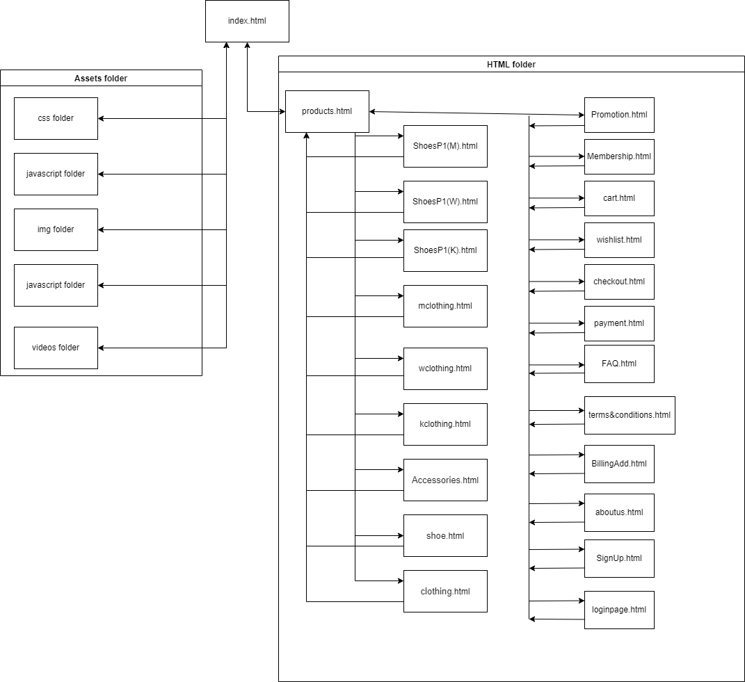

**2.0 Functions or Modules For This Website**

**Home Page**

This is the first web page that the users will see when they first enter this website. It is important for giving good impressions to the users and capturing their attention to continue browsing. It welcomes the users and introduces them to part of the promotion products and new arrivals. They can click ‘See more’ to browse more products if they are interested.

**About Us Page**

This page briefly introduces SportoSense for the users to learn more about this brand. It also contains some feedback and ratings from the customers as a reference for the (potential) customers to decide whether to purchase on this website or not. Last part of the page consists of contact information (phone number and email address) and it allows the users to submit their messages with their name and email address. This is to collect feedback or inquiries from the customers and provide them assistance as well as improvements on the products and services.

**Wishlist Page**

This page records a list of products that the users added from product pages for future reference. It helps users to save or to keep the products that they are interested in but still in consideration. It is also easier to find whenever the users want. When the users decide to buy, they can add that item to cart. On the other hand, if they decide not to buy, they can remove it from the list.

**FAQ Page**

This page recorded some frequently asked questions regarding products, order and payment, shipping and delivery, and return or cancellation. Users can search for the answers here to solve their problems or inquiries. If they could not find the solutions they are looking for, they can always contact us through phone call or email for more information and assistance.

**Product Page**

This page displays the banners of the products that we have on the website through auto slideshows. Also, we include a video for users to understand one of the products series that collaborates with the stars that we have on the website. Lastly, this page can link to the products for three categories which are shoes, clothing and accessories through image overlay zoom.

**Shoe Page & Clothing Page**

These pages are for users to look at our products (shoes and clothing) size chart and links using image overlay zoom to access each product for men, women and kids.

**Clothing (Men/Women/Kids) Page**

These pages consists of all the clothings that are sold on this website. Users can browse through these pages and have size selection and have add to cart and wishlist button.

**Shoes Men Page**

This page consists of all the shoes that are labeled as shoes for men on the website. Users can browse through the page and click the add to cart button if they would like to purchase it.

**Shoes Women Page**

This page consists of all the shoes that are labeled as shoes for women on the website. Users can browse through the page and click the add to cart button if they would like to purchase it.

**Shoes Kids Page**

This page consists of all the shoes that are labeled as shoes for kids on the website. Users can browse through the page and click the add to cart button if they would like to purchase it.

**Login Page**

This page can be accessed by a link from the Membership page. Users must fill out their username and password to log in to their own account from the login page. The password row has a requirement where the users have to input at least one capital letter, one small letter, and one number. There will be an eye icon to click when the users want to check their password in text form to confirm that their input is correct.

**Membership Page**This page includes the introduction which explains what are the reasons for choosing SportoSense, information about the benefits of joining SportoSense as a member and frequently asked questions about SportoSense membership.   
  
**SignUp Page**This page can be accessed by a link from the Membership page. New members must fill out their username, email address, date of birth and password, while existing members may log in using their password and username from the login page. The password row has a requirement where the user has to input at least one capital letter, one small letter, and one number. Until then, the system will not allow the user to sign up and an alert message will pop up to remind the user. After successful signup, the website will bring the user to the login page. **Accessories Page**This page consists of all the items that are labeled as accessories on the website. The accessories page is used to indicate and display the accessories sold at SportoSense. The users may make their purchase in the accessories page, the accessories chosen will then be added into the cart. Furthermore, the accessories page will display the SportoSense’s featured item of the season so that the user may consider making a purchase of the following items.  
 **Promotion Page**The promotion page is where the user can find out about any ongoing promotions. At the top of the page there will be an advertisement banner displaying any current promotion being held such as spring seasoning sale with up to 70% off. Furthermore, the display of price is differ from other product pages where the user can compare the original price with the discounted price. It will be accompanied by the matching discount percentage.  
 **Terms and Condition Page**  
This page talks about the terms and conditions when using the website as well as when the user purchases something from the website. Users are presumed to be complying to the terms and conditions when they browse the website.

**Cart Page**

The page is to record all the products' details including price, quantity, image and name that customers intend to purchase. There are several functions that customers can do in this module. Firstly, customers can increase or decrease the quantity that wants to buy for each product in the cart and also can directly input the quantity. Secondly, the page will calculate and display the subtotal that includes shipping fees, products total and the grand total of the cart before proceeding to checkout. Once they have decided to purchase the specific products, they can proceed to the checkout page by clicking the checkout button.

**Checkout Page**

The page is displayed when the customer clicks on the checkout button on the cart page. Customers are required to fill up the shipping address form. The purpose of this form is to record the customers’ addresses for delivery. There are several required fields that need to be entered by customers such as Full Name, Email, Address, City, State and Postcode. The right-hand side will display the cart summary for customers. The coupon code field is provided for the customer who had redeemed a birthday code to apply and get 10% discount. Next, there is the payment method field that allowed customers to choose their payment method. When the customer clicked on Cash On Delivery button, the page will be redirected to the billing address page. If the customer clicked on the online banking button, there will be a div shown for the customer to select the banks. If the customer clicked on the credit/debit card button, the page will be redirected to the payment page. Lastly, there is a confirm checkout button for customers to submit the form.

**Payment Page**

This page is directed from the checkout page after the customer clicked on credit/debit card payment button. Customers need to fill in all the details on the required fields.

The fields that need to be filled:

1. Name on card
2. Card number
3. Exp Month
4. Exp Year
5. Card Verification Value (CVV)

Lastly, customers clicked on confirm payment button to submit the payment.

**Billing Page**

This page is directed from the checkout page after the customer clicked on cash on delivery payment button. The purpose of this page is to record the billing address of customers for cash on delivery invoice receipts. Customers need to fill in the details on the required fields.

The fields that need to be filled:

1. Full Name
2. Email
3. Address
4. City
5. State (select)
6. Postcode

Lastly, customers clicked on confirm payment button to submit the payment and pay by cash when goods are received by customers on the spot.

**3.0 Design of Webpage**

**Standard Layout**

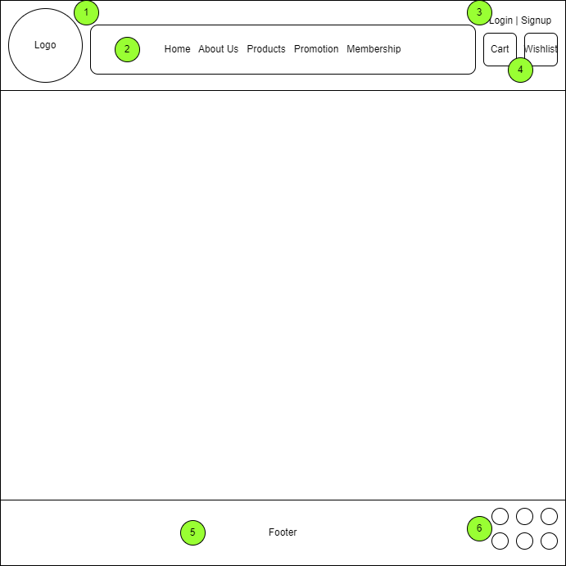

**Description of each webpage Standard Layout**

1. Header background color: #8ACBF0
2. Horizontal navigation bar using unordered list, font Arial and black-color words.
   1. “Home” will link to Home webpage (index.html)
   2. “About Us” will link to About Us webpage (aboutus.html)
   3. “Products” will link to Products webpage (contact_us.html)
      1. include dropdown content [shoe (men/women/kids), clothing (men/women/kids), accessories]
   4. “Promotion” will link toPromotion webpage (Promotion.html)
   5. “Membership” will link to Membership webpage (Membership.html)
   6. “Login” will link to Login webpage (loginpage.html)
   7. “Signup” will link to Sign Up webpage (SignUp.html)
   8. Cart button link to Cart webpage (cart.html)
   9. Wishlist button link to Wishlist webpage (wishlist.html)
3. Footer background color: #8ACBF0
4. Image hotspot for users to link to SportoSense media platform.

**Home Page (Chuang Kian Hui)**

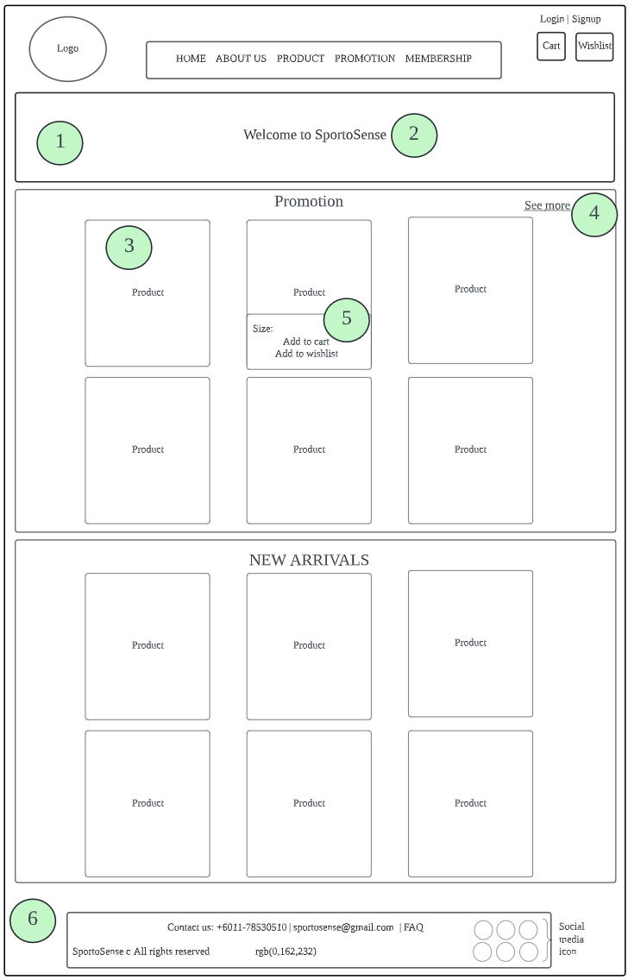

**Description of Home Page**

|  |  |  |
| --- | --- | --- |
| No | Design | Description |
| 1 | Automatic slideshow | The images are put in a slideshow and run automatically as a background of the words ‘Welcome To SportoSense’. This creates a dynamic effect on the website to make this web page look interesting in order to catch the attention of the users. |
| 2 | Cutout text | The welcoming text ‘Welcome to SportoSense’ is shown in cutout form so that it would not block the image slideshow behind and it blends perfectly with the background. |
| 3 | Product cards | In the promotion and new-arrivals section, the products are displayed in cards with product image, name and the price. When the pointer is placed on the product cards, it will be enlarged and with a border. |
| 4 | ‘See more’ hyperlink | ‘See more’ is linked to the promotion page. When it is clicked, the promotion page will be shown to display more promotion products for the users. |
| 5 | Collapsible box | When a product card is clicked, a collapsible box will be shown for the users to select the size of the product and then add this item to cart or to the wishlist. |
| 6 | Linear gradient background color | CSS linear gradient is used to display a smooth transition between light blue to dark purple-ish blue diagonally in the background to make the page look more captivating. |

**About Us Page (Chuang Kian Hui)**

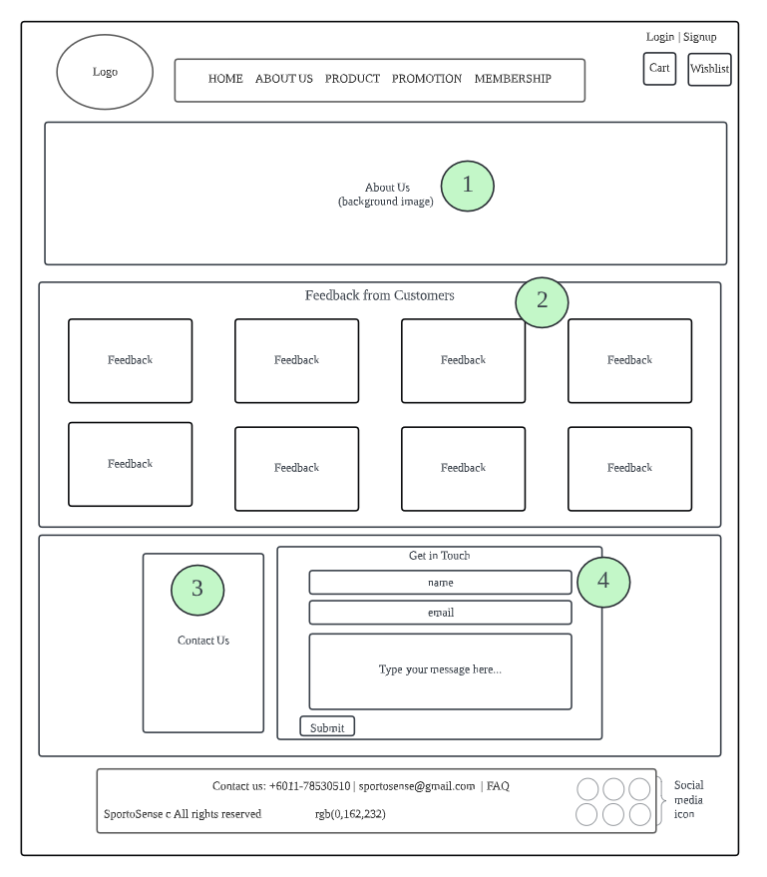

**Description of About Us Page**

|  |  |  |
| --- | --- | --- |
| No | Design | Description |
| 1 | About us section | This section shows a paragraph of introduction to our brand SportoSense with an image background. |
| 2 | Feedback section | This section displays some feedback from the customers as well as their ratings (5-stars) to SportoSense. All of the feedback are presented the same as sticky notes on a wall. |
| 3 | Flip Card | Contact information is hidden behind the flip card. Front part of the flip card is a logo image of SportoSense while the back part displays the contact number and email address of SportoSense. |
| 4 | Get in Touch section | This section allows the users to input and submit their name, email and the messages or inquiries they want to deliver to SportoSense for further assistance or improvement on products or services. |

**Wishlist Page (Chuang Kian Hui)**

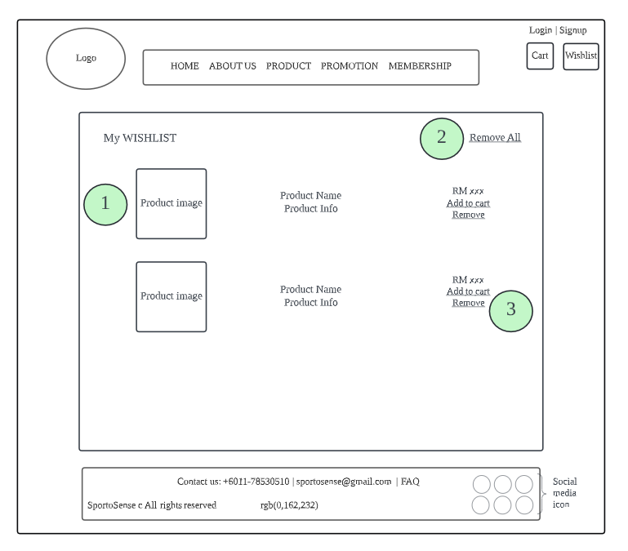

**Description of Wishlist Page**

|  |  |  |
| --- | --- | --- |
| No | Design | Description |
| 1 | Product information | Products that are added into wishlist will be displayed in a list along with the image, item name and its price. It is easier for the users to refer to in the future. |
| 2 | Remove all button | When there are too many items on the list, it would be too inefficient to remove them one by one, so the users can click on this button to clear all the items in the wishlist at once. |
| 3 | Action buttons  (add to cart & remove) | The users can add the item to cart when they decide to purchase while on the other hand they can remove it from the list when they have decided not to buy it. |

**FAQ Page (Chuang Kian Hui)**

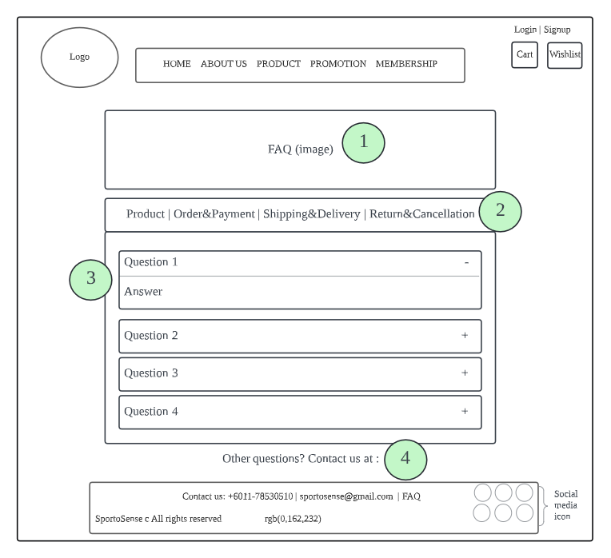

**Description of FAQ Page**

|  |  |  |
| --- | --- | --- |
| No | Design | Description |
| 1 | FAQ logo | A big FAQ logo image is put in the middle to indicate that this is a FAQ page for the users. |
| 2 | Full page tabs | There are 4 main topics of frequently asked questions (Product, Order & Payment, Shipping & Delivery, Return & Cancellation) put in full page tabs. Each tab will show their respective content of relevant questions and answers for the users. |
| 3 | Accordion | In every tab, each question is put in accordion form. When the question is clicked, the answer will show below. Click on the question again and the answer part will be closed. |
| 4 | Contact us section | If the users have any questions other than those listed above, they can contact SportoSense through phone or email to get further assistance. |

**Product Page (Darren)**

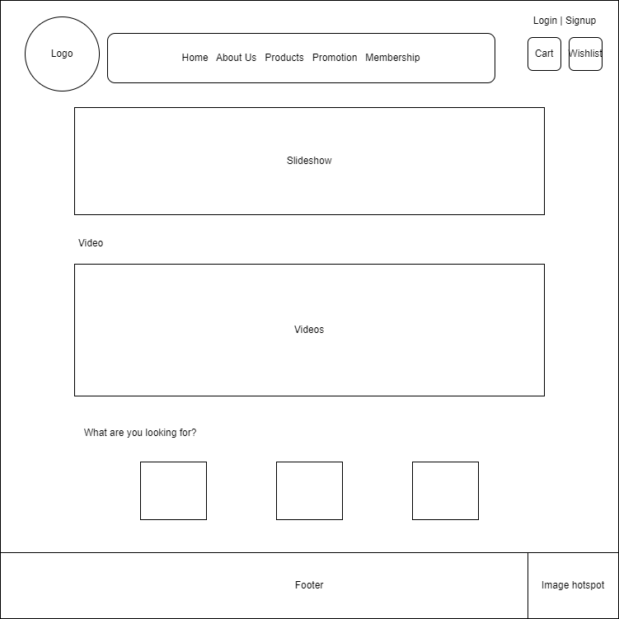**Description of Product Page**

3

1

2

|  |  |  |
| --- | --- | --- |
| No | Design | Description |
| 1 | Slideshow | An area for users to look at some brief view for our products that sells on this website |
| 2 | Videos | To promote our products series to the customers |
| 3 | Looking for products section | There will be three images and in each image it will link to webpages (shoes, clothing and accessories). |

**Shoe Page (Darren)**

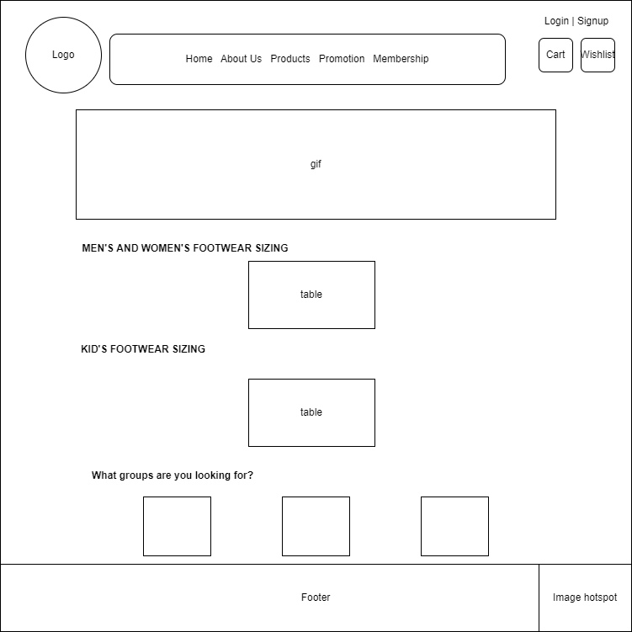

2

1

3

**Description of Shoe Page**

1. An area for users to look at some brief view for our products that sells on this website.
2. Sections for customers to check at the shoe sizing that they wanted in this page.
3. There will be three images and in each image it will link to webpages for shoes men, women and kids.

**Clothing Page (Darren)**

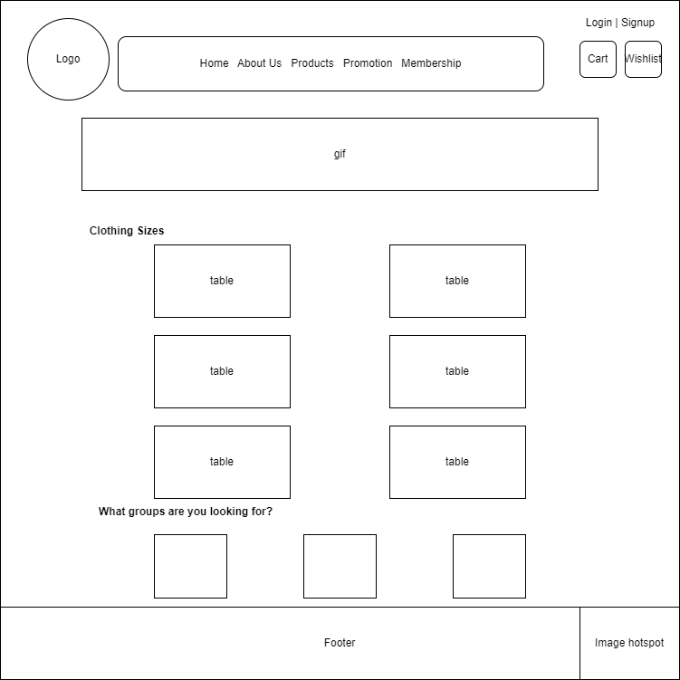

3

2

1

**Description of Clothing Page**

1. An area for users to look at some brief view for our products that sells on this website.
2. Sections for customers to check at the shoe sizing that they wanted in this page.
3. There will be three images and in each image it will link to webpages men, women and kids for clothing.

**Clothing (Men/Women/Kids) Page (Darren)**

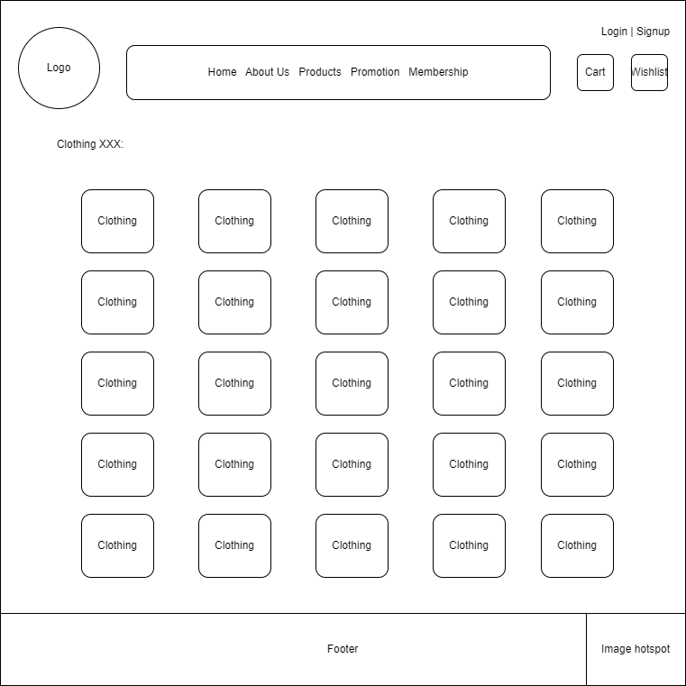

2

1

**Description of Clothing (Men/Women/Kids) Page**

1. Header to let customers know what page they are at now.
2. A 5x5 or 5x4 layout with clothing images. Users can choose the items they want and select the sizes that we set using collapsibles. Also, it has add to cart and wishlist button below the sizes selection area.

**Membership (Soh Chiu Yi)  
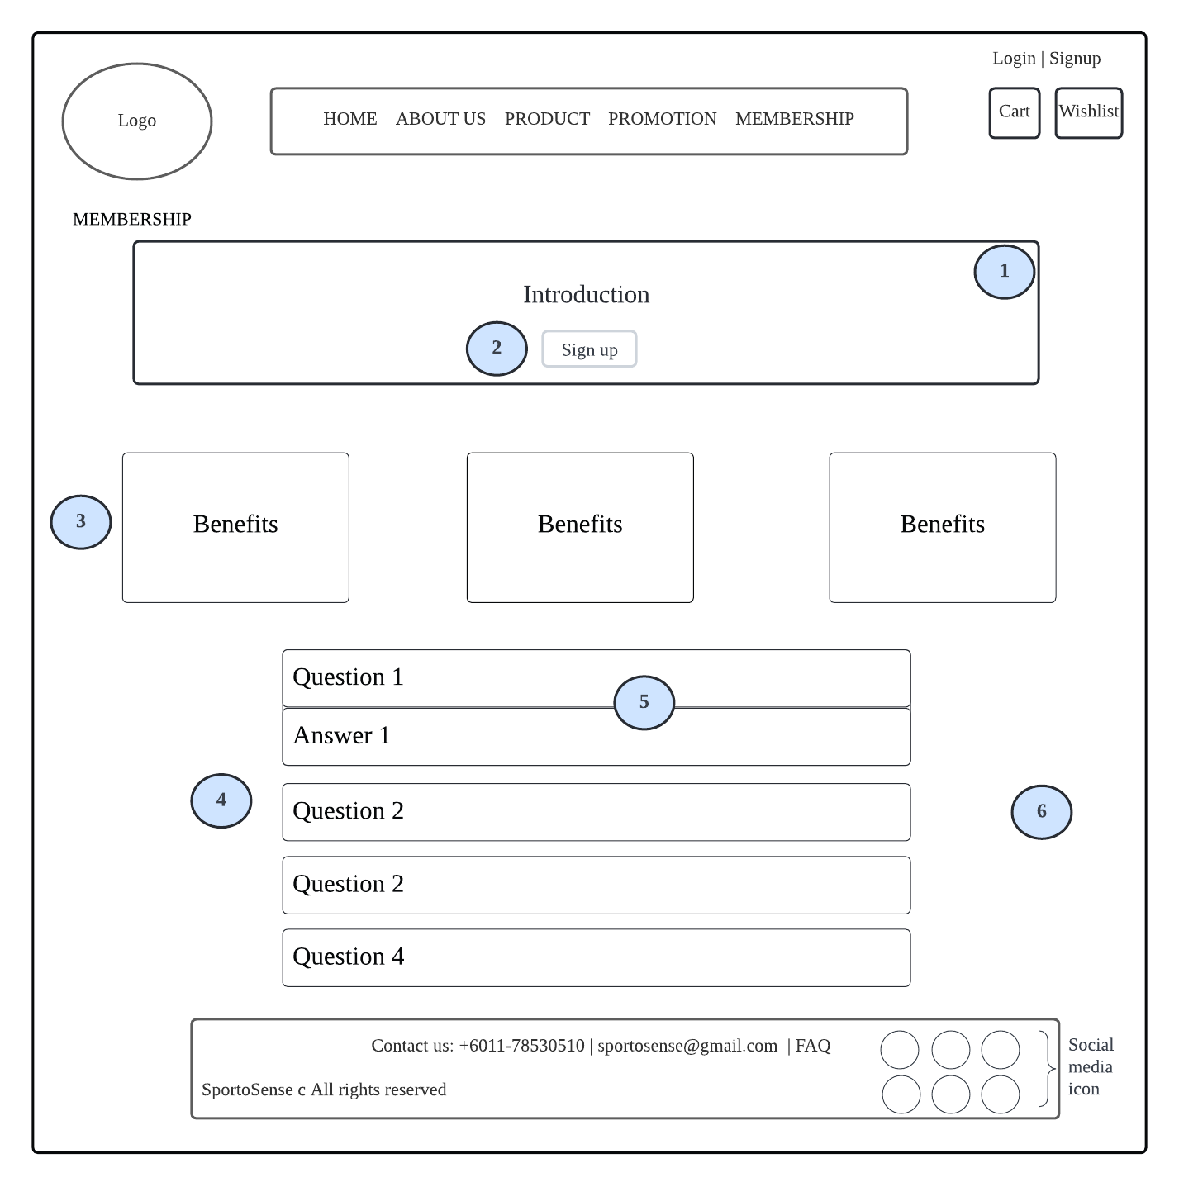  
  
  
  
  
  
  
  
  
  
  
  
  
Description of Membership Page**

|  |  |  |
| --- | --- | --- |
| No | Design | Description |
| 1 | Introduction container | This container contains a brief introduction of the reason for joining the membership. A sign up button is placed at the bottom of the container. |
| 2 | Sign Up button | The user may visit the sign up page by clicking on the sign up button. The button of ‘Sign Up’ at the end of the introduction will lead the user to the SignUp page and proceed with their signup action. |
| 3 | Flexbox (Benefits) | This is about the benefits of membership. There is a clear explanation of each benefit of SportoSense members. |
| 4 | FAQ container | The FAQ questions and answers are neatly arranged in this grid. |
| 5 | Accordion | With the use of responsive accordion dropdown, the membership frequently asked-questions are shown but the user won’t be able to see the answer yet. They need to click on each question then it will expand and then the answer is shown. It will collapse again if they click on another question. |
| 6 | Background | A high-definition background image is used as the background of this webpage. |

**Sign Up (Soh Chiu Yi)  
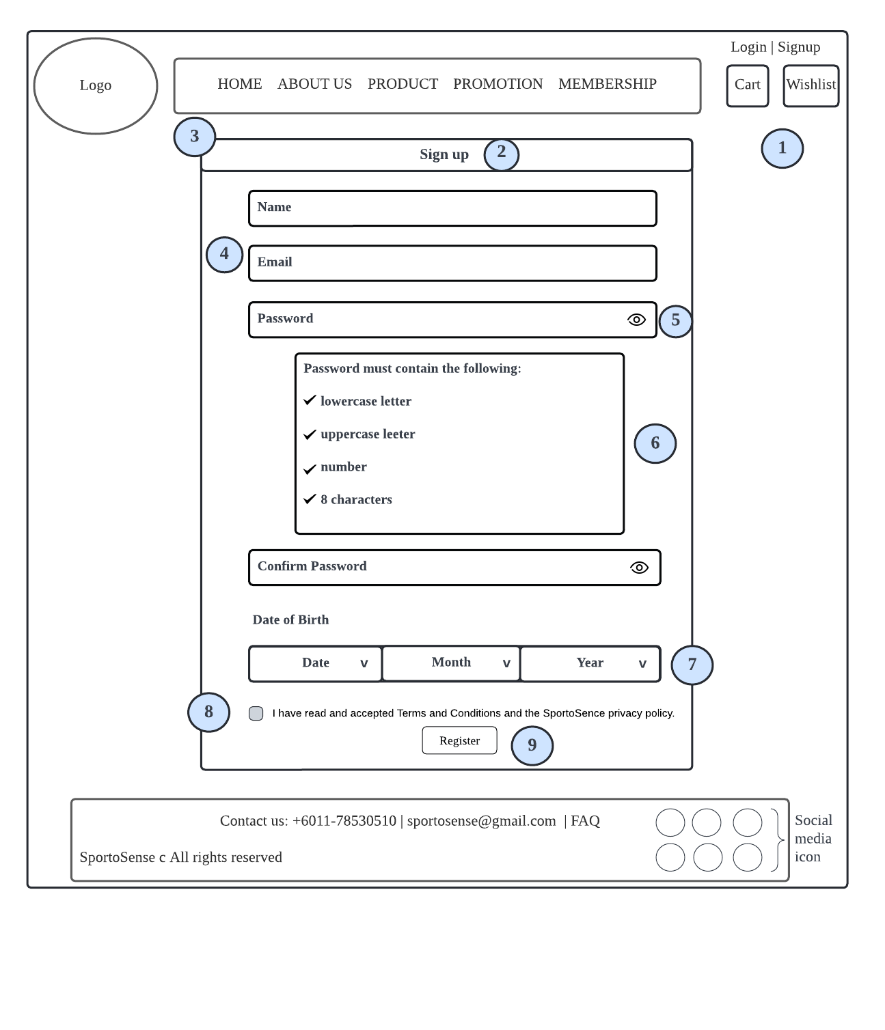  
  
  
  
  
  
  
Description of Sign Up Page**

|  |  |  |
| --- | --- | --- |
| No | Design | Description |
| 1 | Background | A hd background image is used as the background of this webpage. |
| 2 | Header | The header with the word ‘Sign Up’ is placed at the top of the form to indicate that this is the sign up form. |
| 3 | Form | This form contains all the necessary input fields such as name, email, register button etc to let the user fill in and sign up. |
| 4 | Input | This applies the placeholder attribute of the input tag. This gives the user a clear indication of what a particular form field is expecting them to type into it without the need for labels alongside of it or on top of it. |
| 5 | Eye icon | This icon is not just a decoration, it has a function to show and hide the password by using the toggle visibility of password input. The user can click on the icon and the password will be shown and it will become dots again once the user clicks on it. |
| 6 | Password validation | This validation contains four parameters, if the user passes these parameters, it indicates that the user has created a strong password with at least a lowercase letter, an uppercase letter, a number and minimum 8 characters. |
| 7 | Date dropdown picker | The user can use the 3 dropdowns to choose which day, which month and which year respectively for the date of birth input. |
| 8 | Checkbox | The user who ticks the terms and conditions checkbox and submitted the form means he or she agrees to the terms and conditions. |
| 9 | Register button | Once the user fills up all the fields, they may click on the register button and a successful alert message will pop out, eventually it will lead to the login page for them to login. |

**Terms and Conditions (Soh Chiu Yi)  
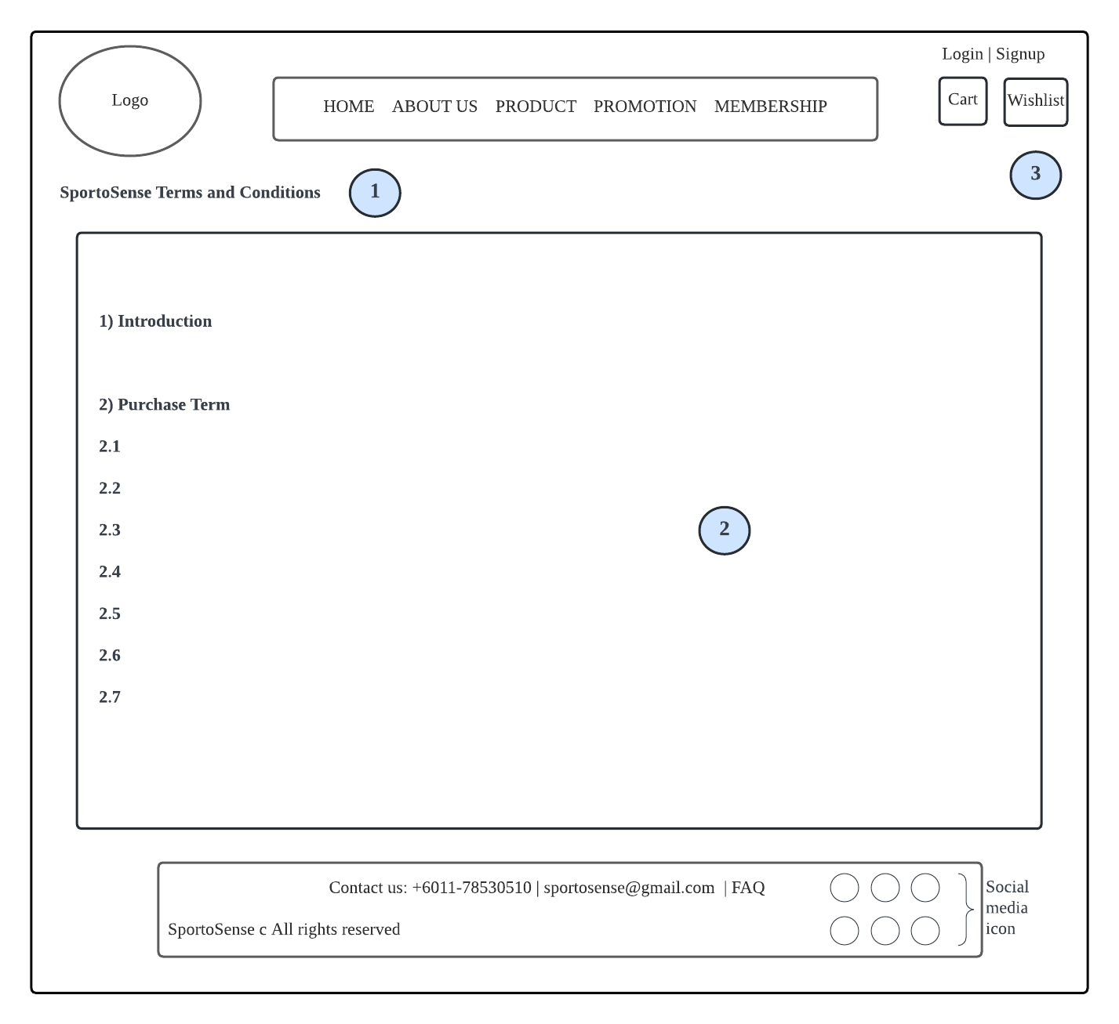  
  
Description of Terms and Conditions Page**

|  |  |  |
| --- | --- | --- |
| No | Design | Description |
| 1 | Header | The header with the word “SportoSense Terms and Conditions” is placed at the top left corner to indicate that this is the terms and conditions. |
| 2 | Terms and Conditions | This section contains the terms and conditions of SportoSense. |
| 3 | Background | A high-definition background image is used as the background of this webpage. |

**Accessories (Soh Chiu Yi)  
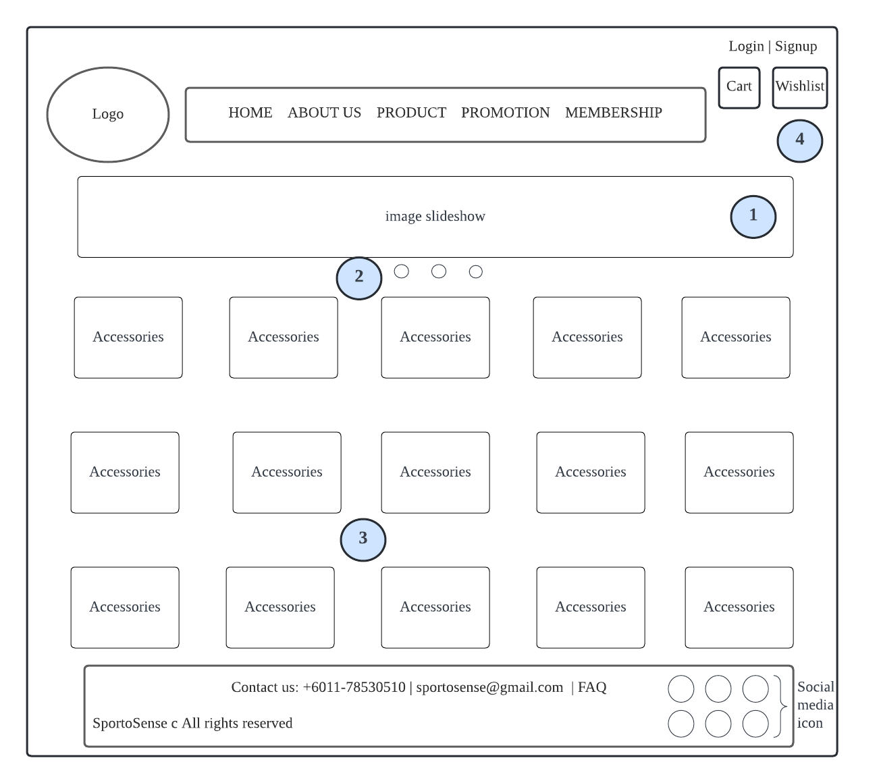  
  
  
  
  
  
  
  
  
  
  
  
  
  
  
  
  
Description of Accessories Page**

|  |  |  |
| --- | --- | --- |
| No | Design | Description |
| 1 | Banner | The 3 banners are designed specifically for the accessories page. The first banner is SportoSense logo, while the design theme of the second and third banners is regarding sports. |
| 2 | Image slider | That banner moves as the user presses it. |
| 3 | Accessories layout | The layout of the promotion page is 5 x 5.When the user hover on the accessories product, it will pop up a box where the option of size, add to cart and add to wishlist function will be displayed. The user can click the add to cart button as well as the add to wishlist button if they would like to purchase it. |
| 4 | Background | The background of this webpage is white colour. |

**Promotion (Soh Chiu Yi)  
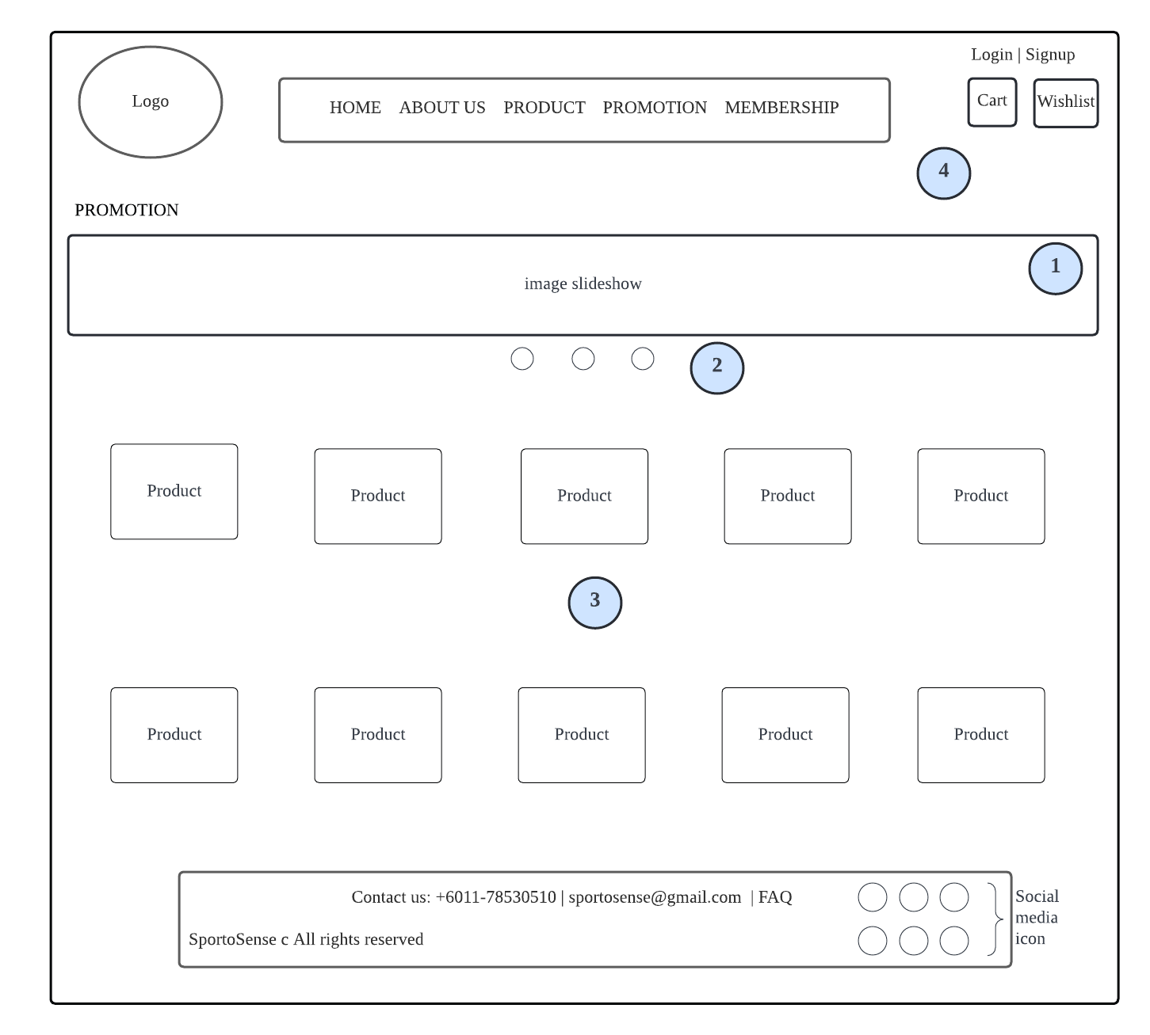  
  
  
  
  
  
  
  
  
  
  
  
  
  
  
  
Description of Promotion Page**

|  |  |  |
| --- | --- | --- |
| No | Design | Description |
| 1 | Banner | The 3 banners are designed specifically for the promotion page. The banners are like an advertisement by telling the users the ongoing promotion and the seasoning sale on our website. |
| 2 | Image slider | That banner moves as the user presses it. |
| 3 | Promotion layout | The layout of the promotion page is 2 x 5. When the user hover on the promotion product, it will pop up a box where the option of size, add to cart and add to wishlist function will be displayed. The user can click the add to cart button as well as the add to wishlist button if they would like to purchase it. |
| 4 | Background | The background of this webpage is white colour. |

**Cart Page (Tee Pei Wen)**

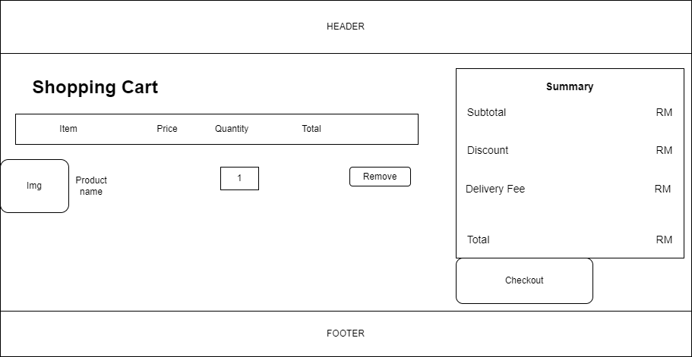

4

6

3

2

1

5

7

**Description of Cart Page**

|  |  |  |
| --- | --- | --- |
| No | Name | Description |
| 1 | Quantity | Change quantity by increase or decrease or directly input. |
| 2 | Product name | The place to display product name that helps customers to identify the product. |
| 3 | Price | Shows the price quoted for each product and the customer is not easily confused. |
| 4 | Page Title | Represents the page functions. It must be large font size and bold to clearly present. |
| 5 | Remove | A button to remove a product from the cart. |
| 6 | Cart Summary | Shows the subtotal, delivery fees and total of the products in cart. |
| 7 | Checkout | A button for user to continue checkout at checkout page. |

**Checkout Page (Tee Pei Wen)**

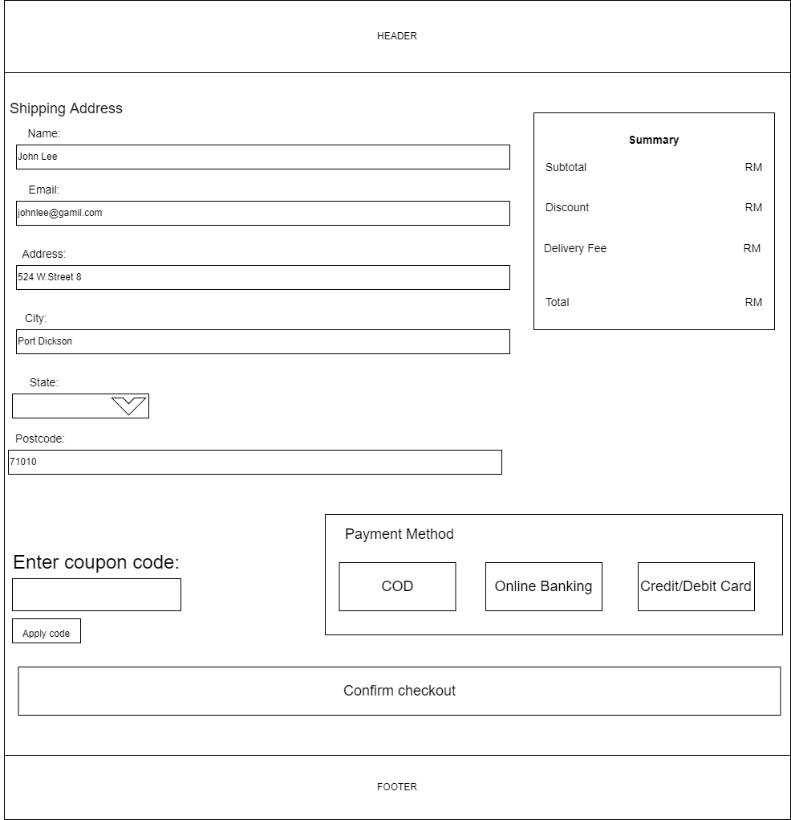

1

3

2

4

5

5

6

9

10

8

7

11

**Description of Checkout Page**

|  |  |  |
| --- | --- | --- |
| No | Name | Description |
| 1 | Name Field | This is required to fill and ask users to fill in their name. |
| 2 | Input placeholder | The design is to guide users input the correct format. |
| 3 | Email Field | Let users input their email. This is a required field for organizations to send some promotion advertisements. Validation: must be email format. |
| 4 | Address Field | This is a required field for organizations to deliver the goods to the stated address. |
| 5 | City, and State | Users need to input the city (this is a required field ) and drop-down list select state. |
| 6 | Postcode | Users need to input postcode and this is a required field. Validation: Only 5 digits. |
| 7 | Coupon field | For users who redeemed a birthday code and get 10% discount. |
| 8 | Cash On Delivery | If users choose one of the payment methods which is COD, it will redirect to the Billing Address page. |
| 9 | Online Banking | One of the payment methods, if users click on it, it will display the hidden div which is a selection of banks. |
| 10 | Credit/Debit Card | If the users click this, it will be redirected to the payment page. |
| 11 | Confirm checkout | For the users to submit the checkout form. |

**Payment Page (Tee Pei Wen)**

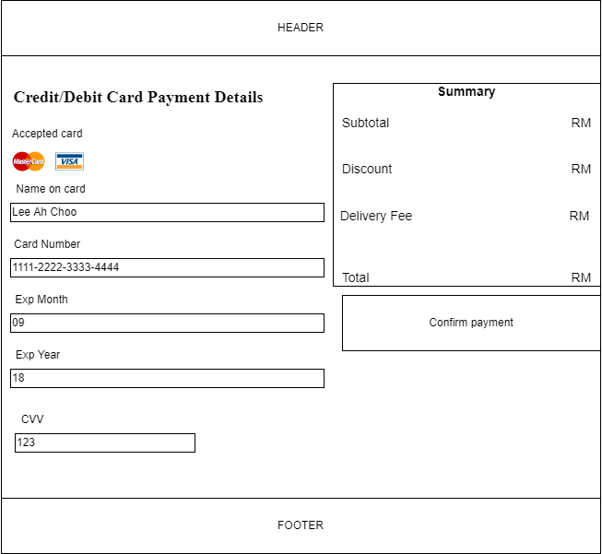

1

2

3

7

4

5

6

**Description of Payment Page**

|  |  |  |
| --- | --- | --- |
| No | Name | Description |
| 1 | Name On Card | This is the place where a user is required to enter their name on their credit or debit card. This is a required field. |
| 2 | Card Number | This is a required field. Validation: Only 16 digits. |
| 3 | Exp Month | This is a required field. Input expired month on the card. Validation: Accept only 2 digits. |
| 4 | Exp Year | This is a required field. Input expired year on the card. Validation: Accept only 2 digits. |
| 5 | CVV | Only accept 3-digit numbers from users. This is the required field. |
| 6 | Placeholder | Provide the user with a clue about what to input. |
| 7 | Confirm payment | User click on it to submit the form. |

**Billing Address Page**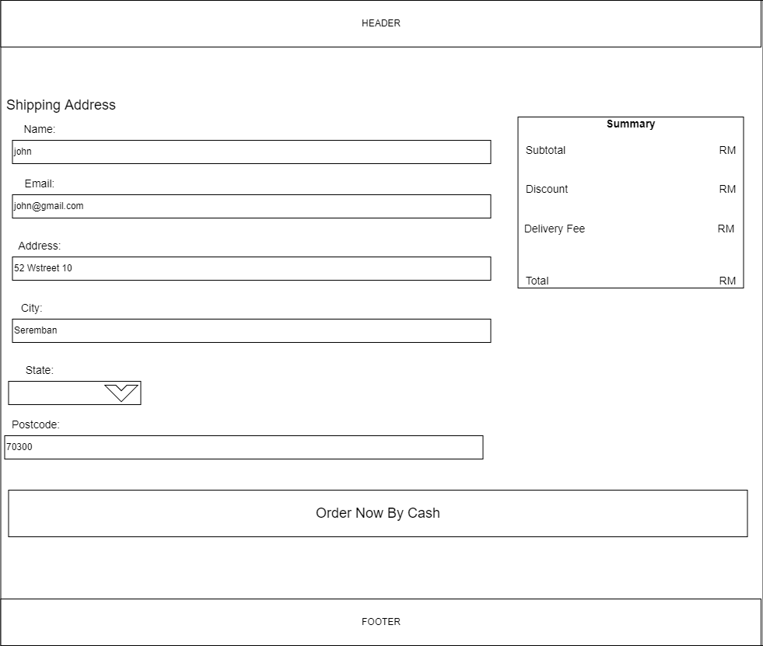

1

2

3

4

5

5

6

7

**Description of Billing Address Page**

|  |  |  |
| --- | --- | --- |
| No | Name | Description |
| 1 | Name Field | This is required to fill and ask users to fill in their name. |
| 2 | Input placeholder | The design is to guide users input the correct format. |
| 3 | Email Field | Let users input their email. This is a required field for organizations to send some promotion advertisements. Validation: must be email format. |
| 4 | Address Field | This is a required field for organizations to deliver the goods to the stated address. |
| 5 | City, and State | Users need to input the city (this is a required field ) and drop-down list select state. |
| 6 | Postcode | Users need to input postcode and this is a required field. Validation: Only 5 digits. |
| 7 | Order Button | For the users to submit the form. |

**Shoes Men/Shoes Women/Shoes Kids (Jason Lee)**

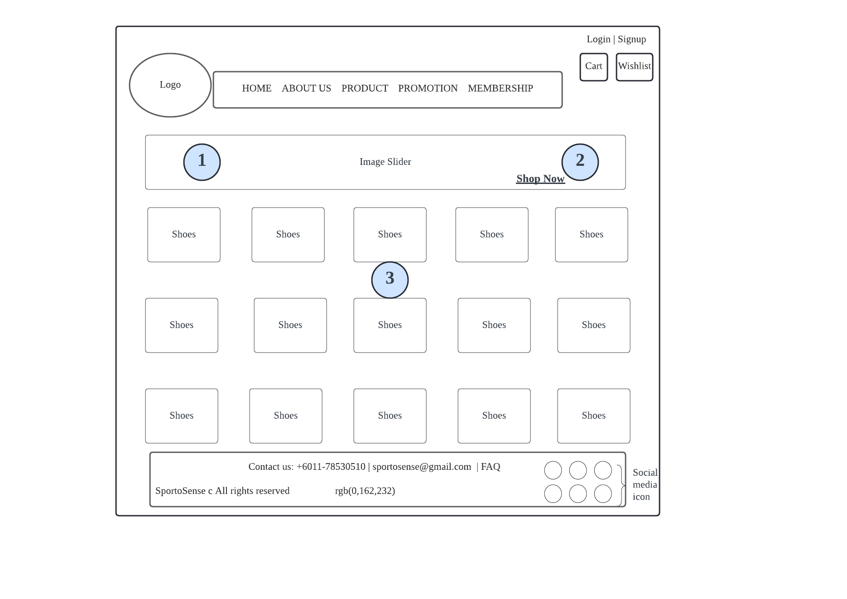

|  |  |  |
| --- | --- | --- |
| **No.** | **Name** | **Description** |
| **1.** | **Image Slider** | **This is an image slider that shows some posters about shoes to attract the users and let them know what product is hot now.** |
| **2.** | **Hotspot of Images(Shop Now)** | **Some of the images will have the word ‘Shop Now’ to let the users click and bring them to the main page of the shoes product.** |
| **3.** | **Shoes Layout** | **This is a 5x5 layout with shoe images. Users can click the shoe they like, then it will drop down a box which contains a choice of size, add to cart button, and add to wishlist button.** |

**Login Page (Jason Lee)**

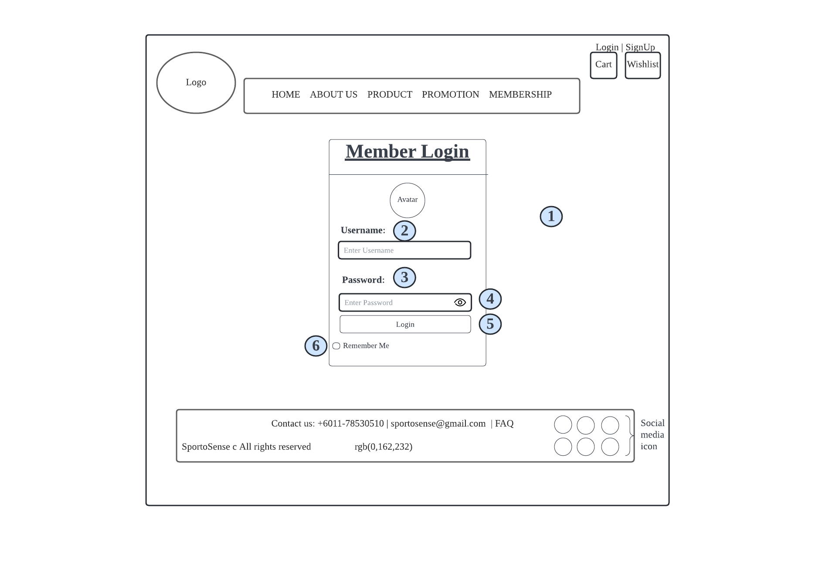

|  |  |  |
| --- | --- | --- |
| **No.** | **Name** | **Description** |
| **1.** | **Background Image** | **This is a background image to cover the entire website** |
| **2.** | **Username Box** | **Let users enter their username, users are required to enter their username, if not it will give a message to alert users to enter their username.** |
| **3.** | **Password Box** | **Let users enter their password, users are required to enter their password, if not it will give a message to alert users to enter their username. And users also need to follow the password format which is at least one capital letter, one small letter, and one number.** |
| **4.** | **Eye Icon Button** | **Let users check their password in text form to confirm that their input is correct.** |
| **5.** | **Login Button** | **After done all the input section, users can finally click the login button and it will bring the user to the homepage of Sportosense** |
| **6.** | **Remember Me Checkbox** | **Let users to store their username and password to let the website remember their information** |

**References:**

Adidas.com. Terms and Conditions. [online] Available at:  
<<https://m.adidas.com.my/en/help-topics-terms_and_conditions_for_website_use.html>> [Accessed 12 April 2022].

Medium. 2022. *How To Create a Shopping Cart UI Using HTML & CSS?*. [online] Available at: <<https://uxplanet.org/how-to-create-a-shopping-cart-ui-using-html-css-e5db3cd55aa0>> [Accessed 16 April 2022].

W3school.com. 2022. *Automatic Slideshow*. [online] Available at: <<https://www.w3schools.com/howto/tryit.asp?filename=tryhow_js_slideshow_auto>> [Accessed 14 April 2022].

W3school.com. 2022. *CSS Gradients*. [online] Available at: <<https://www.w3schools.com/css/css3_gradients.asp>> [Accessed 14 April 2022].

W3schools.com. 2022. CSS Pagination Examples. [online]. Available at: <<https://www.w3schools.com/css/css3_pagination.asp>> [Accessed 10 April 2022].

W3schools.com. 2022. *How To Create a Responsive Header*. [online] Available at: <<https://www.w3schools.com/howto/howto_css_responsive_header.asp>> [Accessed 16 April 2022].

W3schools.com. 2022. *How To Create an Image Overlay Zoom Effect*. [online] Available at: < <https://www.w3schools.com/howto/howto_css_image_overlay_zoom.asp> > [Accessed 17 April 2022].

W3schools.com. 2022. *How TO - Collapse*. [online]. Available at: <<https://www.w3schools.com/howto/howto_js_collapsible.asp>> [Accessed 10 April 2022].

W3school.com. 2022. *How TO - Cutout Text.* [online] Available at: <<https://www.w3schools.com/howto/howto_css_cutout_text.asp>> [Accessed 14 April 2022].

W3school.com. 2022. *How TO - Flip Card*. [online] Available at: <<https://www.w3schools.com/howto/howto_css_flip_card.asp>> [Accessed 14 April 2022].

W3school.com. 2022. *How TO - Full Page Tabs*. [online] Available at: <<https://www.w3schools.com/howto/howto_js_full_page_tabs.asp>> [Accessed 14 April 2022].

W3school.com. 2022. *How TO - Login Form.* [online]. Available at: <<https://www.w3schools.com/howto/howto_css_login_form.asp>> [Accessed 10 April 2022].

W3school.com. 2022. *How TO - Product Card*. [online] Available at: <<https://www.w3schools.com/howto/howto_css_product_card.asp>> [Accessed 14 April 2022].

W3schools.com. 2022. *How TO - Slideshow*. [online]. Available at: <<https://www.w3schools.com/howto/howto_js_slideshow.asp>> [Accessed 10 April 2022].

W3school.com. 2022. *How TO - Star Rating*. [online] Available at: <<https://www.w3schools.com/howto/howto_css_star_rating.asp>> [Accessed 14 April 2022].

W3school.com. 2022. *How TO - Toggle Password Visibility*. [online]. Available at: <<https://www.w3schools.com/howto/howto_js_toggle_password.asp>> [Accessed 10 April 2022].

Youtube.com. 2022. [online] Available at: <<https://www.youtube.com/watch?v=lN9B4uvqVBU>> [Accessed 16 April 2022].