FORM 1

FACULTY OF COMPUTING AND INFORMATION TECHNOLOGY
Programme: RDS2S1__ (Group: __2__)
Assignment
BMDS DATA VISUALIZATION
Name(Block Letters) | Registration No. | Signature | Marks
1. THONG CHENG HOW | 22WMR03154 | ThongCH
2. RYAN KHO YUEN THIAN | 22WMR04097 | RyanK
3. ONG WENG KAI | 22WMR03309 | WengKai
4. YONG ZEE LIN | 22WMR03770 | ZeeLin
5.

Tutor’s Name: Ms Bavani
Date of Submission: 29/09/2023

FORM 2
FACULTY OF COMPUTING AND INFORMATION TECHNOLOGY
Plagiarism Statement and Guideline for Late Submission of Coursework
Read, complete, and sign this statement to be submitted with the written report.
We confirm that the submitted works are all our own work and are in our own words.
Name(Block Letters) | Registration No. | Signature | Date
1. THONG CHENG HOW | 22WMR03154 | ThongCH | 29/09/2023
2. RYAN KHO YUEN THIAN | 22WMR04097 | RyanK | 29/09/2023
3. ONG WENG KAI | 22WMR03309 | WengKai | 29/09/2023
4. YONG ZEE LIN | 22WMR03770 | ZeeLin | 29/09/2023
5.

BMDS 2113- DATA VISUALIZATION
CLO2 Demonstrate ability to communicate information to the viewer using data visualization tools. (A3, PLO5)
CLO3 Produce effective data visualizations in order to provide new insights into a research question. (P4, PLO3)
Criterion | Missing or Unacceptable  (0-3 mark) | Poor  (4-7 marks) | Good  (8-11marks) | Excellent  (12-15 marks) | Marks
Data collection | The data preparation step is missing or very poor.  Irrelevant, inaccurate, or inappropriate information. | The data preparation steps are not listed and described clearly. | The data preparation steps are relevant, offering details about the data collection with some relevant function and techniques | The data preparation steps introduction are informative, succinct, and offer sufficiently specific details about the data collection with more relevant function and techniques
Data entry and cleaning | Data entry and data cleaning are not well shown , missing most important techniques | Analytical methods and results are explained. However, the explanations are confusing, incomplete or lacked relevance to business intelligence. | Analytical methods and results are explained. The explanations are appropriate and related to the business intelligence. | Analytical methods and results are explained well. The explanations are clear, structured, appropriate and related to the business intelligence.
Descriptive Analysis | Analytical methods and results are not properly explained.  The explanations are not aligned with the business intelligence. | Analytical methods and results are explained. However, the explanations are confusing, incomplete or lacked relevance to business intelligence. | Analytical methods and results are explained. The explanations are appropriate and related to the business intelligence. | Analytical methods and results are explained well. The explanations are clear, structured, appropriate and related to the business intelligence.
Visualization | Graphing and visualization are omitted or not irrelevant. | Limited graphing and visualization are presented. | Graphing and visualization are presented. The information is clear. | Graphing and visualization are presented systematically. The information is comprehensive and informative. All graphs and visualizations are linked to appropriately.
Hypothesis Testing | Hypothesis are omitted or confusing. | The Hypothesis is unclear or confusing. Little discussions are presented. | Hypothesis of the research and summary are presented with satisfactory | The significance of the Hypothesis was discussed and shown with appropriate findings
recommendation | No recommendation found based on the result | Need some relevant recommendation based on the result | The recommendation is satisfactory based on the result | the recommendation was completely relevant based on the result
 | 0-3 poor | 4-6 acceptable | 7-9 admirable | 10-12 Exceptional
Presentation | Goal of research unclear, information included that does not support research claims in any way | There is a great deal of information that is not clearly integrated or connected to the research. | Sufficient information with many good points made, uneven balance and little consistency. | An abundance of material clearly related to the research is presented. Points are clearly made and evidence is used to support claims | 1)  2)  3)  4)  5)  6)

TABLE OF CONTENTS

1.0 DATA COLLECTION 9
1.1 An Introduction to KFC and its Current Problem 9
1.2 Actual Data Collection to Address Problem 10
a) Section 1 (Demographic Profile) 10
b) Section 2 (Food Preference and Satisfaction) 14
c) Section 3 (Factors influencing the purchase of KFC products) 17
d) Section 4 (Rating and Feedback) 20
1.3 Creation of Dataset 24
2.0 DATA ENTRY 25
3.0 DATA CLEANING 29
A Summary of the Techniques that We have Used: 29
Variable 1: Gender 29
Variable 2: Age 29
Variable 3: Job 30
Variable 4: Income 30
Variable 5: State 31
Variable 6: Last Purchase Date 31
Variable 7: Frequency 32
Variable 8: favMainFoodItem 33
Variable 9: favSideDish 36
Variable 10: favMenuItem 38
Variable 11: occasion 38
Variable 12: factors 42
Variable 13: Money Spent 44
Variable 14: orderPlacementMethod 45
Variable 15: howCustKnewAbtKfc 48
Variable 16: taste rating 49
Variable 17: price rating 50
Variable 18: satisfaction for customer service 50
Variable 19: Environment/ambience 51
Variable 20: overall satisfaction 52
Variables 21 & 22 52
Variable 23: recommend KFC 53
What Dataset Looks Like After Cleaning 54
4.0 DESCRIPTIVE ANALYSIS 61
4.1 Gender 61
4.2 Age 62
4.3 Job 64
4.4 Income 66
4.5 State 67
4.6 lastPurchaseDate 70
4.7 frequency 72
4.8 favMainFoodItem 73
4.9 favSideDish 74
4.10 favouriteMenuItem 75
4.11 occasion 76
4.12 factors 77
4.13 moneySpent 78
4.14 orderPlacementMethod 79
4.15 howCustKnewAbtKfc 80
4.16 tasteRating 81
4.17 priceRating 82
4.18 customer satisfaction rating 83
4.19 environment rating 84
4.20 overall rating 85
4.21 KFC delivery rating 86
4.22 KFC order rating 88
4.23 recommend KFC 89
4.24 Fries VS Fried Chicken (H16) 90
4.25 Fries VS Burger (H17) 91
4.26 (Fries & Original Fried Chicken) VS (Fries & Spicy Fried Chicken) 92
4.27 Order at counter VS Order at drive thru 93
4.28 KFC app delivery vs KFC pick up 93
4.29 KFC app delivery vs third party delivery 94
4.30 Gender vs Gatherings (H1) 94
4.31 Gender vs fried chicken original (flavour) VS fried chicken spicy (flavour) (H2) 95
4.32 Gender vs Favourite Menu Item (H3) 96
4.33 Gender vs game night (H4) 96
4.34 Gender vs good_service (H5) 97
4.35 Gender VS age group 97
4.36 Job and income group 98
4.36 State and gender group 99
4.37 Gender, Age and Price Rating group 100
4.38 Gender, Age and Customer Satisfaction Rating group 100
4.39 Gender, Age and Environment Rating group 101
4.40 Gender, Age and Overall Rating group 101
4.41 Gender, Age and KFC Delivery Rating group 102
4.42 Gender, Age and KFC Order Rating group 103
4.43 Gender, Age and KFC Recommend KFC group 104
5.0 VISUALIZATION 105
5.1 Gender 105
5.2 Age 107
5.3 Job 109
5.4 Income 111
5.5 State 113
5.6 last purchase date 114
5.7 frequency 116
5.8 money Spent 120
5.9 taste rating 122
5.10 price rating 123
5.11 customer satisfaction rating 124
5.12 environment rating 125
5.13 overall rating 126
5.14 kfc delivery rating 127
5.15 kfc order rating 129
5.16 recommend kfc 131
5.17 Showing the Pearson’s Correlation Coefficient between Numerical Variables 132
5.18 Hypothesis 1 graph 133
5.19 Hypothesis 2 graph 134
5.20 Hypothesis 3 graph 136
5.21 Hypothesis 4 graph 137
5.22 Hypothesis 5 graph 138
5.23 Hypothesis 6 graph 139
5.24 Hypothesis 7 graph 140
5.25 Hypothesis 8 graph 141
5.26 Hypothesis 9 graph 142
5.27 Hypothesis 10 graph 142
5.28 Hypothesis 11 graph 144
5.30 Hypothesis 13 graph 146
5.32 Hypothesis 15 graph 148
5.33 Hypothesis 16 graph 149
5.34 Hypothesis 17 graph 150
5.35 Hypothesis 18 graph 151
5.36 Hypothesis 19 graph 152
5.37 Hypothesis 20 graph 153
6.0 HYPOTHESIS TESTING 154
Hypothesis 1 154
Hypothesis 2 155
Hypothesis 3 157
Hypothesis 4 161
Hypothesis 5 163
Hypothesis 6 165
Hypothesis 7 166
Hypothesis 8 167
Hypothesis 9 168
Hypothesis 10 169
Hypothesis 11 170
Hypothesis 12 171
Hypothesis 13 172
Hypothesis 14 173
Hypothesis 15 174
Hypothesis 16 176
Hypothesis 17 177
Hypothesis 18 178
Hypothesis 19 180
Hypothesis 20 181
7.0 RECOMMENDATION 183
a) Thong Cheng How 183
b) Ong Weng Kai 184
c) Yong Zee Lin 186
d) Ryan Kho Yuen Thian 186
8.0 REFERENCE 188
9.0 APPENDIX 189

1.0 DATA COLLECTION

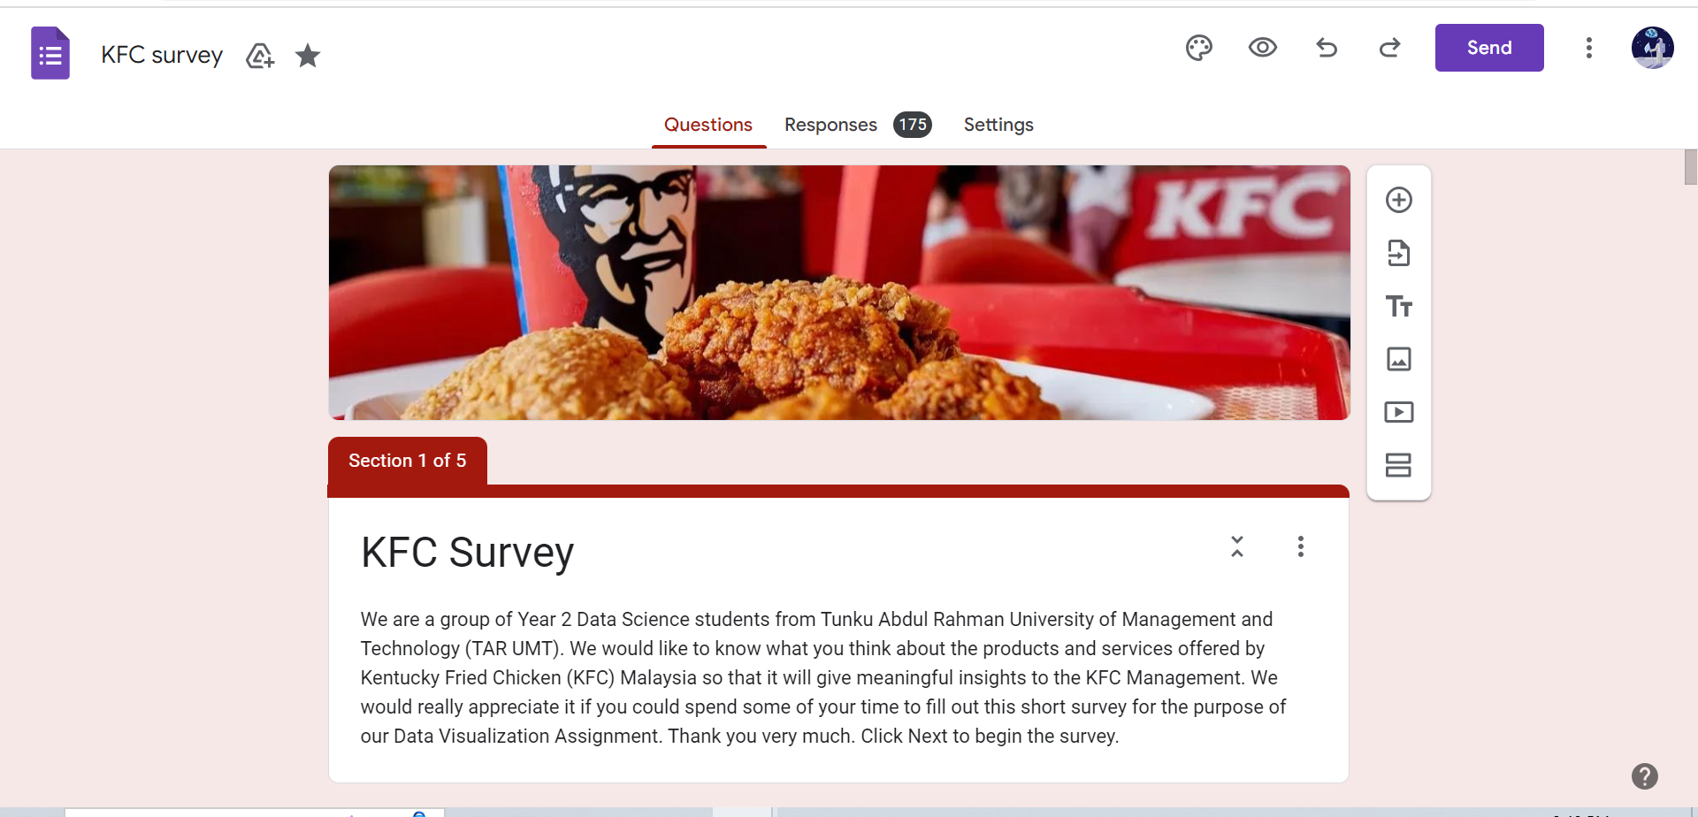
Link to access the google form that we have used for our data collection:
https://docs.google.com/forms/d/1ConAxGf3NN-wYx0MAY88t1EIhO6kbtwiAqXvTU9JBkA/edit

1.1 An Introduction to KFC and its Current Problem
KFC, also known as Kentucky Fried Chicken (KFC), is an American fast food restaurant chain, whose specialty is fried chicken, burgers and more. KFC is currently the second-largest restaurant chain in the world. It sells a variety of products and its outlets are located in several parts of the world, which includes Malaysia.

Although KFC is famous among many in Malaysia, the management team of KFC Malaysia’s branches believes that KFC Malaysia is losing its customers to other competitors, such as Texas Chicken Malaysia, McDonald’s and more famous fast food restaurants. It also believes that some of its food products are not performing well in terms of sales.

1.2 Actual Data Collection to Address Problem
In order to address this problem, we have created a 23 question questionnaire that consists of 4 sections using Google Form to collect the data needed to create the dataset, perform analyses and come up with recommendations for the Management. Questions were made as simple as possible so that it is easy for respondents to understand. The questions were neatly split into sections so that the survey will look more organised and give the respondents an impression that it would not take long for them to fill out the questionnaire.

a) Section 1 (Demographic Profile)
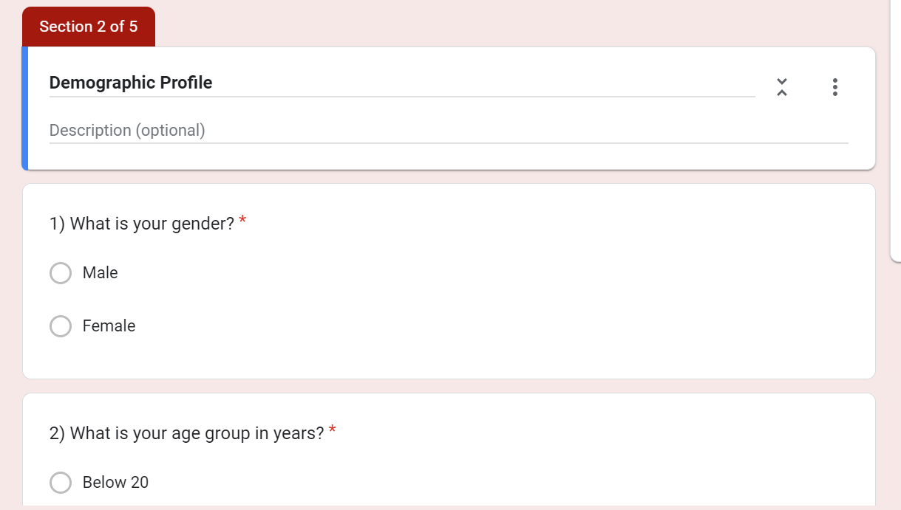
From the above figure, we allow users to enter their demographic information for us to understand more about our respondents in general. This is also a warm-up to allow users to be comfortable with our survey as we want our respondents to enjoy answering our survey. As shown below these are the 5 questions we asked our respondents in the section of demographic profile. The data collected are gender, age group, occupation, income level and state/federal territory, which are all categorical variables.

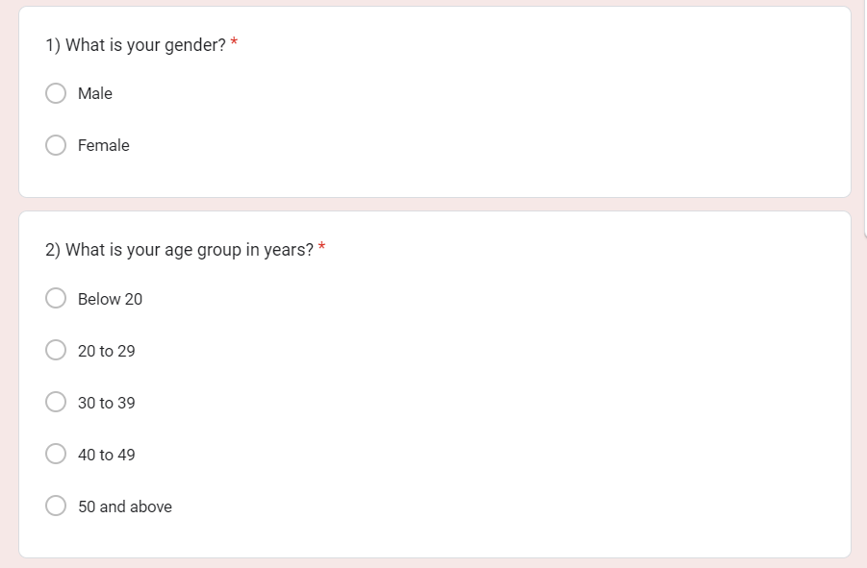
Question 1 to 2 for demographic profile
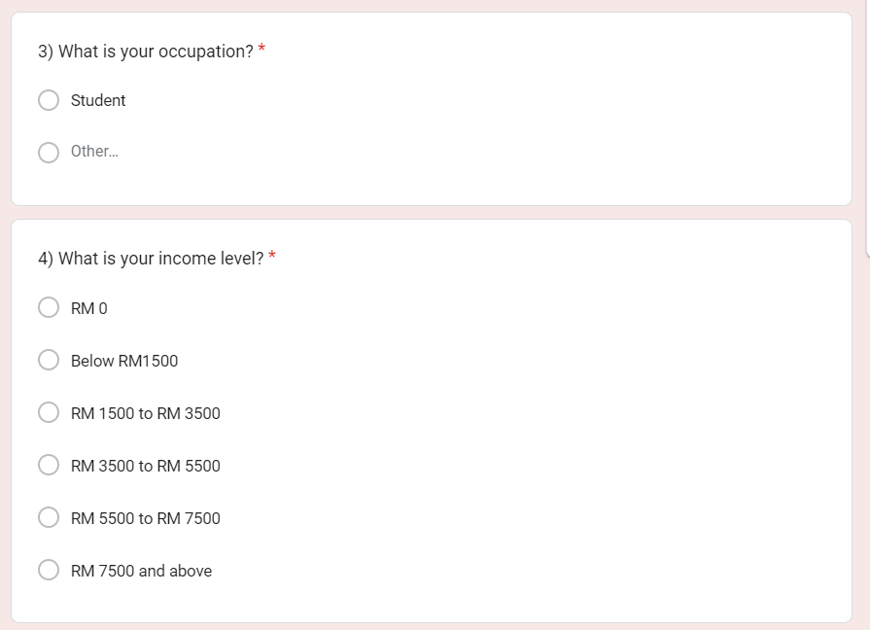
Question 3 to 4 for demographic profile
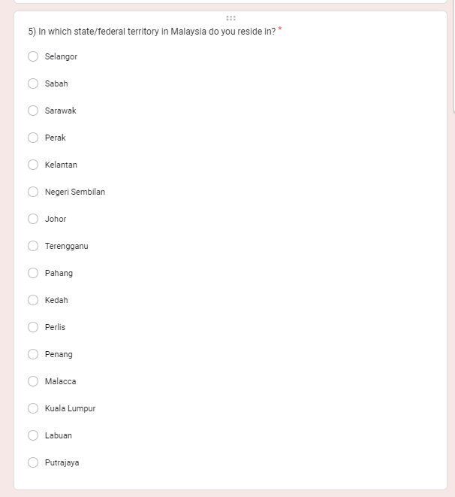
Question 5 for demographic profile

b) Section 2 (Food Preference and Satisfaction)
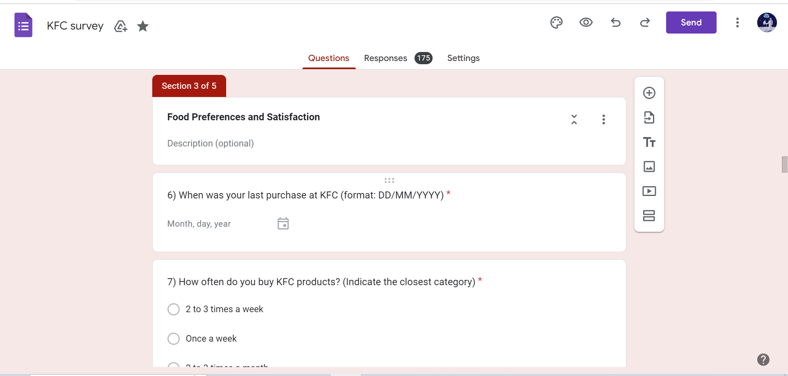

In this section, we want to collect data about our respondents' food preference and satisfaction with KFC. Therefore, this can give us insight into the kind of foods the respondents typically like to enjoy, and when the respondents purchase a KFC product. The reason why we want to know the respondents' purchase habits is to analyse the products that they may like, how often they come to KFC and the different combinations of food that they like to have because everyone has their own preferences for KFC products. With this data, we could help the KFC management to make more informed decisions. The data collected in this section are all categorical.

Below are the screenshots of the questions for this section:

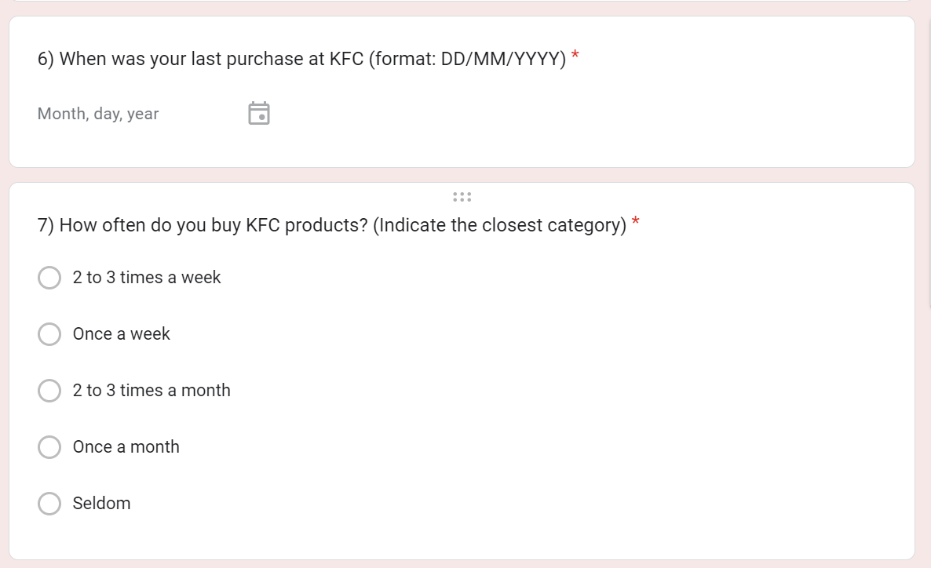
Question 6 and 7 for Food preference and satisfaction

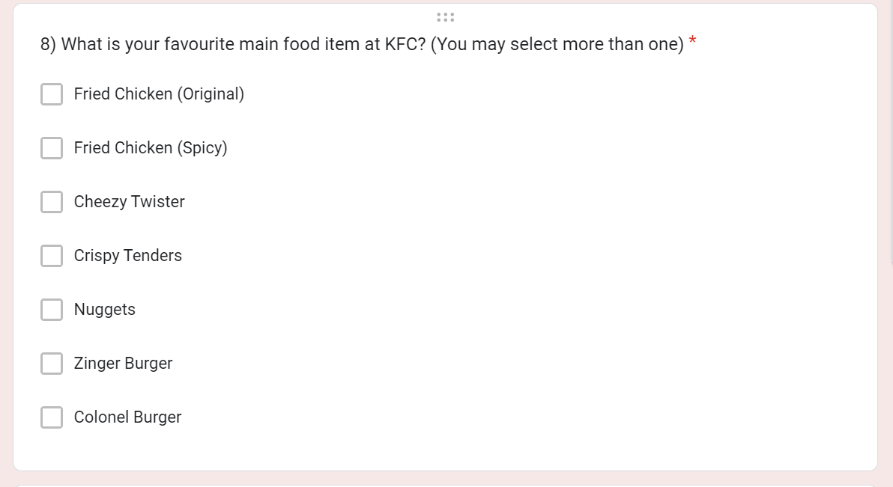
Question 8 for Food preference and satisfaction

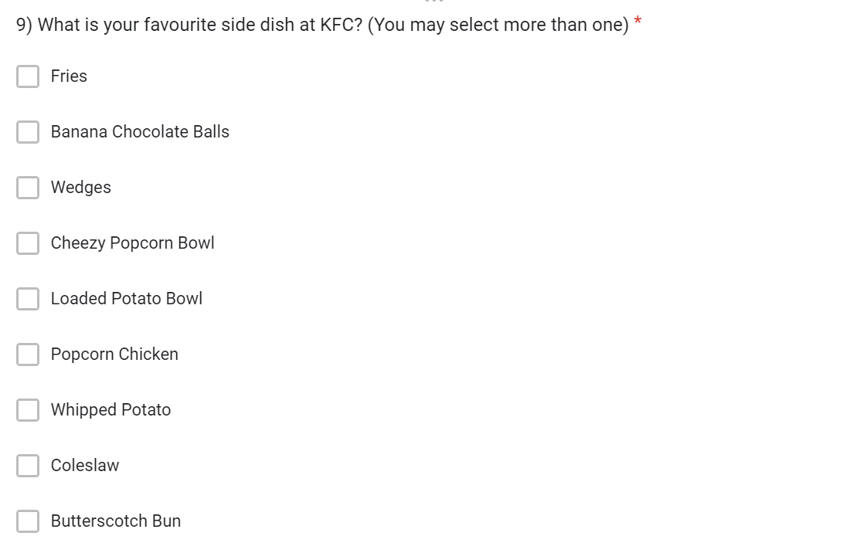
Question 9 for Food preference and satisfaction

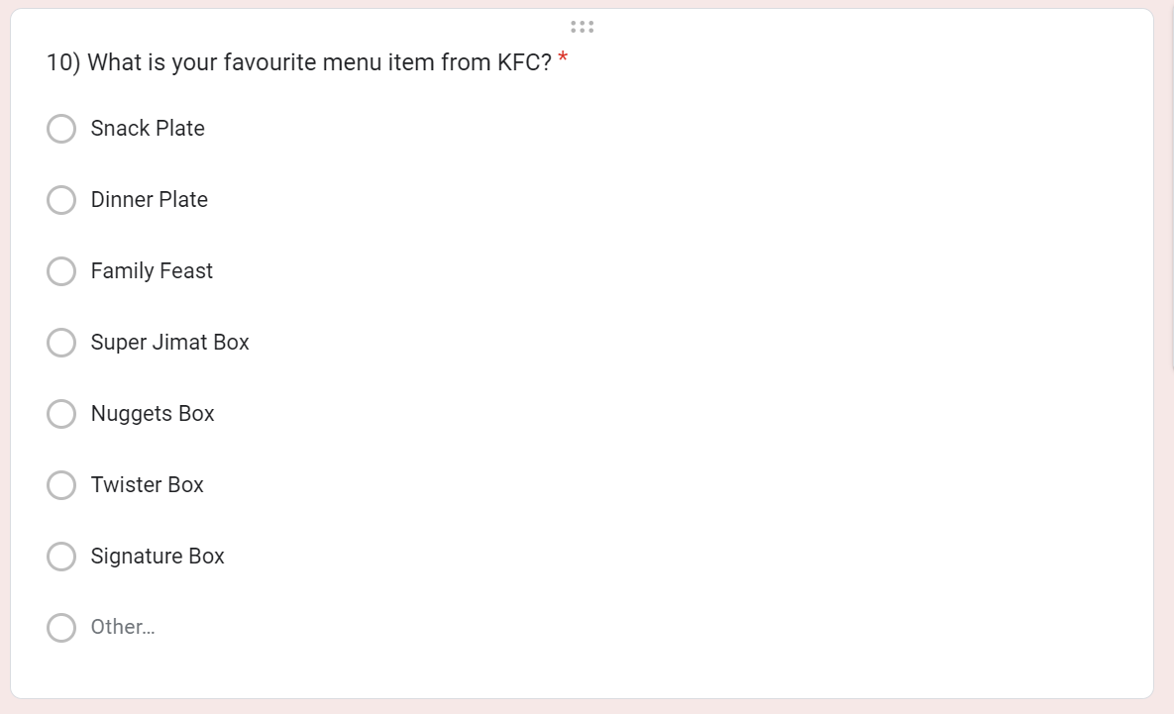
Question 10 for Food preference and satisfaction

c) Section 3 (Factors influencing the purchase of KFC products)
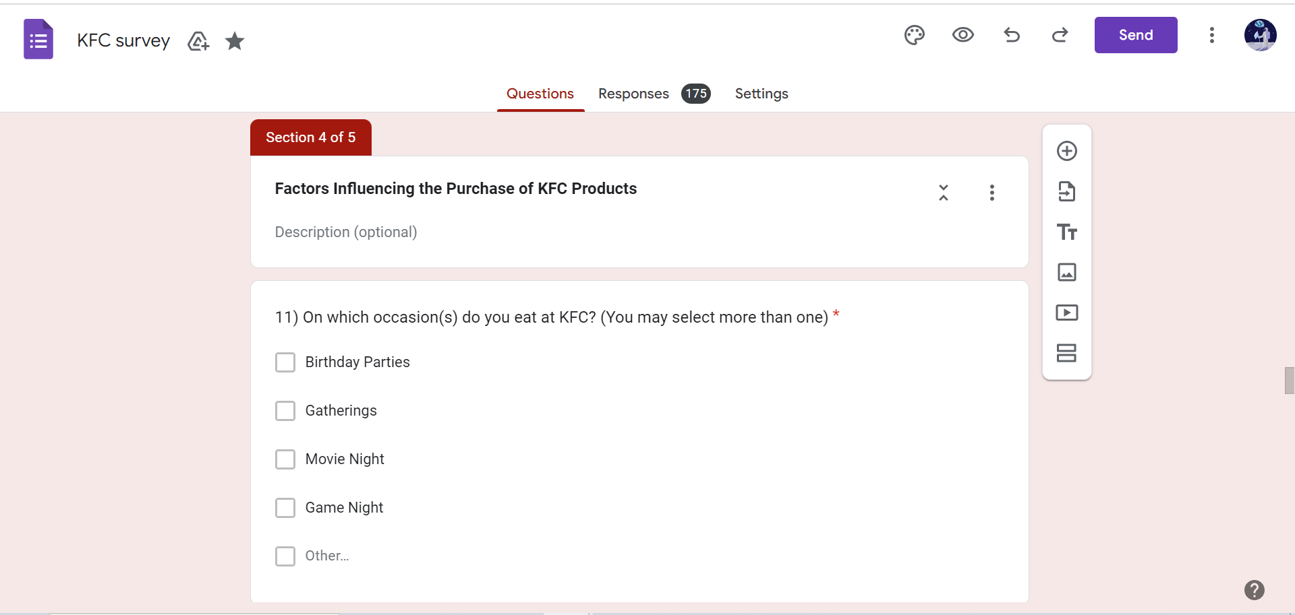
We now proceed to the factors influencing the purchase of KFC products. In this section, we try to understand the reasons/factors for customers to visit KFC. The questions asked here can allow us to analyse the factors that could be the cause of the decrease in sales for KFC products. For example, the management may wonder why the sales for a particular product, for example Banana Chocolate Balls, has gone down by 20% in a particular month or time period. Therefore, after collecting these data from our respondents, we hope that we could analyse the potential factors that are causing KFC to underperform and to help the KFC management to increase sales for its KFC products. All of the data collected in this section are categorical.

Below are the questions we asked the respondents:
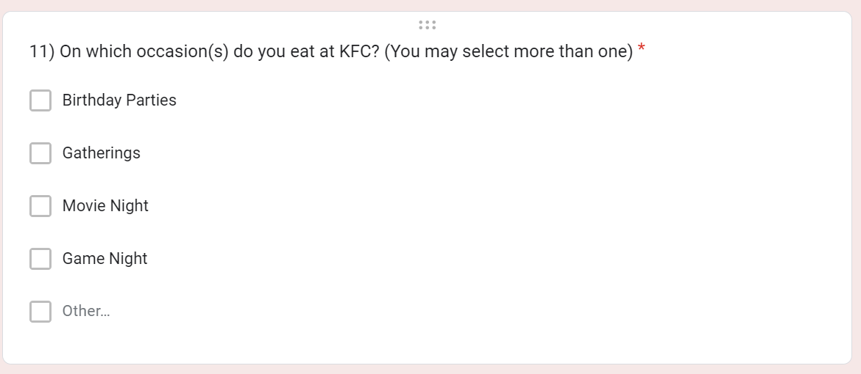
Q11 for Factor influencing the purchase of KFC products

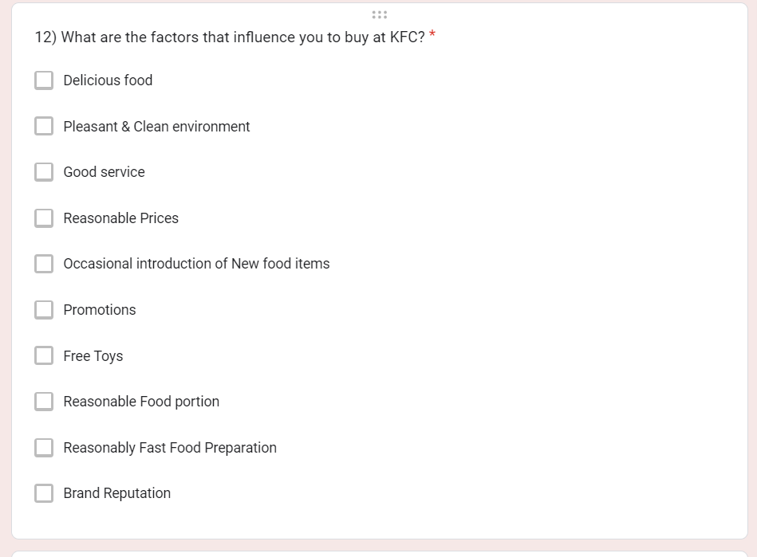
Q12 for Factor influencing the purchase of KFC products

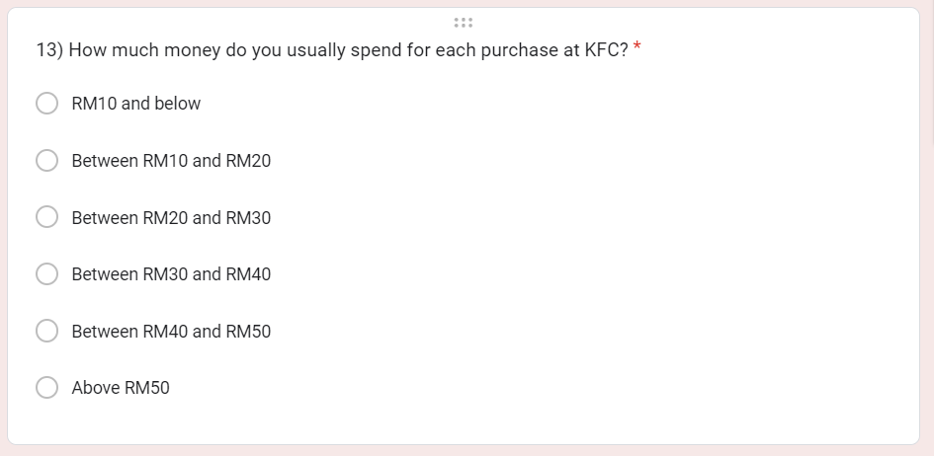
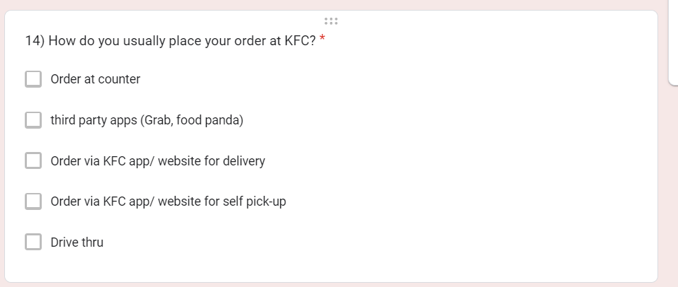
Q13 and Q14 for factors influencing the purchase for KFC products

d) Section 4 (Rating and Feedback)
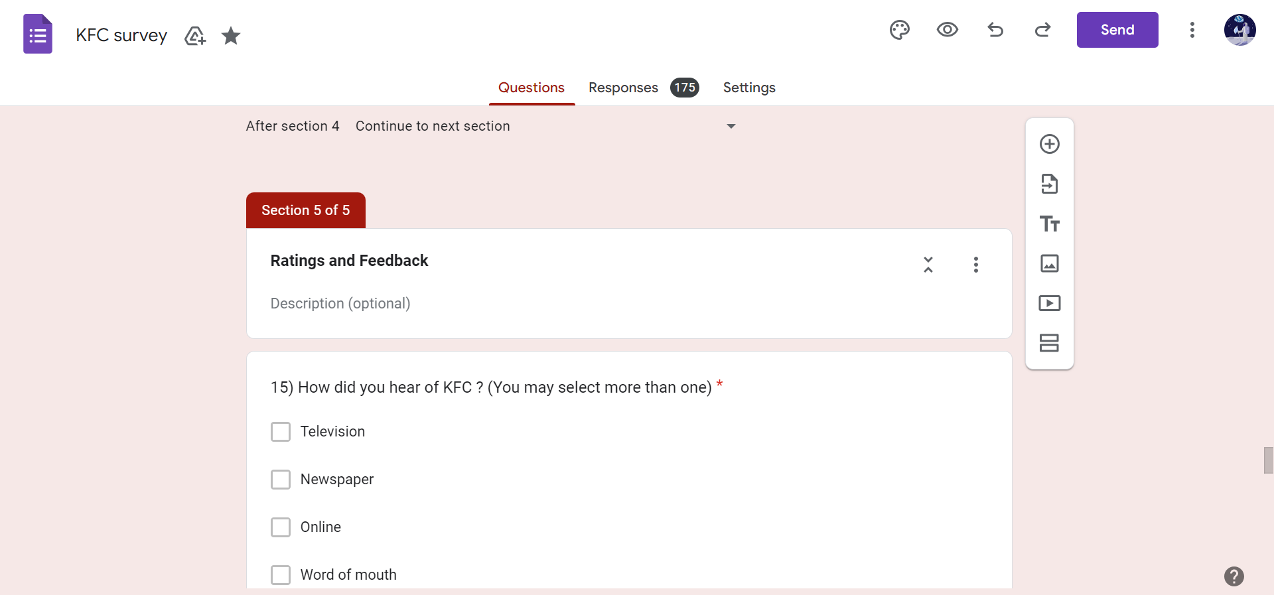
This last section allows the respondents to give their feedback and rate KFC, which could range from their dine-in or takeaway experience to the order placement methods provided by KFC. This section also allows the respondents to rate their overall satisfaction with KFC and give ratings for specific categories, for example the price, environment and the food taste. Another reason for collecting these data is because there could be some relationships between the variables in this section with the variables from other sections, such as the demographic and factor variables.

Below are the questions asked to the respondents in this section (Rating and Feedback):

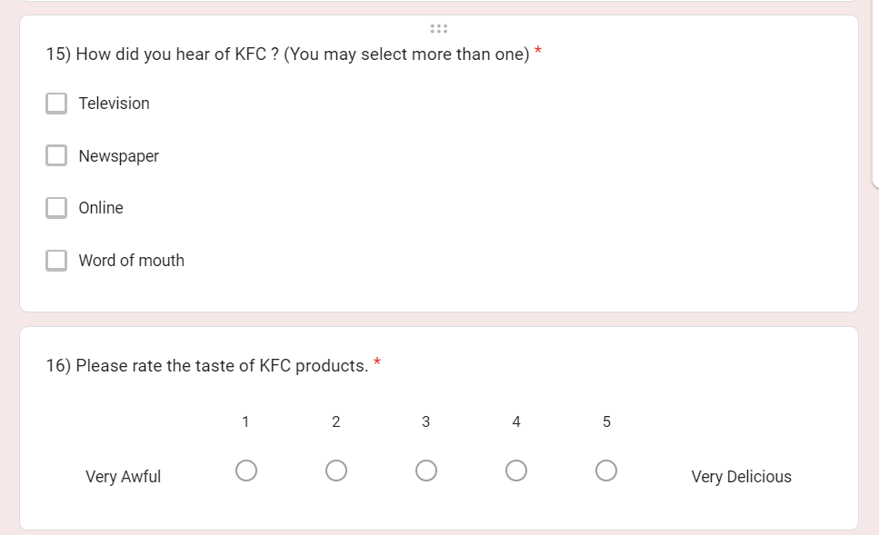
Q15 and Q16 for rating and feedback

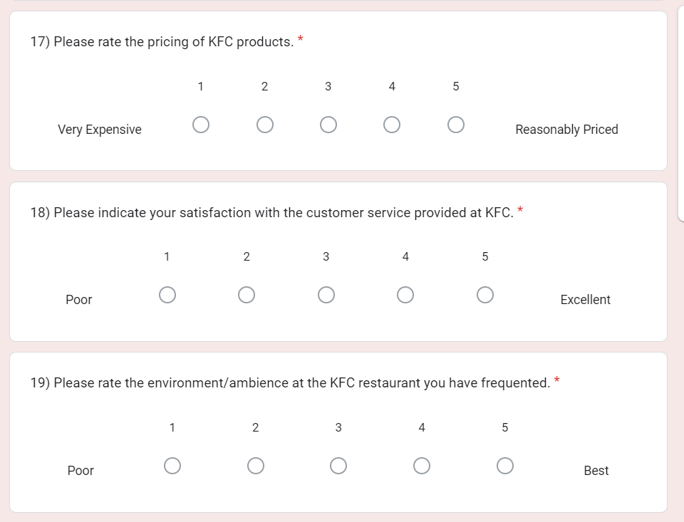
Q17 to Q19 for rating and feedback

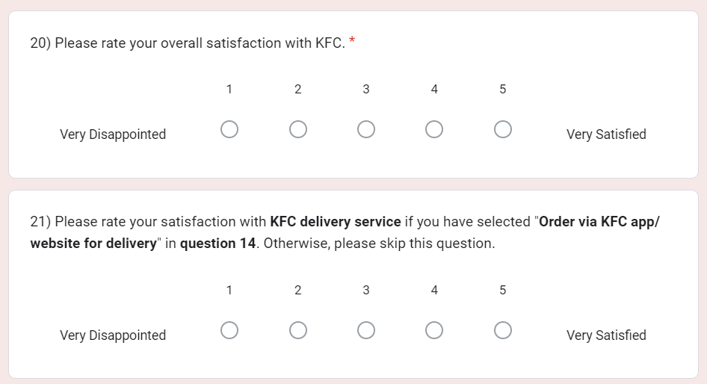
Q20 and Q21 for rating and feedback

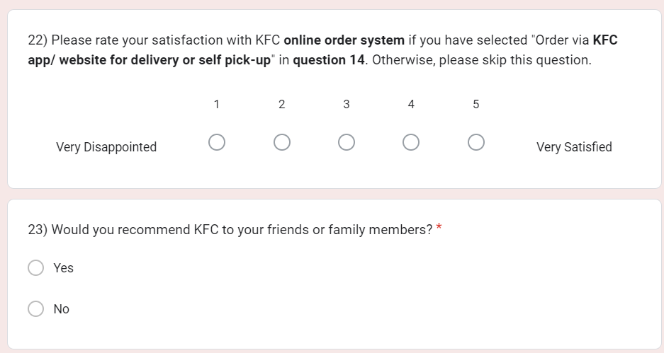
Q22 and Q23 for rating and feedback

After the Google Form was created, we selected our respondents to participate in our survey using Simple Random Sampling at the Kuala Lumpur campus of TAR UMT. Simple Random Sampling allows everyone in the target population to have an equal chance of being selected and allows us to make generalisations about the target population. The majority of our respondents are the students and staff of Tunku Abdul Rahman University of Management and Technology (TARUMT) and we believe that some of the responses were also obtained from their friends and family members.

In the end, we managed to collect 175 responses. We will be using it for analysis and to discover findings that could help the KFC management to improve KFC’s sales, increase their customers’ satisfaction levels and to broadcast their business further. This can help KFC to improve the performance of its products.

1.3 Creation of Dataset
The data collected using Google Form will be stored in a spreadsheet that is provided by Google Form. However, since we are using SAS On Demand For Academics to perform analyses and test hypotheses, we have to manually key in the data into a SAS program file and create a permanent dataset out of it. This will be covered in the next section. After the creation of the dataset, we will also be performing data cleaning.

2.0 DATA ENTRY
In this section, we will be creating a permanent dataset that is based on the 175 responses that we have collected using google form. Since the questionnaire has 23 questions in total, the dataset will also have 23 variables and the values for those variables were manually entered by us. Below are the codes, which show the steps that we have to taken to create the permanent dataset. After creating the dataset, we displayed the data from all 175 respondents.

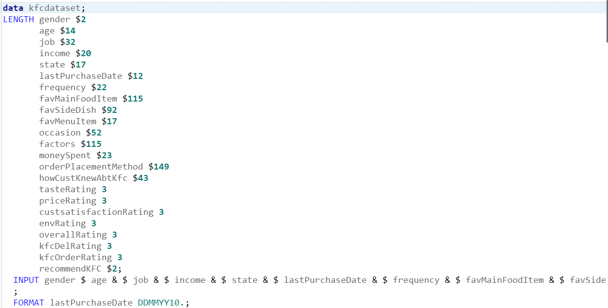
Declaring the variables in SAS

The above figure shows us declaring and defining all 23 variables. The variable names are also made as short and meaningful as possible so that it is easier for us to reference the variables in the later stages.

We have also allocated the size for each of the variables. $ represents character variables. Variables that do not have $ are the numeric variables. We have also specified the date format for the lastPurchaseDate variable that is DDMMYY10 as it best represents the data values that were entered by the respondents. We have also used the symbol, &, to notify SAS to read the variable until it encounters two or more spaces, which act as a delimiter.

After we have defined the variables and their respective sizes, we can now insert the data one by one for all 175 responses.

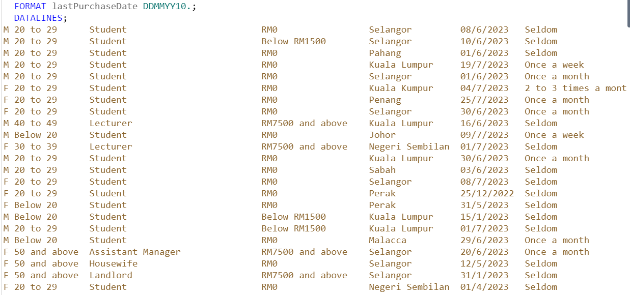
Data inserted into the SAS software that we collected in google form (first 23 records)

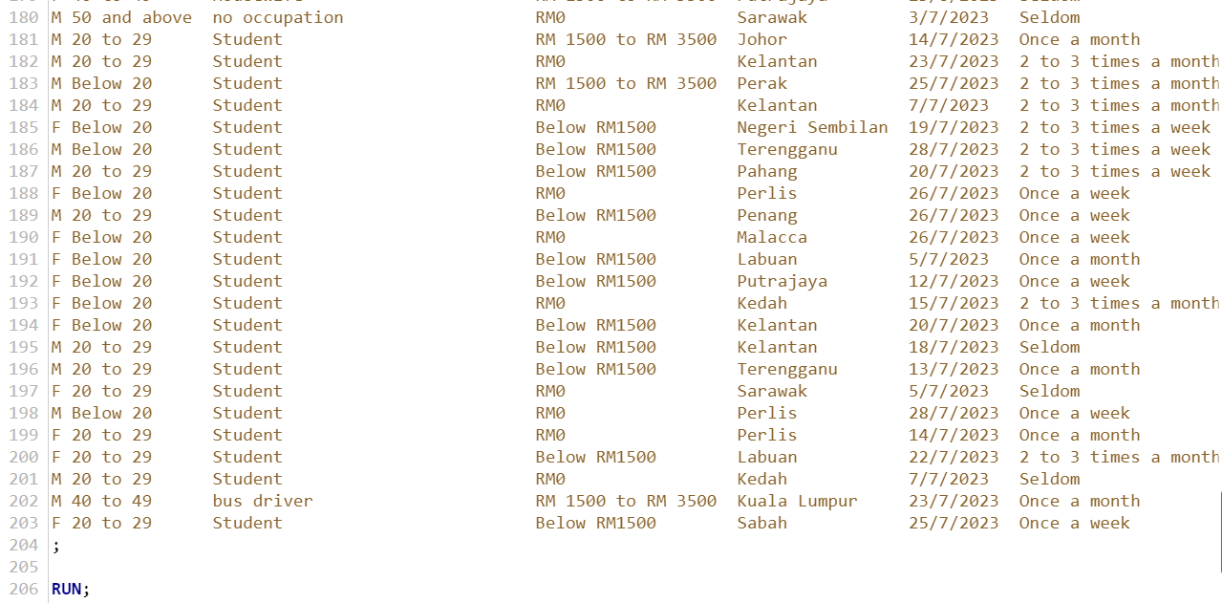
The last few records inserted into SAS software

For your information, each member was assigned to manually enter the data for at least 43 records so that everyone contributes equally to the assignment.

After we have successfully entered the data into SAS, we display the dataset to make sure that everything works as planned and as programmed.

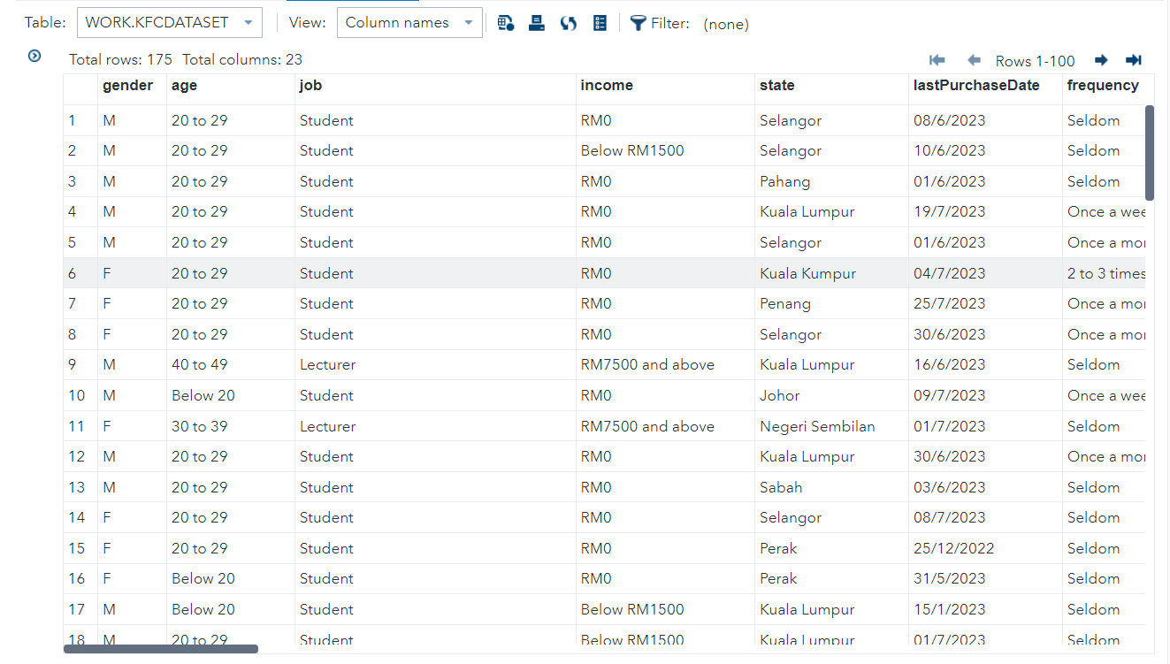
After we have entered the data, as stated we managed to insert all 175 records and all variables.

Since the dataset that you see above is a work dataset (temporary dataset), we are going to convert the work dataset into a permanent dataset to act as our master dataset.

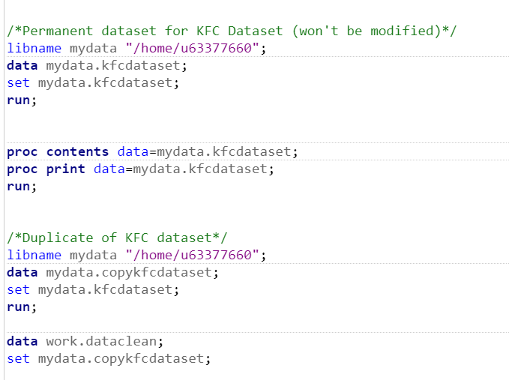
In this stage, we transformed our temporary dataset into a permanent dataset and also created a duplicate dataset that will be used for the purpose of data cleaning so that we will not edit any contents inside the master dataset.

3.0 DATA CLEANING
In this stage, we will use different techniques to understand the data and encode the data to detect outliers, and to make the data as complete as possible.

A Summary of the Techniques that We have Used:
- Label Encoding
  - A technique to transform categorical variables into a numerical format. With this technique, a unique integer represents each label.
- One Hot Encoding
  - Extra columns are created based on how many unique values are found in a categorical variable. Each unique value in a category will be added as another variable.
- Using Regular Expression to Handle Spelling Errors
  - A quicker way of cleaning data in the form of text. When compared to manually splitting character values, it is faster and easier to use.
- Uppercase or Lowercase Values for Consistency
  - Makes data cleaner and easier to be used since the data will be made consistent

Variable 1: Gender
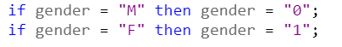
For the gender variable, we have performed label encoding, where we converted the categorical values into numeric values.

Variable 2: Age
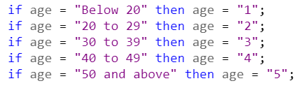
For the age variable, we have performed label encoding, where we converted the categorical values into numeric values.

Variable 3: Job
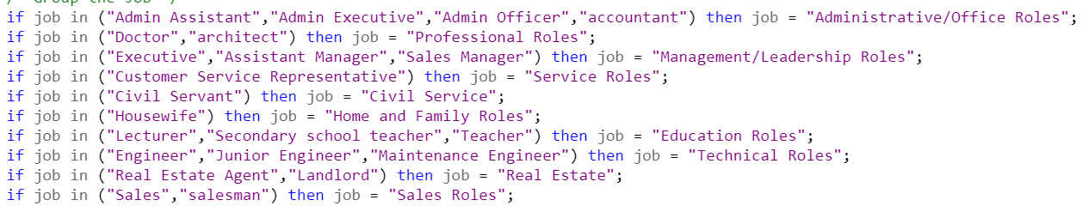
For the Job variable, we have categorised several of the jobs into distinct categories.

Variable 4: Income
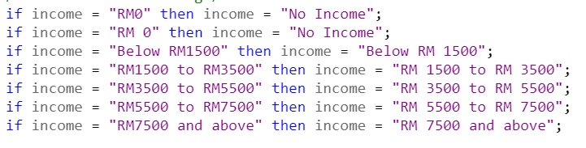
Figure 3.4.1
Fixing Inconsistencies: We noticed that there were inconsistencies in the values when they actually meant the same thing. Therefore, these lines of code were used to standardise the values.

Variable 5: State
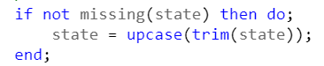
Fixing Spelling error: We also noticed that there was an incorrect spelling for the value “Kuala Lumpur”; therefore, we had to make the value consistent.

Variable 6: Last Purchase Date
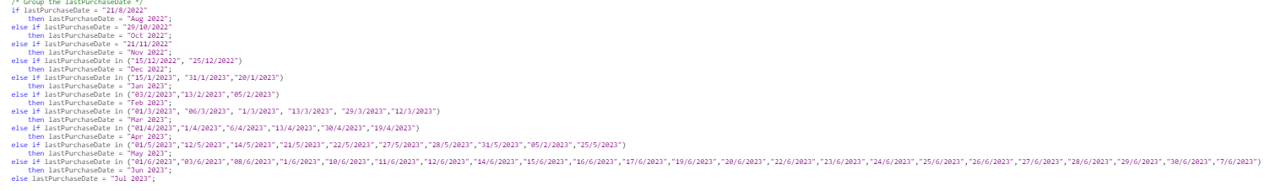

Binning: Since there can be several possible values for last purchase date, we decided to categorise them by month and year so that it is easier to perform analysis.

Variable 7: Frequency
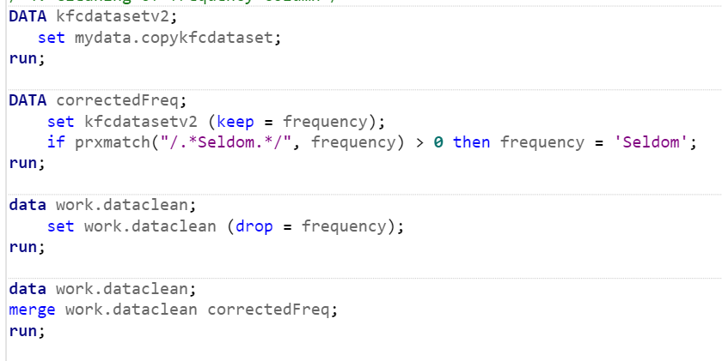
Fixing inconsistency: When we used PROC FREQ to display the unique values and their respective counts, we noticed that the value ‘Seldom’ appeared as 2 separate categories when it was supposed to be one. Therefore, we used Regular Expression to fix the inconsistency.

Variable 8: favMainFoodItem
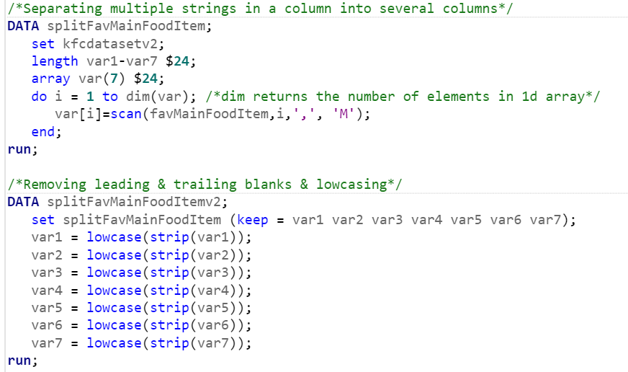
Fixing Spelling Error & One Hot Encoding: Since this column is a multi-valued column that could have up to 7 possible values, we had to split this column into several columns. After that, in each new column, we removed the trailing and leading blanks and lowercase the values.

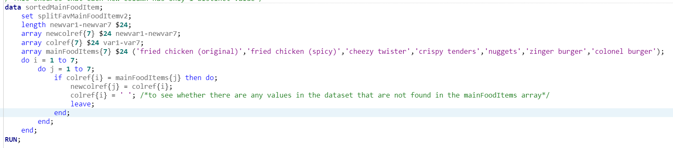

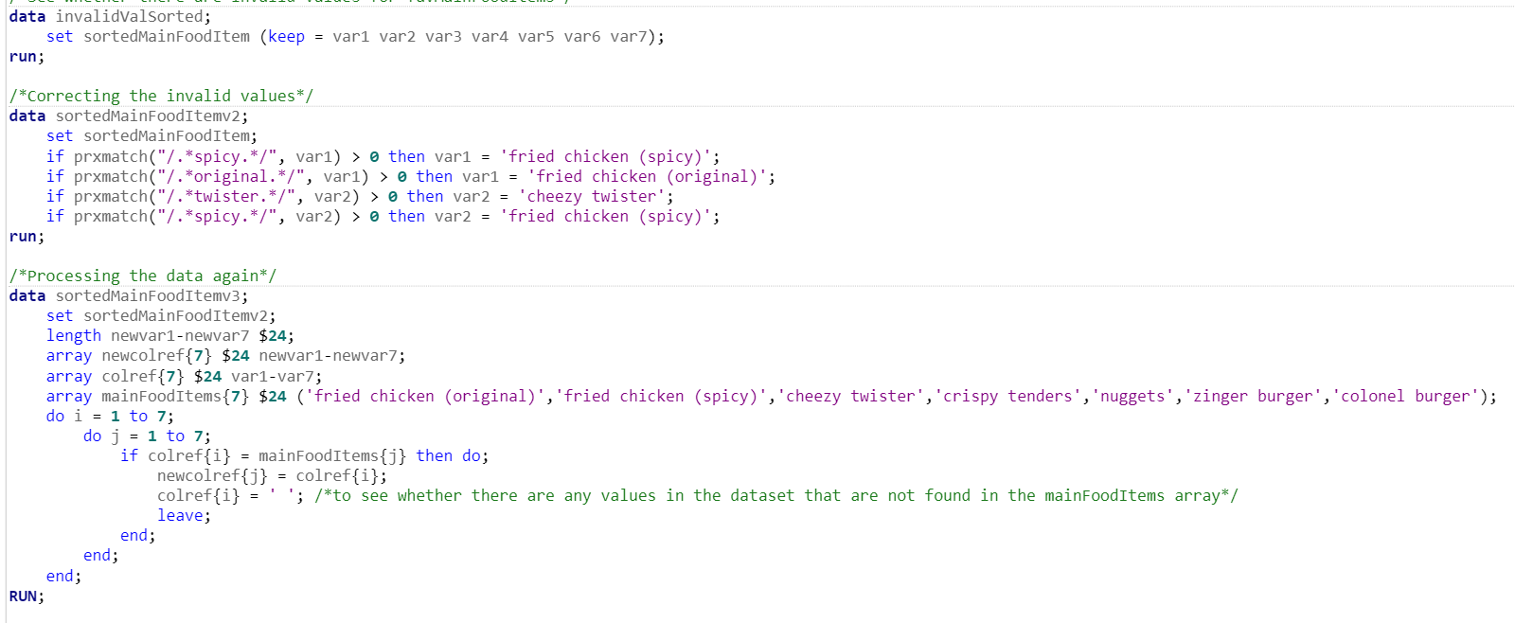
The values are then reshuffled and placed into the correct columns. For example, all of the values ‘fried chicken (original)’ are placed in the first new column so that it is easier to perform analysis.

Even after processing, there were still invalid values so regular expression is used to detect and fix the inconsistency in the values. After that, the leftover values are processed once again.
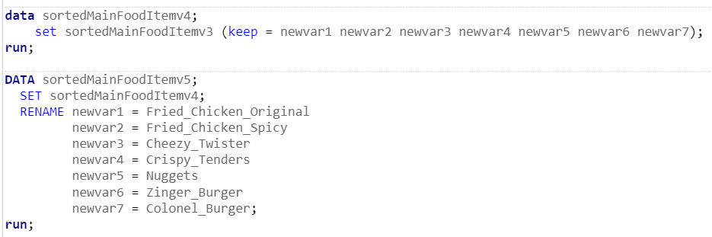
After processing, the new columns are renamed so that they are more readable and understandable.
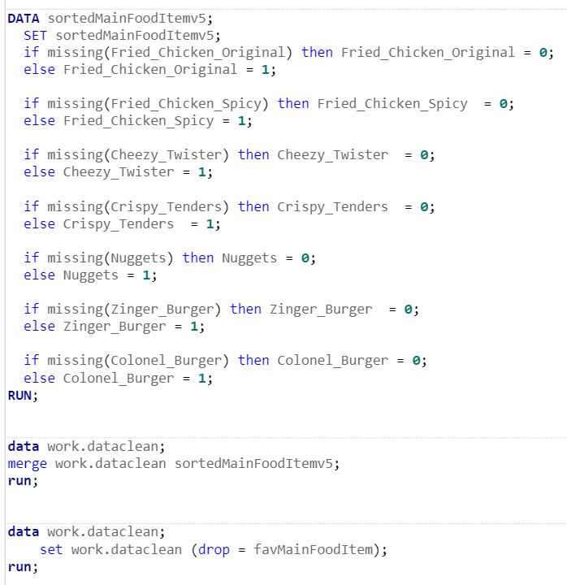
To finish the process of one hot encoding, we replaced the character values with numerical values.

Variable 9: favSideDish
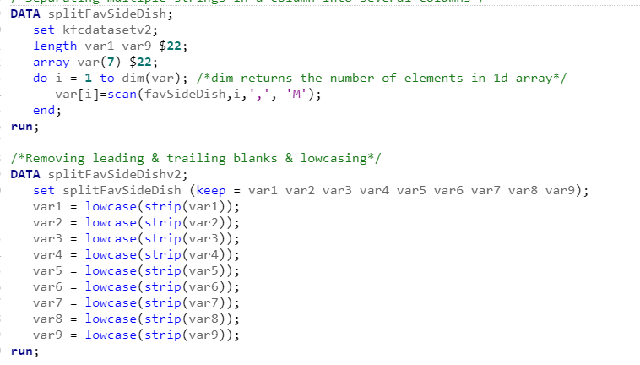
Fixing Spelling Error & One Hot Encoding: Since this column is a multi-valued column that could have up to 9 possible values, we had to split this column into several columns. After that, in each new column, we removed the trailing and leading blanks and lowercase the values.
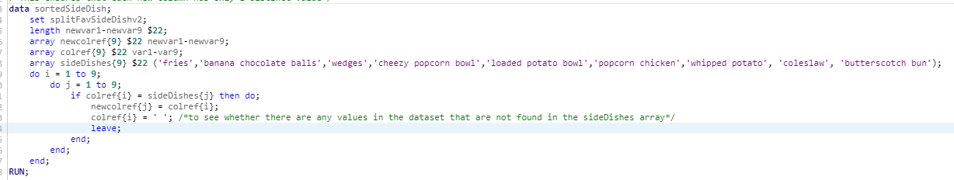

The values are then reshuffled and placed into the correct columns. For example, all of the values ‘fried chicken (original)’ are placed in the first new column so that it is easier to perform analysis.

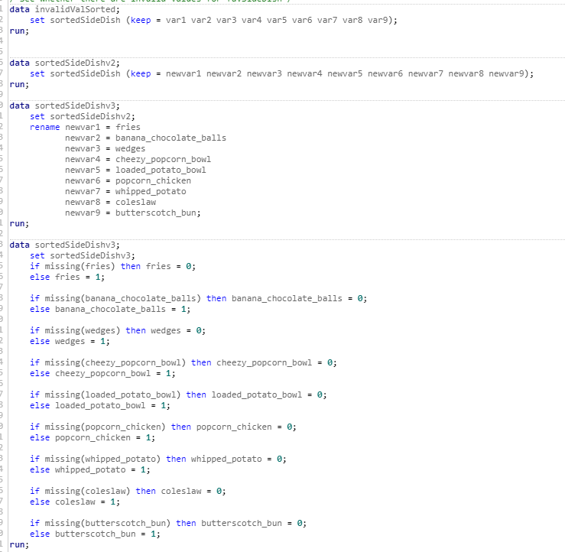
After processing, the new columns are renamed so that they are more readable and understandable. Lastly, to finish the process of one hot encoding, we replaced the character values with numerical values.

Variable 10: favMenuItem
Based on the figure below, we can see that there is no inconsistency or spelling error in this column so there is no need to preprocess or perform any data cleaning for this column.
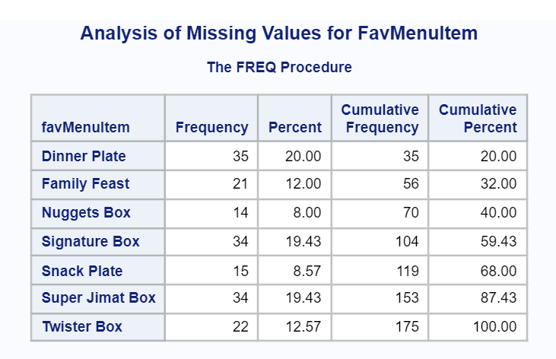

Variable 11: occasion
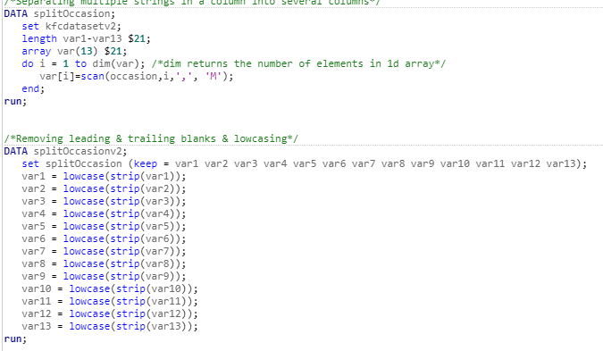
Fixing Spelling Error & One Hot Encoding: Since this column is a multi-valued column that could have up to 13 possible values, we had to split this column into several columns. After that, in each new column, we removed the trailing and leading blanks and lowercase the values.
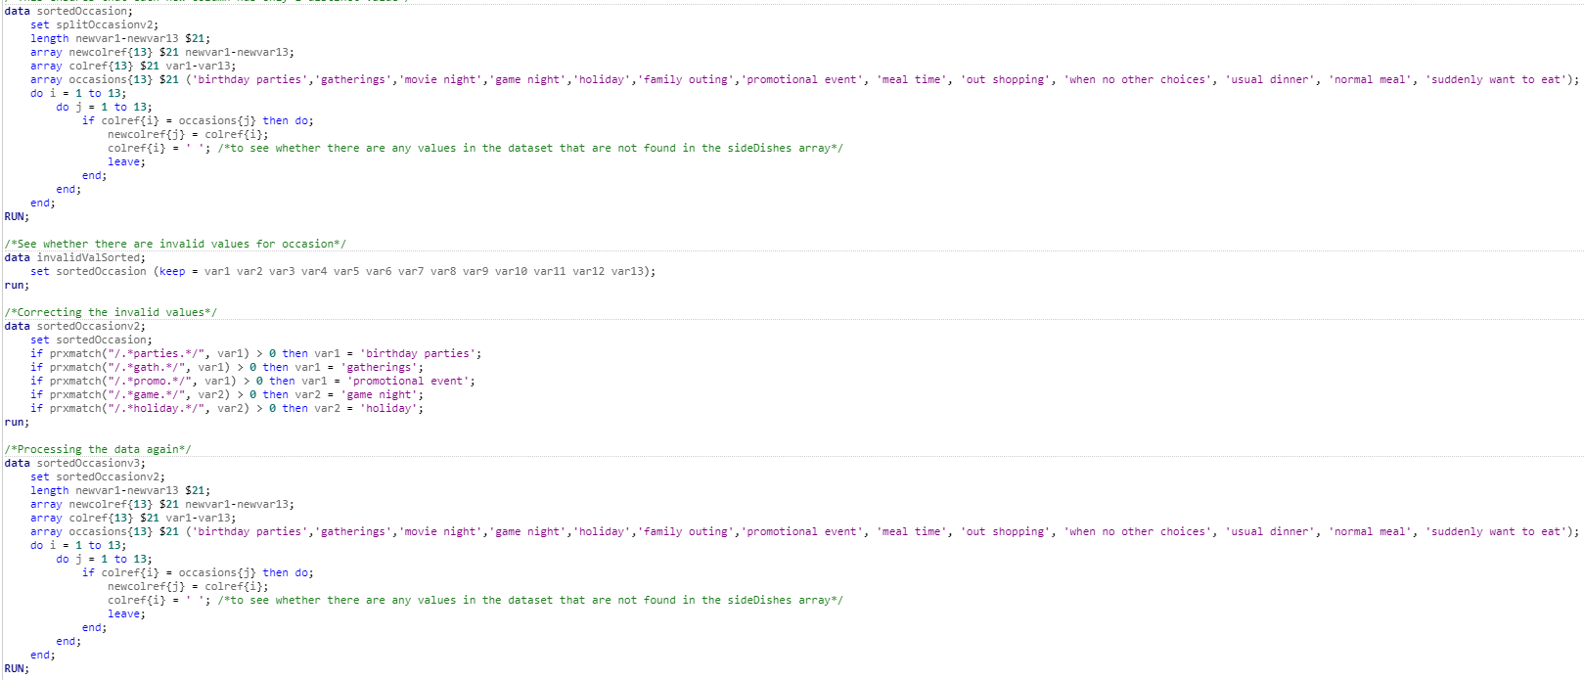

The values are then reshuffled and placed into the correct columns. For example, all of the values ‘birthday parties’ are placed in the first new column so that it is easier to perform analysis. Even after processing, there were still invalid values so regular expression is used to detect and fix the inconsistency in the values. After that, the leftover values are processed once again.

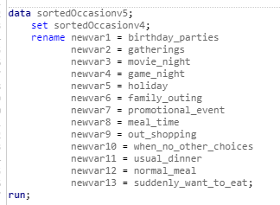
After processing, the new columns are renamed so that they are more readable and understandable.

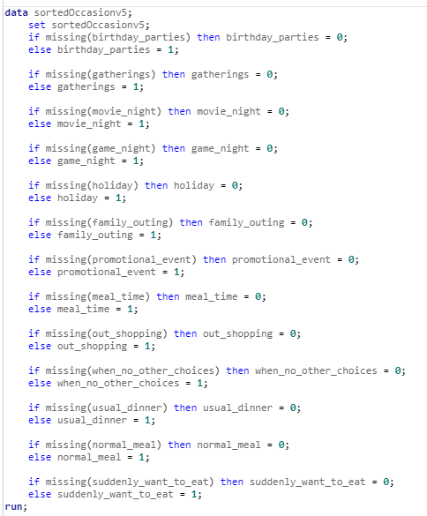
Lastly, to finish the process of one hot encoding, we replaced the character values with numerical values.

Variable 12: factors
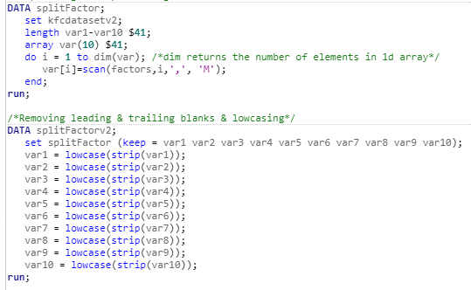
Fixing Spelling Error & One Hot Encoding: Since this column is a multi-valued column that could have up to 10 possible values, we had to split this column into several columns. After that, in each new column, we removed the trailing and leading blanks and lowercase the values.

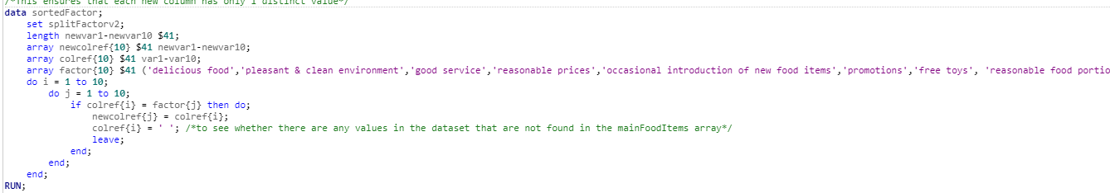

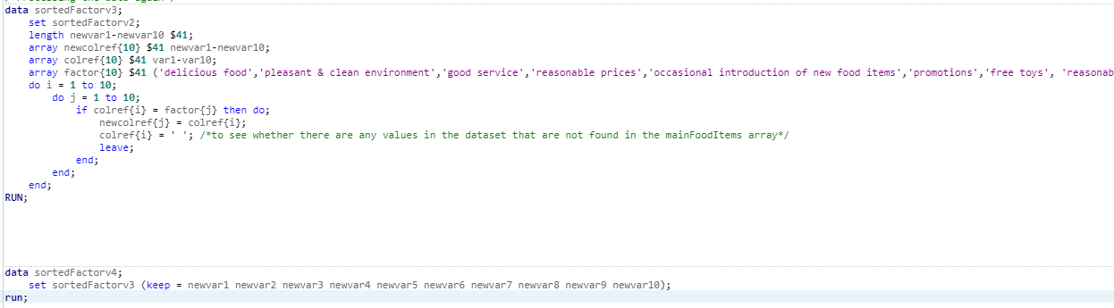

The values are then reshuffled and placed into the correct columns. For example, all of the values ‘delicious food’ are placed in the first new column so that it is easier to perform analysis.
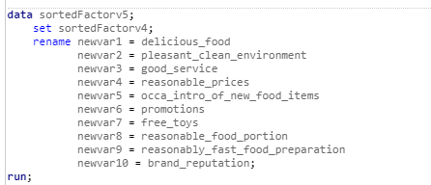
After processing, the new columns are renamed so that they are more readable and understandable.

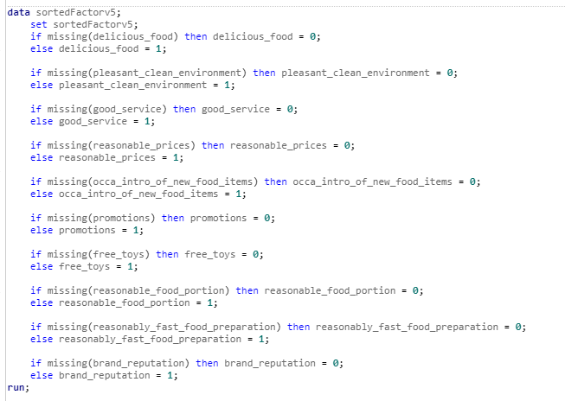
Lastly, to finish the process of one hot encoding, we replaced the character values with numerical values.

Variable 13: Money Spent
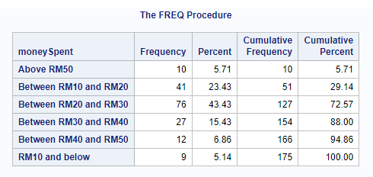

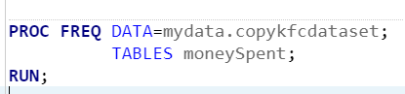

As for the money spent variable, since we allow the user to select only one type of option, we actually will just leave the variable as it is because the data did not contain any outliers. Shown above is the frequency table for moenySpent

Variable 14: orderPlacementMethod
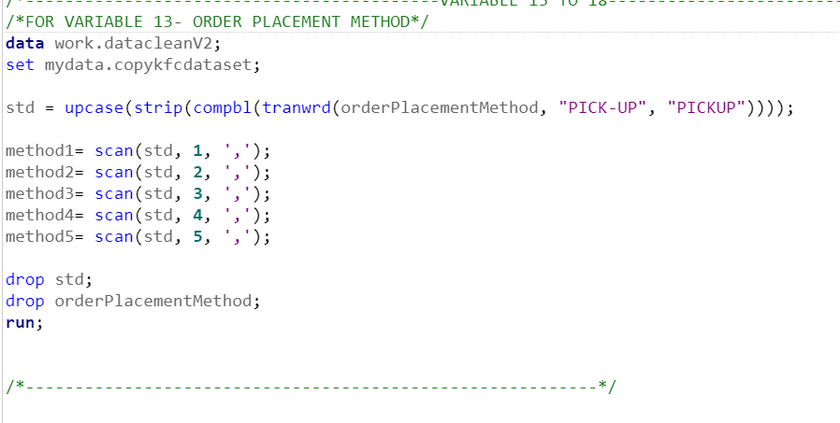
Since inside the order placement method, it contains many options and each respondents can select more than one type of option, from the above code, we first make the options to all capital letter and remove all the trailing and leading spaces as for tranwrd we use it to replace the hyphen for pick-up as to make the finding more possible and faster to search. Making the searching more accurate as possible. Next as for the method1 to method5, we actually split it into different columns as mentioned the respondent can select more than one option.
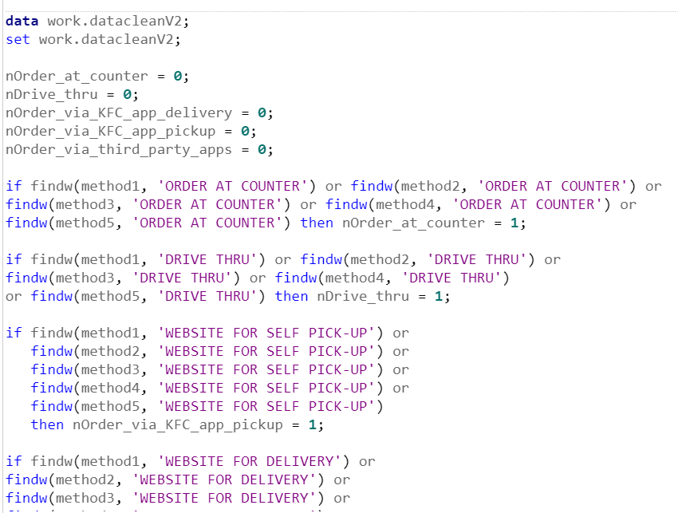
Here we use the find method which is provided in sas to find if this particular substring has been found we replace 0 as 1, as a indication of present for this record.
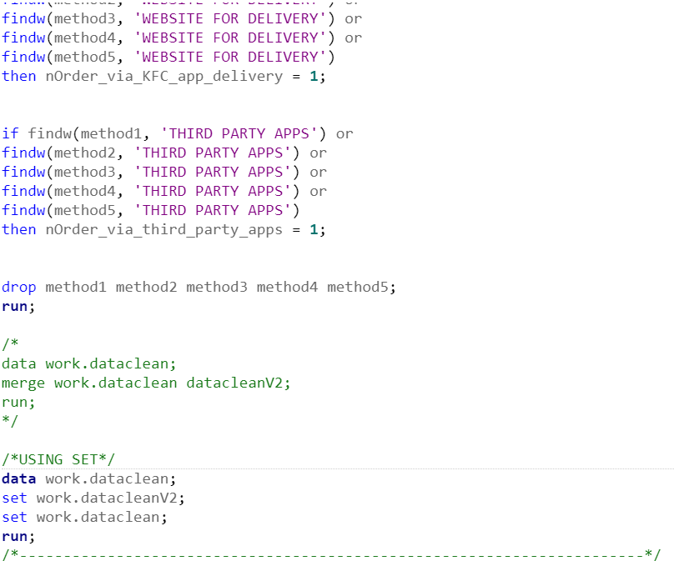
As shown above, since respondents can select multiple options, we should actually separate out the variable as because respondents can have many different variations of selection, therefore we will separate the options based on the number of options contained as now we will now know the frequency for each option by all the respondents.

Variable 15: howCustKnewAbtKfc
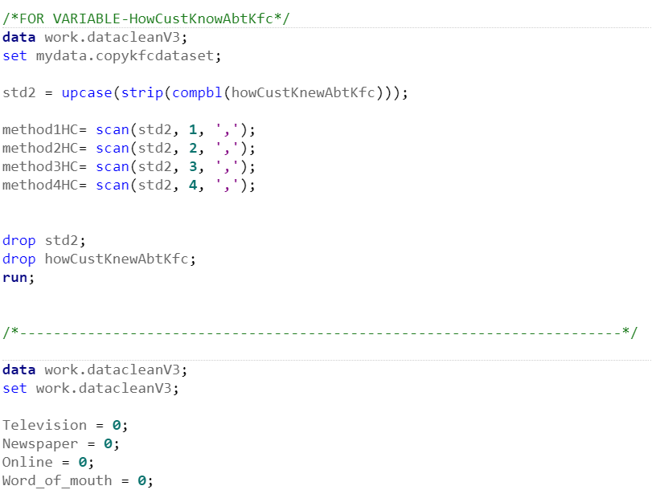
Show here is basically the same method of execution with variable 14, because in this question a user can select more than one option, therefore in the data cleaning stage we have to separate or else it will cause inconsistency to the variable and dataset.
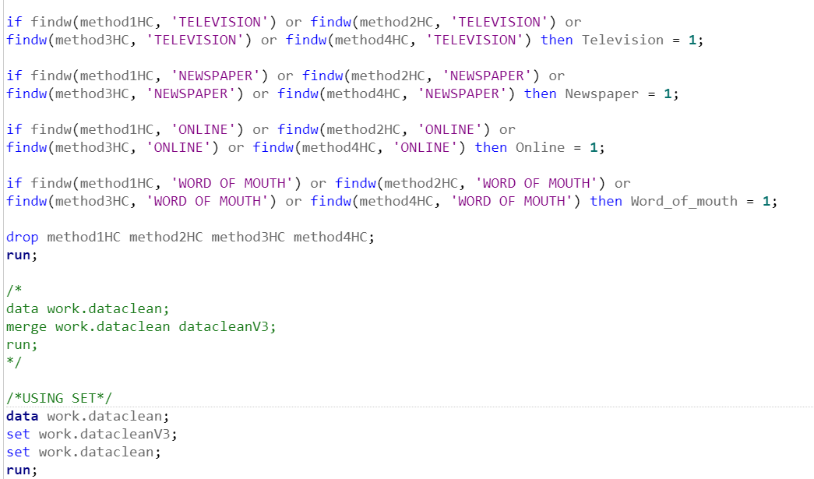
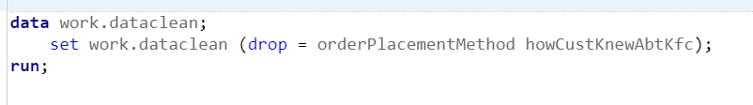
As for this image above, we use the findw method provided by sas to search for all data and replace it with 1 else it will just represent 0 for all columns. The reason why we split is because we can know the accurate frequency for the individual column as because originally the user can select more than one option.

Variable 16: taste rating
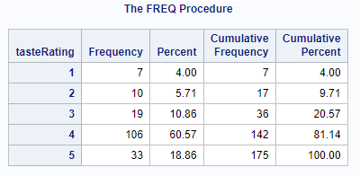
No missing values are detected as it has 175 cumulative frequency which is aligned with the total response we receive from the respondent and No data cleaning process is needed for ordinal categorical data as it is constrained to a specific range (1 to 5) and traditional outlier detection is not applicable as there is no need to identify or remove outliers. There are no data points that would significantly deviate from the majority of the data and all the values within a valid range. So no data cleaning is needed as all the value is a legitimate response and represents the level of satisfaction and all the rating is within the specified range (1 to 5)

Variable 17: price rating
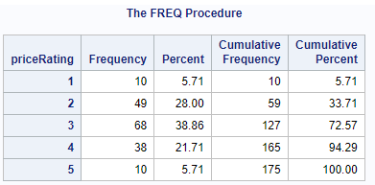
No missing values are detected as it has 175 cumulative frequency which is aligned with the total response we receive from the respondent and No data cleaning process is needed for ordinal categorical data as it is constrained to a specific range (1 to 5) and traditional outlier detection is not applicable as there is no need to identify or remove outliers. There are no data points that would significantly deviate from the majority of the data and all the values within a valid range. So no data cleaning is needed as all the value is a legitimate response and represents the level of satisfaction and all the rating is within the specified range (1 to 5)

Variable 18: satisfaction for customer service
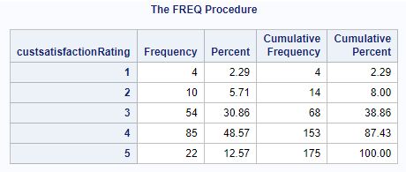
No missing values are detected as it has 175 cumulative frequency which is aligned with the total response we receive from the respondent and No data cleaning process is needed for ordinal categorical data as it is constrained to a specific range (1 to 5) and traditional outlier detection is not applicable as there is no need to identify or remove outliers. There are no data points that would significantly deviate from the majority of the data and all the values a within a valid range. So no data cleaning is needed as all the value is a legitimate response and represents the level of satisfaction and all the rating is within the specified range (1 to 5)

Variable 19: Environment/ambience
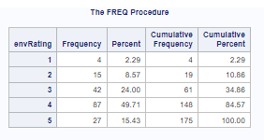
Overall rating is constrained within a specific range of ordinal categorical values (1 to 5), There are no outliers in the traditional sense. Traditional outliers mean there are extreme values that fall significantly outside the expected range. Which is not possible in this case. In the traditional outlier detection setting in some extreme cases, there is an example of a 10 rating and one person rated as 1 and 9 people rated as 5. Using a box plot or Interquartile range( IQR) 1 would be removed and it would identify 1 as the outlier. In this case, it is inappropriate to remove that particular value because each data point, in this case, represents the respondent's opinion or experiences. Each data point is important in this scenario and it is inappropriate to remove it simply because it is different from the others. As traditional outlier detection (box plot or interquartile range) is often designed for continuous numerical data, it is not suitable for ordinal categorical data. Applying them to ordinal categorical data would result in incorrect conclusions. So in conclusion no data cleaning process is needed for ordinal categorical data as it is constrained to a specific range (1 to 5) and traditional outlier detection is not applicable as there is no need to identify or remove outliers. There are no data points that would significantly deviate from the majority of the data and all the values within a valid range. So no data cleaning is needed as all the value is a legitimate response and represents the level of satisfaction and all variables are within the range of (1 to 5).

Variable 20: overall satisfaction
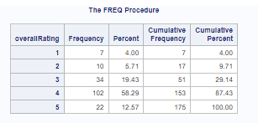
No missing values are detected as it has 175 cumulative frequency which is aligned with the total response we receive from the respondent and No data cleaning process is needed for ordinal categorical data as it is constrained to a specific range (1 to 5) and traditional outlier detection is not applicable as there is no need to identify or remove outliers. There are no data points that would significantly deviate from the majority of the data and all the values a within a valid range. So no data cleaning is needed as all the value is a legitimate response and represents the level of satisfaction and all the rating is within the specified range (1 to 5)

Variables 21 & 22
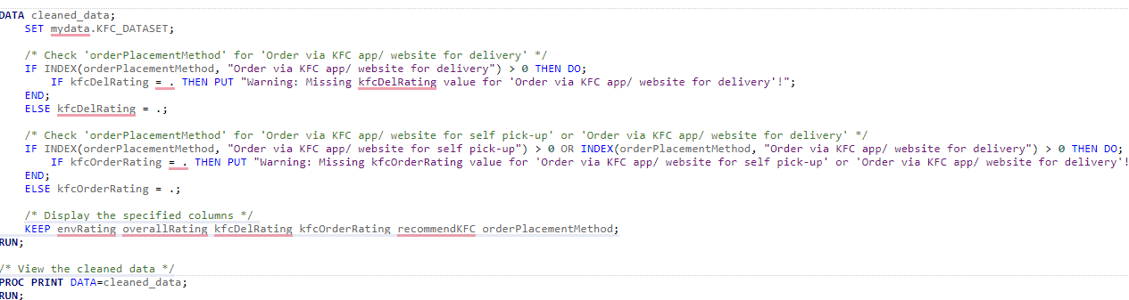

If the Respondent did not select Order via KFC app/ website for delivery" in question 14.replace the value with null. As this question should be answered by those who had choose this option in question 14.
Variables 22
If the Respondent did not select Order via KFC app/ website for delivery or self pick-up in question 14.replace the value with null. As this question should be answered by those who had chosen this option in question 14.

Variable 23: recommend KFC
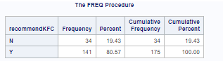
No missing values are detected as it has 175 cumulative frequency which is aligned with the total response we receive from the respondent and No data cleaning process is needed for binary categorical data as it is constrained to a specific range (Y/N). As there are only two possible valid responses, these is no concept of ‘outlier’ in the conventional sense. As Y or N is a legitimate opinion or preference of a respondent. As in this variables there have only Y or N response so no data cleaning needed for this variables.

What Dataset Looks Like After Cleaning

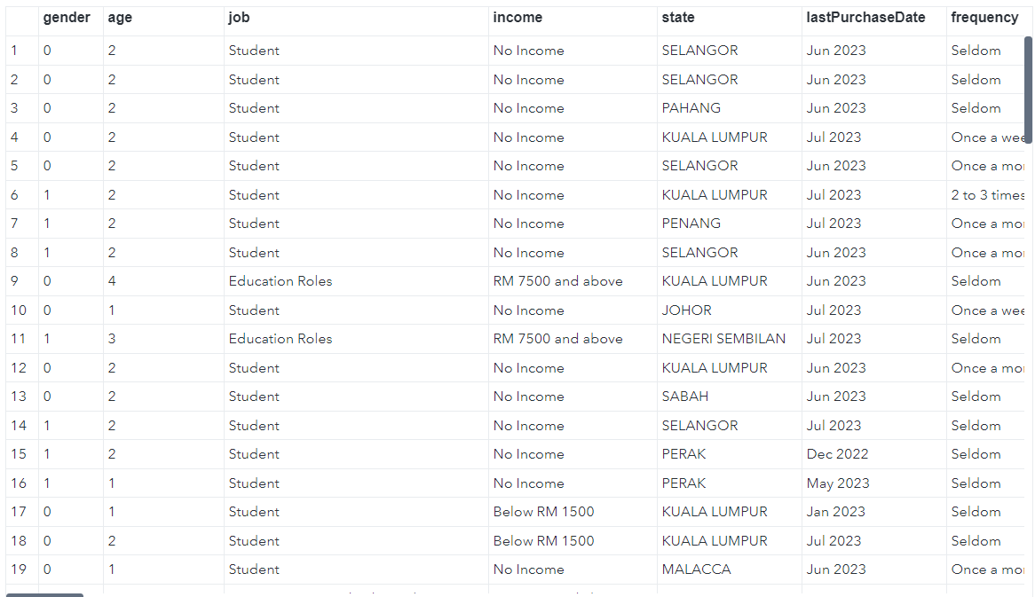
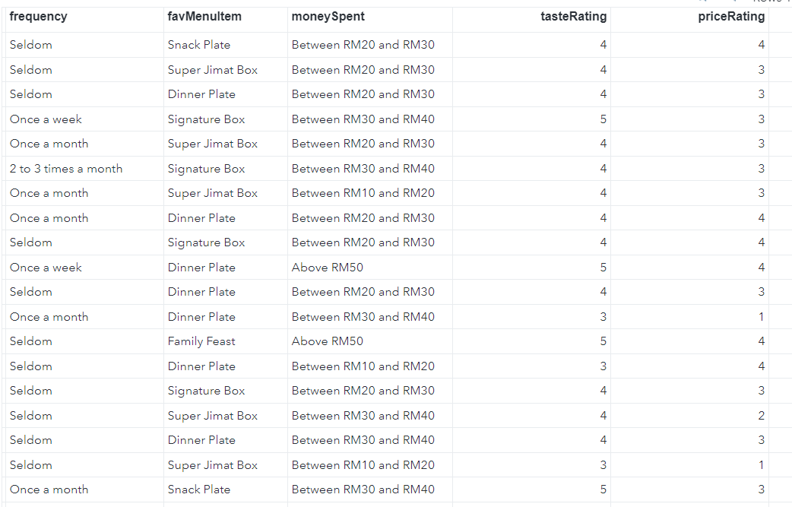
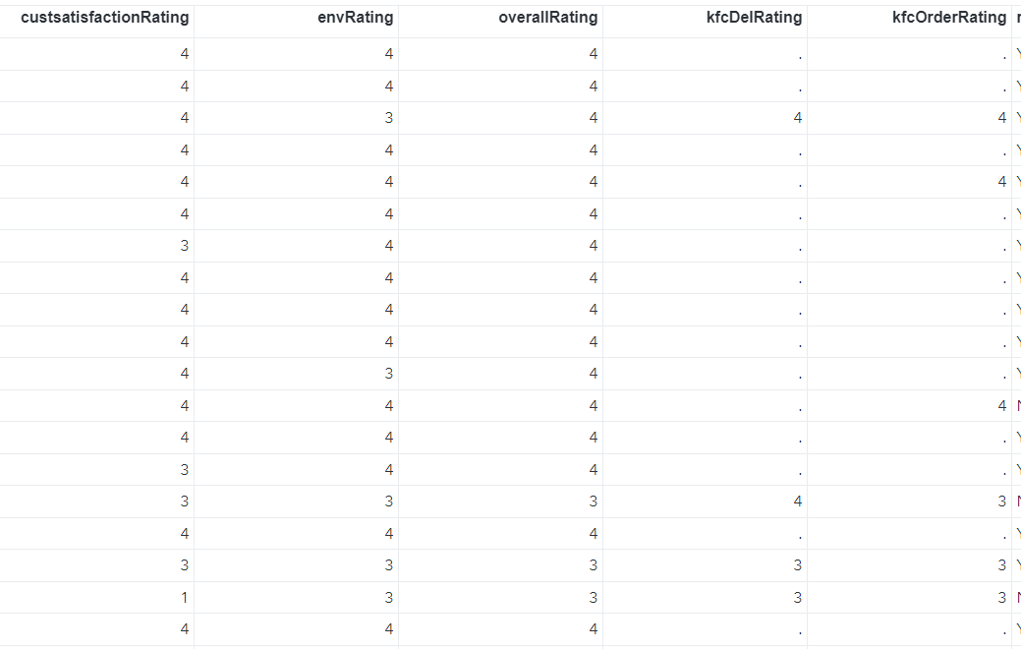
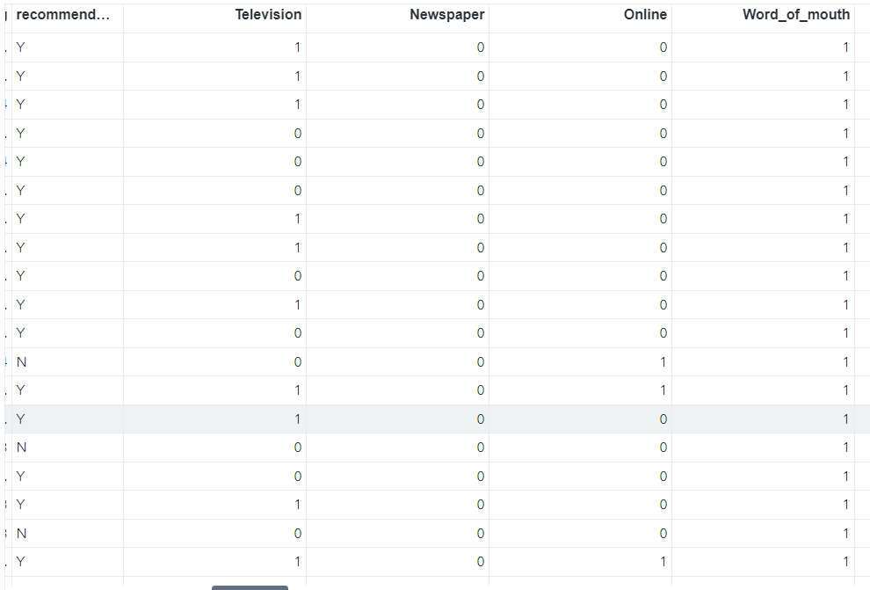
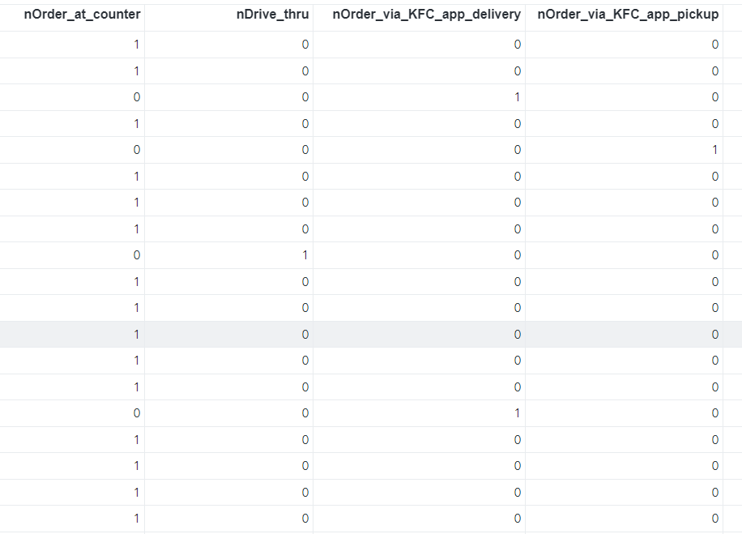
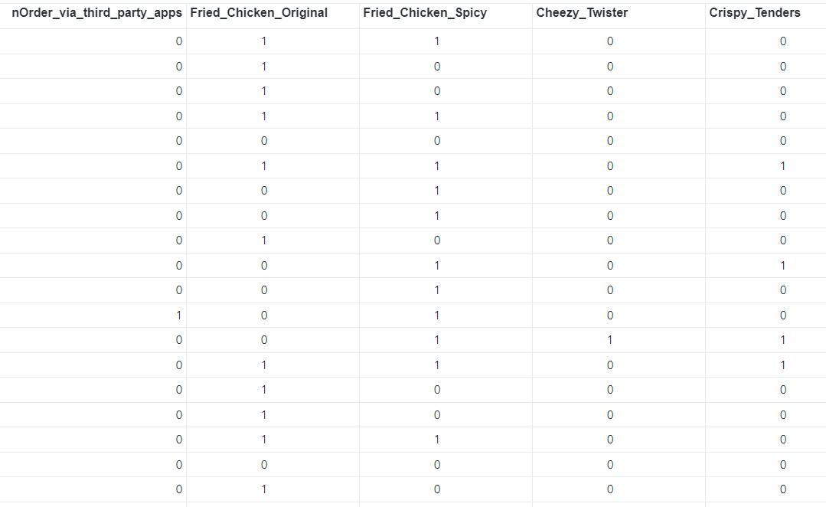
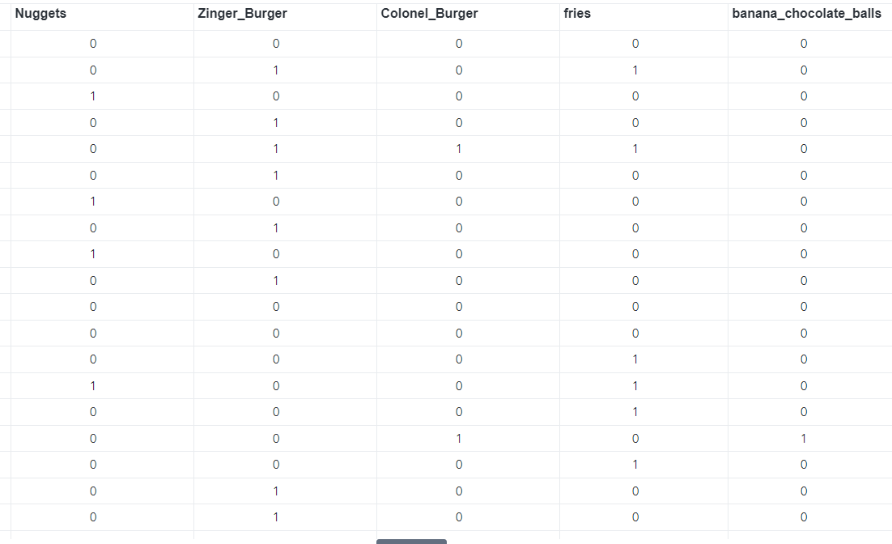
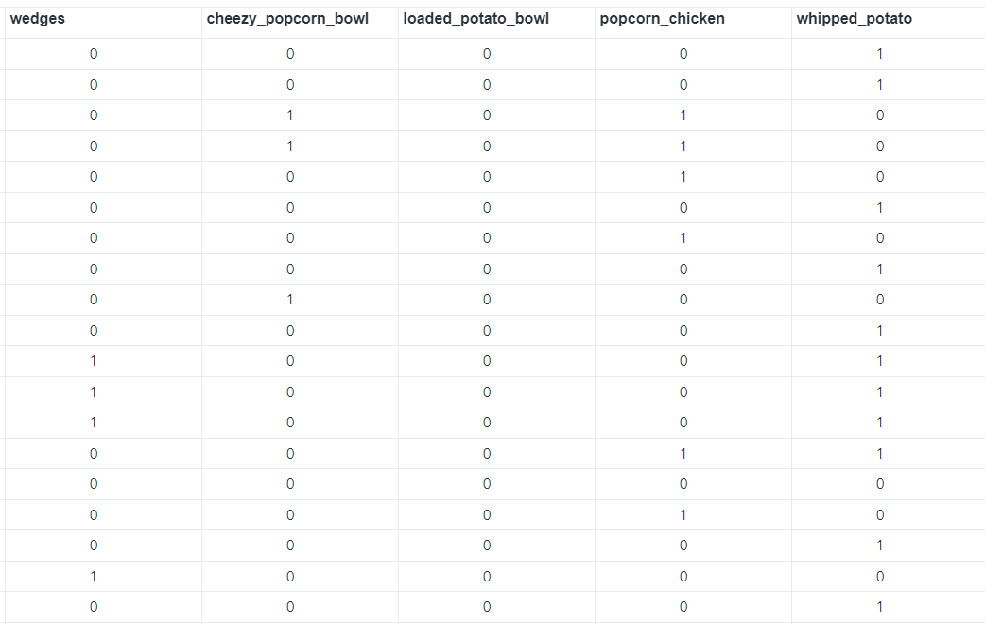
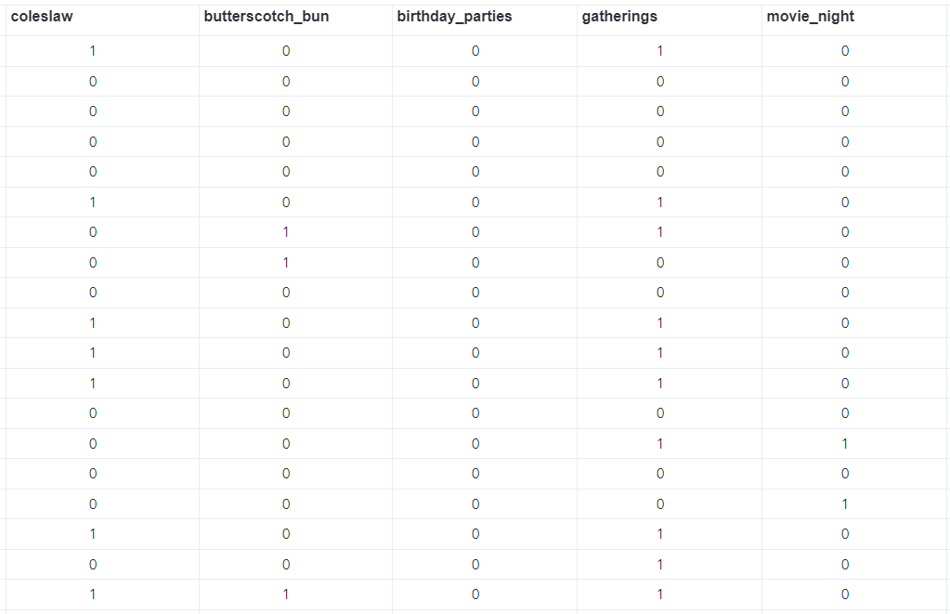
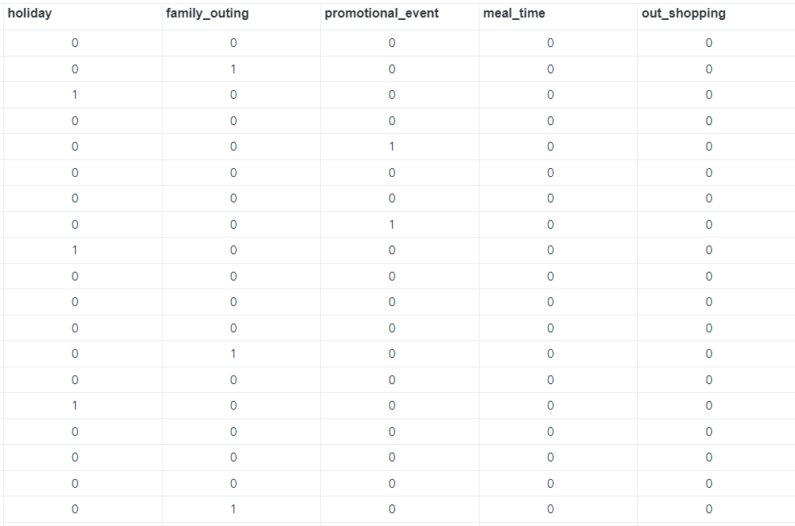
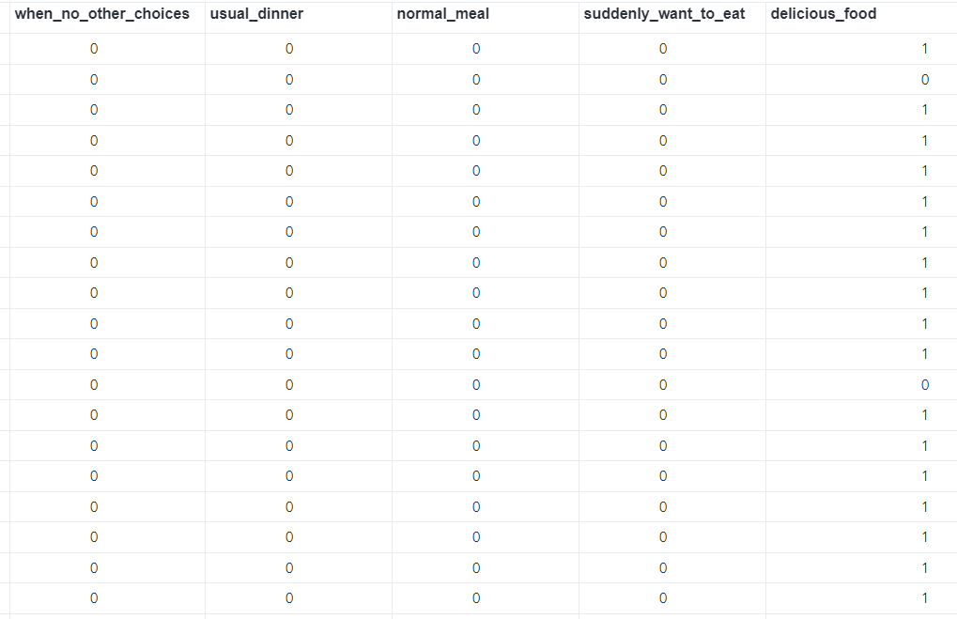
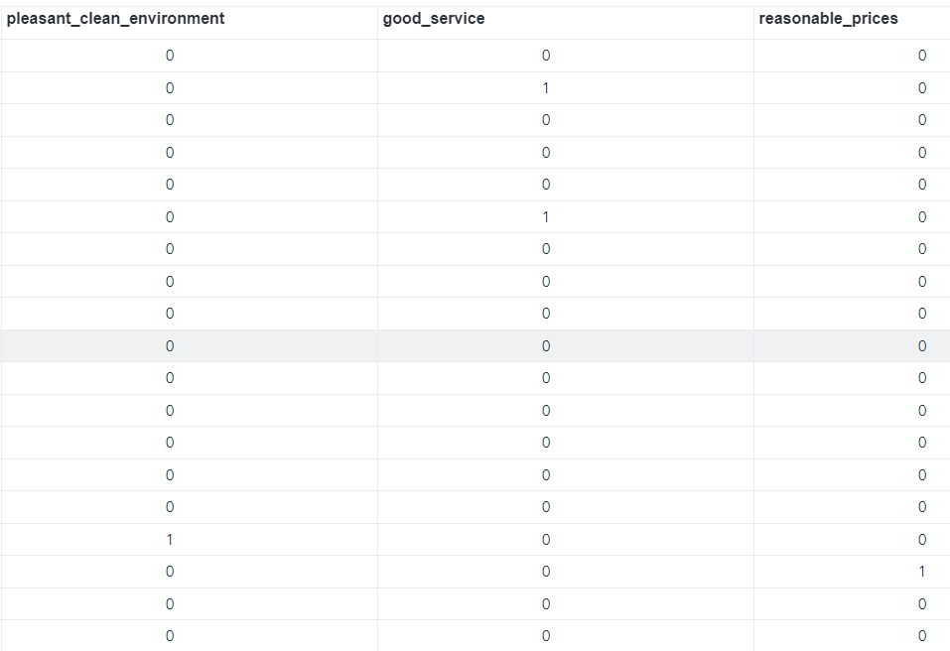
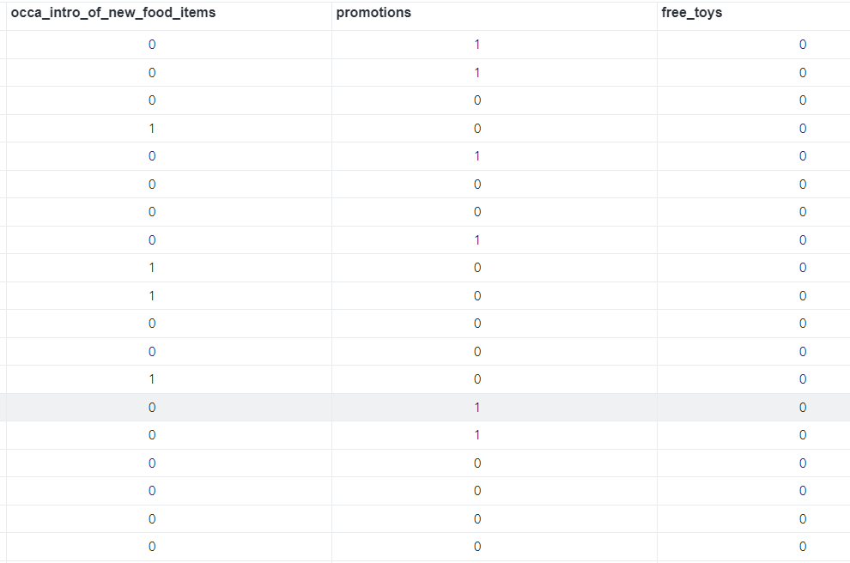
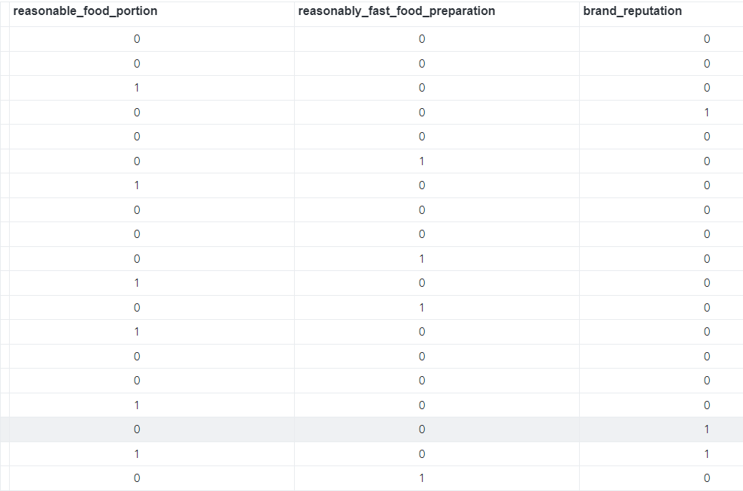

4.0 DESCRIPTIVE ANALYSIS
In this section, we calculated descriptive statistics, such as the mean, median, mode, and standard deviation, proc report and proc tabulate for the variables used in the dataset and generate the frequency distributions and summary reports of some variables to understand their distribution better.

4.1 Gender
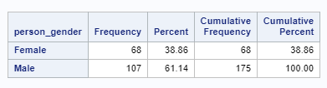
Figure 4.1.a: Frequency distribution of Gender
Based on Figure 4.1.a, gender is a categorical variable. The results show that the majority of the respondents were Males, which forms a proportion of 61.14%, whereas Females form a proportion of 38.86%. This may indicate that the majority of KFC’s customers are Males.

Output | Code
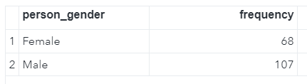 | 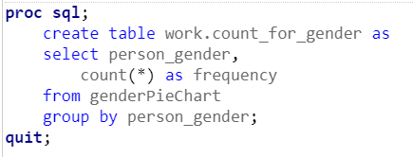
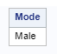 | 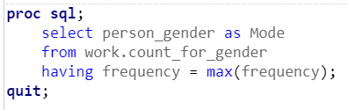
Figure 4.1.b: Descriptive statistic of Gender

As gender is a categorical variable, we can only calculate the mode, which is ‘Male’ since the majority of the respondents are males.

4.2 Age
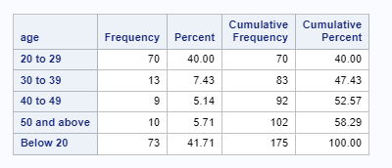
Figure 4.2.a: Frequency distribution of Age
The variable age, which is categorical, is portrayed as age groups. Based on Figure 4.2.a, we can see that the majority of the respondents are people who are below 20 years old (41.71%), which is similar to the proportion of respondents who are aged 20 to 29 (40%). People aged 40 to 49 form the minority (5.14%). This may mean that the majority of KFC Customers are young adults, teenagers and possibly children.

Output | Code
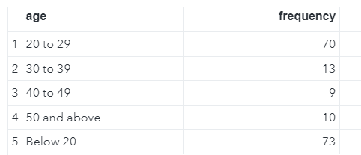 | 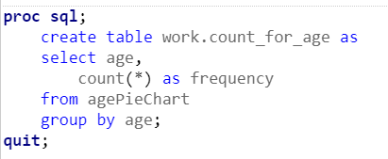
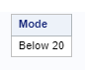 | 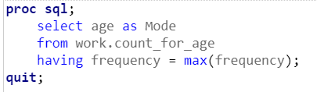
Figure 4.2.b: Descriptive statistic of Gender
As age in this case is a categorical variable, we can only calculate the mode, which is ‘Below 20’.

4.3 Job
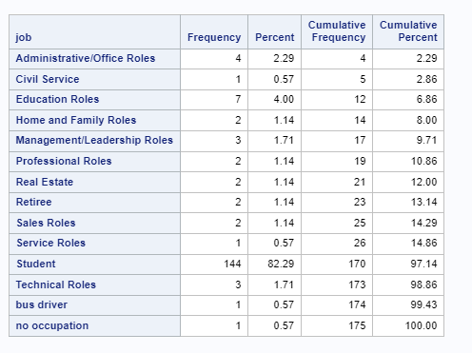
Figure 4.3.a: Frequency distribution of Job

The variable job is a categorical variable. As can be seen from Figure 4.3.a, most of KFC’s customers are students, forming 82.29% of the respondents. This shows that KFC is more popular among students than other job categories.

Output | Code
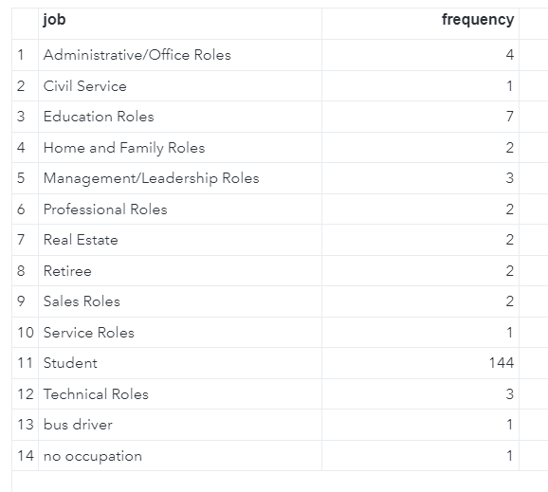 | 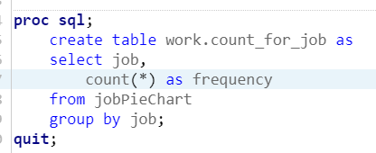
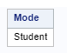 | 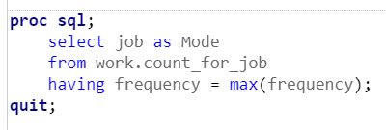
Figure 4.3.b: Descriptive statistic of Job
As job is a categorical variable, we can only calculate the mode, which is ‘Student’.

4.4 Income
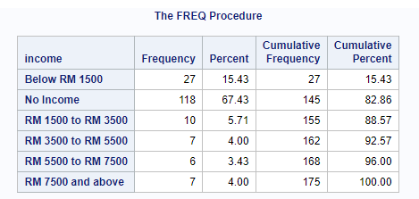
Figure 4.4.a: Frequency distribution of Income
Income is a categorical variable that is ordinal. As can be seen from Figure 4.4.a, the higher the person’s income, the less likely he/she patronises KFC. For example, as we read the frequency count from the “No Income” category to the “RM 7500 and above” category, the frequency count generally decreases from 118 to 7. This indicates that higher paying individuals prefer other food/restaurant options.
Output | Code
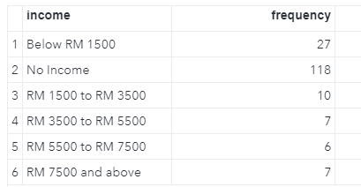 | 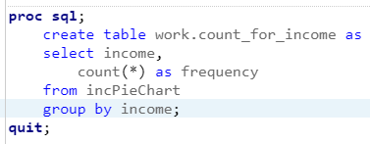
Mode  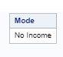 | 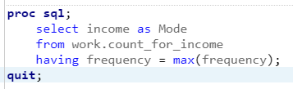
Figure 4.4.b: Descriptive statistic of Income
As income is a categorical variable, we can only calculate the mode, which is ‘No Income’.

4.5 State
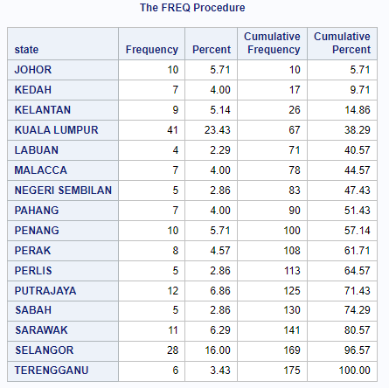
Figure 4.5.a: Frequency distribution of State
State is a categorical variable. Based on Figure 4.5.a, we can see that the majority of KFC’s customers (23.43%) are from Kuala Lumpur (Wilayah Persekutuan), followed by Selangor. Labuan respondents form the minority of the respondents (2.29%). It is clear that each of the states Negeri Sembilan, Perlis and Sabah forms only 2.86% of the respondents. It can also be seen that most of the respondents are from West Malaysia rather than East Malaysia. This could indicate that KFC is more well-known among West Malaysians than East Malaysians.

Output | Code
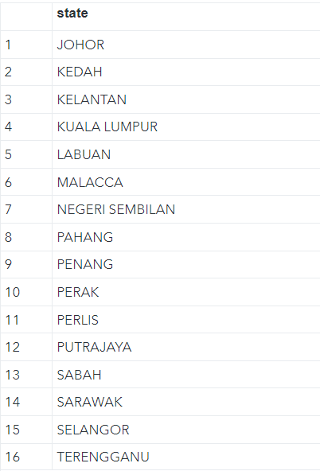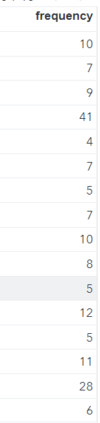 | 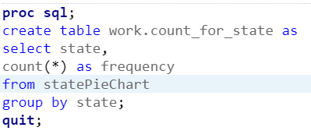
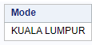 | 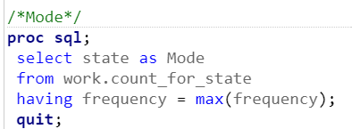
Figure 4.5.b: Descriptive statistic of State
As state is a categorical variable, we can only calculate the mode, which is ‘Kuala Lumpur’.
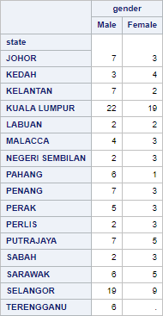

4.6 lastPurchaseDate

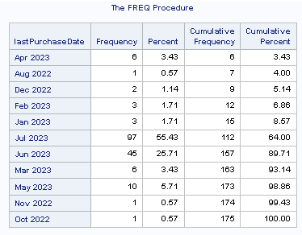
Figure 4.6.a Frequency distribution for last purchase date

lastPurchaseDate is a categorical variable. As shown in Figure 4.6.a, we can see that most of KFC customers purchased in the month of July in 2023 (55.43%). We could also see that in 2022, KFC had the least number of purchases from customers (0.57%) in the months of August, October and November. However, one noticeable trend that we can see in 2023 is that the number of purchases by customers tends to peak towards the middle or the end of the year. From January 2023 to July 2023, the number of customer purchases increased from 3 to 97.

Output | Code
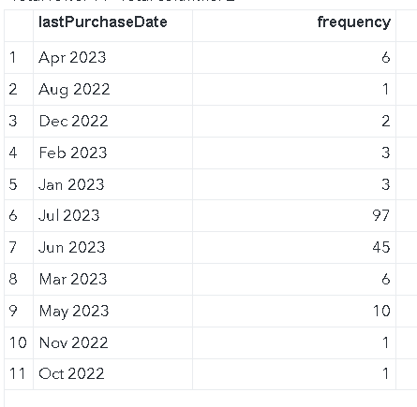 | 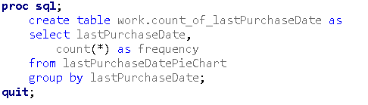
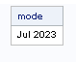 | 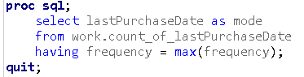
Figure 4.6.b: Descriptive statistic of lastPurchaseDate
As lastPurchaseDate is a categorical variable, we can only calculate the mode, which is ‘Jul 2023’.

4.7 frequency
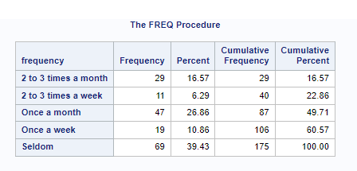
Figure 4.7.a: Frequency distribution for frequency
Frequency is a categorical variable. As shown in Figure 4.7.a, our respondents seldom purchased KFC products because the ‘Seldom’ category has the highest frequency followed by ‘Once a month’ which has the second highest frequency of 47, followed by ‘2 to 3 times a month’, which has a frequency of 29. whereas for ‘2 to 3 times a week’ it has the lowest frequency of only 11. Therefore, the KFC management needs to take action to make its customers purchase KFC products more often in order to boost sales.

Output | Code
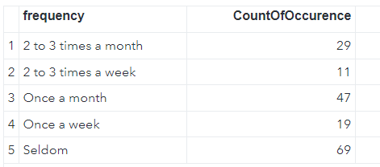 | 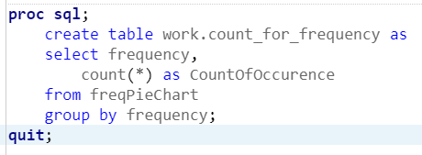
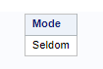 | 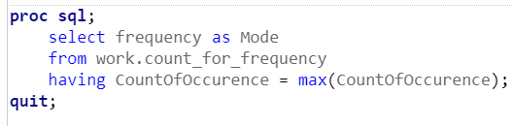
Figure 4.7.b: Calculations of frequency and mode for frequency
Since frequency is a categorical variable, we can only find out the mode for frequency which is ‘seldom’.

4.8 favMainFoodItem
Initially, there was only 1 variable to represent the customer’s favourite main food item, which could have 7 possible values:
- Fried Chicken (Original)
- Fried Chicken (Spicy)
- Cheezy Twister
- Crispy Tenders
- Nuggets
- Zinger Burger
- Colonel Burger
However, since a customer can select multiple favourite main food items, this variable had to be split into 7 variables by implementing One Hot Encoding.
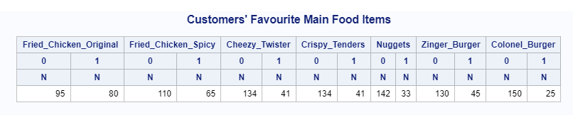

Figure 4.8.a: Frequency distribution for Customers’ Favourite Main Food Items
We can clearly see that Fried Chicken is the hottest/most popular main food item among KFC’s customers as the frequencies for Fried Chicken (Original) and Fried Chicken (Spicy) are 80 and 65 respectively. We could also notice that there is less demand for Nuggets (33) and Colonel Burger (25). The mode is ‘Fried Chicken Original’.

4.9 favSideDish
Initially, there was only 1 variable to represent the customer’s favourite side dish, which could have 9 possible values:
- Fries
- Banana Chocolate Balls
- Wedges
- Cheezy Popcorn Bowl
- Loaded Potato Bowl
- Popcorn Chicken
- Whipped Potato
- Coleslaw
- Butterscotch Bun
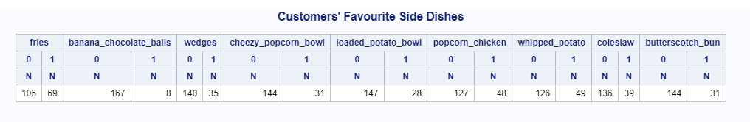
However, since a customer can select multiple favourite side dishes, this variable had to be split into 9 variables by implementing One Hot Encoding

Figure 4.9.a: Frequency distribution for Customers’ Favourite Side Dishes
We can see that Fries is the hottest/most popular item among KFC’s customers as it has the highest frequency of 69. The side dish that is the second most popular among the customers is Whipped potato with a frequency of 49, followed by Popcorn Chicken (48). Banana chocolate balls is the least popular side dish with a frequency of 8.

4.10 favouriteMenuItem
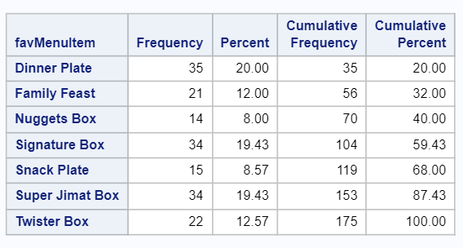
Figure 4.10.a: Frequency distribution for favourite menu item
favMenuItem is a categorical variable. From Figure 4.10.a, we can see that Dinner Plate has the highest demand (20% of the respondents), followed by Signature Box (19.43% of the respondents) and Super Jimat Box (19.43% of the respondents).
Output | Code
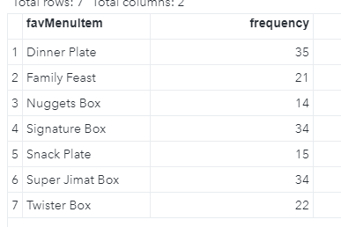 | 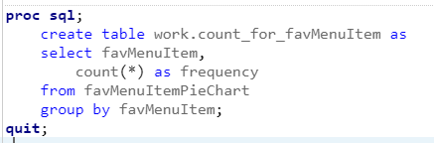
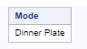 | 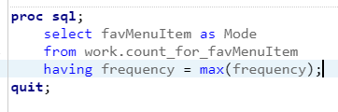
Figure 4.10.b: Descriptive Statistic for favourite menu item

As shown above since favourite menu item is a categorical variable, we can only find the mode for this variable that is ‘Dinner Plate’.

4.11 occasion
Initially, there was only 1 variable to represent on which occasion the customer would go to KFC, which could have 13 possible values:
- Birthday Parties
- Gatherings
- Movie Night
- Game Night
- Holiday
- Family Outing
- Promotional Event
- Meal Time
- Out Shopping
- When no other choices
- Usual dinner
- Normal meal
- Suddenly want to eat
However, since a customer can select multiple occasions, this variable had to be split into 13 variables by implementing One Hot Encoding
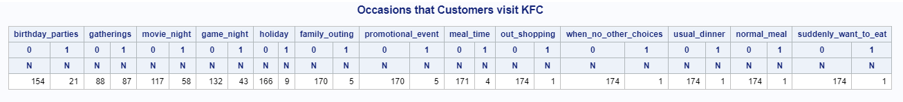

Figure 4.11.a: Frequency table for occasions that customers visit KFC
As shown above, the most frequently visited occasion that customers visit KFC is gatherings with a frequency of 87. It is noticeable that the frequency for out shopping, when there are no other choices and suddenly want to eat is 1 each, which is considered as the lowest frequency.

4.12 factors
Initially, there was only 1 variable to represent the factor that influenced the customer to go to KFC, which could have 10 possible values:
- Delicious food
- Pleasant & Clean environment
- Good service
- Reasonable prices
- Occasional Introduction of New Food items
- Promotions
- Free Toys
- Reasonable Food Portion
- Reasonably Fast Food Preparation
- Brand Reputation
However, since a customer can select multiple factors, this variable had to be split into 10 variables by implementing One Hot Encoding
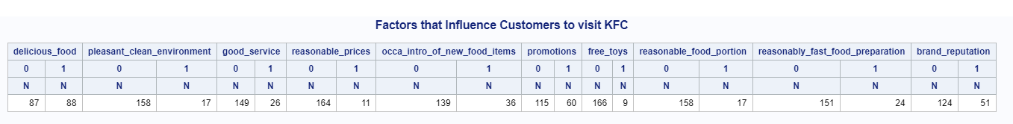

Figure 4.12.a: Frequency table of factors influencing customers at KFC
As shown above, the factor that influences customers to visit KFC the most is because of its delicious food as it has the highest frequency of 88. The second most important factor are the promotions available at KFC with a frequency of 60. However, toys are the least influential factor as it has the lowest frequency of 9. The mode for the factor is ‘Delicious food’.

4.13 moneySpent
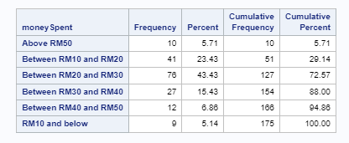
Figure 4.13.a: Frequency distribution for moneySpent
moneySpent is a categorical, ordinal variable. Based on Figure 4.13.a, we can see that the majority of the customers (43.43%) only spent between RM20 and RM30. Very few of the customers spent RM10 and below. Very few of the customers spent above RM50. We can see a pattern here. As the money spent increases from ‘RM10 and below’ to ‘Between RM20 and RM30’, the frequency count increases and peaks. However from ‘Between RM20 and RM30’ to ‘Above RM50’, the frequency count decreases. This shows that customers are not willing to spend too much money at KFC.

Output | Code
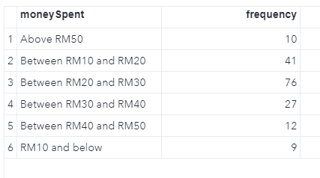 | 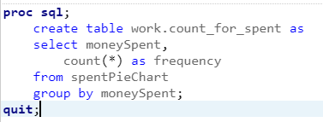
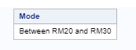 | 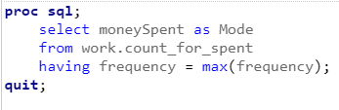
Figure 4.13.b: Descriptive statistic for moneySpent

As moneySpent is a categorical variable, we can only calculate the mode, which is ‘Between RM20 and RM30’.

4.14 orderPlacementMethod
Initially, there was only 1 variable to represent the order placement method that determines the customer order method at KFC, which could have 5 possible values:
- Order at counter
- Drive thru
- Order via KFC app delivery
- Order via KFC app pickup
- Order via third party apps

However, since a customer can select multiple order placement, this variable had to be split into 5 variables by implementing encoding.
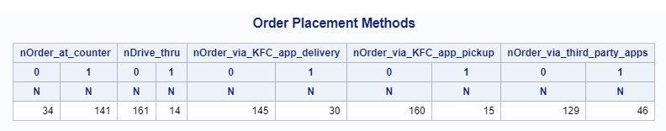
Figure 4.14.a: Frequency table of order placement methods
As shown above the most frequent order placement method is order at the counter where it has a frequency of 141 compared to drive thru which has the least number of orders with a frequency of 14. We can clearly see that drive thru and ordering via KFC app for pickup are not popular options. However, there is some demand for ordering via KFC app for delivery and ordering via third party apps.

4.15 howCustKnewAbtKfc
Initially, there was only 1 variable to represent the how customers knew about KFC that determines the how customers knew about KFC, which could have 4 possible values:
- Television
- Newspaper
- Online
- Word of mouth

However, since a customer can select multiple choices about how a customer knows about KFC, this variable had to be split into 4 variables by implementing encoding.
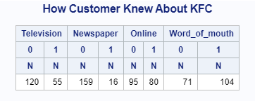
4.15.a: Frequency table for how customer knew about KFC
As shown here, most of the customers knew about KFC via word of mouth with the highest frequency of 104 compared to newspapers that had the lowest frequency of 16.

4.16 tasteRating
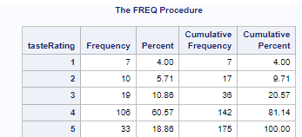
Figure 4.16.a: Frequency distribution of taste rating
tasteRating is a discrete, numerical variable. Most of the people rated the taste as 4, which forms 60.57% of the ratings, followed by 5 (18.86%), 3 (10.86%), 2 (5.71%) and 1 (4.00%). Overall, we can see that the majority of KFC customers like KFC food.

Output | Code
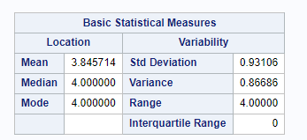 | 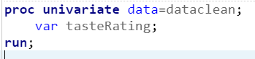
Figure 4.16.b: Descriptive statistics for tasteRating

From Figure 4.16.b, we can see that the values for the mean (3.845714), median (4.00) and mode (4.00) are quite close together. The standard deviation (0.93106) is quite small, which indicates that the data points are quite close to the mean.

4.17 priceRating
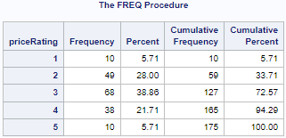
Figure 4.17.a: Frequency table for price rating
Price rating is a numerical variable. As shown in figure 4.17.a, most of the customers (68) rated the price as 3. The ‘1’ and ‘5’ ratings have the lowest frequency that is 10.

Output | Code
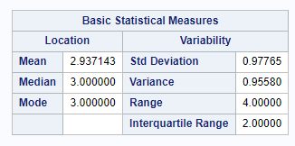 | 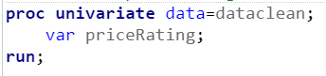
Figure 4.17.b: Descriptive statistics for priceRating

Since price rating is a numerical variable, we are able to calculate the mean, median, mode and standard deviation. The values for the mean (2.937143), median (3.00) and mode (3.00) are quite close together. The standard deviation of 0.97765 is quite small, indicating that the data points are quite close to the mean.

4.18 customer satisfaction rating
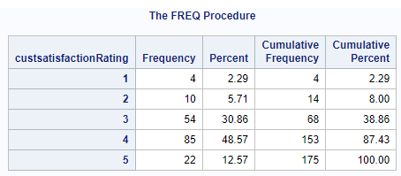
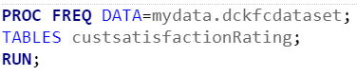
Figure 4.18.a: Frequency table for customer satisfaction rating
Customer satisfaction rating is a numeric variable.The majority of customers (48.57%) chose the rating of ‘4’, followed by ‘3’ (30.86%). Very few customers selected the rating of 1. This indicates that there is some level of customer satisfaction with KFC.

Output | Code
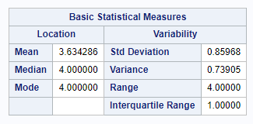 | 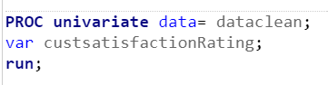

Figure 4.18.b: Descriptive statistics for custsatisfactioRating
SInce customer satisfaction rating is a numerical variable, we can calculate the mode, mean, median and standard deviation. The values for mean (3.634286), median (4.00) and mode (4.00) are quite close to each other. The standard deviation is quite small (0.85968), which indicates that the data points are quite close to the mean.

4.19 environment rating
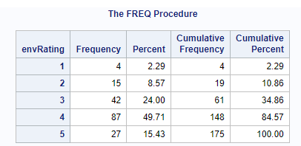
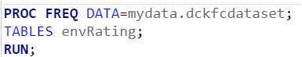
Figure 4.19.a: frequency table for environment rating
Environment rating is a numeric variable. The majority of the customers chose ‘4’ as the rating, followed by ‘3’. Very few customers selected ‘1’. This indicates that most of the customers are quite pleased with the environment at KFC.

Output | Code
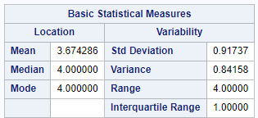 | 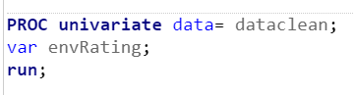
4.19.b: Calculating the mode, median, mean

Since environment rating is a numerical variable, we could calculate the mode, mean, median and standard deviation. The value for mean (3.674286) is a bit far from the values for Median and Mode (4.00). The standard deviation (0.91737) indicates the data points are quite close to the mean.

4.20 overall rating
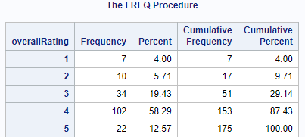
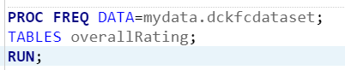
Figure 4.20.a: frequency table for overall rating
Most respondents chose a rating of ‘4’ followed by ‘3’ and ‘5’. The high rating given by the customers indicates that most of the respondents are overall satisfied with KFC, representing 90.29% of the total respondents.

Output | Code
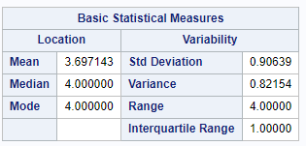 | 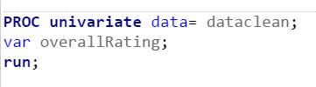

Figure 4.20.b: Descriptive statistics for overall rating
Overall rating is a numerical variable, so mean, mode, median and standard deviation can be calculated. Based on the table, the median and mode of the result is 4, and the mean is 3.7. The moderately high value of the mean indicates that most of the respondents are moderately satisfied with KFC. The standard deviation of 0.90639 indicates that the data points are quite close to the mean.

4.21 KFC delivery rating
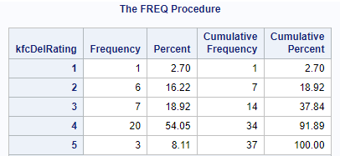
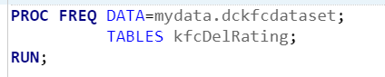
Figure 4.21.a: Frequency table for delivery rating
KFC delivery rating is a numerical variable. The majority of customers (54.05%) selects 4, which indicates a very high rating for kfc’s delivery service with a frequency of 20. Only 1 customer (2.70%) chose 1, which indicates that the customer is not satisfied with the delivery service by KFC.

Output | Code
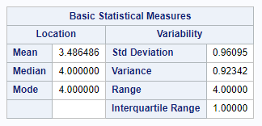 | 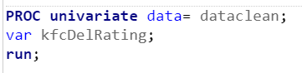

Figure 4.21.b: Descriptive statistics for kfcDelRating
Since kfcDelRating is a numeric variable, we can calculate the mean, median, mode and standard deviation for KFC delivery rating. The mean is around 3.49, which is a bit far from the values for median and mode (4). This indicates that KFC delivery service is slightly more than average.

4.22 KFC order rating
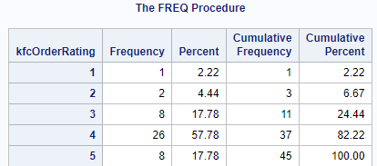
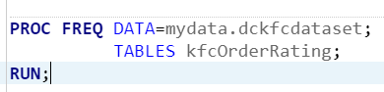
Figure 4.22.a: Frequency table for order rating
KFC order rating is a numeric variable. The majority of the customers rated KFC’s ordering system as 4 while the minority of them chose the ratings of 2 (4.44%) and 1 (2.22%). This indicates that the majority of the customers were satisfied with KFC’s ordering system.

Output | Code
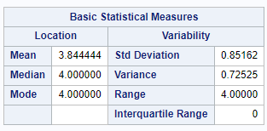 | 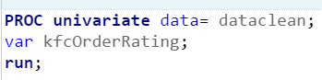

Figure 4.22.b: Descriptive statistics for kfcOrderRating
Since kfcOrderRating is a numeric variable, we could calculate the mean, median, mode and standard deviation. The values for mean (3.844444), mode (4.00) and median (4.00) are quite close to each other. The standard deviation of 0.85162 indicates that the data points are quite close to the mean.

4.23 recommend KFC
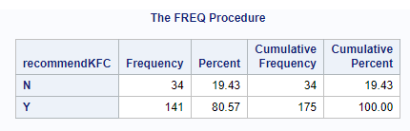
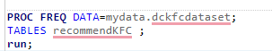
Figure 4.23.a: Frequency table for recommendKFC
Findings: Most of the customers (80.57%) would recommend KFC to their friends or family members; this indicates that overall, most customers are satisfied with KFC food and service; thus, they would introduce it to their friends and family.

Output | Code
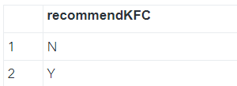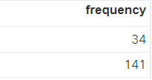 | 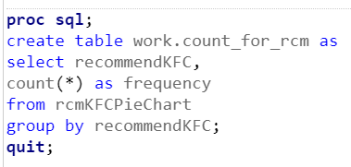
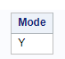 | 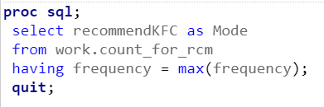

Figure 4.23.b: Mode for recommendKFC
Findings: As recommended KFC is a categorical variable, we can only determine the mode that is Y,which indicates Yes. So, we can know that most of our respondents will recommend KFC to their family or friends.

4.24 Fries VS Fried Chicken (H16)

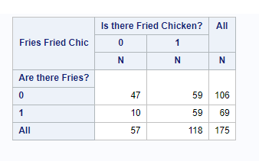
Figure 4.24
Based on Figure 4.24, we can see that 59 out of 175 (33.71%) of KFC’s customers had fries and fried chicken together. 59 out of 175 (33.71%) of KFC’s customers had fried chicken but did not order fries at the same time. However, there were 47 cases (26.86%) where the customers did not order both fries and fried chicken at the same time. Less than 50% of the customers ordered fries. Around 68% of the customers ordered fried chicken, which could be either original fried chicken, spicy fried chicken or both.

4.25 Fries VS Burger (H17)
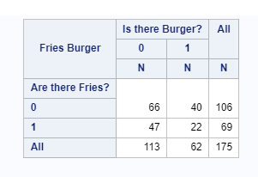
Figure 4.25
Findings: Based on Figure 4.25, we can see that 22 out of 175 (12.57%) of KFC’s customers ordered both fries and burger. 40 out of 175 (22.86%) of KFC’s customers ordered burgers but did not order fries at the same time. However, there were 66 cases where the customers did not order both fries and burger at the same time. Less than 50% of the customers ordered fries. Around 35.4% of the customers ordered burgers, which could be either Colonel Burger or Zinger burger or both.

4.26 (Fries & Original Fried Chicken) VS (Fries & Spicy Fried Chicken)
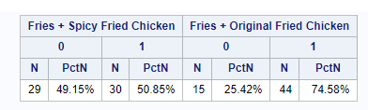
Figure 4.26.a
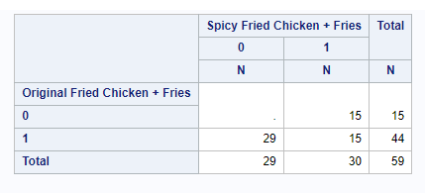
Figure 4.26.b
Findings: The results in both Figures 4.26.a and 4.26.b are based on the respondents who ordered both fries and fried chicken, which could be either original fried chicken or spicy fried chicken.

The left hand side results (Fries + Spicy fried chicken) in Figure 4.26.a shows that the majority (50.85%) ordered fries and at least a spicy fried chicken. The right hand side results (Fries + original fried chicken) in Figure 4.26.a shows that the majority (74.58%) ordered fries and at least an original fried chicken.

In Figure 4.26.b, we can see that the proportion of customers, who ordered fries and at least an original fried chicken, is greater than the proportion of customers, who ordered fries and at least a spicy fried chicken.

4.27 Order at counter VS Order at drive thru
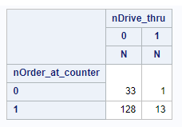
Findings: Based on the above figure, the proportion of customers, who didn't order at the counter and did not order at drive thru, is around 18.86% (33). Customers, who ordered at drive thru but did not order at counter, form 0.57% of the respondents, Customers, who ordered at the counter but not at drive thru, form around 73.14% of the respondents, indicating that the majority of the customers ordered at counter and not at drive thru. Customers, who ordered both at the counter and drive thru, forms around 7.43% (13) of the respondents.

4.28 KFC app delivery vs KFC pick up
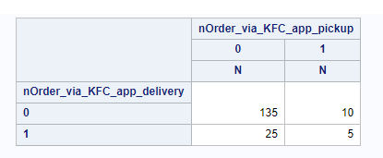
Findings: Based on the above figure, the proportion of customers who did not order via KFC app delivery and did not order via KFC app for pickup is 77.14% (135). The proportion of customers who did not order via KFC app for delivery but ordered via KFC app for pickup is 5.71% (10). As for customers, who ordered via KFC app for delivery but did not order via KFC app for pickup, they form around 14.29% (25) of the respondents. Lastly, the proportion of customers who ordered via KFC app for both delivery and pick up is 2.86% (5).

4.29 KFC app delivery vs third party delivery
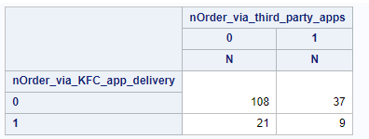
Findings: Based on the above figure, the proportion of customers who did not order via third party apps and KFC app for delivery is 61.71% (108). The proportion of customers who did not order via KFC app for delivery but ordered KFC via third party apps is 21.14% (37). Customers who ordered via KFC app delivery but did not order via third party apps is 12% (21). The proportion of customers who ordered via KFC app for delivery and third party is 5.14% (9).

4.30 Gender vs Gatherings (H1)
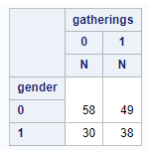
Findings: Based on the above figure, the respondents who are male (0) don't usually go out for gatherings in KFC which indicates 33.14% of the male respondents (58) as for males that attend gatherings in KFC is around 28.00% (49). For females which is indicated as 1, females that don't attend gatherings are around 17.14% (30) as for females that attend gatherings at KFC is around 21.71% (38). Therefore indicates females are more likely to attend gatherings then males.

4.31 Gender vs fried chicken original (flavour) VS fried chicken spicy (flavour) (H2)
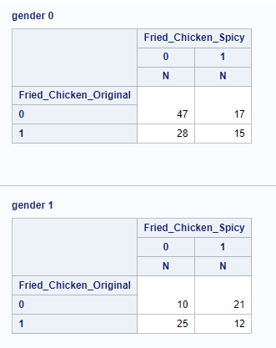
Findings: Gender 0 indicates male. Gender 1 indicates female. Out of all the males, the proportion of males (0) that don't prefer both original fried chicken and spicy fried chicken is around 43.93%, which indicates there is another menu item that males prefer than fried chicken. Females (1) generally prefer original fried chicken but not with spicy fried chicken.

4.32 Gender vs Favourite Menu Item (H3)
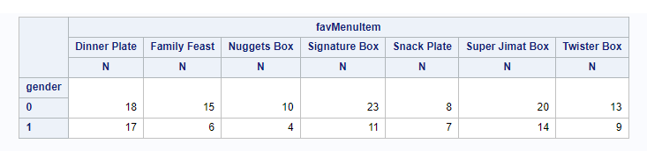
Findings: 0 represents male while 1 indicates female. The figure shows that males (0) generally prefer signature box over any other menu item. The second most preferred menu item among the males is the super jimat box. For females (1) the most preferred menu item is dinner plate followed by super jimat box.

4.33 Gender vs game night (H4)
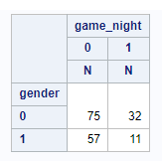
Findings: Under the game night category, 0 represents not game night while 1 represents game night. As shown here, males are more likely to go for game nights than females. As can be seen from the figure, 29.90% of the males are likely to have KFC while having a game night.

4.34 Gender vs good_service (H5)
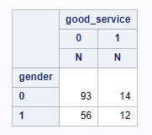

Findings: 0 represents Male while 1 represents Female. The results show that the reason that both males and females come to eat at KFC was not because KFC provided good service. For males, the proportion of males who came to KFC not because of the good service provided is 86.92%. The proportion of males who came to KFC because of the good service provided is 13.08%. As for females, the proportion of females who came not because of the good service is 82.35%.

4.35 Gender VS age group

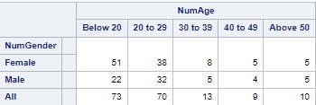
Findings: Most female customers are below the age of 20, and most male customers are in the age group of 20 to 29. The least number of male and female customers are in the age group of 40 to 49. Overall, the main customers for KFC would be at the age of 20 to 29 and below 20.

4.36 Job and income group
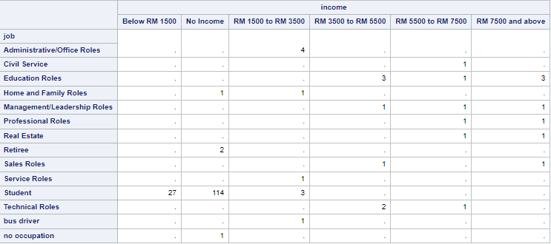
Findings: Based on the table above, most customers are students with no income, followed by students with income below RM 1500 and office roles with income of RM 1500 to RM 3500. Based on the graph above, we can see that most of the customers for KFC are students with no income or with an income below RM1500.

4.36 State and gender group

Findings: Based on the table above, most male and female customers are from Kuala Lumpur, where the frequency for males is 22 and the frequency for females is 19. The 2nd most male and female customers are in Selangor, with 19 and 9 customers. The graph shows that Sabah and Labuan have the lowest number of male customers, with only two customers in total. Additionally, there are no female customers in the Terengganu state.

4.37 Gender, Age and Price Rating group
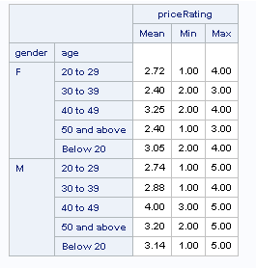
Findings: For price rating the min rating is 1 and max rating is 5. Based on the figure above, the highest mean for the age group is male at the age of 40 to 49 years old that is indicated by a mean of 4.00. As the lowest mean is the female age group of 30 to 39 years old and 50 and above at a mean of 2.40. This shows that male age group between the age of 40 to 49 years old has a higher spending at KFC at a mean of 4.00 compared to females age group.

4.38 Gender, Age and Customer Satisfaction Rating group
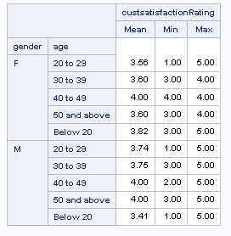
Findings: This table summarises customer satisfaction ratings by gender and age groups on a 1.00 to 5.00 scale. Notably, females aged 40 to 49 had the highest average rating of 4.00, while males aged 50 and above averaged 4.00 as well, with ratings ranging from 3.00 to 5.00. In contrast, males under 20 had the lowest average rating of 3.41, ranging from 1.00 to 5.00. Age groups "20 to 29" and "30 to 39" showed consistent ratings, while the "Below 20" group, especially among females, had the most variability, ranging from 3.00 to 5.00.

4.39 Gender, Age and Environment Rating group
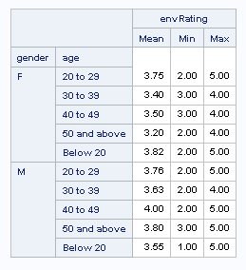
Findings: This table summarises environmental satisfaction ratings by gender and age groups on a scale from 1.00 to 5.00, while males aged 40 to 49 had the highest average of 4.00. Females below 20 had the highest average at 3.82 for females, while males aged below 20 had the lowest average at 3.55. As for females the lowest average is 3.20 at ages at 50 and above. Satisfaction ratings varied widely, especially among males below 20, ranging from 1.00 to 5.00, indicating diverse environmental perceptions in this group.

4.40 Gender, Age and Overall Rating group
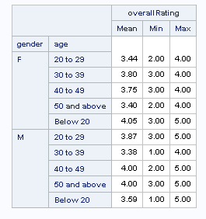
Findings: This table summarises overall satisfaction ratings by gender and age groups on a scale from 1.00 to 5.00. Key highlights include females below 20 having the highest average at 4.05, males aged 40 to 49 and 50 and above with the highest average at 4.00. Notably, the "Below 20" group, especially among males, displays a wide range of ratings from 1.00 to 5.00, indicating diverse satisfaction levels in this demographic.

4.41 Gender, Age and KFC Delivery Rating group
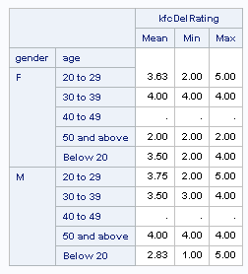
Findings: This table summarises KFC delivery satisfaction ratings on a 1.00 to 5.00. Notably, females aged 30 to 39 and males aged 50 and above consistently report perfect ratings of 4.00 within their respective age groups. In contrast, females and males below 20 exhibit more variable satisfaction ratings ranging from 1.00 to 5.00, reflecting diverse delivery satisfaction levels in these age groups. Please note that some data, particularly in the "40 to 49" age group, appear to be missing and may require further clarification.

4.42 Gender, Age and KFC Order Rating group
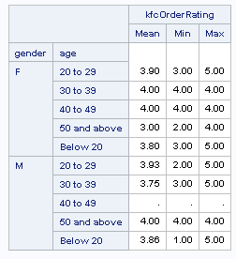
Findings: This table summarises KFC order satisfaction ratings on a 1.00 to 5.00 scale. Females aged 30 to 49 consistently rate their orders at 4.00, indicating high satisfaction. In contrast, males aged 50 and above rate their orders at a mean rating of 4.00. Both females and males below 20 have varying satisfaction levels, ranging from 1.00 to 5.00. Some data points, especially in the "40 to 49" age group for males, are missing and may need further clarification.

4.43 Gender, Age and KFC Recommend KFC group
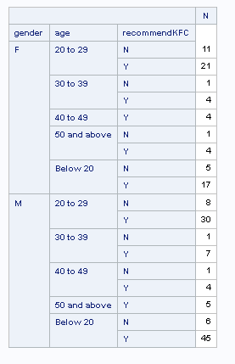
Findings: This table presents data on customer recommendations for KFC, categorised by gender and age groups, with "N" indicating "No" recommendations and "Y" indicating "Yes" recommendations. Notably, it shows that the majority of respondents across all age and gender groups would recommend KFC ("Y" responses), with the highest number of recommendations coming from males aged below the age of 20 years old, totaling 45. Females between 20 to 29 also express strong positive recommendations, with 21 "Yes" responses. The table highlights variations in recommendation patterns among different demographic segments, offering valuable insights into customer satisfaction and advocacy for KFC.

5.0 VISUALIZATION

5.1 Gender
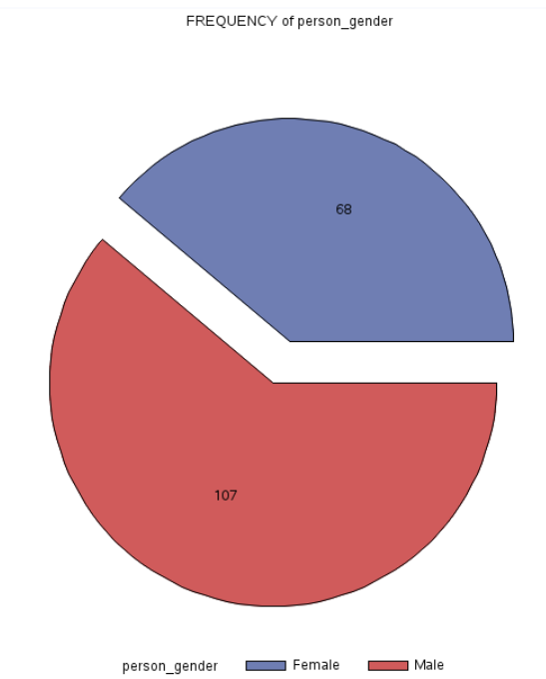

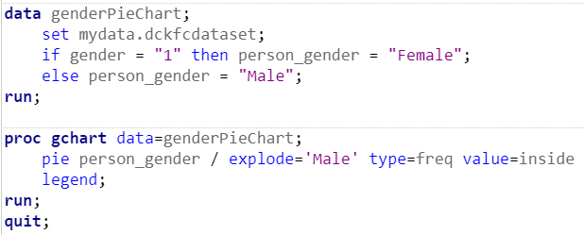
Findings: Based on the figure above, majority of our respondents are male (107) and the remaining are female (68)

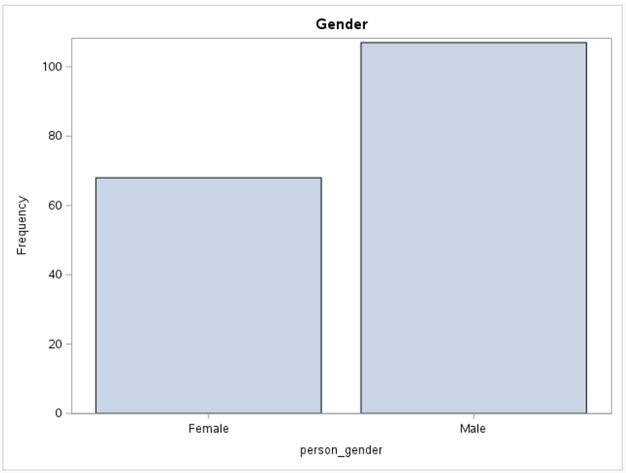
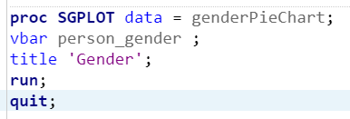

Findings: Based on the pie and bar charts, we can clearly see that the majority of the respondents are males. The number of female customers is slightly higher than half the number of males.

5.2 Age

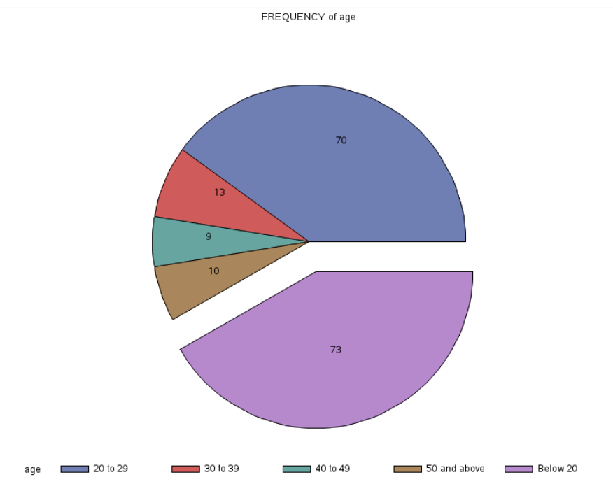

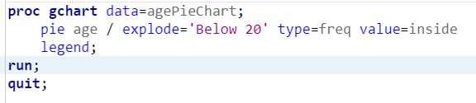
Findings: The majority of the respondents are below 20 years old (73), followed by those aged 20 to 29 years old (70), 30 to 39 years(13), and 50 and above (10). The age group that has the least number of respondents is 40 to 49 years old (9).
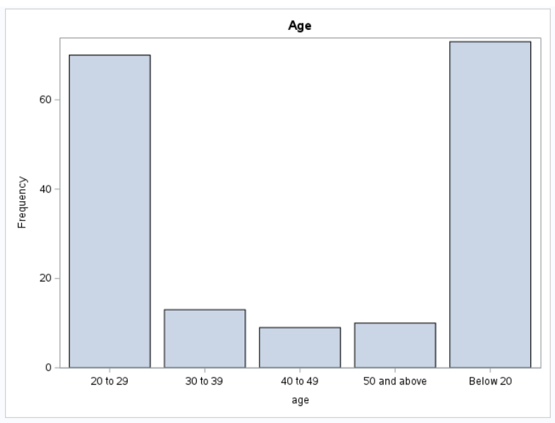
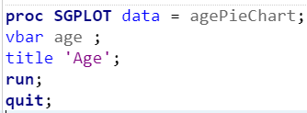
Findings: Based on the pie and bar charts, although the ‘Below 20’ has the highest category, we can see that the ‘20 to 29’ category has the second highest frequency. However, the remaining three categories have approximately equal frequencies.

5.3 Job
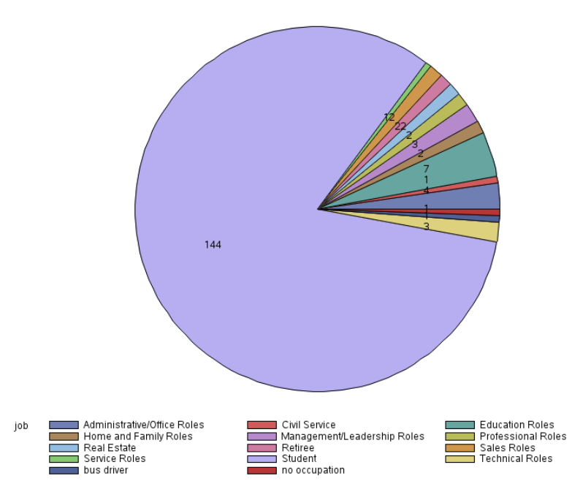

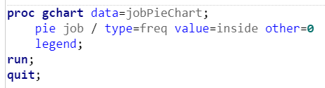
Findings: Based on the figure above, the majority of our respondents are students that are indicated in bright purple (144) and the rest have jobs.
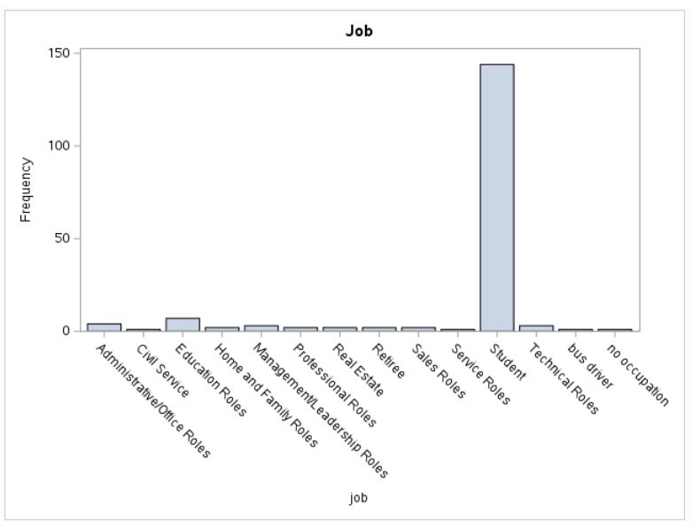
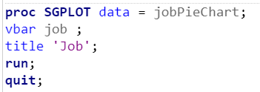

Findings: Based on the pie and bar charts, we can see that almost all of KFC’s customers are students. The next highest category is Education Roles, followed by Administrative/Office Roles. The frequencies for the other categories are close to 0.

5.4 Income
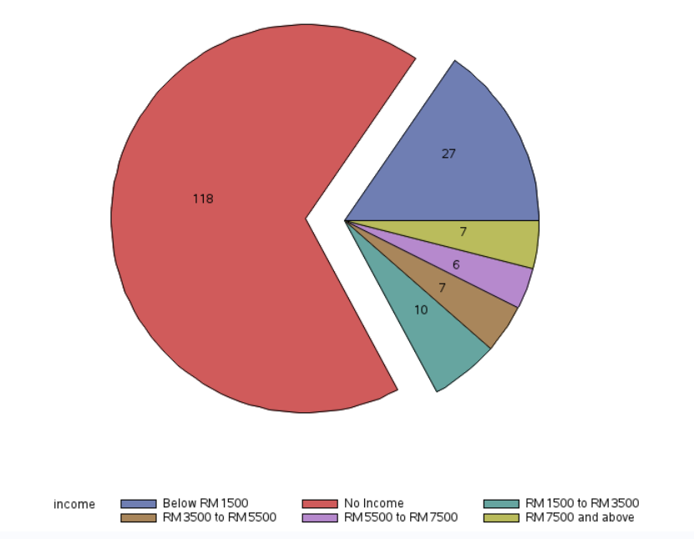
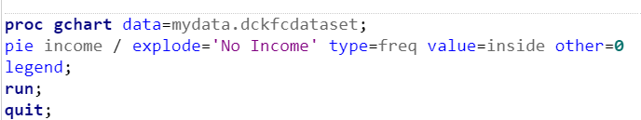
Findings: Based on the figure above, the majority of the customers don't have an income (118). Since students form the majority of the customers, it is possible that a few or some of the students may be working and they could be under at least one of the remaining categories above, for example ‘Below RM1500’.
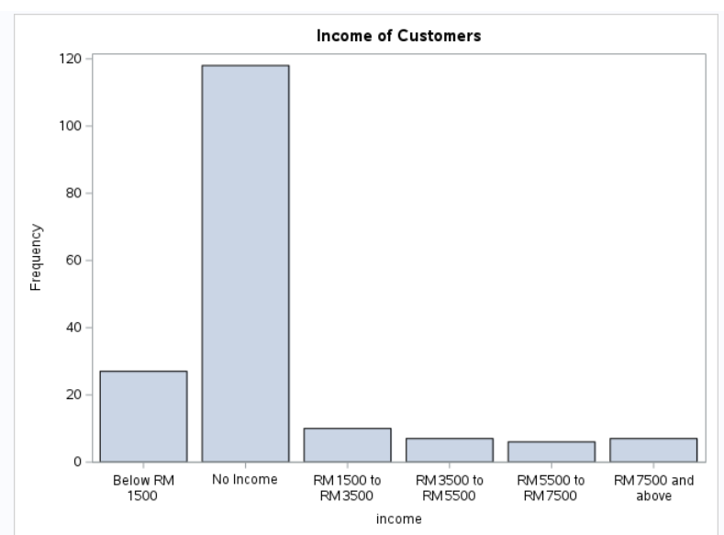
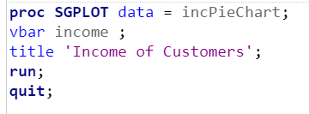
Findings: Based on the pie and bar charts, we can see that the majority of KFC’s customers are not earning any income with a frequency that is almost 120. The next most frequent category is ‘Below RM 1500’.The frequencies for the remaining 4 categories are approximately equal.

5.5 State
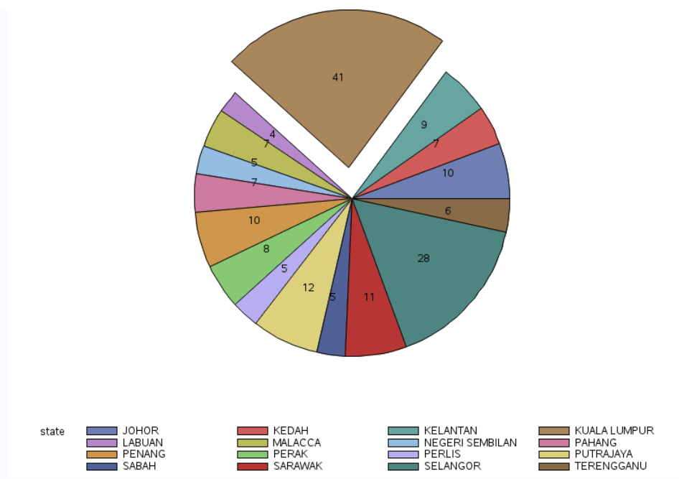
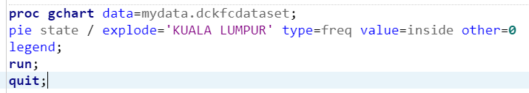
Findings: Based on the pie chart above, most of the customers are from Kuala Lumpur, followed by Selangor.Very few customers came from Labuan.

5.6 last purchase date
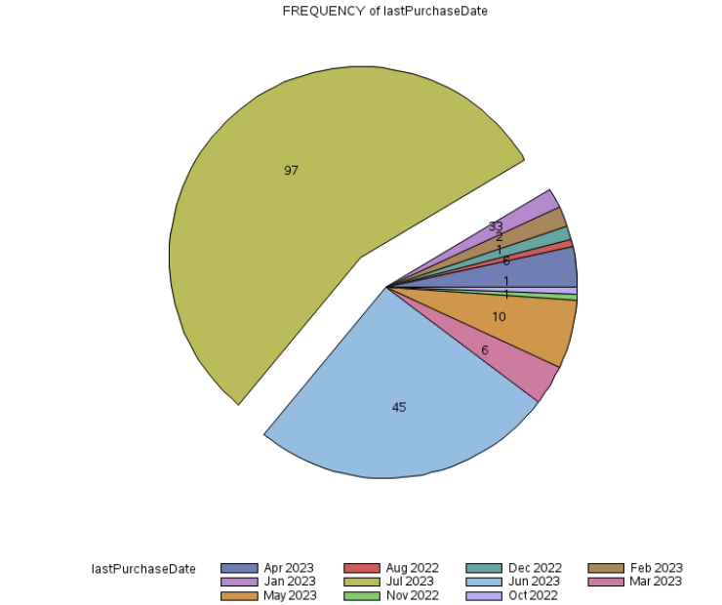

Findings: The restaurant received the highest number of customer purchases in July 2023, followed by June 2023 and May 2023.

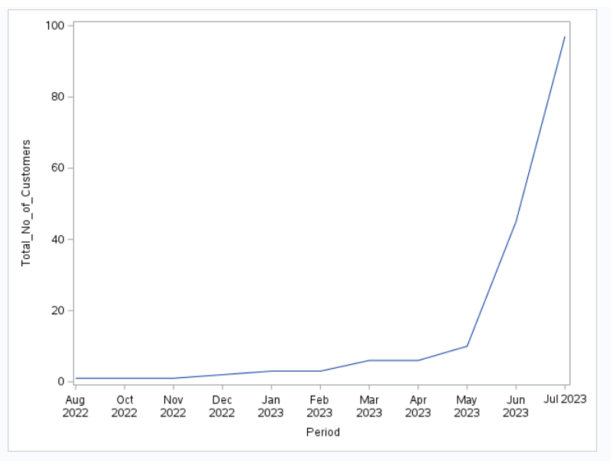
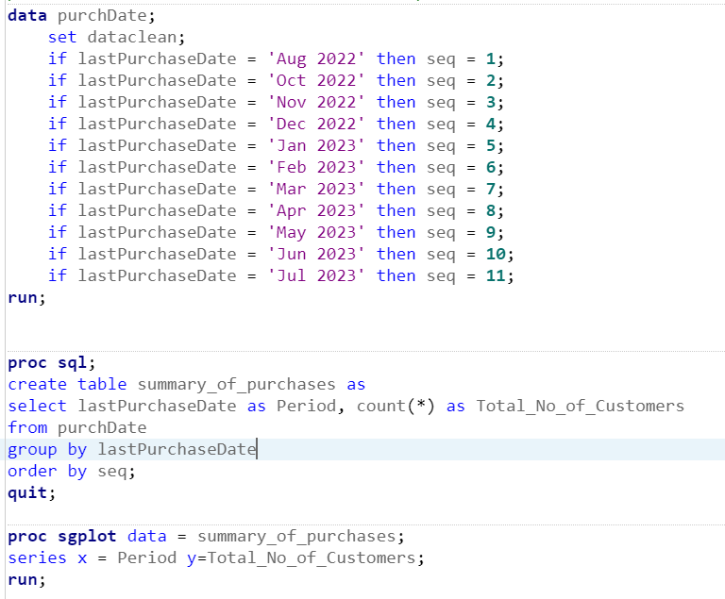
Findings: Based on the line plot on the previous page, the total number of customers at the restaurant initially increased gradually and later increased more rapidly. It eventually spiked in July 2023, which indicates that July 2023 was KFC’s peak period.

5.7 frequency
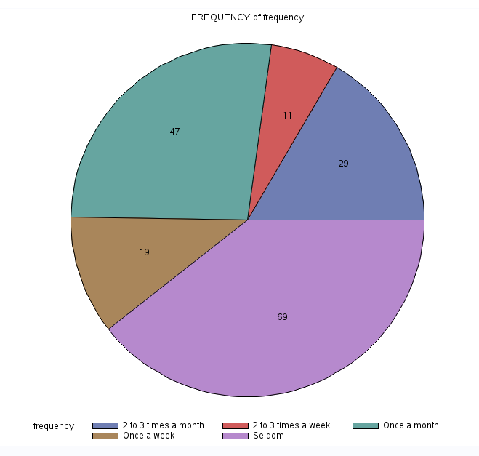
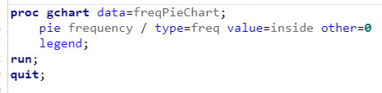
Findings: Based on the graph, the majority of respondents seldom come to KFC (69), followed by once a month. The least number of customers come to KFC 2 to 3 times a week.
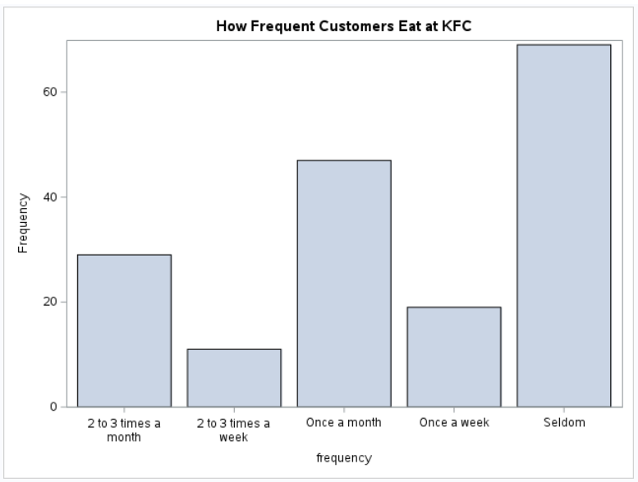
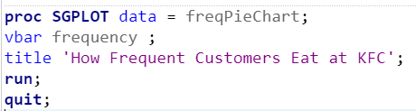
Findings: We can see that KFC’s customers generally do not visit KFC very often. The majority of the customers seldom eat at KFC, followed by customers eating once a month.

5.8 fav Menu Item
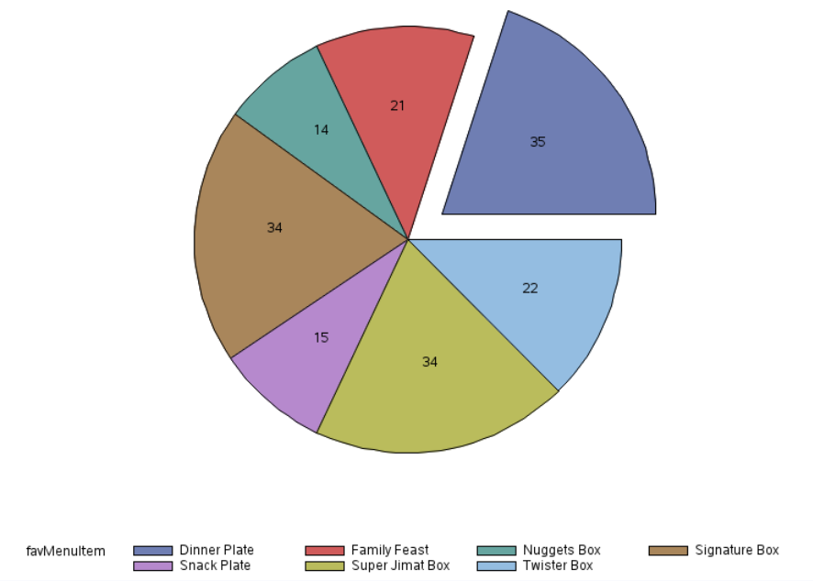
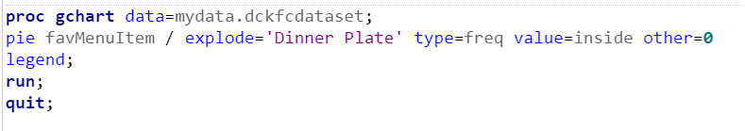
Findings: Based on the graph above, dinner plates are the favourite menu item for most of KFC’s customers, followed by the super jimat box and signature box, which have an equal number of people liking them. The least favourite meal for customers would be the nuggets box.

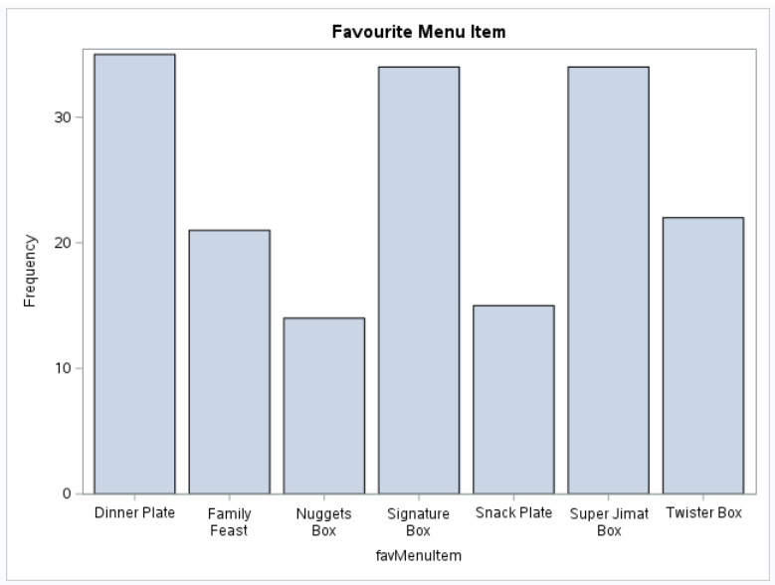
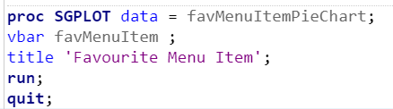
Findings: Dinner plate has the highest customer demand. However, the demand for Signature box and Super Jimat Box are equal and are quite close to the demand for dinner plates. Nuggets box has the lowest demand.

5.8 money Spent
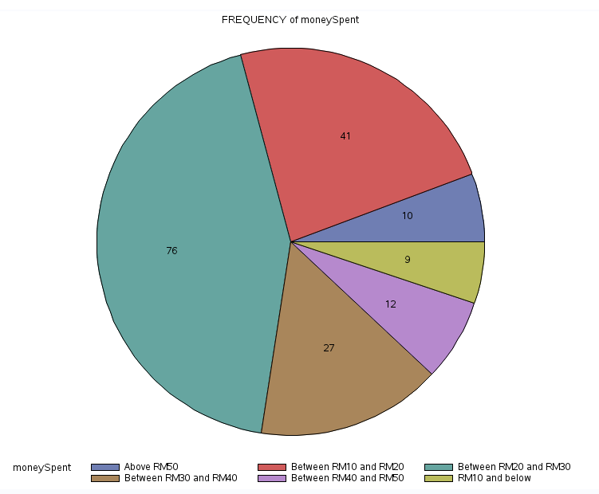

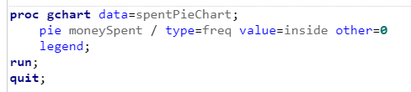
Findings: Based on the graph, most customers would spend between RM 20 and RM 30 each time they go to KFC, followed by Between RM10 and RM20 and between RM30 and RM40. The least number of customers would spend RM 10 and below.
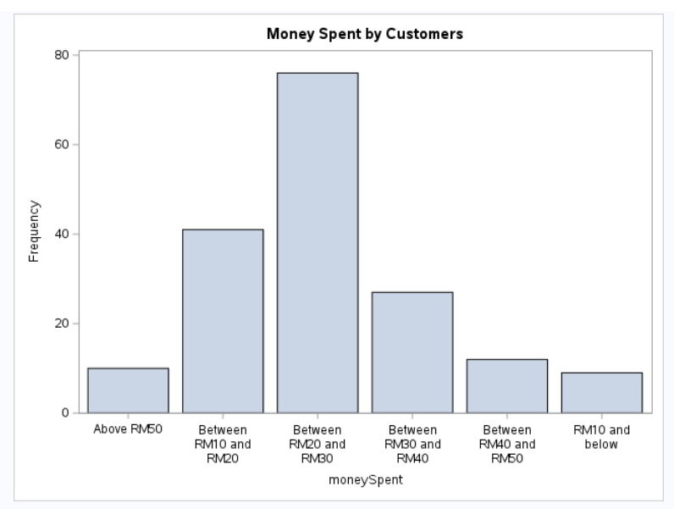
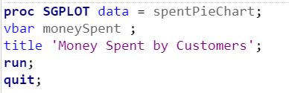
Findings: The majority of the customers spent between RM20 and RM30, followed by Between RM10 and RM20. The proportion of customers spending above RM 50 is approximately the same as the proportion of people spending RM10 and below.

5.9 taste rating
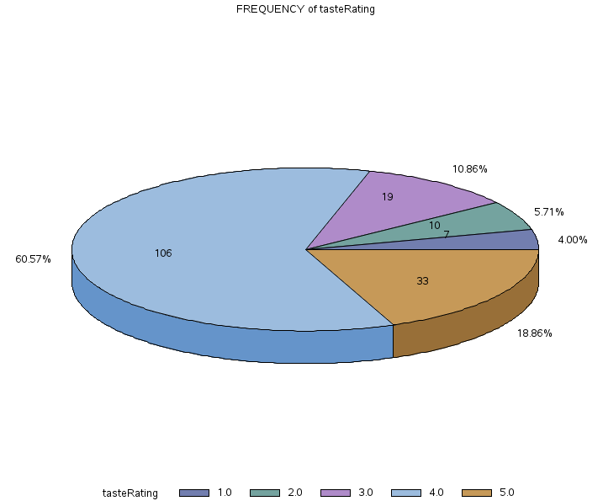
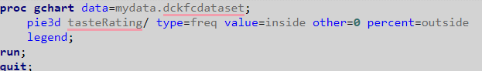
Findings: Based on the chart, the majority of the customers are satisfied with KFC taste, with the rating of 4 contributing 60.57% and rating of 5 contributing to 18.86. So 79.43% in total are either very satisfied or extremely satisfied with KFC taste.

5.10 price rating
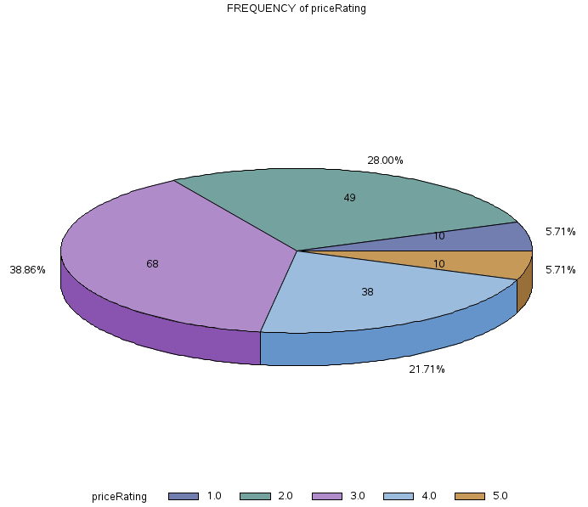
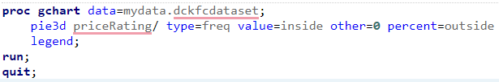
Findings: Most of the customers feel KFC price is moderate (38.86%) followed by 28% who think KFC is somewhat expensive. And 21.71% of the respondents think KFC is somewhat reasonable and cheap.

5.11 customer satisfaction rating
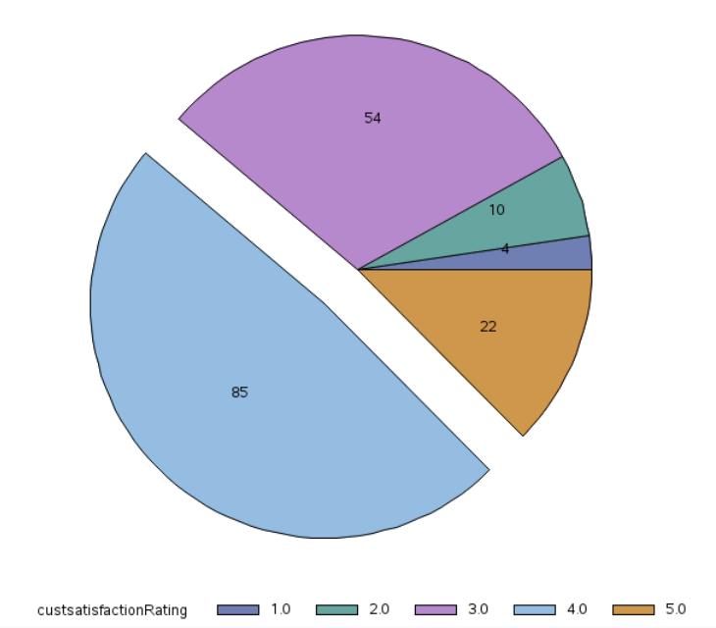
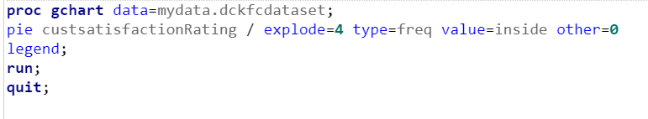
Findings: Based on the chart, most of the customers are satisfied with KFC as the majority of customers gave a rating of 4, followed by 3 and then 5. The least number of customers gave a rating of 1.

5.12 environment rating
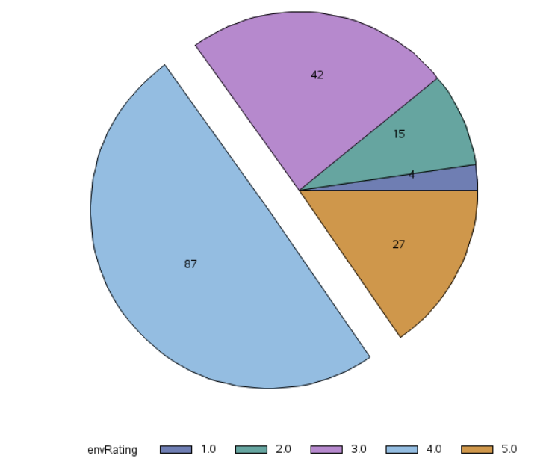
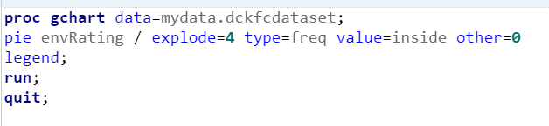
Findings: Based on the figure above, most of the respondents rated the environment as 4, which indicates a high rating out of 5. The least number of respondents (4) rated the environment 1, which means poor rating for the environment.

5.13 overall rating
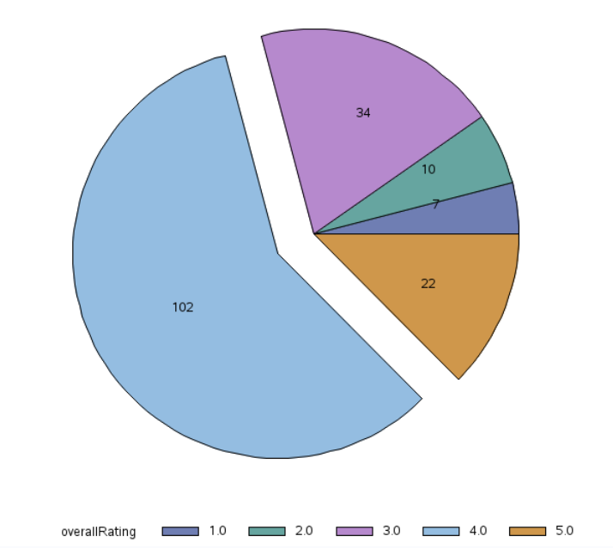
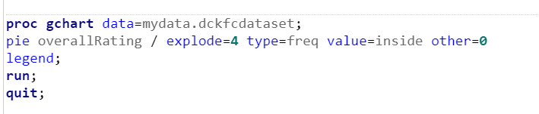
Findings: Based on the figure above, the majority of the respondents rated 4.0 for the overall rating in KFC whereas the least rated rating is 1.0 where only 7 respondents have rated this low.

5.14 kfc delivery rating
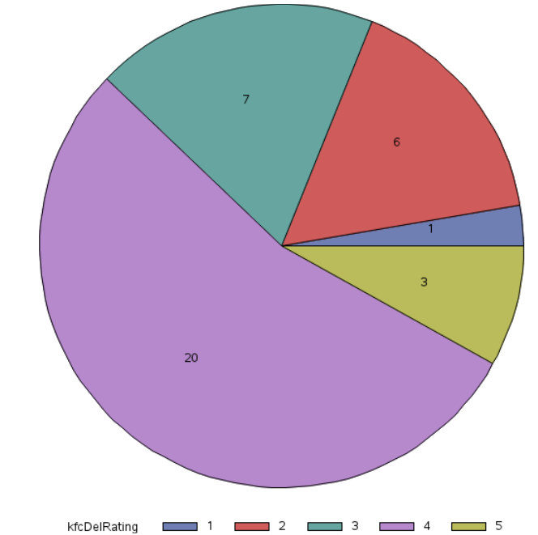
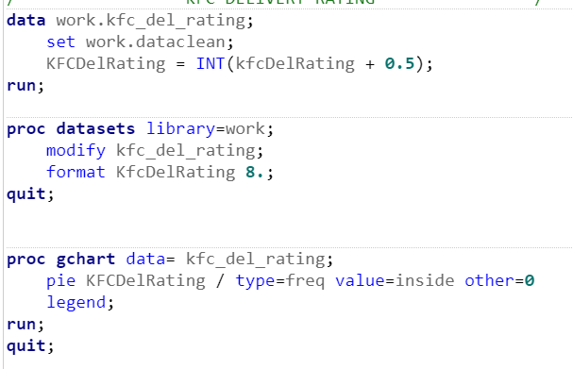
Findings: As for the KFC’s own delivery rating, most of the respondents rated a solid 4 out of 5 for KFC’s delivery service while only 1 person rated 1 for KFC’s delivery.

5.15 kfc order rating
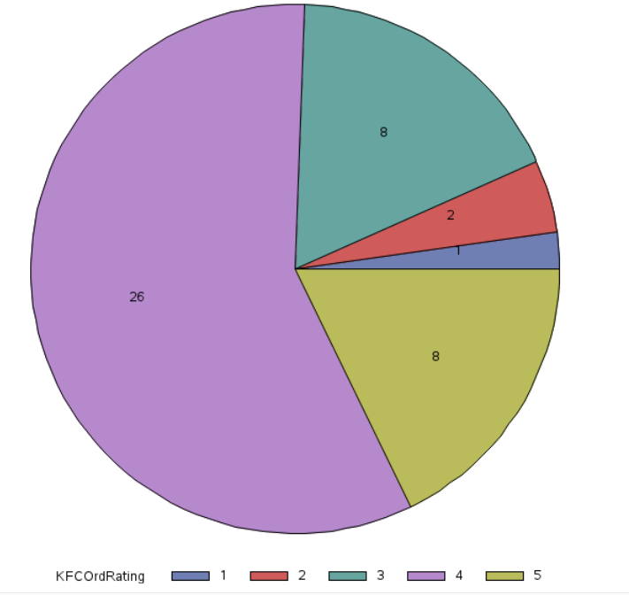
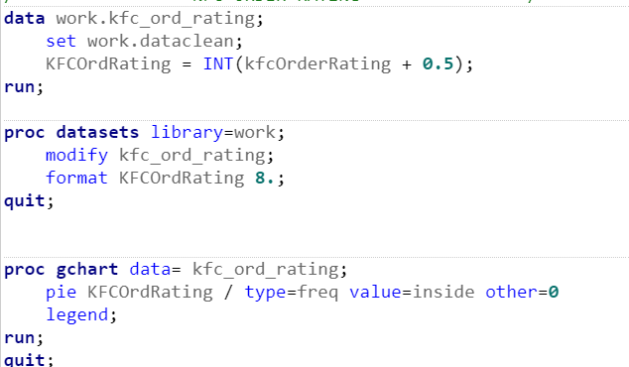
Findings: The majority of the respondents rated 4 for order service at KFC (26), as some of the respondents gave 5 out of 5 for the order service for KFC (8). 1 respondents rated 1 for the order service at KFC.

5.16 recommend kfc
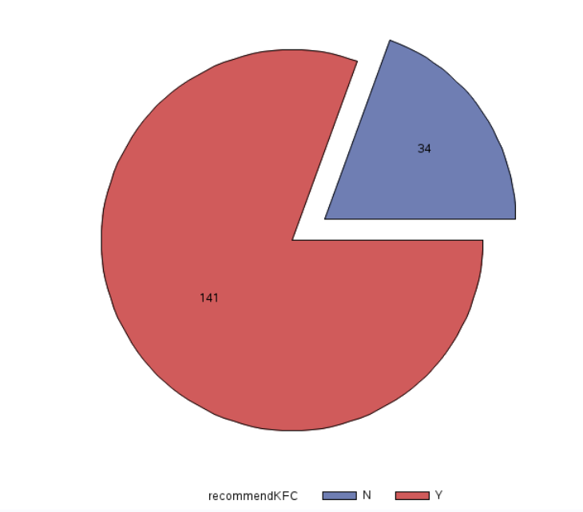
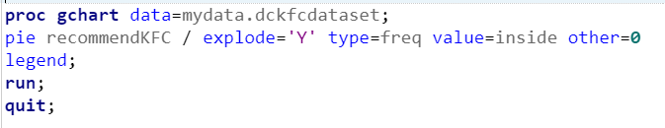
Findings: More than half of the customers would recommend KFC to their friends and family while only less than 25% would not recommend KFC to their friend or family.

5.17 Showing the Pearson’s Correlation Coefficient between Numerical Variables
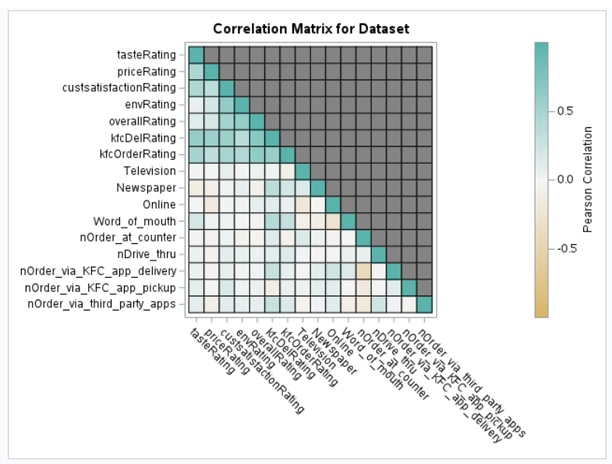
Findings: The above figure shows Pearson's correlation coefficient between the numerical variables that can be found in the cleaned dataset. There are a few things that we can notice:
- Taste rating is positively correlated with price rating, customer satisfaction rating, overall rating, kfc delivery rating and kfc order rating.
- Price rating is positively correlated with customer satisfaction rating, environment rating, overall rating, kfc delivery rating, kfc order rating.
- Customer satisfaction rating is positively correlated with environment rating, overall rating, kfc delivery rating and kfc order rating.
- Environment rating is positively correlated with overall rating, kfc delivery rating and kfc order rating.
- Overall rating is positively correlated with kfc delivery rating and kfc order rating.
- Kfc delivery rating is positively correlated with kfc order rating.
- The white squares in the heatmap indicate no correlation between some variables.

5.18 Hypothesis 1 graph
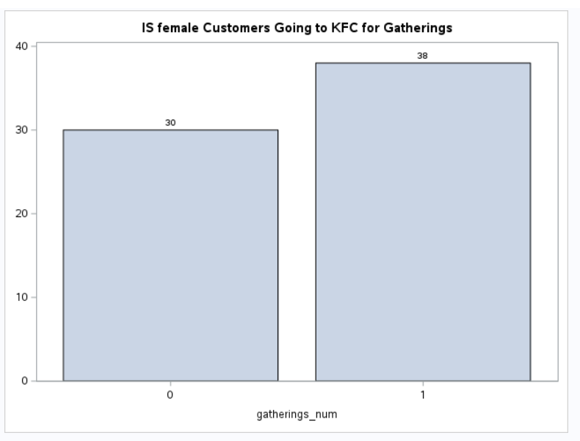
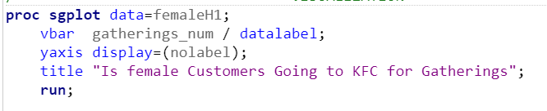
Findings: As stated here 0 indicates no, where a female will not attend gatherings at KFC (30), where 1 indicates yes, where a female will attend gatherings at KFC (38). From hypothesis 1, our conclusion is not all females will attend gatherings at KFC, because 30 out of 68 females will not attend gatherings at KFC, since half of the females do not attend gatherings at KFC, our hypothesis 1 is correct.

5.19 Hypothesis 2 graph
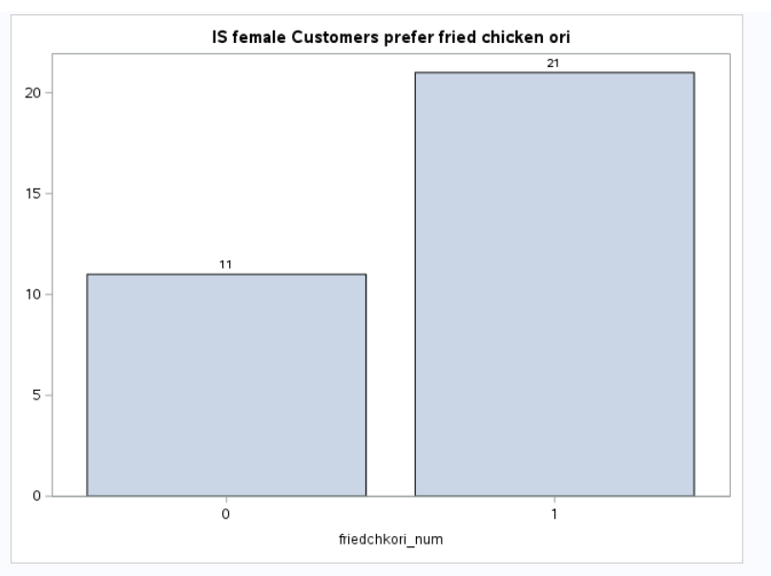
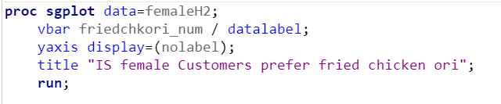
Findings: As shown here 0 indicates - No, 1 indicates - Yes, 11 out of 31 females at the age of 20 to 29 years of age do not prefer fried chicken original flavour as 21 out of 31 females at the age of 20 to 29 years old prefer fried chicken original. As stated in our hypothesis 2 result, females at the age of 20 to 29 prefer fried chicken original flavour more than spicy flavour.
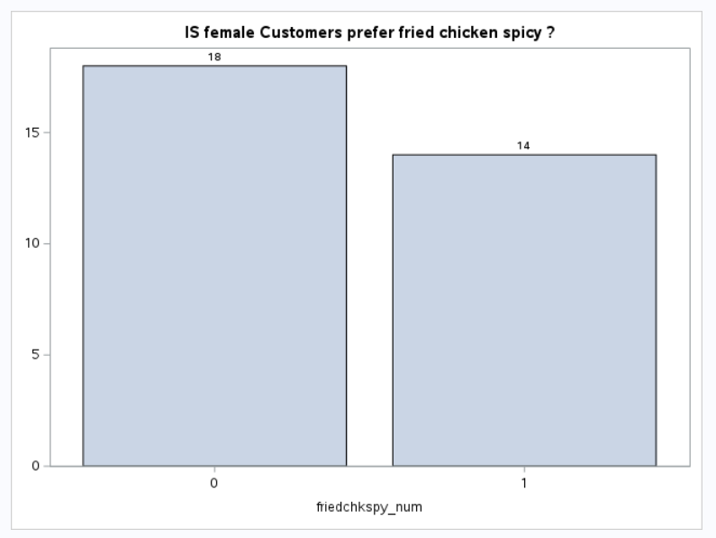
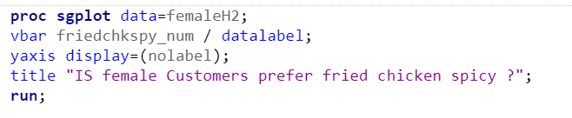
Findings: 0 indicates No, 1 indicates yes, this shows that females at the age of between 20 to 29 (18) do not prefer fried chicken (spicy flavour) as (14) prefer fried chicken spicy flavour.

5.20 Hypothesis 3 graph
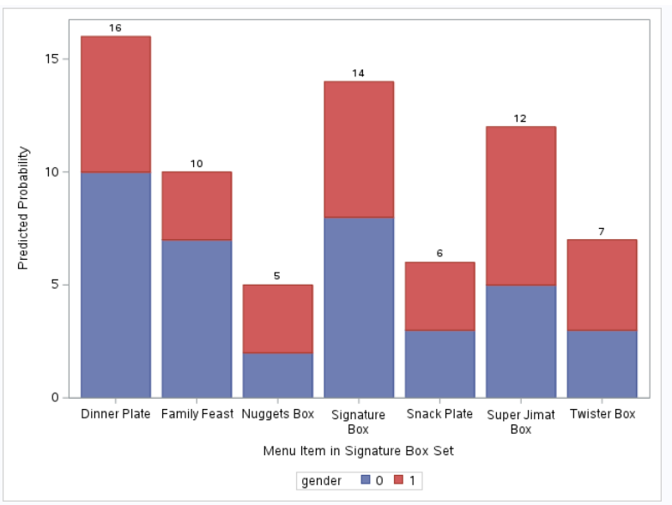
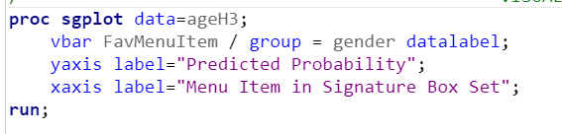
Findings: 0 indicates male, 1 indicates female at the ages of 20 to 29 years of age. We can find out from here dinner plate is eaten by males generally, family feast is also been selected by males generally, as for nugget box more females than males order nugget box, for signature box, as this graph plot more male than females order signature box, as for snack box both genders have equal chances of ordering the snack plate, for super jimat box more female than males orders the super jimat box and lastly for twister box, more female than males order the twister box. But in hypothesis 3, we are testing the significance of males and females at the age of 20 to 29. Whether or not who is more likely to purchase the signature box, we can conclude that males are less likely to order the signature box than females at the age of 20 to 29 years old.

5.21 Hypothesis 4 graph
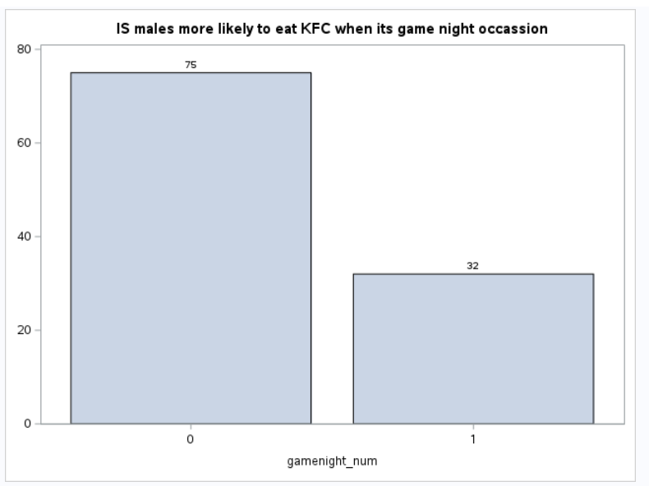
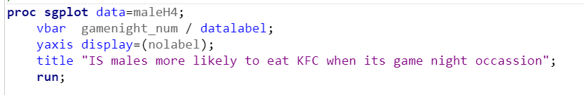
Findings: 0 indicates not having game night when the male is having a different occasion. Where 1 indicates males are having game night, as shown here, 0 (75) of males are not having KFC when they are having different occasions apart from game night, 1 (32) of males are having KFC when they are having an occasion of game night. For our hypothesis we can say males are more likely to have KFC when the male customers are having game night.

5.22 Hypothesis 5 graph
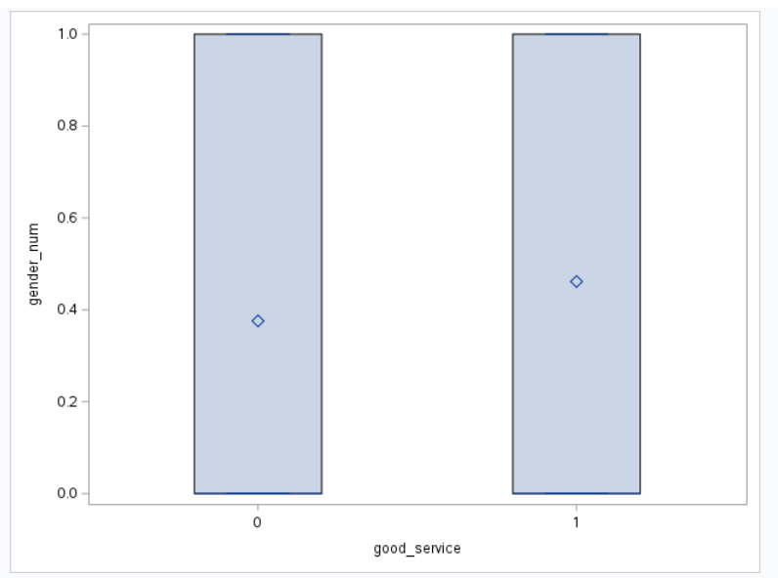
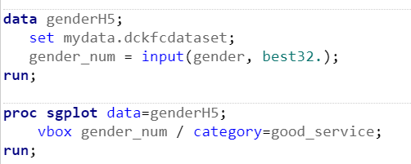
Findings: As shown here 0 indicates not good service and 1 indicates good service. From here the diamond indicates whether male or female come to KFC because of good service, but according to the graph, not all majority of customers come to KFC because of good service, as other reasons are playing an influential role to an individual purchasing KFC. As a result of hypothesis 5, not all customers both male and female, come to KFC because of its good service.

5.23 Hypothesis 6 graph
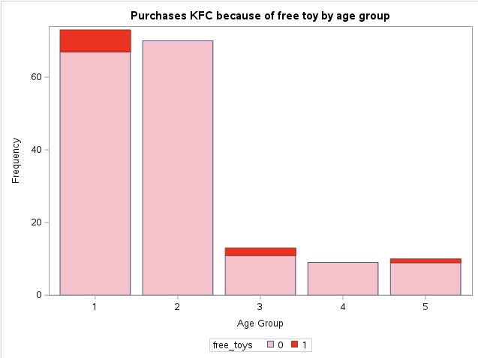
Findings: The red colour represents going to KFC because of free toys and pink is not going to KFC because of free toys. 1 represents below 20, 2 represents 20-29, 3 represents 30-39, 4 represents 40-49 and 5 represents above 50. Based on the graph above, all of the respondents at the age of 40-49 and 20-29 would not go to KFC because of free toys at all. Based on the graph above, most of the respondents in all age group free toys would not be a defining factor to purchase KFC.

5.24 Hypothesis 7 graph
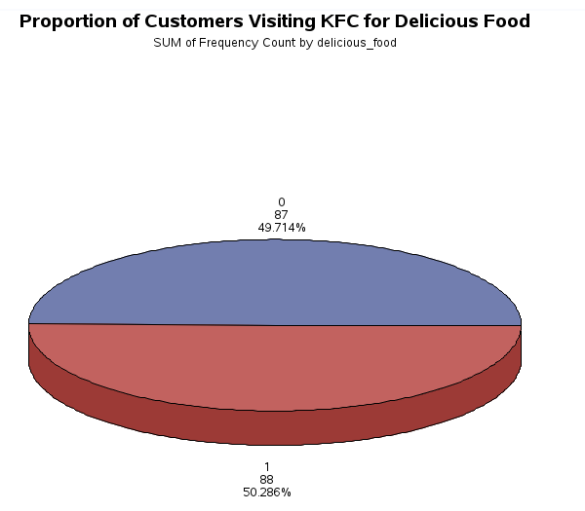
Findings: Most respondents (50.29%) would go to KFC because of Delicious food, and less than half of the respondents (49.71%) would purchase KFC not because of Delicious food.

5.25 Hypothesis 8 graph
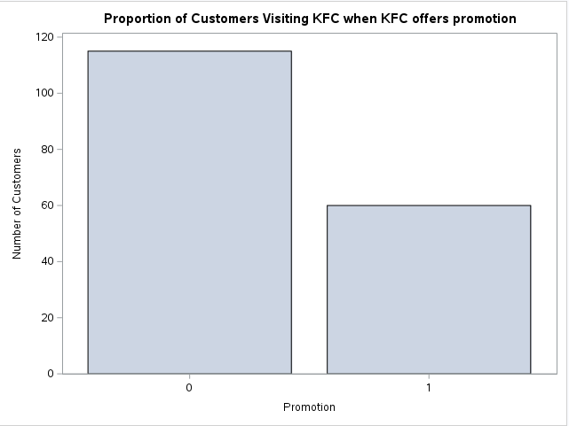
Findings: Promotion is not a significant factor for customers to choose to visit KFC. Most customers do not think promotion would influence their decision of whether to purchase KFC.

5.26 Hypothesis 9 graph
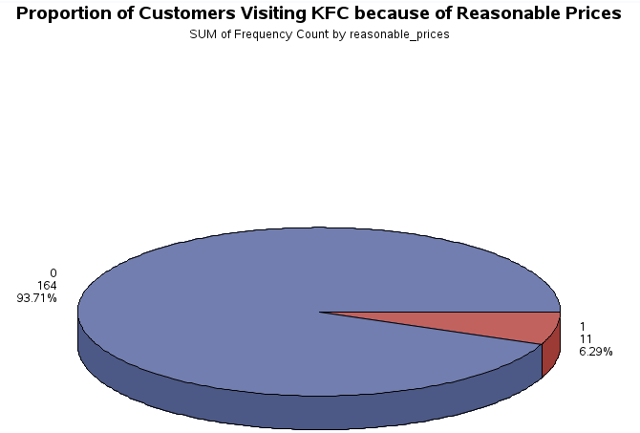

5.27 Hypothesis 10 graph
Findings: Most of the customers (93.71%) Do not agree that they visit KFC for reasonable prices, and only 6.29% of the customers visit KFC for reasonable prices.
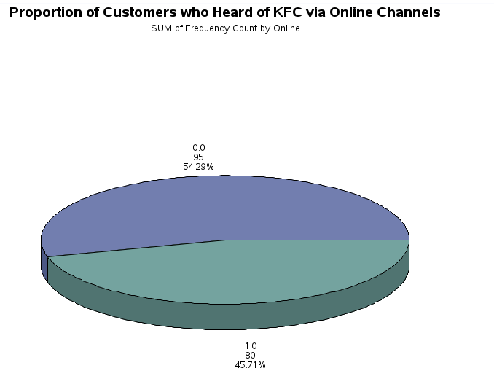
Findings: More than half (54.29%)of the customers heard of KFC via online channels, and the rest, 45.71%, heard of KFC via different channels.

5.28 Hypothesis 11 graph
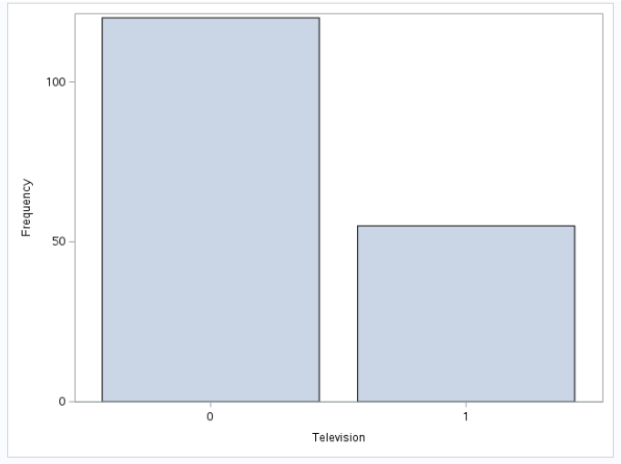
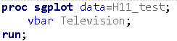
Finding: “0” represents people who heard KFC not via television and “1” represents people who heard KFC via television. According to the figure we can easily conclude that 0 is more than 1.So most people have not heard KFC via television.

5.29 Hypothesis 12 graph
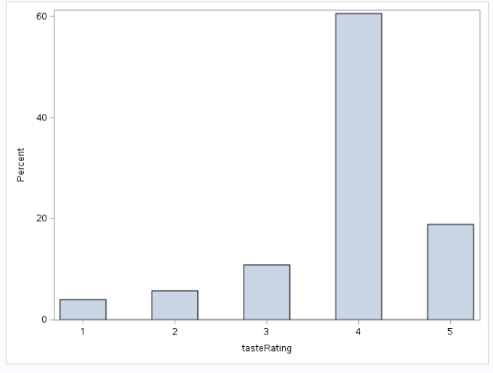
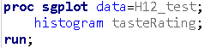
Finding: This is the rating for taste. “1” represents the percentage that people rate the taste very awful, “2” represents the percentage that people rate the taste awful, “3” represents the percentage that people rate the taste fairly good, “4” represents the percentage that people rate the taste delicious, “5” represents the percentage that people rate the taste very delicious. According to the figure we can easily conclude that 4 and 5 is more than 1,2,and 3. So the majority of customers rated KFC’s food taste as either good (4) or excellent (5).

5.30 Hypothesis 13 graph
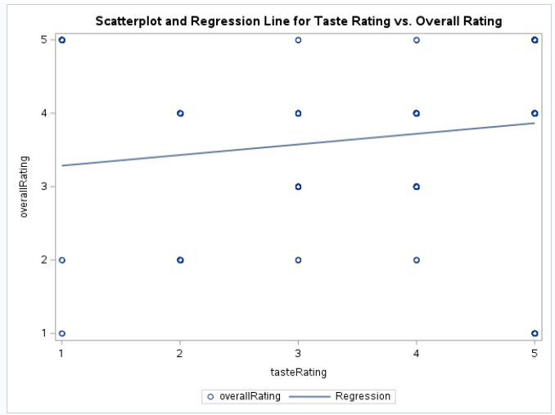
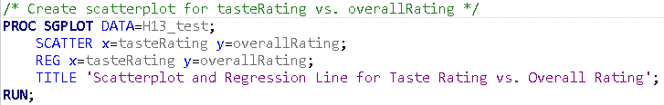

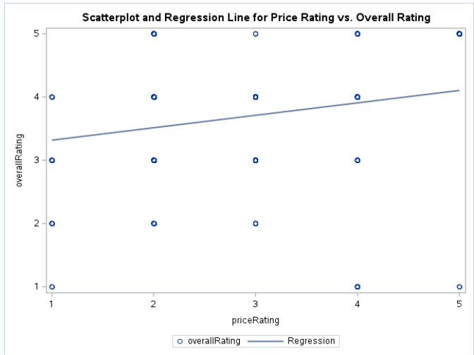
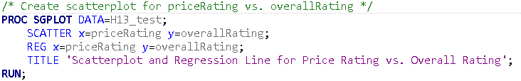
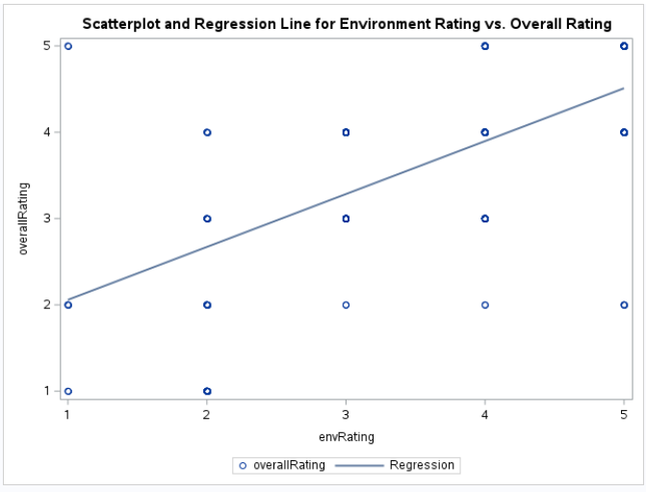
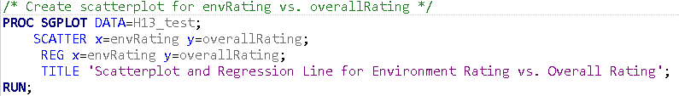
Finding: The graph of this three which compares overall rating with taste rating, price rating, and environment rating. Based on these three graphs, we can know that taste rating, price rating, environment have more or less influenced the overall rating.

5.31 Hypothesis 14 graph
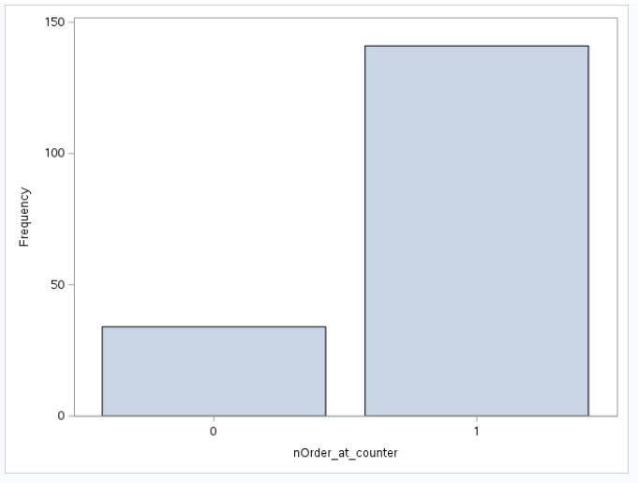
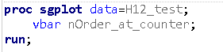
Finding: “0” represents people who do not order food at the counter and “1” represents people who order food at the counter. According to the figure we can easily conclude that 1 is more than 0. So most of the people order food at the counter.

5.32 Hypothesis 15 graph

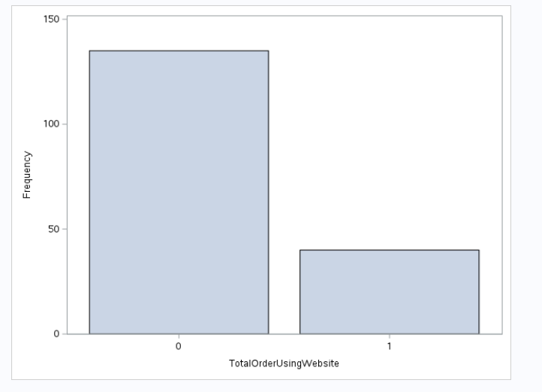
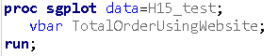
Finding: “0” represents people who do not order food using KFC app or website and “1” represents people who order food using KFC app or website. According to the figure we can easily conclude that 0 is more than 1. So that less than half of the customers ordered via KFC app/website for delivery or self pick up.

5.33 Hypothesis 16 graph
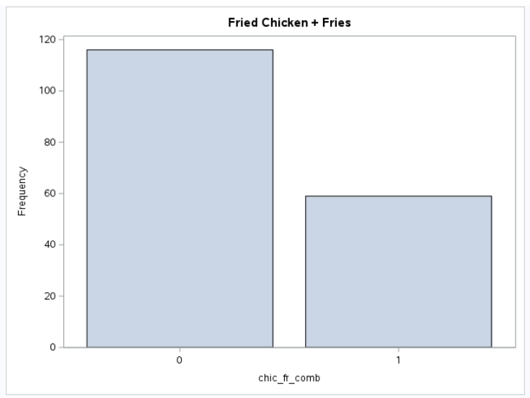
Findings: From the bar chart, almost 34% of the respondents ordered fried chicken and fries together while around 66% of the respondents did not order both fried chicken and fries together.

5.34 Hypothesis 17 graph
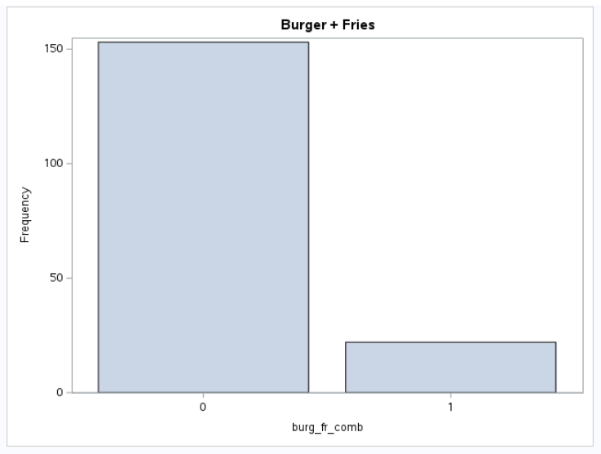
Findings: From the bar chart, approximately 12% of the respondents ordered burger and fries together while around 88% of the respondents did not order both burger and fries together.

5.35 Hypothesis 18 graph
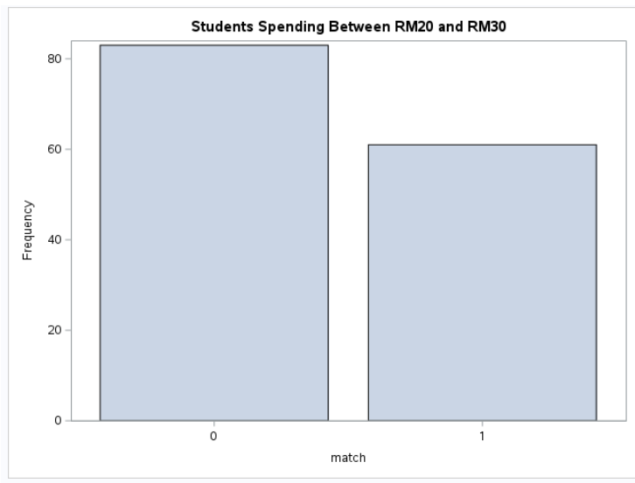

Findings: Among all of KFC’s student customers, approximately 42% of them spent between RM20 and RM30 while around 58% of them did not spend between RM20 and RM30.

5.36 Hypothesis 19 graph
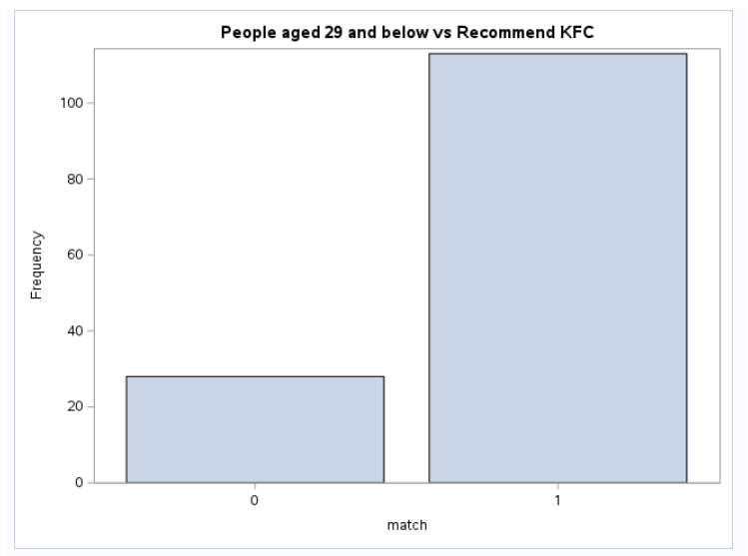
Findings: Among the customers who will recommend KFC to their friends or family, approximately 21% are people who are above 29 years old while around 79% are people who are aged 29 and below.

5.37 Hypothesis 20 graph
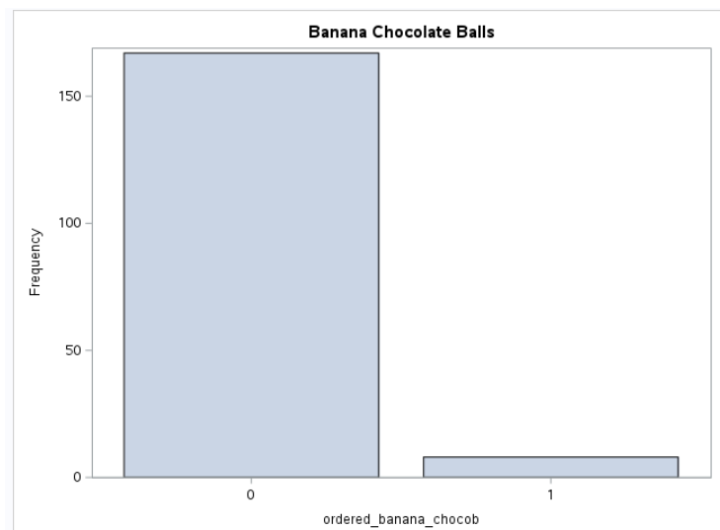
Findings: Among all the 175 respondents, around 6% of them ordered Banana Chocolate Balls while approximately 94% of them did not order Banana Chocolate Balls.

6.0 HYPOTHESIS TESTING

Hypothesis 1
H1: Female customers usually go to KFC for gatherings.
H₀: p <= 0.07692, Female customers usually do not go to KFC for gatherings
H₁: p > 0.07692, Female customers usually go to KFC for gatherings
At a = 0.05, critical value = Z = 1.6449
Rejection region: Z > 1.6449
Result:
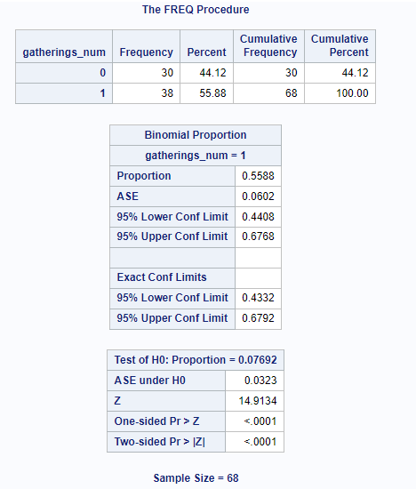
Conclusion: The proportion of females, who usually do not go to KFC for gatherings, is approximately 0.4412 (44.12%). The proportion of females, who usually go to KFC for gatherings, is 55.88%. Since Z =14.9134 > 1.6649, we reject the null hypothesis and accept the alternative hypothesis, i.e. H1, and conclude that female customers usually go to KFC for gatherings.

Hypothesis 2
H2: Most of the females at the age 20 to 29 prefer fried chicken (original flavour) than fried chicken (spicy flavour).
H₀: p <= 0.1429, most of the females at the age 20 to 29 do not prefer fried chicken (original) but prefer fried chicken spicy flavour.
H₁: p > 0.1429, most of the females at the age 20 to 29 prefer fried chicken (original) than fried chicken (spicy)
At a= 0.05, critical value : Z = 1.6449 Rejection region: Z > 1.6449
Result:
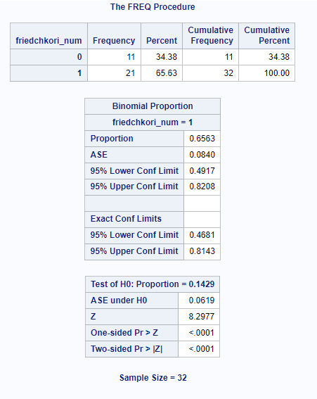

Conclusion: Since z=8.2977 > 1.6449, Reject the null hypothesis and accept the alternative hypothesis i.e. H2 and we conclude that most of the females at the age of between 20 to 29 prefer fried chicken (original) flavour than fried chicken (spicy).

Hypothesis 3
H3: Males at the age of 20 to 29 are more likely to enjoy the signature box set than females at the age of 20 to 29.
H₀: p <= 0.5, male customers of age between 20 to 29 are less likely to enjoy the signature box than females at the age of 20 to 29 as females also enjoy the signature box too.
H₁: p > 0.5, male customers of age between 20 to 29 are more likely to enjoy the signature box than females at the age of 20 to 29.
At a = 0.05, critical value = Z = 1.6449, Rejection region: Z > 1.6449

Result:
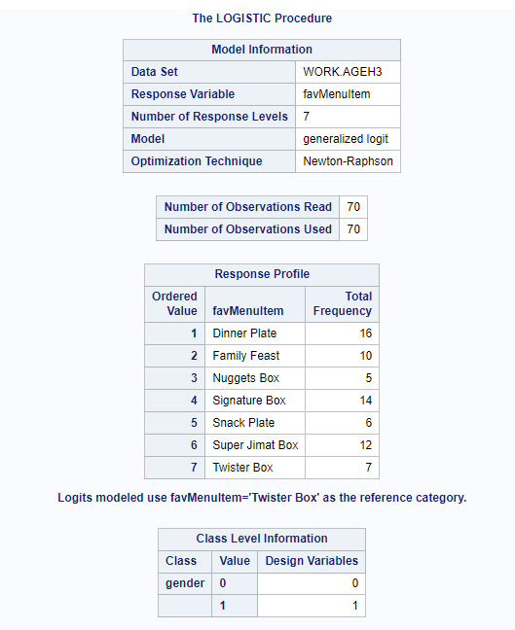
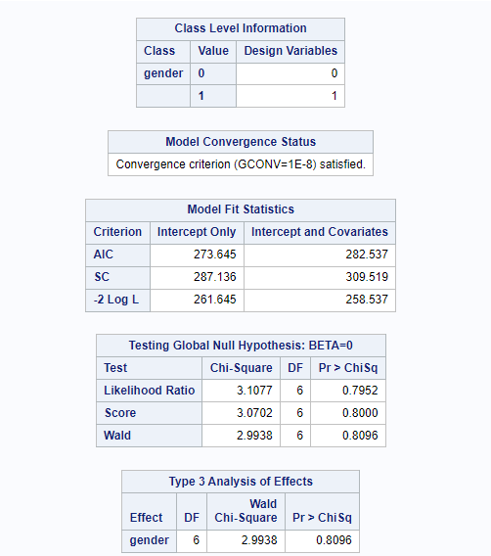
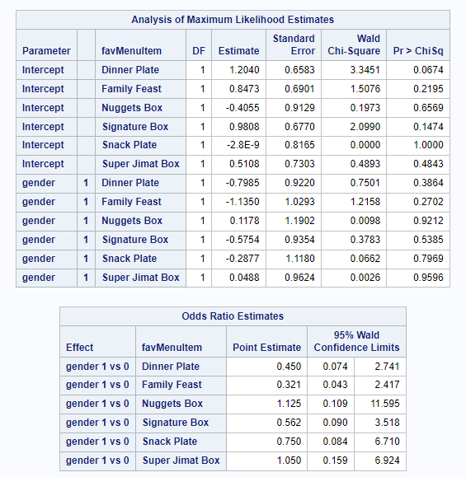
Since females at the age of 20 to 29 prefer the signature box than males at the age of 20 to 29 which is 56.20% and males that prefer the signature box than females (1) at the age of 20 to 29 is 43.80%. p = 0.8096 > 0.05 Therefore we accept the null hypothesis i.e. H3 and reject the alternative hypothesis and we conclude that, male customers of age between 20 to 29 are less likely to enjoy the signature box compared to females at the age of 20 to 29..

Hypothesis 4
H4: Most of the male customers come to KFC on game nights than any other occasions.
H₀: p <= 0.07692, Most of the male customers do not come to KFC on game nights than any other occasions
H₁: p > 0.07692, Most of the male customers come to KFC on game nights than any other occasions
At a = 0.05, critical value = Z = 1.6449
Rejection region: Z > 1.6449

Result:
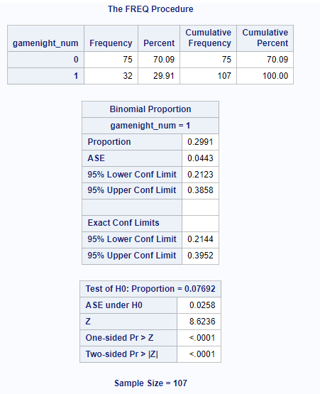
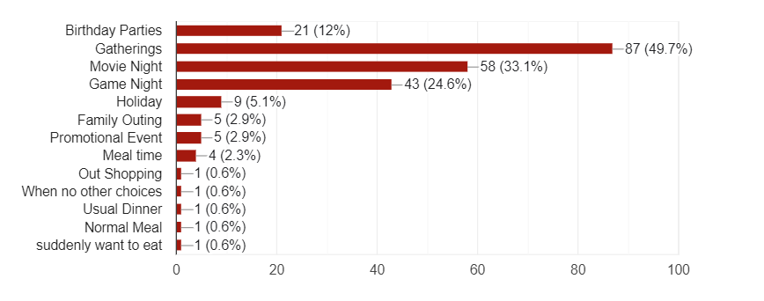
Conclusion: The proportion of males, who came to KFC on game nights, is 29.91%. The proportion of males, who came to KFC on any other occasion, is 70.09%. Since z = 8.6236> 1.6449, we can reject the null hypothesis and accept the alternative hypothesis, i.e. H4. We conclude that most of the male customers come to KFC on game nights than any other occasions.

Hypothesis 5
H5: Male customers are more likely to buy KFC because of the good service provided by KFC.
H₀: p <= 0.1, Male customers are less likely to buy KFC because of the good service provided by KFC.
H₁: p > 0.1, Male customers are more likely to buy KFC because of the good service provided by KFC.
At a = 0.05, critical value = Z = 1.6449
Rejection region: Z > 1.6449
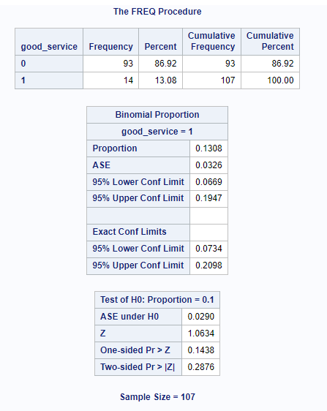

Conclusion: The proportion of male customers that buy KFC because of the good service provided by KFC is 0.1308 while the proportion of male customers that do not buy KFC because of the good service provided is 0.8692. Since, z = 1.0634 < 1.6449, we accept the null hypothesis and reject the alternative hypothesis, i.e. H5. Therefore, we conclude that male customers are less likely to buy KFC because of the good service provided by KFC.

Hypothesis 6
H6: Age group is not significantly associated with whether free toys are the main reason why customers purchase at KFC.
H₀: Age group is not significantly associated with whether free toys is the main reason why customers purchase at KFC
H₁: Age group is significantly associated with whether free toys is the main reason why customers purchase at KFC
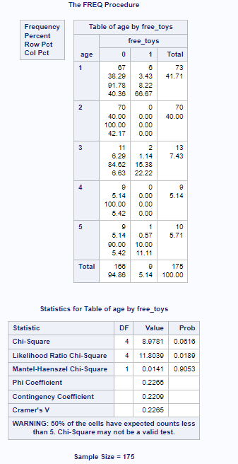
Conclusion: The chi square test value is 8.9781 and corresponding p value of test statistic is 0.0616. Since the p-value is greater than our chosen significance level α = 0.05, we accept the null hypothesis, ie H6. Therefore, we conclude that the age group is not significantly associated with whether free toys are the main reason why customers purchase at KFC.

Hypothesis 7
H7: The majority of customers usually go to KFC to take delight in its delicious food.
H₀: p <= 0.1
H₁: p > 0.1
At a = 0.05, critical value = Z_{a} = 1.6449
Rejection region: Z > 1.6449
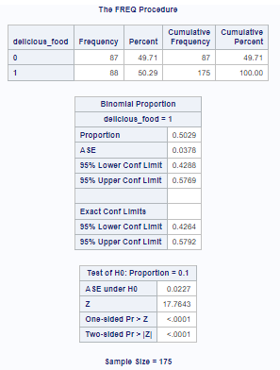
Conclusion: The proportion of customers who went to KFC because of its delicious food is 50.29%. Since z = 17.7643 >1.6449, we reject H₀ and accept H₁ ,i.e. H7. We conclude that most of the customers go to KFC for its delicious food.

Hypothesis 8
H8: The majority of customers usually go to KFC when KFC offers promotions.
H₀: p <= 0.1
H₁: p > 0.1
At a = 0.05, critical value = Z_{a} = 1.6449
Rejection region: Z > 1.6449

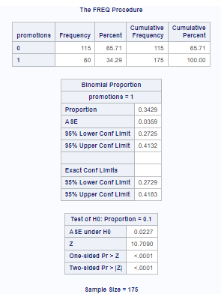
Conclusion: The proportion of customers, who go to KFC because of promotions, is 34.29%. Since z = 10.7090 > 1.6449, we reject H₀ and accept H₁ , i.e. H8, and conclude that most of the customers go to KFC because of promotions.

Hypothesis 9
H9: The majority of customers usually go to KFC because the prices are reasonable.
H₀: p <= 0.1
H₁: p > 0.1
At a = 0.05, critical value = Z_{a} = 1.6449
Rejection region: Z > 1.6449

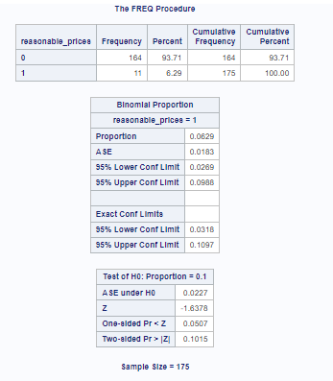
Conclusion: The proportion of customers who usually go to KFC because of its reasonable prices is 6.29%. Since z = -1.6378 < 1.6449, we accept H₀ and reject H₁,i.e. H9, and conclude that the majority of customers usually do not go to KFC because of the reasonable prices.

Hypothesis 10
H10: Most of the customers heard of KFC via online channels
H₀: p <= 0.25
H₁: p > 0.25
At a = 0.05, critical value = Z_{a} = 1.6449
Rejection region: Z > 1.6449

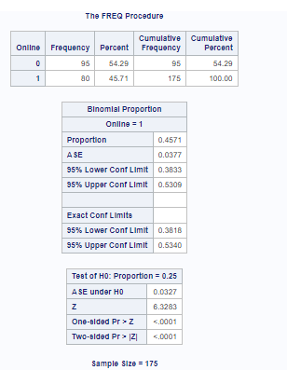
Conclusion: The proportion of customers, who heard of KFC via online channels, is 45.71%. Since z =6.3283> 1.6449, we reject H₀ and accept H₁, i.e. H10, and conclude that the majority of the customers heard of KFC via Online channel.

Hypothesis 11
H11: Most of the customers heard of KFC via television.
H0 : p <= 0.25
H1 : p > 0.25
At a = 0.05, critical value = Z_{a} = 1.6449
Rejection region: Z > 1.6449
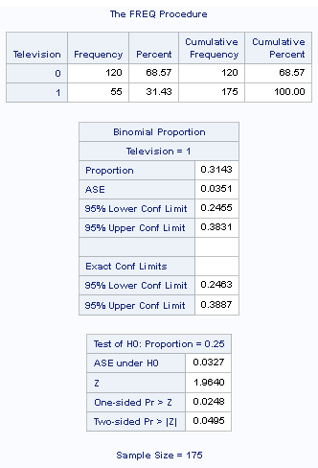
Conclusion : The proportion of people who heard KFC via television is 31.43% while the proportion of people who heard KFC not via television is 68.57%. Since z = 1.9640 > 1.6449, we reject H₀ and accept H₁, in H11. It means that most of the customers have not heard about KFC via television.

Hypothesis 12
H12: The majority of customers rated KFC’s food taste as either good (4) or excellent (5).
H0: p <= 0.2
H1: p > 0.2
At a = 0.05, critical value = Z_{a} = 1.6449, Rejection region: Z > 1.6449

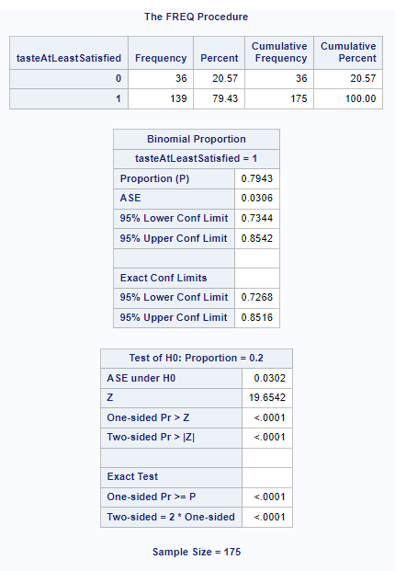

Conclusion : The proportion of customers who rated KFC’s food taste as either good (4) or excellent (5) is 79.43% while the proportion of customers who rated less than 4 is 20.57%. Since z = 19.6542 > 1.6449, we reject H₀ and accept H₁, ie H12. It means that the majority of customers rated KFC’s food taste as either good (4) or excellent (5).

Hypothesis 13
H13: A customer’s overall satisfaction with KFC is determined by at least one of the variables: the taste rating, price rating and environment rating.
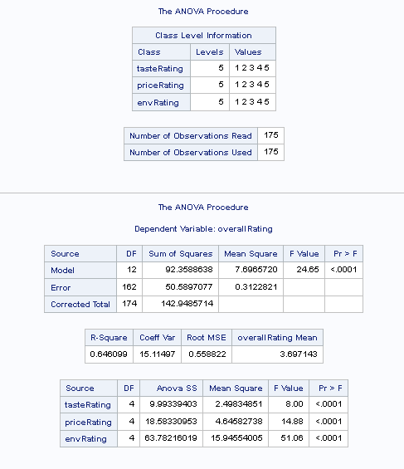
Conclusion : The Model row in the ANOVA table tests the overall significance of the model. The F-value is 24.65, and the associated p-value is <.0001. The R-squared value is 0.646099, indicating that approximately 64.61% of the variation in overall satisfaction can be explained by the independent variables (tasteRating, priceRating, and envRating). The ANOVA table for individual variables (tasteRating, priceRating, and envRating) shows that each of these variables is statistically significant (p < 0.0001). This suggests that a customer’s overall satisfaction with KFC is determined by at least one of the variables: the taste rating, price rating and environment rating.

Hypothesis 14
H14: More than half of the customers make their orders at the counter.
H0 : p <= 0.5
H1 : p > 0.5
At a = 0.05, critical value = Z_{a} = 1.6449
Rejection region: Z > 1.6449
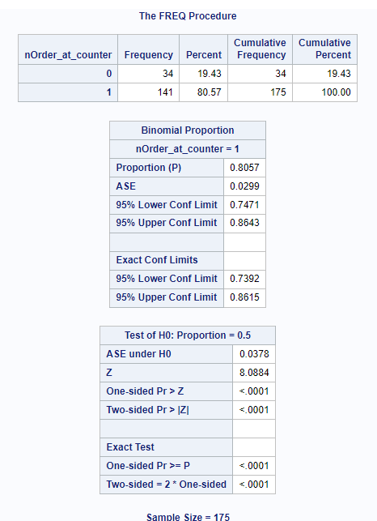

Conclusion : The proportion of the customers who made their orders at the counter is 80.57% while the proportion of the customers who did not make their orders at the counter is 19.43%. Since z = 8.0884 > 1.6449, we reject H₀ and accept H₁, ie H14. It means that more than half of the customers make their orders at the counter.

Hypothesis 15
H15: Less than half of the customers ordered via KFC app/website for delivery or self pick up.
H0 : p >= 0.5
H1 : p < 0.5
At a = 0.05, critical value = Z_{a} = -1.6449
Rejection region: Z < -1.6449
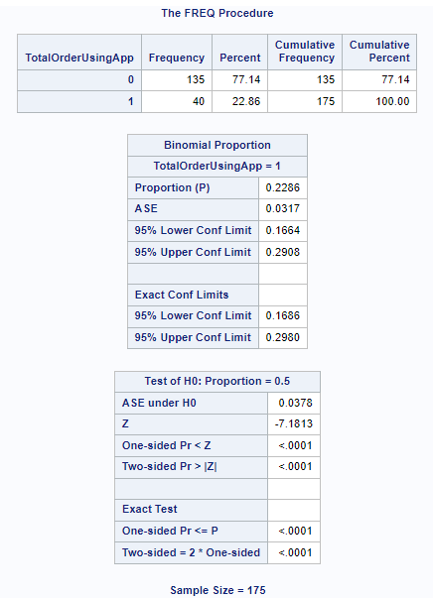

Conclusion : The proportion of the customers who ordered via KFC app/website for delivery or self-pick up is 22.86% while the proportion of the customers who did not order via KFC app/website for delivery or self-pick up is 77.14%. Since z = -7.1813 < -1.6449, we reject H₀ and accept H₁ ie H15. It means that less than half of the customers ordered via KFC app/website for delivery or self pick up

Hypothesis 16
H16: “Fried Chicken and Fries” is the combination of food that is more common than all of the other possible food combinations combined at KFC.
H₀: p <= 0.5
H₁: p > 0.5
At a = 0.05, critical value = Z_{a} = 1.6449
Rejection region: Z > 1.6449
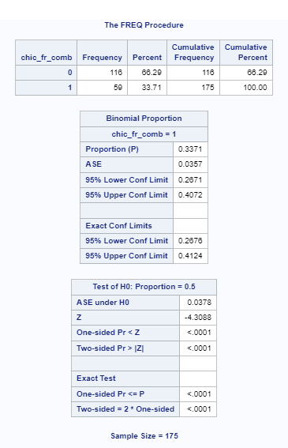
Conclusion: The proportion of customers who ordered a combination of fried chicken and fries is 0.3371 (33.71%). The proportion of customers who ordered another combination is 0.6629 (66.29%). Since, z = -4.3088 < 1.6449, we accept H₀ and conclude that “Fried Chicken and Fries” is not the most common combination of food ordered at KFC. Therefore, H16 is not accepted.

Hypothesis 17
H17: “Burger and Fries” is the combination of food that is more common than all of the other possible food combinations combined at KFC.
H₀: p <= 0.5
H₁: p > 0.5
At a = 0.05, critical value = Z_{a} = 1.6449
Rejection region: Z > 1.6449
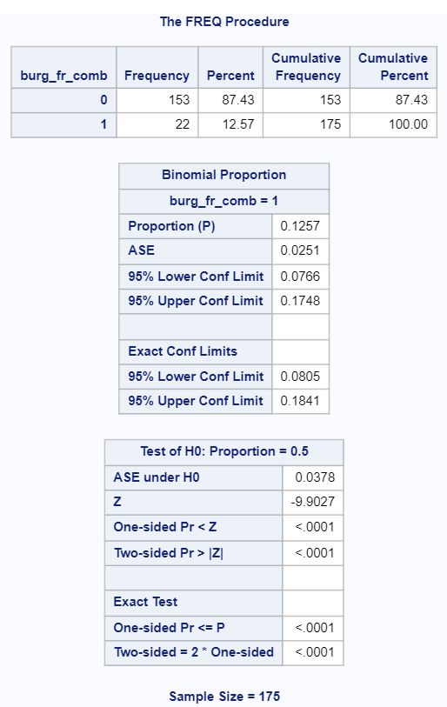
Conclusion: The proportion of customers who ordered a combination of burger and fries is 0.1257 / 12.57%. The proportion of customers who ordered another combination is 0.8743 / 87.43%. Since z = -9.9027 < 1.6449, we accept H₀ and conclude that “Burger and Fries” is not the most common combination of food ordered at KFC. Therefore, H17 is not accepted.

Hypothesis 18
H18: The majority of students spent between RM20 and RM30
H₀: p <= 0.1666667
H₁: p > 0.1666667
At a = 0.05, critical value = Z_{a} = 1.6449
Rejection region: Z > 1.6449
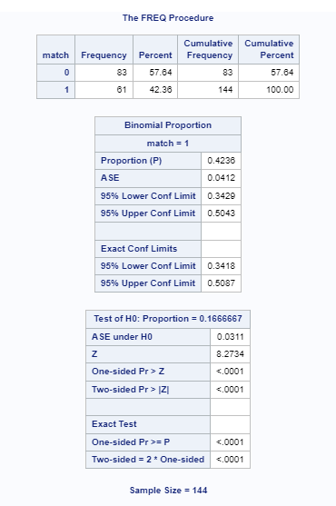

Conclusion: Among KFC’s student customers, the proportion of them spending between RM20 and RM30 is 0.4236. Since Z = 8.2734 > 1.6449, we reject H₀ and conclude that the majority of students spent between RM20 and RM30. Therefore, H18 is accepted.

Hypothesis 19
H19: People aged 29 and below are more likely to recommend KFC to their friends or family members than any other age group.
H₀: P <= 0.25
H₁: P > 0.25
At a = 0.05, critical value = Z_{a} = 1.6449 , Rejection region: Z > 1.6449
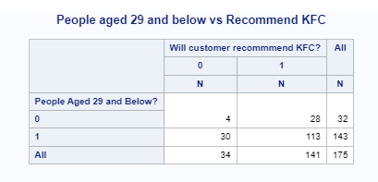
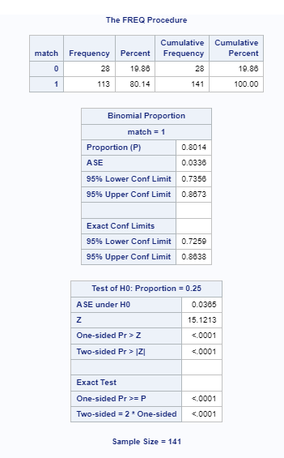

Conclusion: Since Z = 15.1213 > 1.6449 and the one-sided p value is <0.0001 that is less than 0.05, we reject H₀ and conclude that people aged 29 and below are more likely to recommend KFC to their friends or family members than any other age group. Therefore, H19 is accepted.

Hypothesis 20
H20: Most of the customers do not purchase banana chocolate balls.
H₀: p >= 0.1111
H₁: p < 0.1111
At a = 0.05, critical value = Z_{a} = -1.6449 , Rejection region: Z < -1.6449

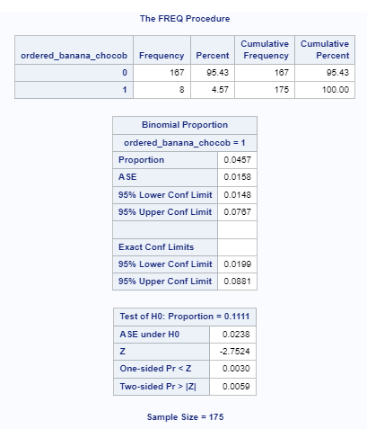

Conclusion: Since Z = -2.7524 < -1.6449 and the one-sided p value is 0.0030 that is less than 0.05, we reject H₀ , accept H₁, i.e. H20, and conclude that most of the customers do not purchase banana chocolate balls.

7.0 RECOMMENDATION
Based on our hypothesis findings and analyses, we have to give recommendations to the higher management to state how to improve the products, price, delivery transportation etc,

a) Thong Cheng How
Since females are more likely to attend gatherings, according to the results of hypothesis one and figure 5.18, our recommendation to KFC is to collaborate with well-known companies that have had a significant social influence on public perceptions with a positive impact. We must also take into account men in order to ensure that both genders have proportionate representation because the majority of women attend gatherings. We could test the sales difference between the previous sales and the event sales, which could give us a rough assumption whether males are more likely to purchase from KFC than females because of KFC partners with major car brands like "Lamborghini" to give gifts on a limited time. The reason why we choose lamborghini is because we believe both genders love luxury cars and can bring a good impression to KFC overall. Regarding hypothesis two and figure 5.19, KFC may provide a unique offer that includes both the original and spicy flavours with every purchase and give coupons of RM5, since we discovered that ladies prefer fried chicken original to fried chicken spicy. We also discovered that men prefer spicy fried chicken, and figure 5.19 shows that some women still like the spicy fried chicken flavour. Therefore we can fulfil both parties' requirements with a win-win solution. As implementing both flavours with a small coupon voucher for customers to enjoy when they come back for their next meal in KFC. Thus making KFC profit to increase and customer satisfaction to increase too. As for hypothesis three and figure 5.20, since we found out that males at the age of between 20 to 29 years old are less likely to order signature box as other females as males typically choose dinner plate, so for our recommendations we would like to suggest since university students are typically at that age of between 20 to 29, we suggest KFC to create set and bundle in the university as a ready to eat meal and can be sold in convenient machines, the reason is because since university life is very hectic and busy life for students, not all students can wait for the restaurants to prepare the meal, therefore KFC could make some ready to eat meals for students that compromises on a mixture of signature and dinner plate since the ages of 20 to 29 years old males and females that prefer this kind of combination. Not only that, KFC also can partner up with Malaysian cashless groups like ‘Touch N Go’ to allow individuals to give students below 20 free meals to enjoy at KFC. As not every student is financially stable, therefore by giving free meals to students, KFC is also helping their brand recognition to get bigger and better, as in the ‘touch n go’ app KFC also could promote their products there too, to increase sales as the cash app is mainly can be used by anyone with a cell phone. As for hypothesis four and 5.21, since we found out that on game night which generally is between 8pm to 12am. Males generally order KFC if they are having game night. We suggest KFC to have an e-sport tournament with different streaming platforms as partnerships, from the event KFC could promote their latest products and give away free gifts if gamers purchase products at KFC above a certain price range. As for hypothesis five and 5.22, since we know that males generally don’t come to KFC because of good service, we found out that the main factor is delicious food from figure 5.22. Therefore we recommend KFC to make the food portion bigger and maintain its deliciousness because if KFC does so, not only the KFC customers can enjoy delicious food, they would also be full as these days our value of money is not that stable. Making food portions bigger can lead to more customers coming to KFC more often.

b) Ong Weng Kai
Based on 4.35, most of the customers for KFC are ‘below 20’ and ‘20-29’; KFC can utilise this information and introduce trendy and unique flavours that appeal to this age group (demographic) as the flavour that the younger generation prefers might not be the same as the other generations. The management can also utilise this information to design some more appealing meals as younger generations tend to love taking some appealing meals and posting them on social media. By doing this, KFC can get some free advertisement from the customers and ultimately expand the number of customers they can approach. Based on the second result of Table 4.36, we can know the customer gender distribution for each state and it can help KFC in several ways. Firstly, KFC can do localised marketing, such as creating a specific marketing campaign for each state based on gender distribution data. For example, Kuala Lumpur has the most female customers; KFC can feature promotions and products that appeal to women, such as strawberry-flavour ice cream. On top of that, KFC can tailor and introduce a special menu that is a limited-time offer that can cater to the tastes of male or female customers. In addition, KFC can offer more pricing and promotional strategies that resonate with the local customer base. For example, if a state has a predominantly female customer base, KFC can introduce 'Ladies Night' or, during 'International Women Days', offer more discounts or promotions targeted at women. Other than that, KFC can utilise gender distribution to reduce waste and optimise supply chain operations, for example, by stocking more popular items with a specific gender in each state. By utilising this information, KFC can create a more effective and personalised approach to menu planning and marketing, ultimately improving customer satisfaction and business growth. Based on the first result of Table 4.36, most customers are students with no income and students with monthly income below RM1500. Based on this information, KFC can design an affordable meal option such as a combo offering budget-friendly meal deals to introduce more competitive and reasonable value-for-money meals. Consider that most customers are price-sensitive and can offer Student discounts to attract more students and partner with local educational institutions to promote these offers. In addition, they can introduce more meal options designed for sharing among friends or family; this can encourage group dining, and it would be more affordable. After that, they can offer delivery service with more discounted or free delivery for orders over a certain amount for students who wish to get delivery service at a cheaper or no price. KFC can also extend operating hours to students with irregular schedules, as sometimes students might need a place to discuss their work or revise. After that, As most customers are students, KFC can also consider engaging with local colleges and universities through events, partnerships or sponsorship to increase brand recognition and loyalty. The reason is that this is the easiest and most direct way to attract more potential customers. By understanding the financial constraints of the student customer base and tailoring the corresponding marketing strategy and offering, KFC can retain this customer and also attract more new customers, which would drive brand loyalty and sales. Based on the finding of hypothesis 6, the age group is not significantly associated with whether free toys are the main reason why customers purchase at KFC. As KFC management can utilise this information and not solely focus on giving free toys in KFC kid meals, they can give free toys to various age groups with different meal sets as not a specific age group would be attracted to free toys only. Based on the finding of hypothesis 10, most customers hear of KFC via online channels; this information is helpful for KFC management as they know where they should allocate their resources to advertise and promote to attract more potential customers. After that, based on hypothesis 7, we can conclude that most customers go to KFC for its delicious food, so delicious food remains the main factor customers would consider when purchasing at KFC. Thus, KFC can utilise this information and develop more variety of food to attract more diverse customers. Hypothesis 8 states that most of the customers go to KFC because of promotions, so KFC can do more promotions to attract more customers to go to KFC to purchase KFC products. Hypothesis 9 states that most customers do not go to KFC because of reasonable prices.So means that price is not the primary factor customers are concerned about, so KFC can develop more variety of Menu with higher price as most of the customers purchase KFC not because of Reasonable price. Compared with the findings in hypotheses 8 and 7, the team can conclude that most customers purchase KFC not because of the reasonable prices; in fact, it is because of the delicious food, but more discounts given by KFC would also attract more customers to purchase KFC products.

c) Yong Zee Lin
Based on the result shown in hypothesis 11, most of the customers have not heard about KFC via television. To maximise their marketing impact, it is recommended that KFC doesn’t have to prioritise television advertising and develop other means such as online. According to the result shown in hypothesis 12, It means that the majority of customers rated KFC’s food taste as either good (4) or excellent (5). To capitalise on this positive feedback, KFC should prioritise maintaining food quality and consider incorporating these ratings into their marketing efforts to reinforce their reputation of delicious food and attract more customers. Based on the result shown in hypothesis 13, it suggests that a customer’s overall satisfaction with KFC is determined by at least one of the variables, which are taste rating, price rating and environment rating. To enhance satisfaction and loyalty, KFC should focus on improving these key elements and regularly gather customer feedback for continuous refinement. According to the result shown in hypothesis 14, it means that more than half of the customers make their orders at the counter. To improve the customer experience, KFC should focus on optimising counter service efficiency, possibly through self-service kiosks, well - trained staff, and regular assessments of customer preferences and wait times. Based on the result shown in hypothesis 15, it means that less than half of the customers ordered via KFC app/website for delivery or self pick up. To encourage digital ordering, KFC should enhance the app/website's usability, launch promotions, and gather feedback to continually improve the digital experience.

d) Ryan Kho Yuen Thian
There are several recommendations that can be brought up to the KFC management. Firstly, based on the results that are shown in 5.33, 5.34 and the hypothesis results of H16 and H17, the “Fried Chicken + Fries” and “Burger + Fries” combinations are not very popular among KFC’s customers. Therefore, the KFC management should not introduce any set meals that contain at least one of those food combinations in the menu. This is because not many customers would want to purchase that kind of set meal so introducing that kind of set meal may not generate much sales or profit for KFC. Secondly, based on the results in 5.35 and H18, the majority of students spent between RM20 and RM30. With that finding in mind, the KFC management should either remove a few of the currently available menu items that are above RM30 or reduce their prices slightly. Otherwise, they may not be purchased by students, who form the majority of KFC’s customers. If the management does not take any of the suggested actions, it could cause KFC to order ingredients that may not necessarily be used in food preparation, taking up unnecessary inventory space and resulting in some of the business’s expenses to be wasted. Moreover, as students form the majority of KFC’s customers and they usually do not earn any income, KFC could introduce small discounts to encourage students to continue patronising the restaurant. This could help KFC to either maintain or increase its sales. Thirdly, with reference to the results in H19 and 5.36, people aged 29 and below are more likely to recommend KFC to their friends or family members than any other age groups. Therefore, KFC should conduct more research in the future to know what kind of menu items that people aged 29 and below prefer so that the management does not wrongly drop important menu items from the menu. If the future research shows that those customers may want to eat other kinds of food that are not currently available in the menu, the management should try to fulfil the customers’ requirements by introducing those new menu items but the KFC’s employees will need to be trained to prepare those foods. Lastly, according to the results in 5.37 and H20, there is very low demand for banana chocolate balls. This means that very little revenue and/or profit is/are generated by continuing to sell banana chocolate balls on the menu. Therefore, the KFC management should either promote this underperforming side dish by introducing a few discounts to clear its stock of banana chocolate balls OR remove banana chocolate balls from the menu since it is not a very profitable side dish.

8.0 REFERENCE
SAS - frequency distributions. Online Courses and eBooks Library. (2023). https://www.tutorialspoint.com/sas/sas_frequency_distributions.htm#:~:text=We%20can%20determine
SAS community. Lithium authentication redirect. (2014). https://communities.sas.com/t5/Graphics-Programming/Appearance-of-percentage-on-pie-chart-annotate/td-p/175345
Zach. (2023, May 9). How to create pie charts in SAS (4 examples). Statology. https://www.statology.org/sas-pie-chart/#:~:text=proc%20gchart%20data%3Dmy_data%3B%20pie%20team%20%2F%20sumvar%3Dpoints,value%20in%20the%20team%20column.
SAS community. Lithium authentication redirect. (2012). https://communities.sas.com/t5/SAS-Procedures/Proc-Tabulate-multiple-titles/td-p/96868
Datalab, A. (2021, November 13). Understanding - “Wald Test.” Medium. https://medium.com/@analyttica/understanding-wald-test-2e3fa7723516
Chris Hemedinger on The SAS Dummy. (2013, June 12). How to build a correlations matrix heat map with SAS. The SAS Dummy. https://blogs.sas.com/content/sasdummy/2013/06/12/correlations-matrix-heatmap-with-sas/

9.0 APPENDIX

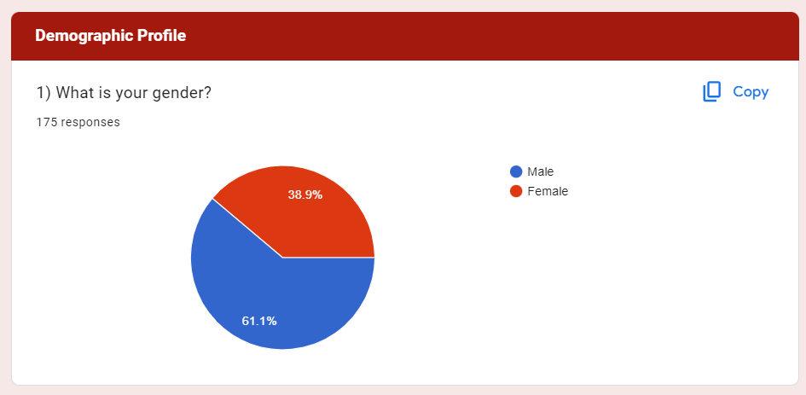
9.1 demographic profile- gender

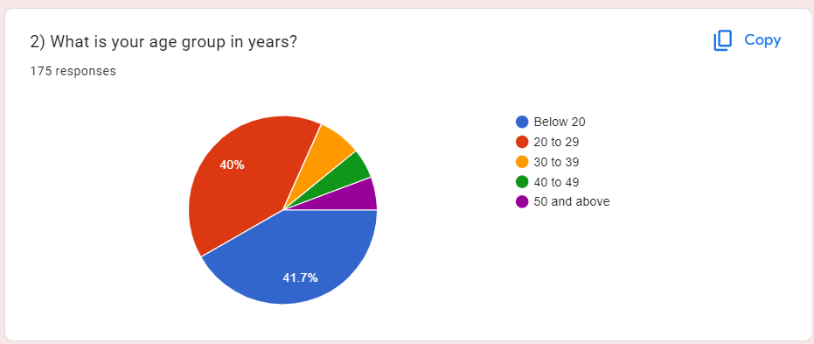
9.2 Demographic profile- age group in years

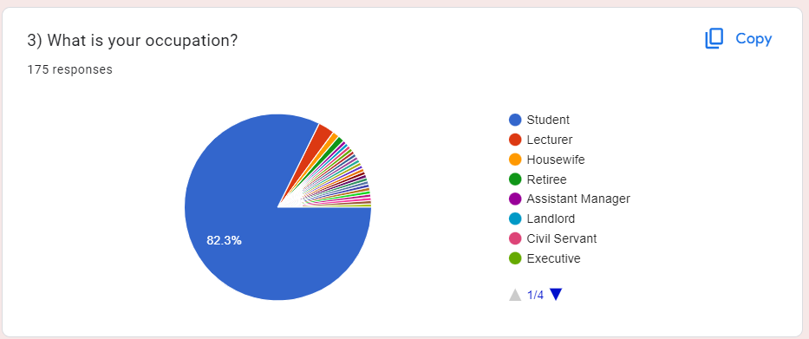
9.3 occupation

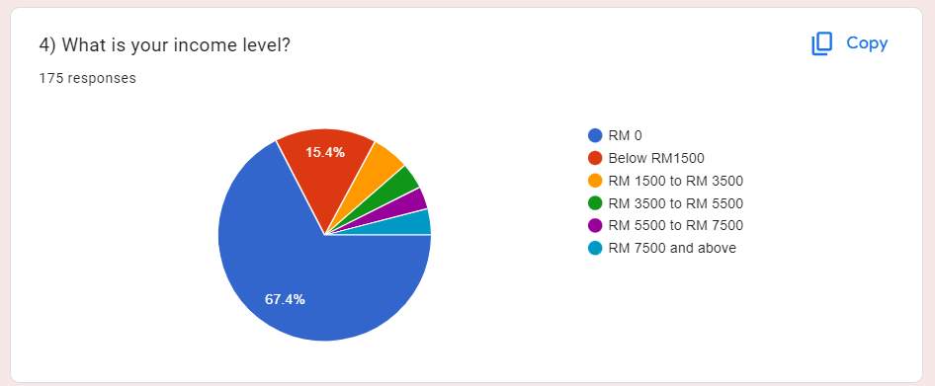
9.4 income level

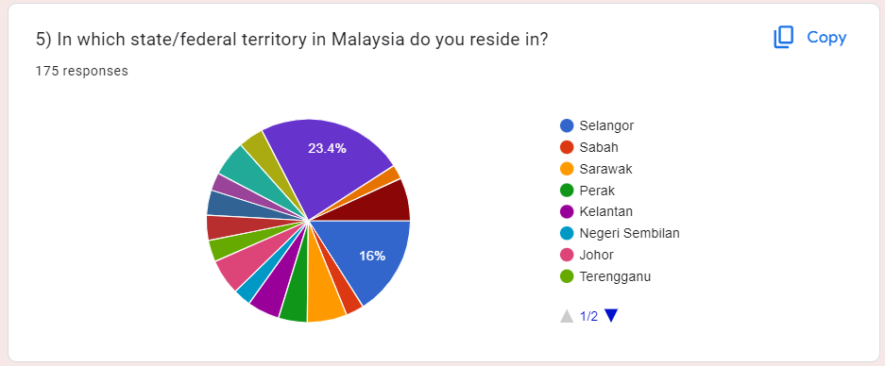
9.5 state/federal territory in Malaysia

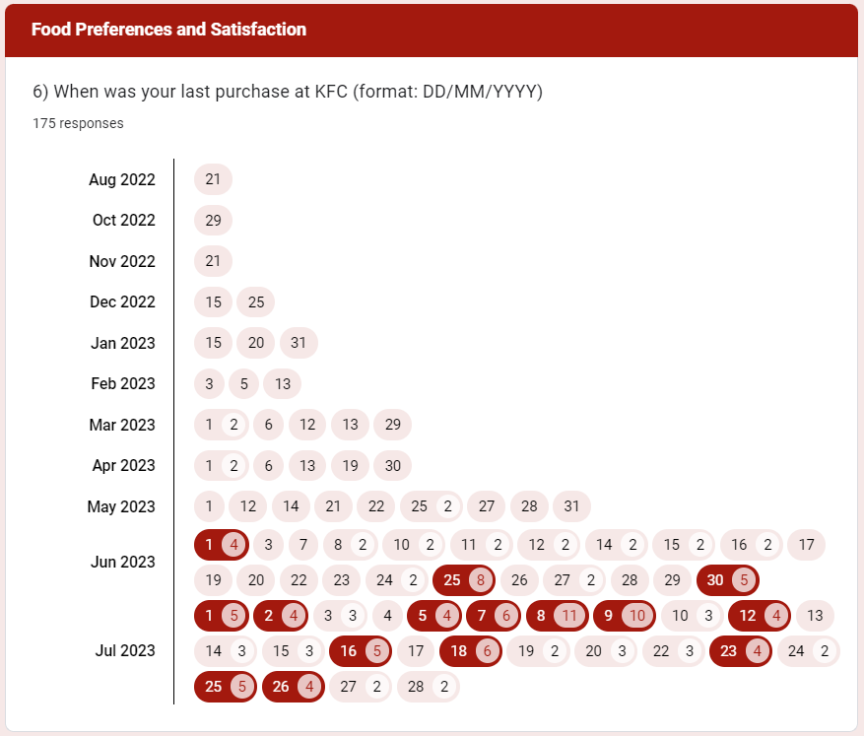
9.6 Food preference and satisfaction

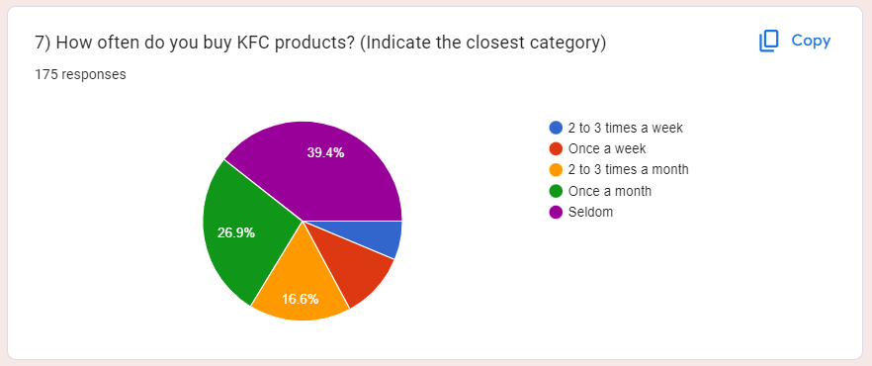
9.7 How an respondents often buy KFC products

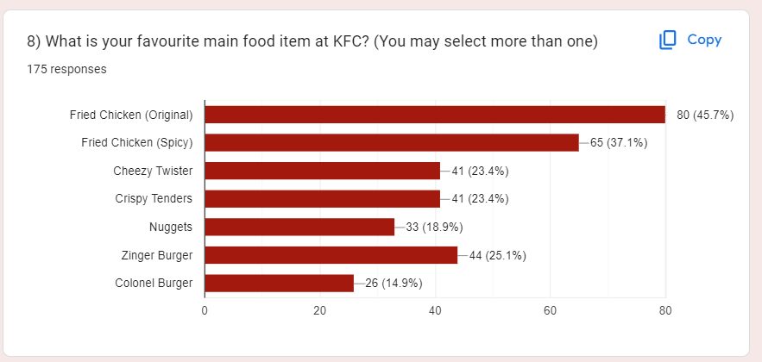
9.8 the respondents favourite main food item at KFC

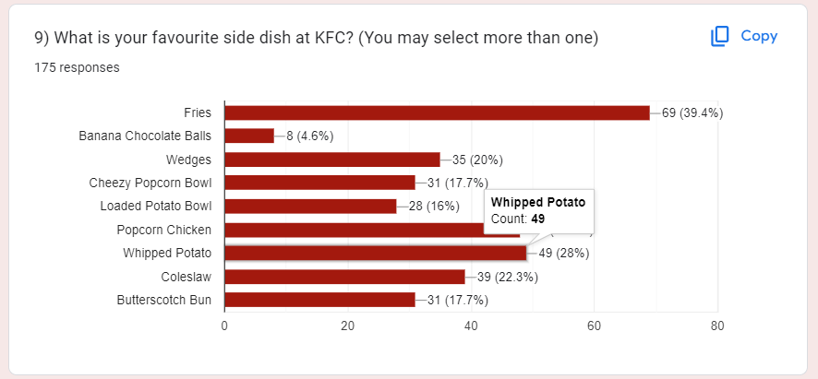
9.9 respondents favourite side dish in KFC

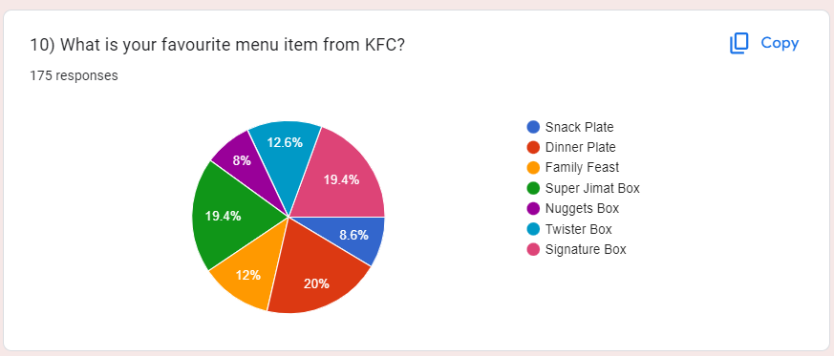
9.10 respondents favourite menu item

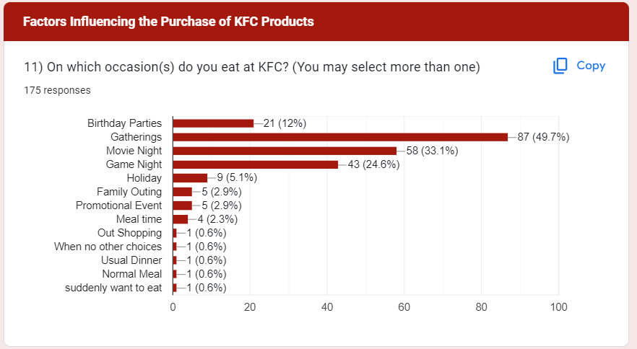
9.11 respondents occasion to eat KFC

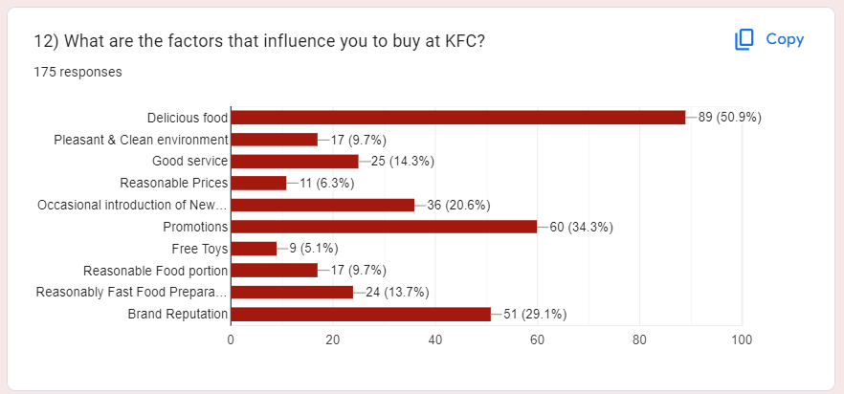
9.12 factors influence the respondents to buy KFC

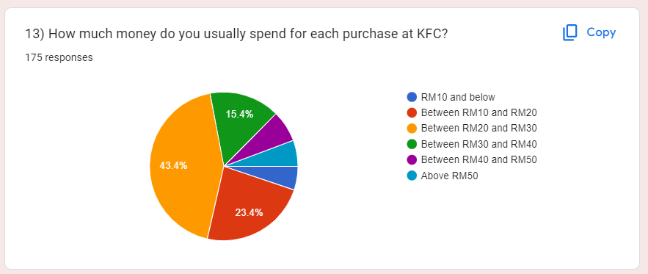
9.13 respondents usual spending in KFC

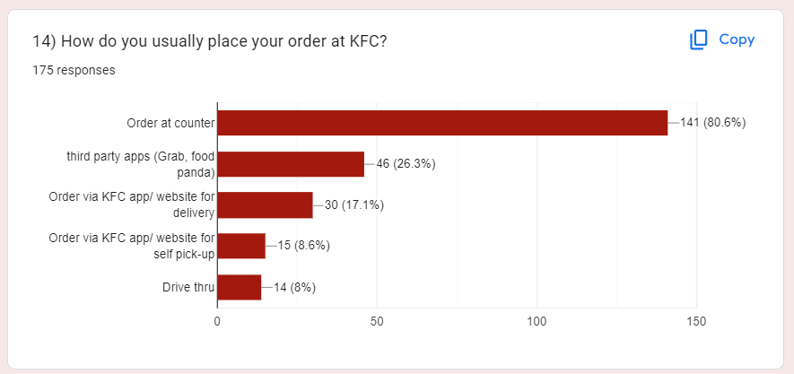
9.14 how respondents usually place their orders at KFC

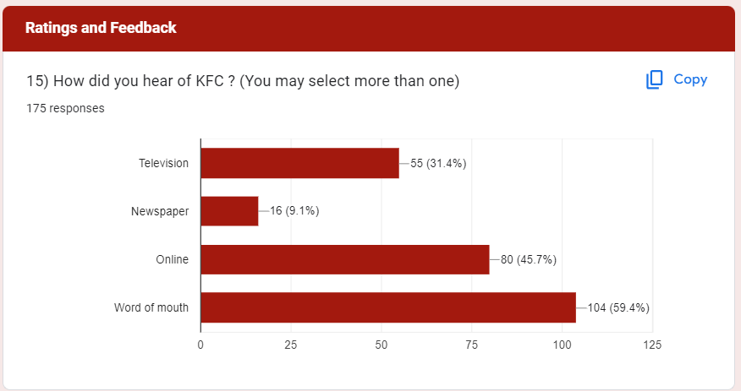
9.15 how respondents hear about KFC

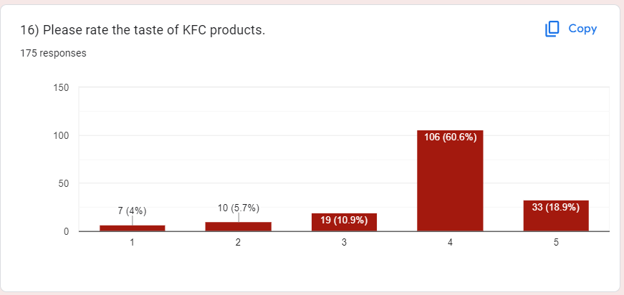
9.16 respondents rating the taste for KFC products

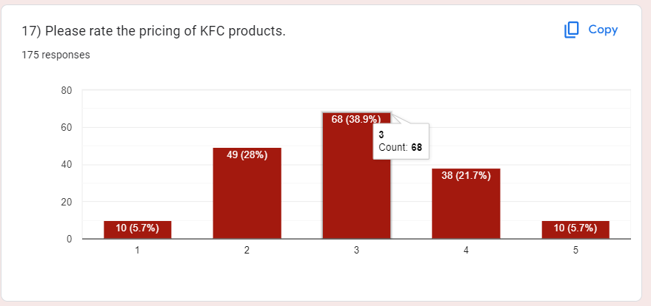
9.17 respondents rating the price for KFC products

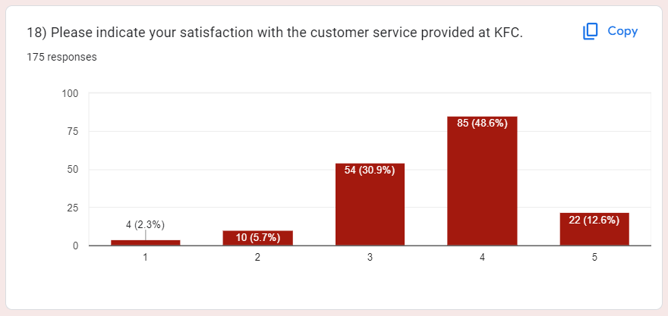
9.18 respondents rating the satisfaction of the customer service provided by KFC

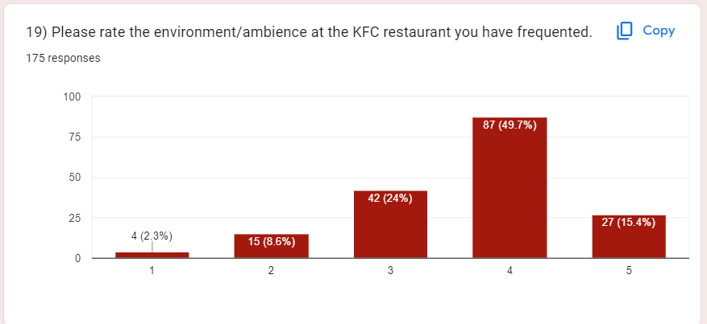
9.19 respondents rating the environment/ambiance at KFC restaurant.

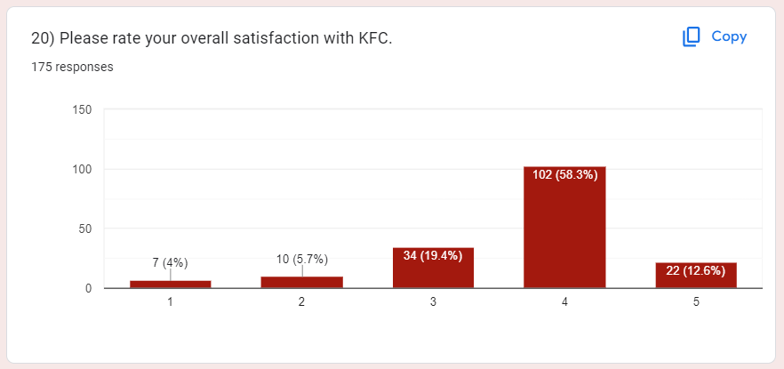
9.20 respondents rating the overall satisfaction for KFC

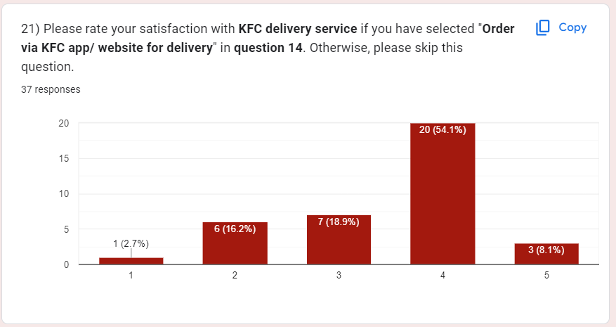
9.21 respondents rating the satisfaction for the KFC delivery service if the respondents order via KFC app/ website for delivery.

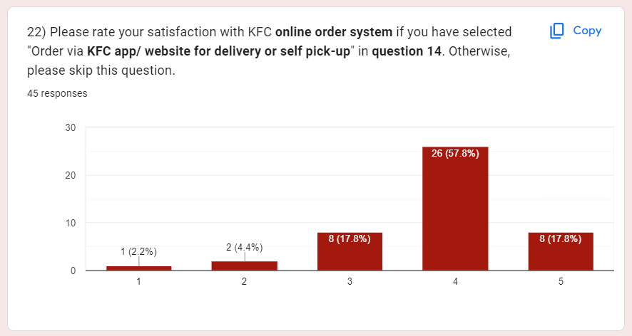
9.22 respondents rated the satisfaction for KFC online order system if the respondents have selected KFC app/website for delivery or self pick-up.

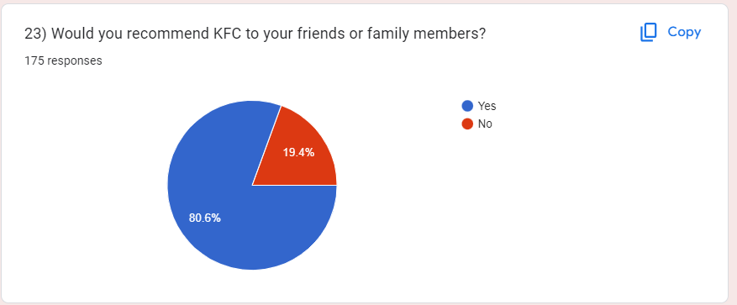
9.23 respondents rated whether they would recommend KFC to their friends or family members.

