Ong, Oleen Hannah S. 12/3/19

2-ECE-B

Data Wrangling with Pandas

Problem 1:

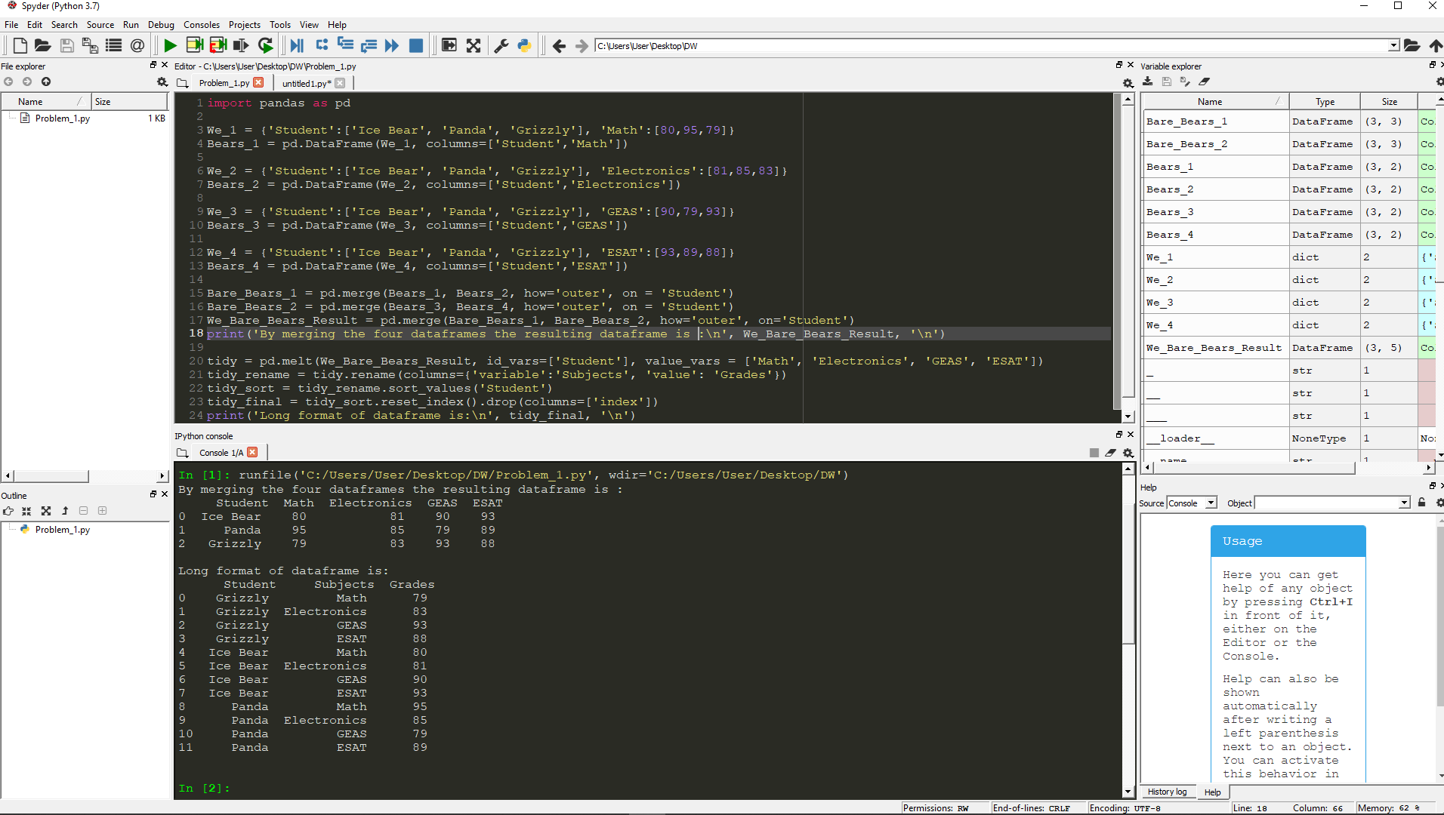

Problem 2: