Ong, Oleen Hannah S. 11/18/2019

2-ECE-B

Numpy

Problem 1:

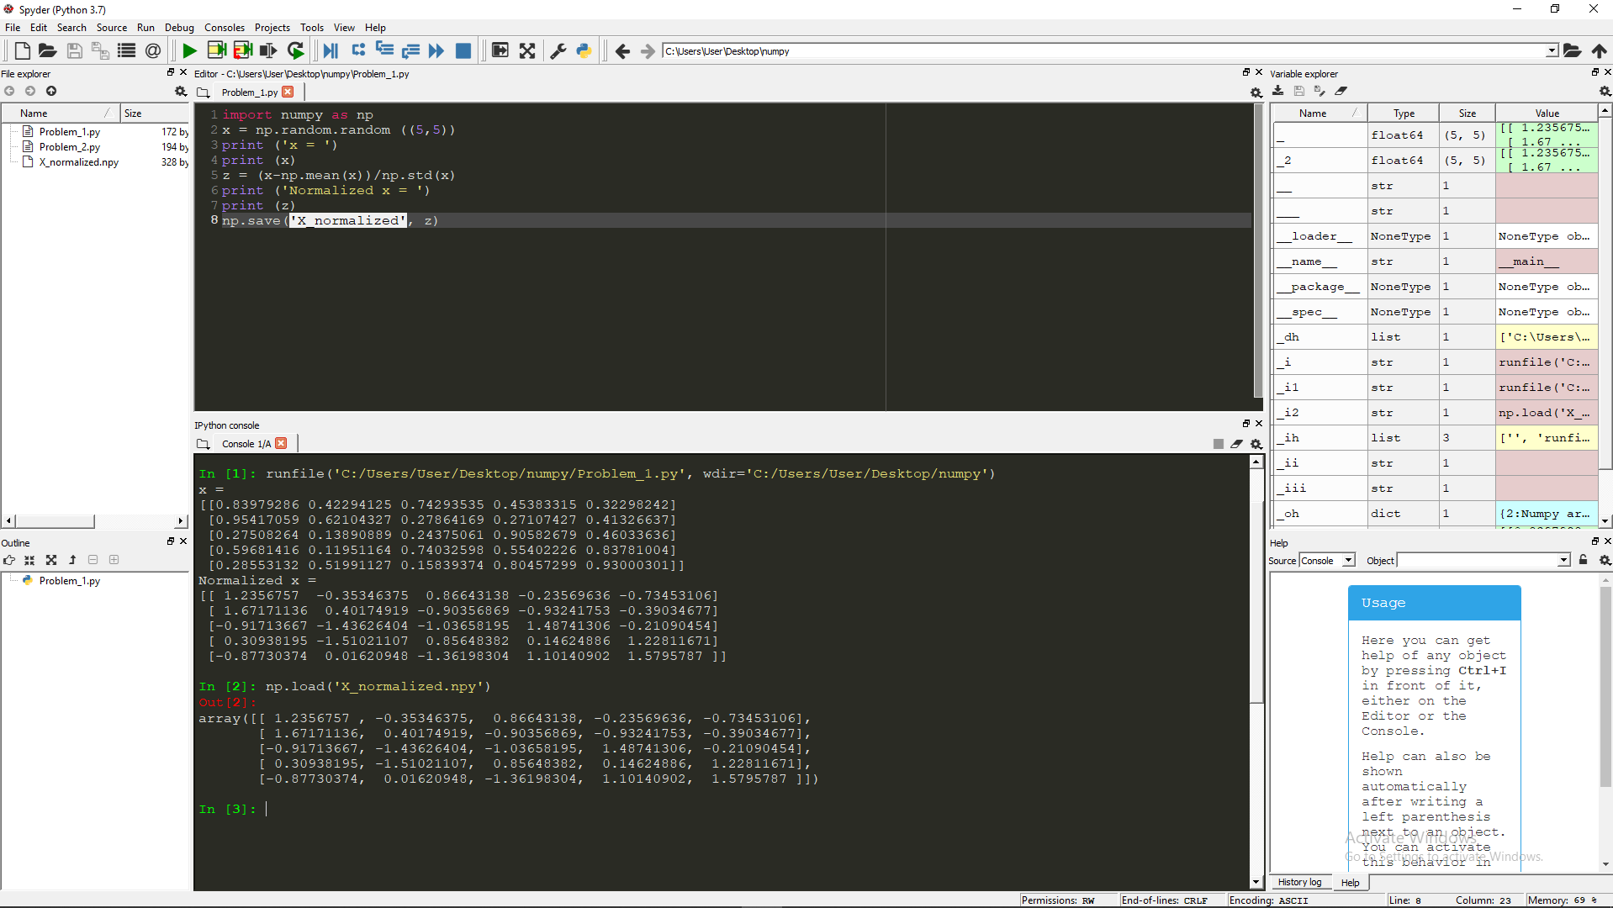

Problem 2:

